California Department of Education
Executive Office
SBE-004 (REV. 11/2017)
addendum-nov21item02

ITEM ADDENDUM
DATE: November 2, 2021
TO: MEMBERS, State Board of Education
FROM: BROOKS ALLEN, Executive Director, California State Board of Education
SUBJECT: Item 02 – 2022-2023 State Board of Education Student Member: Recommendation of Three Finalists for Submission to the Governor for Consideration and Appointment.

Summary of Key Issues
The State Board of Education Screening Committee (consisting of Members Straus (Chair), Glover-Woods and Sun), along with SBE Liaisons to the California Association of Student Councils Member McQuillen and Student Board Member Banankhah recommend that the State Board of Education approve three 2022-23 student member finalists for submission to the Governor, as indicated in Attachment 1.

Attachment(s)
Attachment 1: Recommended Finalists for the 2022-23 Student Member of the Board for the Governor’s Consideration and Appointment (2 Pages)
STATE OF CALIFORNIA
CALIFORNIA STATE BOARD OF EDUCATION
1430 N Street, Suite 5111
Sacramento, CA 95814
Phone:(916) 319-0827
GAVIN NEWSOM, Governor
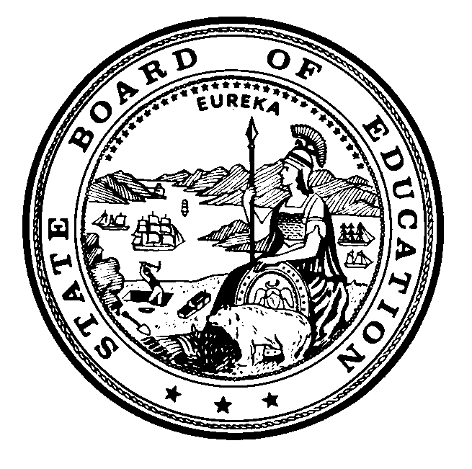

Attachment 1
November 2, 2021
TO: Members, State Board of Education
FROM: Ilene Straus, Chair, and Members of Screening Committee of the State Board of Education
RE: Recommended Finalists for the 2021-2022 Student Member of the Board for the Governor’s Consideration and Appointment
The State Board of Education (SBE) Screening Committee met on Monday, October 18, 2021 to review the applications that were submitted for consideration of the 2022-2023 Student Member of the Board, and selected 12 semi-finalists. The semi-finalists attended the 2021 Student Advisory Board on Education (SABE) conference beginning on October 30, where student delegates listened to presentations made by the semi-finalists, and then voted to select six candidates.
On Monday, November 1, 2021, the SBE Screening Committee interviewed the six candidates, and identified three finalists for consideration by the Board. If approved, the names of these individuals will be submitted to the Governor’s Office for the Governor’s review and consideration. He will appoint one of them as the 2022-2023 Student Member of the Board.
We wish to thank all the students who made the effort to apply, and would like to encourage them to continue offering their impressive abilities to local, regional, or other state activities.
Students who are being recommended as finalists to the State Board of Education by the Screening Committee of the State Board of Education are provided in alphabetical order by last name below:
- Katherine Cheng, Dublin High School, within the Dublin Unified School District, Alameda County
- Naomi Porter, Palos Verdes Peninsula High School, within the Palos Verdes Peninsula Unified School District, Los Angeles County
- Sissi Zhang, Irvington High School, within the Fremont Unified School District, Alameda County

In addition to the finalists named above, the following students were identified as candidates for the 2022-2023 Student Member of the Board:
- Allison Dana, Albany High School, within the Albany Unified School District, Alameda County
- Risha Jain, Monte Vista High School, within the San Ramon Valley Unified School District, Contra Costa County
- Eunyul Kim, Chino Hills High School, within the Chino Valley Unified School District, San Bernardino County
The following students were also identified as semi-finalists for the 2022-2023 Student Member of the Board:
- Dylan Choi, Chaparral High School, within the Temecula Valley Unified School District, Riverside County
- Dawson Kelly, San Marcos High School, within the Santa Barbara Unified School District, Santa Barbara County
- Maana Kolagotla, Christopher High School, within the Gilroy Unified School District, Santa Clara County
- Toni Martin, International Polytechnic High School, within the Los Angeles County Office of Education, Los Angeles County
- Ella Mitchell, Tesoro High School, within the Capistrano Unified School District, Orange County
- Amber Zhao, Walnut High School, within the Walnut Valley Unified School District, Los Angeles County

