California Department of Education
Executive Office
SBE-004 (REV. 11/2017)
addendum-nov22item02

ITEM ADDENDUM
DATE: November 2, 2022
TO: MEMBERS, State Board of Education
FROM: BROOKS ALLEN, Executive Director, California State Board of Education
SUBJECT: Item 02 – 2023-2024 State Board of Education Student Member: Recommendation of Three Finalists for Submission to the Governor for Consideration and Appointment.

Summary of Key Issues
The State Board of Education Screening Committee (consisting of Members Glover Woods (Chair), Escobedo, and Lewis), along with SBE Liaisons to the California Association of Student Councils Member McQuillen and Student Board Member Porter recommend that the State Board of Education approve three 2023-24 student member finalists for submission to the Governor, as indicated in Attachment 1.

Attachment(s)
Attachment 1: Recommended Finalists for the 2023-24 Student Member of the Board for the Governor’s Consideration and Appointment (2 Pages)
STATE OF CALIFORNIA
CALIFORNIA STATE BOARD OF EDUCATION
1430 N Street, Suite 5111
Sacramento, CA 95814
Phone:(916) 319-0827
GAVIN NEWSOM, Governor
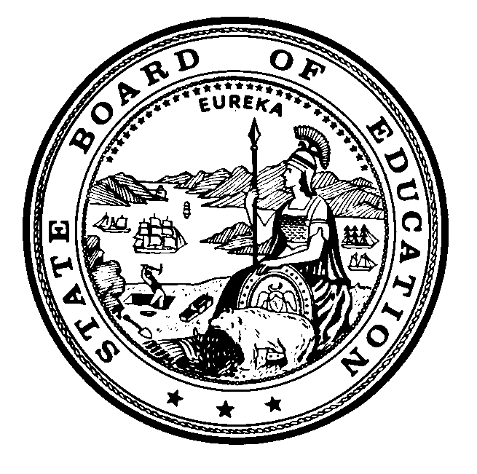

Attachment 1
November 2, 2022
TO: Members, State Board of Education
FROM: Cynthia Glover Woods, Chair, and Members of Screening Committee of the State Board of Education
RE: Recommended Finalists for the 2023-2024 Student Member of the Board for the Governor’s Consideration and Appointment
The State Board of Education (SBE) Screening Committee met on Tuesday, October 18, 2022 to review the applications that were submitted for consideration of the 2023-2024 Student Member of the Board, and selected 12 semi-finalists. The semi-finalists attended the 2022 Student Advisory Board on Education (SABE) conference beginning on October 30, where student delegates listened to presentations made by the semi-finalists, and then voted to select six candidates.
On Tuesday, November 1, 2022, the SBE Screening Committee interviewed the six candidates, and identified three finalists for consideration by the Board. If approved, the names of these individuals will be submitted to the Governor’s Office for the Governor’s review and consideration. He will appoint one of them as the 2023-2024 Student Member of the Board.
We wish to thank all the students who made the effort to apply, and would like to encourage them to continue offering their impressive abilities to local, regional, or other state activities.
Students who are being recommended as finalists to the State Board of Education by the Screening Committee of the State Board of Education are provided in alphabetical order by last name below:
- Anya Ayyappan, Dougherty Valley High School, within the San Ramon Valley Unified School District, Contra Costa County
- Eduardo Corona, Canyon Springs High School, within the Moreno Valley Unified School District, Riverside County
- Kristie To, Northwood High School, within the Irvine Unified School District, Orange County

In addition to the finalists named above, the following students were identified as candidates for the 2023-2024 Student Member of the Board:
- Selah Han, Torrance High School, within the Torrance Unified School District, Los Angeles County
- Sue Oh, Sunny Hills High School, within the Fullerton Joint Union High School District, Orange County
- Katie Xin, Palm Desert High School, within the Desert Sands Unified School District, Riverside County
The following students were also identified as semi-finalists for the 2023-2024 Student Member of the Board:
- Alexa Aguilar, Granite Hills High School, within the Grossmont Union High School District, San Diego County
- Ann Al Bomalallah, El Camino Fundamental High School, within the San Juan Unified School District, Sacramento County
- Keira Bird, Fred C. Beyer High School, within Modesto City Schools, Stanislaus County
- Nethra Dhamodaran, Dougherty Valley High School, within the San Ramon Valley Unified School District, Contra Costa County
- Lavani Madadi, Angelo Rodriguez High School, within the Fairfield Suisun Unified School District, Solano County
- Issei Nagata, Anaheim High School, within the Anaheim Union High School District, Orange County

