California Department of Education
Executive Office
SBE-004 (REV. 11/2017)
addendum-nov23item03

ITEM ADDENDUM
DATE: November 7, 2023
TO: MEMBERS, State Board of Education
FROM: BROOKS ALLEN, Executive Director, California State Board of Education
SUBJECT: Item 03 – 2024-2025 State Board of Education Student Member: Recommendation of Three Finalists for Submission to the Governor for Consideration and Appointment.

Summary of Key Issues
The State Board of Education (SBE) Screening Committee (consisting of Members Glover Woods (Chair), Escobedo, and Lewis), along with SBE Liaisons to the California Association of Student Councils Member McQuillen and Student Board Member Ayyappan recommend that the State Board of Education approve three 2024-25 student member finalists for submission to the Governor, as indicated in Attachment 1.

Attachment(s)
Attachment 1: Recommended Finalists for the 2024-25 Student Member of the Board for the Governor’s Consideration and Appointment (2 Pages)
STATE OF CALIFORNIA
CALIFORNIA STATE BOARD OF EDUCATION
1430 N Street, Suite 5111
Sacramento, CA 95814
Phone:(916) 319-0827
GAVIN NEWSOM, Governor
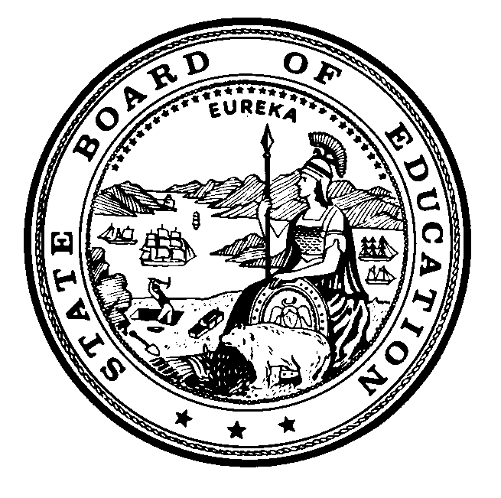

Attachment 1
November 7, 2023
TO: Members, State Board of Education
FROM: Cynthia Glover Woods, Chair, and Members of Screening Committee of the State Board of Education
RE: Recommended Finalists for the 2024-2025 Student Member of the Board for the Governor’s Consideration and Appointment
The State Board of Education (SBE) Screening Committee met on Tuesday, October 17, 2023, to review the applications that were submitted for consideration of the 2024-2025 Student Member of the Board and selected 12 semi-finalists. The semi-finalists attended the 2023 Student Advisory Board on Education (SABE) conference beginning on November 5, where student delegates listened to presentations made by the semi-finalists, and then voted to select six candidates.
On Tuesday, November 7, 2023, the SBE Screening Committee interviewed the six candidates, and identified three finalists for consideration by the Board. If approved, the names of these individuals will be submitted to the Governor’s Office for the Governor’s review and consideration. He will appoint one of them as the 2024-2025 Student Member of the Board.
We wish to thank all the students who made the effort to apply, and would like to encourage them to continue offering their impressive abilities to local, regional, or other state activities.
Students who are being recommended as finalists to the State Board of Education by the Screening Committee of the State Board of Education are provided in alphabetical order by last name below:
- Neil Chandran, Monte Vista High School, within the San Ramon Valley Unified School District, Contra Costa
- Julia Clauson, Bella Vista High School, within the San Juan Unified School District, Sacramento
- Maulik Dhakal, Los Altos High School, within the Mountain View Los Altos Union High School, Santa Clara

In addition to the finalists named above, the following students were identified as candidates for the 2024-2025 Student Member of the Board:
- Hannah Cho, Northwood High School, within the Irvine Unified School District, Orange
- Travis Hodges, Monte Vista High School, within the San Ramon Valley Unified School District, Contra Costa
- Carter McKinzie, Laguna Beach High School, within the Laguna Beach Unified School District, Orange
The following students were also identified as semi-finalists for the 2024-2025 Student Member of the Board:
- Alina Ceja Delgado, Napa High School, within the Napa Valley Unified School District, Napa
- Atticus Chan, Lincoln High School, within the Lincoln Unified School District, San Joaquin
- Kailia Garfield, Mark Keppel High School, within the Alhambra Unified School District, Los Angeles
- Mia Golden, Rio Americano High School, within the San Juan Unified School District, Sacramento
- Alejandra Ramirez, Academy of the Redwoods, within the Fortuna Union High School District, Humboldt
- Venkata Ramisetty, Fremont High School, within the Fremont Union High School District, Santa Clara

