California Department of Education
Executive Office
SBE-003 (REV. 11/2017)
imab-adad-nov23item04

California State Board of Education
November 2023 Agenda
Item #05

Subject
California Assessment of Student Performance and Progress and English Language Proficiency Assessments for California: 2022–23 Results Release.

Type of Action
Information

Summary of the Issue(s)
This item provides a summary of the public release of the 2022–23 California Assessment of Student Performance and Progress (CAASPP) and English Language Proficiency Assessments for California (ELPAC) aggregate results to the Test Results for California’s Assessments website.

Recommendation
This item is information only, there are no recommendations at this time.

Brief History of Key Issues
On October 18, 2023, the California Department of Education (CDE) publicly released the 2022–23 CAASPP and ELPAC summary reports.
The 2022–23 CAASPP summary reports include all results for the following assessments:
- Smarter Balanced English language arts/literacy (ELA) and Mathematics
- California Science Test (CAST)
- California Alternate Assessments (CAAs) for ELA, Mathematics, and Science
- California Spanish Assessment (CSA)
The 2022–23 ELPAC summary reports include all results for the following assessments:
- Initial ELPAC
- Initial Alternate ELPAC
- Summative ELPAC
- Summative Alternate ELPAC
The summary reports are available on the Test Results for California’s Assessments website at https://caaspp-elpac.ets.org. The CDE’s news release regarding the release of the 2022–23 CAASPP and ELPAC results is included in Attachment 1 and posted on the CDE website at https://www.cde.ca.gov/nr/ne/yr23/yr23rel83.asp.
General summaries of student performance at the state level are presented below.

Summary of California Assessment of Student Performance and Progress Results
The proportion of students tested who are socioeconomically disadvantaged increased from 60 percent in 2022 to 63 percent in 2023, as shown in chart 1 and table 1, and the number and share of students who are experiencing homelessness or who are part of the foster care system has also increased. Given the ongoing drops in achievement appearing on many national tests and the relationship between student advantage and achievement, California’s statewide scores are promising.
Overall, against this backdrop, the percentages of California students meeting or exceeding the standards for mathematics, science, and the ELPAC increased, while the percentage of students meeting or exceeding the standard for ELA did not change significantly. Results also improved in the CAAs, which are given to students with the greatest special education needs, in both ELA and mathematics.

Chart 1. Percent of Students Who Met or Exceeded Standard Compared to the Percent of Students Who Are Socioeconomically Disadvantaged
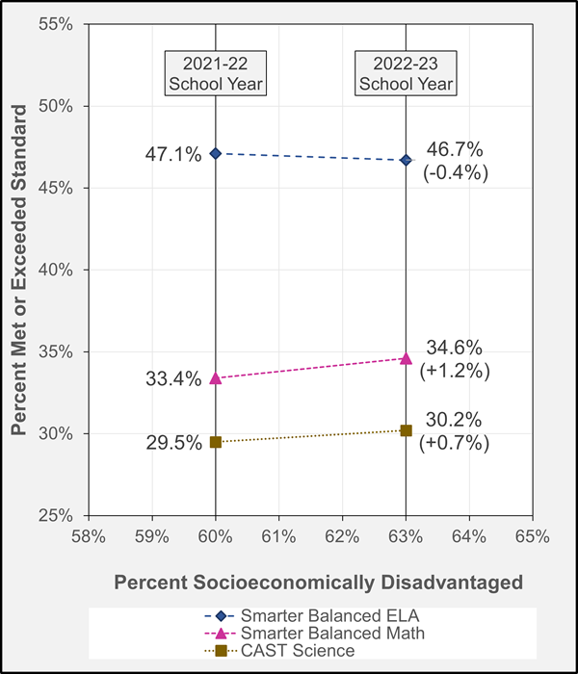

Table 1. Change in Proportion of Students Tested Who Are Socioeconomically Disadvantaged
Year | Socioeconomically Disadvantaged | English Language Arts/Literacy | Mathematics | Science
2021–22 | 60.0% | 47.1% | 33.4% | 29.5%
2022–23 | 63.0% | 46.7% | 34.6% | 30.2%
Difference | 3.0% | -0.4% | 1.2% | 0.7%

English Language Arts/Literacy and Mathematics
When compared to the results from the 2021–22 administration, the percentage of students in California meeting or exceeding standard for mathematics increased from 33.4 percent to 34.6 percent in 2022–23, while the percentage of students meeting or exceeding the standard for ELA did not change significantly.
For mathematics, the mean scale score increased across all grades. For ELA, the mean scale score increased for grades 3 and 11. Overall, the trend of generally maintaining in ELA and achieving slight increases in mathematics mirrors trends in other states using Smarter Balanced Assessment.

California Science Test
Student performance on the CAST showed a continued improvement with a slight increase from the prior year, from 29.5 percent in 2021–22 to 30.2 percent in 2022–23 in the percentage of students meeting or exceeding standard.

California Spanish Assessment
Student performance on the CSA remained very similar to the 2021–22 test administration, with a slight decrease by approximately 1.0 percent of students meeting the highest score reporting range in 2022–23.

California Alternate Assessments for English, Mathematics, and Science
For the CAAs for ELA and mathematics, the percentage of students who reached Level 3 increased—by 2.0 percent for ELA and by 1.0 percent for mathematics—when compared to the 2021–22 administration. The percentage of students reaching Level 3 on the CAA for Science slightly decreased by approximately 2.0 percent.

Summary of English Language Proficiency Assessments for California Results

Initial English Language Proficiency Assessments for California
In 2022–23, there were 221,813 eligible students who took the Initial ELPAC, an increase of approximately 6 percent in the number tested compared to the prior year total of 208,585. Approximately 14.8 percent of eligible students scored at Level 3, which is initial fluent English proficient. This is a slight decrease from the previous year of 15.6 percent.

Initial Alternate English Language Proficiency Assessments for California
This was the first operational year for the Initial Alternate ELPAC. In 2022–23, 864 eligible students took the Initial Alternate ELPAC. Approximately 9.6 percent of eligible students scored at Level 3, which is initial fluent English proficient.

Summative English Language Proficiency Assessments for California
For the Summative ELPAC, the percentage of students reaching Level 4 increased to 16.5 percent in 2022–23, from the prior year of 15.6. The number of students who tested was 1,051,695, a slight decrease of 0.6 percent in the number tested compared to the 2021–22 school year total of 1,058,286. The number of students identified as socioeconomically disadvantaged who earned an overall performance level of 4 increased at a higher rate, from 14.5 percent in 2021–22 to 15.7 percent in 2022–23.

Summative Alternate English Language Proficiency Assessments for California
For the Summative Alternate ELPAC, the percentage of students reaching Level 3 is 26.1 percent in 2022–23, a decrease of approximately 2.6 percent from last year. The number of students who tested increased to 17,773, an increase of 4.7 percent in the number tested compared to the 2021–22 school year total of 16,972. Overall, the changes in performance for Summative Alternate ELPAC across all grades represent normal fluctuations from year to year.

The Test Results for California’s Assessments Website
California provides the Test Results for California’s Assessments website at https://caaspp-elpac.ets.org/, where parents and teachers can view and compare aggregated results among schools, districts, and counties as well as statewide results. Alongside the release of the 2022–23 CAASPP and ELPAC results, several enhancements have been made to this reporting website to further expand and improve users’ access to student achievement and performance data.
Beginning with the 2022–23 results, two new student groups—Long-Term English Learners (LTEL) and At-Risk of becoming LTEL—have been added to the selection of Language Fluency Groups for both the CAASPP and ELPAC. Definitions for these student groups can be found in California Education Code (EC) Section 313.1. In addition, an enhancement has been made to the CAASPP Performance Trend Reports to allow users to compare any single student group with the student group of all students.
In September 2023, Governor Newsom signed Senate Bill 293, which amends EC Section 60641 to require the CDE to make statewide summative CAASPP results publicly available on or before October 15 each year for 2023–24 and subsequent years. The October 18 release date moves the release timing closer to achieving that goal.

Summary of Previous State Board of Education Discussion and Action
In November 2022, the CDE notified the SBE of the public release of 2021–22 CAASPP and ELPAC results (https://www.cde.ca.gov/be/ag/ag/yr22/documents/nov22item12rev.docx).
In October 2019, the CDE notified the SBE of the public release of 2018–19 CAASPP and ELPAC results (https://www.cde.ca.gov/be/pn/im/documents/oct19memoadad03.docx).
In October 2018, the CDE notified the SBE of the public release of 2017–18 CAASPP results (https://www.cde.ca.gov/be/pn/im/documents/memo-pptb-adad-oct18item03.docx).
In October 2017, the CDE notified the SBE of the public release of 2016–17 CAASPP results (https://www.cde.ca.gov/be/pn/im/documents/memo-pptb-adad-oct17item02.doc).

Fiscal Analysis (as appropriate)
Not applicable.

Attachment(s)
- Attachment 1: 2022–23 California Statewide Assessment Results and Chronic Absenteeism Rates Show Student Progress (7 Pages)
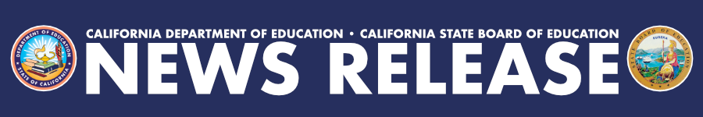
FOR IMMEDIATE RELEASE
REL#23-83
Wednesday, October 18, 2023
Contact: communications@cde.ca.gov
916-319-0818

2022–23 California Statewide Assessment Results and Chronic Absenteeism Rates Show Student Progress
Promising gains in student mathematics and English proficiency scores and consistent scores in science and English Language Arts, paired with reduced chronic absenteeism rates, show hopeful signs of continued recovery.
SACRAMENTO––The California Department of Education (CDE) released assessment results today that indicate the impact of the state recovery effort from the COVID-19 pandemic. The results include data for the California Assessment of Student Performance and Progress (CAASPP) and the English Language Proficiency Assessments for California (ELPAC). Additionally, the CDE released chronic absenteeism rates and “absence by reason” reports that reflect a promising trend of improved student attendance in school.
Given the ongoing drops in achievement appearing on many national tests and the relationship between student advantage and achievement, California’s statewide scores are particularly promising; the proportion of high-need students has also increased in California. Specifically, the proportion of students tested who are socioeconomically disadvantaged increased from 60 percent in 2022 to 63 percent in 2023, as shown in the chart below, and the number and share of students who are experiencing homelessness or who are part of the foster care system has also increased.
Overall, against this backdrop, the percentages of California students meeting or exceeding the standards for mathematics, science, and the ELPAC increased, while the percentage of students meeting or exceeding the standard for English Language Arts (ELA) did not change significantly. Results also improved in the California Alternate Assessments, which are given to students with the greatest special education needs, in both ELA and mathematics.
The percentage of students who met or exceeded the standard on the Smarter Balanced Summative Assessment for mathematics increased from 33.4 percent in 2021–22 to 34.6 percent in 2022–23, with the mean scale scores increasing in all grades. For the California Science Test, student scores were generally consistent with pre-pandemic levels, which shows continued improvement with a small increase from the prior year (from 29.5 percent in 2021–22 to 30.2 percent in 2022–23). The percentage of students who met or exceeded the standard for the Smarter Balanced Summative Assessment for ELA did not change significantly—just 0.4 percentage points from 47.1 percent in 2021–22 to 46.7 percent in 2022–23, with mean scale scores in most grades mirroring this trend but increasing in grades three and eleven. This pattern of generally maintaining in ELA and achieving slight increases in mathematics mirrors trends in other states using the Smarter Balanced Assessment, such as Oregon, Nevada, Connecticut, Delaware, and Washington. For more details on each assessment and student group results, refer to the Test Results for California’s Assessments website.
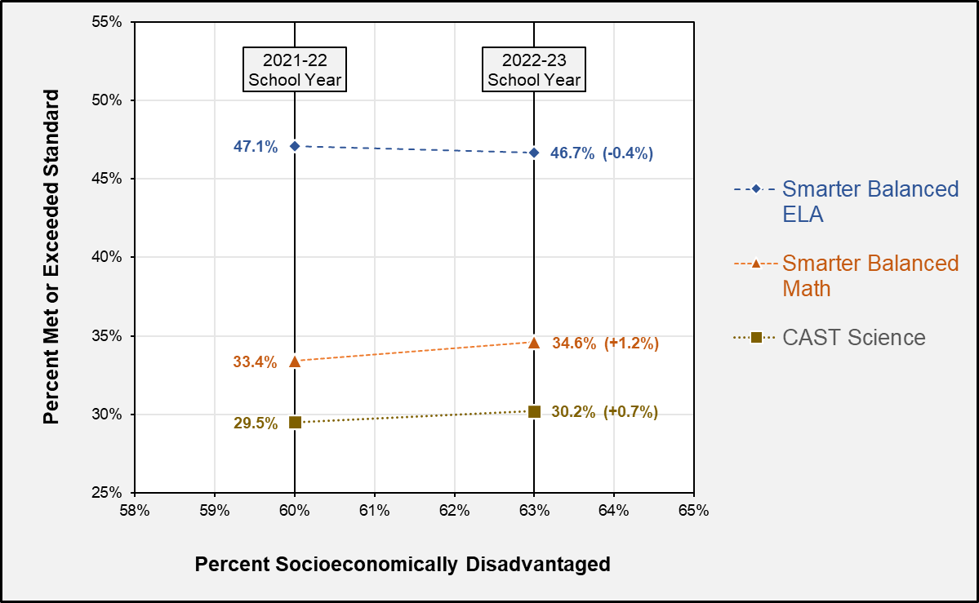
For the Summative ELPAC, the percentage of English Learners who earned the highest overall performance level of 4—the level needed to meet Criterion One of four criteria for reclassification—increased nearly a full percentage point from 15.6 percent in 2021–22 to 16.5 percent in 2022–23. Moreover, the percentage of students identified as socioeconomically disadvantaged who earned an overall performance level of 4 increased at a higher rate, from 14.4 percent in 2021–22 to 15.7 percent in 2022–23, while the students who were not socioeconomically disadvantaged held steady at about 21 percent. For more details on each ELPAC test and additional student group results, refer to the Test Results for California’s Assessments website.
The chronic absenteeism rate, which measures the number of students who missed 10 percent of the days they were expected to attend for any reason, decreased 5.1 percentage points from 30 percent in 2021–22 to 24.9 percent in 2022–23. All student groups showed improved chronic absenteeism rates, with the largest declines demonstrated by our American Indian or Alaska Native, Hispanic or Latino, Pacific Islander, and African American students. In addition, the average number of days absent decreased to 14.6 from a high of 16.7 in the 2021–22 school year.
Compared with other states that have released chronic absenteeism data for the 2022–23 school year, California’s overall decrease is greater than the 11-state average reported by Attendance Works on October 12, 2023, and California’s current rate is lower than states including Colorado, Michigan, Nevada, New Mexico, and Ohio. As a local comparison, the chronic absenteeism rate in New York City Public Schools was 36 percent in 2022–23 compared to Los Angeles Unified School District’s rate of 30.8 percent for the same year.
These data suggest that California has started to turn the corner on student outcomes, and recovery is underway.
“These data show signs of improvement for our students, but we know that our students and local educational agencies will continue to need sustained support,” said Chief Deputy Superintendent of Public Instruction Mary Nicely. “California has proactively invested in additional resources to help our students beyond 2024, when the federal relief funding expires, and has set aside billions of dollars for direct services to support interventions for our students, including an additional $300 million ongoing for our most vulnerable students. The CDE is developing strategies to identify measurable outcomes based on these historic investments and is working on more alignment and cohesion of resources to promote growth and improvements in the future.”
“These results suggest that California’s public schools are beginning to turn the corner on pandemic recovery, with gains on most assessments and a substantial reduction in chronic absenteeism, especially for our most vulnerable groups of students,” said California State Board of Education President Linda Darling-Hammond. “Our Governor and Legislature have substantially increased funding for schools to enable educators to invest in effective strategies like high-dose tutoring, after school and summer learning, mental health supports, and universal preschool to accelerate learning and engage students. Our work is far from done, and we will build on recent investments made in a new Equity Multiplier, reading coaches and literacy specialists, and a state Literacy Roadmap to further empower our educators and our students to continue making equitable gains.”

California’s Multibillion Investments in TK–12 Education and Literacy
In recent years, the state has made historic investments in K–12 public education with a focus on accelerating learning and prioritizing equity. For total K–12 school funding, the 2023 Budget Act provides $108.3 billion Proposition 98 General Fund, including a cost-of-living adjustment of 8.22 percent for the Local Control Funding Formula. In addition to billions of federal COVID-19 recovery funds, schools continue to benefit from $7.9 billion that the state provided in 2022 for the Learning Recovery Emergency Block Grant for school learning acceleration initiatives through 2028 and $3.6 billion for the Arts, Music, and Instructional Materials Discretionary Block Grant, which schools can use for any purpose.
Beginning in the 2022–23 school year, the state began allocating billions to expand access to transitional kindergarten for tens of thousands of four-year-old children to improve kindergarten readiness and long-term student outcomes. The 2022 and 2023 Budget Acts also provided a total of $500 million to fund the Literacy Coaches and Reading Specialists Grant Program, which supports the development of school literacy programs and interventions to help pupils in need of targeted literacy support. Additionally, the 2023 Budget Act included $1 million to create a Literacy Roadmap to help educators apply the state’s curriculum frameworks to classroom instruction, navigate the resources and professional development opportunities available to implement effective literacy instruction, and improve literacy outcomes for all pupils with a focus on equity.
To increase the amount of time that kids can benefit from educational support and enrichment, beginning in 2021, the state allocated $4.4 billion one-time and $4 billion ongoing to expanding learning opportunities beyond traditional school hours. These programs are a key component of the state’s $4.1 billion California Community Schools Partnership Program initiative, which supports schools’ efforts to partner with community agencies and local government to align community resources to improve student outcomes.
The 2023 Budget Act also included a new Equity Multiplier initiative that will provide an ongoing $300 million annually for school sites with a high percentage of socioeconomically disadvantaged pupils and with high non-stability rates. This funding was paired with significant changes to the state’s accountability system that will require schools to be more strategic in their fiscal planning to address school and demographically specific inequities.
The CAASPP and ELPAC summary reports are available to the public on the Test Results for California’s Assessments website. Assessment results are only one measure and should be combined with other information such as report card grades, classroom assignments, or teacher observations to better understand student achievement and progress.
Educational partners who are interested in working with the CDE to improve student performance should email CAStudentPerformance@cde.ca.gov.
#####

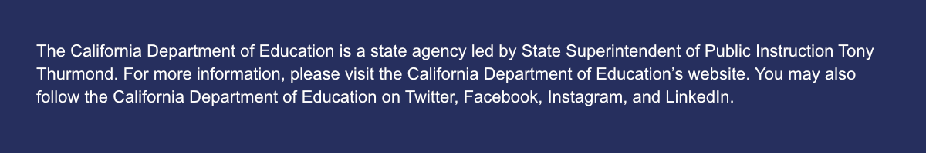
The California Department of Education is a state agency led by State Superintendent of Public Instruction Tony Thurmond. For more information, please visit the California Department of Education’s website. You may also follow the California Department of Education on Twitter, Facebook, Instagram, and LinkedIn.

