2023 Dashboard On-Demand Session: College/Career Indicator Notetaking Guide
California Department of Education | December 2023

Welcome

Agenda
- Overview of the California School Dashboard (Dashboard)
- College/Career Indicator (CCI)
- Frequently Asked Questions (FAQs)
- General Rules About the Dashboard
- Contact Us

Overview of the Dashboard

Dashboard
The Dashboard is an online tool designed to help communities across the state access important information about students in kindergarten through grade twelve. The Dashboard reports how districts and schools are performing on multiple state and local measures that make up California’s accountability system.

What Can I Expect from the 2023 Dashboard?
The Dashboard will still report local indicators and state indicators. The big change will be in the state indicators returning to colors.

Dashboard State Indicators
- Academic Indicators
  - English language arts/literacy (ELA)
  - Mathematics
- English Learner Progress Indicator (ELPI)
- Chronic Absenteeism Indicator
- Graduation Rate Indicator
- Suspension Rate Indicator
- CCI
  - The CCI is reported as a Status Only indicator on the 2023 Dashboard.

Measurement of Performance
For all the other state indicators on the 2023 Dashboard, the measurement of performance for the local educational agencies (LEAs), schools, and student groups on the Dashboard is done by looking at two years of data:
- Current year data equals Status.
- A comparison between the current and prior years’ data equals Change.
It is the combination of Status and Change that determines color performance on the Dashboard and is designated by receiving a color, ranging from Red at the lowest Performance Level to Blue at the highest Performance Level.

Performance Levels
There are five Performance Levels (colors) that can be reported on the Dashboard.
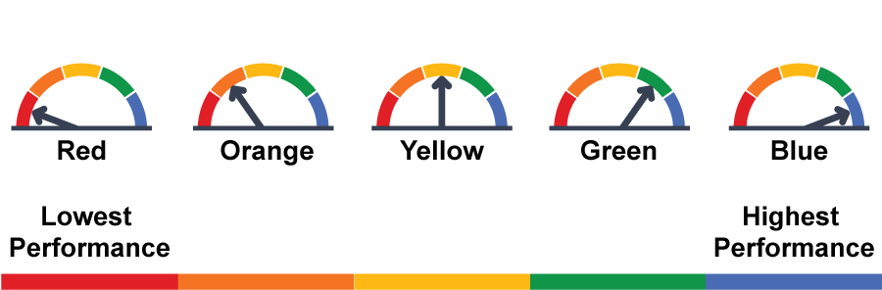
The Performance Levels in order from highest to lowest are Blue, Green, Yellow, Orange, and Red.

CCI Reporting Current Year Data Only
For the CCI, only current year data is reported on the 2023 Dashboard because the California Department of Education (CDE) was unable to report out the CCI in the 2022 Dashboard due to unavailable statewide assessment results. For more information about the 2022 CCI, refer to the CDE 2022 CCI flyer at https://www.cde.ca.gov/ta/ac/cm/documents/collegecareer22.pdf and the CDE 2022 2022 Reference Guide: CCI document at https://www.cde.ca.gov/ta/ac/cm/documents/dbguidecci22.docx.
Because only the current year data, or Status, is being reported for the CCI, the “purple cell phone bar” graphics will be used to identify the Status performance levels for LEAs, schools, and student groups.
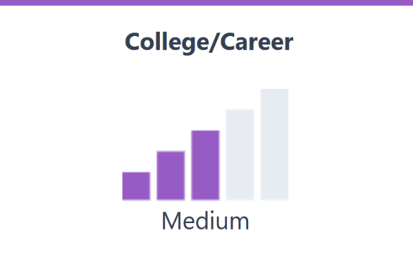

Five Status Levels
The cell phone bars depict each of the five Status levels, which are Very Low, Low, Medium, High, and Very High. Each graphic displays five grey bars, with an additional purple bar filled in as Status improves. The more cell phone bars filled in, the better the performance or result. The Very Low represents the lowest Performance Level while the Very High represents the highest Performance Level.
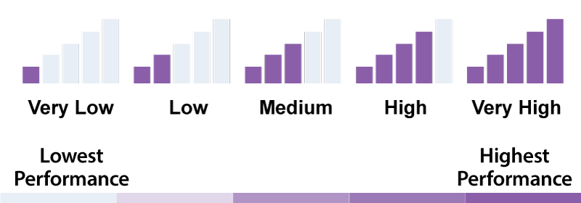

CCI Basics

What is the CCI?
The CCI measures how well districts and schools are preparing their graduates for college and career. The CCI uses what graduates accomplished during their time in high school to determine whether schools and districts are preparing students for college and/or career. It also recognizes that students pursue various options, whether completing: a Career Technical Education (CTE) Pathway, course requirements for
A–G completion, or a course of study specifically designed to meet the student’s individual interests.
As a result, the CCI contains both college and career measures.

Career Measures
The career measures that the State Board of Education (SBE) has approved are the following:
- Pre-Apprenticeships
- State and Federal Job Programs, which are specific to alternative schools (also known as Dashboard Alternative School Status [DASS])
- Transition Classroom and Work-Based Learning Experiences which are specific for students with disabilities who earn a Special Education Certificate of Completion
- CTE Pathway
- Leadership/Military Science

College Measures
The college measures that the SBE has approved are the following:
- Smarter Balanced Summative Assessments for grade eleven
- Advanced Placement or AP exams
- The Met University of California (UC)/California State University (CSU) requirements, which are also known as A–G completion
- International Baccalaureate or IB exams
- State Seal of Biliteracy
- College credit courses
- Leadership/Military Science

CCI Levels
Students are placed in three levels:
- Prepared
- Approaching Prepared
- Not Prepared
The SBE has approved specific criteria that place students in one of these three levels. These criteria are available on the following documents on the CDE website:
- Measures of College Readiness (PDF) at https://www.cde.ca.gov/ta/ac/cm/documents/ccicollege.pdf
- Measures of Career Readiness (PDF) at https://www.cde.ca.gov/ta/ac/cm/documents/ccicareer.pdf

Students Included in the CCI
The same set of students in the Graduation Rate Indicator are used in the CCI, which means all the students included in the combined four- and five-year graduation rate. Therefore, these students are those who graduated in four years (as part of most current graduating class) and students who graduated in five years (as part of the prior year graduating class).

CCI Calculations
To calculate CCI Status for the 2023 Dashboard, a rate is determined using the following numerator and denominator:
- Numerator—total number of graduates in the Class of 2023 who met the “Prepared” criteria plus the total number of fifth-year graduates from the Class of 2022 who met the “Prepared” criteria
- Denominator—total number of students in the 2022–23 combined four- and five-year graduation rate, which is the total number of students who entered grade nine for the first time in 2019–20 for the Class of 2023 plus the total number of students in the Class of 2022 who graduated in five years and met the “Prepared” criteria

CCI on the Dashboard
The CCI baseball card on the Dashboard will be the first level of information available to schools and LEAs related to the CCI. It shows Status levels and Status data along with the equity report.

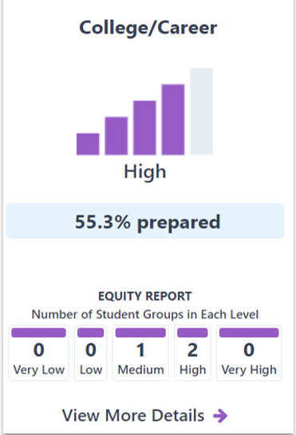

Description of the CCI Baseball Card
In this College/Career baseball card, the Status level is High with four of the five bars in the cell phone bar graphic filled in purple. The Status is 55.3 percent prepared. The equity report displays the number of student groups in each Status level. There are zero student groups in Very Low and Low, one student group in Medium, two student groups in High, and zero student groups in Very High. Finally, there is a link to view more details, which takes you to specific student group information and trends in data over time.

CCI Status Levels
The Status level for an LEA, school, or student group is determined through the use of the Status cut scores set by the SBE.
Table 1. CCI Status Level Cut Scores
Status Level | Cut Scores
Very High | 70 percent or greater
High | From 55 to 69.9 percent
Medium | From 35 to 54.9 percent
Low | From 10 to 34.9 percent
Very Low | 9.9 percent or less

Verify Your CCI Data
LEAs can validate the CCI data prior to the close of the California Longitudinal Pupil Achievement Data System (CALPADS) certification window by reviewing the following:
- CALPADS Reports 3.19 and 3.20 for CTE Pathway completers
- CALPADS Reports 3.10 and 3.11 for College Credit and Leadership/Military Science
- Reports 15.1 and 15.2 for the following measures:
  - Met UC/CSU Requirements (or A–G completion)
  - State Seal of Biliteracy
  - Pre-Apprenticeships
  - State or Federal Job Program
  - Transition Work-based Experience/Transition Classroom-based Work Exploration
Instructions on how to access these reports are available in the 2022–23 Handbook Connecting CALPADS to Dashboard at https://www.cde.ca.gov/ta/ac/cm/documents/caldashhandbook23.docx.
Note that some CCI measures are collected outside of CALPADS. They are
- Advanced Placement Exams from the College Board;
- IB Exams from the IB; and
- Smarter Balanced Summative Assessments from the testing vendor, Educational Testing Service (ETS).

FAQs

How many years of data are used for the CCI?
Up to five years of data are used. Therefore, if a student graduated in four years, then the last four years of data are used to identify what a student accomplished. If the student graduated in five years, then the last five years of data are used.

Is the DASS one-year graduation rate used to calculate the CCI for DASS schools?
No. Due to the US Department of Education’s denial of California’s waiver to continue using modified methods for accountability, the DASS one-year graduation rate can no longer be used.

Will the CCI Status data be used to determine LEA and school support?
Yes. The Status levels will be used to determine Differentiated Assistance at the LEA level and Comprehensive Support and Improvement (CSI)/Additional Targeted Support and Improvement (ATSI) at the school level.

Will any of the new career measures be added into the CCI for the 2023 Dashboard?
No. At the September 2023 SBE meeting, the SBE decided that no new measures would be added into the CCI for the 2023 Dashboard. However, the data for internships, student-led enterprises, simulated work-based learning, and Armed Services Vocational Aptitude Battery will continue to be collected for the 2023–24 school year.

Need Additional Help With the CCI?
- CDE CCI web page:
https://www.cde.ca.gov/ta/ac/cm/dashboardccr.asp
- CDE 2023 Dashboard Technical Guide web page (refer to CCI mini-guide): https://www.cde.ca.gov/ta/ac/cm/dashboardguide23.asp
- CDE School Dashboard Additional Reports web page: https://www6.cde.ca.gov/californiamodel/
  - CCI Status Placement Report
  - College/Career Levels and Measures Report
  - Met UC/CSU Requirements and CTE Pathway Completion Report

General Rules About the Dashboard

A Rule About Charter Schools
Since charter schools are treated as LEAs under the Local Control Funding Formula or LCFF, their data are not included in their authorizer’s Dashboard report. This includes both direct and locally funded charters.
For those that also view the DataQuest web page (https://dq.cde.ca.gov/dataquest/), it features a toggle option to either include or exclude charters from the district reports.

Dashboard for 30 or More Students
- Status level (“cell phone bar”) graphic displayed
- Status level reported
- Held accountable for support determinations (i.e., Differentiated Assistance at the LEA level and CSI/ATSI at the school level)

Dashboard for 11 to 29 Students
- Status level graphic greyed out
- Status level reported
- Not held accountable for support determinations

Dashboard for Fewer than 11 Students
- Status level graphic greyed out
- Status level not reported
- Not held accountable for support determinations

Exception: Foster Youth and Homeless
LEAs with at least 15 students in the current year receive a performance color for Homeless and Foster Youth only.
Charter schools are treated as schools and still require the 30 students to receive a performance color.

District of Special Education Accountability (DSEA)
The DSEA rule is applied to all available state indicators for students with disabilities (SWDs) who receive special education services at another district or county office of education. These students will be “sent back” to the district of residence or DSEA and included in the DSEA’s Dashboard.
For example, the district where the student geographically resides is held accountable for the student’s graduation outcomes and that data is included in the district of residence’s CCI.
Please note that this rule applies to LEAs only. All schools, including charter schools, are held accountable for all SWDs. For more details about this rule, please refer to the CDE DSEA for SWDs flyer at https://www.cde.ca.gov/ta/ac/cm/documents/districtresidencerule.pdf.

Contact Us
- Email: dashboard@cde.ca.gov
- Follow us on X (formerly Twitter): @CDEDashboard

