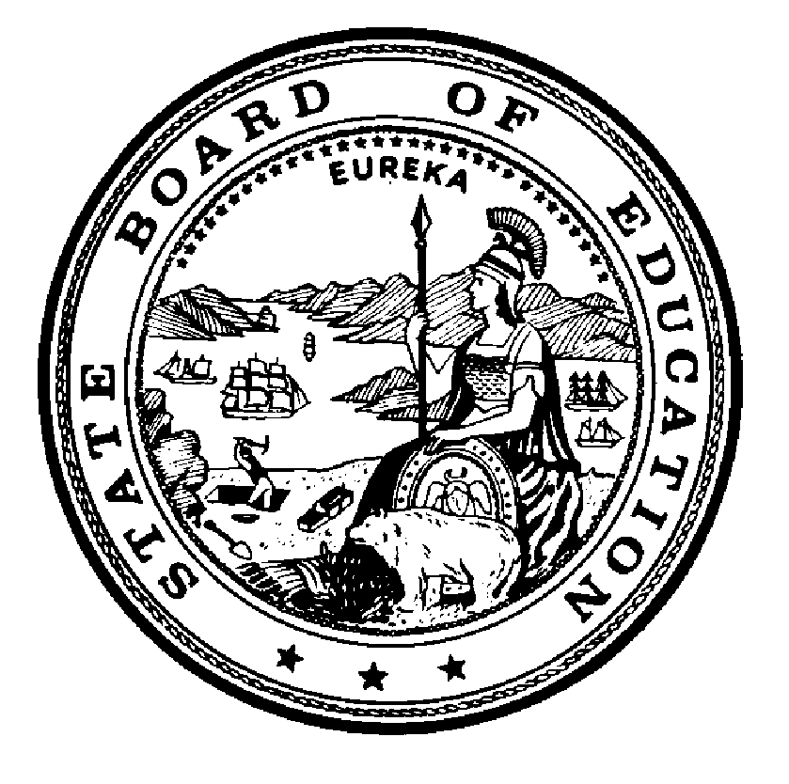

California State Board of Education
Final Minutes
February 24, 2021

Members Present
- Linda Darling-Hammond, President
- Ilene W. Straus, Vice President
- Sue Burr
- Cynthia Glover-Woods
- James J. McQuillen
- Matt Navo
- Kim Pattillo Brownson
- Haydee Rodriguez
- Patricia A. Rucker
- Ting L. Sun
- Zaid Fattah, Student Member
- Tony Thurmond, State Superintendent of Public Instruction (SSPI), Secretary and Executive Officer

Member Absent
- None

Principal Staff
- Brooks Allen, Executive Director, State Board of Education (SBE)
- Judy Cias, Chief Counsel, SBE
- Patricia de Cos, Deputy Executive Director, SBE
- Sara Pietrowski, Policy Director, SBE
- Pamela Castleman, Education Programs Consultant, SBE
- Lisa Hopkins, Associate Governmental Program Analyst, SBE
- Haley Gordon, Staff Services Analyst, SBE
- Stephanie Gregson, Chief Deputy Superintendent, California Department of Education (CDE)
- Rachael Maves, Deputy Superintendent, CDE
- Alex Moos, Education Policy Administrator I, CDE
Please note that the complete proceedings of the February 24, 2021 State Board of Education meeting, including closed-captioning, are available online at: http://www.cde.ca.gov/be/ag/ag/sbewebcastarchive.asp

California State Board of Education
Public Session February 24, 2021
Wednesday, February 24, 2021 – 8:30 a.m. Pacific Time ±
California Department of Education
1430 N Street, Room 1101
Sacramento, California 95814

- Call to Order
- Salute to the Flag
- Communications
- Announcements
- Special Presentations
  - Public notice is hereby given that special presentations for informational purposes may take place during this session.
- Agenda Items
- Day’s Adjournment
President Darling-Hammond called the meeting to order at approximately 8:32 a.m.

AGENDA ITEMS

Item 01
Subject: STATE BOARD PROJECTS AND PRIORITIES.
Including, but not limited to, future meeting plans; agenda items; and officer nominations and/or elections; State Board appointments and direction to staff; declaratory and commendatory resolutions; Bylaw review and revision; Board policy; approval of minutes; Board liaison reports; training of Board members; State Superintendent of Public Instruction Report; State Board of Education President’s Report; and other matters of interest.
Type of Action: Action, Information
Recommendations: The SBE staff recommends that the SBE:
- Approve the Preliminary Report of Actions/Minutes for the January 13-14, 2021 meeting. (Attachment 1)

ACTION: Member Straus moved to approve the SBE staff recommendation to approve the Preliminary Report of Actions/Minutes for the January 13-14, 2021 meeting.
Member Rodriguez seconded the motion.
Yes votes: Members Burr, Darling-Hammond, Fattah, Glover-Woods, McQuillen, Navo, Pattillo Brownson, Rodriguez, Rucker, Straus, and Sun.
No votes: None
Member Absent: None
Abstentions: None
Recusals: None
The motion passed with 11 votes.

Item 02
Subject: The Every Student Succeeds Act: Authorization to Pursue Flexibility on or a Waiver of Assessment, Accountability, and School Identification and Federal Funding Flexibility Requirements.
Type of Action: Action, Information
Recommendation: Because the CDE awaits the ED’s proposed flexibilities and possible waiver options, the CDE has not yet fully determined a recommendation. As noted above, it is anticipated that the ED will issue guidance, possible flexibilities, or waivers to states regarding the administration of assessments in the current 2020–2021 academic year as to, accountability, school identification, and federal funding flexibility requirements. Once the specifics from the ED are available, the CDE will attach them as an Item Addendum, along with an analysis and recommendations for the SBE’s consideration. The Addendum may also include a consideration of state level testing requirements that may need to be addressed in order to avail the state of any federal relief offered.
ACTION 1: Member Straus moved to direct the CDE to prepare a waiver, consistent with the federal template, regarding the flexibilities offered by ED for accountability and school identification, which includes decoupling accountability from this year’s assessments and waiving the requirement that the Academic Achievement indicator be adjusted to account for a participation rate below 95 percent as applicable.
Member Sun seconded the motion.
Yes votes: Members Burr, Darling-Hammond, Fattah, Glover-Woods, McQuillen, Navo, Pattillo Brownson, Rodriguez, Rucker, Straus, and Sun.
No votes: None
Member Absent: None
Abstentions: None
Recusals: None
The motion passed with 11 votes.
ACTION 2: Member Navo moved to extend the 2020-21 test administration window for both the CAASPP and ELPAC to July 30, 2021 as applicable.
Member Straus seconded the motion.
Yes votes: Members Darling-Hammond, Fattah, McQuillen, Navo, Pattillo Brownson, Rodriguez, Straus, and Sun.
No votes: Members Burr and Glover-Woods
Member Absent: None
Abstentions: Member Rucker
Recusals: None
The motion passed with 8 votes.
ACTION 3: Member Straus moved to direct the CDE to prepare a general waiver of the California Science Test for the 2020-21 school year.
Member Glover-Woods seconded the motion.
Yes votes: Members Burr, Darling-Hammond, Fattah, Glover-Woods, McQuillen, Navo, Pattillo Brownson, Rodriguez, Rucker, Straus, and Sun.
No votes: None
Member Absent: None
Abstentions: None
Recusals: None
The motion passed with 11 votes.
ACTION 4: Member Darling-Hammond moved to create a policy means to provide assessment information this school year to parents, educators and the public.
Member Rucker seconded the motion.
Yes votes: Members Burr, Darling-Hammond, Fattah, Glover-Woods, McQuillen, Navo, Pattillo Brownson, Rodriguez, Rucker, Straus, and Sun.
No votes: None
Member Absent: None
Abstentions: None
Recusals: None
The motion passed with 11 votes.
ACTION 5: Member Rucker moved to delegate authority to the State Board of Executive Director, in collaboration with CDE staff, to develop a waiver proposal to bring back to the Board that focuses on a plan for assessments that provide data to parents, educators, and the public which monitors the progress of students in ELA/math and that will propose a means for uniform reporting of that data in both aggregated and disaggregated forms.
Member Sun seconded the motion.
Yes votes: Members Burr, Darling-Hammond, Fattah, Glover-Woods, McQuillen, Navo, Pattillo Brownson, Rodriguez, Rucker, Straus, and Sun.
No votes: None
Member Absent: None
Abstentions: None
Recusals: None
The motion passed with 11 votes.

Item 03
Subject: GENERAL PUBLIC COMMENT.
Public Comment is invited on any matter not included on the printed agenda. Depending on the number of individuals wishing to address the State Board, the presiding officer may establish specific time limits on presentations.

Type of Action: Information
ACTION: No Action Taken.
ADJOURNMENT OF MEETING
At approximately 2:50 p.m., President Darling-Hammond adjourned the meeting.

