California Department of Education, February 2022

Accessing A-G Completion Data on DataQuest and the CDE Webpage

DataQuest
Reports on A-G completion can be found on DataQuest, the Department’s data reporting website which can be accessed at https://dq.cde.ca.gov/dataquest/
Instructions on accessing reports with A-G completion data on DataQuest are listed below.
Once on the DataQuest website, select the level to view the report such as “State” or “County.”
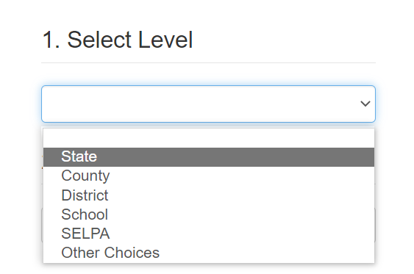
After selecting the level of the report, select the “Four-Year Cohort Graduation Rates & Outcomes” report under the Graduation & Dropout Data subject and then click the “Submit” button.
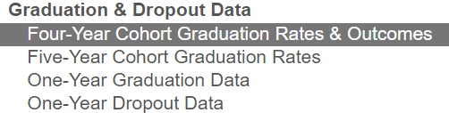
From here, select the school year for the report and then click the “Submit” button.
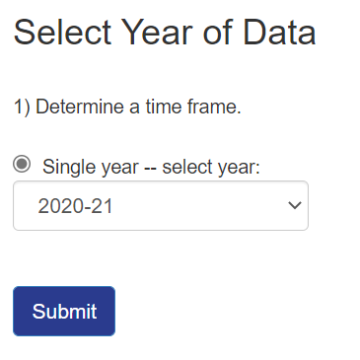
Once on the report page, select the “Four-Year Cohort Adjusted Graduation Rate” report and click the “Submit” button.
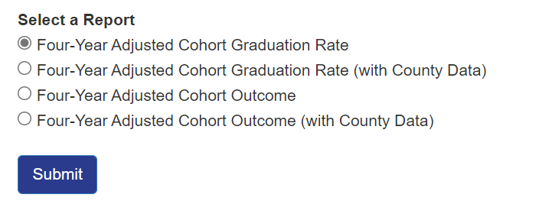
The Four-Year Adjusted Cohort Graduation Rate report includes information on the number of students in the cohort (Cohort Students), the number of students in the cohort who earned a regular high school diploma (Regular HS Diploma Graduates), and the number of graduates who students met A-G requirements (Graduates Meeting UC/CSU Requirements).
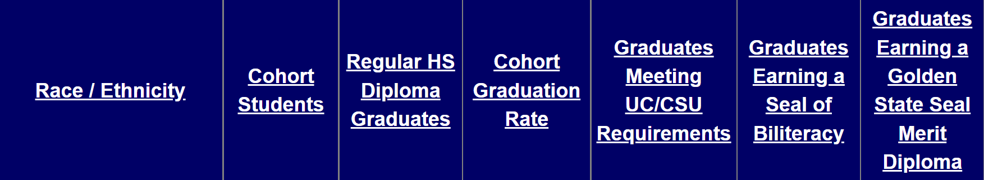
The default report view is aggregated by Race/Ethnicity and displays counts of graduates who met A-G requirements.
Select the + Report Options and Filters expandable link to view the report by Race/Ethnicity, Program Subgroup, or Academic Year.
To view A-G Completion Rates, select the option to view the data as “percents” in the Display Options section.
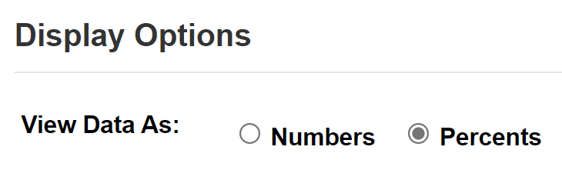
From here, select specific report options, data types, and filters to further narrow the report. (Note that not all options and filters are available for every report due to small n-sizes and for data privacy).
From the statewide level report, the Report Selection section allows users to choose from a list of specific reports as well as the county and the school year for which to view the report.
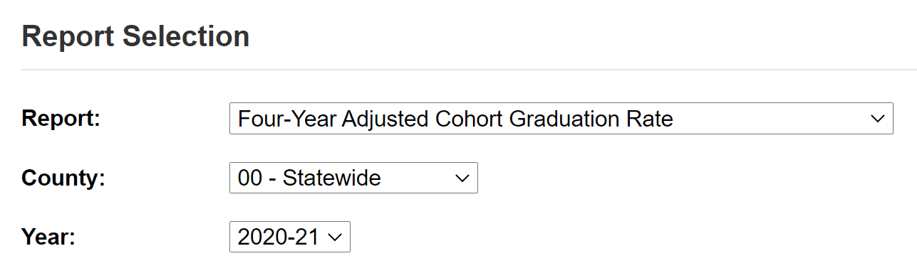
The Report Filters section allows users to choose specific views and further disaggregate the data by selecting from multiple options. A detailed description of these options is available in Appendix A on page 4 of this document.
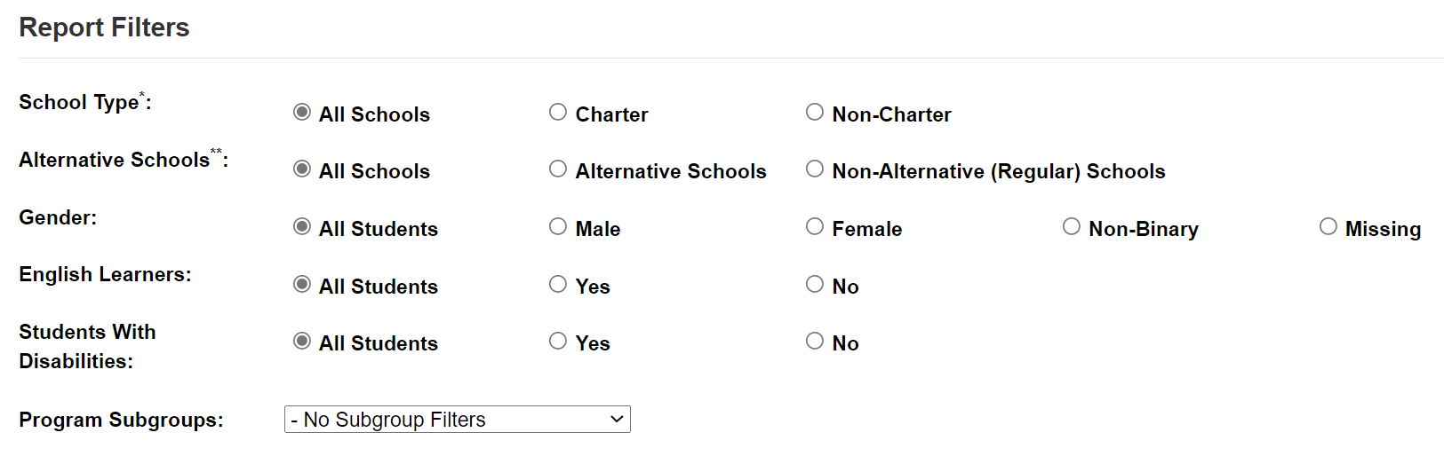

Appendix A for DataQuest Report Filters image
The Report Filters include the following options for the Graduation and Dropout data reports on DataQuest. From the School Type filter users can select to view the report for All Schools, Charter schools, or Non-Charter schools. From the Alternative Schools filter users can select to view the report for All Schools, Alternative Schools, or Non-Alternative (Regular) Schools. From the Gender filter users can select to view the report for All Students, Male students only, Female students only, Non-Binary students, or Missing gender students. From the English Learners filter users can select to view the report for All Students, yes (which means English Learners), or No (which means students who are not English Learners). From the Students with Disabilities filter users can select to view the report for All Students, yes (which means students with an identified disability), or No (which means students with no identified disability). From the Program Subgroups dropdown menu users can select to view the report for Socioeconomically Disadvantaged students, Migrant students, Foster students, or Homeless students.

