Mathematics Framework
Adopted by the State Board of Education on July 12, 2023
Page 1 of 154

Mathematics Framework
Appendix C: Vignettes

Mathematics Framework Appendix C: Vignettes 1
Chapter 2 3
Vignette: A Personalized Learning Approach 3
Vignette: Exploring Measurements and Family Stories 14
Vignette: Math Identity Rainbows 15
Vignette: Productive Partnerships 16
Chapter 3 19
Vignette: Number Talk with Addition, Grade Two 19
Vignette: Grade Four, Multiplication 25
Vignette: Grade Seven, Using a Double Number Line 28
Vignette: Grade Seven, Ratios and Orange Juice 32
Vignette: High School Mathematics I/Algebra I: Polynomials Are Like Numbers 35
Chapter 4 38
Vignette: Estimating Using Structure, Grade Seven 38
Vignette: Number String on an Open Number Line, High School 42
Chapter 6 45
Vignette: Comparing Numbers and Place Value Relationships in Grade Four, With Integrated English Language Development 45
Vignette: Alex Builds Numbers with a Partner (a two-day lesson) 54
Vignette: Habitat and Human Activity 57
Vignette: Students Examine and Connect Methods of Multiplication 61
Vignette: Santikone Builds Rectangles to Find Area 64
Chapter 7 70
Vignette: Followed by a Whale 70
Vignette: Crows, Seagulls, and School Lunches 74
Vignette: What’s a Fair Living Wage? 77
Vignette: Mixing Paint 82
Vignette: Equivalent Expressions—Integrated ELD and Mathematics 87
Vignette: Learning About Shapes Through Sponge Art 99
Chapter 8 104
Vignette: Drone light show 104
Vignette: Blood Insulin Levels 110
Vignette: Finding the Volume of a Complex Shape 116
Vignette: Exploring Climate Change 123
Chapter 10 129
Coaching Vignettes: Making Sense of Content, Student Thinking, and Pedagogy 129
Chapter 11 136
Vignette: Polygon Properties Puzzles 136
Chapter 12 142
Vignette: A Teacher Tries a New Assessment Approach 142
Vignette: Mathematical Thinking for Early Elementary 145
Long Descriptions for Appendix C 148

Chapter 2

Vignette: A Personalized Learning Approach
Spring Hill Middle School will partner with an innovative learning model provider to implement a unique and personalized approach to mathematics that enables each student, grades six through eight, to progress on his or her own learning path. The model integrates a combination of teacher-led, collaborative, and independent learning modalities in ways that enable students to build deep conceptual understanding and apply their learnings in real-world contexts.
At the start of the year, each student in a cohort will take a diagnostic assessment. The resulting data will be used to build a personalized set of mathematical ideas that the student will learn for the year. This will help the students, their teachers, and their parents understand what their learning will focus on this year and why.
Each student’s set of ideas will be different. It may could include some below grade level concepts that the student either didn’t learn the previous year or forgot over the summer, or it may include some above grade level concepts. For a sixth-grade student, for example, it may include some ideas aligned to seventh grade standards and may also include concepts that they otherwise would not learn until eighth grade or integrated high school courses.
Each student’s progress through this set of ideas is made visible using advanced technology that allows students, teachers, and parents to see a snapshot of how a student is doing at any given time. This technology is able to take stock of the needs of the entire class of students and assign a low floor, high ceiling project that everyone in the cohort can engage with. In this example, the project is focused on decomposing shapes to find their area. Over the time that students are engaging in this project, they will also experience shorter lessons on related mathematical ideas that will best support their growth, regardless of what mathematics they know going in.
At the same time, students will also engage in their own personalized schedule of lessons. In these lessons, students will explore related concepts through a variety of modalities. Some of the time they will learn in a large group from a teacher, some of the time they will collaborate with peers on a novel problem, and some of the time they will learn independently. This learning can support and extend the understandings students are building in the project.

The Students
Monique is a currently high achieving sixth grade student who is ready to learn a new sixth grade geometry concept. Over the course of a few weeks, she will work on a project with a heterogeneous group of her peers to make connections between finding the area of a rectangle and calculating the area of new and more complex shapes.
Darren is in Monique’s class. He is less experienced in geometry than Monique but will be able to engage in the same project as Monique because it is accessible at many levels. The task is open enough that Darren is able to utilize his knowledge of sketching to visually explore the task shapes in ways that allow him to reason through possible solution strategies. The project will provide Darren with information about the grade level standards and access to support to help him meet the standards.

The Project
Adapted from Boaler, Munson, and Williams (2018).
In this project, students will explore making art out of polygons on grids. They will use the grids to explore and find ways to determine area through decomposition. They will develop strategies that always work for finding the area of familiar figures and employ those strategies to find the area of any polygon on a grid.
California Common Core State Standards for Mathematics (CA CCSSM) citations:
- 3.MD.7a: Find the area of a rectangle with whole-number side lengths by tiling it, and show that the area is the same as would be found by multiplying the side lengths.
- 3.MD.7d: Recognize area as additive. Find areas of rectilinear figures by decomposing them into non-overlapping rectangles and adding the areas of the non-overlapping parts, applying this technique to solve real-world problems.
- 6.G.1: Find the area of right triangles, other triangles, special quadrilaterals, and polygons by composing into rectangles or decomposing into triangles and other shapes; apply these techniques in the context of solving real-world and mathematical problems.
Slide | Project Description
Slide 4  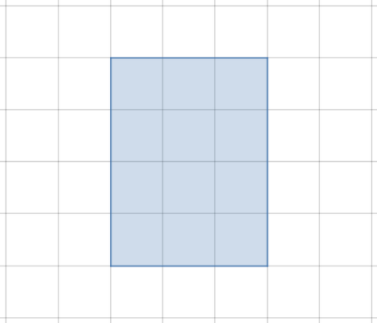 | Goal: Students recognize the need for area to measure the size of a rectangle, given that it has two dimensions.  Possible Teacher Moves:  - Ask students how they would describe this rectangle. If they do not naturally start talking about area or how the rectangle is made up of little squares, it might help to redirect them by asking about the size of the rectangle. You could even draw another rectangle that is a different shape and ask how they would compare the sizes.  - After students have made their observations, define the area of the rectangle as the space occupied by a two-dimensional shape. “You can find the area of this rectangle by counting unit squares or multiplying the dimensions.”  Possible Student Moves:  - “It’s a 3×4 rectangle.”  - “It’s made up of 12 squares.”  - “Its perimeter is 14 units.”  - “Its area is 12 square units. I know that because 3×4=12.”

Slide | Project Description
Slide 5  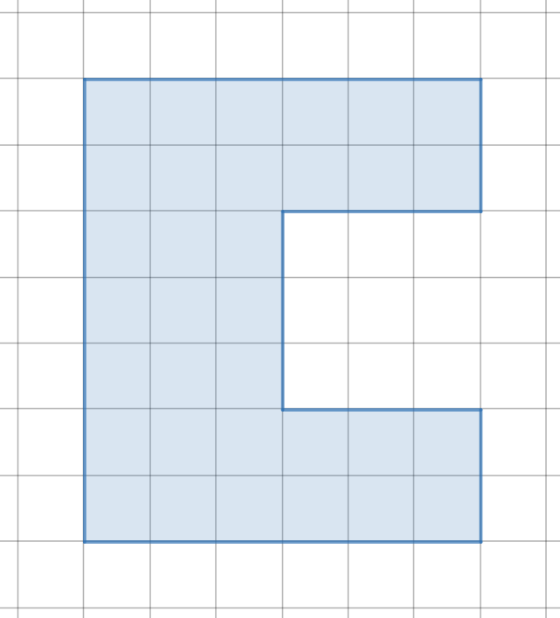 | Goal: Students think about how to measure the size of a polygon given that it has two dimensions.  Possible Teacher Moves:  - Ask students to find the area of the shaded figure.  - Give them time to think. This could happen individually or in pairs.  - Highlight different approaches that students take.  Possible Student Moves:  Students could count the squares, break the shape into three rectangles in multiple different ways or even find the area of the larger 6×7 rectangle and subtract out the 3×3 square. It is important that students see that all of these strategies are equally valid and come to the same conclusion.

Slide | Project Description
Slides 6–9  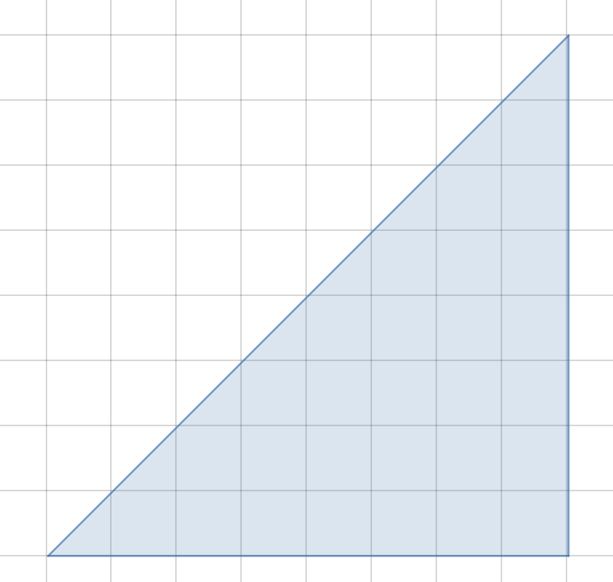  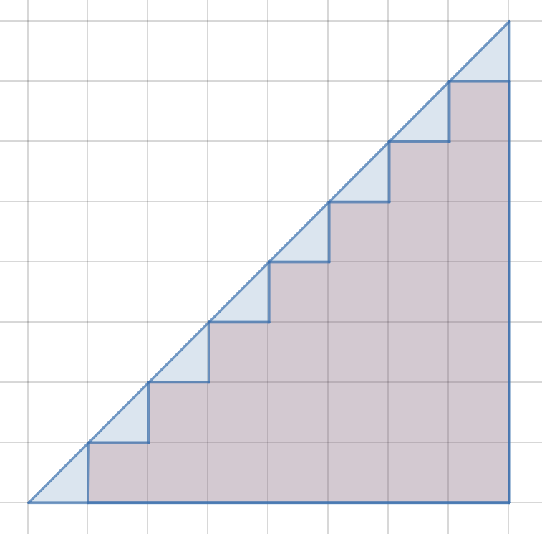  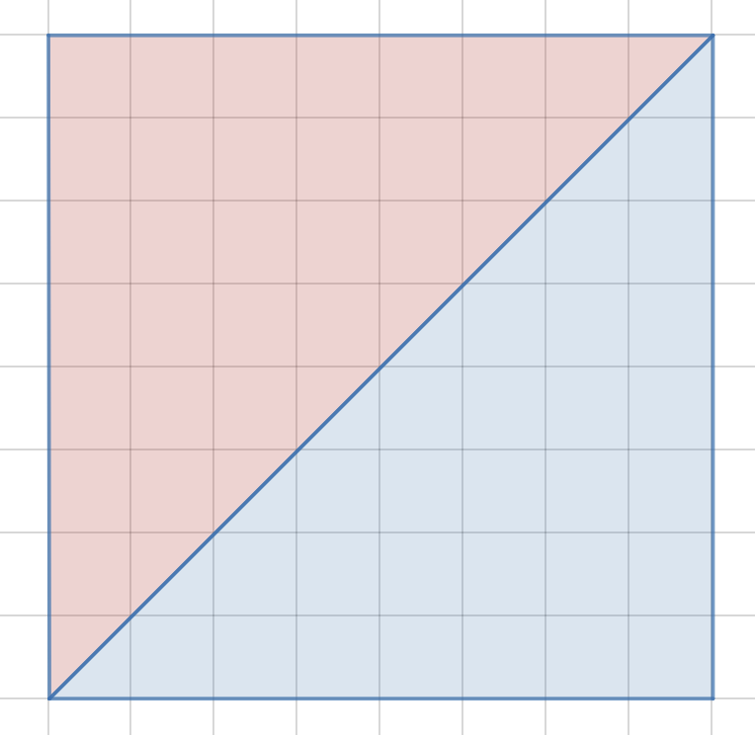  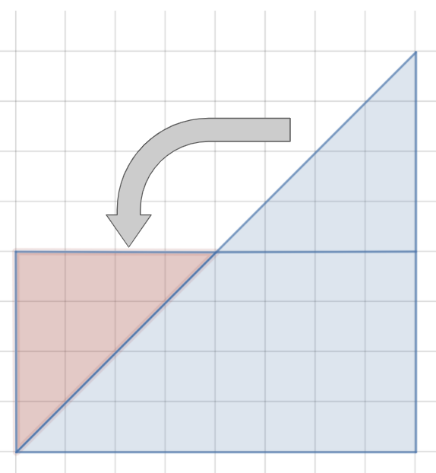 | Goal: Students develop strategies for making sense of partial squares when finding area.  Possible Teacher Moves:  - Show students slide 5 and ask them to explore different ways of finding the area of the triangle.  - Give students time to think. This could be done individually or in a pair.  - Highlight different approaches students take. Some of their approaches might match one of the images on slides 6–8. If so, they can be used to help share that strategy.  - Share the images on slides 6–8 and ask students how each of the images can help them think about the area of the triangle.  Possible Student Moves:  - Students will think about how to do this in a variety of ways. Some possibilities are represented visually on slides 6–8, but they might have other approaches too. If they do, encourage them to share their thinking visually.  - Slide 6 - Students might count or otherwise calculate the number of whole squares first, and then move on to the partial squares. They could count these as halves, or pair them up to make wholes.  - Slide 7 - Students might recognize that two of the triangles make a square, and thus the area of one triangle must be half the area of the square.  - Slide 8 - Students might notice that the top portion of the triangle can be rotated down to make a rectangle.

Slide | Project Description
Slide 10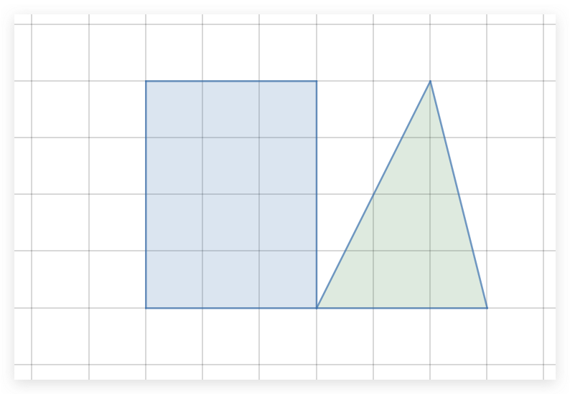 | Goal: Students recognize that a triangle has half the area of a rectangle with the same base and height.  Possible Teacher Moves:  - Ask students how the area of this rectangle and triangle compare.  - It is important to note that the partial squares in this example are not half squares. If students seem to have a misunderstanding about this point, it might help to bring the class together to highlight it.  - It might be helpful to use the original construction so that you can move the pieces around, draw lines, etc.  Possible Student Moves:  - Some students might recognize that the base and height of the rectangle and triangle are the same, and therefore conclude that the areas are either (a) the same or (b) the area of the rectangle is double the area of the triangle. Press these students to show this relationship visually.  - Some students will find the area of each figure to compare their areas. They could do this by counting the full squares and then matching up the partial squares in the triangle to make two 1×2 rectangles.  - Some students may show that, when the triangle is placed on top of the rectangle with the bases aligned, and a line is drawn straight down through the apex of the triangle, it forms two pairs of right triangles with the same dimensions and therefore the same area.

Slide | Project Description
Slide 11  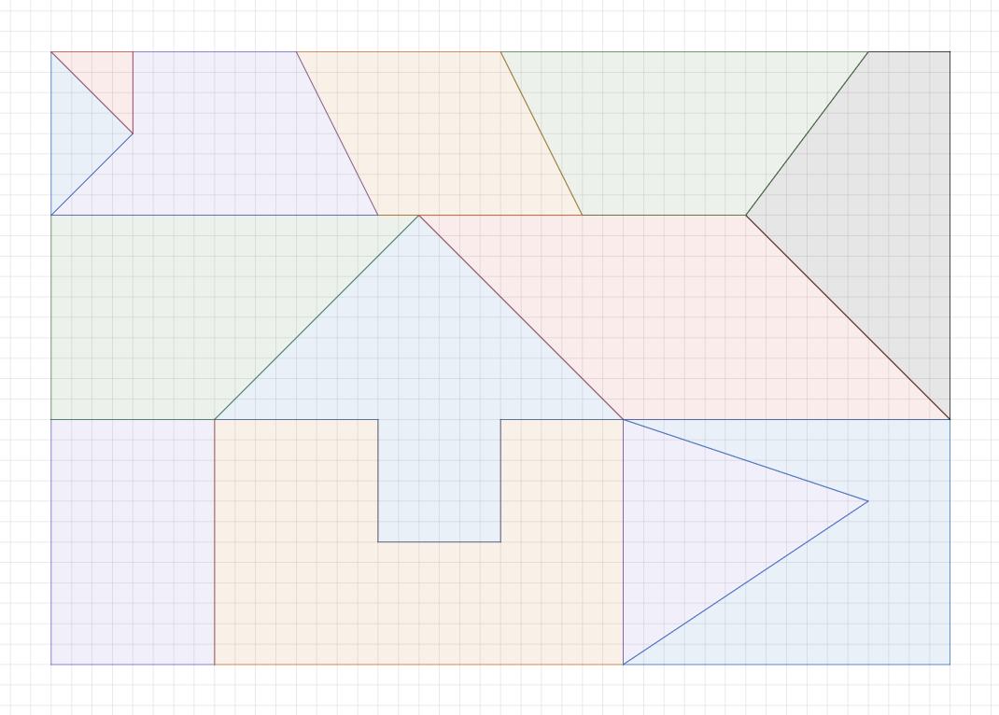 | Goal: Students apply their thinking about finding the area of figures to shapes at various levels of challenge.  Possible Teacher Moves:  - Share this slide. Ask students what shapes they recognize. This is a good opportunity to get a sense for what types of figures students are familiar with.  - Provide the image as a handout to students and ask them to choose three shapes in it to find their area.  - Explain that students will be creating their own grid art as their final project for this deep dive, and it could look something like this or could look different.  - Choose a few students who used different strategies and ask them to share their thinking with the class. Help the class make connections among the different strategies.  Possible Student Moves:  Students may choose more familiar or less familiar figures. Ask them to share their thinking about why they chose the shapes they did and how they found the areas.

Monique’s Experience
Monique started the project with the understanding that shapes can sometimes be broken into smaller rectangles. Through her project work, she is able to extend that big idea to see that shapes can be broken into triangles as well. She is able to make connections between rectangles and triangles and think flexibly about 2D figures. Monique is able to break down the image on slide 11 into different types of triangles and quadrilaterals to create a new image incorporating all different shapes. Using daily exit slip data, algorithms are able to pinpoint that Monique is ready to extend her knowledge past the sixth-grade geometry concept and move onto CA CCSSM 7.G.1. (Know the formulas for the area and circumference of a circle and use them to solve problems; give an informal derivation of the relationship between the circumference and area of a circle.)
The next day, Monique works independently on a virtual lesson that includes instructional videos, Geogebra applets, and interactive practice problems. For example, Monique explores an applet at https://www.geogebra.org/m/WFbyhq9d to see that triangles can be found inside of circles and is able to apply her learning using an interactive platform.
During this non-project time, Monique is working on above grade level skills independently while there are various personalized lessons happening in different cohorts. After this lesson, Monique will have the opportunity to work in a small group with other students who are working on the same concept and teachers will be able to monitor her progress by reviewing her exit slips at the end of the day and checking in with her doing a daily advisory session.
Monique began this project ready to learn the on-grade level concept. Through this low- floor, high-ceiling task, she was able to intuitively learn new concepts and collaborate with peers who were also learning at their own pace. Through the personalized lesson, she was able to extend her knowledge of decomposing shapes to triangles, polygons and even circles, an important understanding for geometry and even calculus.

Darren’s Experience
Coming into the project, Darren is comfortable with the idea of finding the area of a rectangle but has not had much experience with decomposing shapes to find their area. Having the opportunity in this project to connect the arduous task of counting all the squares in a figure composed of rectangles (as in slide 5) to seeing that it can be broken into rectangles with the support of the grid, supports Darren in thinking about finding the area of these shapes in more sophisticated ways.
Later, in a non-project session, Darren has a conversation with a partner about a similar problem, this time without the support of the grid. They are charged with individually finding the area of this figure:
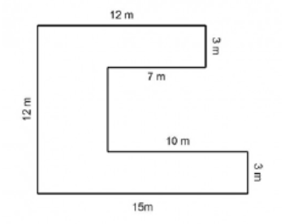
When they have both spent a few minutes working on this, they discuss the following questions:
- Did the problem provide you with all the information you needed to find the area or did you need to figure some values out first?
- Compare the way you broke up the shape with the way your partner did it. Did you use the same strategy? Were there other strategies you could have used?
- What is one mistake that someone might make when trying to find the area of complex shapes like this?
Discussing these questions with a partner helps Darren see that there are many different ways to find the areas of these figures, and they all produce the same answer if they are done correctly. It also helps him identify and put a name to the common error of breaking a figure into shapes that overlap and thus calculating the area of some parts of the figure twice.
All of this work on decomposing rectangular shapes lays a foundation for him to start to study the area of triangles, and extend that thinking to now develop strategies for finding the area of partial squares on the grid. But, before he does that, he experiences a lesson led by a teacher in another non-project session where he explores the different classifications of triangles. (CA CCSSM 5.G.3 - Classify two-dimensional figures in a hierarchy based on properties.) Understanding these classifications will enable Darren to thoroughly explore the different types of possible triangles to ensure that any patterns he sees in finding triangle areas are universal.
In this lesson, after defining the key terms, the teacher breaks the students into small groups to play a game. Students are provided with the following spinners:
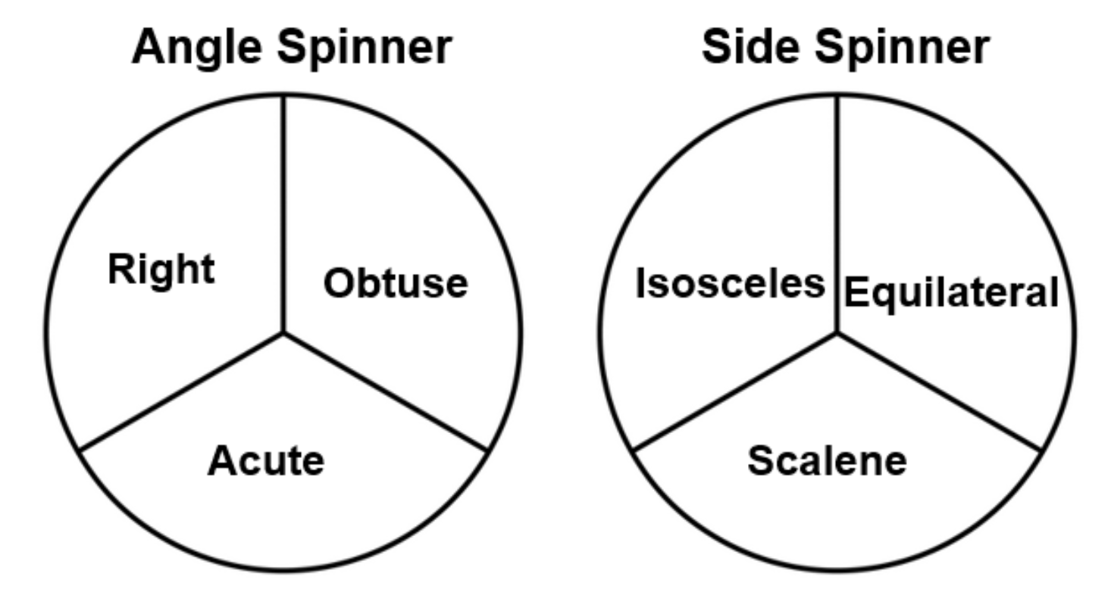
They take turns spinning both spinners and trying to draw a triangle that satisfies both conditions, making note of which triangles are possible or impossible and why. By doing this, they become familiar with the different types of triangles and learn the constraints on creating them.
That sets the stage for Darren to explore the area of triangles. This poses a challenge in that he can no longer think solely in terms of whole squares on a grid. Reasoning about the different strategies for finding the area of the triangle enables him to make sense of, and connections among, a few different approaches. Later, when he comes across fewer regular triangles and other shapes, he is able to apply his thinking about different ways to decompose a figure to develop a problem-solving strategy. His understanding continues to be supported by non-project lessons that connect to and extend the thinking he’s done in the project.
Darren began this project below grade level in this area of geometry and not prepared to dive right into the grade level standards. By engaging in a project with multiple access points, supported by a personalized schedule of large group, small group and individual lessons, he was able to make up significant ground. What’s more, because he engaged with the mathematical ideas involved at a conceptual level through the lens of decomposing shapes, he is poised to do further learning in the future.
(end vignette)

Vignette: Exploring Measurements and Family Stories
A group of students explores their family’s immigration experiences through a measurement lesson on the topic of unit conversion, specifically between the US system and the metric system. Many of the students had experienced immigrating with their families to the US, knew relatives who had, or have family members living in other countries. Through map explorations and a series of discussions, students use and expand their math skills.
On a map, two students located the different places where their relatives lived or that they had heard mentioned. They selected the starting and ending points of immigration and figured out the distances. The discussion continued:
Mary Jo: Yeah so right here to here. Like right here to right here is a mile.
Jocelyn: I think it's more than a mile.
Mary Jo: Eight miles?
Jocelyn: There’s a scale on the map somewhere, let’s look. Let’s measure this, how long is this? Okay, first of all, what are these numbers here, what do those represent?
Mary Jo: Inches, one inch.
Jocelyn: Then what are these numbers?
Mary Jo: Millimeters.
Jocelyn: What’s millimeters?
Mary Jo: Millimeters are more than, no.
Jocelyn: Do you see them mm? Where’s the mm?
Mary Jo: Oh, these are millimeters, these are inches. …”
Source: Diez-Palomar and Lopez Leiva, 2018, 49
(end vignette)

Vignette: Math Identity Rainbows
In Ms. Wong’s high school classroom, tasks are not only deliberately designed to engage students in meaningful mathematics, but are also, at times, designed to support students in noticing that they are already important members of the mathematics classroom community.
One activity Ms. Wong uses with her students involves “math identity rainbows.” Ms. Wong tells students the purpose: “To reflect on and share the strengths that you and your teammates bring to the group. Each person will get six different colored cords. Each color represents a different math practice. Your task is to arrange the cords according to your relative strengths and weaknesses.” She then explains the cords’ colors and identification:
- Pink is persevering: “I try my best and don’t give up, even when I face challenges.”
- Orange is numerical reasoning: “I have good number sense and use numbers flexibly.”
- Yellow is communicating: “I can explain my reasoning clearly to others.”
- Blue is modeling: “I can represent situations in everyday life mathematically to make predictions and solve problems.”
- Purple is pattern recognizing: “I can generalize patterns and see connections between concepts.”
- White is reflecting: “I know what I’ve learned and what I still need to learn.”
Directions: Arrange the cords in the order of your strengths (strongest practices on top).
Through use of this task, Ms. Wong conveys to students a definition of mathematical competence as multi-faceted. She emphasizes, “All of these are extremely important to being mathematicians and everyone has these qualities, but you have different strengths, right? So, the idea is, you are going to order these cords on your desk so that the top strand is what you think your biggest strength is” (Gargroetzi, 2020). Students reflect individually and then share their top strength with their partner. Students then discuss the strengths each group member brings to their mathematical work. Doing so provides students with the opportunity to notice that together they are part of a mathematical community in which each member offers different, important strengths.
Source: Wei and Gargroetzi, 2019.
(end vignette)

Vignette: Productive Partnerships
Tracy, a fourth-grade teacher, joins her students at the carpet in the front of the room to launch the day’s lesson on place value. In one of the first lessons of the year, she introduces the idea of “productive partnerships” before releasing students into small group work. When productive partnerships are the norm in a classroom, students engage in and strengthen their capacity for several mathematical practices, particularly SMPs 1, 3, 5, and 6, all of which involve reasoning, representing mathematical ideas, and communicating. Tracy wants to use the informal nature of this portion of the lesson to illuminate how math “is organized in different text types and across disciplines, using text structure, language features, and vocabulary, depending on purpose and audience.”
The students will make use of several mathematical practices (e.g., SMP.1, 2, 3, 6, 8), and will build skills as they invent and solve calculation problems using the four arithmetic operations (4.OA.4; 4.NBT 4, 5, 6). Tracy has planned her lesson carefully, making it accessible for her students by aligning her expectations with the principles of Universal Design for Learning (UDL), particularly encouraging students to represent their ideas in multiple ways—visually, numerically, and physically.
Tracy begins by asking students what it means to be productive. Students talk with a partner and offer different perspectives and ideas to the whole class. She then calls on a student volunteer to pretend to be her partner and act out what the class suggests they try, in order to work “productively” as partners.
T: How can we show that we are ready to work with our partners?
S: Sit!
T: We should sit? Ok, let’s sit. How should we sit?
Students offer different ideas––sit facing each other; sit side-by-side to share the materials––which Tracy and her student partner model for the class. Tracy solicits suggestions for how they might attend to each other, decide on turns, or work through a disagreement. After discussion, she tells the class that they will try out these ideas in their partnerships today. She then launches the day’s mathematics problem: Four 4s (a task that can be used at any grade level).
Tracy is confident that all her students will be able to engage in this open task, using their unique strengths. Her linguistically and culturally diverse students, especially the English learners, will experience important learning opportunities as they communicate their reasoning to their partners and contribute to the class discussion. (The California English Language Development Standards [ELD Standards] for grade four specify that English learners will “develop an understanding of how language is a complex, dynamic, and social resource for making meaning.”) Tracy posts the problem statement on the whiteboard. She asks the students to read it silently first and then leads a choral reading: “Can we find every number between 1 and 20 using exactly four 4s and any operation?”
She signals for quiet thinking time. After a few seconds, she says, “When I first read this problem, I was not sure what it meant for us to do. Which words in this problem might have caused me confusion?” She uses a think aloud strategy, repeating, “BLANK confused me because…. BLANK confused me because….” After another pause, she asks the students to turn to a partner and ask, “What confused me?” The chatter provides formative feedback, and Tracy continues by prompting students to discuss what they think the problem statement means—which mathematical operations can they think of to use? “Try to be ready to explain what we should do, or perhaps share an example of a number you were able to find between 1 and 20 using exactly four 4s. In a few minutes, we will share our ideas with the whole class.”
Partners turn toward each other to begin discussing the task. Partner discussions are based on an integrated ELD strategy called Three Reads constructive conversations (Los Angeles Unified School District, n.d.), where students first read to understand, then read to identify and understand the math, then read to make a plan. Their discussion is framed by cues on the board: “1) Understand; 2) Understand the math; 3) Make a plan.” She observes that many students are stuck between the second and third stage; they are not entirely sure of how to proceed, especially with regard to using all the operations. Many of the students have limited themselves to addition and are ready to suggest one way to get 16.
For example, one pair describes what they think the problem asks them to do:
Partner 1: Well, we can add all the fours together, and that makes 16.
Partner 2: Yeah, that works, but aren’t we supposed to get all the numbers from 1 to 20 as our answers? How are we supposed to do that?
Partner 1: Oh. What else can we do with the fours?
Tracy brings the class together to thank the students for their successful productive partnerships and to begin discussing what the problem asks and what solutions students have discovered.
Source: (Langer-Osuna, Trinkle, and Kwon, 2019)
(end vignette)

Chapter 3

Vignette: Number Talk with Addition, Grade Two
Early in the school year, second-graders have started work with addition. They have been building on first-grade concepts, now finding “doubles” with sums greater than 20 (2.NBT.5). The teacher is seeking to elevate students’ understanding of a powerful idea in mathematics: taking things apart and refitting them back together can be both strategic and efficient (CC3). In this case, the teacher wants the students to see the numbers as allies and each problem as an opportunity to befriend numbers in new ways. To do this, the teacher begins with a number talk. The intention is to model verbal processing based on a string of problems the children have explored in the preceding week with manipulative materials, story problems, and equations, and then to challenge students to calculate mentally, extending their thinking one step beyond previous work (SMP.2, 3, 6).
Math talks are valuable when they address three key aspects of meaningful interactions for linguistically and culturally diverse English learners: collaborative, interpretive, and productive. The lesson plan is informed by the teacher’s understanding of the Effective Expression, a key theme for English learners (California Department of Education [CDE], 2014a, 207), which supports the implementation of ideas learned from professional development experiences with “5 Practices for Orchestrating Productive Mathematics Discussions” (Smith and Stein, 2018). The teacher anticipates that students will use several strategies for adding two-digit numbers greater than 10. They may: take the numbers apart by place value; use a “counting-on” method, counting on by jumps of 10 and then adjusting, or; count by ones.
Part I: Interacting in Meaningful Ways
- Collaborative (engagement in dialogue with others)
- Exchanging information and ideas via oral communication and conversations
- Interacting via written English (print and multimedia)
- Offering opinions and negotiating with or persuading others
- Adapting language choices to various contexts
- Interpretive (comprehension and analysis of written and spoken texts)
- Listening actively and asking or answering questions about what was heard
- Reading closely and explaining interpretations and ideas from reading
- Evaluating how well writers and speakers use language to present or support ideas
- Analyzing how writers use vocabulary and other language resources
- Productive (creation of oral presentations and written texts)
- Expressing information and ideas in oral presentations
- Writing literary and informational texts
- Supporting opinions or justifying arguments and evaluating others’ opinions or arguments
- Selecting and applying varied and precise vocabulary and other language resources
Source: CDE, 2014b, 14
The teacher reviews the classroom routines and expectations established for number talks:
- The problem is written on the board and students take several minutes of quiet thinking time. (It is important that the problem be presented in horizontal format so that students make active choices about how to proceed; when problems are written in vertical format, students tend to think that using a formal algorithm is required.)
- When they have a solution, students show a quiet thumbs-up signal.
- If students solve the problem in more than one way, they show a corresponding number of fingers.
- When all (or almost all) students signal that they have a solution, the teacher asks students to share their responses with their elbow partner and to show a thumbs up when they are ready to share with the class.
- Student responses are recorded on the board without comment on correctness.
- Students explain, defend, or challenge the recorded solutions, and reach consensus as a class. The teacher refers students to familiar sentence frames for articulating their explanation, defense, or challenges. These provide a foundation for rich discussion of mathematics and can help reduce students’ reluctance to engage.
The first problem posed is 10 + 10 = $◻$. As expected on this familiar, well-practiced addition problem, almost all the children signal a thumbs up within a short time, and all children agree on the answer.
The teacher writes a second problem below the first:
13 + 13 = $◻$.
Several thumbs rise quickly. Some children use their fingers to calculate, while others nod their heads, as if counting mentally. After three minutes, almost all children have found a solution; they whisper to share their answers with their partners. When the teacher calls for answers, a majority of children say the sum is 26; three children think it is 25. Three students explain how they found 26:
- “I know that 13 is 3 more than 10, but there were two thirteens, and 10 + 10 = 20, so 6 more makes it 26.”
- “I started at 13 and counted on 13 more: 14, 15, 16, 17, 18, 19, 20, 21, 22, 23, 24, 25, 26.”
- “Well, I knew that 10 + 10 was 20, so I just took off the threes (in the ones place) and added those, and that made 6. So, 20 + 6 = 26.”
At this point, one of the children who had thought the sum was 25 raises a hand to explain their thinking.
- “I counted on from 13 too, but I got 25. I went: 13, 14, 15, 16, 17, 18, 19, 20, 21, 22, 23, 24, 25.”
Another student who had found an answer of 25 explains further:
- “I did that, too, but it’s not right! We should have started with 14, not 13, so now I think it’s really 26. I changed my mind.”
The teacher asks student “e” to tell more about why they changed their answer. The student explains: “Well, if you were adding an easy one, like 4 + 4, you would use four fingers (the child shows four fingers on the left hand), and then you add on four more (using the remaining finger on the left hand and then fingers on the right hand), so it goes 5, 6, 7, 8.”
The teacher asks the class whether anyone has a challenge or a question. Satisfied, all the students use a signal to say they agree that the correct answer is 26.
The teacher presents the third problem:
15 + 15 = $◻$
Students need more time to think about this one. The teacher can see nods and finger counting and eyes staring up at the ceiling. After about a minute, thumbs start going up. Students offer solutions: 20, 30, and 31.
The teacher points out that this time students have three different answers, so it will be important to listen to all the explanations and decide what the correct answer is.
Student “f” explains how they got 20:
- “See, 1 + 1 is 2, and 5 + 5 = 10, so there’s a 2 and a 0, so it’s 20.”
The teacher thanks child “f” for the explanation and calls on a child who wants to explain the solution of 30.
- “I got 30, because it’s really 10 + 10, not 1 + 1. So, I got 10 + 10 = 20, and then 5 + 5 = 10. And 20 + 10 = 30. I think “f” maybe forgot that the 1 is really a 10.”
Students signal agreement with that statement. The teacher asks who can explain the answer 31.
- “I did that one. I was counting on from 15, and it’s hard to keep track of that many fingers so maybe I counted wrong?”
The teacher records the students’ thinking:
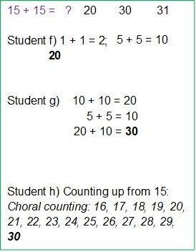
The teacher asks if student “h” would like to count on again. The student agrees, and the whole class counts carefully, starting with sixteen: 16, 17, 18, 19, 20, 21, 22, 23, 24, 25, 26, 27, 28, 29, 30!
Student “h” smiles and nods agreement that the sum is 30.
One more student shares their method to get 30.
- “What I did was start with the first 15 but then I broke up the other 15 to be 10 + 5. So, I added 15 + 10, and that made 25, and 25 + 5 more makes 30.”
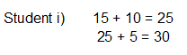
The teacher wants to encourage students to note connections between their methods. To make visible a connection between the methods used by students “h” and “i,” the teacher underlines the first 10 numbers in the counting list of student “h” in green and the remaining five numbers (26 through 30) in blue. Pointing to the list of numbers, the teacher asks the class to think about the way(s) in which the methods of students “h” and “i” are alike: 16, 17, 18, 19, 20, 21, 22, 23, 24, 25 and 26, 27, 28, 29, 30.
The teacher views the day’s number talk as a formative assessment and is satisfied that the lesson provided information about student progress and informed next steps for instruction. Each of the students participated, indicating that the number talk was appropriate to their current level of understanding. Most students showed evidence that they used foundational knowledge that 10 + 10 = 20 to solve the problems and that previous work with “doubles” was effective. The teacher observes that one English learner used the previously taught sentence frames and spoke with increased confidence when disagreeing with another student’s solution. A second English learner shared a solution method publicly for the first time. Upon reflection, the teacher attributes these successes to the lesson’s intentional addition of building in time to allow for strategic stops to explain word meanings, act out the words (with gestures and facial expressions), and identify an illustration for the word. There were instances where the students repeated key vocabulary chorally, a strategy used to provide all students with the confidence to speak and think like mathematicians.
Many of the students used place value to add two-digit numbers and could explain their strategy, although a scattering of students relied on a more basic counting-on strategy. Of these, several (students “d,” “e,” and “h,” and possibly more) used faulty counting-on strategies and may need more practice with this topic.
In the next number talk, the teacher plans to again present two-digit addition problems that do not involve regrouping and to provide further support for students who have so far limited their thinking to the counting-on strategy.
In subsequent lessons, the teacher intends to introduce strings of problems with numbers that do require regrouping, such as 15 + 15, 16 + 16, and 17 + 17. The intent is to promote the strategy of taking numbers apart by place value when this approach makes solving easier. The teacher recognizes that students need more opportunities to hear how their classmates solve and reason about such problems in order to develop their own understanding and skill. For these second graders to enlarge their repertoire of strategies and gain greater place-value competence, it will be vital for the teacher to guide rich discussion among the students in which they explain their reasoning and critique their own reasoning and that of others (SMP.2, 3, 6).
(end vignette)

Vignette: Grade Four, Multiplication
As the fourth-grade students are beginning work with multiplication as comparison (4.OA.2), the teacher selects comparison problems for the students to solve. The teacher recognizes that comparisons offer a means of making sense of many situations in the world, an instance of Driver of Investigation 1 (DI1) – Making Sense of the World. The teacher also notes that students are investigating the effects of multiplication in contexts within this activity and discovering how quantities change multiplicatively (CC2). The teacher designs the lesson to ensure that all students, including several students in the class who have learning differences, have access to the content. Students can opt to work alone or with a partner, with the expectation that they will use verbal or written expression, tools, and/or drawings to make sense of the problems (SMP.1, 5) and then solve and illustrate each (see chapter two for more on UDL and ELD strategies).
The teacher begins the lesson by presenting Problem 1:
- Gina rode her bike five miles yesterday. Her mother rode her bike three times as far. How far did Gina’s mother ride?
Students’ answers for Problem 1 include “8” and “15.” The class previously used number-line diagrams and tape diagrams to solve addition and subtraction problems.
- Two students write 5 + 3 = 8 but provide no illustration or explanation.
- Several students draw number lines showing 5 mi. + 3 mi. (8 miles)
- One student draws a tape diagram showing 5 mi. + 3 mi. (8 miles)
- Students who answer 15 show several different illustrations, not all of which capture or reflect the context of the problem:
Figure C.1 Sample Student Work for Problem 1
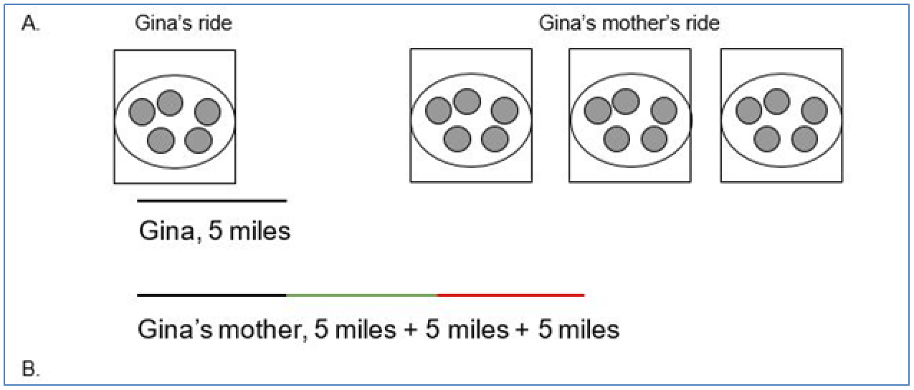
Long description of figure C.1
Students’ work on Problem 2 (below) shows less understanding. This is evident in their work samples; the teacher notes that several students with learning differences particularly struggle with making sense of this problem.
- The tree in my backyard is 12 feet tall. My neighbor’s tree is 36 feet tall. How many times as tall is my neighbor’s tree compared to mine?
Few fourth-graders recognize this as a multiplication situation. Almost all the students either subtract or add the numbers in the problem: 36 − 12 = 24 feet tall or 12 + 36 = 48 feet tall. Only two pairs of students solve the problem correctly, either dividing 36 ÷ 12 = 3 or setting up a multiplication equation, 3 × 12 = 36, and concluding that the neighbor’s tree is three times as tall as theirs.
The differences between students’ work on the two problems puzzles the teacher. After reviewing the various approaches to multiplication in the table “Common Multiplication and Division Situations” (see chapter six), the teacher recognizes that the two-story problems represent quite different types. The first results from an unknown problem. In the second problem, the number of groups is the unknown, a conceptually more difficult situation. Comparison multiplication problems add a level of complexity for linguistically and culturally diverse English learners and others who may be less experienced with the use of academic language in mathematics.
As a follow-up lesson, the teacher plans for the class to explicitly address the concept of multiplication as comparison. The plan relies on a few story situations based on the teacher’s knowledge of students’ lives and experiences. To solve the problems, the students need to think about “how many times as much/many.” Contexts for such problems could include:
This recipe makes only seven muffins. If we bake four times as many muffins for our social studies celebration, will that be enough for our class?
Mayu’s uncle is 26 years old. His grandmother is two times as old as his uncle. How old is his grandmother?
Amalia is nine years old. Her sister is three years old. How many times as old as her sister is Amalia?
Avi has eight pets (counting his goldfish); Laz has two pets. How many times as many pets does Avi have compared to Laz?
Students solve the second problem from the previous lesson (again) with partners and share solutions as a class. The teacher carefully pairs students learning English and others with language needs with students who can support their language acquisition. As students discuss with partners their ideas about what it means to compare and how it can be multiplication, the teacher uses a Collect and Display routine (SCALE, 2017). As students discuss their ideas with their partners, the teacher listens for and records in writing the language students use and may sketch diagrams or pictures to capture students’ own language and ideas. These notes are displayed during an ensuing class conversation, when students collaborate to make and strengthen their shared understanding. Students are able to refer to, build on, and make connections with this display during future discussion or writing.
Once they acquire a firmer understanding of multiplication as comparison, students examine the three answers to the second problem that were previously recorded (24 feet, 48 feet, and three times as tall) and determine together which operation, what kind of illustration, and which solution makes sense in the context of the problem (SMP.2, 3, 5). The class discussion gives students the opportunity to reason about multiplication comparison situations and contrast these with additive comparison situations (CC2).
The teacher explores fourth-grade tasks at Illustrative Mathematics and finds an example called Comparing Money Raised (Illustrative Mathematics, n.d.) that provides further experience with comparison multiplication situations. The discussion of the task and illustrations and explanations of various solution methods provide the teacher with additional insights.
(end vignette)

Vignette: Grade Seven, Using a Double Number Line
Mr. K has noticed that his students struggle with rate problems, especially problems involving fractions. He knows that understanding how quantities vary together is an aspect of exploring changing quantities (CC2). In this case, he hopes to help students achieve a better visual understanding of how two quantities vary together proportionally by structuring their thinking around a model of a double number line using the following problem:
Walking at a constant speed, Dominica walks 4/5 of a mile every 2/3 of an hour. How far does she walk in 1 hour?
The class has often discussed “making a problem easier” as a strategy, so Mr. K employs this approach by asking them to consider the case where “If Dominica walks 2.5 miles in 1/2 hour, how far does she walk in 1 hour?” The class quickly offers that since she has walked double the time, then she walks double the distance. Mr. K applauds their ability to use “doubling” to arrive at the answer and that they can generalize this to “halving” or “tripling,” etc. He frames using a double number line as a way to harness multiplying and dividing to find answers.
He then draws a double number line and labels the top line with miles and the bottom line with hours (to reinforce that distance per unit of time is a common way to label speed).
He then positions the class back to the original question and asks the students to place a vertical bar indicating Dominica’s rate and label it. Students immediately want to know where to place it, and he encourages them to choose a location for themselves, but with plenty of room on both sides. Most students place the line near the center.
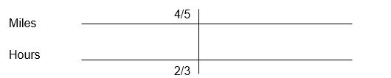
Next, he asks the class to reread the problem and share with a neighbor what they are trying to find. He collects responses at the front, which vary from “how fast she goes in an hour,” to “how far she goes in an hour,” to “how long she is walking.” He is heartened to hear the varied responses as these indicate the students are grappling with the very concepts he wants them to be thinking about: speed, distance, and time. A brief class discussion ensues where they discuss each of these words and phrases in turn and create word bubbles of related words and phrases (fast, speed, rate, velocity, miles per hour), (distance, how far, length, miles, feet, inches, centimeters), (time, how long, hours, minutes, seconds). One student points out how certain phrases are tricky, like “length of time,” which seems to indicate distance but actually refers to an amount of time.
Eventually, the class agrees that the question at the end of the problem indicates that they should be looking for a distance, in miles, that Dominica has traveled in 1 hour. Mr. K asks the students to place another vertical bar at the 1-hour location. Most students agree that it should be to the right of 2/3 hours since 1 is greater than 2/3.
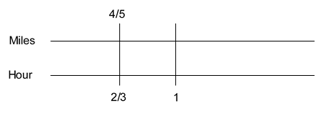
Students immediately try to guess the number of miles corresponding to 1 hour of walking, and Mr. K is glad to see the enthusiasm. Several students recognize that it takes 1/3 added on to 2/3 to get to 1, so then they conclude that adding 1/3 to 4/5 gives the number of miles. A conversation ensues that this might not work, and they look to Mr. K for direction. Mr. K encourages them to think about the simpler case at the outset of their work. From looking at the simpler case, several students recognize that adding 1/2 to both results in 3 miles for 1 hour of walking, which differs from their prior answer. Since this is at the heart of the difference between thinking additively and thinking multiplicatively, Mr. K asks them to consider why this does not work. After some time, one student offers that since the number lines represent different quantities, the top is miles and bottom is hours, adding the same quantity to each is “sort of mixing the miles and hours together, in a way.” A different student observes that, in the first case, 2.5 to 1/2 is different from 3 to 1. A third student states this as “her rate of walking changes when you add the same to both quantities, and it’s supposed to be the same.” Mr. K applauds these justifications and pauses for students to write these three observations down in their journals before moving on.
The class is quiet for a bit as they think about another approach. One student says, “It’s a little over 1.” When Mr. K asks why, they state that they used half of the hours to do it, then “jumped up” to get to 1. The student demonstrates on the double number line by first drawing the blue arrow below and labeling it while saying “divide by 2 to get to 1/3 hours.” They then draw and label the top blue arrow to demonstrate how half of 4/5 is 2/5.
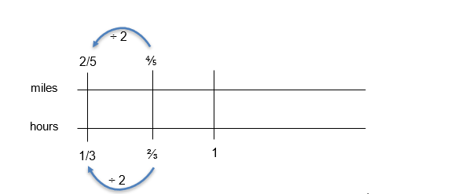
Lastly, the student draws, then labels the bottom red arrow to demonstrate “to get to 1 you have to multiply by 3.” They do the same to the top red arrow, indicating that multiplying 2/5 by 3 gives the answer of 6/5 miles.
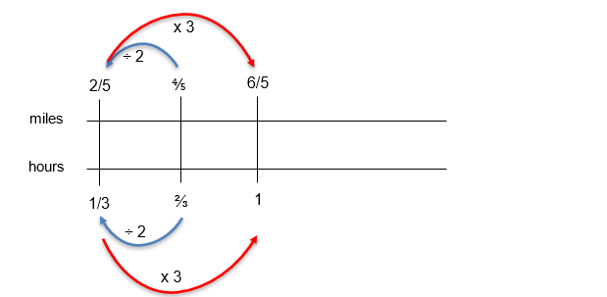
One student offers a different way, saying “I multiplied by 3 first, then cut it in half.” They demonstrate on the board that to get from 2/3 to 2 they used a “tripling” approach, then “halving.” The first student points out that tripling is the same as multiplying by 3, and halving is the same as dividing by 2, so the second student adds that annotation to their diagram.
(end vignette)

Vignette: Grade Seven, Ratios and Orange Juice
Ms. Z wants her seventh-grade math class to develop a deeper understanding of multiple representations used in solving word problems. The class has taken a variety of approaches: concrete (using colored chips and tape), representational (drawing chips and tape diagrams, tables), and abstract (proportional thinking). By discussing the use of multiple means of representation for the same problem, she hopes to provide the options for expression and communication, language and symbols, and sustaining effort and persistence in the guidelines for UDL (see chapter two for more on UDL and ELD strategies). To address particular content standards, she wants the focus to be on recognizing and representing the relationships between quantities (7.RP.2). The specific SMPs she wants students to engage in are 1 (Make sense of problems and persevere in solving them) and 4 (Model with mathematics). She has decided to use the 5 Practices Approach (Smith and Stein, 2011) to facilitate classroom discussion centered around the following task from her seventh-grade college preparatory materials.
Orange Juice Problem
The kitchen workers at a school are experimenting with different orange juice blends using juice concentrate and water.
Which mix gives juice that is the most “orangey”? Explain, being sure to show your work clearly.
Mix A: 2 cups concentrate, 3 cups cold water
Mix B: 1 cup concentrate, 4 cups cold water
Mix C: 4 cups concentrate, 6 cups cold water
Mix D: 3 cups concentrate, 5 cups cold water

Anticipation
Ms. Z anticipates that student pairs will approach the problem in the following ways:
Physically using two colors of chips, or drawing chips on paper, to indicate the cups of concentrate versus cold water for each mix. This approach involves doubling and tripling to achieve comparisons.
Physically using colored tape, or drawing tape diagrams, to indicate the ratio between cups of concentrate to cups of cold water. This approach involves doubling and tripling as well.
Converting each ratio of concentrate to water to a decimal, then comparing decimal values.
Using a common denominator approach to compare the ratios of concentrate to water for each mix.
Converting the ratios to percents and comparing percents.

Monitoring
Ms. Z makes note of which approach each student pair is using. While she has accurately anticipated that several students would utilize tape diagrams, chips, fractions, decimals, and percents, she notices that some students are taking two additional approaches:
Using a double number line to conduct pairwise comparisons
Using a ratio table to “build up” to comparable ratios
In addition, she notices that some students are utilizing the above seven (items a–g) approaches but are using the total mixture (water and concentrate) in their calculations. Although Ms. Z intended to have students present their work using the document camera, she realizes that connecting each of the student’s approaches will be difficult without the work still being viewable after the presentation is over. She quickly places a large piece of poster paper with instructions for each pair to transcribe their solution onto the poster paper.

Selecting and Sequencing
Ms. Z selects one student pair with each type of solution to present their work on the document camera. In doing this, she has checked with and received permission from two of the pairs to demonstrate their approach, even though it resulted in some erroneous work. She decides to focus on the approaches that used concentrate to water comparisons rather than concentrate to total mixture comparisons to avoid confusion. She decides that seeing the problem modeled with concrete materials and drawings of materials is valuable for the class to see first so that the fractions, decimals, and percents to follow have more meaning. Therefore, she has the two groups that used concrete materials (tape or diagrams) share their approach first. The ratio table approach is next, followed by the fraction approach since the common denominators appear in the ratio table. Next is the double number line approach since it involves doubling, tripling, and halving in a way similar to the ratio table. Last are the decimal and percent approaches, which were the most popular but lacked effective explanations. By the time the entire class gets to these last two approaches, they can better ascribe meaning to each of the numbers in the decimals and percents.

Connecting
As each student presents their work, Ms. Z asks the class to compare the approach to prior approaches and note the similarities and differences. While the majority of students converted to decimals, the approaches that students comment on the most are the concrete and diagram approaches, ratio table, percents, and the double number line. While students arrived at a number of different conclusions in looking across the approaches, one student comments that “you can compare the same water or concentrate.” When asked to explain, the student’s response clarified that, by manipulating a ratio to arrive at the same cups of water or the same cups of concentrate, then the ratios could easily be compared. Ms. Z is quick to capitalize on this recognition with her next question: “In comparing fractions, can I compare using common numerators instead of common denominators?” The ensuing conversation is surprising to students who had considered common denominators to be the only means to compare fractions.
(end vignette)

Vignette: High School Mathematics I/Algebra I: Polynomials Are Like Numbers
Ms. G is looking ahead at the curriculum and recognizes that factoring polynomials is a topic that her Mathematics II students have struggled with in the past, both in terms of motivation and in understanding how factoring connects to other topics. With other mathematical concepts, she has had success using the UDL guidelines (CAST, 2018). For this activity, she will focus on guidelines 7 (Recruiting Interest checkpoints 7.1 and 7.2) and 8 (Sustaining Effort and Persistence checkpoints 8.3 and 8.4) to provide options for recruiting interest and strategies for sustaining effort (see chapter 2 for more information on UDL). She aligns this approach with her personal inspiration drawn from SMP.7 (Look for and Make Use of Structure) and SMP.6 (Attend to Precision) as she decides to implement an activity that relies upon their experience with factoring and division of whole numbers to set the stage for working with polynomials.
She begins by asking students to work in pairs to answer the following question: “Without checking on a calculator, is 186 divisible by 3?” Before they begin, she asks for a reminder of what “divisible” means. One student observes that “you can divide into it.” Another student questions this, as “you can divide any number by another number, it just keeps going.” The class eventually arrives at a reasonable definition of divisible as “b is divisible by c if you can divide b by c without any leftover remainder.” Although this definition could be clarified further, Ms. G decides this will suffice for now.
She checks around the room as students discuss the divisibility of 186 by 3. Most pairs are busy doing long division calculations. Two pairs have employed the “trick” of adding the digits 1, 8, and 6 together to get 15 and then declaring that since 15 is divisible by 3 then 186 is too. Ms. G states that they can spend some time thinking about why this divisibility rule works and can collect other rules like this tomorrow. After a minute or so, everyone agrees that 186 is divisible by 3. Ms. G asks, “So how does knowing that 3 is a factor of 186 help you with finding other factors?” One student, who rarely speaks up, remarks that they have another factor now: “186 divided by 3 is 62, so 62 times 3 is 186.” Ms. G then probes further: “And does 62 have factors?” The students recognize that it is even, and so divisible by 2, so 31 is the last factor.
Ms. G comes back to the question of why it is useful to know a factor, and a student exclaims “because it unlocks all the other factors—it’s a key!” Ms. G applauds the class for this realization, and they take note of this on the board and in their notebooks. As they write, Ms. G helps them summarize by noting that 3 helped reveal the structure of 186 by division, and that factors compose the structure of larger numbers when multiplied together.
Ms. G asks the class to consider another question, “How is a polynomial like a number?” One student offers, “It has factors.” Ms. G then begins a bulleted running list of comparisons between polynomials and numbers on the board. Other responses include “polynomials are big, but not all numbers are” and “numbers don’t have variables.” Ms. G encourages the students to keep thinking about this question as she asks the next: “Consider the function $f\left(x\right)=x^{3}-3x^{2}-2x+6$. What can we say about this function?” Answers from students include “it’s got four pieces,” “3 × 2 is 6,” and “it’s a parabola.”
Ms. G: “These are excellent observations. I love it that, in the last one, we are thinking about the graph of the function determined by the polynomial. That’s something really cool about polynomials that numbers don’t really have—wild graphs! Here is a graph of the function determined by the polynomial—what do you notice?”
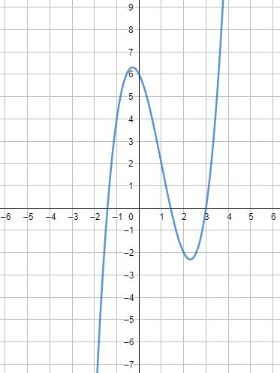
Students discuss in their pairs that the shape is “not really a parabola,” “crosses the x-axis in three places,” “is very swoopy,” “goes to infinity,” and “goes up to 6 and down to –2.”
Ms. G asks them where they think it crosses the x-axis. “At 3, for sure. Then at 1.5 and –1.5 too.” Other students, who have graphed it on their devices, are not as sure: “It looks like it doesn’t cross right at 1.5. It’s close, but not quite.”
Ms. G: “You mean, not precisely? How do we know 1.5 is not a root?” Students calculate that the function value for x = 3 is 0 (indicating a root at 3), but not for x = 1.5 or x = –1.5.
Ms. G: “So if 1.5 is not where it crosses, then where does it cross, exactly? Can factoring help us here?”
Ms. G pauses for an aside here to have the students graph g(x) = (x – 1)(x + 2). As they quickly see the link between root locations on the x-axis and factors of g(x), they then are able to recognize that setting each factor equal to zero and solving gives a root. They then turn back to the cubic polynomial.
Ms. G: “So if we know the factors, it’s easy to find the roots. We see that x = 3 is a root, so one factor is (x – 3). How can we unlock the other factors? What process did we do to unlock the other factors of 186?”
A couple of students’ hands are up: “Long division! Oh, no!”
Ms. G: “Not oh no! Oh yes! We like long division because it’s how we unlock this polynomial! Let’s find those other factors!” Through long division of $x^{3}-3x^{2}-2x+6$ by x – 3, the quotient is $x^{2}-2$.
Ms. G: “So what are those roots?” One pair answers that they don’t know what to do with $x^{2}-2$. Another pair offers that “you can’t factor it, but you can just set it to zero and get an answer of $\sqrt{2}$.” In looking at the graph, the class realizes that $-\sqrt{2}$ is the other exact root. Ms. G reminds them to take note of how much factoring helped them to determine the structure of both numbers and polynomial functions in today’s class.
(end vignette)

Chapter 4

Vignette: Estimating Using Structure, Grade Seven
Big Idea: Proportional relationships
CA ELD: I.A.1, I.A.3, I.B.5, I.C.9, I.C.11
Prior to the lesson, to ensure that all students, including linguistically and culturally diverse learners, are supported, a seventh-grade teacher engages students in an activity to practice the discourse needed to explain their thinking and problem solving. The teacher hopes that this activity will also increase participation. The activity transitions into the teacher introducing the number string activity and writing this problem (MathTalks, n.d.) on the board:
Are there more inches in a mile or seconds in a day?
After some wait time for individual thinking, the teacher asks students to show where they are in their thinking using their fingers, a routine the class knows well: closed fist for “still trying to find an approach to try”; one finger for “have an approach and haven’t got an answer yet”; two fingers for “have an answer with an explanation, and not very confident”; three fingers for “have an answer and an explanation that I’m confident in”; and four fingers for “have tried two or more approaches and confirmed my answer.” After a little more wait time, the teacher asks students to show again their status, and she chooses a student holding up two fingers:
Teacher: Can you describe your approach that might help us figure out which is bigger?
Courtney: I remember there are about 5,000 feet in a mile, so there are about 50,000 inches in a mile since there are about 10 inches in a foot. I rounded them both down. But then with seconds, I tried to figure out 24 × 60 and if I round those, it’s only about 1,200 seconds but that seems too small. [Teacher scribes both calculations, including units where the student included them.]
Teacher: There is some interesting thinking in your groups. Tristán, please share your idea.
Tristán: I tried the same thing, but I got 60,000 inches in a mile instead of 50,000.
Courtney: Did you round 12 inches in a foot down to 10?
Tristán: Oh yeah, I didn’t.
Teacher: Courtney, tell us more about why you thought something wasn’t right with your method?
Courtney: When I tried to figure out the number of seconds, the number seemed too small—it was a lot smaller than the 50,000 I got for inches in a mile.
Bethney: You did 24 × 60?
Courtney: Yeah.
Bethney: Where did you get the 60?
Courtney: Seconds in a minute. And the 24 is hours in a day. Wait… [Teacher adds units to the 24 × 60 on the board from earlier.]
Bethney: I thought it was minutes in an hour. [Teacher adds alternate unit to 60.] So, 24 × 60 is how many minutes in a day?
Courtney: Oh, so I have to times that by 60 again.
Teacher: So, Courtney, now it sounds like you think you could do 24 × 60 and then multiply by 60 again? [Teacher scribes (24 × 60) × 60 on the board.] What units should we add to these numbers to communicate more clearly?
Cameron: The 24 is hours per day, and the first 60 is minutes per hour.
Michael: So, the thing in parentheses is minutes per day. And then the second 60 is seconds per minute.
The discussion continues, exploring several ways that students computed and estimated 24 hours/day × 60 minutes/hour × 60 seconds/minute and 5,280 feet/mile × 12 inches/foot. After several methods have been compared and connected and students seem to agree (with justification) that there are more seconds in a day than inches in a mile, the teacher adds to the problem statement:
Teacher: What if I add this to the problem? [Teacher scribes on board “or breaths in a typical human lifetime?”]
After more wait time and a repeat of the finger routine, the teacher selects a student displaying three fingers who hasn’t already participated:
Teacher: Ji-U, please describe your approach.
Ji-U: I counted while I breathed and decided that a breath takes about four seconds.
Teacher: Who else did something to decide how long a breath takes? [Most students raise their hand.] How long did you estimate? [Chorus of four seconds, five seconds, six seconds.]
The conversation continues with students adapting strategies from earlier, including:
- Searched and found to use 79 years for average lifespan
- Approximated number of seconds in a life, using earlier calculation of seconds/year, then divided by five seconds/breath
- Replaced 60 seconds/minute in earlier calculation with 15 breaths/minute to get number of breaths in a year since I thought each breath was four seconds
- Realized that 24 × 60 × 15 × 79 has to be much bigger than 24 × 60 × 60 since 15 × 79 is more than 60
So, there are more breaths in a 79-year human life!
The teacher concludes this final problem in the string by asking students to think about and then share with a neighbor some descriptions of what they learned or noticed during the talk. Then a few students share something interesting their partner noticed, while the teacher highlights strategies that involve significant use of place-value structure, others that make use of rounding with an explanation of the effect of the rounding, and others that compare products that share factors by comparing the other factors.
The number string offered students the opportunity to notice their own errors without the teacher’s evaluation. As students made sense of the problems in multiple ways, they reflected on their own thinking, made connections, and revised their own thinking. Rather than positioning the student as lacking in mathematical competence, the number string positioned Courtney’s error as an invitation for further sense-making and as a normal part of doing mathematics (UL DP3). The teacher highlighted strategies that made significant use of the structure of numbers and of operations.
(end vignette)

Vignette: Number String on an Open Number Line, High School
Big Idea: Shape, number, and expressions (grade eight)
CA ELD: I.A.1, I.A.3, I.A.4, I.B.5), I.B.7, I.C.9, I.C.11, II.B.5, II.C.6
The teacher uses this activity early in the school year to reinforce structural thinking about the real number system and to begin to establish a class culture of shared exploration, conjecture, noticing, justifying, and communicating.
The teacher introduces the activity by drawing a long horizontal line on the board, with arrow heads at both ends, and placing two marks on the line, labeled a and b (with a to the left of b):
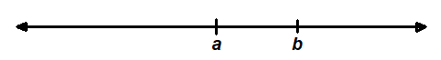
Teacher: I’d like you to think about where on the line I should place a + b. Should it go to the left of a, between a and b, or to the right of b?
After most students show a thumbs-up (the signal for “I’ve got a strategy or explanation”), the teacher explores with the students and discovers that most students have tried several possible values for each variable and have concluded that a + b must be to the right of b. A few students, however, are having trouble not blurting out. The teacher calls on one of these students:
Teacher: Angel, you are shaking your head. Why is that?
Angel: Because –1 + 2.
Quite a few students have an, “Oh, I didn’t think about that” look on their faces. After further sharing, every student generates examples for each possible placement of a + b. Finally, the teacher moves from the number talk into a more-involved team activity, asking—given specific numbers a and b—how to tell where to place a + b. The class generates these generalizations (assuming a and b are real numbers and a < b):
- If a and b are both positive, then a + b is greater than b
- If a and b are both negative, then a + b is less than a
- If a is negative and b is positive, then a + b is between a and b
In pairs, students generate informal justifications for each of these generalizations, which are then refined by the whole class using a “Stronger and Clearer Each Time” instructional routine (UL MLR1). For instance, for the third one, b is positive, so adding it to a moves it to the right of a. So, a + b is greater than a. And a is negative, so adding it to b moves it to the left of b. So, a + b is less than b.
The students think they are done, but the teacher assures them that their list of possibilities is incomplete. One student offers the idea that perhaps b could be negative and a could be positive; other students point out that this is impossible given the original condition that a is to the left of b on the number line. Ultimately, one pair realizes that either a or b could be zero, and students modify their list of statements to include these possibilities. The teacher asks: “Is there anything I could add to the number line that would make it possible to answer the original question?”
Students quickly agree that if they knew where zero was, they could answer the question. At the next math talk opportunity, the teacher again draws a number line with just a and b marked on it as before and asks students this time to think about where a ∙ b should go. After wait time and students displaying thumbs up, the question is, “What different kinds of numbers do you expect to matter?”
Students discuss in pairs, and most believe that it matters whether a and b are positive or negative. Some share examples: –2 ∙ –4 is greater than both –2 and –4; –3 ∙ 5 is less than both factors. A few pairs consider what happens if one factor is zero.
After these considerations are offered and recorded, the teacher asks, “So, if I tell you where zero is, you think you can place a ∙ b on the line?”
Many students say yes or nod; nobody disagrees. The teacher places zero on the number line to the left of a and invites pairs of students to formulate statements about the relationship of a ∙ b to a and b, along the lines of the previous session’s statements about addition. Most pairs do not consider noninteger values for a and b and generate statements such as:
- If a and b are both positive, then a ∙ b is greater than b.
Some pairs have noticed that if a = 1, then the above statement is not true; the class modifies the statement to address this case (either by excluding a = 1 or by adding “or equal to” to the conclusion). If no pairs consider the possibility of a between 0 and 1, the teacher might prompt, “There are some types of numbers I’m worried about that we haven’t considered yet.”
This quickly leads students to consider fractions and decimal numbers less than one, and breaks most of the students’ conjectures. After considerably more work, they generate and justify claims about the (relative) placement of a ∙ b that require knowledge of the placement of –1, 0, and 1 on the number line.
The investigation continues in future classes with consideration of division.
Students’ work in this number string leads to a significant investigation of statements that can be made and justified about the relative locations on the number line of a, b, and a + b, a ∙ b, a – b, or a ÷ b.
Notice several important features of this number string (leading to extended investigation): The number line is a familiar mathematical representation that can be explored to a great depth. Students easily generate their own examples to engage in wondering about the posed questions, and these examples lead to tempting generalizations (conjectures). Some of those generalizations turn out to be false, forcing students to examine a broader set of examples and to look for structure to explain why they are false and how to fix them. Different generalizations will arise in different student teams, leading to a need to justify and to critique others’ arguments.
(end vignette)

Chapter 6

Vignette: Comparing Numbers and Place Value Relationships in Grade Four, With Integrated English Language Development
Source: Tulare County Office of Education under the Creative Commons Attribution-Non Commercial-Share Alike 4.0 International License.
Background: Mrs. Verners’ 30 fourth graders have been learning about place value during the first few weeks of the school year and are approaching the end of the unit. The lessons and math routines have focused on grade-level standards for number and operations in base ten with an emphasis on place value. The task will be one of their first experiences within a larger task focused on the same concepts. The design relies on independent and collaborative work.
The class is predominantly Latinx students, and over half of the students are designated as English learners at the Emerging, Expanding, or Bridging levels. Two students in the class have identified learning disabilities. The fourth-grade team of teachers at this school meets weekly to discuss and plan their math lessons, discussing instructional strategies and resources that they are using to ensure all students feel supported to access and understand the content. In anticipation of this lesson, the teacher used her designated English language development (ELD) time to preview and practice the discourse of “compare and contrast” in a mathematical context (i.e., more than, less than, equal to, greater than, how many more, how many times more) to give English learners the language support needed to participate in the lesson (ELD.PI.4.1).
Lesson Context: Daily lessons and classroom routines have focused on place value. Students know how to identify the place value of given digits, and they write numbers in standard, word, and expanded form. Students compare numbers using their understanding of place value and inequality symbols. They have had some experiences describing these comparisons orally and in writing. Mrs. Verners is working to develop their understanding of how the places within the place value system are related, through multiplying and dividing by 10. Students have analyzed the relationship between the value of a digit in two locations within a number. For instance, they understand that in the number 5,500, the 5 in the thousands place is ten times greater than the 5 in the hundreds place. In this task, they will explore the relationship between values of a common digit as they compare several different numbers.
Mrs. Verners designed the lesson to provide students the opportunities to apply what they have learned about the relationships within the base ten place value system and comparing numbers within the context of a real-world situation. Students initially engage with the content independently, then meet in small groups to collaborate. The strategy with the groupwork is to use a sharing of ideas to deepen student understanding of the relationship between the value of a digit located in different places within numbers. The previous lessons helped students establish a foundation through focused attention on place value concepts. Mrs. Verners and her grade-level team created opportunities to develop background knowledge regarding the places described within the task before beginning the math portion. The teachers decided to integrate a map of the United States in an introductory activity during social studies to start a discussion and to have students identify the geographic locations that are central to the task. The lesson’s learning target, along with the clusters of the CA CCSSM and California English Language Development Standards (CA ELD Standards) on which the lesson focuses are listed below.
Learning Target: The students will organize fourth-grade population data for different locations across the United States in order to compare and describe the relationships between the values of digits within the number.
CA CCSSM:
- 4.NBT.1 - Recognize that in a multi-digit whole number, a digit in one place represents 10 time what it represents in the place to its right. For example, recognize that 700/70 = 10 by applying concepts of place value and division;
- 4.NBT.2 - Read and write multi-digit whole numbers using base-ten numerals, number names, and expanded form. Compare two multi-digit numbers based on meanings of the digits in each place, using >, =, and < symbols to record the results of comparisons;
- 4.OA.1 - Interpret a multiplication equation as a comparison (e.g., interpret 35=5×7 as a statement that 35 is 5 times as many as 7 and 7 times as many as 5). Represent verbal statements of multiplicative comparisons as multiplication equations;
- 4.OA.2 - Multiply or divide to solve word problems involving multiplicative comparison (e.g., by using drawings and equations with a symbol for the unknown number to represent the problem), distinguishing multiplicative comparison from additive comparison;
- SMP.1 - Make sense of problems and persevere in solving them;
- SMP.7 - Look for and make use of structure.
CA ELD Standards (Expanding):
- ELD.PI.4.1 - Exchanging information and ideas with others through oral collaborative discussions on a range of social and academic topics;
- ELD.PI.4.10 - Writing literary and informational texts to present, describe, and explain ideas and information.
Lesson Task: There are almost 400,000 fourth graders in Texas, 40,000 fourth graders in Mississippi, and about 4,000 fourth graders in Washington, DC. There are almost 4 million fourth graders in the United States. (We write 4 million as 4,000,000.)
Use the approximate populations given to solve:
- How many times as many fourth graders are there in Texas as in Mississippi?
- How many times as many fourth graders are there in the United States as in Texas?
- How many times as many fourth graders are there in the United States as in Washington, DC?
(Source: Adapted from Illustrative Mathematics, 2016a)

Lesson Excerpts
Day 1: During social studies, Mrs. Verners introduces the math task to her students, introducing the idea of exploring populations in different locations in the United States. She gives students the task handout that includes a map of the US and asks students to identify their home state. She refers to a copy of the map under the document camera to serve as a visual. Students discuss with their small groups and share their ideas with the whole class. She asks students to shade California yellow.
Next, she asks them to discuss their location in California. Mrs. Verners models how to place a dot to represent their city in its approximate location. She reminds students of the key included on the handout, clarifying that “key” is a multiple-meaning word and asks students if they know of another way this word is used. Mrs. Verners makes a connection between a key, like a house key, and the key on their map, which is used to help you understand the symbols and colors used on the map. The conversation continues and she helps students to identify the United States, Texas, Mississippi, and Washington, DC, on the map and to represent them on the key. Mrs. Verners tells her students that the map will be used for the next day’s math lesson.
Day 2: Mrs. Verners launches the math lesson through a three-read activity (San Francisco Unified School District, 2015). She first asks students to make sense of the context with one another, revisiting the map and telling students that they will be talking about approximate populations of fourth-grade students in these different locations. She asks students to use their personal whiteboard to write synonyms for “estimate” or “approximate.” Informed by a quick formative check of students’ whiteboards, Mrs. Verners asks students to share with their partner their words; she highlights some of the examples she hears on the whiteboard at the front of the classroom. After the students have finished sharing, she pointing to the list on the class whiteboard and says that all the listed words are synonyms that mean about or close to. She explains that when we use numbers that are not exact, we sometimes use the words almost or about to show that these numbers are estimates or approximations. She says that the English word “approximate” is “aproximado” in Spanish, and asks, “Quién sabe otras palabras matemáticas que se oyen igual o similar en ingles? [Who knows other math words that sound similar in English?])” Possible student answers: “Estimado” (estimate), “Angulo” (angle), and “Línea” (line). This reference to cognates supports the linguistic development of students who are Spanish-speaking English learners by using their primary language as an asset to learn English. Mrs. Verner adds these words to the math cognate chart that has been posted in the classroom to both elevate the value of home language and to make cross-language connections that accelerate students’ development of English language proficiency.
Next, she asks students to reason with each other about relevant quantities. To prompt them, Mrs. Verners asks students to estimate the number of fourth graders at their school. Students make individual estimates and record them on their individual whiteboards. They then share their estimates with a partner and justify how they decided on their particular estimate. She lists seven estimates on the whiteboard and asks students to discuss the estimates in their small groups to determine if all the estimates are reasonable —do they make sense?—or not, and why. Mrs. Verners asks two groups to share their thinking with the class. The thinking of the two groups about one estimate, of 300, is similar: Each states that 300 is an unreasonable estimate because their school has three classes of fourth graders and each class is about 30 students, not the 100 students in each class that would be needed to make 300. She tells the class that they just estimated the population of fourth graders at their school and that they will now work with the approximate populations of fourth graders in the locations they marked on their map the previous day.
She asks students to discuss with their partners what they think the term population means. Mrs. Verners reminds the class that, if needed, they can use sentence starters, which include
- I think that…because
- I notice that...
- I agree with...
- I want to add to what…said.
- I respectfully disagree; I think...
She models the use of the “I think that…because” sentence starter as one way to begin describing the meaning of population to a partner. After circulating through the classroom to listen to partners’ conversations, she asks several students to share: “As I listened to you talk with your partners, I heard different ideas about what a population is. Who would like to share what you and your partner discussed? Alex.”
Alex: I think population is like the amount of people in a state.
Sara: I think it could be a city, too.
Mrs. Verners: Would anyone like to add on to what Alex or Sara said? Yes, Maria.
Maria: So, the population is the amount of people in a city or state.
Mrs. Verners: Yes, for this task we are going to think about the population as the number of people in a given location, such as a city, state, or country.
Mrs. Verners then asks students to turn to one another and reason about what mathematical questions they might ask about populations. Once they have shared ideas, Mrs. Verners tells students that they will be looking at the population of fourth-grade students in the different locations they have identified on their maps. She tells the class that she going to read the task aloud and wants students to listen carefully and point to each location on the map when she mentions it in the task. In line with the three-read protocol, which is familiar to the students, they are asked to reread the task silently, underlining or circling important ideas to help them make sense of what they are reading. Students take turns in their small group sharing something that they underlined or circled. Although not all students who are English learners are able to read in their home language, Mrs. Verners provides translations of the task as needed.
To help students organize the population data they were given in the task, they are now asked to individually complete a data table, by writing the fourth-grade population for each location, using digits in standard form. Mrs. Verners explains that “table” is a multiple-meaning word, and that there are different types of tables. In math, she says, tables are used to record information and organize data. She shows students the t-table on their task handout and says it is an example of a table used in math. After asking students to begin working independently, Mrs. Verners asks several of her students to meet her at her small-group table. Here, she works with students who are English learners to collaboratively complete the t-table. She facilitates the conversation using the following types of questions:
- Where in the text can you find the population for each location? How is the population written?
- How can we rewrite the populations from word form to standard form?
- What are the digits in this number? What digits do we use in our base ten number system?
- What do you notice about the location of the digit 4 in the numbers in your table? What does the location of the digit 4 tell you about its value?
After working with the students as they discuss and create their data tables, Mrs. Verners excuses her small group and brings the class back together. She describes how they will work within their small groups during the next portion of the task to answer several questions comparing the population of fourth graders in the different locations and explaining these comparisons in writing.
Mrs. Verners poses the question, “How many times as many is [blank] compared to [blank]? She orchestrates discussion about the difference between additive comparisons and multiplicative comparisons. She then shows the class two sentence frames that she has written on the board. After reading them aloud, tells students that they may use these frames as they are writing, or they may create sentences on their own. Her sentence frames are:
- The number of fourth graders in [blank] is [blank] times as many as the number of fourth graders in [blank].
- There are [blank] times as many fourth graders in [blank] as there are in [blank].
Students are asked to complete a and b, below, collaboratively with their group. Because Mrs. Verners wants to be able to check the level of understanding for individual students, she asks them to complete c on their own after finishing the work on a and b with their group.
- How many times as many fourth graders are there in Texas compared to Mississippi?
- How many times as many fourth graders are there in the United States compared to Texas?
- How many times as many fourth graders are there in the United States compared to Washington, DC?
The teacher circulates as students are working in small groups and ask questions to support and extend their thinking. She has the following questions at the ready, alternating as necessary based on the status of the discussion:
- What do you notice about the numbers/populations listed in your table?
- What relationship do you notice between these numbers?
- What patterns do you notice in the place value of the digit 4?
- What tools might help you as you’re trying to represent the place value of the 4 in each of these numbers? (e.g., base ten blocks, place value chart)
- How would you describe the relationship between the digit 4 in these numbers?
- You noticed that each place value is x 10 the place before it. How might you find the relationship between 4,000 and 4,000,000?
Mrs. Verners selects three groups to share their explanation from question a. Within each group, she selects one student to represent the group and present to the whole class. She considers students who have recently presented and intentionally selects those who have not recently had an opportunity to present their thinking to the whole class, preparing them beforehand so they can plan how they will share. Because she wants to support the class norm that all students have good math ideas, she tries to select students who, collectively, represent a range in the strategies they use. Mrs. Verners asks students who have been selected to share to practice what they will say within their table group before presenting in front the whole class. After the students share their group’s explanation, Mrs. Verners asks questions to deepen student understanding and make connections between the different explanations that were presented. Next, she asks all students to reread their explanations in part a and to strengthen the explanation by adding to it, or to revise their thinking based on what they have heard and considered during the whole-class presentations.
Mrs. Verners then asks students to think about the explanations they have heard with their partner. She asks them to use what they have learned from their work on parts a and b to complete part c independently. She tells the students that she is interested in looking at their work and reading their writing in part c so that she can learn what they understand about comparing numbers. Students write their explanations independently.
Teacher Reflection and Next Steps: Mrs. Verners collects and reviews students’ independent work and explanation from part c. As she reads, she analyzes whether or not students were able to generalize their place value understanding to describe the relationship between the digit 4 in the population of fourth graders in Washington, DC, and the United States. Students have had experience describing the relationship between a digit in a given place value and the value of the place to its right or left; however, this question asks them to describe the relationship of a digit that is three places to the left. As Mrs. Verners analyzes the student work, she discovers that while the majority of her students understand and are able to describe these place value relationships, a small number of students are struggling to express their thoughts in writing. This small group contains students with a range of needs, including some who are English learners (two designated as Emerging ELs, one designated as Expanding EL); one student with a learning disability; and two other students that she has noticed are struggling with place value concepts. She decides to work with these students in small groups the following day to determine if they are having trouble with the concept, if they understand the concept but are having difficulty using writing to explain their thinking, or if they struggle with some combination of understanding and communicating.
Mrs. Verners sees that, generally speaking, this task helped students to deepen their understanding of place value relationships. So she decides that, before the end of the place value unit, she will give students the opportunity to engage in an additional task that will further develop these concepts.
(end vignette)

Vignette: Alex Builds Numbers with a Partner (a two-day lesson)
Grades: One
Content Connections: 2, Exploring changing quantities
Drivers of Investigation: 1, Make sense of the world
Standards for Mathematical Practice: 1, Reason abstractly and quantitatively; 2, Construct viable arguments and critique the reasoning of others.
Alex’s first grade class is building understanding of making numbers. The teacher, Ms. Kim, launches the lesson with a whole-class conversation during which all students gather on the carpet at the front of the room. Half of them are holding a small rekenrek. As shown in figure C.2, a rekenrek is a rack with two rows, or metal rungs, each of which has 10 beads that can be moved along their rung. Ms. Kim holds a larger rekenrek on which she has moved 2 beads from the top rung to one side and 3 beads from the bottom rung to the same side. Pointing to the beads she has pushed to one side of the rack, she asks students, “How many beads do you see on this side of the rack? Turn and talk to your partner about how many beads you see altogether on that side of the rack and how you can tell.” Students turn to their peers and excitedly share their ideas.
Figure C.2 Rekenreks That Can be Used as an Early Grade Math Tool
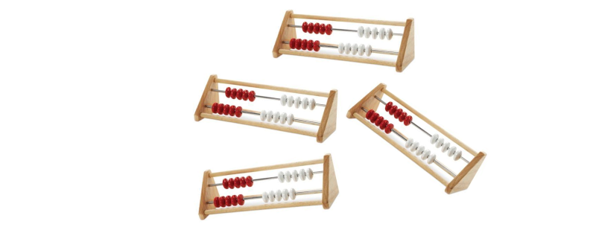
Ms. Kim then asks, “Who wants to share?” Students raise their hands and Ms. Kim calls on Alex, who says, “I see 5 beads.” Because Alex has forgotten to explain how they came up the total number of beads that had been moved to the side, Ms. Kim asks again: “How do you see it,” meaning “How did you come up with that number?” Alex continues, “Because there are 2 beads on the top and 3 on the bottom and that makes 1, 2, 3, 4, 5.” Ms. Kim revoices his response: “I heard you say that you see 5 beads because there are 2 on the top and 3 on the bottom and 2 and 3 make 5 altogether. Is that right? Who agrees with Alex?” Several hands go up in the air.
“Are there other ways to make a 5?” Ms. Kim wonders aloud. “Work with your partner. If you are holding the rekenrek, you are Partner A. Raise your hand if you are Partner A. If you are not holding a rekenrek, you are Partner B. Raise your hand if you are Partner B. Ok, Partner A––How else can you make a 5? Use your rekenrek to show another way to make a 5. Then it will be Partner B’s turn. Partner B—make 5 in a different way.”
Students turn to their partners and begin to move beads. Some students move 5 beads over on the top rung and none on the bottom. Others show 4 on the top and 1 on the bottom. Several others are unsure what to do, so they playfully move beads around on the rekenrek.
Ms. Kim moves around the carpet area, squatting down to meet with particular partner groups and listen to their conversations. After a few minutes, she reconvenes them for a discussion. While moving around the room she has noticed that some of the students who are English learners are having trouble expressing their ideas. She helps model the language needed and has students practice with their partner while moving the beads on their rekenrek. Ms. Kim makes a mental note to review this discourse in tomorrow’s designated ELD lesson.
Now she renews the class discussion by asking, “What were some other ways to make 5?” Students share ways to make 5. Ms. Kim revoices their answers, checking with the class to see whether their different combinations of number count up to 5 and allowing students to revise their thinking when their combination does not.
Ms. Kim then introduces the activity students will be engaged with for the rest of the lesson, at their table with their partner. The teacher gives number cards to each table. In each pair, students then alternate being Partner A, who turns over a number card and uses the rekenrek to represent that number, and Partner B, who prompts Partner A to explain how they decided what beads to move by asking, “How do you see it?” The roles are then reversed and the rekenrek is passed to the second student in the pair who must represent the same number in a different way. This student is also asked to explain “how he sees it.” For each number combination, the partners must agree that it does indeed count to the number on the card.
Alex’s partner holds the rekenrek and quickly turns over a number card, exclaiming, “8!” “So now you have to make an 8,” declares Alex. Partner A moves the beads playfully, first moving 10 beads, some from each rung to the side and then counting them aloud one by one. Upon reaching 8, Partner A pauses and moves the remaining 2 beads away,” saying, “Okay, I made 8.”
“How do you see it?” asks Alex. Partner A responds, “There are 5 on the top and 1, 2, 3 on the bottom. Your turn.”
After taking the rekenrek, Alex moves 1 bead away from the 5 beads Partner A had moved to the side on the top rung and adds 1 bead to the 3 beads Partner A had moved on the second rung. “I see 4 and 4.”
Around the classroom, partners continue to take turns turning over and representing new numbers. Ms. Kim moves from group to group, she asks students to explain their representations, supports partners’ interactions, and record both their representations of numbers and their explanations. She is using this time as a formative assessment opportunity and, based on what she sees and hears, she makes plans for the next day’s discussion about patterns in representing numbers.
(end vignette)

Vignette: Habitat and Human Activity
In this vignette, (Lieberman and Brown, 2020), the teacher works with students to deepen their knowledge and skills of mathematics, science, the California Environmental Principles and Concepts (EP&Cs), and English language arts/literacy (ELA) through an investigation of habitats on or near the school campus. Specifically, they will investigate a real-world problem of how human activities can affect the number and diversity of organisms that live on the campus. The local focus helps ensure that students find the investigation to be relevant and meaningful.
The math-related part of the investigation targets measurement and data: Students will use rulers to generate measurement data (CC 1, 4, DI 3; 3.MD.4); represent data by drawing a scaled picture graph and a scaled bar graph (3.MD.3); learn to recognize area as an attribute of plane figures and understand the concept of area measurement (3.MD.5); and, solve real-world and mathematical problems involving perimeters of polygons (3.MD.8).
For the science part of the investigation, students will gather and analyze evidence (CA NGSS SEP-3 and CA NGSS SEP-4, respectively); construct an argument (CA NGSS SEP-7); and make a claim about the merit of a solution to a problem (CA NGSS 3-LS4-4).
In alignment with EP&C II, students will analyze the results of their investigation to examine how “the long-term functioning and health of terrestrial, freshwater, coastal and marine ecosystems are influenced by their relationships with human societies” (CA EP&C II); and, how “decisions affecting resources and natural systems are based on a wide range of considerations and decision‐making processes (CA EP&C V).
For the ELA aspect of the lesson, based on their investigation students will choose either to write an opinion piece (about a topic or text) that supports a point of view with reasons (ELA W.3.1) or write an informative/explanatory text to examine a topic and clearly convey ideas and information (ELA W.3.2). In the course of this activity, English language development (ELD) standards will also be called into play: P1.C, 9–12; P2.A, 1, 2; P2.B, 3–5; P2.C, 6–7.
Many of the ELD standards below, drawn from the English Language Arts/English Language Development Framework’s Critical Principle Statements (Figure 1.10 of that document) are applicable to this vignette:
Part I: Interacting in Meaningful Ways
- Collaborative (engagement in dialogue with others)
  - Exchanging information and ideas via oral communication and conversations
  - Interacting via written English (print and multimedia)
  - Offering opinions and negotiating with or persuading others
  - Adapting language choices to various contexts
- Interpretive (comprehension and analysis of written and spoken texts)
  - Listening actively and asking or answering questions about what was heard
  - Reading closely and explaining interpretations and ideas from reading
  - Evaluating how well writers and speakers use language to present or support ideas
  - Analyzing how writers use vocabulary and other language resources
- Productive (creation of oral presentations and written texts)
  - Expressing information and ideas in oral presentations
  - Writing literary and informational texts
  - Supporting opinions or justifying arguments and evaluating others’ opinions or arguments
  - Selecting and applying varied and precise vocabulary and other language resources)
Part II: Learning About How English Works
- Structuring Cohesive Texts
  - Understanding text structure and organization based on purpose, text type, and discipline
  - Understanding cohesion and how language resources across a text contribute to the way a text unfolds and flows
- Expanding and Enriching Ideas
  - Using verbs and verb phrases to create precision and clarity in different text types
  - Using nouns and noun phrases to expand ideas and provide more detail
  - Modifying to add details to provide more information and create precision
- Connecting and Condensing Ideas
  - Connecting ideas within sentences by combining clauses
  - Condensing ideas within sentences using a variety of language resources
During an initial exploration of their campus, students look for places to observe plants and animals. They identify these areas on a simple map of the campus and record a few examples of what they observe.
Back in the classroom, students share what they have observed. The teacher introduces the concept of habitat and explains that a healthy habitat provides the resources and conditions necessary for a diversity of organisms (plants and animals) to survive. The teacher also leads a discussion about how human activity can affect the number and types of organisms that will survive in an area.
The teacher and students decide to work together to design an investigation to identify and gather data from areas with different levels of human activity. They plan to compare areas with more plants and animals to those with fewer plants and animals and areas with more human activity to those with less activity. Prior to starting their outdoor investigation, the teacher reviews the relevant math standards and introduces the math practices students will use to analyze the data collected during the investigation.
After discussing the concept of area measurement, students lay out and use yardsticks to measure their rectangular study plots. They collect data by observing the study plots, then create a table in which they record the numbers and types of plants and animals found in the plots. Similarly, they collect and, in another table, record data showing the types and levels of human activities taking place near each plot (by identifying the different types of activities and how many students and adults were involved in each type).
The students calculate the area of the rectangular study plots. They then use the data from their tables to create scaled bar graphs and/or scaled picture graphs of the number of animals and plants in the study plots. The students use the graphs to make statements about the data (e.g., “There are x number of plants/animals in this study plot”; “There are more plants than animals in this plot”; and “There are twice as many animals as plants in this plot.”).
The teacher poses the question, “How do human activities affect the number and diversity, or types, of organisms that live on campus?” Students are asked to construct an argument based on the analysis of their data about the effects of human activities on habitats and the organisms that live there. Working in teams, they design a solution that might minimize the effects of human activities on organisms that live on campus. Using the results of their investigations, the data collected and analyzed, and the graphs, students write informative/explanatory texts that examine the topic of changes to habitats and convey their ideas about the problems and make claims about the merits of their solutions.
As they conclude their investigations, students begin to wonder how and by whom decisions have been made about the design and use of the campus. One student, a new arrival to the school, mentions that there were many more plants and animals at their previous school. This comment prompts another major question and discussion about why some schools have lots of green space, trees, and gardens, and others have few or none. This conversation creates a direct connection to the teacher’s upcoming history–social science unit in which the focus will be on the distribution and use of resources and on environmental justice.
The following week, the class begins a unit on three important topics: the ways in which people have used the resources of the local region and modified the physical environment (History–Social Science [HSS] standard 3.1.2.); the importance of public virtue and the role of citizens, including how to participate in a classroom, in the community, and in civic life (HSS 3.4.2.); and, understanding that individual economic choices involve trade-offs and the evaluation of benefits and costs (HSS 3.5.3).
(end vignette)

Vignette: Students Examine and Connect Methods of Multiplication
A teacher challenges student to multiply 7 × 24 and to explain their strategies. The goal is to promote their critical examination of several methods and to have students look for connections among the methods.
Several students explain their thought processes for solving 7 × 24. Based on student explanations, their teacher uses symbolic notation to record students’ methods on the board, starting with Jax, whose method is shown in figure C.3.
Jax explains: I skip counted by two seven times, and 7 × 2 = 14, so that means 7 × 20 = 140 because 20 is ten times as much as two. Then I had to multiply 7 × 4, and that was 28. I know 2 × 7 is 14, so I added 14 + 14. Then I added 140 + 28 and got 168.
Figure C.3 Documentation of Jax’s Multiplication Method
Long description for figure C.3
Luca explains: I used 25 instead of 24. I did 7 × 25 and that equals 175, because that’s like 7 quarters. But it’s not really 25, it is 24, so I had to take away an extra seven. So I took away five (of the seven) to get 170, and then took away two more to get to 168.
Luca’s method is shown in figure C.4.
Figure C.4 Documentation of Luca’s Multiplication Method
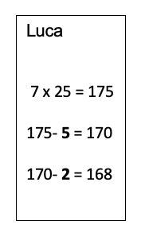
Pippin explains: My way is kind of like Jax’s. I know 7 × 10 = 70, and there are two tens in 24, so I did 7 × 10 again. 70 + 70 = 140. And 7 × 4 = 28, so 140 + 28 = 168.
Pippin’s method is shown in figure C.5.
Figure C.5 Documentation of Pippin’s Multiplication Method
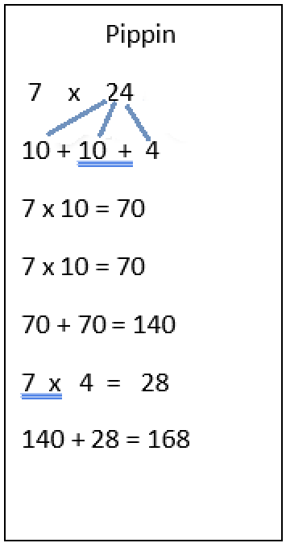
Putting all three methods side by side in front of the class (as shown in figure C.6), the teacher asks students to consider what is the same and what is different about the three methods.
Figure C.6 Side-by-side Documentation of Three Students’ Multiplication Methods
Jax | Luca | Pippin
2, 4, 6, 8, 10,12,14, so  7 × 2 = 14  7 × 20 = 140  7 × 2 = 14, and 14 + 14 = 28, so 7 × 4 = 28  140 + 28 = 168 | 7 × 25 = 175  175 - 5 = 170  170 - 2 = 168 | 7 × 10 = 70  7 × 10 = 70  70 + 70 = 140  7 × 4 = 28
Students point out that all three methods produce the same result, and that they all took the number 24 apart, but that they did that differently. A few students say that that the method Luca used is tricky and they don’t know why Luca did that. The teacher replies that they will talk about Jax and Pippin’s methods first and then ask Luca to explain the thinking behind that method.
The teacher asks Jax and Pippin to describe more about how their methods are alike:
- Jax: We both broke the 24 apart and we both multiplied 7 × 4.
- Pippin: And we both got the same product.
- Teacher: So, you both knew that you could multiply 7 × 24 by taking the 24 apart, finding parts of the product, then putting all the parts together?
- Jax and Pippin: Yes!
- Teacher: Aha! So, you used the distributive property! We will have to try some more problems and see if your method always works.
- Teacher: Now let’s figure out whether Luca used the distributive property, too.
The class focuses attention on Luca’s method, and at the end of the discussion the teacher tells the students that they will have more opportunities to try out these methods on other problems to see when they are useful and how they can help solve problems more easily.
(end vignette)

Vignette: Santikone Builds Rectangles to Find Area
Grades: Three, four
Content Connections: 2, Exploring Changing Quantities; 4, Discovering Shape and Space
Drivers of Investigation: 1, Make Sense of the World; 3, Impact the Future
Concepts: Measurement, area, perimeter, multiplication
Standards for Mathematical Practice: 2, Reason abstractly and quantitatively; 3, Construct viable arguments and critique the reasoning of others; 5, Use appropriate tools strategically; 6, Attend to precision
Background: Santikone’s third grade class is building understanding of the operations of multiplication and division and concepts of perimeter and area. The teacher plans a 2- to 3-day lesson, knowing that these are pivotal concepts and that integrating multiple concepts in a meaningful context is more effective than addressing a single concept in isolation. Like many students in the class, Santikone responds with excitement, is actively engaged, and retains learning well when classroom tasks allow students to approach problems in a variety of ways and when the task involves using math tools. One particular tool available to Santikone is an instructional aide who supports the student’s full participation in these activities.
The teacher has chosen a task that addresses third grade measurement and area content, using only whole numbers, while simultaneously calling on skills of multiplication and division. To conclude the lesson, each student will compose a paragraph explaining their reasoning.
Lesson Context: Santikone and their instructional aide listen as the teacher, Ms. B, describes what the class will be doing:
“Our challenge is to find all the ways to make a rectangle with a loop of string that is 36 inches long. Then we will make some decisions about what these rectangles could be used for, and which would be the best choices.”
Ms. B asks students to imagine what the process for this activity will look like, and what part of the rectangles the string would represent. The teacher draws a rectangle on the board, asking students to think about the line as if it were the string. After a few seconds, Ms. B asks children to talk within their small groups about what part of the rectangle the string represents.
As Santikone’s classmates turn to the task, Santikone and their instructional aide also talk through some ideas in preparation for the whole-class discussion: it’s the outside of the rectangle; it’s the edge; it’s like a fence or maybe a wall. The aide nudges Santikone to record their thinking and rehearse their contribution to the upcoming discussion.
Ms. B opens the floor to the whole class, listening as children talk and recording their ideas, including Santikone’s, about what part of the rectangle is represented by the string. That list includes edge, side, outside, fence, area, perimeter, line. In a short discussion after the students finish with this part of the task, Ms. B reminds them of their previous lesson about what they called the “outside” of a polygon. The class agrees that “perimeter” is the word that best fits and that the class will be making rectangles with a perimeter of 36 inches (SMP.3, 6; 3.MD.8).
Noting that the word “area” appears in their list, Ms. B asks students to recall what they have previously learned about area. The teacher says that after students use their string to explore and find rectangles with a perimeter of 36 inches, the class will talk more about area. Ms. B also reminds them that they may find it useful to refer to the classroom’s math wall, that space on one wall where the class has posted definitions, drawings, and counter-examples of the shapes they have studied so far this year.
During the lesson, Santikone’s aide supports the student in shifting their attention as needed, to the term “area,” to the math wall, and so on.
Ms. B then provides specific directions, asking students to work collaboratively in their small group:
- Arrange the string to form rectangles along the grid lines on your paper.
- Draw each rectangle on the grid paper, recording length and width in inches along the sides (SMP.2, 5, 6; 3.MD.4).
- Talk within your group about how you know you have found all the possible rectangles (SMP.3, 6; 3.G.1).
- Bring your ideas to the class when we gather to share.
Ms. B supplies each group with a large sheet of one-inch grid paper, rulers, and a string loop. Children gather paper, pencils, and markers they will use to record the rectangles they make and move to their work spaces.
Team Investigation: As students organize themselves to start work, Santikone wonders aloud to their aide whether it is possible to use the same string to make many different rectangles—and how many— and whether they will all have the same area. Upon joining their small group, Santikone immediately picks up the string and tries to make a rectangle on the grid paper. Santikone’s aide joins the group and supports Santikone’s interactions by asking peers to repeat, or revoice, what others say, and making sure that Santikone both listens and is heard. When Santikone tries to form the corners but cannot hold the string still, a teammate volunteers to help. The group decides on a plan for working together: Each person will make one rectangle with a helper, then pass the string to the next person so each person gets to build some of the rectangles. Another team member will draw the rectangle and record its dimensions on the grid paper.
Santikone tries again to form a rectangle that is 4 inches wide. A partner helps by holding the string still at two corners while Santikone stretches the string to find that it makes a length of 14 inches. Another team member draws this first rectangle and writes down its dimensions.
Work proceeds until the group is satisfied they have found all the possible rectangles.
After the students have worked to find all the rectangles, Ms. B calls for attention. The teacher tells the class they get to continue the investigation, directing them to
- Work with your group to find the area of each rectangle you found; record the area for each rectangle on your drawing (SMP.2,6; 3.MD.5, 6).
- Talk with your group about what each rectangle could represent in the world and be ready to share with the class (SMP.2,3; ELD PI.10,11,12).
Ms. B circulates as groups find the areas of the rectangles, noting the strategies students use. Some count single unit squares, others count how many rows there are in the figure (e.g., 4 square inches in each row), and count by fours to find the total number of square inches. A few students make multiplication connections, such as “Well, there are four in each row and there are 14 rows, so isn’t that like a multiplication problem?” Ms. B hears a student say the area is like an array. Some students discuss whether they should count the 9 x 9 square they have drawn; they are debating whether a square is also a rectangle. Several students express surprise that there were so many rectangles possible and they all have the same perimeter, but not the same area.
Team Presentation: Ms. B reminds students to think and talk with each other about what each different rectangle they have found might represent in the real world, and to get ready to share their discoveries and ideas. Ms. B circulates among the students, encouraging partners to practice out loud with each other what they will say to the class. Particularly attentive to language development, the teacher pauses a few minutes to support all students, including those who are English learners, in their efforts to express their thinking. During this final phase of the group work, Ms. B also identifies a group of posters that represent different approaches and/or organizational methods; the plan is to invite the students who made these posters to present them as a way of initiating the class discussion. One of the posters Ms. B chooses is the one by Santikone’s group, shown here (figure C.7):
Figure C.7 Student Poster Illustrating the Thinking of Santikone’s Group in Addressing a Rectangle Problem
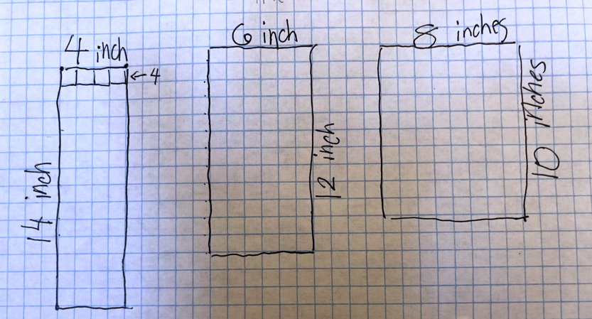
Santikone is excited that their group is asked to share the poster and how the group found the areas of the rectangles. The team members explain how they found each rectangle and report the areas.
Another team shares its thinking, explaining that students figured out they could find areas by multiplying. A rectangle of width 1 inch had a length of 17 inches, and there were 17 square inches in that area. They noticed that 1 × 17 = 17, and that meant they could multiply to find the area.
A lively discussion develops regarding whether the 9 × 9-inch square should be included in the list of rectangles, and Ms. B welcomes this discussion of important grade-level mathematics. Aware that students often need extra time to develop understanding of a square as a special example of the category of rectangles, the teacher asks teams to review their knowledge of what makes a rectangle, something they had discussed previously. Together, the class members review what had talked about and come up with a list of three characteristics of rectangles:
- They have four sides.
- They include square corners.
- They have two sides across from each other that are the same lengths.
Casey agrees with the list in general, but wants to add another characteristic, that rectangles have to have two long sides and two short sides. Sumira challenges: “Why do there have to be long sides and short sides? I thought when we talked before we said all the sides could be the same, like in a square.” Santikone walks to the math wall and reviews the pictures and descriptions of rectangle and square that are posted. Santikone comes back and excitedly tells Sumira that they agree. With a few more minutes of discussion, the class comes to consensus and includes the 9 × 9-inch square rectangle in the list of nine possible rectangles with whole-number length sides, and a perimeter of 36.
Ms. B focuses attention on the questions of which rectangle has the greatest area, and which rectangles would be most useful at school, at home, or in the community, and why.
Students talk a few moments about whether a “long, skinny” or a “shorter, wider” rectangle is better. When the class discussion resumes, Santikone comments that the 1 × 17 rectangle is so long and skinny it would not be useful for many things, and wider ones are probably better for most things. Another student says that some of the rectangles look like they are the shape of a book or a door. Others describe how various rectangles could be the shape of a playground, a pool, a garden, or a sandbox. A number of students claim the rectangles that have the largest areas (the 8 × 10 rectangle and the 9 × 9 square rectangle), would be the “best” for most things.
Lesson Extension and Conclusion: Ms. B introduces a plan for students to write in their journals: they will explain why there are so many different rectangles that have the same perimeter, describe how they could use one of the rectangles to represent something real (e.g., dog run, pool, garden), and explain why they made that choice. Ms. B attends to the students who are English learners and reminds them of the sentence frames they have used and found helpful in past lessons. Ms. B invites them to practice by sharing their responses with a partner and reading their written work aloud when they are finished.
Santikone, having already decided that a pool would be the perfect way to use a rectangle explains this choice in their journal and illustrates a sunny day, blue sky, and a “long, medium-skinny” pool.
(end vignette)

Chapter 7

Vignette: Followed by a Whale
Grade level/Course: Grades five through eight
Drivers of Investigation: 3, Make sense of the world (understand and explain)
Content Connections: 1, Reasoning with data; 2, Exploring changing quantities
Standards for Mathematical Practice: 1, Make sense of problems and persevere in solving them; 2, Reason abstractly and quantitatively; 3, Construct viable arguments and critique the reasoning of others; 4, Model with mathematics; 5, Use appropriate tools strategically; 6, Attend to precision.
Domains of Emphasis: 5.MD, 5. NF, 6.RP, 7.RP, 8.EE, 8.F
Background: Whale beaching is an issue around the globe, and California is not immune. Whales need deep ocean water to live; if they swim too close to the shore, in shallow waters, they can be beached and die. Scientists are not sure why whales beach, but one possibility is that whales are very sociable animals and may follow another animal, especially one that needs help, into shallow waters.
Heather Herd read to her class the book Grayson, by Lynne Cox, which recalls a true-life event of a 17-year-old swimmer who helped a baby whale. When Heather read the book, she saw an opportunity to engage her students in a powerful investigation influenced by mathematical problem-solving. The unit she developed is appropriate for many grade levels, drawing from mathematics in grades five through eight (Youcubed, n.d.a).
The story in Grayson is set in the Pacific Ocean. At age 17, Lynne had completed a three-hour swim workout in 55-degree water when she discovered that a baby gray whale had been following her. When she learned that a fisherman had spotted a mother whale at a nearby offshore oil rig, that knowledge prompted a question: Should she swim out to the oil rig with the baby whale, or should she swim to shore, inducing the baby to follow her and possibly be in danger of getting beached?
Heather knows some of her students struggle with the culture of elite swimming, so part of her reading strategy is to provide visual cues, graphic representations, gestures, realia, and pictures to support their understanding, in line with the principles of Universal Design for Learning. She presents the story to the students every day while wearing a swimming cap, goggles, and sweat suit to class. She also gives students data to help them predict the likelihood of the swimmer’s survival in different scenarios.
The students are enchanted by the story and spend time synthesizing information from different sources—including scale maps, cold-water survival charts, and an article about swimmers’ endurance. Heather’s students benefit from her long-term focus on academic vocabulary instruction, which has helped students—especially those who are English learners—to develop the confidence to correctly decide which math function they should apply for different problems. Her focus on vocabulary has allowed Heather to address a fundamental aspect of her curriculum. With adequate language for understanding, students persevere in this activity at organizing data into new formats: number lines, function tables, and coordinate planes. The students map the swimmer’s different paths, with rates that changed due to ocean current, as shown in figure C.8.
Figure C.8 Ocean Currents Map
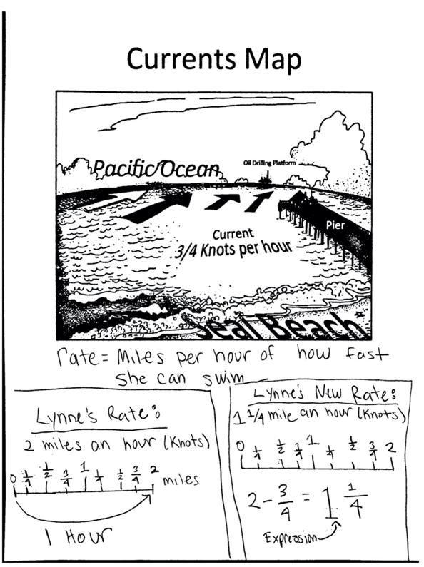
Long description of figure C.8
The students analyze proportional relationships, add fractions, use ratio reasoning to solve problems, compare two different functions, and make use of data. They also persevere in solving a complex problem (SMP.1), construct viable arguments (SMP.3), and critique the reasoning of others (SMP.3).
The figures below (C.9 and C.10) are students’ work showing a current moving 3/4 of a knot against the swimmer as she swims back to the pier. The current against the swimmer changes the swimmer’s rate of progress to 1-1/4 of a mile per hour. Students use the different rates, which they display in tables and graphs like those below.
Figures C.9 and C.10 Student Table and Graph based on Ocean Current Data
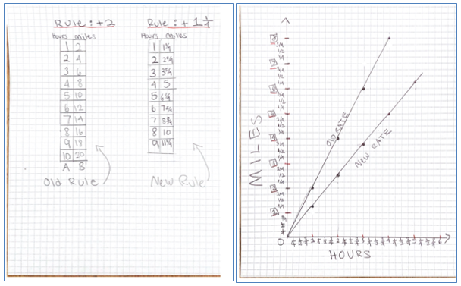
Long description of figures C.9 and C.10
The week before the whale project, Heather had created an ocean scene in her classroom—complete with realia in the form of a cutout of a baby whale. The students researched the names and dimensions of the sea animals that would appear in the story and practiced precision with measurement. The students measured, drew, and cut out the animals to create an ocean scene, but Heather kept the whale story project a surprise until she actually started it.
(end vignette)

Vignette: Crows, Seagulls, and School Lunches
Grade Level/Course: Grade seven
Drivers of Investigation: 2, Predict What Could Happen (Predict); 3, Impact the Future (Affect)
Content Connections: 2, Exploring changing quantities
Standards for Mathematical Practice: 4, Model with mathematics; 5, Use appropriate tools strategically; 6, Attend to precision
Domains of Emphasis: 7.SP
In this vignette, the teacher is focused on having students generate authentic questions and conduct an investigation of the campus community to deepen their knowledge and skills in math, science, and English language arts. She wants them to align the investigation with California’s EP&Cs. She sees this as an opportunity for students to reason with data by building awareness of the connections between mathematical ideas and environmental and social justice issues, on campus and in the local community. To make the assignment relevant to their lives, she has them collect data from the lunch areas and cafeteria.
From a math perspective, the teacher decides to focus the assignment on content related to statistics and probability by having students use random sampling to draw inferences about a population (7.SP.1, 7.SP.2) and, also, to draw informal comparative inferences about two populations (7.SP.3, 7.SP.4).
From a science perspective, student work will focus on planning and carrying out an investigation (CA NGSS SEP-3); analyzing and interpreting data (CA NGSS SEP-4); using mathematical and computational thinking (CA NGSS SEP-5); constructing explanations and designing solutions (CA NGSS SEP-6); examining the cycling of matter and energy transfer in ecosystems (CA NGSS 7.LS2.B), and, developing possible solutions (CA NGSS 7.ETS1.B).
Students will analyze the results of their investigation to examine how “the long-term functioning and health of terrestrial, freshwater, coastal and marine ecosystems are influenced by their relationships with human societies” (CA EP&C II); ”the exchange of matter between natural systems and human societies affects the long‐term functioning of both” (CA EP&C IV); and, how “decisions affecting resources and natural systems are based on a wide range of considerations and decision‐making processes (CA EP&C V).
Based on their investigations, mathematical analysis, and a consideration of the environmental principles, students will “write an informative/explanatory text(s), including the narration of…scientific procedures/experiments, or technical processes” (ELA WHST.6–8.2.a–f), and cite specific textual evidence to support analysis of science and technical texts (ELA RST.6–8.1).
During their initial exploration of campus for the assignment, students observe large numbers of crows and seagulls hovering over the lunch area by the cafeteria, noticing that the number of birds was largest just after lunch. Back in the classroom, the teacher wants to give students opportunities to generate authentic questions about what they observed in the lunch area. So she asks what they are wondering about the situation, noting their responses on the board. Their responses include: When are the largest numbers of birds in the lunch area? What is attracting the birds? Do students at different grades produce different amounts of food waste and trash?
Working in small groups, students then generate several specific questions to investigate, ultimately settling on three, to reflect the fact that students at different grade levels eat lunch at different times: Do students in different grades produce the same amounts and types of food waste and trash? Do students in different grades deal with food waste and trash in the same way? Are there different numbers of birds in the lunch area when different grade-level students are eating?
Prior to having students design their investigation and plan how to collect and analyze data, the teacher introduces the ideas of using random sampling to draw inferences about a population, explaining how this would allow students to draw informal comparative inferences about the populations of students in the three grades. She then guides students in designing a waste audit of food and trash in the lunch area.
After collecting and analyzing their data, the class begins drawing inferences about the amounts and types of food waste and trash produced by students in different grades. They determined that students in different grades discarded their food waste and trash in different ways. They also determine whether the numbers of birds visiting the lunch area varied by the grade level of students who were eating.
Investigation findings result in many other student questions, for example, how the food waste and trash might be affecting students and people living near the school; the plants and animals on and near the campus; local water quality; and the town’s litter prevention program. The teacher suggests they bring their questions to science class so they can expand their studies and work together to explore and implement possible solutions.
As part of a strategy for teaching students about the cycling of matter and energy transfer in ecosystems and developing possible solutions, the science teacher has students examine the effects of food waste and trash. She then challenges students to use the engineering design process to develop a solution to the problems they identified related to the effects of food waste and trash on students, staff, teachers, the campus, community, and local natural systems.
Noting students’ enthusiasm about their designs of possible solutions to the food waste and trash problem, the math and science teachers meet with the English language arts teacher to ask that he develop a related activity. In the activity, students will describe their data collection and statistical analysis, the scientific procedures/experiments they conducted, and the library research that had led them to creating an engineering solution to the lunchtime waste problem.
Each student team is asked to develop both a written description and an oral presentation about their project activities, citing specific textual evidence to support their analysis of the math and science they used to develop their design solutions. They are also asked to discuss what they had discover about the effects of food waste and trash on the long-term functioning and health of plants, animals, and natural systems.
Students then have the chance to present their work and design solutions to students outside their class, the school administration, and the facilities staff.
(end vignette)

Vignette: What’s a Fair Living Wage?
Grade level/Course: Grade eight mathematics
Drivers of Investigation: 3, Impacting the Future
Content Connections: 1, Reasoning with Data
Standards for Mathematical Practice: 1, Make sense of problems and persevere in solving them; 2, Reason abstractly and quantitatively; 3, Construct viable arguments and critique the reasoning of others; 4, Model with mathematics; 5, Use appropriate tools strategically; 6, Attend to precision
CA CCSSM Content Clusters/Standards:
- 8.EE.8.B
Solve systems of two linear equations in two variables algebraically, and estimate solutions by graphing the equations. Solve simple cases by inspection. For example, 3x + 2y = 5 and 3x + 2y = 6 have no solution because 3x + 2y cannot simultaneously be 5 and 6.
- 8.EE.8.C
Solve real-world and mathematical problems leading to two linear equations in two variables. For example, given coordinates for two pairs of points, determine whether the line through the first pair of points intersects the line through the second pair.
- 8.F.2
Compare properties of two functions each represented in a different way (algebraically, graphically, numerically in tables, or by verbal descriptions). For example, given a linear function represented by a table of values and a linear function represented by an algebraic expression, determine which function has the greater rate of change.
- 8.F.4
Construct a function to model a linear relationship between two quantities. Determine the rate of change and initial value of the function from a description of a relationship or from two (x, y) values, including reading these from a table or from a graph. Interpret the rate of change and initial value of a linear function in terms of the situation it models, and in terms of its graph or a table of values.
This lesson focuses on how understanding of mathematics informs understanding of the world, including social justice issues (Berry et al., 2020). Designed to span 90 minutes, this lesson begins with students discussing what they know about living wages and minimum wages. Students are invited to explore and unpack a data visualization (figure C.11) showing how many hours of work at minimum wage are needed to afford rent in different states in the US.
Figure C.11 Data Visualization of Hours at Minimum Wage Needed to Afford Rent
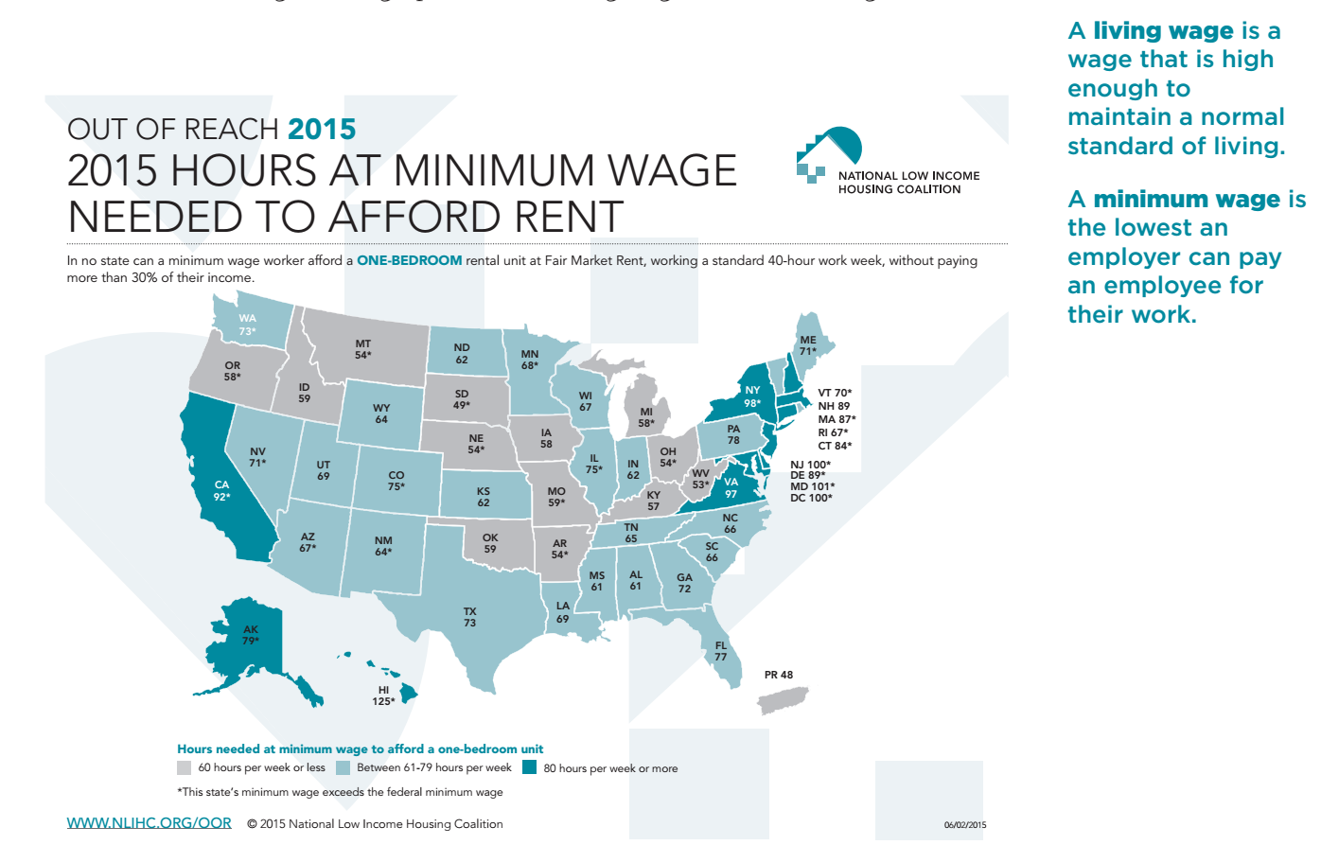
Long description of figure C.11
Source: National Low Income Housing Coalition, 2015.
The lesson also includes a video from CNBC.com and a link to a living wage calculator. After students discuss and consult different resources, the teacher can brainstorm a list of questions that students have about what a living wage is.
Students then work in groups, guided by task cards that describe a particular family and its needs and by focused teacher questions, to consider how many hours each family needs to work in order to pay rent for the type of apartment it needs.

Student Task Cards
RED task card: 1 adult
You are a male who just graduated from high school and need to move out on your own. You found a job making $10.50 per hour, minimum wage for nontipped employees in Chicago, as a restaurant line cook. You work 40 hours per week.
GREEN task card: 1 adult; 1 child
You are a young single mom with one child, and you work as a server at a restaurant. You work 40 hours a week at minimum wage, which, because you also earn tips, is $5.95 per hour. You average about $360 per week in tips.
BLUE task card: 2 adults; 2 children
You are a family with two children under the age of five. Mom stays home to take care of the children. Dad works 40 hours per week at a construction company that pays two times minimum wage. Minimum wage where you live is (Fill in current minimum wage).
YELLOW task card: 1 adult
You are a young, single woman going to school part time and working full time (40 hours per week). You work at the same construction company as the dad of the BLUE family, but most women (including you) make 64 percent of what men at the company make.
ORANGE task card:1 adult
You are a female full-time student who also works 20 hours per week. You work in the library, where you earn the minimum wage of (insert current minimum wage) per hour. However, you also have a scholarship that provides $1,000 at the beginning of every month.
PURPLE task card: 2 adults; 2 children
You are a two-mom family with two children. Both of your children are in school, so both moms work full time (40 hours per week). Both found jobs working for a distribution center in Illinois. The distribution center pays employees $13.00 per hour.
What’s a Fair Living Wage? Part I
Teacher: Today, you’ll be working in groups to figure out the hourly wage necessary for a family in Chicago to afford housing. You will look at real data about hourly wages (the amount of money someone earns per hour) and the cost of renting each month. Your goal is to use mathematics to decide whether or not you think the six families in Chicago are paid fair wages.
As a team, do the following: Figure out how many hours each family needs to work to pay rent for the type of apartment you think is best for the family.
Guidelines:
- Draw a graph and write an equation for each family’s earnings over time.
- Use a different color pencil/marker for each family.
- Identify the dependent and independent variables.
- Use the following data about fair housing rental prices for monthly rent:
Studio | 1 Bedroom | 2 Bedroom | 3 Bedroom | 4 Bedroom
$860 | $1,001 | $1,176 | $1,494 | $1,780
Data source: HUD, n.d.
Your team must work cooperatively to solve the problems in this task. No team member individually has enough information to solve the problems alone!
- Each member of the team will select a task card—Red, Green, Blue, Yellow, or Orange. Do not show your card to your team. You may only communicate the information on the card.
- Everyone can see the PURPLE task card.
- Assume there are four weeks in one month.
You might not need to use all the information on your card to carry out the task.
STOP
Check in with your teacher before you answer the next questions.
As students work in groups, the teacher asks the following questions:
- What percentage of their income do you think people usually spend on housing, food, and other essentials in our area? Is this fair and just? Financial advisors recommend that people spend no more than 30 percent of their monthly income on housing.
- According to the National Low-Income Housing Coalition, the average hourly wage needed to rent a modest two-bedroom home in California is above $23. Based on your experiences and this task, does this seem reasonable or unreasonable, and why?
- How did you decide how many hours of work sufficed to pay rent for the family on your task card on the graph, the table, and/or the equation? How can you determine how much the family on your task card makes if they don’t work?
- What does it mean when the families represented on two different task cards intersect? Do they make the same wage? Who makes more money? Will other lines cross? How do you know? What would be a fair hourly wage for our own city/state/community? How do you know that wage would be fair? Use the graph, table, or equation to explain how you know.
(end vignette)

Vignette: Mixing Paint
Grade level/Course: Grade six mathematics
Drivers of Investigation: 1, Make sense of the world
Content Connections: 2, Exploring changing quantities
Standards for Mathematical Practice: 2, Reason abstractly and quantitatively; 4, Model with mathematics; 5, Use appropriate tools strategically; 6, Attend to precision; 7, Look for and make use of structure
Relevant Content Clusters/Standards:
- 6.RP Understand ratio concepts and use ratio reasoning to solve problems.
- 7.RP Analyze proportional relationships and use them to solve real-world and mathematical problems.
- 8.EE.5 Graph proportional relationships, interpreting the unit rate as the slope of the graph. Compare two different proportional relationships represented in different ways. For example, compare a distance-time graph to a distance-time equation to determine which of two moving objects has greater speed.
- 8.F.4 Construct a function to model a linear relationship between two quantities. Determine the rate of change and initial value of the function from a description of a relationship or from two (x, y) values, including reading these from a table or from a graph. Interpret the rate of change and initial value of a linear function in terms of the situation it models, and in terms of its graph or a table of values.
The task: Students are given a recipe for a paint named Orange Sunglow that calls for three parts of yellow paint to four parts of red paint. They are asked: How many parts of yellow are needed to make a batch that uses 20 parts of red paint?
The approaches:
Approach 1: Tape diagrams
A tape diagram (i.e., a drawing that looks like a segment of tape) can be used to illustrate a ratio. Tape diagrams are best used when the quantities in a ratio have the same units. Figure C.12 shows a representation of the tape diagram used for the Orange Sunglow paint problem.
Figure C.12 Tape Diagram for Orange Sunglow Paint Problem
Note that tape diagrams create a powerful visual cue for students to recognize the part-to-part ratio 3:4, as well as the visualization of both part-to-total ratios, 3:7 and 4:7. A subtlety of this type of problem is that the units, in this case parts, is a general term. A “part” is a generic label—what is essential is the relative ratio of a number of parts to another number of parts. However, the use of the same general unit, “part,” indicates that the size of the part must be the same for both colors of paint used to make Orange Sunglow. Having the teacher distinguish these intricacies can support understanding for all students, but it is especially important—indeed necessary—that teachers provide students English learners with opportunities to understand that a vocabulary term can have multiple meanings. Diagrams (e.g., the tape diagram) provide a fundamental basis for student learning of both mathematics and spoken/written language. As Zwiers (2018) points out, language development is supported when mathematical ideas are paired, either visually or physically, with verbalizations. Tasks that show or require visual thinking and that encourage discussion are ideal, and students can be encouraged to start group work by asking each other, “How do you see the idea? How do you think about this idea?”
One key advantage of using tape diagrams is that they can easily be modeled and made using physical materials that students can manipulate and annotate themselves. Tape diagrams can serve as concrete models, representing specific problems, supporting students as, with additional experiences, they create abstract or mental representations of these models.
Approach 2: Ratio Tables and Unit Rates
Ratio tables, like the one shown in figure C.13, below, present equivalent ratios in a table format, and students can use them to practice using ratio and rate language to deepen their understanding of what a ratio describes.
Figure C.13 Ratio Table for Sunglow Orange Paint Problem
Yellow Parts | Red Parts | Orange Sunglow Parts
3 | 4 | 7
[blank] | [blank] | [blank]
[blank] | [blank] | [blank]
[blank] | [blank] | [blank]
[blank] | [blank] | [blank]
As students generate equivalent ratios and record ratios in tables, they begin to notice the role of multiplication and division in how entries are related to each other. Students also understand that equivalent ratios have the same unit rate.
Tables that are arranged vertically may help students to see the multiplicative relationship between equivalent ratios and help them avoid confusing ratios with fractions (adapted from Common Core Standards Writing Team, 2022).
The teacher can provide the table above as a starting point and encourage students to discuss and then choose ways to fill in the blanks (6.RP.3a). In realizing that equivalent ratios are present in each row, and in identifying several pairs of ratios in the table as part-to-part or part-to-whole relationships, students’ use of ratio language for describing the relationships among entries in the table is strengthened (6.RP.1). Since equivalent ratios express the same unit rate, by dividing entries in any row, unit rates can be found. With a bit of guidance, students can often discover this fact for themselves, as well as the fact that any row in which a 1 appears exhibits unit rate relationships (6.RP.2). For example, if 1 red part is listed, then the rest of the row would be 3/4 yellow parts and 7/4 Sunglow parts. Thus, 1 red to 3/4 yellow is not only an equivalent ratio, but students could say that there are 3/4 yellow parts per every 1 red part. Similarly, students can recognize that there are 4/3 red parts for every 1 yellow part.
Approach 3: Double-Number Lines
A double-number line diagram sets up two number lines with zeroes connected. The same tick marks are used on each line, but the number lines have different units, which is central to how double number lines exhibit a ratio. In the double-number line diagram representing the paint problem that is shown in figure C.14 below, some of the arrows indicate how to find the appropriate number of yellow parts for 20 red parts, and how the unit rate is calculated. (For another, more detailed classroom example focused on double-number lines, see the grade seven vignette titled Grade 7: Using a Double Number Line.)
Figure C.14 Double-number Line Diagram for Orange Sunglow Paint Problem
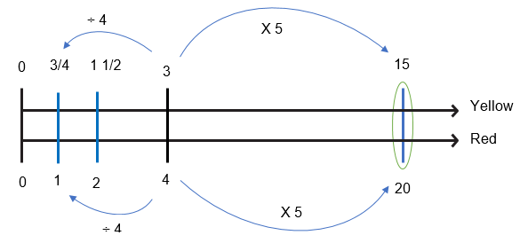Approach 4: Between and Within Ratio Relationships (Extending to seventh and eighth grade)
In recognizing that scaling up from 4 red to 20 red parts requires a factor of 5, and then multiplying 3 yellow by the factor of 5, students are employing a between-ratio relationship. This is sometimes referred to as thinking across the equals sign in the proportional set-up of this problem: 3/4 = y/20.
Students utilizing a within-ratio relationship recognize that the internal factor of 4/3 characterizes the yellow-to-red relationship (4/3 of the number of yellow parts gives the number of red parts). From the reverse direction, red to yellow, the within-ratio relationship recognizes that the internal factor is 3/4 (3/4 of the number of red parts gives the number of yellow parts). Employing this second within-ratio relationship would enable a student to determine that 20 red times 3/4 must result in 15 yellow.
Not only are 4/3 and 3/4 also the unit rates (as described in Approach 2 above), but in seventh grade, students recognize these numbers, 4/3 and 3/4, as the constants of proportionality. In eighth grade, as students understand these values as conversion factors between red and yellow, they can create equations R = 4/3*Y and Y = 3/4*R. Moreover, as students look to graph these relationships in the coordinate plane, they can utilize these unit rates/constants of proportionality/conversion factors as the measures of the steepness of lines in the coordinate plane, since the slope of each line is precisely the ratio of red to yellow or yellow to red. Thus, a strong understanding of ratio relationships provides the basis for understanding slope, one of the most crucial ratios for students to understand in high school.
The problem-based math curriculum Illustrative Mathematics shows a progression of representations from sixth to eighth grade, moving from drawings and double-number line diagrams in sixth grade to tables in seventh grade and bivariate graphs in eighth grade (Kendall Hunt, 2019a, b, c).
Note that since steepness is such a commonly experienced phenomena for children, the use of physical ramps and ramp scenarios can foster a more tactile understanding of ratios and the related concepts of slope, steepness, similarity, and proportionality. Also note that teachers should be aware of language needs of students, especially those who are English learners, and the vocabulary development that might be needed to engage with words and concepts such as “steepness.”
(end vignette)

Vignette: Equivalent Expressions—Integrated ELD and Mathematics
Grade level/Course: Grade six - Integrated ELD and Mathematics
Content Connections: 4, Discovering shape and space
Drivers of Investigation: 1, Make sense of the world (understand and explain)
Standards for Mathematical Practice: 3, Construct viable arguments and critique the reasoning of others; 7, Look for and make use of structure; 8, Look for and express regularity in repeated reasoning
Domains of Emphasis: 6.EE (CA ELD Standards: ELD.PI.6.1, ELD.PI.6.11)
Background: Mr. Garcia’s sixth-grade class recently started a unit on expressions and equations. The class has explored the difference between equations and expressions. Students have also been using the properties of operations to generate equivalent expressions and to determine if two expressions are equivalent.
In this class of 32 students, four students have an Individualized Education Program (IEP) and eight students are English learners. In this latter group, one student is at the Bridging level, five are at the Expanding level, and two are at the Emerging level. Sal, one of the students at the Emerging level, is a newcomer who joined the class several weeks ago after moving to the United States from Mexico. Each of the other three self-contained sixth-grade classes have similar numbers of students who are English learners—between 8 and 10—and a similar composition among them.
Mr. Garcia meets weekly with the other three sixth-grade teachers to collaborate. During this time, the teachers discuss relevant student data and upcoming units of instruction. They also discuss areas of focus for designated and integrated ELD instruction when they deploy their students to receive specialized instruction (see the additional designated ELD resources below).
In addition, the teachers discuss the strengths of their students who are acquiring English, or who have IEPs, and plan the ways they will build on those strengths. The teachers know that diversity enriches all student conversations, especially when students are given multiple ways to access ideas—through visuals, physical manipulatives, and supportive discussions. The teachers’ use of multiple forms of engagement, representation, action, and expression in their mathematics teaching is aligned to the UDL guidelines (CAST, 2018). They plan class discussions that will give students who are English learners—and all students—opportunities to access the language of mathematics in a supportive environment, learning mathematical ideas and mathematical language together (Zwiers, 2018).
Lesson Context: Mr. Garcia’s sixth graders are now several lessons into their unit on expressions and equations. He has been working with his students to create equivalent expressions and to determine whether or not two expressions are equivalent. He wants to use a particular lesson to employ formative assessment strategies that allow him to gauge how well his students currently understand this concept and to determine areas of need—information that will guide his next steps.
Mr. Garcia chooses a lesson from Illustrative Mathematics task in which students will have to determine which student expressions are equivalent and will have to justify their thinking. He hopes the lesson will serve to deepen student understanding of equivalent expressions by connecting such expressions to a familiar context, the perimeter of a rectangle. He believes this context will also be useful for guiding conversations about why expressions are equivalent based on the structure of the rectangle and the parts of the expressions. Mr. Garcia plans to ask students to justify the equivalence of the expressions by connecting the expression to a labeled picture of the rectangle.
Lesson Excerpts: Mr. Garcia’s lesson engages students in analyzing given expressions to determine if they are equivalent. The task also includes a visual support and students are encouraged to connect the expressions to the corresponding elements in the visual representation. Mr. Garcia knows that the multi-model forms of mathematical expression will support the learning of students with learning differences as well as those who are English learners—as well as other students. He is curious about whether students understand that different equivalent expressions can illustrate different aspects of the same situation. He wants to determine which students have internalized the academic language and use it naturally to explain their thinking.
Learning Target: The students will analyze different student expressions for the perimeter of a rectangle to determine if the expressions are equivalent, and they will justify the equivalence in conversations and in writing.
- CA CCSSM: 6.EE.4 - Identify when two expressions are equivalent (i.e., when the two expressions name the same number regardless of which value is substituted into them). For example, the expressions y + y + y and 3y are equivalent because they name the same number regardless of which number y stands for; SMP.7 - Look for and make use of structure; SMP.3 - Construct viable arguments and critique the reasoning of others.
- CA ELD Standards: ELD.PI.6.1 - Exchanging information and ideas with others through oral collaborative discussions on a range of social and academic topics; ELD.PI.6.11 - Justifying own arguments and evaluating others’ arguments in writing.
Mr. Garcia planned the lesson to encourage many opportunities for students to learn the language of mathematics and support the development of English proficiency through a variety of academic conversations in new contexts, paired with the support of visual representations.
Before beginning the lesson, Mr. Garcia creates table groups. Based on knowledge of his individual students, he groups together those who can support each other’s learning. He does not place students according to the support they may require (e.g., based on language learning or learning differences). Instead, he focuses on creating groups in which varied and different strengths complement one another.
He begins the lesson by showing students the image of a rectangle with each length side labeled L and each width side labeled W. He asks them to write an expression for the perimeter of this rectangle using the given variables. He begins this way in order to connect to what students have learned since the beginning of the unit about creating expressions. He believes that having students create their own expressions first will allow them to create a foundation for forming their subsequent arguments about whether or not the other expressions in the task represent the perimeter of the rectangle.
After everyone has created an expression for the image, Mr. Garcia asks them to share their expression in their table groups. He asks the groups to briefly discuss whether the expressions in their group are the same or different, and if they are different, whether the group believes they are equivalent or not.
The teacher then conducts a “collect and display,” by writing student responses on a graphic organizer on the board, using students’ exact words and attributing authorship. He asks specific questions about the different-looking representations, such as, “Where is the 2w in this picture?” “Which term represents this line on the rectangle?”
Mr. Garcia tells students, “I want you to think about the expression you wrote and the other expressions that were shared at your table. Using what you have learned about equivalent expressions—expressions that mean the same thing and have the same value—I want you to explore this task.”
He then provides students with a sheet listing the expressions for the same task that were generated by students in another class. He reads the task aloud as students read along on their own copies of the task. As Mr. Garcia reads, students mark the text to indicate important information, ideas, and questions they may have.
Task: The students in Mr. Garcia’s class are writing expressions for the perimeter of a rectangle of side length L and width W. After they share their answers, the following expressions are on the board.
- Sam: 2 (L + W)
- Joanna: L + W + L + W
- Kiyo: 2L + W
- Erica: 2W + 2L
Mr. Garcia asks: Which of the expressions are correct and how might the students in the other class have been thinking about finding the perimeter of the rectangle?
End task
After the task is introduced, students have several minutes of independent time to think about and work on the task. Mr. Garcia then asks the groups to discuss which of the expressions in the task are correct and to justify their thinking. He circulates around the room while groups are discussing their ideas, making notes about what he is hearing to inform his formative assessment process. He is also considering which student from each group might be willing to share their group’s thinking.
After he stops the group discussion, Mr. Garcia tells the class, “As I walked around the classroom, I heard students using the word equation and expression interchangeably to mean the same thing. Before we share ideas about the task, I want your groups to discuss whether or not equation and expression mean the same thing. If not, how are they different?
Mr. Garcia stops at one of the tables to listen to the discussion. He tells the table group that he would like them to share their conversation with the class and he asks Cecily, an English learner at the Expanding level, if she would be willing to share for the group. She agrees and he asks her to practice with her group what she will say before sharing with the whole class.
After group discussion is complete, he tells the class that he has asked Cecily to share Table 4’s ideas with the class. Her sharing starts a brief exchange:
Cecily: My group discussed how equations and expressions are different. We think that equations have equal signs and expressions do not.
Mr. Garcia: Can anyone add on to what Cecily said? Alex.
Alex: My group agreed with Cecily’s group, and we also said that an equation shows two expressions that are equal to each other. The expression on one side equals the expression on the other side.
Mr. Garcia: Okay, so Alex, you’re saying that if 5x is an expression (Mr. Garcia writes this on the whiteboard and labels it expression) then 5x = 4x + 2 is an equation (Mr. Garcia writes this on the whiteboard and labels it equation), correct?
Alex: Yes, an equation is made up of two expressions.
Mr. Garcia: Now that you’ve heard some ideas about the difference between expressions and equations, please tell your group what you have learned.
Students discuss the difference between expressions and equations table group as Mr. Garcia again walks around the classroom to gauge understanding. He intentionally visits two groups in which one member is an English learner to see if these students are understanding the conceptual difference behind these two math terms.
Next, Mr. Garcia brings the class back together to have a class conversation about the task. He asks students to share a correct expression and explain how the parts of the expression relate to the picture. Mr. Garcia has also been using talk moves (Chapin, O’Connor, and Anderson, 2013) with his class to strengthen their classroom discussions, and he makes a conscious effort to model and use these moves throughout the discussion. Recently, he has been focusing on supporting the talk moves of reasoning and turn and talk.
Now, he says, “Looking at today’s task, can you share an expression that is correct and explain why you believe that it’s correct?” After giving students time to think and refer to their work, he asks them who would like to share.
Gabby starts, saying, “I think Erica is correct because 2W + 2L means that there are 2 widths and 2 lengths.”
Mr. Garcia responds, “When you say that there are 2 widths and 2 lengths, can you show us what you mean using this picture of the rectangle?” (He points to where an image of the rectangle displayed by aa projector.)
Gabby walks to the front of the room, points to the rectangle, and says, “The two widths are the sides on the left and right. The two lengths are the top and the bottom.”
Eduardo speaks up, asking, “Well, then why doesn’t the equation say W + W + L + L?”
Mr. Garcia turns the question over to the class: “Is there an expression that has it written the way Eduardo suggested?” Note that when Mr. Garcia asks his question, he correctly uses the term expression rather than the term equation, which Eduardo had used. Mr. Garcia decides to make this gentle correction by using the correct term in his restatement of the question, and he a note to himself to listen to Eduardo’s subsequent partner conversation to see if he truly understands the concept and term expression.)
Gabby responds to the question: “Yes, Joanna’s way shows it like that. It’s just in a different order.”
Talking again to the class, Mr. Garcia says, “So, if Joanna’s way, her expression, shows what Eduardo mentioned, turn and talk to your partner about which property you could use to rewrite L + W + L + W as W + W + L + L and about how you know this property would work?”
Students discuss the property they would use to demonstrate that two expressions are equivalent. As they are discussing, Mr. Garcia walks to Eduardo’s group to listen to how Eduardo explains his thinking. He hears Eduardo use the term expression correctly in his explanation. However, he makes a note to continue to reinforce this concept with students over the duration of the unit because he notices that some students continue to struggle in accurately using these math terms.
In the course of listening to the various groups, Mr. Garcia pre-selects two that he will ask to share their ideas about which property can be used to rewrite the expression. One of them includes a student who has struggled recently, so Mr. Garcia wants him to be able to share his ideas with the class to demonstrate his success with this idea. He also asks a pair of girls to share, students who have not shared a math idea with the class during the last several lessons. Mr. Garcia wants to create opportunities for all student voices to be heard and valued, so he carefully selects and records which students share their ideas during math class. As the two pairs share with the class, he asks each group to justify their reasoning by explaining how they know that the commutative property allows them to change the order of an addition expression. He then shifts the conversation: “Now that we’ve talked about two of the equivalent expressions, I’d like to see if there are any expressions from the list that are not equivalent.”
Jordan responds, starting the following exchange:
Jordan: I think that Kiyo’s expression is wrong.
Mr. Garcia: OK, Jordan, since Kiyo isn’t here to explain her thinking, can you explain what Kiyo might have been thinking to come up with the expression 2l + w?
Jordan: I think Kiyo included the top and the bottom, but just didn’t go all the way around.
Mr. Garcia: Thank you, Jordan. Who agrees that Kiyo’s expression is incorrect? (Students show their silent signal for agree or disagree.) I see that the majority of the class agrees with Jordan. Please turn and talk with your partner about why you agree or disagree.
Mr. Garcia provides time for students to talk with their partners, before asking if anyone would like to share and calling on Sara.
Sara explains, “We agree with Jordan because we just tried a rectangle that is 7 inches long by 4 inches high, and Kiyo’s expression says 18 but it’s really 22.”
“Oh, so you tried a specific example,” Mr. Garcia notes. “Who else tried an example? (Several hands go up.) That’s an important strategy to keep in mind. Emilia, I heard you talking about a different idea with your partner. Do you agree with Jordan?”
Emilia says, “I agree with Jordan that Kiyo is incorrect because she has 2l, but she only has 1W, so I think that she forgot one of the widths”.
Mr. Garcia asks Emilia to show what they mean using the projected image.
Emilia explains: These are her two lengths and she only wrote W, so she has 1 width included, but she forgot this one (pointing to the other side).
Mr. Garcia asks students to repeat what Emilia said to their partners. After they have done so, Mr. Garcia shares several ideas and key points that he has heard from students during the lesson. He refers to examples on the board from earlier in the lesson that illustrate the difference between an expression and an equation. He also elaborates on several of the student ideas to connect to the mathematical goal of today’s lesson.
Next, Mr. Garcia draws the class’s attention to two sentence frames, shown below. that he has written on the board and tells students that they may choose to use these frames or they can create their own sentences to begin their writing today. The sentence frames are:
- [blank] and [blank] are equivalent expressions because [blank].
- The expressions [blank] and [blank] are equivalent because [blank].
Mr. Garcia tells students that on the back of their task sheet, he wants them to select two of the expressions that are equivalent and explain how they know the expressions are equivalent. He asks them to include numbers, words, and pictures to strengthen their explanation.
Mr. Garcia gives students several minutes to complete their writing. They know that in mathematics, they can use expressions and/or visuals to support their writing. Mr. Garcia wraps up class by having students read their writing to their partner, provide feedback to each other, and revise their writing as needed. Students turn in their writing to end the class session.
Next Steps: Mr. Garcia reads through the student explanations and sorts them into two piles: Got It and Not Yet (Van de Walle and Folk, 2005). He looks at the responses in the Not Yet pile to understand students’ mathematical thinking, with that understanding informing his next instructional moves. He discovers that a group of his students are having difficulty justifying equivalence through use of the distributive property, making errors while distributing. He decides to support this small group of students by working with them at the back table over the next several days.
Mr. Garcia also decides to recheck the Got It pile and observes that students were less likely to choose to explain the equivalence of expressions using the distributive property, making him think that this may be an area for growth for the class overall. Based on this, he decides that instead of just working with the Not Yet students, he will do further work with the whole class on the distributive property.
The structure he chooses for that further work is a “re-engaging lesson” (Inside Mathematics, n.d.). This lesson structure uses student work for the purpose of uncovering incomplete understanding, providing feedback on student thinking, helping students go deeper into the mathematics, and encouraging students to reflect on their own learning. Re-engaging is an alternative to reteaching, in which a teacher simply selects a different activity to try to get at the mathematical target of the lesson.
Several possible activities fit within this re-engaging lesson structure (San Francisco Unified School District Mathematics Department, 2015). Among them are brief math (or number) talks; a Math Hospital in which the teacher compiles common mistakes and students work in teams to identify the errors, diagnose why the errors are common, and correct the errors; and highly structured Formative Re-engagement Lessons, as designed by the Silicon Valley Mathematics Initiative (Inside Mathematics, n.d.).
In this case, Mr. Garcia chooses to hold a math talk using visual models to reinforce the distributive property, followed by a Math Hospital that is based on their own work. He is pleased to see that many of his students recognize their own errors represented on the “common errors” sheet, and have good conversations about the sources of mistakes and possible fixes.
As Mr. Garcia continues to teach the lessons in the expressions and equations unit, he uses what he learned about his students from this re-engaging lesson to connect ideas and deepen student understanding of equivalent expressions. Mr. Garcia gives the students opportunities to write expressions, compare and contrast those expressions, compare and contrast the ideas of equation and expression, relate expressions to pictures, explain why they agree or disagree with a claim, justify their reasoning about each of them, and examine and correct common errors that arose. These are all rich opportunities for students to use language in supporting their reasoning and for Mr. Garcia to learn more about their thinking and language use.
Source: Task: “Rectangle Perimeter 2,” Illustrative Mathematics (2016b), Cluster 6.EE.
Apply and extend previous understandings of arithmetic to algebraic expressions.
Resources
“Expression vs. Equation,” Ask Dr. Math, Math Forum at Drexel
Chapin, S. H., O’Connor, C., & Canavan Anderson, N. (2013). Classroom Discussions in Math: A Teacher’s Guide for using talk moves to support the Common Core and more, Third Edition. Sausalito, California: Math Solutions.
Kazemi, E. & Hintz, A. (2014). Intentional Talk: How to Structure and Lead Productive Mathematical Discussions. Portland, Maine: Stenhouse Publishers.
Smith, M. S., & Stein, M. K. (2011). 5 Practices for Orchestrating Productive
Mathematics Discussions. Reston, Virginia: The National Council of Teachers of Mathematics, Inc.
Van de Walle, J. A., & Folk, S. Elementary and Middle School Mathematics: Teaching Developmentally. Toronto: Pearson Education Canada, 2005.
William, D. (2011). Embedded Formative Assessment. Bloomington, Indiana: Solution Tree Press.
Companion Documents
Equivalent Expressions Designated ELD Connected to Mathematics in Grade Six Equivalent Expressions Designated ELD: Math & ELD 5-Day Lesson Plan D-ELD 6th
Additional Information
This vignette, Equivalent Expressions—Integrated ELD and Mathematics, was adapted from one created by the Tulare County Office of Education under the Creative Commons Attribution-NonCommercial-ShareAlike 4.0 International License.

Content Connection 2 CA CCSSM Clusters of Emphasis
- 6.NS: Apply and extend previous understandings of multiplication and division to divide fractions by fractions. Compute fluently with multi-digit numbers and find common factors and multiples. Apply and extend previous understandings of numbers to the system of rational numbers.
- 6.EE: Apply and extend previous understandings of arithmetic to algebraic expressions. Reason about and solve one-variable equations and inequalities.
- 6.RP: Understand ratio concepts and use ratio reasoning to solve problems.
- 7.EE: Use properties of operations to generate equivalent expressions. Solve real-life and mathematical problems using numerical and algebraic expressions and equations.
- 7.RP: Analyze proportional relationships and use them to solve real-world and mathematical problems.
- 7.NS: Apply and extend previous understandings of operations with fractions to add, subtract, multiply and divide rational numbers.
- 8.NS: Know that there are numbers that are not rational and approximate them by rational numbers.
- 8.EE: Work with radicals and integer exponents. Understand the connections between proportional relationships, lines and linear equations. Analyze and solve linear equations and pairs of simultaneous linear equations.
(end vignette)

Vignette: Learning About Shapes Through Sponge Art
Course/Grade Level: Sixth grade
Drivers of Investigation: 1, Making Sense of the World
Content Connections: 4, Discovering Shape and Space

Content Connection 4 CA CCSSM Clusters of Emphasis
- 6.G: Solve real-world and mathematical problems involving area, surface area, and volume.
- 7.G: Draw, construct, and describe geometrical figures and describe the relationship between them. Solve real-life and mathematical problems involving angle measure, area, surface area, and volume.
- 8.EE: Understand the connections between proportional relationships, lines and linear equations. Analyze and solve linear equations and pairs of simultaneous linear equations.
- 8.G: Understand congruence and similarity using physical models, transparencies, or geometry software. Understand and apply the Pythagorean Theorem. Solve real-world and mathematical problems involving volume of cylinders, cones, and spheres.
Relevant CA CCSSM Clusters/Standards:
- 6.G: Solve real-world and mathematical problems involving area, surface area, and volume.
- 7.G: Draw, construct, and describe geometrical figures and describe the relationship between them. Solve real-life and mathematical problems involving angle measure, area, surface area, and volume.
Suzy Dougal, a grade-six teacher, has been wondering how to support students’ learning about shapes. In previous classes, she has seen students struggle with 2-D representations of 3-D shapes as they were learning about surface area and volume. She decides to see if having students work instead with molding clay might help. The next day she brings in molding clay, along with some clay-cutting tools, including thin wire, fishing line, and dental floss. She also brings a rectangular prism that she has made from the blue clay.
She begins the activity by showing students the prism she made and asking them to think about cutting the clay prism with one straight cut and to consider the two shapes that would result from the cut. More specifically, she asks them to think about the shape of the new faces that will result from the cut. Students talk in pairs, sharing their ideas about ways to cut the shape and what the two resulting shapes might look like. Meanwhile, Ms. Dougal cuts the prism at a diagonal from one short edge through the other short edge, as shown in figure C.15.
Figure C.15 Rectangular Clay Prism Cut to Make Two New Shapes
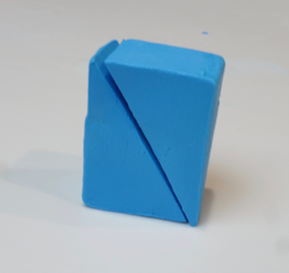
Ms. Dougal does not separate the two shapes after cutting; instead she asks students:
- “What do you think the shape of the new face is?”
- “How many faces does the new shape have?”
- “What are the similarities and differences between the two new shapes?”
- “How is the new face shape similar or different than the shapes of the other faces?”
Students turn and talk to their partners.
Note that for many of the new geometry terms her students are encountering, Ms. Dougal provides scaffolds and supports, particularly for students who are English learners. She is especially mindful of words that have multiple meanings, including one that students might know from everyday life, such as the term “faces.”
After the students discuss their ideas in pairs and share them with the class, Ms. Dougal separates the prism into the two new pieces. She then traces the new face on the document camera so students can clearly see the shape of the new face. Ms. Dougal asks the class, “How accurate were your predictions?” She then asks, “What different two-dimensional face shapes can you make by slicing a rectangular prism?”
After this discussion, Ms. Dougal provides students with their own clay and a cutting tool, as well as isometric and regular-dot paper. She asks them to use the clay to create a shape, then cut the solid shape to find different shapes that can be made by slicing. For each slice, the group makes a sketch of how they cut the solid and trace the sides of the faces to record the new shape they created, as shown in figure C.16, below. Students are asked to record their findings and look for patterns. Students create nets of the original solid and then nets of the two resulting solids following the cut.
Figure C.16 Recording New Faces After Cutting Original Rectangular Prism
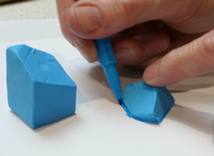
For the next phase of the exploration, Ms. Dougal asks students to think of all the different ways to create shapes from cutting one solid. Students are asked to make these cuts and consider the areas of each new face. As they record their observations for each new shape they cut, they focus on the resulting face from the cut. Students consider the area of the new face and the surface area of the new shape, as well as approximating the volume. For the cut shapes, students discuss the patterns they found in their data. Ms. Dougal asks some of her own questions as well to promote further exploration:
- “How are the nets for the original shape and the new shape similar to and different than the original shape?”
- “What data did you collect?”
- “What patterns did you find in your data?”
- “Did you find any patterns between the types of cuts you made?”
Ms. Dougal shares her lesson with her friend Ms. Woodbury. Ms. Woodbury loves the idea and decides to try it with some adaptations with her sixth-grade students, who are also working on representations of 3-d objects and nets (6.G.3). She asks students to trace the new face image after they have made a cut. Instead of using clay, her students work with rectangular sponges. The students use paint on the prism faces before and after the cuts to show the different shapes. Students are asked to consider slides, flips, and turns.
Ms. Woodbury connects the activity to geometric transformations and she asks students to upload an image of their sponge painting patterns into Desmos so they can further explore transformations by duplicating two or more of their shapes and then moving them in order to explore the transformation pathways of the shapes. Figure C.17 shows some of the sponge art that has been uploaded into DESMOS.
Figure C.17 Sponge Art Uploaded into DESMOS
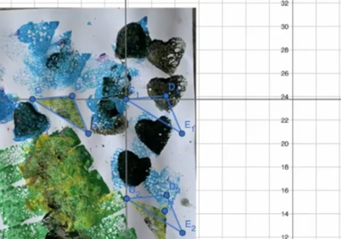
Source: Youcubed, n.d.b.
(end vignette)

Chapter 8
The vignettes in this chapter illustrate teaching approaches which can be utilized in a variety of courses and within either of the two pathways described in chapter 8. Each of the first three vignettes demonstrates a Content Connection, while the fourth one demonstrates several. For a more robust description of the Content Connections at the high school level, see chapter 8.

Vignette: Drone light show
Course: Mathematics III, Algebra II
Content Connection: 2, Exploring changing quantities
Driver of Investigation: 3, Impacting the Future
Domains of Emphasis: HS.A-SSE, HS.A-CED, HS.F-BF, HS.F-TF, HS.G-GMD, HS.G-MG
SMPs: SMP.4, 5, 7
Source: Consortium for Mathematics and its Applications (COMAP), High School Mathematical Contest in Modeling (HiMCM)—2017 Problems.
Problem: Drone Clusters as Sky Light Displays
Intel© developed its Shooting Star TM drone and is using clusters of these drones for aerial light shows. In 2016, a cluster of 500 drones, controlled by a single laptop and one pilot, performed a beautifully choreographed light show.
Our large city has an annual festival and is considering adding an outdoor aerial light show. The Mayor has asked your team to investigate the idea of using drones to create three possible light displays.
For each display:
Determine the number of drones required and mathematically describe the initial location for each drone device that will result in the sky display (similar to a fireworks display) of a static image.
Determine the flight paths of each drone or set of drones that would animate your image and describe the animation. (Note that you do not have to actually write a program to animate the image, but you do need to mathematically describe the flight paths.)
Students are instructed to work together in three groups to design a solution to the problem. All three groups start out by reading the task and discuss the task. They are then given access to the video, which includes closed captioning, and then prompted to conduct a search for photos and clip art of Ferris wheels as a type of moving light system. Some groups want to watch the video several more times to be sure they understand. From experience, they know that this is not the kind of problem that allows them to find the answer in the back of the textbook. This kind of a problem can be approached in a variety of ways, and the challenge of the openness of the problem is thrilling! This flexibility aligns with the UDL principle - Provide multiple means of engagement by optimizing individual choice and autonomy. Students will need to think about the math tools and processes they have already learned before and apply them to a new context. This can be understood as the “formulate” stage of the Modeling Cycle.
Over the course of the year, students have had several previous opportunities to engage in the math practice of modeling. Students know that math models help both to describe and predict real-world situations, and that models can be evaluated and improved. With every group member contributing to the brainstorm, students quickly start sketching as a way to visualize solution paths. As students are drawing, they explain and label their diagrams to show the “initial location,” for example. Some students are eager to get to display three, where they get to create their own design.
The teacher notices three unique approaches arising in the groups’ work, particularly in how they have decided to model the changing quantities within the problem. The teacher is pleased to see use of visuals and diagrams, as these are important ways of seeing and understanding mathematics and critical supports for students. As the teacher listens to the small group work, she acknowledges how well the groups are making space for everyone’s ideas. At first, the teacher notes that students are not writing much, but she has learned not to intervene too quickly. Instead, she allows their ideas to build, with the firm belief that her students will make progress.
Group A: The students in this group have decided to model the problem on the idea of pixels in a grid that make up images on a television screen. The team draws an image of a Ferris wheel on the grid, and numbers every “pixel” in their grid that will need to be lit up by a drone to represent the circumference of the Ferris wheel. Next, the group has decided to model the rotation of the wheel by programming some drones to stay in place and some to move in a particular pattern. They know the pixels for the triangle don’t move so these drones will be programmed to stay in place. And for the circle, it’s a loop.
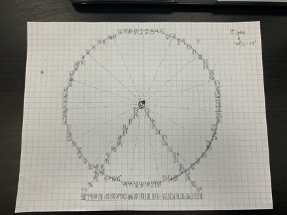
Group B: In this group, students have decided to model the Ferris wheel using polar coordinates. They decided that programming the coordinates (x,y) for the drones that make the circle of the Ferris wheel would require defining a unique x and y for every single drone! But, in polar coordinates (r,theta), the outer circle of the Ferris wheel can be thought of as many points in the plane sharing the same radius, which means that they would only need to change the theta for each drone’s coordinates and keep the r the same. The group determines with coordinates representing the wheel, spokes, and triangle posts of the Ferris wheel. To model the rotation of the wheel, the angle (theta) that each drone is programmed to will increase by 5° for a total of 72 moves of the circle to complete one full rotation of the wheel. To model the rotation of the spokes, the angle (theta) that each drone is programmed to will increase by 30° for a total of 12 moves, to complete one full rotation of the wheel. The drones placed to represent the base of the Ferris wheel are programmed to stay in place.
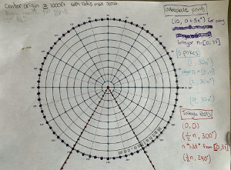
Group C: This group selected an image of the Great Seattle Wheel to use as their guide. They decided to model the image of the Ferris wheel using the equation of a circle in the cartesian plane, and various dilations of the outer circle to create inner circles that will model the spokes of the wheel. Finally, the group decides to utilize and online graphing tool that will allow them to rotate the image within the plane to model the turn of the wheel. The group creates equations for 20 lines that start at the center of the circle, intersect each concentric circle, and end at the outer circle. While this is a slight modification to the 21 spokes on the Great Seattle Wheel, it allows the degrees of each arc length to be integer values, which the students agree will be easier to work with. These lines separate the circle into 20 equal sectors—each with an arc length of 18°. They decide to program a drone at each intersection of the circles and the lines to represent the spokes. A discussion ensues about the number of drones that must be placed between each spoke intersection on the outer circle to create an outline of the circle that looks smooth, the group decides on three for now because 18° is easily divided into three. Ultimately, the group decides to utilize an online graphing tool (GeoGebra) that will allow them to rotate the image within the plane to model the turn of the wheel. The group discusses the rate of rotation and degree of rotation that would be most appropriate to model the movement and speed of the Great Seattle Wheel.
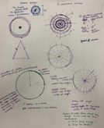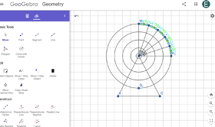
After students have worked out the details of their models, each group presents their approach to the problem. Some students jot a few notes down to help them remember key ideas and terms. They prepare to describe their model and explain their choices to their peers. Students prepare a poster, using colors to highlight key features of their model. The teacher circles around and helps students who want to do a quick run-through of their presentation, giving students feedback to strengthen their work, supporting language learning by clarifying how content vocabulary supports the mathematics, and suggesting ways to better convey the information in presentation-worthy academic discourse as she does so. Each presentation is followed by a short question and answer session. Each presentation poster is displayed at the front of the class, clearly showing a wide range of methods and approaches.
Following these presentations, the teacher conducts a Gallery Walk, allowing smaller groups of students to spend a few minutes viewing the posters up close. This activity is followed by a whole-class discussion on the different strategies taken by each group, including a discussion about the affordances and challenges presented by each choice for modeling the changing quantities in the problem. Throughout this process, the teacher is taking notes on feedback, including areas of strength and where possible improvement is needed as students engage with the modeling cycle. She will use this information in responding to the students’ presentations during evaluation, and framing the next modeling task.

Disciplinary Language Development
This task provides extended opportunity to deepen in the area of mathematical modeling within an authentic context. The challenging nature of this task encourages collaboration, building on one another’s ideas and key skills using students’ mathematical language. In groups, students make use of the full array of mathematical resources to construct their models, utilizing prior mathematics learning. The visual nature of the task, along with the video, and their presentation posters expand the modalities in mathematics, supporting the UDL guidelines, which move beyond the more typical confined to calculations and symbols. Here, the visuals are not support for their models, they are the models themselves.
(end vignette)

Vignette: Blood Insulin Levels
Grade level: Mathematics I/Algebra I
Content Connection: 3, Taking Wholes Apart and Putting Parts Together
Driver of Investigation: 1, Make Sense of the World (Understand and Explain)
Domains of Emphasis: HS.F-IF, HS.F-LE
SMPs: SMP.1, 4, 5
Ms. Alfie loved science and all things mathematics. She found that her Mathematics I students did not feel the same way she did about STEM subjects. She was excited to teach Mathematics I using Core Plus with the goal of exciting her students about the role mathematics plays in the world around them.
Ms. Alfie was midway through Mathematics I and felt her students were ready for a math investigation that included medicine, coming from Core Plus 1. In her materials she found several examples that included the concept of half-life and she wondered how she could use a medical context to introduce exponential functions. She also wondered how students would embrace the topic, knowing that fractions and number sense were not topics students felt confident about. The activities they had completed around linear functions earlier in the year had helped them learn to interpret slope as a fraction and interpreting slopes within the context of the problem. For example, Ms. Alfie’s students were happy to consider an equation in the form y = 3/4x + 5 as starting at the y intercept, (0,5) and increasing 3/4 of a unit vertically for every horizontal step. They also thought about it as three steps up and four steps right for every unit. She wanted to challenge and extend her students’ thinking about rates of change that were not constant, for example exponential decay in context, i.e., every 60-minute increase in time the amount of drug might decrease by 50 percent in the body.
Ms. Alfie began the unit by doing a graph talk, using real world data from the Centers for Disease Control (CDC). A graph talk is a math routine where students were asked to study the graph and be ready to share what they notice and wonder. Ms. Alfie purposefully left the title of the graph off and asked students to brainstorm what the data was about. This is analogous to students reading a news article and having to develop a “headline” that captures the main idea.
Figure C.18 Percentage of Diabetes Diagnoses by Race/Ethnicity and Sex
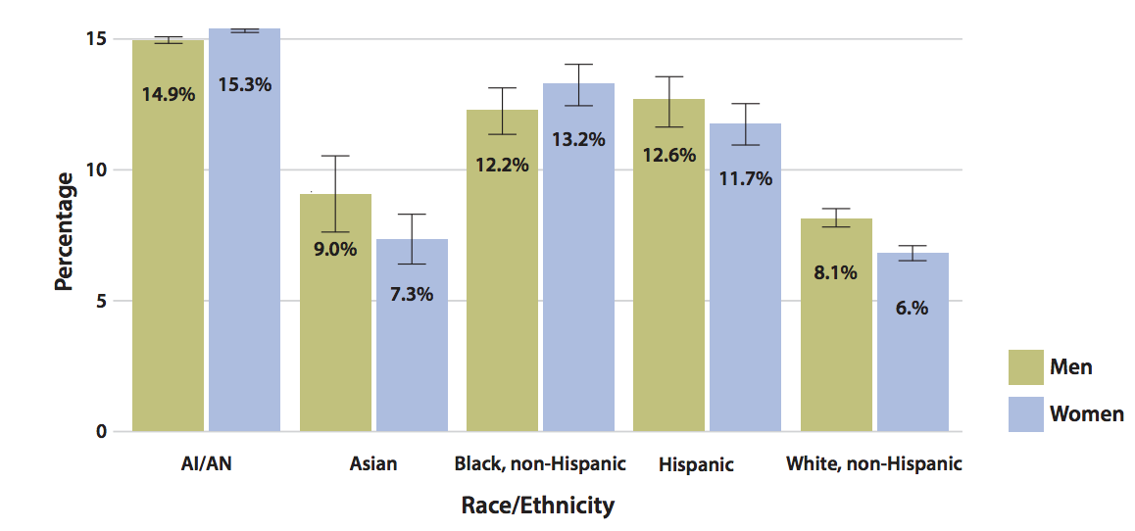
Long description of figure C.18
Source: Centers for Disease Control and Prevention, 2017.
As students discussed the graph and the information they wondered if the graph showed participation in sports, academic clubs, or favorite television shows. Her students did not come close to the actual story (a way of creating a narrative to express what is being communicated) of the graph which shows data of the estimated age-adjusted prevalence of diagnosed diabetes cases in the US for adults from 2013–2015. But Ms. Alfie knows that with more experiences with interpreting graphs and other visual display of data, her students would learn to identify the main themes.
The activity was supported by Ms. Alfie’s collaboration with a teacher who supported content-specific ELD instruction to English learners in her class. This designated ELD support included helping the students to understand and develop the critical language and grammatical structures necessary for successful engagement in this activity. With this base of understanding, Ms. Alfie’s lesson could focus on integrated ELD support and ensure all students had the access necessary to engage with the work.
The students were prepared when, after the data talk and the story reveal, Ms. Alfie asked the class to spend 20 minutes in small groups looking up information on diabetes. Each group had three types of roles: the recorder, the searcher/investigator, and brainstormers. Ms. Alfie was aware that for many students in the community, diabetes was not any medical condition, but one that affected family members deeply. She framed the investigation around using math and data science more specifically to understand the prevalence and treatments of diabetes. This was a mathematical investigation of a real-world problem, and it relied on scaffolding the context with specific medical vocabulary. On this language foundation, the first step in understanding a real-world phenomenon is to gather information. She asked each group to share the research they had found and as a class the discussion continued about the disease as well as the use of prescription drugs to improve the health and well-being of people living with the disease. Ms. Alfie then asked students to look for more information about diabetes and the hormone, insulin, and the role it plays in the body. Information was not just limited to online research. The community clinic also had pamphlets and health advice about diabetes. The students discussed the difference between public information (in the form of a pamphlet) can differ from online internet searches and sources. Ms. Alfie used these different texts to focus students as they looked closer at issues around the dosing of insulin, as it is a common therapy for diabetes.
First Ms. Alfie shared with students the function: y = 10(0.95)x. She explained to students that the body metabolizes drugs in an interesting way and while different bodies process drugs differently we can model the metabolism of a drug with a function. Her multilingual students had worked with the science vocabulary in the lesson, and helped support her when other students needed support with understanding the meaning of “metabolize.” Students looked up varying definitions and came to understand that it means to “break down” over time in this context. (Assess the multilingual students’ understanding of phrasal verbs such as “break down” and “look up,” and conduct a mini-lesson on these linguistic structures, if necessary.) And it turns out that different medicines break down at different rates in our bodies. Although it seems like a straight-forward definition, many students could possibly do all computations without ever understanding this central idea.
Ms. Alfie returned to the idea of representing data in the form of a story. She told students the equation told a story of insulin metabolism and she asked students to use DESMOS to illustrate and study the function. In groups, students were asked to study the graph and make a table of values where x represented time and y represented the units of insulin that were injected at t=0. Together, they brainstormed responses to the question: What story does the function illustrate? Or put another way, how does the function behave?
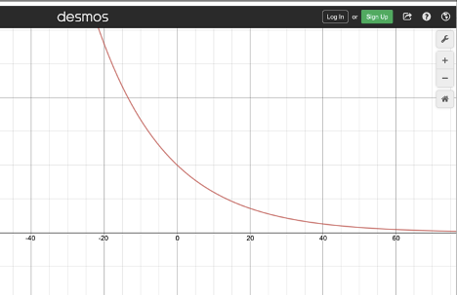
Students worked together graphing the function and thinking about what the values meant in the table as well as the values that were in the function. Students did not always agree on how to interpret the graph or the values of the function. When they disagreed, members took turns explaining their reasoning, and responding to questions from their peers. To explain more clearly and avoid unnecessary confusion, they decided to label their axes, agree on phrases such as, “When x is 20, y is [blank],” and so on. They discussed as a class how the function was decreasing and how the output was decreasing in a way that was not linear. This prompted a discussion of questions students generated, such as: What insulin level is too high or too low? What dosage is needed to maintain a safe level? And What happens when you skip a dose or delay for hours?
Figure C.19 Table of Insulin Levels as a Function of Time
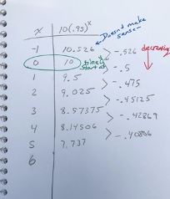
Ms. Alfie asked students to think using various forms of mathematical representations beyond graphs. She introduced the table in figure C.19 to stimulate more thinking.
She posed the following questions:
- What is the initial amount of insulin administered?
- How much time has passed when the amount of insulin is 50 percent?
- When does the amount of insulin reach zero?
As the lesson continued students asked questions about how often a drug should be administered and why some types of medicine say one time per day, two times per day and three times per day. The lesson continued with students analyzing different equations for drug metabolism such as penicillin, where the half-life is about 1.4 hours.
As a way of wrapping up the investigation, the teacher asked students to connect what they had learned about how insulin metabolizes in the body over time with the broader theme of diabetes awareness and treatment in the community. This reinforced the use of mathematics, as well as the terms and language acquired in the lesson, and helped students solidify their understanding. Some students still had lingering questions, such as: Do people have different metabolic rates? Why do some people take different dosages of insulin? Why do some take it at different times of the day? From the students’ work and conversation, Ms. Alfie knew that the lesson had sparked solid mathematical thinking about variables. She wondered if a representative from the community health center could come speak with her class about these questions.
(end vignette)

Vignette: Finding the Volume of a Complex Shape
Course: Mathematics II
Content Connection: 4, Discovering Shape and Space
Driver of Investigation: 1, Make Sense of the World (Understand and Explain)
Domains of Emphasis: HS.N-Q, HS.G-GMD, HS.G-MG
SMPs: SMP.1, 2, 3, 5
Marina Lopez is preparing to teach her integrated high-school mathematics class, with a group-based interactive task that will help prepare students for learning calculus. She is using an approach that gives students the opportunity to explore a mathematics problem before being taught formal content that might help them solve it (Deslauriers et al., 2019). Her plan is to ask students to consider ways to find the volume of a complex shape, specifically a lemon. Prior to this activity, Marina has spent time in her class building and reinforcing group-work norms and she has previously made use of a structured approach to group work known as Complex Instruction (Cohen and Lotan, 2014) and specifically assigning roles for members of the groups. She continues to use this because of the ways it makes authentic use of different roles to reinforce the fact that students are important resources for each other.
She opens the task on the first day by asking students to discuss situations in which they might need to find the volume of a complex shape. Students consider packaging objects and the need to work out materials for packaging. Marina then shares that they will consider this in more depth by considering ways to find the volume of a lemon. She holds up a lemon and asks the class “How can we find the volume of a lemon?” While a few hands are immediately raised she does not call on anyone but tells the group they will have an opportunity over the next two days of class to answer the question using lemons and various resources. As students work in groups to tackle this problem, they will review what volume is and how it is measured, and how it relates to other measures of shapes such as surface area.
Marina knows that concrete materials are not just for elementary students. Mathematicians use models, illustrations, and visual representations to explore ideas, strategies that are highlighted in the guidelines of UDL. When students visualize they bring important brain pathways into their learning of mathematics. Prior to class Marina has setup a table at the back with different supplies including different colors of modeling clay, vases, knives, and cutting boards, pipe cleaners, scissors and a few other materials. Groups are free to choose from the assortment of materials provided. To facilitate the use of materials, students are instructed that only the resource manager is allowed to get up to get supplies from the resource table and they can only have three supplies out at one time. During the early weeks of her class Marina helped her class develop a set of group work norms and has previously used roles for groupwork so students are used to these structures and have been working on engaging productively in groups (see also Cabana, Shreve, and Woodbury, 2014). Note the image of the supply table in figure C.20 below.
Figure C.20 Supply Table for Student Use
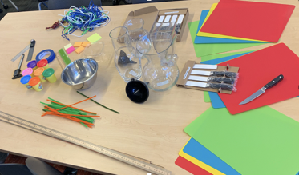
Animated noise begins to fill the room as students start talking in their groups and sharing their ideas. With much experience in group work, students exhaust the brainstorm process to collect as many ideas as possible and invite each group member to share their ideas. When ideas are not clear, they ask clarifying questions posted on the wall that promote justification and help students understand. Students also take one idea as a spark and build off it, elaborating and extending in new ways. Over time, these ideas become the group’s ideas, not just the ideas from one person. They have been given one lemon for today but have also been told they will be able to get a second lemon tomorrow, so they have some freedom to play and even mess up their lemons.
As groups begin to dig into the problem, Marina reminds students to capture their ideas with notes, drawing, and sketches so that they don’t lose track of their thinking. Students know not to worry about “complete sentences or perfect spelling” since they are just exploring ideas. Marina listens closely to discussion in each group, making quick notes of what she hears students saying. Their language is exploratory and imaginative at this stage of the lesson, e.g., “Would peeling the lemon help?” and “What about squeezing the lemon first?” and, “Is this a good way to cut it up?” Some of the students in class are multilingual and represent different levels of English language development. As designed, these students not only have access to the task, but also multiple opportunities to use language to explore their ideas and share their mathematical thinking. The concrete materials, small-group work, and structured group presentations all provide key supports in language developments.
One group decided to use a bowl and water from the drinking fountain to see how the height of the water changes once the lemon is under the water. They draw a quick sketch to describe their idea (figure C.21 below). The students decide to use a marker to mark up the bowl like a beaker and begin filling it with water.
Figure C.21 Student Use of Beakers and Water to Determine Volume
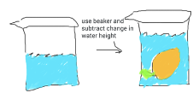
Another group has selected modeling clay and is attempting to make a mold of the lemon. They record their plan and describe that they will carefully fill the mold with water, and then find a way to measure the amount of water the mold holds (see figure C.22 below).
Figure C.22 Student Use of Modeling Clay to Determine Volume
A third group has opted to use a knife and cutting board. They have decided that the shape of the lemon is very close to that of a sphere, so they can use the volume of a sphere formula to approximate the volume. To measure the lemons diameter and radius, they will cut the lemon in half, as shown in their diagram in figure C.23.
Figure C.23 Students Halve a Lemon to Determine Diameter and Radius
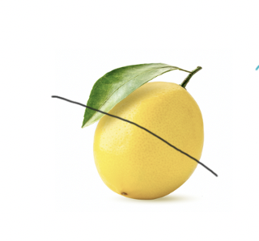
As this first period nears its end, Marina reminds students that they will be getting new lemons tomorrow so if they want to consider using the knives and cutting boards provided now would be the time. She also reminds them to be sure to document the work they did today and where they want to start tomorrow. They should plan to keep discussing and working as homework so they can be ready to create posters and present on day two.
For the second day of the project, students pick up where their work the previous day ended. One group finalizes its ideas and begins creating a poster to share their strategies with the class. Adam and Andres’ group managed to try two ideas, but they engage in a debate over the best ways to present their work. Marina reminds her students that the group’s reporter should take the lead in the creation of the poster, but that other roles in the group should be ready to share-out later in class. She says this as she walks among groups handing out additional lemons.
Marina knows that this is a group-worthy task because it draws on many aspects of mathematical thinking. Students are making connections to science and ideas of measurement through displacement, and to surface area, and still others groups are using a sort of “decomposition” approach by forming small cylinders. As she continues to circulate Marina, notes the different strategies she sees groups using to document their progress, and starts planning ways to sequence the group presentations so they meet specific learning targets she wants to highlight with this lesson.
After the 15 minutes pass, Marina calls her students back together and asks a group who attempted to use a water displacement method (but was not able to finish) to share first. As they share, she writes key phrases and words on the board that highlight their creative problem solving and calls on a second group that got further using a similar method. Marina asks this group to share their thinking and build on the work of the first group. Marina refers to her notes capturing what she heard during the groupwork as a way to highlight examples of mathematical language they were using. As this second group wraps up, Julio questions the group by wondering how the displacement method (shown below) might relate to his group’s method of negative space.
Figure C.24 Student Work Using Negative Space
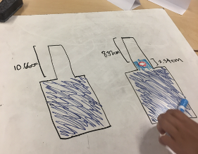
Marina invites Julio’s group to present next. This group presents a solution using modeling clay surrounding the lemon and molded into the shape of a rectangular prism. First, they found the volume of their prism with the lemon inside, then they explained that they removed the lemon from the modeling clay and reformed it in the shape of a rectangular prism and found the volume again. They explained that the difference between the two volumes had to be the same as the volume of the lemon. Note their work in figure C.25 below.
Figure C.25 Students Reshape Modeling Clay to Determine Volume
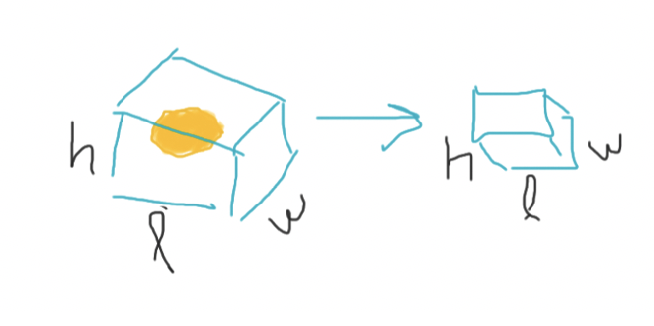
Other students in the class respond to this group’s idea with enthusiasm, citing excitement for its creativity. One student from the team that used a displacement approach raised her hand and connected with the idea that this team’s method was kind of like an “opposite” of what her team did. Several students nodded in agreement. The fact that students intuited the idea of “opposite” indicates that they paying attention to the relationship among methods, namely their inverse relationship which they cannot yet define completely. This is cognitively complex work which develops over time, and students are reaching into their mathematics to find words that convey their ideas.
Finally, Marina asks a fourth group to share their explanation. Silvia explains that the group tried many things, but their favorite method involved slicing up the lemon into many pieces. The group decided that each slice could be thought of like a very short cylinder. So, the group found the volume of each slice using the formula for the volume of a cylinder and then added them all together in the example below.
Figure C.26 Students Slice Lemon to Determine Volume
As Silvia explains her groups work, several other students appear to be taking notes and multiple hands are immediately raised to ask questions.
A whole class discussion ensues around the various strategies that groups utilized. Marina is careful not to rush the discussion, and to unpack students’ comments and questions that she does not understand at first. At times, other students rephrase for one another to see if the idea is clearer. Marina poses the questions:
- “What are the strengths and challenges to these approaches?”
- “Which approach would you say is most accurate?”
- “How do you know?”
This metacognitive part of the lesson helps students move beyond just the lemon itself, towards noticing the methods they use in their analysis. The students take turns commenting on and comparing each other’s strategies. Marina closes the class period by acknowledging the various mathematical practices that students engaged with and highlights the multiple dimensions of content that students utilized.
(end vignette)

Vignette: Exploring Climate Change
Course: Algebra I/ Mathematics I
Content Connection: 2, Exploring Changing Quantities
Driver of Investigation: 3, Impact the Future (Affect)
Domains of Emphasis: HS.S-IC, HS.S-ID
SMPs: SMP.1, 2, 3, 4

Background Reading on Climate Change
With the beginning of the Industrial Revolution of the in the mid-1700s, the world began to see many changes in the production of goods, the work people did on a daily basis, the overall economy and, from an environmental perspective, the balance of the carbon cycle. The location and distribution of carbon began to shift as a result of the Industrial Revolution and have continued to change over the last 250 years as a result of the growing consumption of fossil fuels, industrialization, and several other societal shifts. During this time, the distribution of carbon among Earth's principal reservoirs (atmosphere; the oceans; terrestrial plants; and rocks, soils, and sediments) has changed substantially. Carbon that was once located in the rock, soil, and sediment "reservoir," for example, was extracted and used as fossil fuels in the forms of coal and oil to run machinery, heat homes, and power automobiles, buses, trains, and tractors. (This provides a good opportunity for discussing and reinforcing California Environmental Principle IV. "The exchange of matter between natural systems and human societies affects the long-term functioning of both.") Before the Industrial Revolution, the input and output of carbon among the carbon reservoirs was more or less balanced, although it certainly changed incrementally over time. As a result of this balance, during the 10,000 years prior to industrialization, atmospheric CO2 concentrations stayed between 260 and 280 parts per million (ppm). Over the past 250 years human population growth and societal changes have resulted in increased use of fossil fuels, dramatic increase in energy generation and consumption, cement production, deforestation and other land-use changes. As a result, the global average amount of carbon dioxide hit a new record high of 407.4 ppm in 2018—with the annual rate of increase over the past 60 years approximately 100 times faster than previously recorded natural increases.
The "greenhouse effect" impacts of rising atmospheric CO2 concentrations are diverse and global in distribution and scale. In addition to melting glaciers and ice sheets that many people are becoming aware of, the impacts will include sea level rise, diminishing availability of fresh water, increased number and frequency of extreme weather events, changes to ecosystems, changes to the chemistry of oceans, reductions in agricultural production, and both direct and indirect effects on human health. (This offers a good opportunity to reinforce California Environmental Principle II. "The long-term functioning and health of terrestrial, freshwater, coastal and marine ecosystems are influenced by their relationships with human societies.”)

Mathematics/Science/English Languages Arts/Literacy (ELA) Task
Determine the relative contributions of each of the major greenhouse gases and which is the greatest contributor to the global greenhouse effect and, therefore, should be given the highest priority for policy changes and governmental action. Examine the growth patterns of related human activities and their relative contributions to release of the most influential greenhouse gas. Based on these factors, analyze the key components of the growth patterns and propose a plan that would reduce the human-source release of that greenhouse gas by at least 25–50 percent, and determine how that change would influence the rate of global temperature change.

Classroom Narrative
Mathematics, science, and language arts teachers met to co-plan this interdisciplinary task. They each felt that the task was challenging and authentic, requiring students to draw from different disciplines to forge a solution, just as is done in the real world. They developed a sequence of activities to get the students started, being careful not to over-scaffold the task or to give students too much guidance toward possible solutions pathways, but ensuring their work supplemented and supported the larger task.
Launch: Student teams are provided with the task and then read the article “Climate Change in the Golden State” (California EEI, n.d.) to gather evidence about the scale and scope of the effects of climate changes in California. As this is an extended text, the ELA teacher offers guidance on how to access this document using a screen reader. This support aligns with the UDL principle, Provide multiple means of representation. The ELA teacher also provides an interactive note-taking guide for students to use. Students highlight parts that are not clear, they note important claims made by the authors, and formulate their own questions to share in groups. Students ask: Who is most affected if we do not try to fix problems related to climate change? Who is most affected if we do? Should we care about climate change? Students use their reading and research skills as basis for tackling the question of climate change.
Orienting Discussion: The class discusses four key questions:
- Why do temperatures seem to be increasing? What are possible causes?
- Can the recent changes in California’s climate be explained by natural causes?
- If natural causes cannot explain the rising temperatures, what other factors have produced these changes?
- If temperatures in California’s climate continue to rise, what effects will this have on humans and the state’s natural systems?
Having read and processed the key article, students start to unpack these questions. Students look up the meaning of “anthropogenic,” then rephrase the questions in their own words to see if they understand the meaning. Both the reading and the initial class discussion prepare students to push forward.
Motivated to help reduce climate change in California and globally, students decide to break down their task into more manageable pieces:
- Determining the major greenhouse gases;
- Analyzing the relative contributions of each gas and deciding which is the greatest contributor to global climate change and thus should be given the highest priority for policy changes and governmental action;
- Collecting data on the human activities that cause increases to the release of the most influential greenhouse gas;
- Analyzing the key components of the growth patterns of this gas;
- Based on influences to the growth pattern, developing a plan to reduce the human-source release of that greenhouse gas by 25–50 percent; and,
- Determining how their plan would influence the rate of global climate change.

Team Research
Students start researching online, using familiar criteria to vet the trustworthiness of the data sources.
They visit https://www.climate.gov and the California Air Resources Board (https://ww2.arb.ca.gov) to gather most of the data they need.
At https://www.climate.gov they discover a graph that shows the influence of the major human-produced greenhouse gases from 1980–2020.
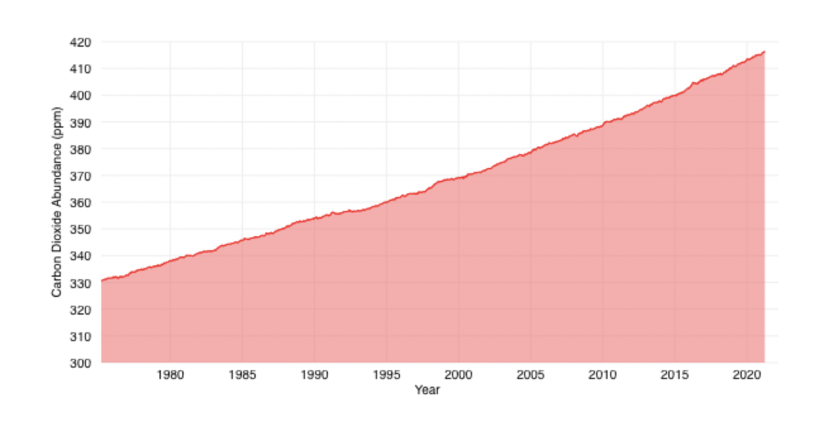
Source: Lindsey, 2023.
Looking at the graph and prompted by the teacher’s questions, “What do you notice? What do you wonder?” students wonder about various aspects and implications. They jot these wonderings down and then speak in small groups. They notice that all major contributing gases seem to be increasing over time, though some say CFC-11 isn’t obviously increasing; and others note that CFC-12 seems to have leveled out around 1990. Some students question this, as both still look like they are “going up” on the graph; this disagreement and ensuing discussion helps all students make sense of the graph.
Through a process of collaboration, they work together to synthesize their questions into coherent and meaningful inquiries:
- Why are there labels on both vertical axes? What do the three labeled axes represent?
- Why is there a labeled 43-percent increase? An increase in what? Over what time frame? How was this calculated?
- What does this data display suggest is the most important greenhouse gas?
- How does the year-to-year growth change over these 38 years?
Most teams choose to focus their efforts on reducing CO2 emissions based on the graph above. One team decides to work with methane because they believe that CO2 emissions are harder to reduce, and they believe they can make a bigger difference by reducing methane emissions. The increased autonomy accessed this unit empowers students to explore and allow the results of those explorations to direct them—not typical instruction in math, science, or ELA. The teachers work with some groups that may struggle with the openness of the task. Teachers encourage students to build from and explore each other’s ideas.
Each team researches the sources of human emissions of the gas they have chosen, uses their understanding of political and psychological opportunities and barriers to decide on most-likely policy shifts to achieve the desired 25–50 percent reduction in emissions, and prepares a presentation for the class outlining their solutions. The teaching team provides additional expertise to help interpret the complexity of the information students are collecting and synthesizing.

Team Presentations
As teams prepare for their presentations, they return to the driving question of the task. From all the data they collected, they must now distill the most important information to describe their analysis and recommendations. Part of each presentation is a version of the National Oceanic and Atmospheric Association graph above, extended into the future with the assumed implementation of the team’s proposal. Calculating the impact of their proposal on the rate of temperature change will require interpreting the left vertical axis label on the graph. The teaching team videotapes the presentations and reports to capture the range of practices that students are using such as quality of their research, analysis of data, effectiveness of their visuals, and clarity of their report, given audience, and purpose.
After all teams have presented, the final activity is to put all the pieces together to address the following big idea: What will be the impact on climate change if all the teams’ proposals are implemented?
(end vignette)

Chapter 10

Coaching Vignettes: Making Sense of Content, Student Thinking, and Pedagogy
Grade Levels: Elementary Grades One, Two, and Four
Focus: Supporting the learning of practicing mathematics teachers within their teaching environments
Source: Jen Munson, Assistant Professor, Northwestern University
Each vignette below provides a brief example of three types of sense-making—making sense of mathematics content, student thinking, and pedagogy—through and within mathematics coaching, drawn from data from a research study on effective mathematics coaching (Munson, 2018a). Each case involves a coach working one-on-one with a teacher, but sense-making like that illustrated here can occur with a coach working with groups of teachers in much the same way.

Making Sense of Content: Co-planning for Joining and Separating Whole Numbers
Carmen, a 17-year veteran elementary teacher, had a goal of making mathematics more engaging for her second graders by incorporating rich tasks that required them to make sense of concepts. To choose or design such tasks in the unit she was teaching at the time, Carmen first needed to understand the mathematical concepts involved in joining and separating multidigit numbers and strategies for doing so beyond the traditional algorithm she had been taught as a student. Together with another second-grade teacher in her school, Carmen began reading a text for elementary mathematics teachers about the ideas within joining and separating numbers (Van de Walle et al., 2012). She tried out various mathematical tasks in the text herself to understand how different strategies and representations worked. She then turned to her coach to discuss what she had read, the ideas that were exciting or confusing, and how these might translate into what students might or could do.
In co-planning, Carmen met with her math coach, and they first focused on making sense of the joining and separating strategies described in Carmen’s professional reading. Carmen shared the strategies from the text she had tried to use herself and what she learned from those attempts. One thing Carmen found surprising was using addition to solve a problem that was written as subtraction. For instance, Carmen said that it had never occurred to her to solve problem like 34 - 27 by adding on to 27 to reach 34. As Carmen and her coach talked, they explored how closely coupled addition and subtraction are conceptually, so much that one never has to subtract, because every subtraction problem can be conceived of as a missing addend problem. Because Carmen’s own schooling had rigidly separated addition and subtraction problems, she was surprised and delighted to see ways of breaking down this barrier.
Carmen then shared with the coach strategies that she found confusing or nonintuitive to use herself. In particular, Carmen was struggling to use the open number line as a tool for adding or subtracting. She had never thought visually or linearly about joining and separating numbers and doing so without prerecorded markers made this strategy feel as open-ended as the number line itself. Carmen and the coach discussed how to think spatially about numbers so that joining and separating could decompose the number line into a series of hops from one point to another. The coach modeled her own thinking about how the number line represented a way of thinking about joining and separating as distances rather than digits. The coach gave some examples of how she thought through problems like 34 - 27 as hopping up from 27 to 30 and then from 30 to 34, using the decade number as a stopping point to decompose the distance between 27 and 34. Carmen and the coach tried this way of thinking together, and the coach pointed out that many children conceive of numbers as distances and that this model could be supportive of their reasoning about joining and separating, even if it was less intuitive to Carmen.
Near the end of their conversation, Carmen and her coach bridged from reasoning about the content to considering how her new thinking could be reflected in her teaching. They discussed the kinds of tasks Carmen might try with her students to open up space for them to invent strategies for joining and separating numbers. One key idea that emerged was the use of context to support students’ sense-making; rather than giving students purely numerical tasks as she had done in the past, Carmen and her coach designed story problems that involved joining or separating so that students could—and needed to—interpret the situations and develop their own strategies.
In this example, co-planning was a key activity for the teacher and coach to have time to move between making sense of professional readings, mathematical concepts, strategies, and the pedagogical implications of each. In their conversation, the teacher and coach grounded their discussion in Carmen’s goals, and the shared expertise of the text, the teacher, and the coach, each of whom brought important ideas and had a hand in making sense of content in a way that informed Carmen’s teaching.

Making Sense of Student Thinking: Clinical Interviews about the Meaning of the Equal Sign
Quinn, an early career first-grade teacher, was nearing the end of a unit on addition, subtraction, and the meaning of the equal sign with his students. In this unit, he challenged students to make sense of equations, finding missing values to make equations true, and determine whether an equation was true or false. Quinn’s coach had been involved in co-planning some of this unit with Quinn and was present in the classroom during teaching some days to observe and talk with Quinn about what she noticed about student thinking.
Quinn launched each day’s lesson with a number talk. Afterward, students typically worked in partners playing games that challenged them to make sense of equations. Some students had been very vocal throughout the unit, explaining their own reasoning and revoicing one another’s thinking. But Quinn had come to feel that his sense of what the class was learning was driven by some—not all—students’ participation. Some students had been absent, while others were simply quieter. Quinn’s assessment was that his students were learning and moving toward his goals for this unit, but he was uncertain if this was true for all students.
To get a more complete picture of what his students had learned and what they still needed to learn in the unit, Quinn and his coach decided to conduct clinical interviews with targeted students while the class played equation games. A clinical interview involves asking a student to do carefully chosen mathematical work and discuss their thinking along the way with an interviewer. The goal of a clinical interview is to learn more precisely what the student understands. Quinn and his coach decided that interviewing Quinn’s quiet first-graders would give them better information than a written assessment, allowing them to ask follow-up questions and probe for reasoning. They selected four students from whom Quinn wanted to learn and designed two brief tasks to give them one-on-one: one involved finding the missing part of an equation (13 + … = 18) and the other involved determining whether an equation was true or false (15 - 5 = 13 + 2). From these two tasks they hoped to learn how students understood the meaning of the equal sign and how to use it to determine equality.
Quinn and his coach sat on the carpet with one student at a time. Quinn led the interviews, presenting each task in turn to the child. As the student worked with manipulatives and a whiteboard, Quinn and the coach each asked probing questions to understand how the student was solving the problem, what reasoning the student was using, and how they could articulate both their process and reasoning. During the interviews, when students became overwhelmed, the coach stepped in to modify the task so that students could still show what they understood. For instance, when Amber froze upon seeing 13 +… = 18 and said she couldn’t do that because the numbers were too big, the coach changed the task to 3 +… = 5 so that the numbers were not a barrier, and the teacher could still learn how the child made sense of a missing addend and the equal sign. At times during the interviews, Quinn expressed confusion about what a child was doing or thinking. At these moments, the coach either paused the interview to talk with the teacher about what they were noticing and how to interpret the student’s thinking or asked the child additional questions to try to elicit their thinking to make it clearer.
Between the individual interviews, Quinn and the coach discussed what they had learned about how the students were thinking, what they understood, what they were ready to learn, and what opportunities to learn they might need next. They found some trends. Some students needed more opportunities to count objects to build one-to-one correspondence above 20. They all could make sense of the equal sign as having the same value on both sides, but they needed more experience with equations with expressions on both sides (such as the true or false task: 15 - 5 = 13 + 2). Some students could find a missing addend when the task was in context (e.g., Thirteen children were on the playground. Some more kids came. Now there are 18 kids on the playground. How many kids came?), but not when it was in an equation (13 + ... = 18).
After the lesson, Quinn and his coach talked about an instructional plan to meet the needs of the students interviewed, along with the class as a whole, during the remainder of the unit. This example indicates how important it is for first-graders to have manipulatives and whiteboards available to support their thinking and explaining. Practicing counting objects above 20 with accurate one-to-one correspondence is also important, as is having objects in groups of 10 to give meaning to numbers as tens and ones. Problems with a context are also important for children to build meanings for equations. Children can be asked to tell such stories as well as solve them and relate them to equations.
In this example, the coach and teacher interacted with students about their thinking during mathematics, and in doing so they were able to gather, notice, and interpret student thinking in real time together. This allowed both the teacher and coach to make sense of student thinking grounded in the evidence they both generated in the interviews. So often, teachers are left explaining what students did, thought, or understood to a colleague after the fact, someone who did not witness the events and did not have the opportunity to notice student thinking themselves. The coach in this case was in the classroom with the teacher and students to support both the gathering of formative assessment data and the interpreting of student thinking. As with the previous vignette, this collaborative work was a gateway to planning future instruction.

Making Sense of Pedagogy: Side-by-Side Coaching During Conferring
Jane, a fourth-grade mathematics teacher leader, had built routines in her classroom around mathematical inquiry, in which each day students were given a task in context that they did not yet know how to solve. Students were asked to grapple with this task in small groups using strategies, models, and materials of their choice. During this collaborative work time, Jane circulated, conferring with the groups about their thinking and supporting their inquiry (Munson, 2018b). However, Jane felt she could learn more about how to use conferring to support students’ mathematical thinking, and she accepted an invitation from her coach to work together on this pedagogy in the classroom.
For four weeks, two days each week, Jane and her coach engaged in side-by-side coaching to support Jane’s goal of learning a pedagogical practice, conferring. Each day followed a similar pattern: Jane and her coach touched base briefly at the start of each lesson, Jane launched the lesson, they conferred with students together, Jane ended the lesson with a whole-class discussion, and Jane and her coach debriefed what they had learned about pedagogy and from students that day.
During side-by-side coaching, Jane and her coach conferred with students together, moving throughout the classroom, side by side, to talk with students about their thinking. At times Jane led interactions with students while the coach observed, while at other times the coach modeled conferring or they co-led interactions. Throughout the four weeks, they focused on various parts of conferring and the thinking and decision-making that accompanied them. They worked together on (1) how to elicit student thinking and what features of student thinking to attend to, (2) how to interpret student thinking, particularly thinking-in-progress, which can be challenging to understand, (3) how to decide what students need next to advance their thinking, and (4) what moves the teacher could use to help students move their thinking forward. They accomplished this by enacting the pedagogy together, talking through the myriad decisions that Jane needed to make in the moment to uncover, understand, and respond to her students’ thinking.
By threading together teaching, professional development, and professional discourse, Jane’s classroom became a rich site for teacher learning during teaching. Jane learned to slow down her interactions with students, give more time to eliciting student thinking, focus on ensuring students deeply understand the context of the tasks they solve, and issue fewer directives to students, instead allowing them to make more mathematical decisions.
In this example, side-by-side coaching, in which teaching and professional learning happen together in the classroom, supported the teacher in making sense of a particular pedagogy. Instead of talking in the abstract, working on this pedagogy together in the classroom allowed the teacher to see and experiment with pedagogical moves with her own students within the lessons she had designed.

Closing Thoughts
It is worth noting that in each of these vignettes, the teachers’ goals for professional learning shaped both what the teacher and coach worked to make sense of—content, student thinking, or pedagogy—and how they worked together. Effective coaching aligns the teachers’ goals with coaching activities that allow the teacher to actively make sense with a knowledgeable colleague.
(end vignette)

Chapter 11

Vignette: Polygon Properties Puzzles
Students in Ms. Thompson’s fourth-grade class have been exploring the attributes of polygons. They have compared and contrasted physical models and illustrations of polygons, attending to features such as angle size, number of sides, and whether the figures have any parallel or perpendicular sides. Lessons have included polygons that students view as “typical” as well as atypical examples. Today, Ms. Thompson will ask her students to draw polygons that meet specific criteria as a way to show their understanding. Her planning is informed by an adaptation of five challenges from About Teaching Mathematics (Burns, 2007). Students will illustrate the figures using technology, specifically Whiteboard. Some of the standards addressed in the lesson include:
- SMP.1, 3, 5, 6, 7
- Content Standards: 3.G.1; 4.G.1, 2, 4.MD.5; 5.G.3, 4
- ELD Standards: PI.1; PI.2; PI.3; PI.4; PI.5; PI.9; PI.12
Ms. Thompson is deliberate and selective in the use of technology. She plans to use Whiteboard for this lesson as she finds it can facilitate the use of mathematical practices and increase focus on the mathematics content. Her expectation is that this use of technology will
- reduce the challenge of drawing straight lines by using Whiteboard’s line tool;
- encourage collaboration and discourse between partners who are sharing one Chromebook, and later, among the larger group;
- support linguistically and culturally diverse English learners;
- support students with learning differences in accessing the tasks and finding meaning in their learning;
- increase engagement for the many students who are enthusiastic users of technology;
- foster growth mindsets and promote the correction of errors and revision of work in progress;
- enable the class to see and compare various student products in a highly visible, large-scale format via Google Casting or the link sharing within Whiteboard;
- use class time efficiently, allowing for full discussion and analysis; and
- serve as a quick way to engage in the formative assessment process as student work is instantly transmitted to the teacher’s view.
Ms. Thompson uses Google Classroom (and is familiar with other learning management systems) and Whiteboard (by the Math Learning Institute) often for lessons. These students have worked in collaborative groups for several months, sharing and explaining their thinking digitally. They share their work using links or the share code and posting them into their assignments on Google Classroom. The class has established effective collaboration protocols (e.g., stay on your own page, let everyone speak, do not delete others’ work, add to someone else’s thinking, everyone has equal access to the tool). Students are arranged in four-person table groups. They know how to partner up and then switch partners in their table group quickly. The class has a system for Chromebook management: One partner is responsible for getting two Chromebooks out before the morning meeting; the second partner returns the devices to the charging station during afternoon cleanup time.
The teacher considered language barriers and the needs of individual students as she planned partners and heterogeneous groups. Ms. Thompson has 12 English learners in this class. To support their learning, she
- has placed the one Emerging English learner (EL) student with a language-proficient Spanish-speaking student to help with translations and collaboration;
- will create and display sentence frames for this student to use during discussion and collaboration;
- provided the seven English learners who are at the Bridging stage and the four English learners who are at the Expanding level with sentence stems to support them as they discuss and explain their thinking;
- has paired a student with an Individualized Education Program (IEP) for reading with a student who can help them access the written material; and
- situated two students who have IEPs for math with partners who are supportive and able to share the work equitably and inclusively.
In this lesson, students will use a familiar classroom routine, “Convince Yourself, a Friend, a Skeptic.” They will
- solve each problem with a partner (convince yourself);
- justify their mathematical argument to the other pair in their table group, who will ask questions and encourage further explanation (convince a friend); and
- prepare to convince the class, who will challenge and probe any inconsistencies (convince a skeptic).
Ms. Thompson begins the lesson by focusing attention on an image the class explored the day before: a square that is not oriented on the horizontal. She asks partners to describe the figure using precise mathematical terms, as they did in the previous lesson.
Students offer many of the terms that emerged in the earlier lesson, which Ms. Thompson records for the class: square, rectangle, tilted square, diamond, right angles, square corners, parallel sides, perpendicular, equal side lengths. Several students raise their hands to challenge the term “diamond,” arguing that it is an informal term and that “a square is still a square, even if it is tilted!” Ms. Thompson comments that students have shown they could convince others and could take the role of skeptics; she encourages them to continue to attend to the properties of polygons in today’s lesson, too.
Ms. Thompson tells the students that this time, they will share one Chromebook with their designated partner, using Whiteboard to illustrate a series of polygons with particular properties. This causes excitement among her students; almost all are enthusiastic about using Whiteboard and working with their partners.
Ms. Thompson tells the class that they will draw a series of polygons that include specific properties. As she posts each one, students will read the task aloud together and then think quietly about how they might draw the figure. Once they have an idea, they should show a “thumbs up” to signal that they are ready to start work on the Chromebook. After partners solve each problem, they must convince the other partners at the table and plan to explain and justify their thinking in the whole-class “skeptics” discussion.
Ms. Thompson posts Task 1: “Make a triangle with one right angle and no two sides the same length.”
The class reads the statement aloud twice, carefully and slowly. Ms. Thompson signals for quiet thinking and watches as students begin responding with their thumbs up. When she is satisfied that partners are ready to begin, she invites them to start illustrating on Whiteboard.
As anticipated, students are successful and confident on the first task, having practiced by exploring triangles of various types. Ms. Thompson displays four student responses for the class to consider, selecting examples that are oriented differently. Some students express surprise about how many different ways the figure can be drawn and still meet the requirements. Ms. Thompson asks students to talk with their partners, using the sentence frames as necessary in their role as skeptics, and be ready to question, challenge, or probe any inconsistencies they note in the triangles displayed. After a few moments, a few questions/challenges are posed:
- How can we tell if C has a right angle when it’s “lying down” like that?
- Is B really a right-angle triangle if the right angle is pointing to the left?
- Convince us about D, too! It’s pointing to the left!
Ms. Thompson invites the partners whose images are being questioned to respond. In two cases, students ask if they can measure side lengths to assure that they are all different. Ms. Thompson allows the class to reach consensus independently, agreeing that all four examples are right triangles with three sides of different lengths.
Ms. Thompson presents Task 2: “Make a triangle with exactly two congruent angles.”
The procedures from the first task are duplicated here: read aloud, pause to think, then collaborate with a partner—but this time the second partner is the lead illustrator.
Ms. Thompson circulates, stopping beside her Emerging English learner student and partner to listen. To provide support for but not single out her Emerging English learner student, she asks the pair to draw or use hands to demonstrate what is meant by “congruent” angles. A brief exchange assures her that the partners are working effectively; she reminds the pair to rehearse how they could defend their illustration to their table partners and the class. Several student pairs are discussing congruence as she moves through the groups, some referring to their journals or the word wall listing mathematics terms. In quick check-ins with the remaining groups comprised of English learner students, Ms. Thompson notes that two of the Bridging students are letting their partners do most of the talking; she reminds students of the classroom norms related to “equal voices,” then engages with each pair in ways that engage the quieter students. After instilling this balance, she encourages each, noting that partner time is a time for safe practice. Before leaving each group, she reminds the students that what she has heard is worth sharing when the time comes to discuss with the class, inviting her English learner students to reiterate for their peers what they developed in pairs.
When Ms. Thompson posts several students’ illustrations, she includes an example with three congruent angles, not “exactly” two as the task specified. This non-example promotes energetic discussion and respectful challenges from friendly skeptics.
The class continues with two more tasks:
- Task 3: “Make a four-sided polygon with no parallel sides.”
- Task 4: “Make a four-sided polygon with one right angle and all sides different lengths.”
As Ms. Thompson circulates, encourages, and listens intently, she acquires insights into students’ understandings and strengths, and uncovers a few misconceptions. She notes with satisfaction that students are actively using mathematical practices, in particular, SMPs 3 and 6. These observations guide her as she orchestrates the skeptics’ discussion for each task.
Ms. Thompson will use students’ responses to the final task, an exit ticket, as a formative assessment. She has designed two exit tickets so that each student can express and share their own understanding independently rather than with support from their partner.
She tells the class that rather than repeating the “Convince Yourself, a Friend, a Skeptic” routine, they will respond independently. Each student may choose to respond using paper and pencil or Whiteboard. Those who respond digitally share their work via the link sharing button and post it into their Google Classroom assignment. The paper copies are collected.
The exit ticket tasks involve concepts of parallel sides and angle measurement, which are key understandings in the grade four standards (4.MD.5, 6; 4.G.1,2).
Task 5:
- Make a four-sided polygon with no right angles but with opposite sides parallel.
- Make a four-sided polygon with at least two angles greater than 90º.
As she reflects on the lesson, Ms. Thompson notes the following:
- Whiteboard’s immediacy expedited the students’ creation, and the teacher’s selection and presentation, of work samples.
- Images were large, detailed, and easily viewed by all students.
- With few exceptions, students were engaged throughout the lesson.
- All students were able to use the technology to make their own polygons.
- Partners shared the use of the device smoothly.
- The level of challenge was appropriate for almost all students.
- Three of the seven English learner students who are at the Bridging stage were willing to speak with their individual partners but remained quiet in table and whole-class discussions.
- Two of the four English learner students at the Expanding level justified their reasoning confidently during the whole-class discussion.
During the next lesson, Ms. Thompson will create an opportunity for students to correct any misunderstandings that were revealed, as well as solidify their learning by sharing and analyzing examples of Task 5 illustrations.
(end vignette)

Chapter 12

Vignette: A Teacher Tries a New Assessment Approach
Vince is an experienced high school teacher who has been teaching for over 20 years in diverse classrooms which include students who are linguistically and culturally diverse English learners and students with learning differences. Vince uses a traditional system of testing and grading in his classroom but recently read about assessment for learning and wondered if the summative assessments he had been using could be used in a formative manner. Instead of giving tests as summative assessments, as he had in previous years, he decided to incorporate the assessments into his teaching, asking students to answer as many problems as they could.
Before beginning, Vince and the students reviewed the questions as a class to be sure everyone understood the directions, along with any words that may have multiple meanings. This ensured that all students had access to the questions. Using principles of UDL, he also briefly discussed the multiple modes students could use to express their thinking and show steps, including diagrams, words, equations, tables, and flowcharts. When students identified questions, they could not answer because they were too difficult, he asked them to mark these questions and then use the help of a resource—such as a book, class notes, or translation software—to work out solutions. Once the assessment was completed, the work that students had done on the marked problems became the work they discussed in class. Vince made sure to include as many voices and visuals in the conversation as possible. He reported that the discussions gave him the best information he had ever had on his students’ understanding of the mathematics he was teaching.
The Classroom Challenges housed at the Mathematics Assessment Resource Service (MARS) provide a rich repository of free lessons supporting teachers in formative assessment. Each lesson is structured around an active learning experience for students with a rich task, and teachers are provided with common issues to look for in student responses to questions, as well as samples of, and guidance for, analyzing student work.
For example, Maximizing Area: Gold Rush is a sample grade-seven lesson that includes a guide to address common student questions. This lesson exemplifies how teachers can adjust their questioning strategies for students based on formative assessment data regarding student misconceptions (University of Nottingham, 2016).

Maximizing Area: Gold Rush
Background: In the 19th century, many prospectors travelled to North America to search for gold. A man named Dan Jackson owned some land where gold had been found. Instead of digging for the gold himself, he rented plots of land to the prospectors.
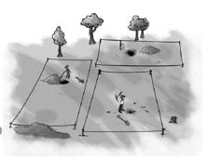
Problem: Dan gave each prospector four wooden stakes and a rope measuring exactly 1000 meters. Each prospector had to use the stakes and the rope to mark off a rectangular plot of land.
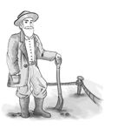
- Assuming each prospector would like to have the biggest plot, what should the dimensions of the plot be, once the prospector places the stakes. Explain your answer.
- Read the following statement:
“Join the ropes together! You can get more land if you work together than if you work separately.”
Investigate whether the statement is true for two or more prospectors working together, sharing the plot equally, and still using just four stakes. Explain your answer.
Figure C.27 describes common issues that arise for students in this lesson as well as prompts teachers can use in response.
Figure C.27 Common Student Issues and Teacher Questions and Prompts
Common Issues | Suggested Questions and Prompts
Does not understand the concept of an area and/or perimeter or does not know how to find the area or perimeter of a rectangle | What does the length of the rope given to a prospector measure?  How could you measure the amount of land enclosed by the rope?  How do you find the area of a rectangle?  How do you find the perimeter of a rectangle?
Calculates the total amount of land but not the amount of land for each prospector (Q2) | You’ve worked out the total area of land for both/all of the prospectors; how much land will each prospector get?
Emphasizes only the human impact of sharing the land (Q2)  Example: The students states that when two people share, they can help each other out.  Or: The student states that when sharing the land, people are more likely to steal from each other. | Now investigate whether combining ropes affects the amount of land each prospector gets.
Does not investigate any or very few rectangles  Example: The student draws just one rectangle and calculates its area (Q1). | Now investigate the area of several different rectangles with the same perimeter but different dimensions.
Works unsystematically | How can you now organize your work?  How do you know for sure your answer is the best option?
Presents work poorly  Example: The student presents the work as a series of unexplained numbers and/or calculations. | Would someone unfamiliar with this work understand your method?
Only investigates two prospectors sharing land | Suppose three, four, or five prospectors share land. What area of land would each prospector get?
(end vignette)

Vignette: Mathematical Thinking for Early Elementary
Mr. A’s kindergarten class is conducting an investigation when they realize that they need to use mathematical thinking [SEP-5]. Mr. A’s class receives a package of silkworm eggs and is amazed how they all hatch on almost the same day! One student asks how quickly they will grow and another wonders how big they will get. The students decide that they would like to track the growth [CCC-7] of their silkworms and measure them daily. Mr. A wants the students to come up with a way to answer the question, “How big [CCC-3] are they today?” through a visual display of their measurement data. The students need to find a way to summarize all their measurements using a graphical display. Mr. A was guided by research about the different developmental levels in understanding how to display data (figure C.28, table 9.4 from the Science Framework).
Figure C.28 Developmental Levels of the Ability to Display Data
Level | Descriptor
6 | Create and use data representations to notice trends and patterns and be able to recognize outliers.
5 | Create and use data representations that recognize scale as well as trends or patterns in data.
4 | Represent data using groups of similar values and apply consistent scale to the groups.
3 | Represent data using groups of similar values (though groups are inconsistent).
2 | Identify the quantity of interest but only consider each case as an individual without grouping data together.
1 | Group data in ways that don’t relate to the problem of interest.
Source: Adapted from NRC, 2014
One group orders each of the 261 measurements by magnitude, making a bar for each worm. The display uses a full 5 feet of wall space (figure 9.13A from the Science Framework; level 2 on table 9.4). Another group makes a bar graph with a bin size of just 1 mm per bin, which leads to 50 different bars (figure 9.13B from the Science Framework; level 4 on table 9.4 from the Science Framework). Also, this group’s vertical axis only extends to six worms at the top of the paper, so bars with more than six worms are cut off. A third group creates a more traditional bar graph with measurements placed into bins. Rather than using bars, the group uses circles stacked one on top of the other. Unfortunately, different students draw the circles for each bin, and they are not the same size and are therefore not comparable (figure 9.13C from the Science Framework; level 3 on table 9.4 from the Science Framework).
Figure C.29: Facsimiles of Student-Created Representations of Silkworm Length Data
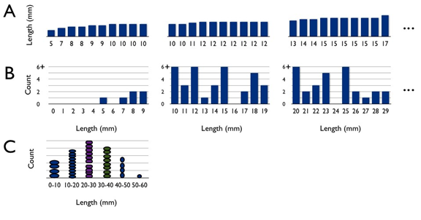
Long description of figure C.29
Source: Adapted from Lehrer, 2011.
Mr. A leads a discussion about which representations are most useful for understanding silkworm growth. Mr. A recognizes that each representation is at a different developmental level and uses that understanding to highlight different concepts with different students (grouping versus consistent grouping, for example). As students examine the graphs [SEP-5] with better understanding of what they represent, they notice a pattern [CCC-1] that there are more medium-sized silkworms and fewer short or long ones (level 5 on Table 9.4 from the Science Framework), which allows Mr. A to introduce the concept of variability. Students begin to ask questions about why some silkworms are growing so much faster than others. Mr. A’s targeted guidance about how to represent data helped elevate the scientific discussion.
Commentary:
Science and Engineering Practices (SEPs). The emphasis of the rubric is on the ability to count and recognize similar values, examples of using mathematical thinking [SEP-5] at the primary level.
Disciplinary Core Ideas (DCIs). While the activity supports the DCIs that plants and animals have unique and diverse lifecycles (LS1.B) and that individuals can vary in traits (LS3.B), the task does not assess student understanding of these DCIs.
Crosscutting Concepts (CCCs). Students cannot complete this task without attention to scale and quantity [CCC-3], including the use of standard units to measure length. The rubric in table 9.4 from the Science Framework emphasizes student ability to recognize patterns [CCC-1] as they create their data representations.
Resource:
Based on NRC, 2014
Source: CDE, 2018, Chapter 9.
(end vignette)

Long Descriptions for Appendix C

Figure C.1: Gina’s Bike Ride
Figure shows five shaded circles inside an oval shape. To show Gina’s mother’s ride, the same image (five shaded circles inside an oval shape) is repeated three times, showing a total of 15 circles. In illustration B, a line segment represents five miles (labeled “Gina, 5 miles”). Below that line segment a line segment three times that length is shown. The second line segment is comprised of three equal size parts joined as one length: The first five-mile length is one color, the second five-mile length is a different color, and the third five-mile length is another color. This is labeled “Gina’s mother 5 miles + 5 miles + 5 miles.” Return to figure C.1 graphic

Figure C.3: Documentation of Jax’s Multiplication Method
The figure shows steps in Jax’s thinking. At the top of the figure is the 7 x 24 expression provided by the teacher. Annotation underneath the 24 with a “cherry diagram” illustrates how the 24 is composed of 20 + 4. The next two rows illustrate how Jax calculated with the resulting 20 and 4. First, they multiplied 7 x 20 to get 140. Next, they multiplied 7 x 4 to get 28. The final row shows the addition of the resulting sums from the prior two rows with the equation 140 + 28 = 168. Return to figure C.3 graphic

Figure C.8: Current Maps
The “Current Maps” shows Seal Beach with a pier on the right extending into the Pacific Ocean. Arrows on the water illustrate northeasterly wind, which is blowing in the direction of an oil drilling platform at 3/4 knots per hour. Below image, notes read, “rate = miles per hour of how fast she can swim.” Lynne’s rate is calculated at “2 miles an hour (knots)” and shown on a number line. Lynne’s new rate is calculated at “1 1/4 mile an hour (knots).” It is also shown on number line and includes the expression 2 - 3/4 = 1 1/4. Return to figure C.8 graphic

Figures C.9 and C.10 Student Table and Graph based on Ocean Current Data
Two sheets of graph paper. Sheet 1 shows the old rule (+ 2) in a table comparing hours (A) to miles (B) and the new rule (+ 1 1/4) in a table comparing hours (A) to miles (B). Sheet 2 illustrates the graph of the old rate and the new rate in Miles (Y axis) over Hours (X axis). Return to figure C.9 and C.10 graphics

Figure C.11: Hours at Minimum Wage Needed to Afford Rent
2015 Hours at minimum wage needed to afford rent for a one-bedroom unit. An asterisk indicates the state’s minimum wage exceeds the federal minimum wage.
Location | Hours per week
Alabama | 61
Alaska | 79*
Arizona | 67*
Arkansas | 54*
California | 92*
Colorado | 75*
Connecticut | 84*
Delaware | 89*
Florida | 77
Georgia | 72
Hawaii | 125*
Idaho | 59
Illinois | 75*
Indiana | 62
Iowa | 58
Kansas | 62
Kentucky | 57
Louisiana | 69
Maine | 71*
Maryland | 101*
Massachusetts | 87*
Michigan | 58*
Minnesota | 68*
Mississippi | 61
Missouri | 59*
Montana | 54*
Nebraska | 54*
Nevada | 71*
New Hampshire | 89
New Jersey | 100*
New Mexico | 64*
New York | 98*
North Carolina | 66
North Dakota | 62
Ohio | 54*
Oklahoma | 59
Oregon | 58*
Pennsylvania | 78
Puerto Rico | 48
Rhode Island | 67*
South Carolina | 66
South Dakota | 49*
Tennessee | 65
Texas | 73
Utah | 69
Vermont | 70*
Virginia | 97
Washington | 73*
Washington D.C. | 100*
West Virginia | 53*
Wisconsin | 67
Wyoming | 64
A living wage is a wage that is high enough to maintain a normal standard of living. A minimum wage is the lowest an employer can pay an employee for their work. The graphic depicts that in no state can a minimum wage worker afford a one-bedroom rental at Fair Market Rent, working a standard 40-hour week, without paying more than 30% of their income. Return to figure C.11 graphic

Figure C.18 Percentage of Diabetes Diagnoses by Race/Ethnicity and Sex
A bar graph includes data for age-adjusted estimated prevalence of diagnosed diabetes by race/ethnicity group and sex. The graph shows:
- American Indian/Alaskan Natives: men 14.9 percent, women 15.3 percent
- Asian: men 9 percent, women 7.3 percent
- Black, non-Hispanic: men 12.2 percent, women 13.2 percent
- Hispanic: men 12.6 percent, women 11.7 percent
- White, non-Hispanic: men 8.1 percent, women 6 percent
Return to figure C.18 graphic

Figure C.29: Facsimiles of Student-Created Representations of Silkworm Length Data
This figure shows three different student graphs. Graph A is a bar graph; length is on the y-axis (no markings or units); there are numbers on the x-axis as follows: 5, 7, 8, 9, 9, 10, 10, 10, and 10. New page has 10, 10, 11, 12, 12, 12, 12, 12, 12, and 12. New page has 13, 14, 14, 15, 15, 15, 15, 15, 15, and 17…
Graph B is a bar graph. On the y-axis is the label “Count” marked from 0 to 6+ in increments of 2. On the x-axis is “Length (mm)” and ranges from 0 to 29… in increments of 1. There are no bars at 0 to 4; a bar with height 1 at 5; 6 is empty; 7 has 1; 8 has 2; 9 has 2; 10 has 6+; 11 has 3; 12 has 6+; 13 has 1; 14 has 3; 15 has 6+; 16 has 0; 17 has 2; 18 has 5; 19 has 3. New page: 20 has 6+; 21 has 2; 22 has 3; 24 has 0; 25 has 6+; 26 has 2; 27 has 1; 28 has 2; 29 has 2. Graph C is a kind of bar graph with intervals. On the y-axis is the label “Count” with no markings or units. On the x-axis in Length in mm. The first interval is 0-10 and has 4 in it. The second interval is 10–20 and has 10 in it. The third interval is 20-30 and has 10 in it. Also, because of the size difference in the ovals and the gap in the data, this line appears much taller than the one before it. The fourth interval is 30-40 and has 8 in it. The fifth interval is 40-50 and has 4 in it. The sixth interval is 50-60 and has one in it. Return to figure C.29 graphic
California Department of Education, October 2023

