Mathematics Framework
Adopted by the State Board of Education on July 12, 2023
Page 1 of 56

Mathematics Framework
Chapter 7: Mathematics: Investigating and Connecting, Grades Six through Eight

Mathematics Framework Chapter Seven: Mathematics: Investigating and Connecting, Grades Six through Eight 1
Introduction 2
The Importance of Middle School Math Experiences 3
Investigating and Connecting Mathematics 4
Teaching the Big Ideas 7
Designing Instruction to Investigate and Connect the Why, How, and What of Mathematics 8
The Importance of the Drivers of Investigation and Content Connections 10
The Importance of the Standards for Mathematical Practices 12
Investigating and Connecting, Grades Six Through Eight 16
Support for English Learners 18
Content Connections Across the Big Ideas, Grades Six Through Eight 21
The Big Ideas, Grades Six Through Eight 40
Conclusion 49
Long Descriptions for Chapter 7 50

Introduction
Mathematics in the middle grades, the focus of this chapter, builds on the foundational understanding of math concepts students learned in the earlier grades, including place value, arithmetic operations, fractions, geometric shapes and properties, and data and measurement. Students’ solid grasp of these concepts supports their learning of the major middle-grade topics: proportional reasoning, rational numbers, measurement in geometrical and data science scenarios—concepts that, in turn, provide the base for success in high school mathematics.
The critical element of success continues to be piquing students’ curiosity and interest through engagement with meaningful and relevant math activities and experiences. As this chapter discusses, students’ middle school experiences are pivotal in shaping their attitudes toward math and self-perceptions as math learners. Combined with the guidance they receive, those experiences determine whether or not students get on a pathway to high level math, crucially affecting their mathematics futures in high school and beyond.

The Importance of Middle School Math Experiences
Middle grade mathematics experiences are pivotal not just because of the content students are learning and the mathematical practices they are honing, but also because this is a critical period in the development of their attitudes toward math and perceptions of themselves as math learners. It is a time when students make choices about mathematics coursework—or have those choices made for them—that have long-term implications, including for their college and career achievements (Falco, 2019). Among these choices are whether some or all students begin the high school math sequence with Algebra I or Mathematics I in middle school. As described in chapters 8 and 9, this can enable students who are well-prepared to experience more course-taking options in high school. At the same time, it is important that schools organize for student success to ensure that lack of readiness or curriculum gaps do not undermine foundational understanding for students who accelerate, or for others. Whether middle schools decide to teach the CA CCSSM grade six through eight curriculum to all or most students or to enable some or all students to accelerate before high school, they should be prepared to close learning or curriculum gaps in planful ways to enable maximum success for all students. Strategies for doing so are detailed in chapter 9. Research conducted in middle school settings has found that over the course of a school year many middle-grade students come to perceive mathematics as less valuable and report reduced effort and persistence in in this subject area (Pajares and Graham, 1999).
Middle school girls in particular tend to exhibit reduced self-efficacy around mathematics (Falco, 2019), and that self-efficacy—belief in one’s own mathematics ability—is a significant predictor of high school math success (Petersen and Hyde, 2017). Moreover, girls as a group, as well as African American and Latino students in general, are underrepresented in Science, Technology, Engineering, and Mathematics (STEM) fields. Students in these groups tend to experience significantly more academic barriers to mathematics exposure in the elementary and middle grades, barriers that are negatively associated with high school math achievement (Williams et al., 2016).
This framework is intended to help teachers ensure that the math experiences of all their students are positive. It highlights the importance of keeping students actively engaged in learning mathematics by piquing their curiosity and eliciting their interest through math activities and experiences that students find meaningful and relevant. The idea is for teachers to help students experience the “wonder, joy, and beauty of math” (National Council of Teachers of Mathematics) and help students develop and sustain a positive identity as capable mathematics learners.
As discussed in chapter one, teachers activate students’ curiosity and positive disposition toward mathematics by providing a learning environment that inspires wonder and affirms the connections among the math topics students encounter. As they learn, students recognize that their learning is part of the magnificent and coherent body of mathematical understanding. In this learning environment, instruction shows students that their own thinking about mathematics matters and that their differing backgrounds and capabilities contribute to a greater mathematical understanding for everyone in the class. Students come to see that with every hard-won realization, subtle and creative explanation, and deeper connection or complex idea produced, their understanding is expanding and they are advancing as developing mathematicians. In this environment. Teachers are champions of the cause and facilitators of learning, rather than disseminators of information for students to learn by rote.

Investigating and Connecting Mathematics
The goal of the California Common Core State Standards for Mathematics (CA CCSSM) at every grade is for students to make sense of mathematics. To achieve this goal, the framework recommends taking a “big ideas” approach to math teaching, one in which mathematics is presented as a series of big ideas that enfold clusters of standards and connect concepts. As with transitional kindergarten through grade five classrooms, for grades six through eight, the framework envisions mathematics teaching and learning as a vibrant, multidimensional, interactive, and student-centered endeavor of investigating and connecting big ideas. In that process, teachers focus on ensuring that instruction meets the full range of student learning needs.
Starting in the earliest grades and throughout the middle and high school grade levels, teachers design and carry out instruction that engages students in investigating the big ideas and connecting content and mathematical practices within and across grade levels and mathematical domains. This approach emphasizes students’ active engagement in the learning process and provides students with frequent opportunities for students to work with one another in connecting and communicating about the big ideas.
Frequent opportunities for mathematical discourse, like implementing structured math talks, create a climate for mathematical investigations, which promote understanding (Sfard, 2007), language for communicating (Moschkovich, 1999) about mathematics, and development of mathematical identities (Langer-Osuna and Esmonde, 2017). Teachers create opportunities for students to construct mathematical arguments and attend to, make sense of, and respond to the mathematical ideas of others. This discourse, in turn, supports development of language proficiency in mathematics.
Ensuring frequent opportunities for mathematical discourse. As discussed in chapter 2, teachers facilitate student engagement and learning when they take an assets-based approach to instruction—notably by cultivating a classroom environment that is both culturally and linguistically responsive. Providing frequent opportunities for mathematical discourse is one way of developing this type of climate for mathematical investigations. Mathematical discourse can focus student thinking on tasks like offering, explaining, and justifying mathematical ideas and strategies, as well as attending to, making sense of, and responding to other people’s mathematical ideas.
Mathematical discourse entails communicating about mathematics with words, gestures, drawings, manipulatives, representations, symbols, and other tools that are helpful for learning. In the early grades, for example, students might explore geometric shapes, investigate ways to compose and decompose them, and reason with peers about attributes of objects. Teachers’ orchestration of mathematical discussions (see Stein and Smith, 2011), such as the reasoning segment of the activity in the example, involves modeling mathematical thinking and communication, noticing and naming students’ mathematical strategies, and orienting students to one another’s ideas.
Supporting development of language proficiency in mathematics. Mathematics is considered by many to be a universal language, recognized throughout the world. All California transitional kindergarten through grade twelve students are learning the language of math, including its vocabulary. But students who are English learners integrated in an English-only setting face the added challenge of learning mathematics content and the language of instruction simultaneously. These students bring experiences, perspectives, and ideas that enrich the classroom for all, and instructional strategies that are designed to meet their needs, and that are aligned with the California English Language Development Standards (CA ELD Standards), support mathematical learning for all students.
Students who are English learners are most supported in learning the languages of English and mathematics when they are given the opportunity to reason about mathematics in small-group and whole-class discussions, listening to and connecting with the ideas of other students (Zwiers, 2018). Students who engage in such conversations develop these two important languages simultaneously. As Zwiers points out, it is more productive to create engaging tasks that challenge students to use reasoning, than to isolate particular words or use sentence starters: “We don’t want to put the cart of language before the horse of understanding” (2018, 10).
Language development is supported when mathematical ideas are paired either visually or physically with verbalizations. Tasks that show or require visual thinking and that encourage discussion are ideal, and students can be encouraged to start group work by asking each other, “How do you see the idea? How do you think about this idea?” Support can also include the use of students’ first language.
The English Learners Success Forum provides guidance on ways to develop students’ language proficiency as they learn mathematics. That guidance encompasses five focus areas (English Learners Success Forum, n.d.):
- Interdependence of Mathematical Content, Practices, and Language;
- Scaffolding and Supports for Simultaneous Development;
- Mathematical Rigor Through Language;
- Leveraging Students' Assets; and
- Assessment of Mathematical Content, Practices, and Language.
(For more on support for students who are English learners, see the section “Investigating and Connecting, Grades Six Through Eight,” below.)

Teaching the Big Ideas
As discussed in chapter two, teaching the big ideas of mathematics is one of the five main components of teaching for equity and engagement. Big ideas are central to the learning of mathematics, link numerous mathematics understandings into a coherent whole, and provide focal points for student investigations (Charles, 2005). In this framework, the big ideas are delineated by grade level and are the core content of each grade. For example, in grade six there are 10 big ideas that form an organized network of connections and relationships; the ideas are distance and direction, nets and surface area, variability in data, relationships between variables, the shape of distribution, graphing shapes, fraction relationships, model the world, patterns inside numbers, and generalizing with multiple representations. The big ideas and their connections for each middle-grade level are diagramed below in the section, “The Big Ideas, Grades Six Through Eight.”
In the classroom, teachers engage students with the big ideas by designing instruction around students’ investigations of intriguing experiences that are relevant to students’ grade level, background, and interests. Investigations motivate students to learn focused, coherent, and rigorous mathematics. They also help teachers keep instruction focused on the big ideas. Far from haphazard, investigations as envisioned in this framework are guided by a conception of the why, how, and what of mathematics—a conception that makes connections across different aspects of content and also connects content with mathematical practices.
Instructional materials should primarily focus on tasks that invite students to make sense of important ideas, wonder in authentic contexts, and seek to investigate mathematical questions. As students discuss mathematical ideas, their current understandings may provide opportunities for rich discussion. Teachers who work through an investigation themselves before their students embark on it can anticipate and prepare students to take advantage of such moments. They can also note the ways mathematical practices emerge in the investigations. It is important to remember that teachers and students alike are doers of mathematics, and that their understanding of the material evolves in the doing. For teachers, that doing includes lesson planning, implementation, and reflection.
As students work through mathematical investigations, they and their teacher can engage in discussions around the ideas that emerge in the investigation. The concepts students identify and the connections they make are just as important as finding answers.

Designing Instruction to Investigate and Connect the Why, How, and What of Mathematics
To help teachers design instruction using the big-ideas approach, figure 7.1 maps out the interplay at work when this conception is used to structure and guide student investigations (see chapter 1). Three Drivers of Investigation (DIs)—sense-making, predicting, and having an impact—provide the why of an activity. Eight Standards for Mathematical Practice (SMPs) provide the how. And four Content Connections (CCs), which ensure coherence throughout the grade levels, provide the what.
Figure 7.1 The Why, How, and What of Mathematics
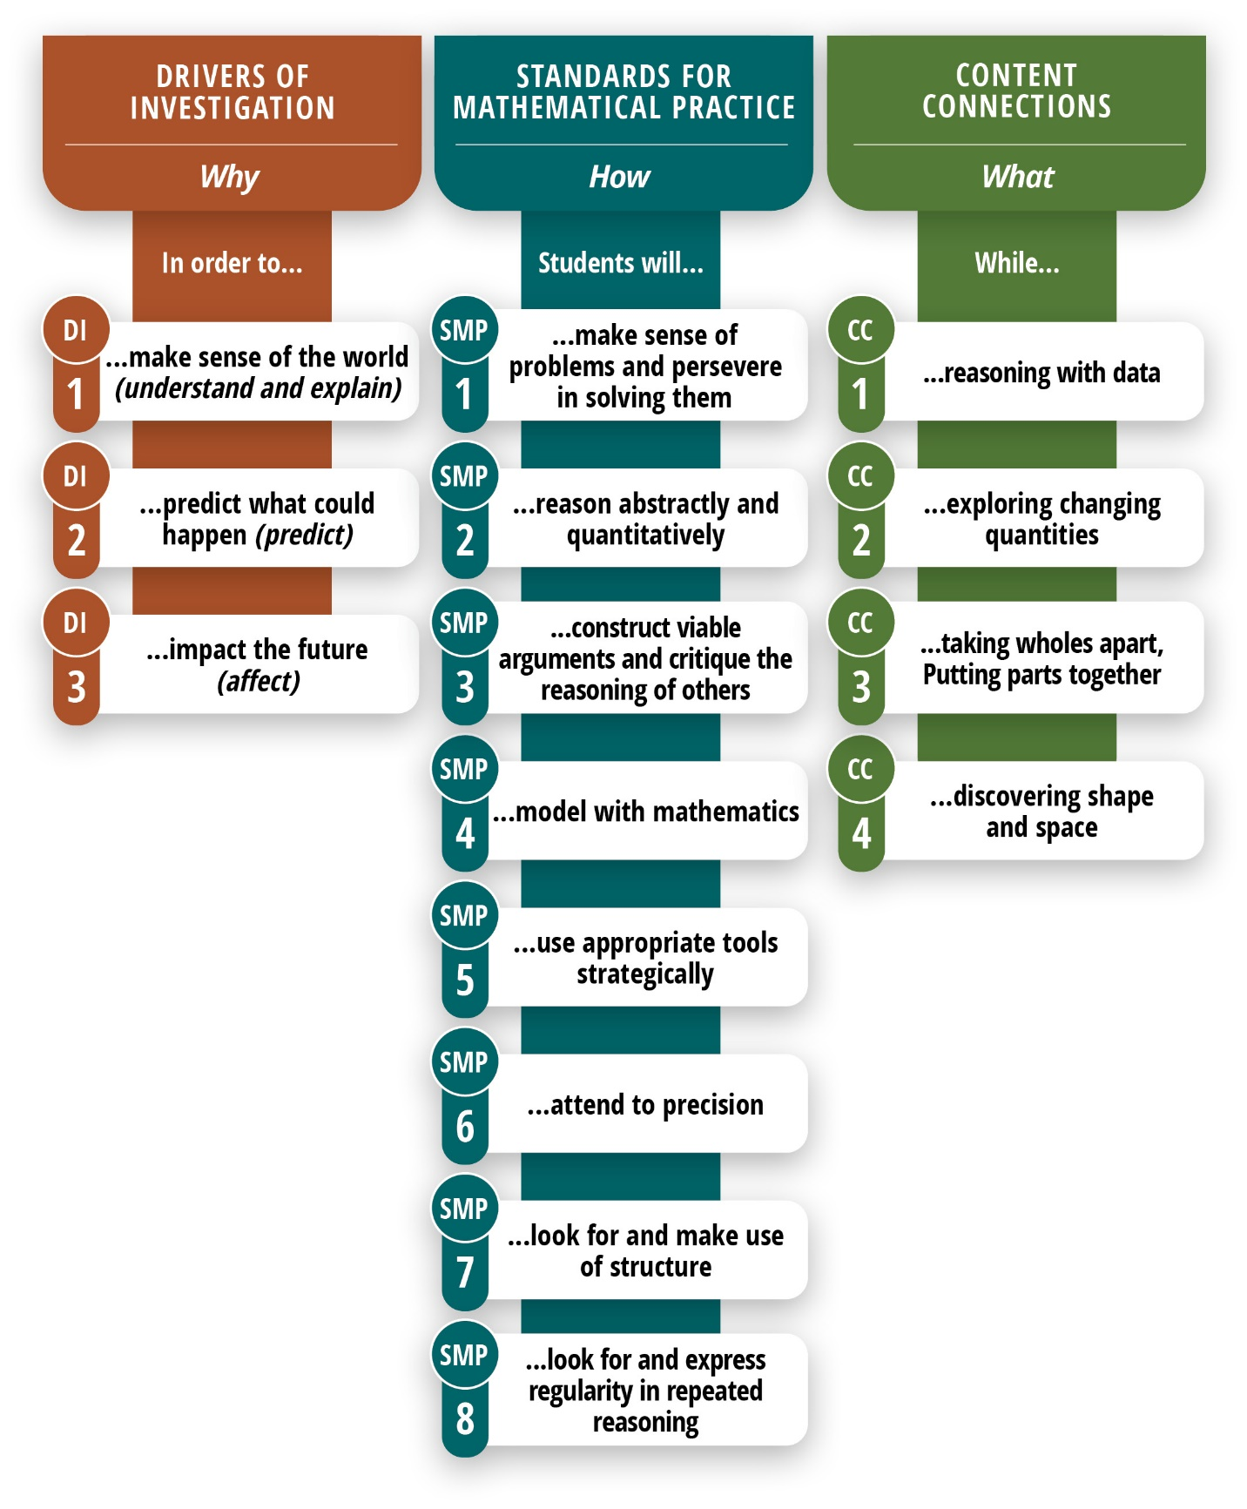
Long Description of figure 7.1
Figure 7.2 Drivers of Investigation, Standards for Mathematical Practices, and Content Connections
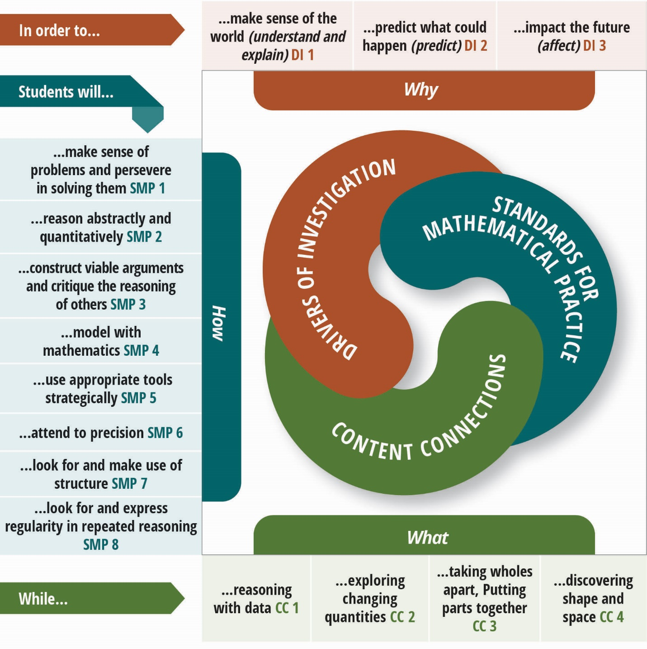
Long description of figure 7.2

The Importance of the Drivers of Investigation and Content Connections
While chapter five focuses on the SMPs, this chapter and chapter six (grades TK–5) are organized around Drivers of Investigation and Content Connections. The three DIs aim to ensure that there is always a reason to care about mathematical work and that investigations allow students to make sense, predict, and/or affect the world. The four CCs organize content and connect the big ideas—that is, provide mathematical coherence—throughout the grades.

Drivers of Investigation
DI1: Make sense of the world (understand and explain)
DI2: Predict what could happen (predict)
DI3: Impact the future (affect)

Content Connections
CC1: Reasoning with data
CC2: Exploring changing quantities
CC3: Taking wholes apart, putting parts together
CC4: Discovering shape and space
To teach the grade level’s big ideas, a teacher will design instructional activities that link one or more of the CCs with a DI—for example, link reasoning with data (CC1) to predict what could happen (DI2), or link exploring changing quantities (CC2) to impact the future (DI3). Because students actively engage in learning when they find purpose and meaning in the learning, instruction should primarily involve tasks that invite students to make sense of the big Ideas through investigation of questions in authentic contexts.
An authentic activity or task is one in which students investigate or struggle with situations or questions about which they actually wonder. Lesson design should be built to elicit that wondering. For example, environmental issues on the school campus or in the local community provide rich contexts for student investigations and mathematical analysis, which, concurrently, help students develop their understanding of California’s Environmental Principles and Concepts. A mathematics activity or task can be considered authentic if, as students attempt to understand the situation or carry out the task, they see the need to learn or use the mathematical idea or strategy.
The four CCs are of equal importance; they are not meant to be addressed sequentially. As captured in figure 7.2, Content Connections, Standards for Mathematical Practices, and Drivers of Investigation, there is considerable crossover between and among the practice standards and the content connections.
The content involved over the course of a single investigation cuts across several CA CCSSM domains—for example, it may involve both Measurement and Data (MD), Number and Operations in Base Ten (NBT), as well as Operations and Algebraic Thinking (OA). Students simultaneously employ several of the SMPs as they conduct their investigations.
The vignette Followed by a Whale exemplifies how the combination of DIs, CCs, and SMPs can provide a powerful three-dimensional form of learning for students. Integrating math with science and language arts, it features a task in which students learn the real-life story of a swimmer who is followed by a baby whale. The swimmer needs to decide if she should continue swimming to the shore, possibly beaching or endangering the baby whale, or swim out to a nearby oil rig where the whale’s mother may be located. To decide on a course of action, students must analyze proportional relationships, add fractions, use ratio reasoning, compare two different functions, and make use of data. They also need to account for ways their action will impact the future.

The Importance of the Standards for Mathematical Practices
The CA CCSSM offer grade-level-specific guidelines for what mathematics topics are considered essential to learn and for how students should engage in the discipline using the SMPs. The SMPs reflect the habits of mind and of interaction that form the basis of math learning—for example, reasoning, persevering in problem solving, and explaining one’s thinking. The SMPs provide clear intent for the types of productive actions and habits of thinking students engage in as they learn mathematics. As indicated by the joint statement released by the University of California, California State University, and Community College systems (Intersegmental Committee of the Academic Senates, 2013), the SMPs provide a sound foundation for the types of mathematical work expected in higher education.

Standards for Mathematical Practice
SMP1. Make sense of problems and persevere in solving them
SMP2. Reason abstractly and quantitatively
SMP3. Construct viable arguments and critique the reasoning of others.
SMP4. Model with mathematics
SMP5. Use appropriate tools strategically
SMP6. Attend to precision
SMP7. Look for and make use of structure
SMP8. Look for and express regularity in repeated reasoning
To teach mathematics for understanding, it is essential to purposefully cultivate students’ use of the practices. The introduction to the CA CCSSM is explicit on this point. Identifying content standards and practice standards as two halves of a powerful whole, it says effective mathematics instruction requires that the SMPs be taught as carefully and intentionally as the content standards (CA CCSSM, 3). The SMPs are designed to support students’ development across the school years. Whether in the primary grade levels or high school, for example, students make sense of problems and persevere to solve them (SMP.1).
The importance of the SMPs is discussed at length in chapter four, which provides additional guidance on how teachers can cultivate students’ skillful use of the practices. Using three interrelated SMPs for illustration, chapter four demonstrates how teachers across the grade levels can incorporate key mathematical practices and integrate them with each other to create powerful math experiences centered on exploring, discovering, and reasoning. Such experiences enable students to develop and extend their skillful use of the practices as they move through the progression of math content in the coming grade levels.
The SMPs are central to the mathematics classroom. From the earliest grades and on through the middle and higher grade levels, mathematics requires that students make sense of and work through problems, and students need the SMPs to successfully do so.

What is a Model?
Modeling, as used in the CA CCSSM, is primarily about using mathematics to describe the world. In elementary mathematics, a model might be a representation, such as a math drawing or a situation equation (operations and algebraic thinking), line plot, picture graph, or bar graph (measurement), or a building made of blocks (geometry). In grades six and seven, a model could be a table or plotted line (ratio and proportional reasoning) or box plot, scatter plot, or histogram (statistics and probability). In grade eight, students begin to use functions to model relationships between quantities. In high school, modeling becomes more complex, building on what students have learned in kindergarten through grade eight.
Representations such as tables or scatter plots often serve as intermediate steps in developing a model rather than serving as models themselves. The same representations and concrete objects used as models of real-life situations are used to understand mathematical or statistical concepts. The use of representations and physical objects to understand mathematics is sometimes referred to as “modeling mathematics,” and the associated representations and objects are sometimes called “models.”
Readers are encouraged to review current information about modeling in the CCSS progressions.
Because SMPs are linguistically demanding, as students learn and use them they develop both skill in the practices and the language needed for fully engaging in the discipline of mathematics. Regularly using the SMPs gives students opportunities to make sense of the specific linguistic features of the genres of mathematics, and to produce, reflect on, and revise their own mathematical communications. That being said, educators must remain aware of and provide support for students who may grasp a concept, yet struggle to express their understanding. For students who are English learners, as well as for students with other special learning needs, small-group instruction can be useful for helping students develop the language needed for engaging with the mathematical concepts and standards for an upcoming lesson. (See chapter four for further discussion.)
As students use the SMPs, teachers have the opportunity to engage in formative assessment and provide students with real-time feedback. Students can express an idea in their own words, build a concrete model, illustrate their thinking pictorially, and/or provide examples and possibly counter examples. A teacher might observe them making connections between ideas or applying a strategy appropriately in another related situation (Davis, 2006). Many useful indicators of deeper understanding are actually embedded in the SMPs themselves. For example, teachers can note when students analyze the relationships in a problem so that they, the students, can understand the situation and identify possible ways to solve the problem (SMP.1). Other examples of observable behaviors specified in the SMPs include students’ abilities to use mathematical reasoning to justify their ideas (SMP.3); draw diagrams of important features and relationships (SMP.4); select tools that are appropriate for solving the particular problem at hand (SMP.5); and accurately identify the symbols, units, and operations they use in solving problems (SMP.6).
Students who regularly use the SMPs in their mathematical work develop mental habits that enable them to approach novel problems, as well as routine procedural exercises, and to solve them with confidence, understanding, and accuracy. Specifically, recent research shows that an instructional approach focused on mathematical practices may be important in supporting student achievement on curricular standards and assessments and that it also contributes to students’ positive affect and interest in mathematics (Sengupta-Irving and Enyedy, 2014).

Investigating and Connecting, Grades Six Through Eight
In grades six through eight, students deepen their understanding of fractions developed in the earlier grades, especially division of fractions, and develop an understanding of ratios and proportions. These understandings bridge to a new type of numbers—rational numbers—that are inclusive of all the number types students have previously studied (whole numbers, integers, fractions, and decimals). Students connect ratios, rates, and percentages and use these ideas to engage in proportional reasoning as they solve authentic problems. By writing, interpreting, and using expressions and equations, students can solve multistep problem situations. By characterizing quantitative relationships using functions, they further develop understanding of rates and changing quantities. Measurement and classification ideas associated with two- and three-dimensional shapes and figures are connected to real-world and algebraic representations. Measurement questions extend to the need for measuring populations, using statistical inferences with sampling.
Rather than insisting on mastery of prior content or, especially, computational speed and recall, it is important for teachers to focus on ensuring that students have access to the content needed for the investigation at hand. (See chapter 3 for explanation of the framework’s interpretation of fluency as flexibility in thinking, rather than only as only speed in use of memorized facts.) Thus, tools that allow increased focus on sense-making and building number sense should be readily available. These include calculators and online tools, but also strategies and scaffolds centered on students who are English learners. When used strategically, such tools allow students greater access and can also support students’ completion of the mathematics assessments in the California Assessment of Student Performance and Progress (CAASPP).
These tools do not replace the as-needed reinforcement or continued development of students’ understanding of earlier grade-level concepts. However, instruction should enable students to engage in grade-level investigations without a remedial precursor. When grade-level activities entail a need for students to understand math content and practices they have previously encountered, but perhaps not mastered, students have an incentive and are therefore more ready to revisit and deepen their understanding of the earlier material.
A note on unfinished learning from previous grades: Students develop and learn at different times and rates. For this or other reasons, some start a new grade level with unfinished learning from earlier grade levels. In such cases, teachers should not automatically assume these students to be low achievers, require interventions, or need placement in a group that is learning standards from a lower grade level. Instead, teachers need to identify students’ learning needs and provide appropriate instructional support before considering interventions or any change in standards taught. Figure 7.3 (adapted from Fossum, 2018) provides a helpful guide for supporting for students with unfinished learning.
Figure 7.3 Supporting Students Who Have Unfinished Learning from Earlier Grades
Common Instructional Misstep | Recommended Alternative
Blindly adhering to a pacing guide calendar | Use formative data to gauge student understanding and inform pacing
Halting whole-class instruction to provide a broad review of past material | Provide just-in-time support within each unit or during intervention
Trying to address every gap a student has | Prioritize and address the most essential prerequisite skills and understanding for upcoming content
Trying to build missing understanding of past material from the ground up or going too far back in the learning progression | Trace the learning progression, diagnose, and go back just enough to provide access to grade-level material
Re-teaching students using previously failed methods and strategies | Provide a new experience to re-engage students, as appropriate (San Francisco Unified School District Mathematics Department, 2015)
Disconnecting intervention from content students are learning in math class | Connect learning experiences in intervention and universal instruction (CAST, 2018)
Choosing content for intervention based solely on students’ weakest areas | Focus on big ideas from current or previous grades as they relate to upcoming content
Teaching all standards addressed in an intervention in a step-by-step, procedural way | Consider the Aspect of Rigor called for in this framework (chapter 1) when designing and choosing tasks, activities, or learning experiences
Over-reliance on computer programs in intervention | Facilitate rich learning experiences for students to complete unfinished learning from previous or current grade
When students would benefit from extra support, it is advisable to offer them opportunities to engage with math in ways that differ from their previous math exposure—for example, by using more-visual approaches or using metaphorical models, such as a pan balance as an equation. Teachers and administrators at the middle-grade levels, as well as parents of students at these levels, are encouraged to read Chapter 9: Structuring School Experiences for Equity and Engagement. That chapter contains information for schools to consider as they structure activities, classes, and schedules that can meet the many and varied needs of math learners at these levels, including preparing all students for success in high school mathematics courses and beyond.

Support for English Learners
While some students, indeed, lag in math mastery, for others, what appears to be lack of understanding may be attributable, at least in part, to their inability to adequately communicate their understanding. Here, too, providing appropriate instructional support, for both content and language development is essential. In such cases, teachers can use scaffolds and supports specifically oriented to students who are English learners.
Instruction should always be designed to ensure that students at all levels of language development can engage deeply with the important mathematical ideas of the instruction (Walqui and van Lier, 2010). Principles and strategies for language development—especially important for students who are English learners, but valuable for all students—can be explored in Moschkovich (2013), Zwiers et al. (2017), and Zwiers (2018), among many others.
Among instructional principles that enable engagement for students across the broad spectrum of English language ability are
- focus on students’ mathematical reasoning, not accuracy in using language (Moschkovich, 2013);
- support sense-making (Zwiers et al., 2017);
- optimize output and cultivate conversation (Zwiers et al., 2017);
- use student conversations to foster reasoning and related language (Zwiers, 2018); and
- maximize linguistic and cognitive meta-awareness (Zwiers et al., 2017).
Deliberate instructional routines can support the implementation of these principles. The following recommendations reference the state’s ELD Standards they help achieve:
- Use iteration to help students develop stronger and clearer ideas and language (e.g., through successive pair-shares; asking students to students convince yourself, a friend, a skeptic). [CA ELD Standards Part I.A.1, Part I.B.5–6, Part I.C.9–12, Part II.B.3–5].
- Collect and display student thinking and sense-making language (e.g., gather and show student discourse; use number and data talks) [CA ELD Standards Part I.B.5–8].
- Have students critique, correct, and clarify the work of others (e.g., ask them to critique a partial or flawed response; have them use an always-sometimes-never organizer to evaluate mathematical statements) [CA ELD Standards Part I.A.1, Part I.B.5–6, Part I.C.9–12, Part II.B.3–5].
- Create a need for students to communicate by distributing information within a group (e.g., information-gap cards, games) [CA ELD Standards Part I.A.1–4, Part I.B.5].
- Have students to explore a context and to co-craft related questions and problems. [CA ELD Standards Part 1.A.1–4, Part I.B.5].
- Create opportunities for students to reflect on the way mathematical questions are presented, and equip them with tools for negotiating meaning (e.g., three reads; values/units chart) [CA ELD Standards Part I.5–8].
- Foster students’ meta-awareness and ability to make connections between approaches, representations, examples, and language (e.g., have them use compare-and-connect solution strategies; which one doesn’t belong?) [CA ELD Standards Part I.A.1, Part I.B.5–6, Part I.C.9–12, Part II.B.3–5].
- Support rich and inclusive discussions about mathematical ideas, representations, contexts, and strategies (Use whole-class discussion supports; have students do numbered heads together) (Zwiers et al., 2017) [CA ELD Standards Part I.A.1–4].
The generic term “English learner” masks a great deal of variability in students’ experiences. For students at secondary level, some researchers (e.g., Freeman and Freeman, 2002) group English learners by those who are newly arrived, which generally means within the last four or five years, and have a pre-arrival history of adequate schooling; those who are newly arrived and have a history of limited formal schooling; and those who are designated as long-term English learners.
By understanding students’ lives outside of school and their previous schooling experiences, schools can thoughtfully place students who are English learners in the appropriate, and supported, setting for learning mathematics. Older students who had sufficient opportunity for schooling before arriving are focused more on translating the content and building on their existing mathematics literacy skills. Students who had limited formal schooling benefit from programs with rich experiences in which they can develop academic literacy, perhaps even reading. For both of these student types, access to native language instruction serves as a bridge to instruction in English. Dual-language, bilingual programs, and other blended approaches can offer mathematics courses in a combination of students’ first language and of the target language, in this case English.
Students who are long-term English learners tend to have somewhat different characteristics from newly arrived English learners. Many are US-born and their entire education experience has been in US schools. Although they are generally native English speakers, English is not their home language and it’s for that reason they were placed in language development programs in their early grades. A formal exit from most of these programs requires students to demonstrate English proficiency on state-approved assessments and (usually) to also show on-grade-level academic performance. Many students cannot meet this high threshold, causing them to remain in language support programs for many years.
Among students who are long-term English learners, many can speak and write conversational English, both with their peers and with teachers. In this sense, they may be hard to distinguish from other English learners. These factors can mask their literacy needs, obscuring the support they require to succeed academically. Students who are long-term English learners tend to underperform and are often placed in lower academic tracks. Understanding this can help schools develop mathematics course pathways that are equitable, that provide the academic language scaffolding needed by these students need, and that provide such support without putting them into programs for students who are newly arrived English learners. Heterogeneous classrooms can provide a broader array of access points and supports for both new and long-term English learners.
Across these broad groups of students who are English learners, the basic components of effective programs remain the same. Students should learn content with rich thematic instruction that attends to big ideas and with challenging and connected content, in a learning environment that incorporates collaboration, feedback, language scaffolding, and respect for cultural diversity (Freeman and Freeman, 2002).

Content Connections Across the Big Ideas, Grades Six Through Eight
The big ideas for each grade level define the critical areas of instructional focus. By way of the Content Connections, the big ideas unfold in a progression across the grade levels, in accordance with the CA CCSSM principles of focus, coherence, and rigor. Figure 7.4, Progression Chart of Big Ideas through Grades Six Through Eight, identifies some of the big ideas for grades six through eight and indicates the CCs with which they are readily associated. The chart is followed by discussion of each CC, which highlights specific associated SMPs, content standards, and activities.
Later in this section, find, for each grade level from six through eight, a figure with a diagram of the big ideas for that grade level, as well as figure with a table of the CCs, big ideas, and standards specific to the grade level.
Figure 7.4: Progression Chart of Big Ideas, Grade Levels Six Through Eight
Content Connections | Big Ideas: Grade Six | Big Ideas: Grade Seven | Big Ideas: Grade Eight
Reasoning with Data | Variability in data | Visualize Populations | Data explorations
Reasoning with Data | The shape of distributions | Populations and samples | Data graphs and tables
Reasoning with Data | n/a | Probability Models | Interpret scatter plots
Exploring Changing Quantities | Fraction relationships | Proportional Relationships | Multiple representations of functions
Exploring Changing Quantities | Patterns inside numbers | Unit rates in the world | Linear equations
Exploring Changing Quantities | Generalizing with multiple representations | Graphing relationships | Slopes and intercepts
Exploring Changing Quantities | Relationships between variables | Scale Drawings | Interpret scatter plots
Taking Wholes Apart, Putting Parts Together | Model the world | Shapes in the world | Cylindrical investigations
Taking Wholes Apart, Putting Parts Together | Nets and Surface Area | 2-D and 3-D connections | Pythagorean explorations
Taking Wholes Apart, Putting Parts Together | n/a | Angle relationships | Big and small numbers
Discovering shape and space | Nets and Surface Area | Shapes in the world | Shape, number, and expressions
Discovering shape and space | Distance and direction | 2-D and 3-D connections | Pythagorean explorations
Discovering shape and space | Graphing shapes | Scale drawings | Cylindrical investigations
Discovering shape and space | n/a | Angle relationships | Transformational geometry
The following section explains the four Content Connections and provides examples for each.

CC1: Reasoning with Data
Grades six through eight mathematics courses should give prominence to statistical understanding and reasoning with and about data—reflecting the growing importance of data in most mathematical situations that students will encounter in their lives. In support of understanding and explaining their world, predicting it, and affecting it—all Drivers of Investigation—students will carry out investigations using data they have generated or have accessed from publicly available sources. These investigations help students see data investigations as integral to their own lives, including other disciplines they do or will study, such as science and social studies. Data-based investigations will draw from Content Connections, such as exploring changing quantities.
An example of a data investigation that integrates learning in different subjects is described in the vignette Crows, Seagulls, and School Lunches. The lesson described in the vignette gives students opportunities to wonder about a situation that directly affects them and generate questions based on what they wonder about: the gathering of different kinds of birds at the student eating area during and after lunchtimes. Drawing on environmental, scientific, and mathematical standards, the vignette also shows how an authentic inquiry in which students collect and analyze data can cover all three Drivers of Investigation, allowing students to reason with data in a way that helps them make sense of the world, predict what could happen, and impact the future.
The CA CCSSM articulate a range of new expectations for data literacy, statistics, and data sense-making in the middle grades, some of which are new to teachers—who are not likely to have been taught this content themselves. (For ways to ensure teacher support to rethink mathematics teaching and acquire needed skills and strategies, see chapter 10.) The content includes
- data in the world: exploration, interpretation, decision making, ethics;
- statistical variability: Describing, displaying, and comparing;
- sampling to understand a population: randomness, bias, how many?;
- multivariate thinking expressing dependence with functions and equations, to answer the question “are they related?”; and
- probability as the basis for data-based claims, the answer to the question, “what are the chances?”
As in earlier grade levels, students experience quantitative modeling as a tool to help them understand their worlds via a process that begins with wondering questions. The middle grades also mark the beginning of the mathematical modeling cycle (Pelesko, 2015; see box What is a Model? above), and more formal instruction and investigations with statistics, data science, and science (NGSS Lead States, 2013). (See also chapter 5.)
One important aspect of data literacy is highlighting for students how many of them—along with many adults—regularly surrender personal data, whether through apps, online purchases, or interactive video games—and helping them investigate the potential ramifications.
On the more positive side, students should develop an understanding of the new and creative ways data can be displayed, beyond bar graphs or pie charts. Ideal data visualizations to share with students to help develop their data literacy are interesting and relevant to students and that also display data in new ways for students or that have some quirks or features that make the visualization harder to read but may also make it more engaging. Instruction oriented to data literacy can start with a data talk (modeled after a number talk) that begins with a complex data visualization, in which students are asked, what do you notice, what do you wonder, what is going on in this visualization. The New York Times section “What is Going on in this Graph?” (NY Times, n.d.) provides current, topical, and novel representations of data that can serve as strong examples for data talks.
Data talks provide a space for students to consider and interpret a variety of data and data representations in a low-stakes, exploratory environment. After considering a particular visualization, provided along with any necessary supports and scaffolds (including those related to language) and enough time to process it, students discuss what they notice. This helps them engage in conversations in which they describe their observations and insights, including, for example, how the visual is structured, one or more questions that the data are answering, or any questions about the data that are not addressed by the visual or that, instead, are prompted the visual. Teachers need not be experts in the content displayed in the visual; in fact, when teachers field questions they cannot answer, they can use it as an opportunity to model the curiosity that comes when an answer is not known. That modeling demystifies a common notion among students that teachers have limitless knowledge; by doing so, it reinforces the idea that understanding is an ongoing endeavor for everyone and that curiosity is always an opportunity to understand more.
Data talks also offer a valuable way for teachers to be culturally responsive in their instruction by bringing in student experiences and helping students develop critical consciousness: the ability to identify, analyze, and solve real-world problems that result in social inequalities. Further detail and ideas for the teaching of data literacy and data science are given in chapter 5.
The vignette What’s a Fair Living Wage exemplifies lessons focused on a data visualization. In this case, one that helps students see how mathematics can inform their understanding of the world, including social justice issues (adapted from Berry et al., 2020). As students explore cases of different wage earners and their ability to make ends meet, they use systems of two linear equations to show how many hours of work at minimum wage are needed to afford rent in different states in the US.
Teachers can poll their students to find out about their interests and build lessons about data visualization around those interests, both to motivate learning and to bridge cultural divides in the classroom. While some students may not readily see connections between mathematics and sports, for example, data visualization is a powerful means of exploring performances of athletes. One example of a data visualization that students may enjoy shows the basketball shots of Warrior’s point guard Stephen Curry, as highlighted in chapter five; the data visualization is available on the statistics and analytics website FiveThirtyEight (2015). Another sports-oriented example, available from the National Collegiate Athletic Association, shares Division 1 women’s soccer games between 2017 and 2019 (approx. 6500 games). (YouCubed, 2020a.)
Online sources can provide rich datasets for students to explore and connect their learning to the big mathematical ideas at their grade level. For example, figure 7.5 shows a data visualization and website link that a teacher might use with her students to explore important environmental issues.
Figure 7.5 Environment-Oriented Data Visualization
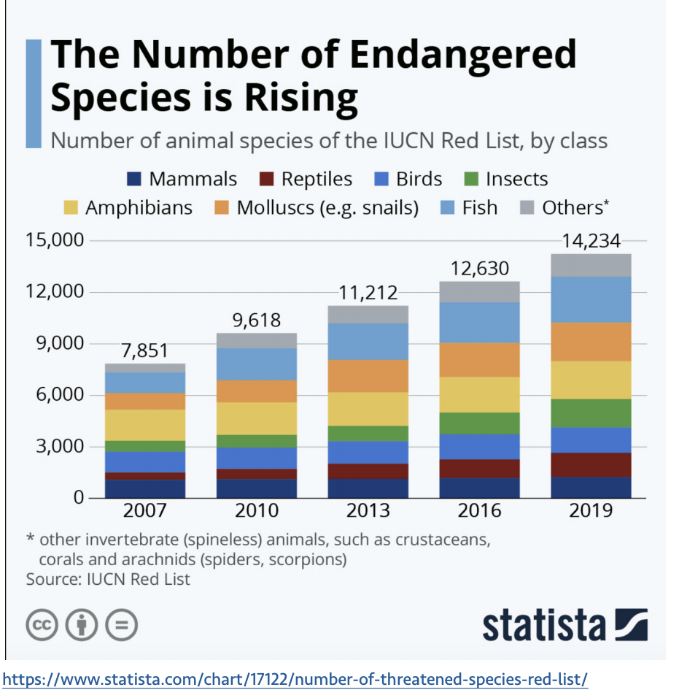
Long description of figure 7.5
Similarly, the Common Online Data Analysis Platform (CODAP, n.d.) enables students to explore data sets. When having students do so, teachers can encourage them to ask questions of the data—whether they are part of a data set teachers import into CODAP or one of the datasets it provides. In any of the data investigations, students can investigate patterns of association in bivariate data, visually exploring them by dragging two variables to the different axes in the CODAP tool. Students can collect survey data and compare the data with other previously collected survey data, drawing comparative inferences about two populations.
As the discussion and vignettes above illustrate, there are many ways in which middle school students can be invited to be data explorers, learning about tools and measures as they investigate questions they find interesting. In this way, students are able to learn many of the common statistical and data science ideas formally introduced in the middle grades—such as measures of center (mean, mode, median) and spread (range), but also address the additional clusters of emphasis from the standards included below (see chapter 5 for more information).

Content Connection 1 CA CCSSM Clusters of Emphasis
- 6.SP: Develop understanding of statistical variability. Summarize and describe distributions.
- 7.SP: Use random sampling to draw inferences about a population. Draw informal comparative inferences about two populations. Investigate chance processes and develop, use, and evaluate probability models.
- 8.SP: Investigate patterns of association in bivariate data.
- 8.EE: Understand the connections between proportional relationships, lines and linear equations.
- 6.RP: Understand ratio concepts and use ratio reasoning to solve problems.
- 7.RP Analyze proportional relationships and use them to solve real-world and mathematical problems.

CC2: Exploring Changing Quantities
Counting, organizing, adding, subtracting, multiplying, and dividing quantities have been of primary importance for much of students’ mathematics experiences in transitional kindergarten through grade five. In grade six, students are introduced to the idea that, in many cases, quantities act in concert rather than alone. Developing an understanding of how quantities can vary together begins with the transition from part-to-whole ratios (fractions) to other ratios that can be written in fraction form. The understanding of part: whole fractions established in grade levels three through five provides students with the foundation they need to explore other ratios, rates, and percents in grades six through eight. In grade six, students’ prior understanding of multiplication and division of whole numbers and fraction concepts, such as equivalence and fraction operations, contribute to their study of ratios, unit rates, and proportional relationships. In grade seven, students deepen their proportional reasoning as they investigate proportional relationships, determine unit rates, and work with two-variable equations. In grade eight, they build on their work with unit rates from grade six and proportional relationships from grade seven to compare graphs, tables, and equations of proportional relationships and form a pivotal understanding for the slope of a line as a type of unit rate. This learning progression culminates in grade eight with students’ introduction to functions as one of the most important types of co-varying relationships between two quantities. In a sense, in grades six through eight, students transition from an understanding of quantities as independent of one another to quantities that vary together.
Through investigations in this connected content area, students build many concrete examples of functions. CC2 connects easily with CC1: reasoning with data, through many rich modeling and statistics investigations. Specific contextualized examples of functions are crucial precursors to students’ work with such categories of functions as linear, exponential, quadratic, polynomial, and rational and to the abstract notion of function. Notice that the name of the CC calls out changing quantities, not changing numbers. In considering how quantities change, as opposed to strictly numbers, a greater variety of contexts and representations is possible, as are connections among quantities (e.g., relating paint and area). Functions referring to authentic contexts give students concrete representations that can support reasoning, providing multiple entry paths and reasoning strategies and require engaging in SMP.2 (Reason abstractly and quantitatively). Authentic contexts also help maintain and build connections between mathematical ideas and students’ lives.

Ratios and Proportions
Education research over the past several decades has focused on students’ understanding of ratios and proportional situations, largely because of the crucial bridge that ratios and proportions form between fractions (in elementary grades) and linear relationships (in high school grades). The type of thinking that students exhibit as they work on proportional situations is known as proportional reasoning, which Lamon (2012) defines as “reasoning up and down in situations in which there exists an invariant (constant) relationship between two quantities that are linked and varying together” (3). The researcher also points out that this type of reasoning goes well beyond simply setting up or solving equations of the form a/b = c/d (see also chapter 3 for issues that arise when cross-multiplying).
Lamon (1993) has characterized two dimensions of proportional reasoning, in general, as relative thinking and unitizing. Lamon describes relative thinking as the ability to compare quantities in problem situations, while unitizing is the ability to shift the perception of the unit (or whole/unit whole) to incorporate composite units. Activities and problems that foster the development of these dimensions of proportional reasoning should be utilized as possible. In general, emphasis should be placed on students’ ability to recognize the connections between representations of the quantities in problems and the connections between solution strategies, rather than on solely finding answers.
Carpenter et al. (1999) proposes four stages of students’ development of proportional reasoning:
- Level 1: Students focus on random calculations or additive differences in ratio work.
- Level 2: Students perceive a ratio as a single unit and can scale up or down the ratio, in a multiplicative or additive fashion, by scale factors that are whole numbers.
- Level 3: Students still conceive of a ratio as a single unit, but they can scale the ratio by non-integer amounts.
- Level 4: Students recognize and make use of the relationship within a ratio and between two equivalent ratios.
Steinthorsdottir and Sriraman’s 2009 investigation of the learning of proportions by middle-grade girls yielded evidence in support of providing sequenced tasks at all four levels to support students’ development of proportional reasoning. Specifically, the researchers found that tasks helping students to think about multiplicative relationships both between and within ratios were beneficial for students’ learning of proportions. The norms of productive discourse and provision of appropriate scaffolding further supported the learning.

Relative Thinking
The approaches described in the grade six vignette Mixing Paint illustrate the relative thinking described by Lamon (2012) and demonstrate a progression from understanding of ratios to understanding proportional reasoning by focusing on connections between differing viewpoints of the problem. In the vignette, students are given a recipe for Orange Sunglow Paint that calls for three parts of yellow paint to four parts of red paint. They are asked: How many parts of yellow are needed to make a batch that uses 20 parts of red paint?

Algebra
Algebra is often taught through symbols and symbol manipulation, but students benefit from approaching content in different ways. Mathematics with which students engage visually and through words is especially important to combine with number and symbol work. Approaching algebra visually enables students to see mathematics as a creative and connected subject. One of the most well-known and effective lessons for introducing students to thinking about algebra visually, and for helping them understand algebraic equivalence, is the “border problem.”
In this activity, students are asked to look briefly at a border around a square, like one shown in figure 7.6, below. Both the square and the border consist of some number of smaller squares, and students are asked to work out how many there are in the border, without counting them (see also Boaler and Humphreys, 2005). To prevent students from having time to count the squares, it is important that they can see the figure only briefly.
Students determine many different answers for the number of squares on the border—40, 38, and the correct answer of 36 are typical. A variety of responses—along with the teacher’s specific open-ended questions and academic conversation sentence frames—give teachers the opportunity to ask students to justify different answers, to construct viable arguments, and to critique the reasoning of others. As the lesson progresses, students think numerically and then verbally and eventually algebraically about ways to describe the number of squares in any border and the different ways in which students see the number. These different ways of seeing the border offer an opportunity for students to develop multiple ways of seeing and flexibly understanding algebraic equivalence.
Figure 7.6 Squares with Borders for Use in the Border Problem
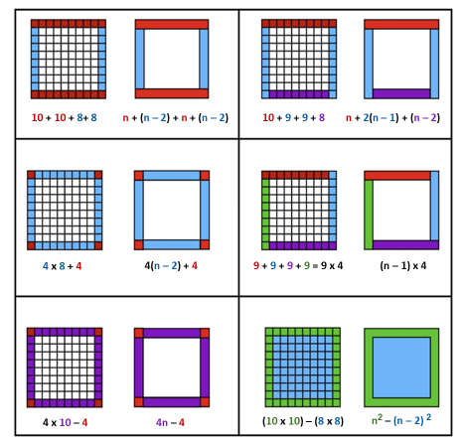
Long description of figure 7.6
Source (with full lesson plan): YouCubed, 2018.
Illustrating another aspect of teaching CC2, the vignette Equivalent Expressions—Integrated ELD and Mathematics portrays a teacher using a particular lesson to employ formative assessment strategies that allow him to gauge how well his students currently understand whether two expressions are equivalent.

CC3: Taking Wholes Apart and Putting Parts Together
Students enter the middle-grade levels with many experiences of taking wholes apart and putting parts together:
- Decomposing numbers by place value
- Assembling sub-products in an area representation of two-digit by two-digit multiplication
- Finding area of a plane figure by decomposing into rectangular or triangular pieces
- Exploring polygons and polyhedra in terms of faces, edges, vertices, and angles
Decomposing challenges and ideas into manageable pieces and assembling understanding of smaller parts into understanding of a larger whole are fundamental aspects of doing mathematics. Often these processes are closely tied with SMP.7 (Look for and make use of structure). This CC spans and connects many typically separate content clusters in number, algebra, and shape and space. Decomposing an area computation into parts can lead to an algebraic formulation as a quadratic expression, in which the terms in the expression have actual geometric meaning for students.
It is common to hear teacher stories of students who “know how to do all the parts, but can’t put them together.” Mathematics textbooks often handle this challenge by doing the intellectual work of assembly for the students (perhaps assuming that by reading repeated examples, students will eventually be able to replicate). Word problems that provide or identify the exact or relevant mathematical information for students, sub-problems that lay out intermediate calculations and all the reasoning, and references to worked examples that are almost identical to the problem a student must work are all ways of allowing students to avoid the need to assemble understanding rather than developing that ability.
Problems that are presented with insufficient or mathematically extraneous information; investigations that require students to decide how to decompose a problem, splitting their work into discrete segments, and, then assemble understanding at the conclusion; and problems that require piecing together factors affecting mathematical behavior (such as the function assembly problems in the high school section of chapter 4) are all ways to engage in this CC.
This CC can serve as a vehicle for student exploration of larger scale problems and projects, many of which will intersect with other CCs as well. Investigations in this CC require students to decompose challenges into manageable pieces and assemble understanding of smaller parts into understanding of a larger whole. When students conduct an investigation related to this CC, it is crucial that decomposing and assembly be a student task, not one that is taken on by teacher or text. It’s helpful to have students start with a simpler problem. In solving that simpler problem, students can gain insight into the essential aspects of larger scale problems. Mathematicians also regularly draw visual representations of relationships even when the ideas being explored are not geometric (Su, 2020).
In grades six through eight, this CC will be especially important, and helpful, as students develop understanding of the number system, Pythagorean theorem, scientific notation, and angles.

Unitizing
In the problem that is the basis for the snapshot Building Apartments, students unpack the notion of what constitutes the whole (also called the unit or unit whole). While identifying the whole is fundamental to understanding fractions in grades three through five (as described in chapters 3 and 6), it also is essential to students as they make sense of proportional situations (Lamon, 2012).

Snapshot: Building Apartments
Grade Level/Course: Grade six
Drivers of Investigation: 2, Predict What Could Happen
Content Connections: 3, Taking Wholes Apart and Putting Parts Together
Standards for Mathematical Practice: 1, Make sense of problems and persevere in solving them; 2, Reason abstractly and quantitatively; 3, Construct viable arguments and critique the reasoning of others; 4, Model with mathematics; 7, Look for and make use of structure; 8, Look for and express regularity in repeated reasoning

Content Connection 3 CA CCSSM Clusters of Emphasis
- 6.NS: Apply and extend previous understandings of multiplication and division to divide fractions by fractions. Compute fluently with multi-digit numbers and find common factors and multiples. Apply and extend previous understandings of numbers to the system of rational numbers.
- 6.EE: Apply and extend previous understandings of arithmetic to algebraic expressions. Reason about and solve one-variable equations and inequalities.
- 7.EE: Use properties of operations to generate equivalent expressions. Solve real-life and mathematical problems using numerical and algebraic expressions and equations.
- 6.RP: Understand ratio concepts and use ratio reasoning to solve problems.
- 7.RP Analyze proportional relationships and use them to solve real-world and mathematical problems.
- 7.NS: Apply and extend previous understandings of operations with fractions to add, subtract, multiply and divide rational numbers.
- 8.NS: Know that there are numbers that are not rational, and approximate them by rational numbers.
- 8.EE: Work with radicals and integer exponents. Understand the connections between proportional relationships, lines and linear equations. Analyze and solve linear equations and pairs of simultaneous linear equations.

Relevant CA CCSSM Content Clusters/Standards:
- 6.EE: Apply and extend previous understandings of arithmetic to algebraic expressions. Reason about and solve one-variable equations and inequalities.
- 6.RP: Understand ratio concepts and use ratio reasoning to solve problems.
- 7.RP Analyze proportional relationships and use them to solve real-world and mathematical problems.
Background: Ms. K often begins the day with her homeroom students by exploring school and community events and happenings. Today, she notices an article in the local newspaper about how bird nesting houses are being built in the park by the river. The birds of this species are highly social and prefer to have a variety of enclosures for mating and rearing their young. Since her class has been working on ratio and proportion problems, she sees an opportunity to connect an understanding of ornithology, specifically how environmental factors can influence organisms’ growth (NGSS, MS-LS-1-5), with an understanding of the relevant mathematics for that week. She asks students to work with a partner, and she poses the following situation for her class:
After analyzing local bird populations of a particular species, scientists determined that, in order to meet the bird community’s needs, multichamber houses are needed. Every time they build three single-chamber houses, they should build four two-chamber houses and one three-chamber house.
(adapted from Lamon, 1993)
Ms. K then asks each student pair to draft three questions about the given situation, after which she collects the questions on the board. She notices many of them touch on how many total chambers there could be or how many total birds can be accommodated. Because she has encouraged students to ask questions, they are able to develop their natural curiosity about ways that numbers, and groups of numbers, fit together. Many of the initial questions are about the reasons why some bird species like to live communally, which allows for a fascinating comparison between the preferred living arrangements of these particular birds and those of people. Four questions in particular seem fruitful to explore mathematically. After the class helps her further clarify them, she writes the final questions on the board and has each student pair choose one that the partners will investigate. She gives them 20 minutes, after which they will report their findings to the class by making a small poster. The questions are:
- Why do the birds like to build nests in the houses like this? Why not all single chamber houses, for example?
- How many houses of each kind are needed to accommodate a certain number of birds (like 50, 100 or 150)? Is there a pattern between the number of houses and number of birds?
- How many birds could be accommodated if a certain number of the houses (like 50 or 100) are built? Is there a relationship between the number of birds and number of houses?
- If the park only allows for a certain number of houses (like 50,100, 150) to be built, how many of each kind should there be? Is there a relationship between number of houses and how many of each kind?
As students work in pairs, Ms. K notices that many are drawing tables and diagrams to organize their work. In thinking about this problem, students need to be mindful of the many types of units (groups) involved in it: groups of each size house, groups of eight houses, total group of birds, total group of chambers, total group of houses. In attending to these different types of units (or wholes), students develop the understanding that there is flexibility in allocating how many parts are in a whole, and that this flexibility offers a new perspective when engaging in proportional reasoning.
(end snapshot)

CC4: Discovering Shape and Space
Students need mathematical tools to explore and understand the shape and space of the physical world; as such, teachers should continue to offer instruction that motivates such explorations. As in other aspects of math teaching and learning, maintaining connection to concrete situations and authentic questions is crucial and this content area could be investigated with any of the three Drivers of Investigation, to help students understand, predict or affect.
Geometric problem situations encourage different modes of thought than do numerical, algebraic, and computational situations. It is important to realize that “visual thinking” or “geometric reasoning” is as legitimate as algebraic or computational thinking; and, for some students, geometric thinking can provide access more readily than other modes to rich mathematical work (Driscoll et al., 2007). The CA CCSSM support this visual thinking by defining congruence and similarity in terms of dilations and rigid motions of the plane, and through its emphasis on physical models, transparencies, and geometry software.
As emphasized throughout this framework, flexibility in moving between different representations and points of view brings great mathematical power. Students should not experience geometry primarily as a way to formalize visual thinking into algebraic or numerical representations. Instead, they should have occasion to gain insight into situations presented numerically or algebraically by transforming them into geometric representations, as well as the more common algebraic or numerical representations of geometric situations. For example, students can use similar triangles to explore questions about integer-coordinate points on a line presented algebraically (Driscoll et al., 2017).
In grades three through five, students develop many foundational notions of two- and three-dimensional geometry, such as area (including surface area of three-dimensional figures), perimeter, angle measure, and volume. Shape and space work in grades six through eight is largely about connecting these notions to each other, to students’ lives, and to other areas of mathematics.
In grade six, for example, two-dimensional and three-dimensional figures are related to each other via nets and surface area (6.G.4), two-dimensional figures are related to algebraic representation via coordinate geometry (6.G.3), and volume is connected to fraction operations by exploring the size of a cube that could completely pack a shoebox with fractional edge lengths (6.G.2). (The vignette Learning About Shapes Through Sponge Art describes a sixth grade teacher supporting students in learning about shapes, using molding clay, since she has seen students struggle with 2-D representations of 3-D shapes as they were learning about surface area and volume.) In grade seven, relationships between angle or side measurements of two-dimensional figures and their overall shape (7.G.2), between three-dimensional figures and their two-dimensional slices (7.G.3), between linear and area measurements of two-dimensional figures (7.G.4), and between geometric concepts and real-world contexts (7.G.6) are all important foci.
In grade eight, two important relationships between different plane figures—congruence and similarity—are defined and explored in depth and used as contexts for reasoning in the manner discussed in chapter 4. The Pythagorean Theorem is developed as a relationship between an angle measure in a triangle and the area measures of three squares (8.G.6). Also, in grade eight, several clusters in the Expressions and Equations standards domain should sometimes be approached from a geometric point of view, with algebraic representations coming later: In an investigation, proportional relationships between quantities can be first encountered as a graph, leading to natural questions about points of intersection (8.EE.7, 8.EE.8) or the meaning of slope (8.EE.6).

The Big Ideas, Grades Six Through Eight
The foundational mathematics content—that is, the big ideas—progresses through transitional kindergarten through grade twelve in accordance with the CA CCSSM principles of focus, coherence, and rigor. As students explore and investigate the big ideas, they will engage with many different content standards and come to understand the connections between them.
Each grade-level-specific big-idea diagram below (figures 7.7, 7.9, and 7.11) shows the ideas as colored circles of varying sizes. A circle’s size indicates the relative importance of the idea it represents, as determined by the number of connections that particular idea has with other ideas. Big ideas are considered connected to one another when they enfold two or more of the same standards; the greater the number of standards one big idea shares with other big ideas, collectively, the more connected and important the idea is considered to be.
Each big idea diagram is followed by a figure (figures 7.8, 7.10, and 7.12, respectively) that reiterates the grade-specific big ideas and, for each idea, shows associated content connections and content standards, as well as providing some detail on how content standards can be addressed in the context of the CCs described in this framework. The figures provide a deeper look into how each big idea at each grade level is situated within a broader content connection, and how each big idea includes several CA CCSSM content standards. Given this nesting, teaching to these big ideas can be seen as an efficient form of standards-aligned instruction.
It should be said that there are many interpretations of big ideas in mathematics, and those presented in these figures are one variation. Providing mathematics teachers with adequate release time to collaborate with colleagues and engage in discussions around their vision of big ideas at their grade level or in a particular course can enable them to create rich, deep tasks that invite students to explore and grapple with those big ideas (Arbaugh and Brown, 2005).
Figure 7.7 Grade Six Big Ideas
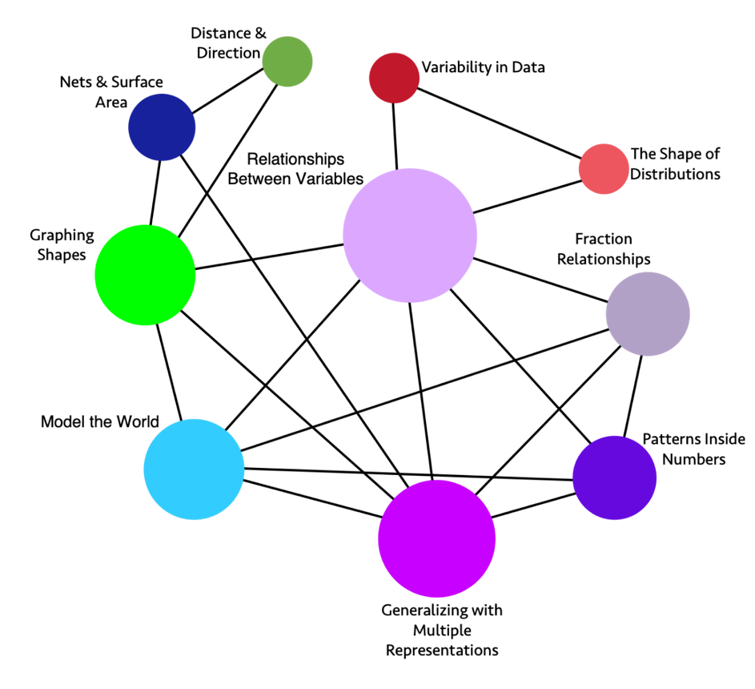
Long description of figure 7.7
Figure 7.8 Grade Six Content Connections, Big Ideas, and Content Standards
Content Connection | Big Idea | Grade Six Content Standards
Reasoning with Data | Variability in Data | SP.1, SP.5, SP.4: Investigate real world data sources, ask questions of data, start to understand variability - within data sets and across different forms of data, consider different types of data, and represent data with different representations.
Reasoning with Data | The Shape of Distributions | SP.2, SP.3, SP.5: Consider the distribution of data sets - look at their shape and consider measures of center and variability to describe the data and the situation which is being investigated.
Exploring Changing Quantities | Fraction Relationships | NS.1, RP.1, RP.3: Understand fractions divided by fractions, thinking about them in different ways (e.g., how many 1/3 are inside 2/3?), considering the relationship between the numerator and denominator, using different strategies and visuals. Relate fractions to ratios and percentages.
Exploring Changing Quantities | Patterns inside Numbers | NS.4, RP.3: Consider how numbers are made up, exploring factors and multiples, visually and numerically.
Exploring Changing Quantities | Generalizing with Multiple Representations | EE.6, EE.2, EE.7, EE.3, EE.4, RP.1, RP.2, RP.3: Generalize from growth or decay patterns, leading to an understanding of variables. Understand that a variable can represent a changing quantity or an unknown number. Analyze a mathematical situation that can be seen and solved in different ways and that leads to multiple representations and equivalent expressions. Where appropriate in solving problems, use unit rates.
Exploring Changing Quantities | Relationships Between Variables | EE.9, EE.5, RP.1, RP.2, RP.3, NS.8, SP.1, SP.2: Use independent and dependent variables to represent how a situation changes over time, recognizing unit rates when it is a linear relationship. Illustrate the relationship using tables, 4 quadrant graphs and equations, and understand the relationships between the different representations and what each one communicates.
Taking Wholes Apart, Putting Parts Together | Model the World | NS.3, NS.2, NS.8, RP.1, RP.2, RP.3: Solve and model real world problems. Add, subtract, multiply, and divide multi-digit numbers and decimals, in real-world and mathematical problems - with sense making and understanding, using visual models and algorithms.
Taking Wholes Apart, Putting Parts Together  and  Discovering Shape and Space | Nets and Surface Area | EE.1, EE.2, G.4, G.1, G.2, G.3: Build and decompose 3-D figures using nets to find surface area. Represent volume and area as expressions involving whole number exponents.
Discovering Shape and Space | Distance and Direction | NS.5, NS.6, NS.7, G.1, G.2, G.3, G.4: Students experience absolute value on numbers lines and relate it to distance, describing relationships, such as order between numbers using inequality statements.
Discovering Shape and Space | Graphing Shapes | G.3, G.1, G.4, NS.8, EE.2: Use coordinates to represent the vertices of polygons, graph the shapes on the coordinate plane, and determine side lengths, perimeter, and area.
Figure 7.9 Grade Seven Big Ideas
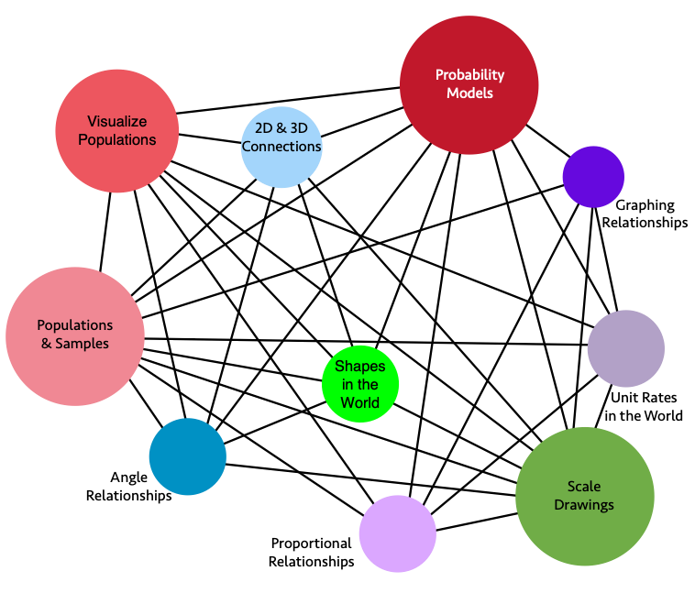
Long description of figure 7.9
Figure 7.10 Grade Seven Content Connections, Big Ideas, and Content Standards
Content Connection | Big Idea | Grade Seven Content Standards
Reasoning with Data | Populations and Samples | SP.1, SP.2, RP.1, RP.2, RP.3, NS.1, NS.2, NS.3, EE.3: Study a population by taking random samples and determine if the samples accurately represent the population.  - Analyze and critique reports by examining the sample and the claims made to the general population  - Use classroom simulations and computer software to model repeated sampling, analyzing the variation in results.
Reasoning with Data | Visualize Populations | SP.3, SP.4, NS.1, NS.2, NS.3, EE.3: Draw comparative inferences about populations - consider what visual plots show, and use measures of center and variability  - Students toggle between the mathematical results and their meaningful interpretation with their given context, considering audiences, implications, etc.
Reasoning with Data | Probability Models | SP.5, SP.6, SP.7, SP.8, RP.1, RP.2, RP.3, NS.1, NS.2, NS.3, EE.3: Develop a probability model and use it to find probabilities of events and compound events, representing sample spaces and using lists, tables, and tree diagrams.  - Compare observed probability and expected probability.  - Explore potential bias and over-representation in real world data sets, and connect to dominating narratives and counter narratives used in public discourse.
Exploring Changing Quantities | Proportional Relationships | EE.2, EE.3, RP.1, RP.2, RP.3: Explore, understand, and use proportional relationships: - using fractions, graphs, and tables.
Exploring Changing Quantities | Unit Rates in the World | RP.1, RP.2, RP.3, EE1, EE.2, EE.3, EE.4: Solve real world problems using equations and inequalities, and recognize the unit rate within representations.
Exploring Changing Quantities | Graphing Relationships | EE.4, RP.1, RP.2, RP.3: Solve problems involving proportional relationships that can lead to graphing using geometry software and making sense of solutions.
Taking Wholes Apart, Putting Parts Together  and  Discovering Shape and Space | 2-D and 3-D Connections | G.1, G.2, G.3, NS.1, NS.2, NS.3: Draw and construct shapes, slice 3-D figures to see the 2-D shapes. Compare and classify the figures and shapes using area, surface area, volume, and geometric classifications for triangles, polygons, and angles. Make sure to measure with fractions and decimals, using technology for calculations
Taking Wholes Apart, Putting Parts Together  and  Discovering Shape and Space | Angle Relationships | G.5, G.6, NS.1, NS.2, NS.3: Explore relationships between different angles, including complementary, supplementary, vertical, and adjacent, recognizing the relationships as the measures change. For example, angles A and B are complementary. As the measure of angle, A increases, the measure of angle B decreases.
Discovering Shape and Space  and  Exploring Changing Quantities | Scale Drawings | G.1, EE.2, EE.3, EE.4, NS.2, NS.3, RP.1, RP.2, RP.3: Solve problems involving scale drawings and construct geometric figures using unit rates to accurately represent real world figures. (Use technology for drawing)
Discovering Shape and Space  and  Exploring Changing Quantities | Shapes in the World | G.1, G.2, G.3, G.4, G.5, G.6, NS.1, NS.2, NS.3: Solve real life problems involving triangles, quadrilaterals, polygons, cubes, right prisms, and circles using angle measures, area, surface area, and volume.
Figure 7.11 Grade Eight Big Ideas
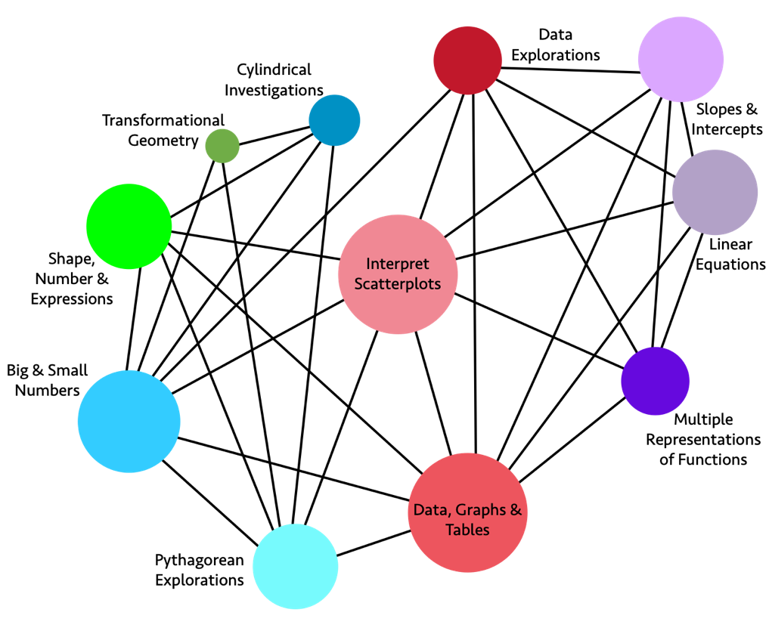
Long description of figure 7.11
Figure 7.12 Grade Eight Content Connections, Big Ideas, and Content Standards
Content Connection | Big Idea | Grade Eight Content Standards
Reasoning with Data  and  Exploring Changing Quantities | Interpret Scatter plots | SP.1, SP.2, SP.3, EE.2, EE.5, F.1, F.2, F.3: Construct and interpret data visualizations, including scatter plots for bivariate measurement data using two-way tables. Describe patterns noting whether the data appear in clusters, are linear or nonlinear, whether there are outliers, and if the association is negative or positive. Interpret the trend(s) in change of the data points over time.
Reasoning with Data | Data, Graphs, and Tables | SP.3, SP.4, EE.2, EE.5, F.3, F.4, F.5: Construct graphs of relationships between two variables (bivariate data), displaying frequencies and relative frequencies in a two-way table.  - Use graphs with categorical data to help students describe events in their lives, looking at patterns in the graphs.
Reasoning with Data | Data Explorations | SP.1, SP.2, SP.3, SP.4, EE.4, EE.5, F.1, F.2, F.3, F.4, F.5: Conduct data explorations, such as the consideration of seafloor spreading, involving large data sets and numbers expressed in scientific notation, including integer exponents for large and small numbers using technology.  - Identify a large dataset and discuss the information it contains  - Identify what rows and columns represent in a spreadsheet
Exploring Changing Quantities | Linear Equations | EE.5, EE.7, EE.8, F.2, F.4, F.5: Analyze slope and intercepts and solve linear equations including pairs of simultaneous linear equations through graphing and tables and using technology.
Exploring Changing Quantities | Multiple Representations of Functions | EE.5, EE.6, EE.7: Move between different representations of linear functions (i.e., equation, graph, table, and context), sketch and analyze graphs, use similar triangles to visualize slope and rate of change with equations containing rational number coefficients.
Exploring Changing Quantities | Slopes and Intercepts | EE.5, SP.1, SP.2, SP.3: Construct graphs using bivariate data, comparing the meaning of parallel and non-parallel slopes with the same or different y-intercepts using technology.
Taking Wholes Apart, Putting Parts Together  and  Discovering Shape and Space | Cylindrical Investigations | G.9, G.6, G.7, G.8, NS.1, NS.2: Solve real world problems with cylinders, cones, and spheres. Connect volume and surface area solutions to the structure of the figures themselves (e.g., why and how is the area of a circle formula used to find the volume of a cylinder?). Show visual proofs of these relationships, through modeling, building, and using computer software.
Taking Wholes Apart, Putting Parts Together  and  Discovering Shape and Space | Pythagorean Explorations | G.7, G.8, NS.1, NS.2, EE.1, EE.2: Conduct investigations in the coordinate plane with right triangles to show that the areas of the squares of each leg combine to create the square of the hypotenuse and name this as the Pythagorean Theorem. Using technology, use the Pythagorean Theorem to solve real world problems that include irrational numbers.
Taking Wholes Apart, Putting Parts Together | Big and Small Numbers | EE.1, EE.2, EE.3, EE.4, NS.1, NS.2: Use scientific notation to investigate problems that include measurements of very large and very small numbers. Develop number sense with integer exponents (e.g., 1/27 =1/3³ = 3⁻³).
Discovering Shape and Space | Shape, Number, and Expressions | G.9, G.6, G.7, G.8, EE.1, EE.2, NS.1, NS.2: Compare shapes containing circular measures to prisms. Note that cubes and squares represent unit measures for volume and surface area. See and use the connections between integer exponents and area and volume.
Discovering Shape and Space | Transformational Geometry | G.1, G.2, G.3, G.4, G.5, G.6, G.7, G.8: Plot two dimensional figures on a coordinate plane, using geometry software, noting similarity when dilations are performed and the corresponding angle measures maintain congruence. Perform translations, rotations, and reflections and notice when shapes maintain congruence.

Conclusion
The middle grades are critical years when students often decide whether they want to continue or dis-identify with mathematics. This chapter outlines a vision for middle school mathematics that engages students in problems that elicit curiosity about the world and prompt wondering about mathematical relationships. Mathematical explorations that students encounter in middle school can give them opportunities to appreciate mathematics, leading them to include math in their future plans. Classroom discussions can allow development of self-awareness as well as collaboration and social-emotional skills, as they learn to value the perspectives of others. Discussions of mathematical ideas also support all students, including English learners, in learning the language of mathematics.

Long Descriptions for Chapter 7

Figure 7.1 The Why, How, and What of Mathematics (accessible version)
Why  Drivers of Investigation | How  Standards for Mathematical Practice | What  Content Connections
In order to…  - Make Sense of the World (Understand and Explain)  - Predict What Could Happen (Predict)  - Impact the Future (Affect) | Students will…  - Make Sense of Problems and Persevere in Solving them  - Reason Abstractly and Quantitatively  - Construct Viable Arguments and Critique the Reasoning of Others  - Model with Mathematics  - Use Appropriate Tools Strategically  - Attend to Precision  - Look for and Make Use of Structure  - Look for and Express Regularity in Repeated Reasoning | While…  - Communicating Stories with Data  - Exploring Changing Quantities  - Taking Wholes Apart, Putting Parts Together  - Discovering Shape and Space
Return to figure 7.1 graphic

Figure 7.2 Drivers of Investigation, Mathematical Practices, and Content Connections
A spiral graphic shows how the Drivers of Investigation (DIs), Standards for Mathematical Practice (SMPs) and Content Connections (CCs) interact. The DIs are listed under “In order to...”: Make Sense of the World (Understand and Explain); Predict What Could Happen (Predict); Impact the Future (Affect). The SMPs are listed under “Students will...”: Make sense of problems and persevere in solving them; Reason abstractly and quantitatively; Construct viable arguments and critique the reasoning of others; Model with mathematics; Use appropriate tools strategically; Attend to precision; Look for and make use of structure; Look for and express regularity in repeated reasoning. Finally, the CCs are listed under, “While...”: Communicating Stories with Data; Exploring Changing Quantities; Taking Wholes Apart, Putting Parts Together; Discovering Shape and Space. Return to figure 7.2 graphic

Figure 7.5 Environment-Oriented Data Visualization
Bar graphs display with left axis representing number of endangered species on the IUCN Red List, by class, labeled from 0 to 15,000. Bottom axis is in years, 2007 to 2019, with one bar every three years, so five bars total. The bars increase in height to indicate that the number of endangered species has risen from 2007 to 2019. The height of the first bar, for year 2007, is 7,851, the second bar is 9,618 for year 2010, the third bar is 11,212 for year 2013, the fourth bar is 12,630 for year 2016, and the height of the last bar, for year 2019, is 14,234. The bars are also color coded to indicate more specificity for eight types of species: mammals, reptiles, amphibians, birds, insects, mollusks, fish and other (including other invertebrate [spineless] animals, such as crustaceans, corals, and arachnids [spiders, scorpions]). Source: IUCN Red List. Link is provided at bottom of graphic: https://www.statista.com/chart/17122/number-of-threatened-species-red-list/ Return to figure 7.5 graphic

Figure 7.6 Squares with Borders for Use in the Border Problem
Six rectangles include two squares each. Squares include borders comprised of various shadings. Rectangle one includes two squares shaded to indicate 10 + 10 + 8 + 8 and n + (n – 2) + n + n (n – 2). Rectangle two includes two squares shaded 10 + 9 + 9 + 8 and n + 2(n – 1) + (n – 2). Rectangle three includes two squares shaded 4 × 8 + 4 and 4(n – 2) + 4. Rectangle five includes two squares shaded 9 + 9 + 9 + 9 = 9 × 4 and (n – 1) × 4. Rectangle five includes two squares shaded 4 × 10 – 4 and 4n – 4. Rectangle six includes two squares shaded (10 × 10) – (8 × 8) and n squared – (n – 2) squared. Return to figure 7.6 graphic

Figure 7.7 Grade Six Big Ideas
The graphic illustrates the connections and relationships of some sixth-grade mathematics concepts. Direct connections include:
- Variability in Data directly connects to: The Shape of Distributions, Relationships Between Variables
- The Shape of Distributions directly connects to: Relationships Between Variables, Variability in Data
- Fraction Relationships directly connects to: Patterns Inside Numbers, Generalizing with Multiple Representations, Model the World, Relationships Between Variables
- Patterns Inside Numbers directly connects to: Fraction Relationships, Generalizing with Multiple Representations, Model the World, Relationships Between Variables
- Generalizing with Multiple Representations directly connects to: Patterns Inside Numbers, Fraction Relationships, Model the World, Relationships Between Variables, Nets & Surface Area, Graphing Shapes
- Model the World directly connects to: Fraction Relationships, Relationships Between Variables, Patterns Inside Numbers, Generalizing with Multiple Representations, Graphing Shapes
- Graphing Shapes directly connects to: Model the World, Generalizing with Multiple Representations, Relationships Between Variables, Distance & Direction, Nets & Surface
- Nets & Surface directly connects to: Graphing Shapes, Generalizing with Multiple Representations, Distance & Direction
- Distance & Direction directly connects to: Graphing Shapes, Nets & Surface Area
- Relationships Between Variables directly connects to: Variability in Data, The Shape of Distributions, Fraction Relationships, Patterns Inside Numbers, Generalizing with Multiple Representations, Model the World, Graphing Shapes
Return to figure 7.7 graphic

Figure 7.9 Grade Seven Big Ideas
The graphic illustrates the connections and relationships of some seventh-grade mathematics concepts. Direct connections include:
- Angle Relationships directly connects to: Scale Drawings, 2D & 3D Connections, Populations & Samples, Proportional Relationships, Shapes in the World, Visualize Populations, Probability Models
- Scale Drawings directly connects to: 2D & 3D Connections, Graphing Relationships, Populations & Samples, Unit Rates in the World, Proportional Relationships, Visualize Populations, Probability Models, Angle Relationships
- Graphing Relationships directly connects to: Populations & Samples, Unit Rates in the World, Proportional Relationships, Probability Models, Scale Drawings
- 2D & 3D Connections directly connects to: Scale Drawings, Angle Relationships, Probability Models, Proportional Relationships, Visualize Populations, Shapes in the World, Populations & Samples
- Populations & Samples directly connects to: 2D & 3D Connections, Scale Drawings, Angle Relationships, Probability Models, Proportional Relationships, Visualize Populations, Shapes in the World, Unit Rates in the World, Graphing Relationships
- Unit Rates in the World directly connects to: Populations & Samples, Graphing Relationships, Scale Drawings, Proportional Relationships, Probability Models, Visualize Populations
- Shapes in the World directly connects to: Populations & Samples, 2D & 3D Connections, Proportional Relationships, Scale Drawings, Angle Relationships, Probability Models, Visualize Populations
- Visualize Populations directly connects to: 2D & 3D Connections, Scale Drawings, Angle Relationships, Probability Models, Proportional Relationships, Populations & Samples, Shapes in the World, Unit Rates in the World
- Probability Models directly connects to: 2D & 3D Connections, Scale Drawings, Angle Relationships, Proportional Relationships, Visualize Populations, Shapes in the World, Unit Rates in the World, Graphing Relationships, Populations & Samples
- Proportional Relationships directly connects to: 2D & 3D Connections, Scale Drawings, Angle Relationships, Probability Models, Populations & Samples, Visualize Populations, Shapes in the World, Unit Rates in the World, Graphing Relationships
Return to figure 7.9 graphic

Figure 7.11 Grade Eight Big Ideas
The graphic illustrates the connections and relationships of some eighth-grade mathematics concepts. Direct connections include:
- Data Explorations directly connects to: Slopes & Intercepts, Linear Equations, Multiple Representations of Functions, Data Graphs & Tables, Interpret Scatter plots, Big & Small Numbers
- Slopes & Intercepts directly connects to: Linear Equations, Multiple Representations of Functions, Data Graphs & Tables, Interpret Scatter plots, Data Explorations
- Linear Equations directly connects to: Slopes & Intercepts, Data Explorations, Multiple Representations of Functions, Data Graphs & Tables, Interpret Scatter plots
- Multiple Representations of Functions directly connects to: Data Graphs & Tables, Interpret Scatter plots, Data Explorations, Slopes & Intercepts, Linear Equations
- Data Graphs & Tables directly connects to: Multiple Representations of Functions, Linear Equations, Slopes & Intercepts, Data Explorations, Interpret Scatter plots, Shape Number & Expressions, Big & Small Numbers, Pythagorean Explorations
- Pythagorean Explorations directly connects to: Data Graphs & Tables, Interpret Scatter plots, Cylindrical Investigations, Transformational Geometry, Shape Number & Expressions, Big & Small Numbers
- Big & Small Numbers directly connects to: Pythagorean Explorations, Data Graphs & Tables, Interpret Scatter plots, Data Explorations, Cylindrical Investigations, Transformational Geometry, Shape Number & Expressions
- Shape Number & Expressions directly connects to: Big & Small Numbers, Pythagorean Explorations, Data Graphs & Tables, Interpret Scatter plots, Cylindrical Investigations
- Transformational Geometry directly connects to: Big & Small Numbers, Pythagorean Explorations, Cylindrical Investigations
- Cylindrical Investigations directly connects to: Big & Small Numbers, Pythagorean Explorations, Shape Number & Expressions, Transformational Geometry
- Interpret Scatter plots directly connects to: Data Explorations, Slopes & Intercepts, Linear Equations, Multiple Representations of Functions, Data Graphs & Tables, Pythagorean Explorations, Big & Small Numbers, Shape Number & Expressions
Return to figure 7.11 graphic
California Department of Education, October 2023

