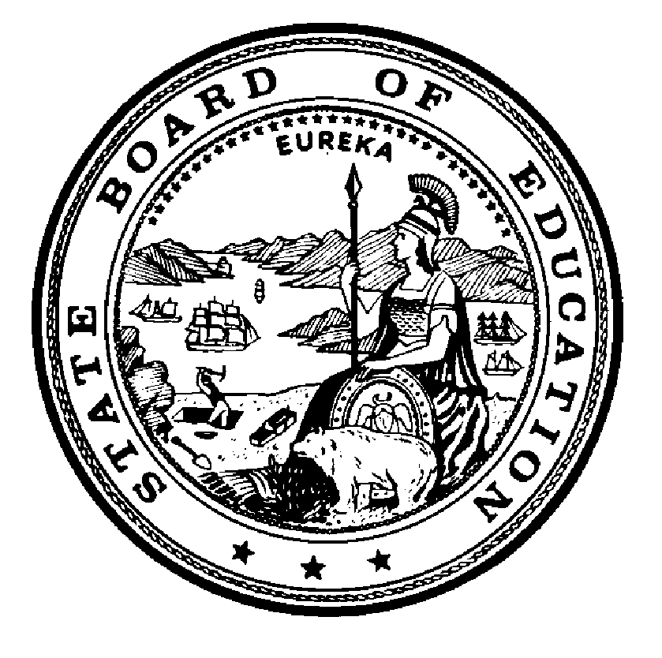

California State Board of Education
Final Minutes
April 12, 2018

Members Present
- Michael W. Kirst, President
- Ilene W. Straus, Vice President
- Sue Burr
- Bruce Holaday
- Feliza I. Ortiz-Licon
- Patricia A. Rucker
- Niki Sandoval
- Ting L. Sun
- Karen Valdes
- Trish Williams
- Jaden Gray, Student Member
- Tom Torlakson, SSPI

Members Absent
- None

Principal Staff
- Karen Stapf Walters, Executive Director, State Board of Education (SBE)
- Judy Cias, Chief Counsel, SBE
- Patricia de Cos, Deputy Executive Director, SBE
- David Sapp, Deputy Policy Director and Assistant Legal Counsel, SBE
- Janet Weeks, Director of Communications, SBE
- Laila Fahimuddin, Policy Consultant, SBE
- Sara Pietrowski, Policy Consultant, SBE
- Pamela Castleman, Education Programs Consultant, SBE
- Glen Price, Chief Deputy Superintendent, California Department of Education (CDE)
- Stephanie Papas, Education Policy Administrator I, CDE
- Tom Adams, Deputy Superintendent, CDE
- Keric Ashley, Deputy Superintendent, CDE
- Amy Holloway, General Counsel, CDE
- Edmundo Aguilar, Chief Counsel II, CDE
Please note that the complete proceedings of the April 12, 2018 State Board of Education meeting, including closed-captioning, are available online at: https://www.cde.ca.gov/be/ag/ag/sbewebcastarchive.asp

California State Board of Education
Public Session April 12, 2018
Thursday, April 12, 2018 – 1:30 p.m. Pacific Time ±
California Department of Education
1430 N Street, Room 1101
Sacramento, California 95814
- Call to Order
- Salute to the Flag
- Communications
- Announcements
- Report of the State Superintendent of Public Instruction
- Special Presentations
  - Public notice is hereby given that special presentations for informational purposes may take place during this session.
- Agenda Items
- Adjournment
Vice President Straus called the meeting to order at approximately 1:30 p.m.
Report of the State Superintendent of Public Instruction

AGENDA ITEMS DAY 1

Item 01
Subject: Update on the Development of the California State Plan for the Every Student Succeeds Act: Approval of the Revisions to the State Plan for Resubmission to the U.S. Department of Education.
Type of Action: Action, Information
CDE and SBE Recommendations: The CDE and SBE staff recommend that the SBE approve the revised State Plan for submission to the ED, pending the SBE Executive Director approval of final revisions requested by the SBE and correction of any typographical errors.
The CDE further recommends that the SBE delegate authority to CDE, subject to approval of the SBE Executive Director, to pursue, as expeditiously as possible so they can be resolved prior to release of the 2018 California School Dashboard, a waiver of ESSA statute for the English learner proficiency indicator (ESSA, Section 1111(c)(4)(C)(iv)) to allow California to maintain the current calculation that includes reclassified students and long-term English learners.
ACTION 1: Member Sun moved to approve the revisions to the ESSA State Plan.
Member Rucker seconded the motion.
Yes votes: Members Holaday, Gray, Sandoval, Williams, Sun, Kirst, Straus, Burr, Ortiz-Licon, Valdes, and Rucker.
No votes: None
Member Absent: None
Abstentions: None
Recusals: None
The motion passed with 11 votes.
ACTION 2: Member Sun moved to approve the staff recommendation to delegate authority to pursue a waiver on the ESSA statute for the English learner proficiency indicator.
Member Rucker seconded the motion.
Yes votes: Members Holaday, Gray, Sandoval, Williams, Sun, Kirst, Straus, Burr, Ortiz-Licon, Valdes, and Rucker.
No votes: None
Member Absent: None
Abstentions: None
Recusals: None
The motion passed with 11 votes.

Item 02
Subject: GENERAL PUBLIC COMMENT. Public Comment is invited on any matter not included on the printed agenda. Depending on the number of individuals wishing to address the State Board, the presiding officer may establish specific time limits on presentations.
Type of Action: Information
ACTION: No Action Taken.
MEETING ADJOURNED
President Kirst adjourned the meeting at approximately 3:21 p.m.

