English Language Arts/English Language Development Framework
A Guide for Tracing the Language Development Theme
Abstract
Language development is one of five key themes of a robust and comprehensive instructional program in ELA/literacy for all students. This guide is intended to support California educators in the use of the components within the ELA/ELD Framework that focus on language development, which is at the core of the California ELA/Literacy strands—Reading, Writing, Speaking and Listening, and Language.
California Department of Education
Curriculum Frameworks and Instructional Resources Division
March 2016
English Language Arts/English Language Development Framework
Tracing the Language Development Theme

Table of Contents
Purpose of This Guide 2
What is in This Guide 2
Recommended Approaches for Working with This Guide 3
Suggested Process 3
Convening Groups 4
Reading the ELA/ELD Framework 5
Language Development 6
Essential ELA/ELD Framework Resources 7
Discussion Based on the Reading 11
Reflection and Discussion Questions 13
Activity to Facilitate Implementation 15
Curriculum Frameworks and Instructional Resources, California Department of Education 1
March 2016

Purpose of This Guide
This guide is intended to support California educators (district administrators, principals, instructional coaches, department chairs, grade level leaders, classroom teachers) in the use of the components within the ELA/ELD Framework that focus on language development, which is at the core of the California ELA/Literacy strands—Reading, Writing, Speaking and Listening, and Language. The activities included here may be used in collaborative meetings or discussions to explore how language development should be the central purpose for students as they interact with text, produce text, participate in discussions, give presentations, and engage in research in all content areas.
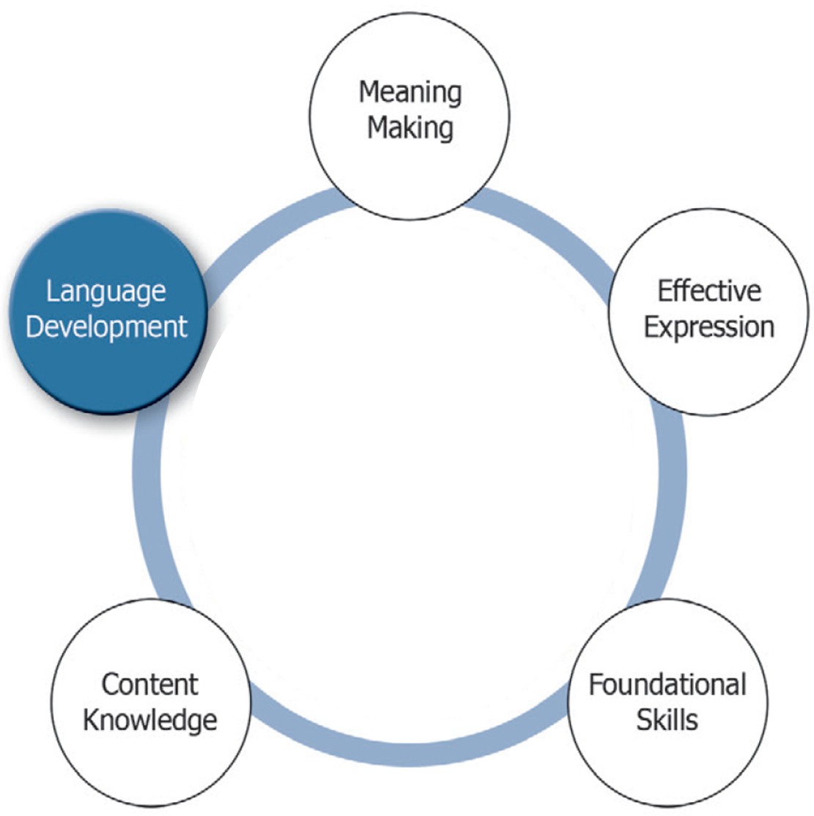

What is in This Guide
This guide offers a list of the components within the ELA/ELD Framework that focus on language development. Before delving into the resources identified for the language development theme, reading the “Introduction to the Framework” chapter in the ELA/ELD Framework is highly recommended as it provides an essential overview to the vision, guiding principles, and organization of the framework. After reading the “Introduction to the Framework,” the entry point in working with these resources could vary based on the level of individual expertise or the local program, school, or district priorities.
The driving goal of this document is to provide guidance to California educators in providing a robust and comprehensive instructional program in ELA/literacy for all students.

Recommended Approaches for Working with This Guide

Suggested Process
To help ensure that all individuals are informed and prepared to engage in examining and discussing the guidelines in the ELA/ELD Framework that address language development:
- Clarify the purpose for convening and the expectations of participants. (See examples under Convening Groups below for more information.)
  - A grade level team or cohort of high school teachers agrees to read the key passages and figures that pertain to language development for their grade level or grade span as a way to develop a shared view of the skills students need to develop and to identify a few strategies to implement to ensure students use language in increasingly sophisticated ways.
  - A cohort of instructional coaches discusses Figure 2.12. Academic Language; Figure 2.13. Categories of Vocabulary; and Figure 2.14. Understanding Register, and how the strategies can be used to develop a stronger sense of how language development might be implemented in the classroom, how they can articulate that it is a local priority, play a role in aligning resources to support its implementation, and/or include these practices in school/district plans.
  - A school leadership team (principal and teacher leaders) meet as a study group to gain a common understanding of the vision of language development in ELA/ELD in the framework, focusing on the sections and figures identified in Chapter 2, and talk about how to use the study guides to lead professional learning at grade-level meetings.
- Provide guidance on what participants will be reading, how they will be reading it, and what they will do after they read selections from the ELA/ELD Framework. (See Reading the ELA/ELD Framework below for more details.)
- After each meeting, participants set goals and identify indicators of progress toward attainment of goals. Facilitators keep participants informed of any progress made in response to their implementation action or input.
Convening Groups
When people are asked to be part of any meeting, they are being asked to commit their time, attention, and energy. When convening a group to engage in discussions that focus on language development, consider:
- Who should participate? What are the expectations of these participants? (Besides engaging in discussions, and implementing agreed-upon approaches to support a robust and comprehensive instructional program in ELA/literacy for all students, will participants also be expected to provide input on determining new initiatives?) What prior knowledge and experience, if any, should participants have in understanding the relationship between language development and literacy, reading comprehension, the writing process, structuring student discussions, facilitating student presentations, and organizing opportunities for students to engage in research?
- How will the purpose and objectives of the meeting(s) be communicated? How will the participants’ roles, time commitment, and other expectations be communicated?
- How will the participants’ interest and engagement be maintained? What strategies will be utilized to help establish or develop trust and mutual respect to encourage honest conversations and ensure all views are heard?
- Who can successfully design and facilitate effective meetings? Will this crucial role be designated to one individual, or will this responsibility be shared?
The time the group meets may be adjusted to accommodate longer discussions or time constraints. Suggested times for activities:
- Allow 20–30 minutes for participants to share responses to the reading. (See the section titled Discussion Based on the Reading.)
- Allow 20–30 minutes for participants to reflect and develop common agreements. (See the section titled Reflection and Discussion Questions.)
- Allow 20–30 minutes for participants to draft specific implementation activities. Completion of this task may be prolonged as information is gathered from appropriate stakeholders. (See the section titled Activity to Facilitate Implementation.)
Reading the ELA/ELD Framework
Reading and analyzing the resources highlighted in this guide can happen independently, before individuals meet, in order to best utilize participants’ discussion time. Those leading these activities (reading select portions of the ELA/ELD framework, facilitating discussions, and guiding the identification of strategies to implement) may ask participants to read the relevant sections and respond by using a strategy that supports meaning. This provides an opportunity for participants to utilize firsthand a strategy they may later choose to incorporate into their own practice. Some options include:
- Follow the Know, Think You Know, Want to Know protocol. Process:
  - Label chart paper with three columns: Know, Think You Know, Want to Know.
  - Give a topic to the groups and have them complete the charts.
  - Post the charts and have the group look for patterns and themes
- Follow the Focused Reading protocol. Process:
  - Members read and mark text for purposes, such as:
Affirms prior knowledge
! Surprises you
? You wish to know more about this
  - Within small groups and in round-robin fashion, members explore the items they marked. Each member shares only one item at a time.
  - Explore only items marked as ! or ?.
Sample prompts, graphic organizers, and templates are provided to support discussions and facilitate the identification of follow-up actions. These suggested activities can be found in the sections titled Reflection and Discussion Questions and Activities to Facilitate Implementation. These activities can be modified to align with appropriate program, school, or district priorities, as well as the expertise of the audience.

Language Development

Essential ELA/ELD Framework Resources
Note: Some section titles are provided in parentheses to assist the reader in locating the referenced content.
Ch. | Pages | Section Title | Select Figures and Snapshots
Intro-duction to the Framework | 1–14 | Introduction to the Framework | Fig. 1.1. Capacities of Literate Individuals  Fig. 1.2. Values for Educating English Learners
1 | 8 | (Guiding Principles)  – The responsibility for learners’ literacy and language development is shared | n/a
2 | 53 | Essential Considerations in ELA/Literacy and ELD Curriculum, Instruction, and Assessment | Fig. 2.1. Circles of Implementation of ELA/Literacy and ELD Instruction
2 | 69,  78–83 | Key Themes of ELA/Literacy and ELD Instruction – Language Development | Fig. 2.12. Academic Language  Fig. 2.13. Categories of Vocabulary  Fig. 2.14. Understanding Register
2 | 90 | Amplification of the Key Themes in the CA ELD Standards  – Language Development and Effective Expression | n/a
2 | 110–111 | A Focus on Language Development and Content: Promoting Collaborative Discussions About Content | n/a
3 | 141–145 | (Key Themes of ELA/Literacy and ELD Instruction)  – Language Development | Fig. 3.5. Selected Academic Vocabulary and Complex Grammatical Structures from Rumpelstiltskin by Paul O. Zelinsky  Fig. 3.6. Selected Academic Vocabulary and Complex Grammatical Structures from Surprising Sharks by Nicola Davies
3 | 172–174 | (Key Themes of ELA/Literacy and ELD Instruction in Transitional Kindergarten)  – Language Development | Fig. 3.14. California Preschool Learning Foundations Related to Language Development
3 | 205–207 | (Key Themes of ELA/Literacy and ELD Instruction in Kindergarten)  – Language Development | Fig. 3.22. Questions for The Little Red Hen by Vera Southgate
3 | 241–242 | (Key Themes of ELA/Literacy and ELD Instruction in Grade One)  – Meaning Making | n/a
4 | 293–298 | (Key Themes of ELA/Literacy and ELD Instruction)  – Language Development | Fig. 4.5. Sample Academic Language from Bunnicula: A Rabbit-Tale of Mystery by Deborah and James Howe  Fig. 4.6. Sample Academic Language from The Story of Snow: The Science of Winter’s Wonder by Mark Cassino with Jon Nelson
4 | 321 | (Key Themes of ELA/Literacy and ELD Instruction in Grade Two)  – Language Development | n/a
4 | 353–354 | (Key Themes of ELA/Literacy and ELD Instruction in Grade Three)  – Language Development | n/a
5 | 402–405 | (Key Themes of ELA/Literacy and ELD Instruction)  – Language Development | Fig. 5.4. Selected Academic Language from Where the Mountain Meets the Moon by Grace Lin  Fig. 5.5. Selected Academic Language from We Are the Ship: The Story of Negro League Baseball by Kadir Nelson
5 | 427–429 | (Key Themes of ELA/Literacy and ELD Instruction in Grade Four)  – Language Development | Fig. 5.10. Greek and Latin Roots
5 | 467 | (Key Themes of ELA/Literacy and ELD Instruction in Grade Five)  – Language Development | n/a
6 | 518–522 | (Key Themes of ELA/Literacy and ELD Instruction)  – Language Development | n/a
6 | 552–553 | (Key Themes of ELA/Literacy and ELD Instruction in Grade Six)  – Language Development | Snapshot 6.2. Reading Complex Texts About Slavery in Ancient History
6 | 588–589 | (Key Themes of ELA/Literacy and ELD Instruction in Grade Seven)  – Language Development | Snapshot 6.6. Analyzing and Discussing the Use of Language in Science Texts, Designated ELD Connected to Science in Grade Seven
6 | 619–622 | (Key Themes of ELA/Literacy and ELD Instruction in Grade Eight)  – Language Development | Fig. 6.27. Sentence Detective Practice  Snapshot 6.9. Developing and Defending an Argument, Integrated ELA/Literacy and Civic Learning Instruction in Grade Eight
7 | 681–685 | (Key Themes of ELA/Literacy and ELD Instruction)  – Language Development | n/a
7 | 726–727 | (Key Themes of ELA/Literacy and ELD Instruction in Grades Nine and Ten)  – Language Development | Snapshot 7.1. Investigating Language, Culture, and Society: Linguistic Autobiographies, Integrated ELA and ELD in Grade Nine
7 | 772–771 | (Key Themes of ELA/Literacy and ELD Instruction in Grades Eleven and Twelve)  – Language Development | Fig. 7.24. Noticing Language Activity (Syntax: Participial Modifiers)

Discussion Based on the Reading

Structure Opportunities to Share Insights from the Reading
Designate a facilitator. The facilitator guides participants to conduct a close reading of the language development guidelines and resources in the ELA/ELD Framework. Although the facilitator may choose any appropriate reading strategy, including those mentioned on page 5, the following tool may not only prompt participants to identify those language development guidelines that resonate with their practice, it might also prompt self-reflection.

Tracing the Language Development Theme
The tool on page 12 is designed to facilitate a close reading of the language development guidance and resources in the ELA/ELD Framework. Please note that the use of this tool is optional, and it can be modified to align with program, school, or district priorities, as well as the expertise of the audience. The sample included in the first row is provided to illustrate its use.
Directions:
- Each participant selects 3–4 statements or phrases from the sections they have read in the ELA/ELD Framework that focus on language development (see pages 7–10 for the ELA/ELD Framework resources focused on language development) and captures them in the first column, titled What the Text States.
- For each statement or phrase, in the column titled My Interpretation, the participant writes what it means to him/her.
- Participants then consider what practices the ELA/ELD Framework suggests, either explicitly or implicitly, that may have an implication on student learning activities or the participant’s practice that might best promote language development.
- Participants discuss their responses in pairs or small groups.
Note: Having the opportunity to collaborate with others in order to discuss or refine instructional modifications may further encourage an individual’s perseverance in effectively implementing the chosen practice.

Tracing the Language Development Theme
What the Text States | My Interpretation | Implications for my Students/my Practice
Example: “Some students may be unfamiliar with the language necessary to engage in some school tasks, such as participating in a debate about a controversial topic, writing an explanation about how something works in science, taking a stand in a discussion and supporting it with evidence, comprehending a historical account or a math problem in a textbook, or critiquing a story or novel.” (p. 69). | I think this is true for all students. This language gap may be due to a lack of opportunities to practice and develop these ways of using language and not a reflection of students. | Most of my students are chatty. Upon reflection, I’m noticing that most of the language they tend to use serves a social purpose—they are not as willing to talk when the conversation turns academic. So I need to make sure the tasks I structure for my students involve academic language development. Following Vygotsky’s Zone of Proximal Development model (or planned scaffolding as presented on p. 100 in the ELA/ELD Framework), I need to make sure my students use language, as various ELA standards state, in “increasingly sophisticated” ways. I need to be mindful that some students may need support to progress along the language development continuum.
[to be filled by educator] | [to be filled by educator] | [to be filled by educator]
[to be filled by educator] | [to be filled by educator] | [to be filled by educator]
[to be filled by educator] | [to be filled by educator] | [to be filled by educator]

Reflection and Discussion Questions

Identify Effective Assessment Practices to Implement that Support Language Development
Designate a facilitator. The facilitator guides participants to consider the following questions and prompts, based on the responses they captured in the previous activity in the Implications for my Students/my Practice column (see the Tracing the Language Development Theme activity on pages 11–12), then captures participants’ responses:
- Which practices are used in your classroom/program/school/district that are promoting students’ language development skills? What evidence indicates that these practices are effective for all students?
- As priorities change, students and teachers gain experience with new assessments, content/curriculum is realigned, or students’ needs evolve, some practices may no longer serve their original or intended purpose. Identify some practices that you may consider retiring.
- Similarly, as priorities change, students and teachers gain experience with new assessments, content/curriculum is realigned, or students’ needs evolve, some innovative or promising practices may be called for. Identify some practices that you may consider incorporating into your classroom/program/school/district that support language development
- Participants can capture their responses in the organizer titled Keep Doing, Stop Doing, Start Doing provided on page 14.

Keep Doing, Stop Doing, Start Doing
Keep Doing | Stop Doing | Start Doing
(Practices in your classroom/program/school/district with a proven, positive impact on language development skills) | (Practices to retire) | (Promising practices to implement)
[to be filled by educator] | [to be filled by educator] | [to be filled by educator]

Activity to Facilitate Implementation

Determine What Practices to Implement to Support Language Development
The instruction that supports language development you choose to implement may depend on students’ needs and local priorities. Consider which activities are the most important (those most likely to have an impact on student success) and which are the most urgent and cannot be put off until later. A third consideration is which actions you have the resources/capacity to implement.
Setting Goals and Keeping Track of the Success of Implementation
This tool is designed to guide the identification of a priority practice that supports language development. The sample included on page 16 is provided to illustrate its use. Please note that the use of this tool is optional, and it can be modified to align with program, school, or district priorities, as well as the expertise of the audience.
Directions:
- Each participant selects a priority practice to implement.
- For the chosen priority practice, each participant writes a measurable goal.
- Participants then consider what instructional modifications and support best promote the success of the goal.
- Participants periodically reflect on the growth students have made toward achieving the goal.
Sample Goals
Principal’s perspective: One hundred percent of the ELA, ELD, Math, Science, and History teachers (WHO) will employ at least one of five agreed-upon language development strategies (WHAT) regularly (WHEN) so that all students experience a coherent set of expectations and support as they develop increasingly sophisticated academic language skills (WHY).*
Instructional Coach’s/TOSA’s perspective: Ninety percent of [the teachers I am working with] (WHO) will incorporate tasks that require students to employ domain-specific and general academic vocabulary and phrases in reading, writing, speaking, and listening (WHAT) regularly and strategically (WHEN) so that all students improve their language skills (WHY).*
*These sample goals are provided as a reference only. As educators develop similar goals, they will likely further define parameters and ensure they are aligned to local priorities.
Setting Goals and Keeping Track of the Success of Implementation
(This sample reflects a teacher’s perspective)
Practice: Regularly build in opportunities during class for students to purposefully use language in increasingly sophisticated ways.
Measurable Goal: One hundred percent of my students (WHO) will regularly use “domain-specific and general academic vocabulary and phrases in reading, writing, speaking, and listening” (ELA/ELD Framework p. 19) (WHAT) every day, as appropriate to the content and the task at hand (WHEN) so that they use language in increasingly sophisticated ways. (WHY).
Instructional Modifications:
- I will communicate to students the language expectations, along with content objectives.
- I will look for opportunities to emphasize the need for students to be more thorough and more precise in their verbal exchanges and in their writing.
- I will model those same expectations and intentionally employ clear, precise language myself!
I need to be mindful that some students may need support to progress along the language development continuum. (Note to self—use word walls, sentence starters; ask colleagues for additional ideas.)
Growth
Date: 10/16
Letty and Toua seem to need reminders (but not sentence frames) before they use clear, precise language. The word wall is proving to be very useful for them!
I have encouraged some Emerging and Expanding ELs to either write or practice saying what they will be sharing out to the class. Most other students have been responding more quickly.
Date: 10/22
All students have embraced the expectation that they use language in increasingly sophisticated ways. The phrase I use to prompt them to use domain-specific or more precise academic vocabulary is, “Try that again.” By now they are aware of the tools they can use (the word wall and sometimes the sentence starters).
Date: 11/4
The number of times I need to prompt students to use precise language continues to decrease. And occasionally, students say, “I’d like to try that again,” when they consider that they can articulate an idea more accurately.
Setting Goals and Keeping Track of the Success of Implementation

Practice:
Measurable Goal | Instructional Modifications | Growth
[to be filled by educator] | [to be filled by educator] | Date:

