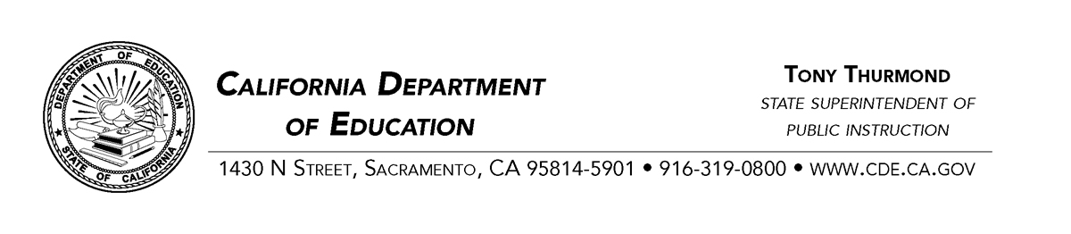
June 1, 2023
Dear County Superintendents, Administrators including Charter Schools, and Principals:

School Safety Legislation
Assembly Bill 452 Pupil safety: parental notification, firearm safety laws
Senate Bill 906 School safety: homicide threats
Effective July 1, 2023
There is an urgent need to ensure parent and guardian responsibility for safe storage of firearms and prevention of access to firearms. It is also critically important for all schools, districts, and county offices of education to engage multidisciplinary behavioral threat assessment teams to assist in identifying student behavior that could lead to homicidal incidents, to intervene swiftly and effectively to prevent such disasters, and to address identified mental health needs of students.
Two bills were legislated in response to the alarming increase in school shootings in California and throughout the United States, some of which are committed by children who have access to firearms and whose actions lead to injuries and death that could have been prevented.
This communication provides an overview of the new laws and a link to model content for parent and guardian notification of California laws regarding safe storage of firearms and prevention of child access to weapons.
The California Legislature has found and declared the following:
- Firearms are the third leading cause of death of children in America. Every day, eight children and teens are shot in instances of family fire, which is a shooting involving an improperly stored or misused gun found in the home resulting in injury or death.
- Data shows that 75 percent of school shootings are facilitated by children having access to unsecured or unsupervised firearms at home. Eighty-seven percent of children know where their parents’ firearms are stored and 60 percent report that they have handled them.
- Over 80 percent of teens who have died by suicide used a firearm that belonged to someone in their home.
- Data suggest that 93 percent of school shooters planned their attacks in advance and exhibited concerning behavior and communications.

Assembly Bill (AB) 452 Pupil safety: parental notification, firearm safety laws.
Section 48986 is added to the Education Code requiring that beginning on July 1, 2023, all kindergarten through grade twelve school districts, county offices of education (COEs), and charter schools shall annually inform parents and guardians of California’s child access prevention laws and laws relating to the safe storage of firearms at the beginning of the first semester or quarter of the regular school term. You can find AB 452 on the California Legislative Information web page at https://leginfo.legislature.ca.gov/faces/billTextClient.xhtml?bill_id=202120220AB452.
Senate Bill (SB) 906 School safety: homicide threats.
Sections 49390 through 49395 are added to the EC. This bill seeks to address homicidal threats in middle and high schools and applies only to local educational agencies that serve pupils in any grades from 6-12 as part of a middle school or high school. LEAs serving these pupils must include information about child access prevention laws and laws relating to the safe storage of firearms in the annual notifications to parents/guardians at the beginning of the first semester or quarter of the regular school term. The law states that school officials are required to report homicidal threats or perceived threats, as defined, to law enforcement who must conduct an immediate investigation and threat assessment, as defined. You can find SB 906 on the California Legislative Information web page at https://leginfo.legislature.ca.gov/faces/billNavClient.xhtml?bill_id=202120220SB906.
Parent/guardian annual notification that satisfies the model content requirement of AB452 and SB906 can be found here https://www.cde.ca.gov/ls/ss/vp/documents/safefirearmseng.docx.
It is our collective responsibility to ensure that students, staff, families, and communities are as prepared and safe as possible. Thank you for your attention and commitment to school safety.
If there are questions, please contact the School Health and Safety Office by email at SHSO@cde.ca.gov.
Sincerely,
Tony Thurmond
State Superintendent of Public Instruction
TT:nz

