California Department of Education  SBE-002 (REV 05/17/04) | info-cib-pdd-apr05item01
State of California | Department of Education

Information memorandum

Date: | March 23, 2005

TO: | Members, STATE BOARD of EDucation

FROM: | Sue Stickel, Deputy Superintendent  Curriculum and Instruction Branch

SUBJECT: | National Board Certified Teachers: Distribution of California Teachers

With the announcement of 443 new National Board Certified Teachers (NBCTs) in November 2004, the number of NBCTs in California increased to 3,087. Nationwide, 8,056 teachers earned national certification in 2004, bringing the national total to 40,200. A directory of these exemplary teachers is available at http://www.nbpts.org/nbct/directory.cfm with search parameters of name, state, city, district, or certification area.

California is fourth in the nation in the number of teachers holding national certification. The following graph illustrates the growth in the number of NBCTs since 1994, when the first group of teachers earned certification from the National Board for Professional Teaching Standards (NBPTS.)

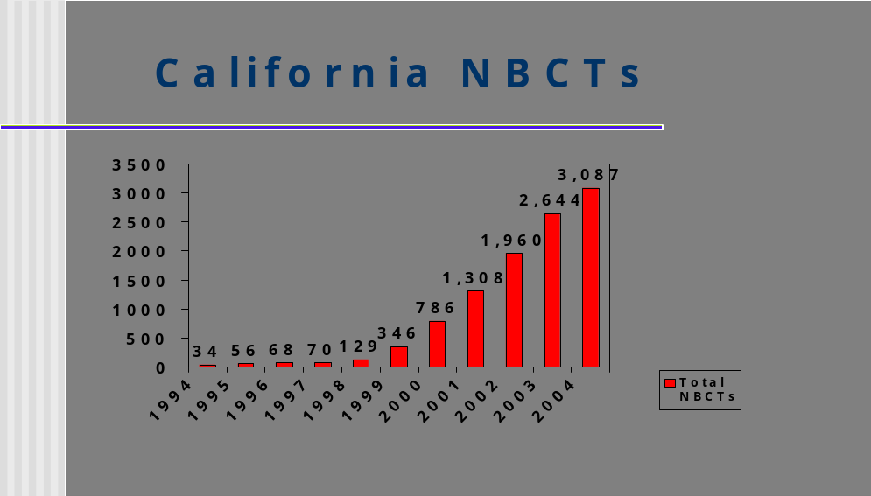

California Education Code Section 44395 provides a $20,000 incentive for NBCTs who teach in high-priority schools, paid over four consecutive years. Approximately
50 percent of these teachers received a $5,000 payment for the 2003-04 school year.

Several recent studies describe the effectiveness of NBCTs:
- Research by The CNA Corporation (November 2004) found that students of NBCTs did a measurably better job than other ninth and tenth graders on year-end math tests in Miami-Dade County (FL) Public Schools. All else being equal -student characteristics, school environment, and teacher preparation - teachers who had achieved National Board Certification helped their students achieve larger testing gains than did colleagues without the certification. The study isolated the effects of National Board Certification from other factors that could influence student learning and testing gains, such as teacher experience and education levels, per-pupil spending, school size, student performance above or below grade level and student motivation. The full text of the CAN Miami-/Dade research report is available at http://www.can.org/documents/CavaluzzoStudy.pdf
- Research by Arizona State University (September 2004) found that students of NBCTs outperformed students of non-NBCTs on the Stanford-9 Achievement Test, with learning gains equivalent on average to spending more than an extra month in school each year. The study compared test scores of third, fourth, fifth, and sixth grade students in fourteen Arizona school districts. The full text of the Arizona State University report is available at http://espaa.asu.edu/epaa/v12n46/.
- Research by the University of Washington and The Urban Institute (March 2004) found that students of NBCTs realized year-end testing improvements averaging 7 to 15 percent more than peers whose teachers were not NBCTs. The researchers studied the annual test scores of North Carolina students in grades three, four and five from three academic years: 1996-97, 1997-98, and 1998-99. Data for the study came from the North Carolina Department of Public Instruction, which has an accountability system that allows researchers to link student and teacher records over time. Over 600,000 student records in reading and mathematics were successfully linked to individual teachers, thus yielding pre-test and post-test scores. The full text of the university of Washington/Urban Institute report, which documented similar gains in student achievement, is available at http://www.crpe.org/workingpapers/pdf/NBPTSquality_report.pdf.

A National Board certificate attests that a teacher was judged by his or her peers as one who is accomplished, makes sound professional judgments about students, and acts effectively on those judgments. It allows teachers to gauge their skills and knowledge against objective standards of advanced practice. National Board Certification complements, but does not replace state licensing. While state-licensing systems set entry-level standards for novice teachers, National Board Certification establishes advanced standards for experienced teachers.

For each of 24 certificate areas, the NBPTS offers a performance-based assessment, which takes from one to three years to complete. The assessment process includes two components:
National Board Certified Teachers…
Page 4 of 4

- Candidates must submit a portfolio comprised of three classroom-based entries, including videos, to document the candidate’s teaching practice. The fourth entry documents the teacher’s work with students’ families and the community as well as the teacher’s professional growth.

- Candidates are also required to sit for a three-hour assessment of their content knowledge.

National Board Certification raises the quality of the teaching profession. It creates a high standard for the profession and the process leading to national certification offers high quality professional development. Accomplished teachers form the core of the teaching profession. Their knowledge and leadership are central to any effort to educate each of our students to high academic standards.

Of the 321 school districts with NBCTs, the following thirty-six districts have ten or more.

Anaheim City SD | Los Angeles USD | San Diego City USD
Baldwin Park USD | Manhattan Beach USD | San Francisco USD
Chaffey Joint Union HSD | New Haven USD | San Juan USD
Chula Vista ESD | Oakland USD | Santa Ana USD
Claremont USD | Palo Alto USD | Santa Clara USD
East Side Union HSD | Pasadena USD | Santa Monica Blvd. Charter
Folsom-Cordova USD | Placentia-Yorba Linda USD | Santa Monica-Malibu USD
Glendale USD | Poway USD | Sequoia Union HSD
Grossmont Union HSD | Riverside USD | Tamalpais Union HSD
La Mesa-Spring Valley SD | Rocklin USD | Walnut Valley USD
Lennox ESD | Salinas Union HSD | Whittier Union HSD
Long Beach USD | San Bernardino City USD | William S. Hart Union HSD

NBCTs are distributed throughout the state.

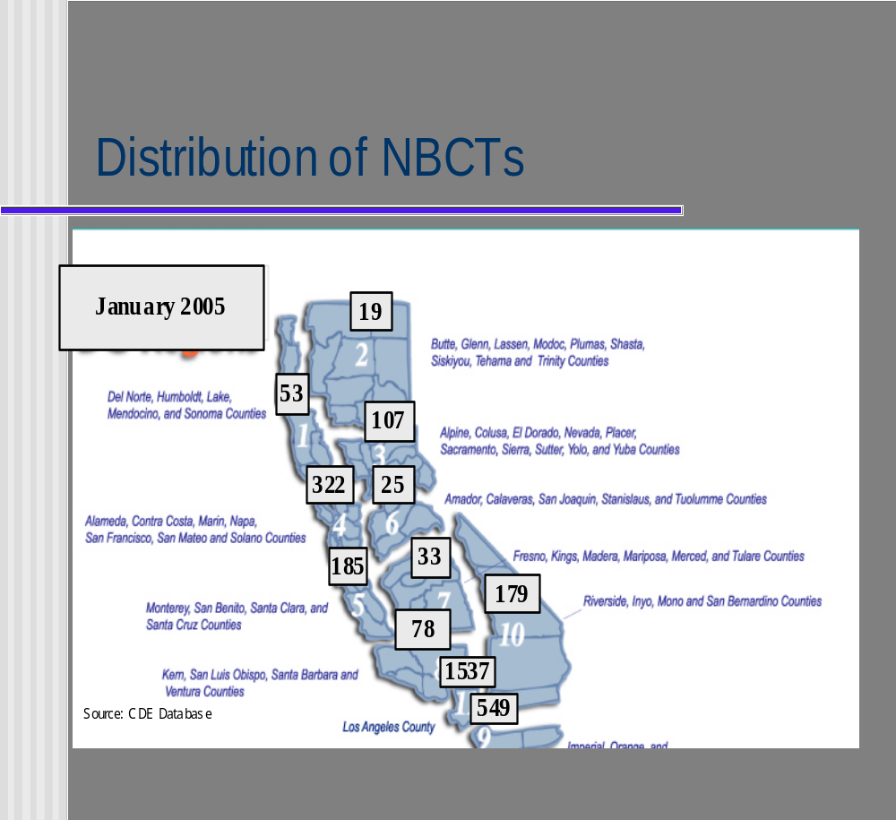

Additional information regarding National Board certification for California teachers is available at http://www.cde.ca.gov/pd/ps/te/nbpts.asp.

