Mathematics Framework
Adopted by the State Board of Education on July 12, 2023
Page 1 of 43

Mathematics Framework
Chapter 1: Mathematics for All: Purpose, Understanding, and Connection

Mathematics Framework Chapter 1: Mathematics for All: Purpose, Understanding, and Connection 1
Introduction 3
Audience 4
Why Learn Mathematics? 5
What We Know about How Students Learn Mathematics 7
Mathematics as Launchpad or Gatekeeper: How to Ensure Equity 10
Teaching the Big Ideas 15
Designing Instruction to Investigate and Connect the Why, How, and What of Mathematics 18
Drivers of Investigation 22
Standards for Mathematical Practice 23
Content Connections 23
How the Big Ideas Embody Focus, Coherence, and Rigor 25
Focus 25
Coherence 27
Rigor 30
Assessing for Focus, Coherence, and Rigor 33
Emphases of the Framework, by Chapter 34
Conclusion 38
Long Descriptions of Graphics for Chapter 1 39
Note to reader: The use of the non-binary, singular pronouns they, them, their, theirs, themself, and themselves in this framework is intentional.

Introduction
A society without mathematical affection is like a city without concerts, parks, or museums. To miss out on mathematics is to live without an opportunity to play with beautiful ideas and see the world in a new light.
—Francis Su (2020)
Welcome to the 2023 Mathematics Framework for California Public Schools, Kindergarten Through Grade Twelve (Mathematics Framework). This framework serves as a guide to implementing the California Common Core State Standards for Mathematics (CA CCSSM or the Standards), adopted in 2010 and updated in 2013. Built upon underlying and updated principles of focus, coherence, and rigor, the standards map out what California students need to know and be able to do, grade by grade, in mathematics.
The standards hold the promise of enabling all California students to become powerful users of mathematics in order to better understand and positively impact the world—in their careers, in college, and in civic life. The Mathematics Framework provides guidance to California educators in their role of helping fulfill that promise. It lays out the curricular and instructional approaches that research and evidence show will afford all students the opportunities they need to learn meaningful and rigorous mathematics, meet the standards, access pathways to high level math courses, and achieve success.
To help educators attain the goal of ensuring deep, active learning of mathematics for all students, this framework is centered around the investigation of big ideas in mathematics, connected to each other and to authentic, real world contexts and taught in multidimensional ways (see page 14) that meet varied learning needs. While this approach to mathematics education is a tall order, research shows that it is the means to both teach math effectively and make it accessible to all students. This framework invites readers to reimagine mathematics and move toward a new century of mathematical excellence for all.

Audience
The Mathematics Framework is intended to serve many different audiences, each of which contributes to the shared mission of helping all students become powerful users of mathematics as envisioned in the CA CCSSM. First and foremost, the Mathematics Framework is written for teachers and those educators who have the most direct relationship with students around their developing proficiency in mathematics. As in every academic subject, developing powerful thinking requires contributions from many, meaning that this framework is also directed to:
- parents and caretakers of transitional kindergarten through grade twelve (TK–12) students who represent crucial partners in supporting their students’ mathematical success;
- designers and authors of curricular materials whose products help teachers to implement the standards through engaging, authentic classroom instruction;
- educators leading pre-service and teacher preparation programs whose students face a daunting but exciting challenge of preparing to engage diverse students in meaningful, coherent mathematics;
- professional learning providers who can help teachers navigate deep mathematical and pedagogical questions as they strive to create coherent K–12 mathematical journeys for their students;
- instructional coaches and other key allies supporting teachers to improve students’ experiences of mathematics;
- site, district, and county administrators to support improvement in mathematics experiences for their students;
- college and university instructors of California high school graduates who wish to use the framework in concert with the standards to understand the types of knowledge, skills, and mindsets about mathematics that they can expect of incoming students;
- educators focused on other disciplines so that they can see opportunities for supporting their discipline-specific instructional goals while simultaneously reinforcing relevant mathematics concepts and skills; and
- assessment writers who create curriculum, state, and national tests that signal which content is important and the determine ways students should engage in the content.
The framework includes both snapshots and vignettes—classroom examples that illustrate for readers what the framework’s instructional approach looks like in action and how it facilitates the building of the big ideas of mathematics across the grades. Snapshots are shorter examples that are included in the text throughout the framework. Vignettes are longer and are referenced in chapters with a link to the full vignette in the appendix.

Why Learn Mathematics?
Without mathematics, there’s nothing you can do. Everything around you is mathematics. Everything around you is numbers.
—Shakuntala Devi, Author and “Human Calculator”
Mathematics grows out of curiosity about the world. Humans are born with an intuitive sense of numerical magnitude (Feigenson, Dehaene, and Spelke, 2004). In the early years of life, this sense develops into knowledge of number words, numerals, and the quantities they represent. Babies with a set of blocks will build and order them, fascinated by the ways the edges line up. Count a group of objects with a young child, move the objects and count them again, and the child is enchanted by still having the same number.
Human minds want to see and understand patterns (Devlin, 2006). Mathematics is at the heart of humanity and the natural world. Birds fly in V formations. Bees use hexagons to build honeycombs. The number pi can be found in the shapes of rivers as they bend into loops, and seashells bring the Fibonacci sequence to life. Even outside of nature, mathematics engenders wonder. What calculations were used to build the Pyramids? How do suspension bridges work? What innovations led to the moon landing, the Internet? Yet most of us did not get the chance to wonder mathematically in school. Instead, young children’s joy and fascination are too often replaced by dread and dislike when mathematics is introduced as a fixed set of methods to accept and remember.
This framework lays out an approach to curriculum and instruction that harnesses and builds on students’ curiosity and sense of wonder about the mathematics they see around them. Students learn that math enriches life and that the ability to use mathematics fluently – flexibly, efficiently and accurately – empowers people to influence their lives, communities, careers, and the larger world in important ways. For example, in everyday life, math applies to cooking, personal finance, and buying decisions. In the community, algebra can help explain how quickly water can become contaminated and how many people drinking that water can become ill each year. In the larger world, statistics and probability help us understand the risks of earthquakes and other such events and can even predict what and how ideas spread.
In the earliest grades, young students’ work in mathematics is firmly rooted in their experiences in the world (Piaget and Cook, 1952). Numbers name quantities of objects or measurements such as time and distance, and objects or measurements illustrate such operations as addition and subtraction. Soon, the set of whole numbers itself becomes a context that is concrete enough for students to grow curious about and to reason within—with real-world and visual representations always available to support reasoning.
Students who use mathematics powerfully can maintain this connection between mathematical ideas and the relevance of these ideas to meaningful contexts. At some point between the primary grades and high school graduation, however, too many students lose that sense of connection. They are left wondering, what does this have to do with me or my experiences? Why do I need to know this? Absent tasks or projects that enable them to experience that connection and purpose, they end up seeing mathematics as an exercise in memorized procedures that match different problem types. Critical thinking and reasoning skills barely seem to apply. Yet these are the very skills university professors and employers want in high school graduates. A robust understanding of mathematics forms an essential component for many careers in the rapidly-changing and increasingly technology-oriented world of the twenty-first century.
This framework takes the stance that all students are capable of accessing and achieving success in school mathematics in the ways envisioned in the standards. That is, students become inclined and able to consider novel situations (arising either within or outside mathematics) through a variety of appropriate mathematical tools. In turn, successful students can use those tools to understand the situation and, when desired, to exert their own power to affect the situation. Thus, mathematical power is not reserved for a few, but available to all.

What We Know about How Students Learn Mathematics
Students learn best when they are actively engaged in questioning, struggling, problem solving, reasoning, communicating, making connections, and explaining—in other words, when they are making sense of the world around them. The research is clear that powerful mathematics classrooms are places that nurture student agency in math. Students are willing to engage in “productive struggle” because they believe their efforts will result in progress. They understand that the intellectual authority of mathematics rests in mathematical reasoning itself—mathematics makes sense! (Nasir, 2002; Gresalfi et al., 2009; Martin, 2009; Boaler and Staples, 2008). In these classrooms, mathematics represents far more than calculating. Active-learning experiences enable students to engage in a full range of mathematical activities—exploring, noticing, questioning, solving, justifying, explaining, representing, and analyzing. Through these experiences, students develop identities as powerful math learners and users.
Decades of neuroscience research have revealed that there is no single “math area” in the brain, but rather sets of interconnected brain areas that support mathematical learning and performance (Feigenson, Dehaene, and Spelke, 2004; Hyde, 2011). When students engage in mathematical tasks, they are recruiting both domain-specific and domain-general brain systems, and the pattern of activation across these systems differs depending on the type of mathematical task the students are performing (Vogel and De Smedt, 2021; Sokolowski, Hawes, and Ansari, 2023). In addition, growing evidence about “brain plasticity” underscores the fact that the more one uses the brain in particular ways, the more capacity the brain has to think in those ways. One study conducted by neuroscientists in Stanford’s School of Medicine examined the effects of a tutoring intervention with students who had been diagnosed as having mathematical “learning disabilities” and those with no identified difficulties in mathematics (Iuculano et al., 2015). Prior to the intervention, the group of students with identified “learning disabilities” had lower mathematics performance and different brain activation patterns than students who had no identified difficulties in mathematics. After eight weeks of one-on-one tutoring focused on strengthening student understanding of relationships between and within operations, not only did both sets of students demonstrate comparable achievement, but they also exhibited comparable brain activation patterns across multiple functional systems (Iuculano et al., 2015). This study is promising, insofar as it suggests that well-designed and focused math experiences may support brain plasticity that enables students to access and engage more productively in the content.
All mathematical ideas can be considered in different ways––visually; through touch or movement; through building, modeling, writing and words; through apps, games and other digital interfaces; or through numbers and algorithms. The tasks used in classrooms should offer multiple ways to engage with and represent mathematical ideas. Multiple representations can help maintain the high cognitive demand of the task for students (Stein et al., 2000) and invite students to engage in the ideas visually; through touch or movement; through building, modeling, writing and words; through apps, games and other digital interfaces; or through numbers and algorithms. Such tasks have been found to support students with learning differences (Lambert and Sugita, 2016) as well as high achievers seeking greater challenges (Freiman, 2018). The guidelines in Universal Design for Learning (or UDL), which are designed to support learning for all, illustrate how to teach in a multidimensional way using multiple forms of engagement, representation, and expression (CAST, 2018).
The advances in what is known about how students learn mathematics have not been consistently incorporated in U.S. mathematics education as they have been in many other high-achieving countries. As figure 1.1 shows, the U.S. now ranks about 32nd in the world in mathematics on the Programme for International Student Assessment (PISA), well below the average among participating Organisation for Economic Co-operation and Development (OECD) countries. This reflects both how the U.S. teaches mathematics and how its systems have tolerated inequality in funding, staffing, and curriculum access. Studies of high achieving countries find that their standards (or national course of study) guiding content are fewer and higher, with greater coherence (Schmidt, Houang, and Cogan, 2002). Topics are studied more deeply, with applications to real world problems. Instructional practices include collaborative problem-solving strategies, heterogeneously grouped classrooms, and an integrated approach to mathematics from grade school through high school.
Figure 1.1 Mathematics Performance (PISA)
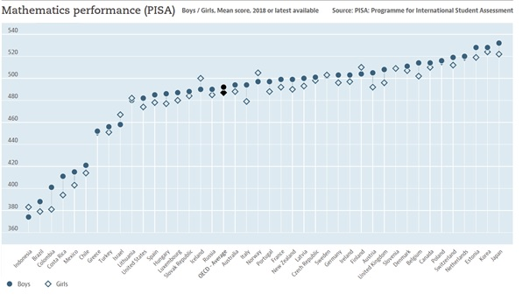
Long description of figure 1.1
Source: Organisation for Economic Cooperation and Development, 2021 (https://data.oecd.org/pisa/mathematics-performance-pisa.htm).
The Common Core standards, including the CA CCSSM, are based on research about how high-achieving countries organize and teach mathematics. There is still work to be done to reach the kind of curriculum organization and teaching that allows for consistently high achievement in mathematics, and the urgency is clear. Besides this country’s nationwide lag relative to other advanced countries, California fourth graders and eighth graders score in the bottom third of states (NAEP, 2022). Only 33 percent of students met or exceeded math achievement standards on California’s most recently reported state tests (CDE, n.d.). Moreover, the data lay bare a serious equity issue. There are significant racial and socioeconomic math achievement gaps; Black, American Indian or Alaska Native, and Latino students in particular are, on average, lower-achieving on state and national tests.

Mathematics as Launchpad or Gatekeeper: How to Ensure Equity
Math literacy and economic access are how we are going to give hope to the young generation.
—Bob Moses and Charles Cobb (Moses and Cobb, 2002, 12)
Mathematics can serve as a powerful launchpad for nearly any career or course of study. However, it can also be a gatekeeper that shuts many students out of those pathways to success. As illustrated in a number of high-achieving countries, with strong instruction, the vast majority of students can achieve high levels of success, becoming powerful mathematics learners and users (see figure 1.1).
However, the notion that success in mathematics can be widespread runs counter to many adults’ and students’ ideas about school mathematics in the United States. Many adults can recall receiving messages during their school or college years that they were not cut out for mathematics-based fields. Negative messages are sometimes explicit and personal— “I think you’d be happier if you didn’t take that hard mathematics class” or “Math just doesn’t seem to be your strength.” Some messaging may be expressed more generally— “This test isn’t showing me that these students have what it takes in math. My other class aced this test.” These perceptions may also be linked to labels— “low kids,” “bubble kids,” “slow kids” —that lead to a differentiated and unjust mathematics education for students, with some channeled into low level math. But students also internalize negative messages, and many self-select out before ever getting the chance to excel because they have come to believe “I’m just not a math person.” Students also self-select out when mathematics is experienced as the memorization of meaningless formulas—perhaps because they see no relevance for their learning and no longer recognize the inherent value or purpose in learning mathematics. When mathematics is organized differently and pathways are opened to all students, mathematics plays an important role in students’ lives, propelling them to quantitative futures and rewarding careers (Burdman et al., 2018; Guha et al., 2018; Getz et al., 2016; Daro and Asturias, 2019).
Educators need to recognize and believe that all student groups are, in fact, capable of achieving mathematical excellence (NCSM and TODOS, 2016). Every student can learn meaningful, grade-level mathematics at deep levels.
One aim of this framework is to respond to the structural barriers to mathematics success. Equity—of access and opportunity—is essential and influences all aspects of this document. Overarching principles that guide work towards equity in mathematics include the following:
- All students deserve powerful mathematics instruction that cultivates their abilities and achievement.
- Access to an engaging and humanizing education—a socio-cultural, human endeavor—is a universal right.
- Student engagement must be a goal in designing mathematics curriculum, co-equal with content goals.
- Students’ cultural backgrounds, experiences, and language are resources for teaching and learning mathematics (González, Moll, and Amanti, 2006; Turner and Celedón-Pattichis, 2011; Moschkovich, 2013).
- All students, regardless of background, language of origin, differences, or prior learning are capable and deserving of depth of understanding and engagement in rich mathematics tasks.
Three kinds of awareness can help teachers ensure that all students have access to and opportunities for powerful math learning. First, teachers need to recognize—and convey to students—that everyone is capable of learning math and that each person’s math capacity grows with engagement and perseverance. Second, while many teachers view student diversity—in backgrounds, perspectives, and learning needs—as a challenge or impediment to a teacher’s ability to meet the needs of each student, diversity is instead an asset. And third, teachers need to understand the importance of using a multidimensional approach in teaching mathematics, since learning mathematical ideas comes not only through numbers but also through words, visuals, models, and other representations. This framework elaborates on these three as follows:
Hard work and persistence is more important for success in mathematics than natural ability. Actually, I would give this advice to anyone working in any field, but it’s especially important in mathematics and physics where the traditional view was that natural ability was the primary factor in success.
—Maria Klawe, Computer Scientist, Harvey Mudd President (in Williams, 2018)
Seeing opportunities for growth in math capacity. Stanford University psychologist Carol Dweck and her colleagues have conducted research studies in different subjects and fields for decades showing that people’s beliefs about whether intelligence is fixed or changeable can influence what they achieve. Teachers may have low expectations for students that will influence their teaching just as students’ own perceptions of whether they have a “math brain” (Heyman, 2008) —a brain they are born with that is suited for math or not—will influence their learning. For example, one of the important studies Dweck and her colleagues conducted took place in mathematics classes at Columbia University (Good, Rattan, and Dweck, 2012), where researchers found that young women received messaging that they did not belong in the discipline. The women who held a fixed mindset—that is, a view that intelligence is innate and unchangeable—reacted to the message that mathematics was not for women by dropping out. Those with a growth mindset, however, protected by the belief that anyone can learn anything with effort, rejected the stereotype and persisted.
Multiple studies have found that students with a growth mindset achieve at higher levels in mathematics. Further, when students change their mindsets, from fixed to growth, their mathematics achievement increases (Blackwell, Trzesniewski, and Dweck, 2007; Dweck, 2008; Yeager et al., 2019). In a meta-analysis of 53 studies published between 2002 and 2020, direct interventions designed to promote a growth mindset were linked to improved academic, mental health, and social functioning outcomes, especially for people prone to adopting a fixed mindset (Burnette et al., 2022). Moreover, emerging research suggests that aspects of school context play a critical role in shaping students’ beliefs in themselves as mathematics learners (Walton and Yeager, 2020). These factors include teacher beliefs about students’ potential to succeed in mathematics (Canning et al., 2019; Yeager et al., 2021), use of instructional practices that consistently promote a growth mindset (Sun, 2019), and policies about when and how students can choose to enroll in advanced mathematics (Rege et al., 2021).
Meeting varied learning needs. Once an educator recognizes and believes that every student can learn meaningful, grade-level mathematics at deep levels, the challenge is to create classroom experiences that allow each student to access mathematical thinking and persevere through challenges. Students must be encouraged and supported to draw on whatever past knowledge and understandings they bring into an activity and to persevere through (and perhaps beyond) the activity’s target mathematical practice and content goals.
Creating such classroom experiences is not easy. For example, some educators automatically associate classroom diversity with a need for “differentiated instruction.” Interpreting that approach as a requirement to create separate individualized plans and activities for each student, they despair at the scale of the task. But this framework asserts a different approach to thinking about the diversity that characterizes so many California classrooms. Under the framework, the range of student backgrounds, learning differences, and perspectives, taken collectively, are seen as an instructional asset that can be used to launch and support all students in a deep and shared exploration of the same context and open task. Chapter two lays out five components of classroom instruction that can meet the needs of diverse students: plan teaching around big ideas; use open, engaging tasks; teach toward social justice; invite student questions and conjectures; and center reasoning and justification.
Using a multidimensional approach to mathematics. Learning mathematical ideas comes not only through numbers, but also through words, visuals, models, algorithms, tables, and graphs; from moving and touching; and from other representations. Research in mathematics learning during the last four decades has shown that when students engage with multiple mathematical representations and through different forms of expression, they learn mathematics more deeply and robustly (Elia et al., 2007; Gagatsis and Shiakalli, 2004) and with greater flexibility (Ainsworth et al., 2002; Cheng 2000).
This framework highlights examples that are multi-dimensional and include mathematical experiences that are visual, physical, numerical, and more. These approaches align with the principles of Universal Design for Learning (UDL), a framework designed to help all students by making learning more accessible by encouraging the teaching of subjects through multiple forms of engagement, representation, and expression. Visual and physical representations of mathematics are not only for young children, nor are they merely a prelude to abstraction or higher-level mathematics; they can promote understanding of complex concepts (Boaler, Chen, Williams, and Cordero, 2016). Some of the most important high-level mathematical work and thinking are visual.
The evidence showing the potential of brains to grow and change, the importance of times of struggle, and the value in engaging with mathematics in multidimensional ways—should be shared with students. Understanding these things can promote a growth mindset that supports perseverance and achievement (Blackwell, Trzesniewski, and Dweck, 2007; Boaler et al., 2018).

Teaching the Big Ideas
Planning teaching around big ideas, the first component of equitable, engaging teaching, lays the groundwork for enacting the other four. To reach the goal of deep, active learning of mathematics for all, this framework encourages a shift away from the previous approach of identifying the major standards (or “power” standards) as focal points for organizing curriculum and instruction (see box). It instead encourages teachers to think about TK–12 math as a series of big ideas that, across grade levels, enfold clusters of standards and connect mathematical concepts, such as number sense.
Built around principles of focus, coherence, and rigor, the California standards lay out both content (the subjects by grade) and related practices (skills such as problem solving, reasoning, and communication) with which students should engage. The content standards are comprehensive but make clear that not all ideas are created equal or are of equal importance. Given that, the previous power standards focus made sense and was effective in many ways. But the power standards approach can fall short on helping students see connectedness across mathematical ideas. Big ideas open the door to connectedness, clarity, and engagement. Organizing instruction around grade-level big ideas, in which the power standards are embedded, can lead to greater achievement by many more students.
Big ideas are central to the learning of mathematics and link numerous mathematics understandings into a coherent whole(Charles, 2005). Big ideas and the connections among them serve as a schema—a map of the intellectual territory—that supports conceptual understanding. Learning scientists find that people learn more effectively when they understand a map of the domain and how the big ideas fit together (National Research Council, 2000). Within that map, they can then locate facts and details and see how they, too, fit.
In this framework, the big ideas are delineated by grade level. They can be found in the chapters that focus on grade level bands—chapter six, transitional kindergarten through grade five; chapter seven, grades six to eight; and chapter eight, grades nine to twelve. As an example, there are ten big ideas for sixth grade that form the organized network of connections and relationships, illustrated in figure 1.2 below.
Figure 1.2 Grade Six Big Ideas
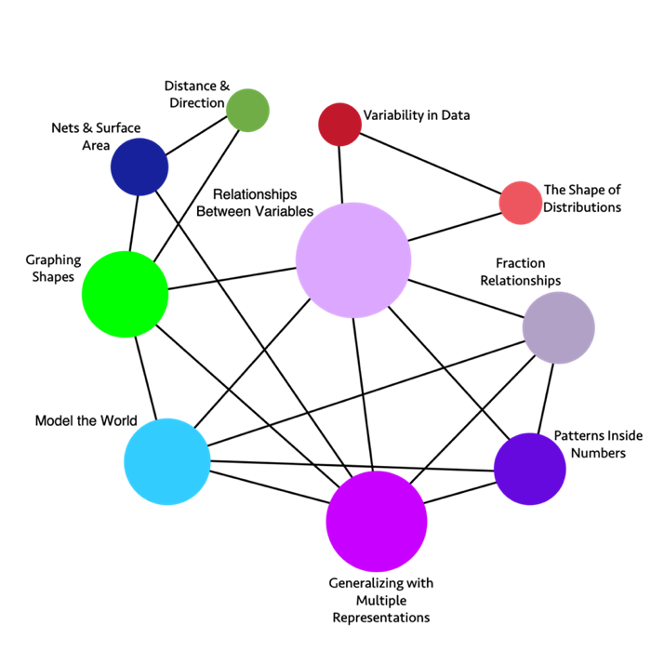
Long description of figure 1.2
Note: The sizes of the circles vary to give an indication of the relative importance of the topics. The connecting lines between circles show links among topics and suggest ways to design instruction so that multiple topics are addressed simultaneously.
Shifting the Emphasis to Big Ideas
Since California’s standards adoption, over a decade of experience has revealed the kinds of challenges the standards posed for teachers, administrators, curriculum developers, professional learning providers, and others. Because the standards were then new to California educators (and curriculum writers), the 2013 California Mathematics Framework was comprehensive in its treatment of the content standards, including descriptions and examples for both major and minor individual standards.
This framework reflects a revised approach, advocating that publishers and teachers avoid organizing around the detailed content standards and instead organize around the most important mathematical ideas. It has become clear that mathematics is best learned when ideas are introduced in a coherent way that shows key connections among ideas and takes into account a multi-year progression of learning. Educators must understand how each student experience extends earlier ideas (including those from prior years) and what future understanding will draw on current learning. Thus, standards are explored within the context of learning progressions across (or occasionally within) grades, rather than one standard at a time (see also Common Core Standards Writing Team, 2022). Students must experience mathematics as coherent within and across grades. The emphasis in the framework on progressions across years (in chapters three, four, and five as well as in the grade-band chapters six, seven, and eight) reflects this understanding.
This framework thus illustrates how teachers can organize instruction around the most important mathematical concepts—"big ideas”—that most often connect many standards in a more coherent whole. While important standards previously identified as “major” or “power” standards will continue to be very prominent, the framework encourages that they be addressed in the context of big ideas and the progressions within them—for example, the progression of the concepts of number sense or data literacy from transitional kindergarten through grade twelve.

Designing Instruction to Investigate and Connect the Why, How, and What of Mathematics
In the classroom, teachers teach their grade level’s big ideas by designing instruction around student investigations of intriguing, authentic problems. They structure and guide investigations that pique curiosity and engage students. One middle school teacher, for example, presented her students with the dilemma of a swimmer being followed by a baby whale. Should the swimmer guide the baby whale out to an oil rig where the baby’s mother has been seen—a risk to the swimmer—or head safely to shore, which is safer for the swimmer but risks that the baby whale getting beached? Enchanted by the story, students spent time on math-related tasks such as synthesizing information from different sources (maps, cold water survival charts), learning academic vocabulary to decide which function they may apply, and organizing data into number lines, function tables and coordinate planes—key aspects of this teacher’s curriculum. They analyzed proportional relationships, added fractions, compared functions, and used data. In short, they learned math content, explored content connections, and employed mathematical practices as they persevered to solve an interesting, complex problem. (See chapter seven where this example is elaborated.)
Such investigations motivate students to learn focused, coherent, and rigorous mathematics. They also help teachers to focus instruction on the big ideas—in this case illustrating inquiry and the use of data. Far from haphazard, the investigations are framed by a conception of the why, how, and what of mathematics—a conception that makes connections across different aspects of content and also connects content with mathematical practices.
To help teachers design this kind of instruction, figure 1.3 maps out the interplay at work when this conception of the why, how, and what of mathematics is used to structure and guide student investigations. One or more of the three Drivers of Investigation (DIs)—sense-making, predicting, and having an impact—provide the “why” of an activity. California’s eight Standards for Mathematical Practice (SMPs) provide the “how.” And four types of Content Connections (CCs)—which ensure coherence throughout the grades—provide the “what.” The DIs, SMPs, and CCs are interrelated; the activities within each can be combined with any of the activities within the others in a multiplicity of ways.
Figure 1.3 The Why, How, and What of Learning Mathematics
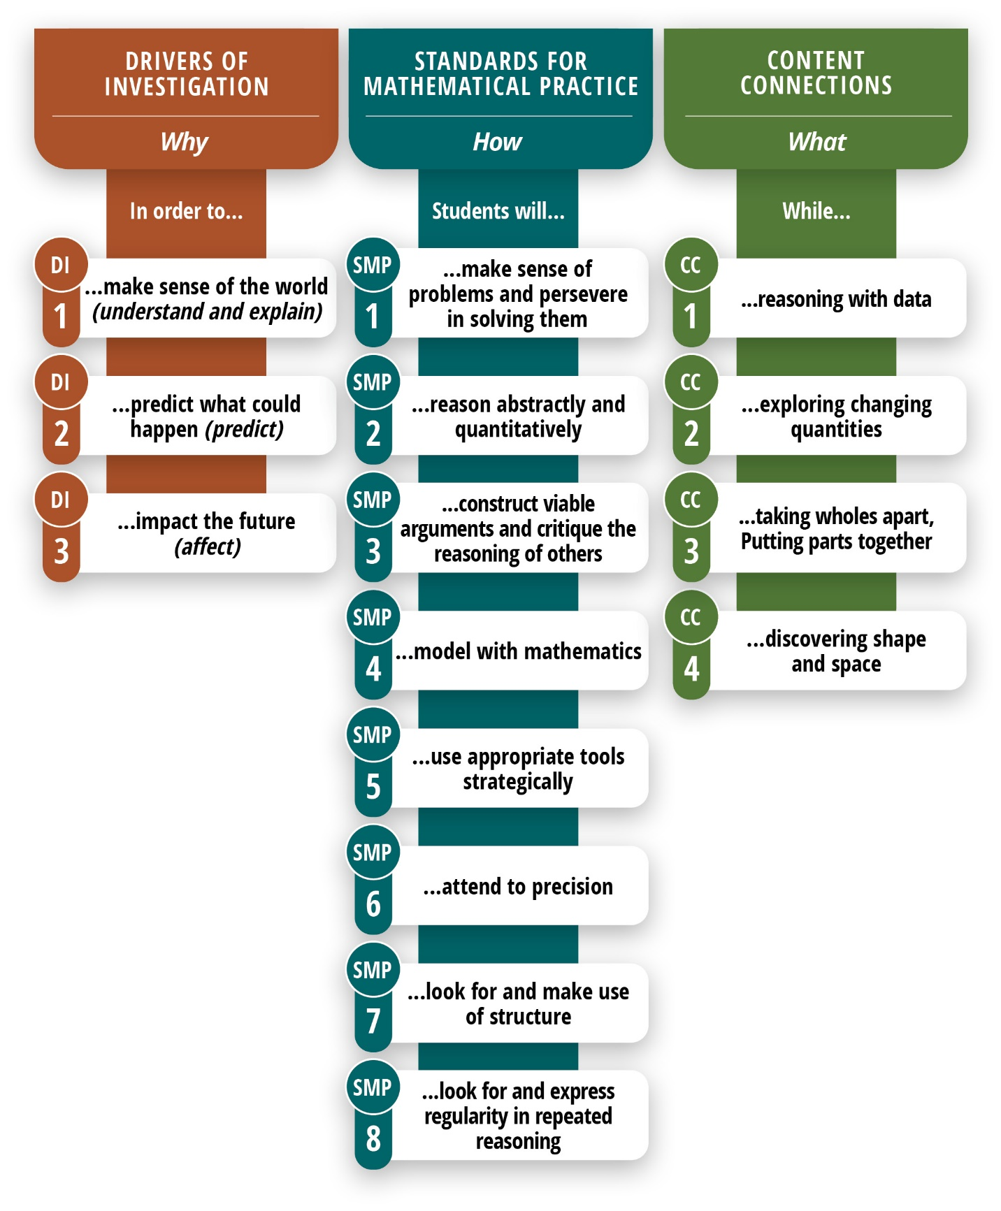
Long description of figure 1.3
The following diagram (figure 1.4) is meant to illustrate how the Drivers of Investigation can propel the ideas and actions framed in the Standards for Mathematical Practice and the Content Connections.
Figure 1.4 Drivers of Investigation, Standards for Mathematical Practices, and Content Connections
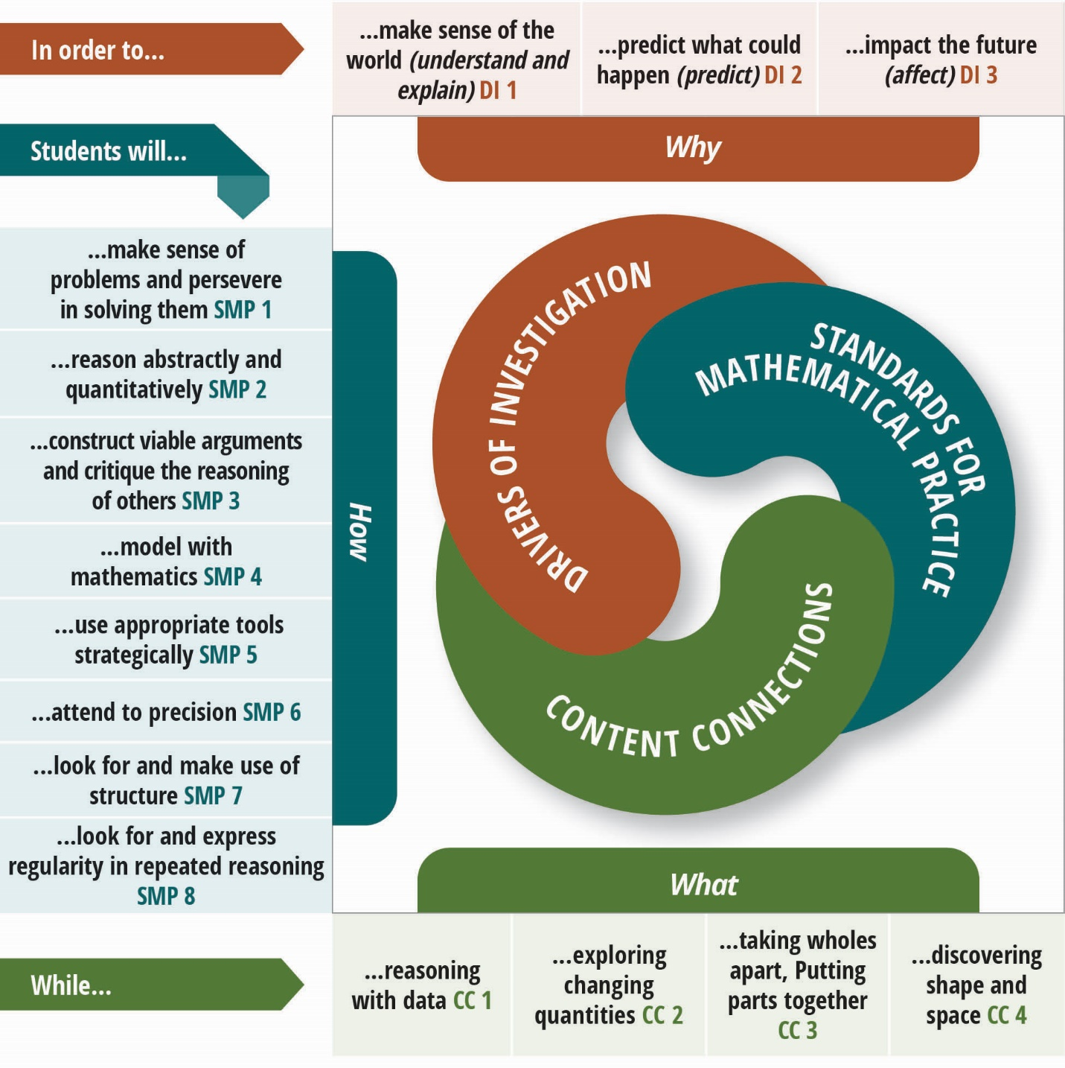
Long description of figure 1.4
Source: Adapted from the California Digital Learning Integration and Standards Guidance, 2021.

Drivers of Investigation
DI1: Make Sense of the World (Understand and Explain)
DI2: Predict What Could Happen (Predict)
DI3: Impact the Future (Affect)
The Drivers of Investigation (DIs) serve a purpose similar to that of the Crosscutting Concepts in the California Next Generation Science Standards—that is, they both elicit curiosity and motivate students to engage deeply with authentic mathematics. They aim to ensure that there is always a reason to care about mathematical work.
To guide instructional design, the DIs are used in conjunction with the Standards for Mathematical Practice (SMPs) and the Content Connections (CCs). For example, to make sense of the world (DI1), students engage in classroom discussions in which they construct viable arguments and critique the reasoning of others (SMP3) while exploring changing quantities (CC2).
Teachers can use the DIs to frame questions or activities at the outset for the class period, the week, or longer. They can refer to DIs in the middle of an investigation (perhaps in response to students asking “Why are we doing this again?”) or circle back to DIs at the conclusion of an activity to help students see why it all matters. The purpose of the DIs is to leverage students’ innate wonder about the world, the future of the world, and their role in that future, in order to motivate productive inclinations (the SMPs) that foster deeper understandings of fundamental ideas (the CCs and the standards), and to develop the perspective that mathematics is a lively, flexible endeavor by which we can appreciate and understand much about the inner workings of the world.

Standards for Mathematical Practice
SMP1. Make sense of problems and persevere in solving them
SMP2. Reason abstractly and quantitatively
SMP3. Construct viable arguments and critique the reasoning of others.
SMP4. Model with mathematics
SMP5. Use appropriate tools strategically
SMP6. Attend to precision
SMP7. Look for and make use of structure
SMP8. Look for and express regularity in repeated reasoning
The SMPs embed the habits of mind and habits of interaction that form the basis of math learning—for example, reasoning, persevering in problem solving, and explaining one’s thinking. To teach mathematics for understanding, it is essential to actively and intentionally cultivate students’ use of the SMPs. The introduction to the CA CCSSM is explicit on this point, saying that the SMPs must be taught as carefully and practiced as intentionally as the content standards, as two halves of a powerful whole, for effective mathematics instruction. The SMPs are designed to support students’ development across the school years. Whether in primary grades or high school, for example, students make sense of problems and persevere in solving them (SMP1).
Unlike the content standards, the SMPs are the same for all grades, K–12. As students progress through mathematical content, their opportunities to deepen their knowledge of and skills in the SMPs should increase.

Content Connections
CC1: Reasoning with Data
CC2: Exploring Changing Quantities
CC3: Taking Wholes Apart, Putting Parts Together
CC4: Discovering Shape and Space
The four CCs described in this framework organize content and provide mathematical coherence through the entire TK–12 grade span. They embody the understandings, skills, and dispositions expected of high school graduates. Capacities embedded in the CCs should be developed through investigation of questions in authentic contexts—investigations that will naturally fall under one or more of the DIs.
CC1: Reasoning with Data. With data all around us, even the youngest learners make sense of the world through data. In transitional kindergarten through grade five, students describe and compare measurable attributes, classify objects, count the number of objects in each category, represent their discoveries graphically, and interpret the results. In grades six through eight, prominence is given to statistical understanding and to reasoning with and about data. Grades nine through twelve also emphasize reasoning with and about data, reflecting the growing importance of data as the source of most mathematical problems that students will encounter in their lives. Investigations in a data-driven context—with data either generated or collected by students or accessed from publicly available sources—help students integrate mathematics with their lives and with other disciplines, such as science and social studies. Most investigations in this category also involve aspects of CC2: Exploring Changing Quantities.
CC2: Exploring Changing Quantities. Young learners’ explorations of changing quantities help them develop a sense of meaning for operations and types of numbers. The understanding of fractions established in transitional kindergarten through grade five provides students with the foundation they need to explore ratios, rates, and percents in grades six through eight. In grades nine through twelve, students make sense of, keep track of, and connect a wide range of quantities and find ways to represent the relationships between these quantities in order to make sense of and model complex situations.
CC3: Taking Wholes Apart, Putting Parts Together. Students engage in many experiences involving taking apart quantities and putting parts together strategically. These include utilizing place value in performing operations (such as making 10), decomposing shapes into simpler shapes and vice versa, and relying on unit fractions as the building blocks of whole and mixed numbers. This CC also serves as a vehicle for student exploration of larger-scale problems and projects, many of which will also intersect with other CCs. Investigations in this CC require students to decompose challenges into manageable pieces and assemble understanding of smaller parts into an understanding of a larger whole.
CC4: Discovering Shape and Space. In the early grades, students learn to describe their world using geometric ideas (e.g., shape, orientation, spatial relations). They use basic shapes and spatial reasoning to model objects in their environment and to construct more complex shapes, thus setting the stage for measurement and initial understanding of properties such as congruence and symmetry. “Shape and space” in grades six through eight is largely about connecting foundational ideas of area, perimeter, angles, and volume to each other, to students’ lives, and to other areas of mathematics—for example, connecting nets and surface area or two-dimensional shapes and coordinate geometry. In grades nine through twelve, California’s mathematics standards support visual thinking by defining congruence and similarity in terms of dilations and rigid motions of the plane and also by emphasizing physical models, transparencies, and geometry software.

How the Big Ideas Embody Focus, Coherence, and Rigor

Focus
I didn’t want to just know the names of things. I remember really wanting to know how it all worked.
—Elizabeth Blackburn, Winner of the 2009 Nobel Prize for Physiology or Medicine
The principle of focus is closely tied to depth of understanding, called out in this framework to reflect concern about the prevalence in California schools of mathematics curricula that are a mile wide and an inch deep. The challenging reality is that the math standards contain so many concepts and strategies that many teachers are at a loss as to how best to teach to them comprehensively. Thus, the tendency has been to take one of two instructional approaches: cover some standards at the depth they merit while skipping others, or try to cover all grade-level standards but compromise opportunities for students to gain a deep understanding of any one of them.
The standards, however, are not a design for instruction, and should not be used as such. The standards lay out the understanding and know-how students are expected to gain at each grade level and the mathematical practices they are expected to master by the conclusion of high school. The standards say little about how to help students achieve that understanding and know-how or build those practices. Using a baking analogy, the standards would tell us what the cake should look, smell, taste, and feel like once it is baked (and at intermediate points along the way), but are not themselves the recipe for baking the cake.
Designing instruction for focus. This framework’s answer to the coverage-versus-depth challenge inherent in the principle of focus is to lay out the following instructional design principles (and examples) that make the standards achievable. For instruction that embodies focus:
- Design class activities around big ideas, with an emphasis on investigations and connections, not individual standards. Typically, an investigation should enfold several clusters of content standards and multiple practice standards (though in some instances a single content standard is essentially synonymous with a big idea). Connections between those content standards then become an integral part of the class activity, rather than an additional topic to cover. The dual emphasis on investigations and connections is reflected in the titles and structures of the grade-banded chapters (chapters six, seven, and eight) as well as in the DIs and CCs.
- Concentrate on the ways activities fit within a multi-year progression of learning. Educators must understand how each classroom experience for students expands earlier ideas (including those from prior years) and what aspects of future understanding will draw on current learning. Students must experience mathematics as coherent across grades. The framework’s emphasis on progressions across years (in chapters three, four, and five as well as in the grade-band chapters six, seven, and eight) reflects this imperative. This contrasts with the approach of choosing “power standards;” instead, the focus is on big ideas that are central to mathematical thinking, integrate many smaller standards, and are part of critical progressions.
- Construct tasks that are worthy of student engagement.
  - Problems (tasks which students do not already have the tools to solve) precede teaching of the focal mathematics necessitated by the problem. That is, the major point of a problem is to raise questions that can be answered and encourage students to use their intuition to address the questions before learning new mathematical ideas (Deslauriers et al., 2019).
  - Exercises (i.e., tasks for which students already have the tools) should either be embedded in a larger problem that is motivating (e.g., an authentic problem, perhaps involving patterns, games, or real-world contexts, such as environmental or social justice), or should address strategies whose improvement will help students accomplish some motivating goal.
  - Students should learn to see that investigating mathematical ideas, asking important questions, making conjectures, and developing curiosity about mathematics and mathematical connections are all parts of their learning process.

Coherence
I like crossing the imaginary boundaries people set up between different fields—it's very refreshing. There are lots of tools, and you don't know which one would work. It's about being optimistic and trying to connect things.
—Maryam Mirzakhani, Mathematician, 2014 Fields Medalist
The Standards for Mathematical Practice (SMPs) and the Content Standards are intended to be equally important in planning curriculum and instruction (CA CCSSM, 2013, 3). The content standards, however, are far more detailed at each grade level, and are more familiar to most educators. As a result, the content standards continue to provide the organizing structure for most curriculum and instruction. Because the content standards are more granular, many curriculum developers and teachers find it easy when designing lessons to begin with one or two content standards and choose tasks and activities which develop that standard. Too often, this reinforces the concept as an isolated idea.
Instead, instruction and instructional materials should primarily include tasks that enfold interconnected clusters of content. These “big idea” tasks invite students to make sense of and connect concepts, elicit wondering in authentic contexts, and necessitate mathematical investigation. In summarizing research on the optimum ways to learn, the National Research Council and the Commission on Behavioral and Social Sciences concluded that: “Superficial coverage of all topics in a subject area must be replaced with in-depth coverage of fewer topics that allows key concepts in the discipline to be understood. The goal of coverage need not be abandoned entirely, of course. But there must be a sufficient number of cases of in-depth study to allow students to grasp the defining concepts in specific domains within a discipline” (Bransford, Brown, and Cocking, 2000, 20).
That research underlies this framework’s recommendation that instruction focus on big ideas that allow teachers and students to explore key concepts in depth, through investigations. The value of focusing on big ideas—for teachers, as well as their students—cannot be overstated.
Designing instruction for coherence. Organizing instruction in terms of big ideas provides coherence because it helps teachers avoid losing the forest for the trees and it helps students assemble the concepts they learn into a coherent, big-picture view of mathematics. For instruction that embodies coherence:
- Center instruction on the why, how, and what of mathematics—the big ideas that link the Drivers of Investigation (why we do mathematics) with the Standards for Mathematical Practice (how we do mathematics) and the Content Connections (what connects mathematics concepts within and across domains);
- Attend to progressions of learning across grades, planning for grade-level bands rather than for individual grades (as illustrated in chapter six for transitional kindergarten through grade five; chapter seven for grades six through eight; and chapter eight for grades nine through twelve). Guiding principles for doing this include:
  - design from a smaller set of big ideas, spanning TK–12, within each grade band;
  - plan for a preponderance of student time to be spent on authentic problems that each encompass multiple content and practice standards, situated within one or more big ideas;
  - design to reveal connections: between students’ lives and mathematical ideas and strategies, and between different mathematical ideas; and
  - devote constant attention to opportunities for students to bring other aspects of their lives into the mathematics classroom: How does this mathematical way of looking at this phenomenon compare with other ways to look at it? What problems do you see in our community that we might analyze? Teachers who relate aspects of mathematics to students’ cultures often achieve more equitable outcomes (Hammond, 2014).
Each of the grade band chapters identifies the big ideas for each grade level and presents the ideas as network maps that highlight the connections between the big ideas. (See the above example of the sixth-grade network map.) These chapters illustrate this framework’s approach to instructional design by focusing on several big ideas that have great impact on students’ conceptual understanding of numbers and that also encompass multiple content standards.
Each of these chapters also includes examples of authentic activities for student investigations. An authentic activity or problem is one in which students investigate or struggle with situations or questions about which they actually wonder. Lessons should be designed to elicit student wondering. Many contexts can be reflected in such lessons—for example, activities related to students’ everyday lives or relevant to their families’ cultures. However, some contexts are purely mathematical, as when students have enough experience to notice patterns and wonder within them. Examples of contexts that provoke student curiosity include:
- Environmental observations and issues on campus and in the local community (which concurrently help students develop their understanding of California’s Environmental Principles and Concepts)
- Puzzles
- Patterns—numerical or visual—in purely mathematical settings
- Real-world or fictional contexts in which something happens or changes over time

Rigor
True rigor is productive, being distinguished in this from another rigor which is purely formal and tiresome, casting a shadow over the problems it touches.
—Émile Picard (1905)
In this framework, rigor refers to an integrated way in which conceptual understanding, strategies for problem-solving and computation, and applications are learned so that each supports the other. Using this definition, conceptual understanding cannot be considered rigorous if it cannot be used to analyze a novel situation encountered in a real-world application or within mathematics itself (for new examples and phenomena). Computational speed and accuracy cannot be called rigorous unless it is accompanied by conceptual understanding of the strategy being used, including why it is appropriate in a given situation. And a correct answer to an application problem is not rigorous if the solver cannot explain both the ideas of the model used and the methods of calculation.
In other words, rigor is not about abstraction. In fact, a push for premature abstraction leads, for many students, to an absence of rigor. It is true that more advanced mathematics often occurs in more abstract contexts. This leads many to value more abstract subject matter as a marker of rigor. “Abstraction” in this case usually means “less connected to reality.”
But mathematical abstraction is in fact deeply connected to reality. Consider what happens when second graders use a representation with blocks to argue that the sum of two odd numbers is even. If students see that this same approach (a representation-based proof; see Schifter, 2010) would work for any two odd numbers, they have abstracted the idea of an odd number, and they know that what they are saying about an odd number applies to one, three, five, etc. (Such an argument reflects SMP7: Look for and make use of structure.)
Abstraction must grow out of experiences in which students see the same mathematical ideas and representations showing up and being useful in different contexts. When students figure out the size of a population, after 50 months using a growth of three percent a month, their bank balance after 50 years using an interest rate of three percent per year, or the number of people after 50 days who have contracted a disease that is spreading at three percent per day, they will abstract the notion of a quantity growing by a certain percentage per time period, recognizing that they can use the same reasoning to understand the changing quantity in other contexts. This is the basis of mathematical rigor, often expressed in terms of validity and soundness of arguments.
Rigorous mathematics learning as defined here can occur through an investigation-driven learning cycle. Notice in this brief description that the application to an authentic context supports the development of mathematical concepts and problem-solving strategies:
- Exploration in a familiar context generates authentic questions and predictions or guesses
- Attempts to understand those questions reveals mathematical objects, quantities, and relationships
- Mathematical concepts and strategies for understanding these objects, quantities, and relationships are developed and/or introduced
- Mathematical work is translated back to the original context and compared with initial predictions and with reasonableness
Designing instruction for rigor. Thus, the challenge posed by the principle of rigor is to provide all students with experiences that interweave mathematical concepts, problem-solving (including appropriate computation), and application, such that each supports the other. For instruction that embodies rigor:
- Ensure that abstract formulations follow experiences with multiple contexts that call forth similar mathematical models.
- Choose varied mathematical contexts for problem-solving that provide different opportunities for students to use skills, content, and representations for important concepts, so that students can later use those contexts to reason about the mathematical concepts raised. The Drivers of Investigation provide broad reasons to think rigorously in ways that enable students to recognize, value, and internalize linkages between and through topics (Content Connections).
- Ensure that computation serves students’ genuine need to know, typically in a problem-solving or application context. In particular, in order for computational algorithms (standard or otherwise) to be understood rigorously, students must be able to connect them to conceptual understanding (via a variety of representations, as appropriate) and be able to use them to solve authentic problems in diverse contexts. An important aspect of this understanding is to recognize the power that algorithms bring to problem solving: knowing only single-digit multiplication and addition facts, it is possible to compute any sum, difference, or product involving whole numbers or finite decimals.
- Choose applications that are authentic for students and enact them in a way that requires students to explain or present solution paths and alternate ideas. Support students in the class to use different skills and content to solve the same problem and facilitate discussions to help students understand why different approaches result in the same answer.
- After student problem-solving, consider engaging the class in a debriefing of selected student solutions, pointing out where incorrect answers helped redirect the thinking and work towards the correct answer.

Assessing for Focus, Coherence, and Rigor
Mathematical notation no more is mathematics than musical notation is music. A page of sheet music represents a piece of music, but the notation and the music are not the same; the music itself happens when the notes on the page are sung or performed on a musical instrument. It is in its performance that the music comes alive; it exists not on the page but in our minds. The same is true for mathematics.
—Keith Devlin (2003)
To gauge what students know and can do in mathematics, we need to broaden assessment beyond narrow tests of procedural knowledge to better capture the connections between content and the SMPs. For example, assessing a good mathematical explanation includes assessing not only how students mathematize a problem, but also how they connect the mathematics to the context and explain their thinking in a clear, logical manner that leads to a conclusion or solution (Callahan et al., 2020). One focus area in the English Learner Success Forum (ELSF) guidelines for improving math materials and instruction for English learners is assessment of mathematical content, practices, and language. The guidelines in this area specifically note the need to capture and measure students’ progress over time (ELSF guideline 14) and to attend to student language produced (ELSF guideline 15).

Emphases of the Framework, by Chapter
Because the CA CCSSM adopted in 2010 represented a substantial shift from previous standards, the 2013 Mathematics Framework included detailed explications and examples of most content standards. This 2023 edition of the framework includes several additional types of chapters, reflecting the following new emphases:
Foster more equitable outcomes. TK–12 mathematics instruction must foster more equitable outcomes in mathematics and science. To raise the profile of that imperative, Chapter 2, Teaching for Equity and Engagement, promotes instruction that supports equitable learning experiences for all and challenges the deeply-entrenched policies and practices that lead to inequitable outcomes. Chapter two replaces two chapters that were in the previous framework, one on instruction and one on access.
This 2023 framework rejects the false dichotomy that equity and high achievement are somehow mutually exclusive, and it emphasizes ways in which good teaching leads to both. Reflecting the state’s commitment to equity, every chapter in this framework highlights considerations and approaches designed to help mathematics educators create and maintain equitable opportunities for all.
Focus on connections between standards as well as progression across grades. Given educators’ more-advanced understanding of the individual standards, this framework focuses on connections between standards, within grades and across grades. Two chapters are devoted to exploring the development, across the TK–12 timeframe, of particular content areas. One is Chapter 3, Number Sense. Number sense is a crucial foundation for all later mathematics and an early predictor of mathematical perseverance. The other is Chapter 5, Mathematical Foundations for Data Science. Data science has become tremendously important in the field since the last framework.
The other new chapter, Chapter 4, Exploring, Discovering, and Reasoning With and About Mathematics, presents the development of three related SMPs across the entire TK–12 timeframe. While it is beyond the scope of this framework to develop this kind of progression for all SMPs, this chapter can guide the careful work that is required to develop SMP capacities across the grades.
The idea of learning progressions across multiple grade levels is further emphasized in the grade-banded chapters: Chapter 6, Investigating and Connecting, Transitional Kindergarten through Grade Five; Chapter 7, Investigating and Connecting, Grades Six through Eight; and Chapter 8, Investigating and Connecting, High School. For each grade band, the Drivers of Investigation and Content Connections provide a structure for promoting relevant and authentic activities for students. These chapters and others include snapshots and vignettes to illustrate how this structure facilitates the framework’s instructional approach and the building of big ideas across grades. “The key to prioritizing learning is to move beyond grade-level check lists and instead think of progressions of important learning that cut across grade levels” (CGCS, 2020).
Build an effective system of support for teachers. Chapter 9, Structuring School Experiences for Equity and Engagement, and Chapter 10, Supporting Educators in Offering Equitable and Engaging Mathematics Instruction, present guidance designed to build an effective system of support for teachers as they facilitate learning for their students. These chapters include advice for administrators and leaders and set out models for effective teacher learning.
Ensure that technology, assessment, and instructional materials support rigorous, math curricula, equitable access, and inquiry-based instruction. Chapter 11, Technology and Distance Learning in the Teaching of Mathematics, describes the purpose of technology in the learning of mathematics, introduces overarching principles meant to guide such technology use, and provides general guidance for distance learning. Chapter 12, Mathematics Assessment in the 21st Century, addresses the need to broaden assessment practices beyond finding answers to recording student thinking and to create assessment systems that put greater emphasis on learning growth than on performance. The chapter reviews “Assessment for Learning” and concludes with a brief overview of the Common Core-aligned standardized assessment used in California: the California Assessment of Student Performance and Progress.
To help ensure that instructional materials serve California’s diverse student population, Chapter 13, Instructional Materials to Support Equitable and Engaging Learning of the California Common Core State Standards for Mathematics offers support to publishers and developers of those instructional materials. This chapter also provides guidance to local districts on the adoption of instructional materials for students in grades nine through twelve as well as on the social content review process, supplemental instructional materials, and accessible instructional materials.
Chapter 14, Glossary: Acronyms and Terms, provides a list of acronyms commonly used in mathematics teaching and learning conversations, and working definitions and descriptions for many of the terms used in this framework.
Explicitly Focus on Environmental Principles and Concepts (EP&Cs). While the Drivers of Investigations and Content Connections are fundamental to the design and implementation of instruction under the standards, teachers must be mindful of other considerations that are a high priority for California’s education system. These include the EP&Cs, which allow students to examine issues of environmental and social justice.
Environmental literacy is championed by the California Department of Education, the California Environmental Protection Agency, and the California Natural Resources Agency. It is also fully embraced in a 2015 report prepared by a task force of the State Superintendent of Public Instruction, A Blueprint for Environmental Literacy: Educating Every Student in, about, and for the Environment (CDE Foundation, 2015). Strongly reinforcing the goal of environmental literacy for all kindergarten through grade twelve students, the blueprint states that “the central approach for achieving environmental literacy…is to integrate environmental literacy efforts into California’s increasingly coherent and aligned K–12 education landscape so that all teachers are given the opportunity to use the environment as context for teaching their core subjects.” It also advocates that all teachers have the opportunity to use the environment as a relevant and engaging context to “provide learning experiences that are culturally relevant” for teaching their core subjects of math, English language arts, English language development, science, and history–social science.
The Environmental Principles (figure 1.5) are the critical understandings that California has identified for every student in the state to learn and be able to apply. Developed in 2004, California’s EP&Cs reflect the fact that people, as well as their cultures and societies, depend on Earth’s natural systems. The underlying goal of the EP&Cs is to help students understand the connections between people and the natural world so that they can better assess and mitigate the consequences of human activity.
Figure 1.5 California’s Environmental Principles
Principle | Description
Principle I—People Depend on Natural Systems | The continuation and health of individual human lives and of human communities and societies depend on the health of the natural systems that provide essential goods and ecosystem services.
Principle II—People Influence Natural Systems | The long-term functioning and health of terrestrial, freshwater, coastal and marine ecosystems are influenced by their relationships with human society.
Principle III—Natural Systems Change in Ways that People Benefit from and Influence | Natural systems proceed through cycles that humans depend upon, benefit from, and can alter.
Principle IV—There are no Permanent or Impermeable Boundaries that Prevent Matter from Flowing Between Systems | The exchange of matter between natural systems and human societies affects the long-term functioning of both.
Principle V—Decisions Affecting Resources and Natural Systems are Complex and Involve Many Factors | Decisions affecting resources and natural systems are based on a wide range of considerations and decision-making processes.
Source: CEEI, 2020.
Classroom activities can simultaneously introduce the EP&Cs and develop important mathematics through investigations into students’ local community and environment. The EP&Cs and environmental literacy curricula can provide meaningful ways to teach and amplify many of the ideas that are embedded in the CA CCSSM (Lieberman, 2013). Vignettes that provide examples of connections between mathematics instruction and the EP&Cs are included in chapters five, six, seven, and eight of this framework.
Every Californian needs to be ready to address the environmental challenges of today and the future, take steps to reduce the impacts of natural and anthropogenic (human-made) hazards, and act in a responsible and sustainable manner with the natural systems that support all life. As a result, the EP&Cs have become an important piece of the curricular expectations for all California students in mathematics and other content areas.

Conclusion
This Mathematics Framework lays out the curricular and instructional approaches that research and evidence show will afford all students the opportunities they need to learn meaningful and rigorous mathematics, meet the state’s mathematics standards, access pathways to high level math courses, and achieve success. Student learning is enhanced when they are actively engaged in making sense of the world around them. Everyone is capable of learning math, and each person’s math capacity grows with engagement and perseverance. With a focus on equity, this framework rejects the false dichotomy that equity and high achievement are somehow mutually exclusive, and it emphasizes ways in which good teaching leads to both.
A key component of equitable, engaging teaching is planning math teaching around big ideas. Across grade levels, big ideas enfold clusters of standards and connect mathematical concepts. Teachers teach their grade level big ideas by designing instruction around student investigations of intriguing, authentic problems, framed by a conception of the why, how, and what of mathematics. When implemented as intended, such investigations can tap into students’ curiosity and motivate students to learn focused, coherent, and rigorous mathematics. This approach to math education is the means to both teach math effectively and make it accessible to all students.

Long Descriptions of Graphics for Chapter 1

Figure 1.1: Mathematics Performance (PISA)
Boys / Girls, Mean score, 2018 or latest available.
Source: Programme for International Student Assessment (PISA)
Location | Boys | Girls
Australia | 494 | 488
Austria | 505 | 492
Belgium | 514 | 502
Brazil | 388 | 379
Canada | 514 | 510
Chile | 421 | 414
Colombia | 401 | 381
Costa Rica | 411 | 394
Czech Republic | 501 | 498
Denmark | 511 | 507
Estonia | 528 | 519
Finland | 504 | 510
France | 499 | 492
Germany | 503 | 496
Greece | 452 | 451
Hungary | 486 | 477
Iceland | 490 | 500
Indonesia | 374 | 383
Ireland | 503 | 497
Israel | 458 | 467
Italy | 494 | 479
Japan | 532 | 522
Korea | 528 | 524
Latvia | 500 | 493
Lithuania | 480 | 482
Luxembourg | 487 | 480
Mexico | 415 | 403
Netherlands | 520 | 519
New Zealand | 499 | 490
Norway | 497 | 505
OECD - Average | 492 | 487
Poland | 516 | 515
Portugal | 497 | 488
Russia | 490 | 485
Slovak Republic | 488 | 484
Slovenia | 509 | 509
Spain | 485 | 478
Sweden | 502 | 503
Switzerland | 519 | 512
Turkey | 456 | 451
United Kingdom | 508 | 496
United States | 482 | 474
Return to figure 1.1 graphic

Figure 1.2: Grade Six Big Ideas
The graphic illustrates the connections and relationships of some sixth-grade mathematics concepts. Direct connections include:
- Variability in Data directly connects to: The Shape of Distributions, Relationships Between Variables
- The Shape of Distributions directly connects to: Relationships Between Variables, Variability in Data
- Fraction Relationships directly connects to: Patterns Inside Numbers, Generalizing with Multiple Representations, Model the World, Relationships Between Variables
- Patterns Inside Numbers directly connects to: Fraction Relationships, Generalizing with Multiple Representations, Model the World, Relationships Between Variables
- Generalizing with Multiple Representations directly connects to: Patterns Inside Numbers, Fraction Relationships, Model the World, Relationships Between Variables, Nets & Surface Area, Graphing Shapes
- Model the World directly connects to: Fraction Relationships, Relationships Between Variables, Patterns Inside Numbers, Generalizing with Multiple Representations, Graphing Shapes
- Graphing Shapes directly connects to: Model the World, Generalizing with Multiple Representations, Relationships Between Variables, Distance & Direction, Nets & Surface
- Nets & Surface directly connects to: Graphing Shapes, Generalizing with Multiple Representations, Distance & Direction
- Distance & Direction directly connects to: Graphing Shapes, Nets & Surface Area
- Relationships Between Variables directly connects to: Variability in Data, The Shape of Distributions, Fraction Relationships, Patterns Inside Numbers, Generalizing with Multiple Representations, Model the World, Graphing Shapes Return to figure 1.2 graphic

Figure 1.3. The Why, How and What of Learning Mathematics (accessible version)
Drivers of Investigation  Why | Standards for Mathematical Practice  How | Content Connections  What
In order to…  - Make Sense of the World (Understand and Explain)  - Predict What Could Happen (Predict)  - Impact the Future (Affect) | Students will…  - Make Sense of Problems and Persevere in Solving them  - Reason Abstractly and Quantitatively  - Construct Viable Arguments and Critique the Reasoning of Others  - Model with Mathematics  - Use Appropriate Tools Strategically  - Attend to Precision  - Look for and Make Use of Structure  - Look for and Express Regularity in Repeated Reasoning | While…  - Reasoning with Data  - Exploring Changing Quantities  - Taking Wholes Apart, Putting Parts Together  - Discovering Shape and Space
Return to figure 1.3 graphic

Figure 1.4: Content Connections, Mathematical Practices, and Drivers of Investigation
A spiral graphic shows how the Drivers of Investigation (DIs), Standards for Mathematical Practice (SMPs) and Content Connections (CCs) interact. The DIs are the “Why,” described as, “In order to...”: DI1, Make Sense of the World (Understand and Explain); DI2, Predict What Could Happen (Predict); DI3, Impact the Future (Affect). The SMPs are the “How,” listed under “Students will...”: SMP1, Make sense of problems and persevere in solving them; SMP2, Reason abstractly and quantitatively; SMP3, Construct viable arguments and critique the reasoning of others; SMP4, Model with mathematics; SMP5, Use appropriate tools strategically; SMP6, Attend to precision; SMP7, Look for and make use of structure; SMP8, Look for and express regularity in repeated reasoning. Finally, the CCs are the “What,” listed under, “While...”: CC1, Reasoning with Data; CC2, Exploring Changing Quantities; CC3, Taking Wholes Apart, Putting Parts Together; CC4, Discovering Shape and Space.
Return to figure 1.4 graphic
California Department of Education, October 2023

This definition is more specific and somewhat more demanding than the CA CCSSM’s requirement that “rigor requires that conceptual understanding, procedural skill and fluency, and application be approached with equal intensity” (CA CCSSM, 2013, 2). For a fuller exploration of the meaning of rigor in mathematics and its implications for instruction, see Dana Center, 2019.

