Current California K–12 Content Standards, Curriculum Frameworks, and K–8 Instructional Materials Adoptions
- Content Standards development is initiated by special legislative direction.
- Curriculum Framework development is initiated by specific legislative funding. Each Framework includes a chapter for the evaluation criteria of corresponding instructional materials.
- Instructional materials adoption timelines are set by the State Board of Education and often follow the completion and adoption of the corresponding Curriculum Framework and/or the adopted evaluation criteria for adopting instructional materials in the content area.
Below is the most recent adoption information for each content area
SUBJECT | LATEST CONTENT STANDARDS ADOPTION DATE | LATEST CURRICULUM FRAMEWORK ADOPTION DATE | LATEST INSTRUCTIONAL MATERIALS ADOPTION DATE
Arts Education  https://www.cde.ca.gov/ci/vp/ | 2019 | 2020 | 2021
Career Technical Education  https://www.cde.ca.gov/ci/ct/ | 2013 | 2007 | There are no SBE-adopted instructional materials for CTE.
Computer Science  https://www.cde.ca.gov/be/st/ss/computerscicontentstds.asp | 2018 | There is no authorization for a computer science curriculum framework. | There are no SBE-adopted instructional materials for computer science.
English Language Arts/ English Language Development  https://www.cde.ca.gov/ci/rl/ | 2010 | 2014 | 2015
Health Education  https://www.cde.ca.gov/ci/he/ | 2008 | 2019 | 2004 (The scheduled 2020 instructional materials adoption was cancelled by the SBE)
History–Social Science  https://www.cde.ca.gov/ci/hs/ | 1998 | 2016 | 2017
Mathematics  https://www.cde.ca.gov/ci/ma/ | 2010 | 2023 | 2014
Model School Library  https://www.cde.ca.gov/ci/cr/lb/schoollibstnds2017.asp | 2010 | There is no authorization for a model school library curriculum framework. | There are no SBE-adopted instructional materials for model school library.
Physical Education  https://www.cde.ca.gov/ci/pe/ | 2005 | 2008 | There are no SBE-adopted instructional materials for physical education.
Science  https://www.cde.ca.gov/ci/sc/ | 2013 | 2016 | 2018
World Languages  https://www.cde.ca.gov/ci/fl/ | 2019 | 2020 | 2021

Sample Framework Timeline with Key Milestones
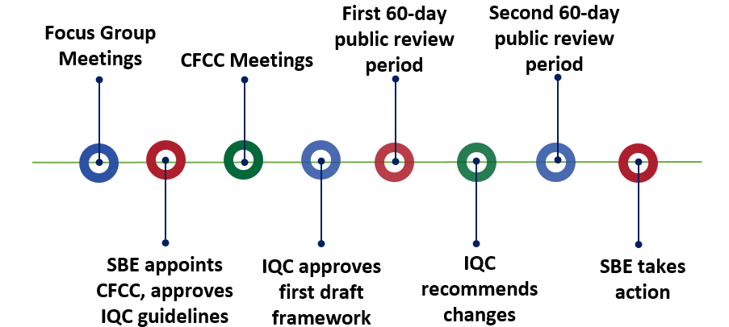
The framework process takes place over a period of approximately three years. The sample timeline above includes the following key milestones:
- Multiple focus group meetings take place in various locations, typically over a two-month period.
- The State Board of Education (SBE) appoints members to the Curriculum Framework and Evaluation Criteria Committee (CFCC) and approves the Instructional Quality Commission (IQC) guidelines.
- Multiple CFCC meetings occur, typically over a 6–8 month period.
- The IQC reviews, edits, and approves the first draft of the framework.
- The draft framework is posted for the first 60-day public review period.
- The IQC recommends edits to the draft.
- The draft framework is posted for the second 60-day public review period.
- The SBE takes action on the framework.

Sample Instructional Materials Adoption Timeline with Key Milestones
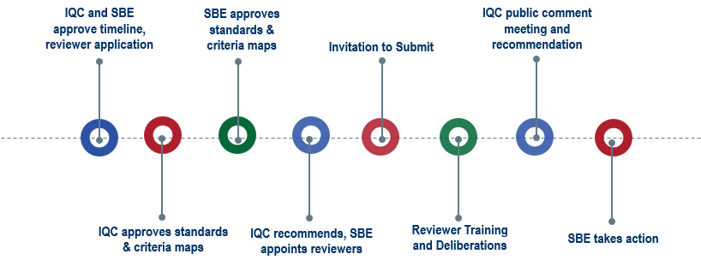
The instructional materials adoption process takes place over a period of approximately two years. The sample timeline above includes the following key milestones:
- The IQC recommends the timeline and online reviewer application to the SBE, and the SBE approves the timeline and application.
- The IQC approves the evaluation criteria and standards maps.
- SBE approves the evaluation criteria and standards maps.
- The IQC recommends reviewers to the SBE, and the SBE appoints reviewers.
- The publisher Invitation to Submit meeting takes place, and submission forms are due approximately two months later.
- Reviewer training takes place for approximately one week, publishers submit materials for review, and reviewers reconvene for deliberations approximately three months after training. Reviewers make program adoption recommendations to the IQC.
- The IQC holds a public meeting to receive public comment and makes recommendations to the SBE.
- The SBE holds a public meeting to receive public comment and takes action on program recommendations.
California Department of Education, November 2023

