Item 2.A.1.
Attachment 3
History–Social Science Subject Matter Committee
May 16, 2019
Page 1 of 25
California Department of Education, May 2019

Chapter 3: UC-Approved Course Outlines Overview

Overview
The statute that authorized the development of this model curriculum, Education Code Section 51226.7, requires the inclusion of “examples of courses offered by local educational agencies that have been approved as meeting the A–G admissions requirements of the University of California and the California State University, including, to the extent possible, course outlines for those courses.” This chapter addresses these course outlines, including guidance for local education agencies in their use.
The course outlines have been gathered into a series of appendices that align to the course models provided earlier in the model curriculum. They were all submitted for A–G approval by local educational agencies (LEAs) that administer high schools in California. They include general survey/introductory courses, African American Studies courses, Chicana/o/x and Latina/o/x Studies courses, Native American Studies courses, Asian American/Pacific Islander Studies courses, and comparative Ethnic Studies courses that combine any or all of the above. They are for a range of grade levels within the span of ninth through twelfth grade. The courses included are suitable examples for both semester and year-long elective course offerings in history–social science and literature/language arts, but there are also outlines that are alternative versions of core courses (like the eleventh grade United States History and Geography course) with an Ethnic Studies focus.
The A–G Requirements are a sequence of high school courses that students must complete to be eligible for admission to the University of California (UC) and California State University (CSU). The current A–G requirement includes 15 courses in a range of subject areas, all of which must be completed with a grade of C or higher. These courses represent the basic level of academic preparation that high school students should achieve to be ready to undertake university-level work.
Each year, the University of California Office of the President (UCOP) solicits lists of courses from LEAs to identify courses that can be used to meet the UC and CSU admission requirements. LEAs can submit their courses for A–G approval through an online portal (https://hs-articulation.ucop.edu/guide/). UC admissions staff and subject matter experts review submissions and approve the courses based on criteria that include rigor, required prerequisites, the level of student work required, course assignments and assessments, and the instructional materials used. Courses may be rejected if they lack sufficient content aligned to those criteria. Once a course is approved, it is added to an LEA’s course list and is available for schools throughout the state to use. It is recommended that all Ethnic Studies courses offered in California high schools seek A–G approval.
Working in collaboration with the UCOP, the California Department of Education (CDE) gathered examples of course outlines that fit within the discipline of Ethnic Studies. The course outlines gathered in the appendices are not an exhaustive list of every possible course that can be considered to be an “Ethnic Studies” course. They include a representative sample of available courses, a snapshot that was taken at a particular moment in time during the development of this model curriculum. LEAs are constantly developing new courses, and users of this model curriculum are encouraged to visit the UC A–G Course Management Portal at the link above to access the searchable database containing the latest course listings currently being offered by California LEAs.

How to Use the Outlines
The course outlines provided with this model curriculum are intended to offer guidance to teachers and administrators interested in developing courses/units in Ethnic Studies. Every course is unique, and LEAs are encouraged to tailor their particular courses to the needs and interests of their student population. While the course outlines offer a wide range of potential courses, they are not intended to limit an LEA’s options. The authorizing statute encourages LEAs to submit their own Ethnic Studies course outlines for approval as A–G courses.
The course outlines include a wide range of suggested courses. Some include considerable detail, including unit narratives, suggested resources, and descriptions of classroom activities and student assignments. Others have little more than a brief course overview. The format has been modified slightly in order to address CDE posting and accessibility requirements, but the content of the course outlines themselves has not been edited. These outlines are based on actual courses that LEAs have been offering in California schools. However, the inclusion of specific resources and/or activities within these course descriptions does not imply an endorsement of these items by the State Board of Education (SBE) or the CDE. The development of the model curriculum did not include a state-level review of the resources included in the UC A–G course outlines. LEAs should evaluate any resources suggested in the course outlines to ensure that the materials that they are using best address their local needs.
It is important to note that none of the course outlines included in the appendices represent a complete curriculum. LEAs will still need to develop lessons, train teachers, and select instructional materials that will enable them to implement courses based upon these outlines. The course models in chapter 2 provide some examples of lessons and activities that can flesh out a course outline into a complete ready-to-teach course. The remainder of this chapter includes additional guidance for LEAs in completing these tasks.

Guide to Developing a Local Curriculum with Ethnic Studies Principles
When developing a local curriculum, the first step is to assemble a team to do the work. These team members should have appropriate professional training on curriculum development. Teachers with an Ethnic Studies background who will be implementing the curriculum should take the lead on this process, but it should also include teachers from other content areas. Ethnic Studies is by its very nature interdisciplinary, and Ethnic Studies teachers can draw from the experiences of not only other history–social science teachers, but teachers in language arts, visual and performing arts, and other subjects as well. This collaboration will help to ensure that the curriculum is aligned to the skill expectations in the state’s history–social science and language arts content standards, but beyond that, it can help to ensure that the concepts and principles of Ethnic Studies are present throughout the curriculum and are not just limited to the Ethnic Studies classroom. Schools and administrators should develop a process for evaluation of courses developed and supported through high quality Ethnic Studies professional learning.
Administrative support is also essential to the successful implementation of a new curriculum, as teacher training and other opportunities for professional learning should be incorporated into the curriculum plan. This will help ensure that future teachers will be equipped with the necessary skills, content knowledge and critical mindsets, and be able to pick up and teach the curriculum long after its initial development. It should also be acknowledged that there will be districts that may be undertaking this process for the first time without experienced teachers who are trained in Ethnic Studies content and pedagogy. In those cases, it will be particularly important for administrators to support their teachers in order to ensure that they are sufficiently prepared to implement a successful Ethnic Studies program.
It is also important to engage students and the community in the curriculum development process. Student participation during the curriculum development process is integral to the effectiveness of Ethnic Studies curriculum. That participation should begin at the school level. Many LEAs have policies that support student engagement in the processes of school and district administration, however, for those that do not have inclusive systems of shared governance, there are many ways that teachers can encourage their students to become active in their school community. Student work can also contribute to the ongoing development of a curriculum, both in terms of contributing content and refining existing content and assessments. Students can create units of study, help to select textbooks and instructional materials, and teach Ethnic Studies units to other students. Students can also serve as a liaison to their community. Remember that the Education Code’s sections on the rights and responsibilities of parents and guardians includes access to the curriculum materials used in the classes in which their child is enrolled.
In order to develop a curriculum that is culturally and community relevant and responsive, teachers and administrators need to be familiar with both their student population and the community they come from. Chapter 1 of this model curriculum stresses the importance of these connections in order to accomplish the goals of Ethnic Studies in the classroom. The team developing the model curriculum needs to go beyond just the checkboxes on a demographic report and understand how the prior life experiences of their student population affect the knowledge and attitudes that they bring to the classroom. With that knowledge in hand it will be easier to develop a curriculum that will engage students and speak to them in a way that they can understand and appreciate.
The curriculum frameworks adopted by the State Board of Education contain voluminous information that can guide teachers and administrators in the development of a local curriculum. They contain chapters on access and equity that emphasize the importance of designing curriculum to support all students, including those who have special needs and second language acquisition needs. These chapters provide guidance for how to differentiate instruction to address those needs, including a discussion of Universal Design for Learning (UDL), a set of strategies for planning instruction and presenting content that enables students to access and use disciplinary knowledge in a variety of ways that address their needs, assets, and strengths. Finally, the frameworks contain chapters on instructional strategies and professional learning that provide guidance for both teachers and administrators in planning, implementing, and supporting an inquiry-based instructional program that supports student engagement with the curriculum.
The History–Social Science Framework is of particular importance and should be considered an essential companion document to this model curriculum for current and prospective Ethnic Studies teachers. The framework, updated in 2016, was organized around four key instructional shifts: inquiry, literacy, content, and citizenship. These shifts are strongly aligned with the core principles of Ethnic Studies as a discipline. The framework contains a suggested elective course in Ethnic Studies designed to be used as a history–social science elective in grade nine. This model curriculum obviously goes into much more detail, but the framework relies upon a similar instructional approach, presenting essential questions to direct student inquiry, classroom examples with lesson models, and suggestions for ways that students can participate in service learning or activism in their school or local community.
Three sample templates for developing an Ethnic Studies curriculum are provided below.
The first is a lesson template that matches the sample lessons included in the course models in Chapter 2. It contains both general concepts that are common to other content areas and some specific areas that are specific to Ethnic Studies. A discussion of the specific components of this template follows.
The second is a unit plan template that allows teachers to curate a more dynamic, responsive, and relevant learning experience. This tool is meant to serve as the bridge between the larger course overview, which maps out the overall year’s (or semester) scope and sequence, and the day-to-day lesson plans, which provide detailed teacher moves and preparation specific to a lesson.
The third template is a sample course outline, in this case for a thematic Ethnic Studies course similar to the one that was modeled in Chapter 2. This outline has a detailed breakdown of course objectives and units and some suggested lesson ideas to incorporate. The UC-approved course outlines provided in the Appendices contain numerous other examples for how to organize a course that could prove instructive. Furthermore, UC approves and adds courses on an annual basis, thus, it is recommended that educators check for updates for new curriculum in areas where there are a few options available.

Table: Sample Lesson Template
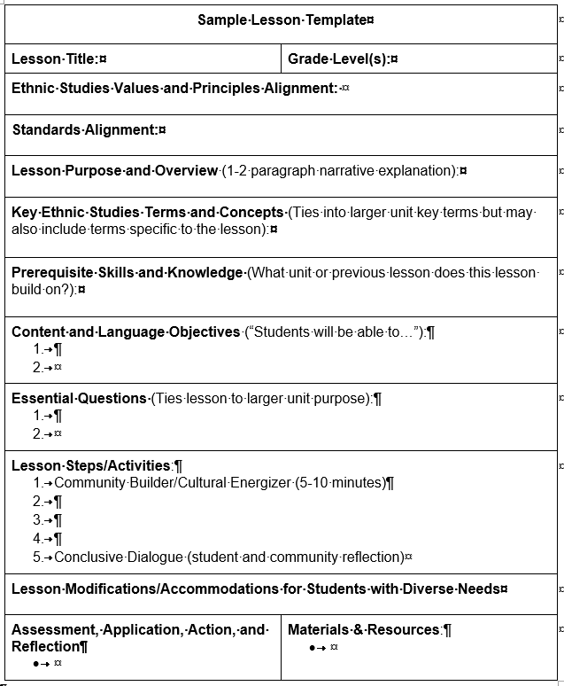
Lesson Title and Grade Level(s): Add title of the lesson and grade level.
Ethnic Studies Values and Principles Alignment: Each lesson should draw from and be informed by the Ethnic Studies values and principles described in chapter 1.
Standards Alignment: Lessons should be aligned to the academic content standards adopted by the SBE. In the History–Social Science Content Standards for California Public Schools, grade nine is reserved as an elective year. Therefore, most Ethnic Studies courses that are offered as electives will not align to specific grade-level history–social science content standards. However, teachers may want to show alignment to standards in the grade eleven United States History and Geography course or the grade twelve Principles of American Democracy course, as a way of demonstrating how Ethnic Studies content connect to other history–social science disciplines. However, the history–social science standards also include a set of Historical and Social Sciences Analysis skills for grades nine through twelve. These skills, organized under the headers of Chronological and Spatial Thinking, Historical Research, Evidence, and Point of View, and Historical Interpretation, do connect directly with the objectives of a rigorous Ethnic Studies course.
Other standards that should be addressed are the California Common Core State Standards for English Language Arts and Literacy in History/Social Studies, Science, and Technical Subjects (CCSS for ELA/Literacy) and the California English Language Development Standards (CA ELD Standards). The CCSS for ELA/Literacy include grade-level expectations for student skill development in reading, writing, speaking and listening, and language, with an expectation on the skills needed to prepare students for college and careers. In particular, the writing and reading expectations for students in Ethnic Studies courses should align strongly with the expectations in the CCSS for ELA/Literacy. The CA ELD Standards provide progressions across the grade levels for students at the emerging, expanding, and bridging levels of English language acquisition.
Lesson Purpose and Overview: Each lesson should have a brief narrative overview of the lesson and its purpose. This narrative should describe how the lesson is connected to the broader unit, describe the specific concept(s) and/or topic(s) that students will engage, and begin to highlight some of the texts (i.e. primary and scholarly sources) that students will delve into. The purpose of this section is to provide a clear description on how the lesson topic connects to skill development, and to provide a glimpse into the overall lesson.
Key Ethnic Studies Terms and Concepts: The lesson outline should also have a list of the critical academic vocabulary specific to Ethnic Studies that students will learn over the course of instruction. These terms and concepts should connect directly to the lesson topic.
Prerequisite Skills and Knowledge: Each lesson should identify what unit or previous lesson(s) the current lesson builds upon.
Content and Language Objectives: The lesson objectives identify what the desired takeaways are from the lesson. In other words, when the lesson is concluded, a student should have gained an understanding of the lesson content and be able to demonstrate that knowledge using specific skills. It is essential that lesson objectives to be written with active verbs based on cognitive demand (example: students will be able to infer the imperialist motives of Columbus using his journals). One way teachers can approach this is utilizing Understanding by Design (UbD).
Essential Questions: The use of essential or guiding questions is an approach that was used within the History–Social Science Framework to support student inquiry. Framing instruction around questions of significance allows students to develop their content knowledge in greater depth. This approach transforms students into active learners, as they are able to conduct research and evaluate sources in an effort to develop a claim about the question.
Lesson Steps/Activities: The steps in the lesson should be clear and discrete. In addition to more conventional lesson activities, teachers should consider including a cultural energizer and/or community building activity at the start of each lesson. They can include traditional icebreakers that involve movement, music, and games, and community-unity chants. The class can also begin with silent reflection on a question related to the lesson, followed by small group sharing, and culminating with a larger class wide discussion. Energizers or community builders should typically take no more than 10-15 minutes, depending on the activity. If done well, the energizer/community builder will pique student interest in the lesson, generate energy and enthusiasm for learning, and facilitate connection between students, the teacher, and the larger community.
Another activity to consider at the end of the lesson is a community reflection. This activity concludes the lesson with a meaningful reflection of student experience as it pertains to the objectives of the day. Teachers can facilitate this portion in various ways. For example, teachers can ask students to complete a silent, pen-to-paper response to a prompt. Teachers should create prompts that encourage students to reflect upon learnings and challenges, outstanding questions, connections to prior learning, and so on. The key to this portion of the lesson is that it be used to meaningfully review key takeaways, clarify mis/understandings, answer questions, generate questions, and connect to the larger purpose of the course.
Lesson Modifications/Accommodations for Students with Diverse Needs: Describe modifications to activities, assessment, and the overall lesson that are necessary to meet the diverse learning needs of students. These may include, but are not limited to, including additional language and writing support for ELD students; the use of additional audio, video, or other forms of media; and the inclusion of supplemental activities or assessments for more high-achieving/functioning students.
Assessment, Application, Action, and Reflection: Instruction cannot be effective if the teacher is unable to determine if the students have mastered the content. Furthermore, students should be able to transfer skills and knowledge learned to solve problems. Therefore it is important to include both formative and summative assessment within the lesson plan. Formative assessment takes place during instruction and allows the teacher to modify that instruction to assist learning. Summative assessments measure student achievement or progress toward mastery of the content, may take place at the end of a lesson, unit, or term, and may take the form of a performative task.
Materials & Resources: The selection of materials and resources can be difficult. At the very least, there needs to be sufficient resources for students to conduct the lesson activities, address the essential questions, and achieve the lesson objectives. There is certainly a range of primary and secondary sources that can accomplish these goals. But teachers need to be aware of some concerns when selecting resources. Online resources are plentiful, but have to be approached with caution. Links often expire, and while the content is usually available somewhere else, it can at times be difficult to find the new location. A web page that hosts a resource may also have content or links that can take students to sites that are inappropriate or offensive.
That particular issue is less present in print materials, but those materials also need to be reviewed carefully. The Education Code has requirements for social content that prohibit districts from adopting instructional materials that include advertising or contain content that demeans, stereotypes, or patronizes various specified groups. There are also potential copyright issues when using sources that are not within the public domain. For these reasons, LEAs may wish to focus on resources that are not commercial in nature, or websites that are from *.gov, *.edu, or, in some cases, *.org domains. When commercial products, such as a textbook or DVD, are used, LEAs should make sure that those materials are properly vetted through the local selection process for instructional materials (see below).
Table: Sample Unit Plan Template
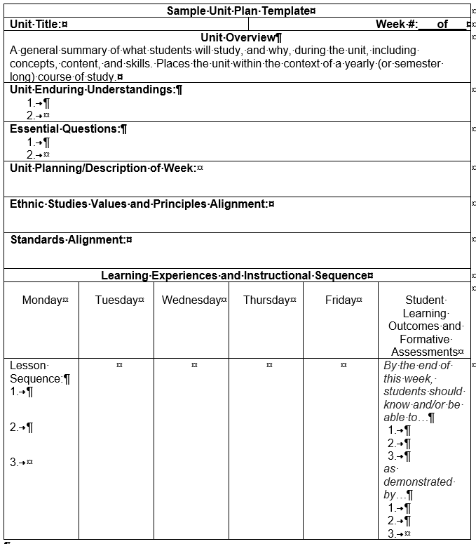
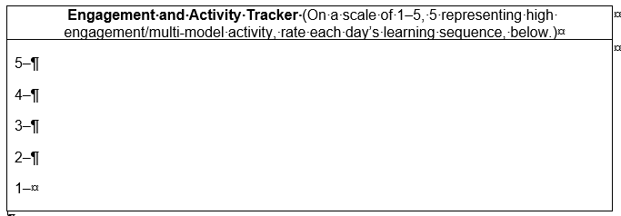
Summative Assessments/Performance Tasks:
Identify when the summative assessment(s) will be given and indicate where it will be administered in the appropriate week. What will students be able to do at the end of the unit? Plan backwards from your summative assessment(s), keeping in mind what students will need to be successful.
Unit Overview: A general summary of what students will study, and why, during the unit, including concepts, content, and skills. Places the unit within the context of a yearly (or semester long) course of study.
Unit Enduring Understandings: An Enduring Understanding is a statement that summarizes important ideas and core processes that are central to a discipline and have lasting value beyond the classroom.
Essential Questions: An Essential Question is an overarching question that provides focus and engages students. Framing instruction around questions of significance allows students to develop their content knowledge in greater depth.
Unit Planning/Description of Week: Provide a brief overview of what students will be engaging for the week.
Ethnic Studies Values and Principles Alignment: Each unit should draw from and be informed by the Ethnic Studies values and principles described in chapter 1.
Standards Alignment: Units should be aligned to the academic content standards adopted by the SBE.
Learning Experiences and Instructional Sequence: Identify and sequence the daily and/or weekly instructional experiences and best practices that will allow students to meet the student learning outcomes independently. Allows instructor to consider and plan an engaging learning experience for students, including appropriate activities, differentiation and best practices, for all students.
Student Learning Outcomes and Formative Assessments: Describes how students will demonstrate what they know and are able to do related to the unit outcomes. Formative assessments are ongoing and allow teachers to monitor learning and build student capacity towards the unit’s summative assessment.
Engagement and Activity Tracker: This tool allows teachers to keep the diverse learning community in mind while planning. In Ethnic Studies, it is paramount that energizers, engaging multimodal activities, and a multiplicity of student tasks are utilized throughout the learning experience. Teachers can use this section to rate both their lessons and instructional sequence for the unit and ensure that moments tending toward the static and less active, are followed by periods of dynamic activity, and that moments of intensive, individual, silent and sustained reading or writing are followed by collective discussion and multimodal exercise.
Summative Assessments/Performance Tasks: These should be administered at the end of each unit. They asses understanding, knowledge and skills. Summative assessments can be in the form of a culminating writing assignment, a class publication, the delivery of an oral presentation, etc. They should also address the essential questions. And finally, they should provide students opportunity to demonstrate agency in a real-world context.

Sample Course Outline: Introduction to Ethnic Studies
Course Purpose
Ethnic studies is designed to give students both an introduction to the experiences of ethnic communities that are generally underrepresented or misrepresented in textbooks and other widely used teaching resources. This course will equip students with a powerful way to understand race, ethnicity, nationality, and culture in the United States in order to make a truer democracy. Furthermore, students will explore the critical connections between themselves, their communities, the larger world and the systemic institutional structures used to organize society.
Throughout the course, students will learn about problems various communities have faced and the social movements they initiated to address those problems. Students will explore how people throughout this country’s history have fought for freedom, inclusion, justice, and democracy. Students will learn about the many powerful acts, both individual and collective, of resistance to oppression. We will celebrate solidarity between communities. We will highlight the commitment, struggle and sacrifices that have been endured, to make the ideals of this nation a reality for all.
This course will challenge students to think deeply about who they are, where they come from, and the path ahead as they set, and seek, to accomplish their goals. This class will encourage students to apply what they have learned to reimagine what they (as individuals, as a community, as a society) can be. The road will not be easy, but students will be supported throughout their journey to discover and use their power––for the benefit of themselves, their community, and society more broadly.
Course Goals
Through active engagement in the learning experience, students will be able to:
- explore a diverse set of narratives and primary sources across race, ethnicity, class, gender, sexuality, nationality and culture;
- describe the ways in which these categories are socially constructed and how they affect their lives as well as the lives of others;
- engage in structural analyses and critique of systems, institutions, power and privilege;
- critically examine the social construction of race and racism within the United States and its impact and legacy;
- participate in building a healthy, supportive and critical community that fosters allyship & solidarity;
- Agency community accountable and responsible individual; and
- develop critical writing, reading, thinking and organizational skills.
Course Outline
Semester 1: Reflecting on my world
Unit 0 (2–3 weeks): Introduction to Ethnic Studies; Building Our Community
Unit 1 (4–8 weeks): Identity Formation & Indigeneity
Unit 2 (4–8 weeks): Neocolonialism; Systems of Power and Oppression that create Inequality
Semester 2: Acting in my world
Unit 3 (4–10 weeks): Dehumanization & Humanization
Unit 4 (4–8 weeks): Transformational Change
Key Concepts and Definitions
Community A group of people that share particular characteristics (i.e., race, class, gender, neighborhood, nationality, culture, and interests) and/or maintain a sense of fellowship with others due to common interests, goals, and attitudes.
Identity formation is the act of knowing oneself and the combination of attributes, values, attitudes, and cultural traits that distinguish an individual. This is a genealogical process by which we, as well as others, define our sense of membership and belonging.
Indigeneity is a person’s connection to their ancestral lands, origins, and cultures, serving as a key component of one’s identity formation. It includes recognizing the indigenous people’s precolonial connection to the land where the course is being taught, their tribal sovereignty, and self-determination.
Systems of power are structures that have the capacity to control circumstances within economic, political and/or social-cultural contexts. These systems can be wielded by those in power and go on to determine how society is organized and functions. Oppressive systems of power create inequality in society.
Dehumanization is the act of wielding power to deny a person or group fundamental human qualities and rights.
Humanization is the recognition and/or restoration of the inherent dignity, inalienable rights, and other human qualities within a person or group of people.
Transformational Change is the deconstruction of the status quo in an effort to create new systems and ideas that reimagine new futures and ways of being. Transformational change is often done in development of organizations and social movements towards the eradication of colonialism.
Unit Progression & Overview
Unit 0 (2–3 weeks): Introduction to Ethnic Studies; Building Our Community
This unit will help students gain a deeper understanding of their own histories and identities, while simultaneously being exposed to the backgrounds of their peers.
- This exchange will help facilitate community building within the classroom, get students to recognize the interconnectedness of each other, and provide community building tools for students to utilize beyond the classroom.
Essential Questions:
- How do our individual perspectives shape the way we experience the world?
- What happens when different perspectives lead to divergent understandings?
- How can differing perspectives and experiences unite us for a common good?
Key Terms
- Respect, Trust, Reciprocity, Unity, Love, Self-determination, Critical Consciousness, Hope, Responsibility, Honesty, Loyalty, Work ethic, Character, Self-improvement, Self-reflection, Resilience
Lesson Ideas:
Human Bingo. Hi, my name is...
What is Ethnic Studies? Answers (via letters) from your peers.
Unit 1 (4–8 weeks): Identity Formation & Indigeneity
This unit will provide students with the tools and skills to name and better express their complex and varying identities.
- In learning about the various identities of their peers, students will be able to learn to build community and solidarity across lines of difference.
- Students will be engaged in a process of identifying and uncovering their connections to their ancestral lands, customs, culture, and learn that there are federally recognized and nonfederally recognized indigenous lands and cultures.
Essential Questions
- Who are you/we? And from where did you/we come?
- Who’s holding the power to tell stories of our nation, our communities, our families?
- Whose voice are we hearing? Whose voice is being left out?
- Why is it important to consider a multiplicity of perspectives in developing our understanding of people and society?
Key Terms
- Race, Ethnicity, Nationality, Culture, Gender, Sexuality, Community, Intersectionality, Point of View, Eurocentrism, Narrative, Counternarrative, Master narrative, Nature vs. nurture
Lesson Ideas:
The Road of Life (Who are you and how did you get here?)
Point of View and the Fight in the Hallway
What is History, herstory, and history of X?
AutoEthnography
Unit 2 (4–8 weeks): Systems of Power
This unit will provide students with the knowledge to identify systems of power and how they shape our society.
- Students will be able to understand how certain systems of power are leveraged to further marginalize some and benefit those in power, while also recognizing systems that advocate for justice.
Essential Questions
- Can societies be organized efficiently AND fairly/equitably?
- What is net worth by race?
- Why and how have systems been utilized to organize society?
- Who has the power to make decisions within society?
- What has been the impact of existing systems to our society?
Key Terms
- Capitalism, Colonialism, Imperialism, Patriarchy, White Supremacy, Heteronormativity, Institution, Privilege, Hierarchy, Hegemony, Power, Systemic, Oppression
Lesson Ideas:
Social Construction of Race
Migration
Unit 3 (4–10 weeks): Dehumanization & Humanization
This unit will allow students to interrogate how people have historically been dehumanized via systems of power.
- Students will examine historical examples of how people have resisted dehumanization and asserted their humanity.
Essential Questions
- How have people historically responded to dehumanizing systems and other social constructs?
- What role does narrative making play in shaping perceptions of individuals and communities?
Key Terms
- Human Rights, Equity, Equality, Social Construct, Oppression, Four I’s of Oppression, Alienation, Objectification
Lesson Ideas:
The Four I’s of Oppression: Ideological, Institutional, Interpersonal, Internalized
Oral History
Campaign Development
Unit 4 (4–8 weeks): Transformational Change
This unit will provide students with the skills and tools to develop solution-based praxis grounded in justice and humanization, which can be utilized to improve themselves, their families, communities, and the world.
Essential Questions:
- What are the responsibilities of critically engaged citizens in a democratic society?
- Is transformative social change possible when working within existing institutions?
- What does equity, justice, and democracy look like in practice (locally, nationally, globally)?
- Is allyship across race, class, gender, sexuality possible? If so, how? If not, what barriers and obstacles persist?
Key Terms
- Social movements, Justice, Critical Thinking (Thinking CAUSALLY, Thinking HISTORICALLY, Thinking SYSTEMS & POWER), Praxis, Change, Transformative resistance, Agency, Solidarity, Problem-solving
Lesson Ideas:
Introduction to Causation: Things happen for a reason OR there’s a reason for why things happen
Solidarity & Shared Struggle
Social Movements
Youth Participatory Action Research
Core Skills (CCSS Literacy)
Reading
- Identify the missing perspective and biases in a given source.
- Compare and contrast multiple perspective or points of view on a given historical event or issue.
- Evaluate different version of a historical event in different mediums.
- Apply knowledge gained from texts to inform reading of additional texts on the same topic, issue or time period.
Informative/Explanatory Writing
- Summarize, paraphrase and/or quote information when appropriate.
- Create and use outlines to organize information in a logical sequence.
- Gather information from relevant and credible sources, both primary and secondary.
- Cite sources using appropriate citations formats.
- (research and technology use) Conduct short- and long-term research projects based on self-generated questions to support/refute arguments.
Argumentative Writing
- Organize evidence and information from multiple credible sources based on historical analysis.
- Apply historical thinking skills (reasons/reasoning) to logically connect a claim(s) and/or counterclaim(s) with multiple lines of evidence to support or refute a historical argument.
Speaking & Listening
- Cooperate with peers to establish rules, goals, and decision-making formats.
- Share the dissemination of information.
- Actively encourage participation.
- Listen to others in group, ask questions.
- Use technology, including the Internet, to produce, publish, and interact with others about writing, including linking to and citing online sources.

Selecting Existing Curricula and Instructional Materials
LEAs have a great deal of flexibility when it comes to the selection of instructional materials for use in their schools. Education Code Section 60000(c) states that it is the responsibility of an LEA’s governing board to establish courses of study and to select the appropriate instructional materials for those courses. While there is a state-level process by which the SBE adopts instructional materials, that process only applies to kindergarten through grade eight materials. High school materials, including materials for elective courses such as Ethnic Studies, are adopted at the local level by the LEA governing board (Education Code Section 60400).
LEAs are required to adopt materials that meet certain requirements in code, such as the requirement that instructional materials “accurately portray the cultural and racial diversity of our society” (Education Code Section 60040). However, the process by which materials are selected at the local level varies significantly. Most LEAs have policies that govern this process. Typically the process begins when a local selection committee is chosen. Education Code Section 60002 states that, “Each district board shall provide for substantial teacher involvement in the selection of instructional materials and shall promote the involvement of parents and other members of the community in the selection of instructional materials.” But how exactly that involvement is carried out depends on the LEA. Another way to honor the principles of Ethnic Studies is to have students be involved in this process as well, either through direct involvement in district policy development or through community outreach to engage others in the selection process.
Governing boards should make these decisions through an open and public process that provides for public input and teacher leadership throughout the process. It is important that all steps related to the development of a local curriculum, including the selection of materials, are transparent and involve all stakeholders in the community. This process can be time-consuming and difficult, but it is the best way to ensure that the materials used are high quality and support effective instruction and student learning.
The SBE has adopted a policy document that provides a set of guidelines for piloting textbooks and instructional materials. While focused on kindergarten through grade eight, much of the guidance in the document applies to the selection of materials for the secondary grades as well. These guidelines include tasks such as the creation of a representative selection committee, the definition and prioritization of evaluation criteria, and establishing a pilot process to determine which available materials best meet local needs. The curriculum frameworks adopted by the SBE also include criteria for the selection of instructional materials that can be used by LEAs as a model.

Education Code sections 51100-51102.
UDL is discussed on pages 540–543 of the History–Social Science Framework, and pages 910–913 of the English Language Arts/English Language Development Framework. UDL is just one of a number of universal access strategies present in both frameworks.
History–Social Science Framework, Chapter 14, pp. 310–314.
Some examples of energizers have been provided in Appendix B.
More information about these requirements can be found in the State Board of Education’s Standards for Evaluating Instructional Materials for Social Content, 2013 Edition. Available at https://www.cde.ca.gov/ci/cr/cf/lc.asp (Accessed March 6, 2019).
“Guidelines for Piloting Textbooks and Instructional Materials,” State Board of Education Policy 01-15 (January 2015), https://www.cde.ca.gov/ci/cr/cf/documents/impilotingguidelines.doc (Accessed February 20, 2019).
See Chapter 23 of the History–Social Science Framework for California Public Schools, and Chapter 12 of the English Language Arts/English Language Development Framework for California Public Schools.

