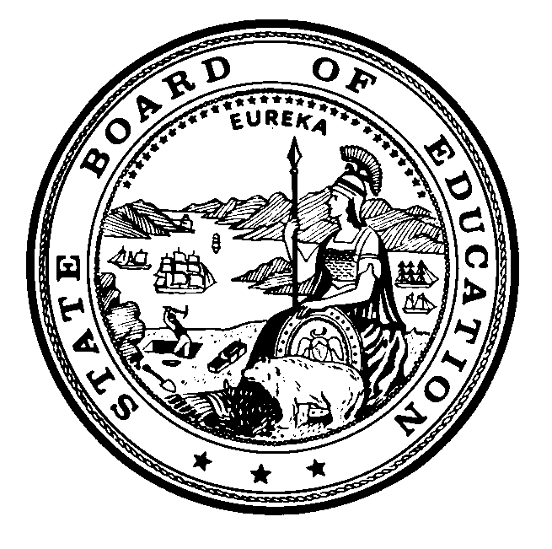
Instructional Quality Commission
An Advisory Body to the California State Board of Education

Instructional Quality Commission Meeting Dates
Commission will consider for approval on November 16, 2022

2023 Dates
REVISED - Wednesday–Thursday, January 25–26, 2023
Wednesday–Thursday, March 15–16, 2023
Wednesday–Thursday, July 26–27, 2023
REVISED - Tuesday, August 15, 2023
Wednesday–Thursday, September 20–21, 2023
Wednesday–Thursday, November 15–16, 2023
All meetings, unless otherwise indicated, will be held at the
California Department of Education Building
1430 N Street
Sacramento, CA 95814

