Item 2.A.1.
Attachment 1
World Languages Committee
July 26, 2018

2019 World Languages Standards Revision Process
This chart shows the roles of the Instructional Quality Commission (IQC), the State Board of Education (SBE), and the public, as well as the major steps in the World Languages Standards revision process. All meetings are open to the public.
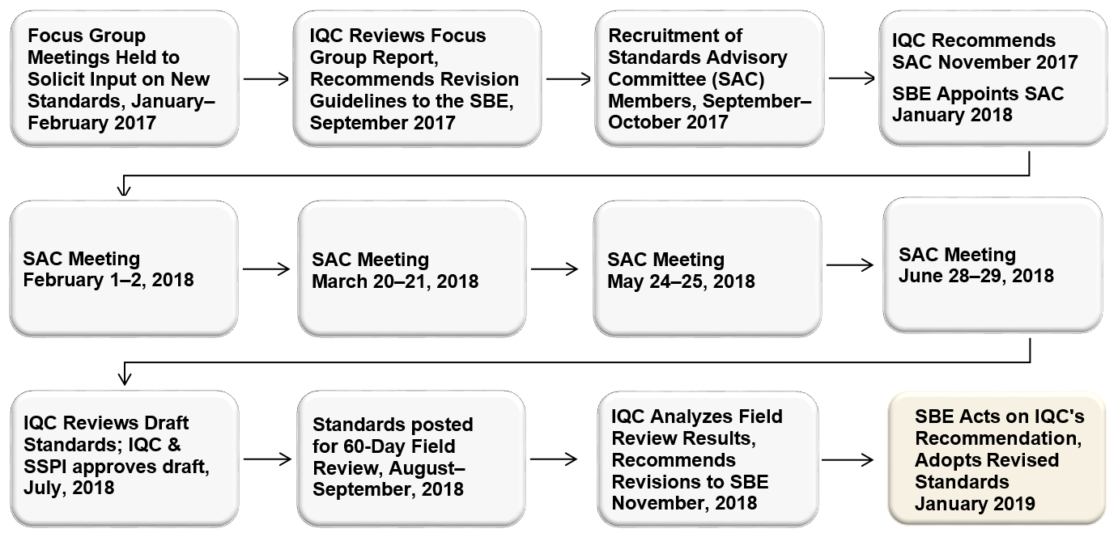
*This timeline is subject to change. State Board of Education will only take action on changes to the approved timeline if they affect Instructional Quality Commission or SBE action dates.
Visit https://www.cde.ca.gov/be/cc/cd/wlstdsrevisionprocess.asp for a long description of this flowchart.

