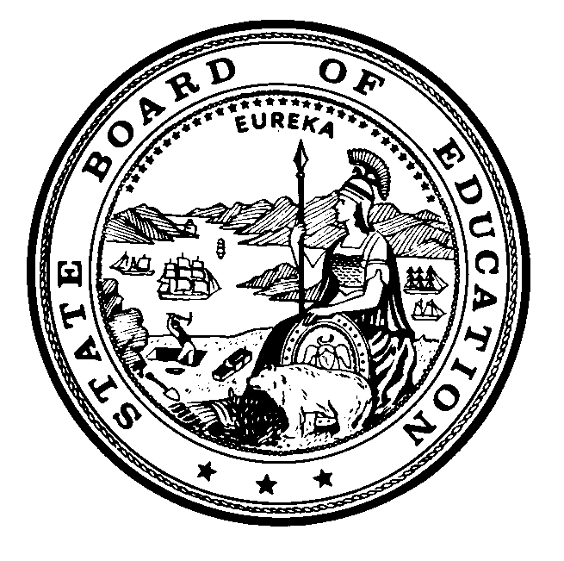
Item 1. H.
Full Commission
September 19–20, 2019
Instructional Quality Commission
An Advisory Body to the California State Board of Education

Proposed Revised

Instructional Quality Commission Meeting Dates
Commission to consider for approval on September 19, 2019

2019 Meeting Dates
NEW – Friday, October 4, 2019 – Public Comment Meeting
Thursday–Friday, November 14–15, 2019

2020 Meeting Dates
Wednesday–Thursday, January 15–16, 2020
CANCEL – Monday, April 6, 2020
NEW – Monday, April 13, 2020 or Friday, April 17, 2020
Wednesday–Thursday, May 13–14, 2020
Thursday, August 13, 2020
Wednesday–Thursday, September 16–17, 2020
Wednesday–Thursday, November 18–19, 2020
All meetings, unless otherwise indicated, will be held at the
California Department of Education Building
1430 N Street
Sacramento, CA 95814

