California Workforce Pathways Joint Advisory Committee
cwpjac-aug21item01
Page 1 of 2
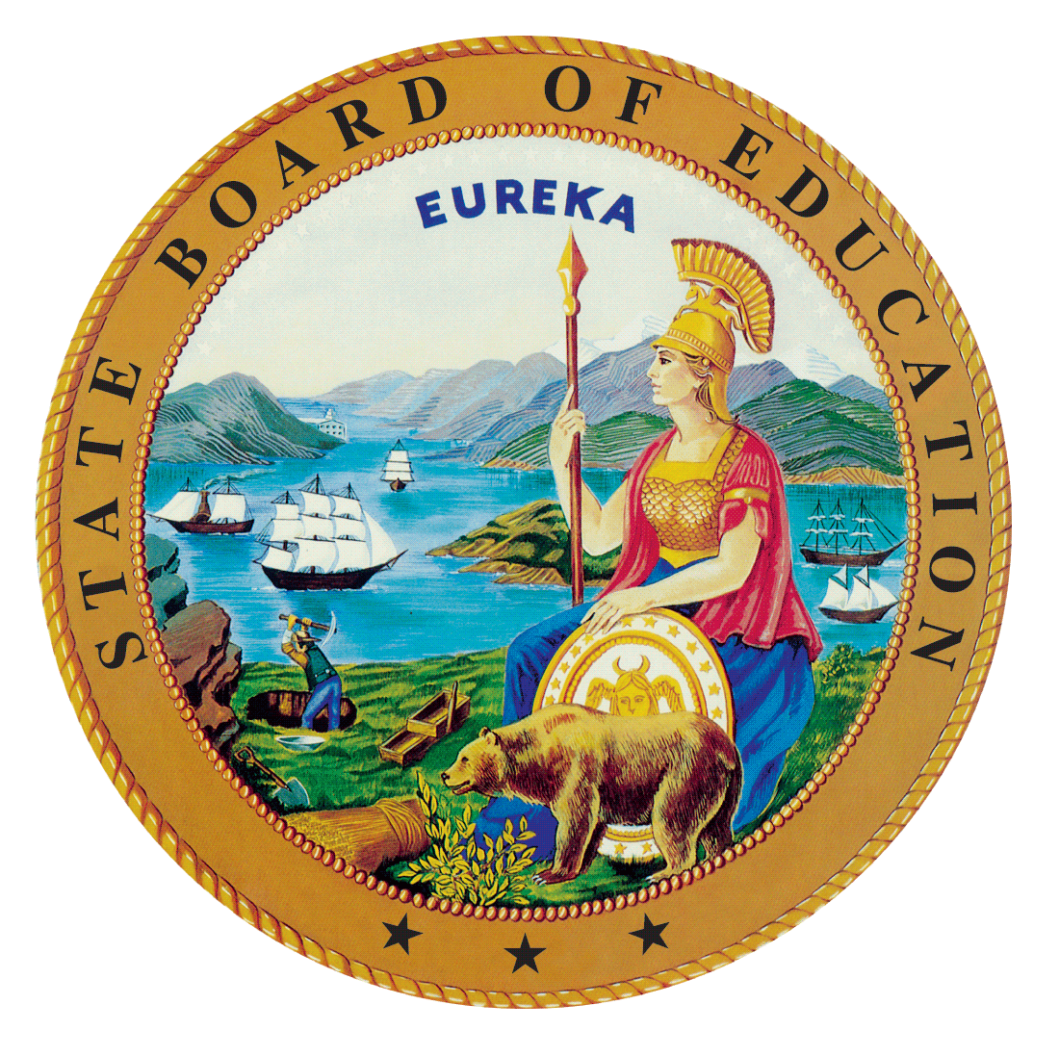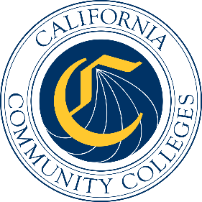

California Workforce Pathways
Joint Advisory Committee
August 6, 2021
Agenda Item 01
Posted by the California Department of Education

Subject
Approval of the California Workforce Pathways Joint Advisory Committee’s May 14, 2021, Preliminary Report of Actions/Draft Minutes.

Type of Action
Information, Action

Summary of the Issue(s)
After the California Workforce Pathways Joint Advisory Committee (CWPJAC) holds a public meeting, a recording of the meeting is typically posted within a few days on the CWPJAC’s web page at https://www.cde.ca.gov/ci/ct/gi/workpathjac.asp. The final Report of Actions/Minutes is posted following the CWPJAC’s approval at its subsequent scheduled meeting.

Recommendation
The State Board of Education, the California Department of Education, and the California Community Colleges Chancellor’s Office staff jointly recommend that the CWPJAC review and approve the May 14, 2021, Preliminary Report of Actions/Draft Minutes (Attachment 1).

Brief History of Key Issues
The CWPJAC addresses systems alignment policies specific to career pathways within the context of state and federal investments, furthering California’s policy objectives regarding workforce pathways in the state’s regional economies.

Summary of Previous California Workforce Pathways Joint Advisory Committee Discussion(s) and Action(s)
This is a standing Agenda Item which allows the CWPJAC members to review and approve the Preliminary Report of Actions/Draft Minutes for the previous CWPJAC meeting.

Attachment(s)
Attachment 1: Preliminary Report of Action (7 pages)

