California Workforce Pathways Joint Advisory Committee
cwpjac-aug22item04
Page 1 of 2
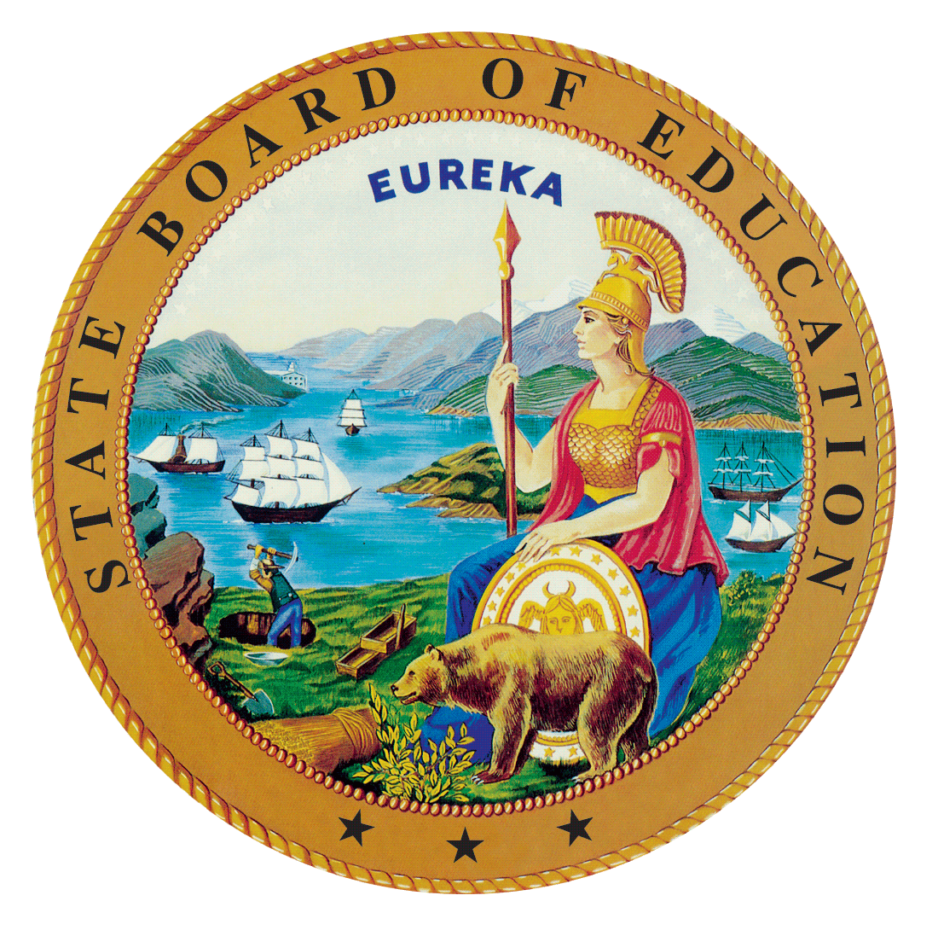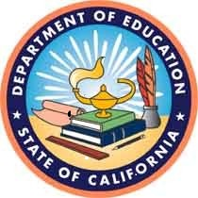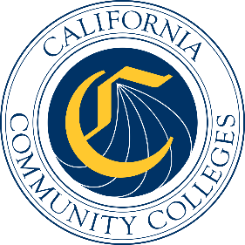

California Workforce Pathways
Joint Advisory Committee
August 11, 2022
Agenda Item 04
Posted by the California Department of Education

Subject
Update on Kindergarten through Grade Twelve Work-based Learning Programs.

Type of Action
Information

Summary of the Issue(s)
This update was a request made by a California Workforce Pathways Joint Advisory Committee (CWPJAC) member at the March 2022 CWPJAC meeting.

Recommendation
Not applicable.

Brief History of Key Issues
Not applicable.

Summary of Previous California Workforce Pathways Joint Advisory Committee Discussion(s) and Action(s)
Not applicable.

Attachment(s)
None.

