California Workforce Pathways Joint Advisory Committee
cwpjac-feb24item03
Page 1 of 5
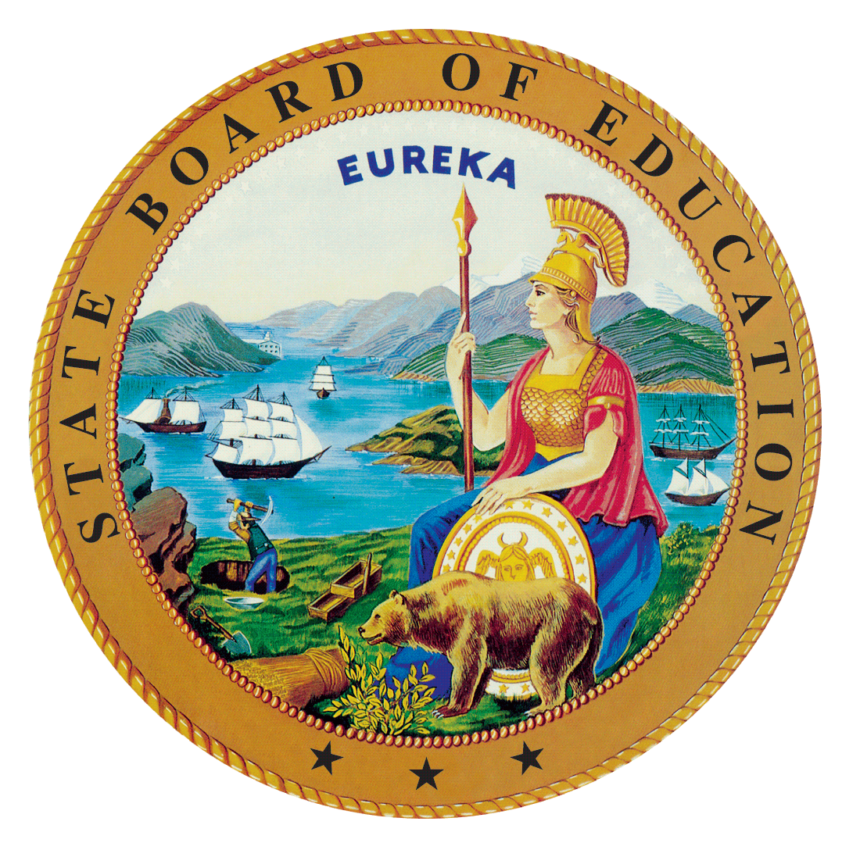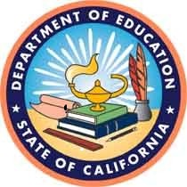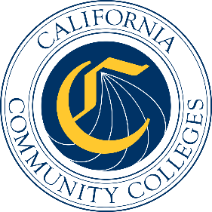

California Workforce Pathways
Joint Advisory Committee
February 9, 2024
Agenda Item 03
Posted by the California Department of Education

Subject

Update on the California State Plan for Career Technical Education Project.

Type of Action
Information

Summary of the Issue(s)
The California State Team (CAST), consisting of core leadership of the State Board of Education (SBE), the California Department of Education (CDE), and the California Community Colleges Chancellor’s Office (CCCCO) was formed in October 2019 to oversee the development of the comprehensive California State Plan for Career Technical Education (CTE). At the July 2020 California Workforce Pathways Joint Advisory Committee (CWPJAC) meeting, the CAST presented a recommended approach to create a Strategic Plan/Call to Action in the development of the California State Plan for CTE.
At the September 2020 meeting, the CAST provided an update regarding the framing of the State Plan using a Call to Action approach, as outlined in the Brief History of Key Issues below.
The CAST discussions have centered on developing: (a) specific strategic areas of focus; (b) expertise required to assist with providing necessary bandwidth to accomplish the work; and (c) a detailed scope of work.
Upon advice and guidance from CWPJAC members on the more detailed scope of work, the CAST team began the process of developing a draft outline of a forward-looking document that becomes California’s Strategic Plan/Call to Action for CTE. Jobs for the Future (JFF) under contract with CCCCO worked on the first and second phase of the project. The first phase was focused on engaging with various interest holders to gain an understanding of the context of the development process. The first part of phase one included a planning session with the CWPJAC at its August 6, 2021, meeting to receive guidance and recommendations on JFF’s recommended approach of hosting study sessions, as well as focus group sessions to gather input from various interest holders and practitioners, both of which were conducted virtually. A survey of parents and students is also in progress to ensure that their input is gathered at the outset of the development phase.
The second part of phase one was the actual State Plan development work, including the draft and updating of the plan, and the public comments that were collected during a 45-day Public Comment period.

Recommendation
No Recommendation

Brief History of Key Issues

Approach and Areas of Focus
This session will provide an update on the future work to be completed in partnership with CAST and JFF. The two teams have been working on the identification and development of tools that LEAs and community colleges can use for their regional model pathway development. The session will also focus on the alignment of the Career Education Masterplan and the California State Plan for Career Technical Education.
The previous session provided an update to the work completed of part one of Phase two in partnership with CAST and JFF. The two teams worked together with staff from the field to develop and plan the 10 Regional Implementation Convenings to create a model for regional implementation of CTE pathways. The Convening Team completed the 10 convenings during a 3.5-week period between September and October 2023.
The broad intent of the Strategic Plan/Call to Action approach for the California State Plan for CTE is to provide cohesion and direction to the current state, regional, and local level work through visionary and innovative approaches that are relevant for interest holders, and particularly for students and employers as the system’s ultimate benefactors. The goal of the Strategic Plan/Call to Action is to lay out the state’s future vision for CTE, both in the short-term (i.e., in the next five years) and long-term (i.e., in ten years), using creative strategies while preserving intentionality of California’s student-centered approach and the California Way.
In the immediate term, the Strategic Plan/Call to Action will also address lessons learned from the COVID-19 pandemic in order to build from our collective experiences and knowledge for the benefit of student learning and skills obtainment, and to tie them into efforts shared from Future of Work initiative and future employability. During this time, college and career pathway programs have become more critical for helping to stabilize the economy and enable employers to hire workers with skills they need.
In the development of the State Plan for CTE, the scope of work was organized into four key areas with equity and access being foundational threads throughout:
- Workforce supply that meets demand (industry interactions and partnerships, in-demand skills and clusters, etc.)
- Delivery (competency-based education, CTE online, experiential/work-based learning, apprenticeship, adult education, curriculum, etc.)
- Data that informs the investments (common outcomes, aligned data systems that captures cradle to career, etc.)
- Systems alignment (dual enrollment, teacher and faculty preparation, teacher credentialing, career pathways, etc.)
The following cross cutting themes further support the key areas above:
- Career Pathways
- Dual Enrollment
- Regional Partnership Development
- CTE Teacher and Faculty Preparation Pipeline
- Work-based Learning
Sources of Inspiration
The CWPJAC’s Guiding Policy Principles to Support Student-Centered K–14+ Pathways and the 12 Essential Elements of a High-Quality College and Career Pathway are foundational to guide a student-centered approach. They feature topics such as online education; competency-based education; credential transparency; and facilitation of education and workforce transitions (from elementary to middle to high school to all segments of postsecondary education and training). Because students come with a diverse set of knowledge, skills, and abilities, the system must be ready to meet them at their level. Exploring these and other topics will set the stage for a forward-looking Strategic Plan/Call to Action that becomes the California State Plan for CTE.
A comprehensive California State Plan for CTE should be grounded within the larger context of state education and workforce development priorities and initiatives, as exemplified in the work surrounding the Future of Work and its focus on high road employment and training opportunities to create high quality jobs, use a job quality index as a way to intentionally address economic inequities and lift communities up, and to build on worker demands. More information on the Future of Work Commission is available on their web page at https://www.labor.ca.gov/labor-and-workforce-development-agency/fowc/.
Additional important resources are the citations within the Federal Strengthening Career and Technical Education for the 21st Century Act (Perkins V) State Plan, as well as input provided by stakeholders and public comment that are intended to be considered in the development of a California State Plan for CTE. These include:
- Continuing to align Perkins V accountability indicators to current state measures, and data collection methodology.
- Refining the definition of size, scope, and quality to consider the many variations that exist within kindergarten through grade twelve local educational agencies and community colleges across California.
- Strengthening inter-segmental and inter-sectoral connections.
- Exploring options for teacher and faculty preparation, including considering how industry experience can support and strengthen college and career pathways, in partnership with staff of the California Commission on Teacher Credentialing as the options relate to preparing kindergarten through grade twelve educators.
- Addressing barriers and strategies to increase dual/concurrent enrollment opportunities.
- Considering ways to promote work-based learning within high-quality college and career pathways across diverse communities in California.
Even before the development of the federal Perkins V State Plan, the above list had been under discussion for several years through the development of high-quality CTE programming, and funded through state and federal funding sources. A goal of the Strategic Plan/Call to Action for CTE is to signal priority areas and efforts to achieve greater alignment and outcomes to the field.

Summary of Previous California Workforce Pathways Joint Advisory Committee Discussion(s) and Action(s)
November 20, 2023: CDE and JFF staff provided an overview of the 10 regional convenings that were hosted across California. The convenings provided a platform for K-12 stakeholders and community college staff to discuss the development of pathways for students to continue on into college.
May 26, 2023: CDE and JFF staff presented the next steps for the work on the California State Plan for CTE. Next steps include the process for selecting the host sites for the 10 Regional Convenings that will be held across the state between K12 and CCCCO sites. JFF shared a brief overview of the regional planning tool.
March 10, 2023: CDE and JFF staff presented the final draft of the California State Plan for CTE. The presentation included the summary of the work that has led up to the final draft of the plan and a review of the themes from the 45-day Public Comment Period.
February 3, 2023: CDE and JFF staff presented the final draft of the California State Plan for CTE. The presentation included the summary of the work that has led up to the final draft of the plan and a review of the themes from the 45-day Public Comment Period.

Attachment(s)

None

