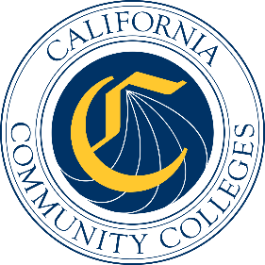

California Workforce Pathways
Joint Advisory Committee
February 9, 2024
Agenda Item 06
Posted by the California Department of Education

Subject
Review of Career Technical Education Data in Meeting the Career Technical Education Incentive Grant Data Metrics, Pursuant to California Education Code Sections 53071 and 88828.

Type of Action
Information

Summary of the Issue(s)
This agenda item presents information and data that was requested by the California Workforce Pathways Joint Advisory Committee (CWPJAC) members at the November 20, 2023, CWPJAC meeting.

Recommendation
No recommendation

Brief History of Key Issues
N/A

Fiscal Analysis (as appropriate)
N/A

Attachment(s)
None

