Posted by the California Department of Education – November 2021.
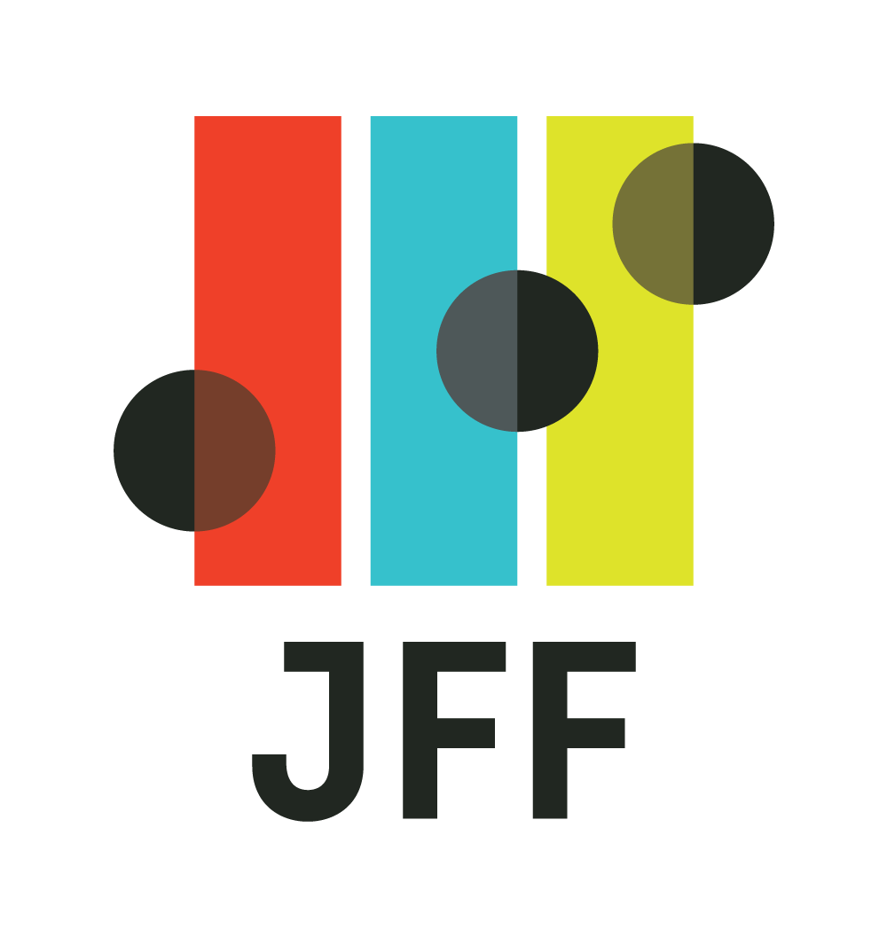

Agenda for Study Session #2

Overview
As a step in the development process for the California State Plan for Career Technical Education (CTE), this second of two study sessions will help California Workforce Pathways Joint Advisory Committee (CWPJAC) members explore bold and visionary ideas and drivers of transformation and change for an equitable future of work and CTE Participants will hear from national leaders about the current and future demand for skills and jobs, and how the lines between K-12 education, postsecondary education, and the labor market must be blurred to better meet the needs of those in the workforce, those seeking to enter the workforce, and employers who are seeking talent, connecting the dots to help prepare for success in the world of work. Speakers will share research, insights, and forward-looking innovations for CWPJAC members to consider and potentially adapt to the California context as the state develops and implements the State Plan for CTE to increase economic mobility. The study session is designed to be interactive and engaging, and speakers will be invited to challenge and inspire CWPJAC members and to inform the Committee’s thinking.
Time (min.) | Item | Learning Outcome
10 | Introduction  A reflection on what was discussed during the last study session and what will be discussed today.  Speakers: Members of the CAST | Committee members understand the connection between the first and second study sessions.
60 | The Labor Market Now and in the Future  A discussion on EMSI Burning Glass’s latest labor market research and insights, including what jobs and skills will drive the post-pandemic recovery and implications for the future of work, credentials, CTE development, and equity.  Link: https://www.burning-glass.com/research-project/after-storm-recovery-jobs/ [Link removed; no longer valid]  Speakers: Joel Simon, Vice President – Workforce Strategies, EMSI Burning Glass | Committee members understand changes in the labor market and explore implications for the CA State Plan for CTE.
60 | The Big Blur  An argument for erasing the boundaries between high school, college, and careers—and creating one new system that works for everyone.  Link: https://www.jff.org/resources/the-big-blur-an-argument-for-erasing-the-boundaries-between-high-school-college-and-careers-and-creating-one-new-system-that-works-for-everyone/  Speaker: Joel Vargas, Vice President, JFF | Committee members glean insights and ideas – keeping in mind the California Way – for driving innovation in high-quality CTE and explore implications for the CA State Plan for CTE.
10 | Final Discussion | Committee members identify key takeaways for the development of the CA State Plan for CTE.

Agenda for November 19, 2021

