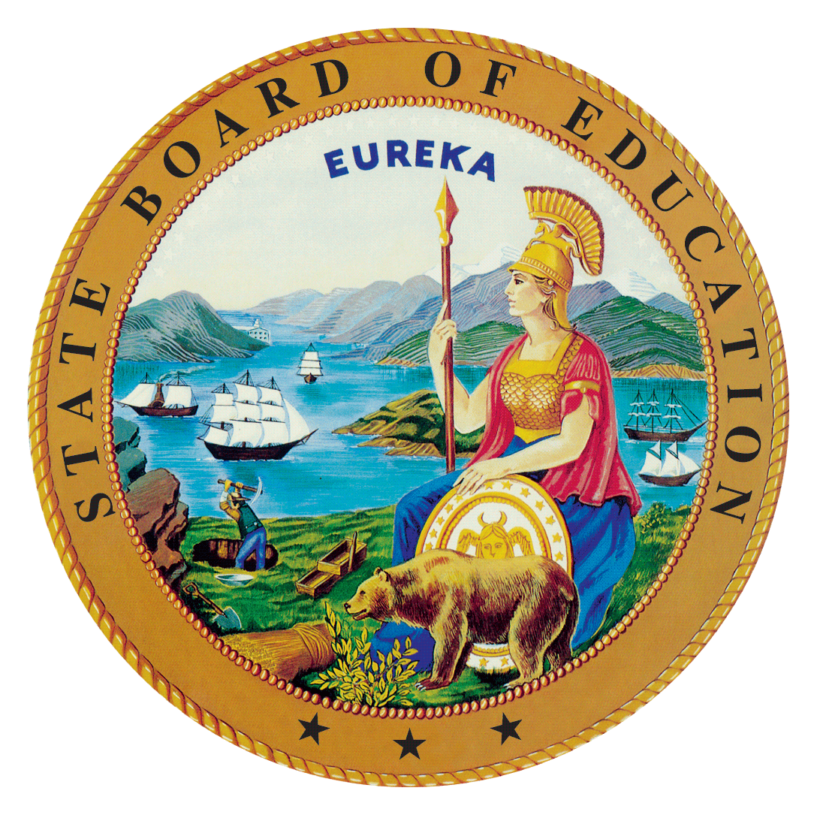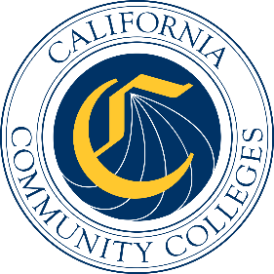

California Workforce Pathways
Joint Advisory Committee
February 2019
Agenda Item #02

Subject
California Career Technical Education (CTE) Initiatives: Update on the Career Technical Education Incentive Grant (CTEIG) and the K–12 Strong Workforce Program (K–12 SWP)

Type of Action
Information

Summary of the Issue(s)
This is an update to the work of implementing the CTEIG and the K–12 SWP State CTE funding legislation, including a demonstration on the NOVA system.

Recommendation
Staff from the California Department of Education (CDE) and California Community Colleges Chancellor’s Office (CCCCO) recommend that the California Workforce Pathways Joint Advisory Committee (CWPJAC) receive an update and provide any feedback on the progress of work to this date, as deemed necessary.

Brief History of Key Issues
The CTEIG application was released to the field on December 19, 2018 with a submission deadline of 5:00 p.m. on January 25, 2019. The CDE staff took a different approach to the application process, and instead of the usual narrative application developed a comprehensive self-evaluation rubric based on the requirements in CTEIG legislation and cross-referenced to the Guiding Policy Principles to support K–14+ Pathways document developed by the CWPJAC.
The CDE staff continue to review CTEIG applications, the CDE received 364 applications. This number is consistent with the 2017–18 third round of the original CTEIG but down slightly from the 2015–16 first round of the original CTEIG which was authorized as one-time funding. We anticipates the numbers may be down due to the 2:1 dollar match requirement in CTEIG, as well as the inclusion of more consortia applicants.
The K–12 SWP application for funding was released in January 2019, and the submission deadline is March 15, 2019. The application process is using the NOVA platform that the CCCCO uses for applications, and reporting. Activities to support the implementation of the K–12 SWP this past month include a bidder’s conference, informational webinars, and an update of the Frequently Asked Questions located on the CCCO’s Doing What Matters web page, http://www.doingwhatmatters.cccco.edu/StrongWorkforce/K12SWPFAQs.aspx. At the CWPJAC meeting staff will provide a brief demonstration of the NOVA platform.

Summary of Previous California Workforce Pathways Joint Advisory Committee Discussion(s) and Action(s)
The CWPJAC, per Education Code sections 53071 and 88828, has the responsibility for making recommendations regarding the use of metrics for the CTEIG and the K–12 SWP, as well as providing input on guidance developed for the K–12 SWP.
January 11, 2019: The CWPJAC heard an update on CTEIG, and K–12 SWP. This update included information presented by the CDE staff on the December 19, 2018 release of the CTEIG Request for Applications (RFA). The CCCCO staff presented an update on the development of the RFA for the K–12 SWP, as well as an update on the regional information meetings held around the State.
December 14, 2018: Final review and approval of the metric recommendations for both the CTEIG and K–12 SWP was unanimously approved by the CWPJAC. Final recommendations were submitted to the Department of Finance for consideration.
November 26, 2018: The CDE and CCCCO staff provided an in-depth review of proposed metrics, and their alignment to the CWPJAC Guiding Policy Principles to support K–14+ Pathways document. Based on direction from CWPJAC, the CDE and CCCCO staff revised the proposed metrics to operationalize the data, as well as provide information on the source of data collection.
September 28, 2018: The CDE and CCCCO staff jointly presented an initial overview of the CTEIG and K–12 SWP metrics and received feedback, guidance and direction on appropriate metrics for measurement of CTE program quality, and student achievement in kindergarten through grades fourteen (K–14) CTE programs.

Fiscal Analysis (as appropriate)
Funding available to eligible recipients under the CTEIG is $150 million annually, and on-going. Funding available under the K–12 SWP is $164 million, of which $150 million is available to eligible recipients. The remaining $14 million is for K–14 Technical Assistance Providers.

Attachment(s)
None

