California Workforce Pathways Joint Advisory Committee
cwpjac-jul20item01
Page 1 of 3
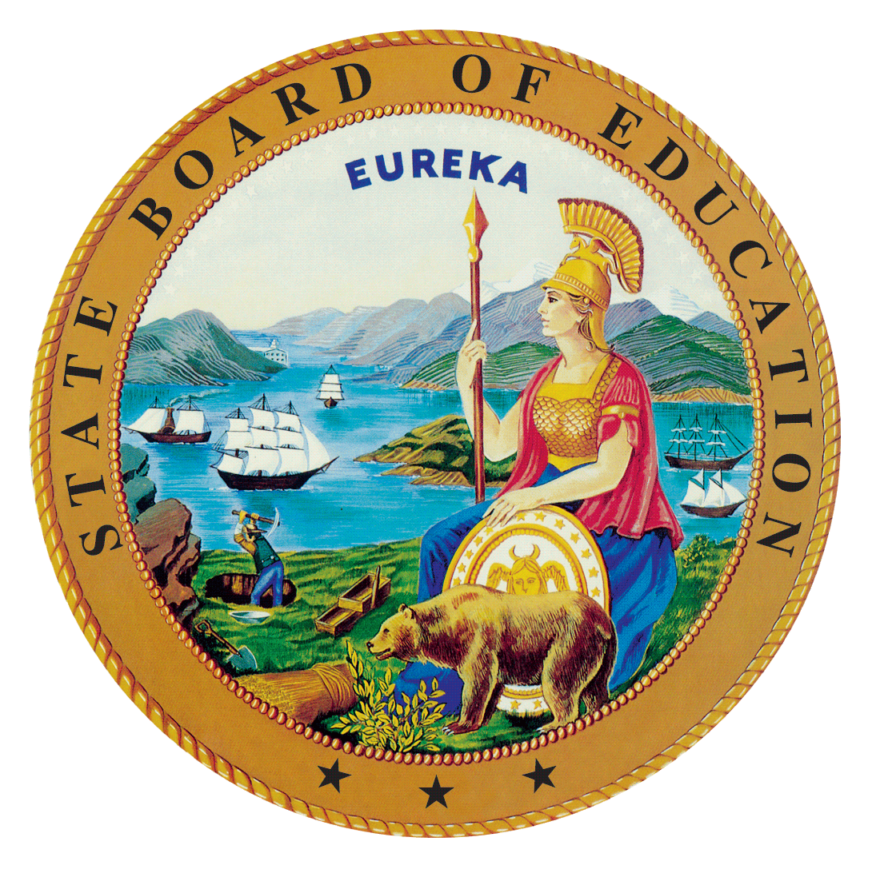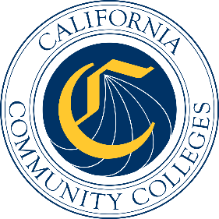

California Workforce Pathways
Joint Advisory Committee
July 10, 2020
Agenda Item 01
Posted by the California Department of Education

Subject
Approval of the California Workforce Pathways Joint Advisory Committee’s May 8, 2020 Preliminary Report of Action.

Type of Action
Information, Action

Summary of the Issue(s)
The California Workforce Pathways Joint Advisory Committee (CWPJAC) usually holds a public meeting every other month. After the meeting has concluded, staff compile a Preliminary Report of Action to document the meeting’s main activities. A recording of the meeting, is posted within a few days of the meeting and is posted on the CWPJAC’s webpage at, https://www.cde.ca.gov/ci/ct/gi/workpathjac.asp. The Report of Action is posted following CWPJAC approval at the subsequent scheduled meeting.
Recommendation
The State Board of Education, the California Department of Education, and the California Community Colleges Chancellor’s Office staff jointly recommend that the CWPJAC review and approve the May 8, 2020 Report of Action.

Brief History of Key Issues
The CWPJAC addresses systems alignment policies specific to career pathways within the context of state and federal investments; furthering California’s policy objectives regarding workforce pathways in the state’s regional economies.

Summary of Previous California Workforce Pathways Joint Advisory Committee Discussion(s) and Action(s)
May 8, 2020: Approval of the March 2, 2020 Report of Action.
March 2, 2020: Approval of the January 31, 2020 Report of Action.
January 31, 2020: Approval of the November 25, 2019 Report of Action.
November 25, 2019: Approval of the November 7, 2019 Report of Action.
November 7, 2019: Approval of the October 11, 2019 Report of Action.
October 11, 2019: Approval of the July 12, 2019 Report of Action.
July 12, 2019: Approval of the May 29, 2019 Report of Action.
May 29, 2019: Approval of the March 11, 2019 Report of Action.
March 11, 2019: Approval of the February 19, 2019 Report of Action.
February 19, 2019: Approval of the January 11, 2019 Report of Action.
January 11, 2019: Approval of the December 14, 2018 Report of Action.
December 14, 2018: Approval of the November 26, 2018 Report of Action.
November 26, 2018: Approval of the September 19, 2018 Report of Action.
September 19, 2018: Approval of the May 11, 2018 Report of Action.
May 11, 2018: Approval of the March 16, 2018 Report of Action.
March 16, 2018: Approval of the December 15, 2017 Report of Action.
December 15, 2017: Approval of the September 15, 2017 Report of Action.
September 15, 2017: Approval of the July 14, 2017 Report of Action.
July 14, 2017: Approval of the May 12, 2017 Report of Action.
May 12, 2017: Approval of the March 10, 2017 Report of Action.

Attachment(s)
Attachment 1: Preliminary Report of Action (5 pages)

