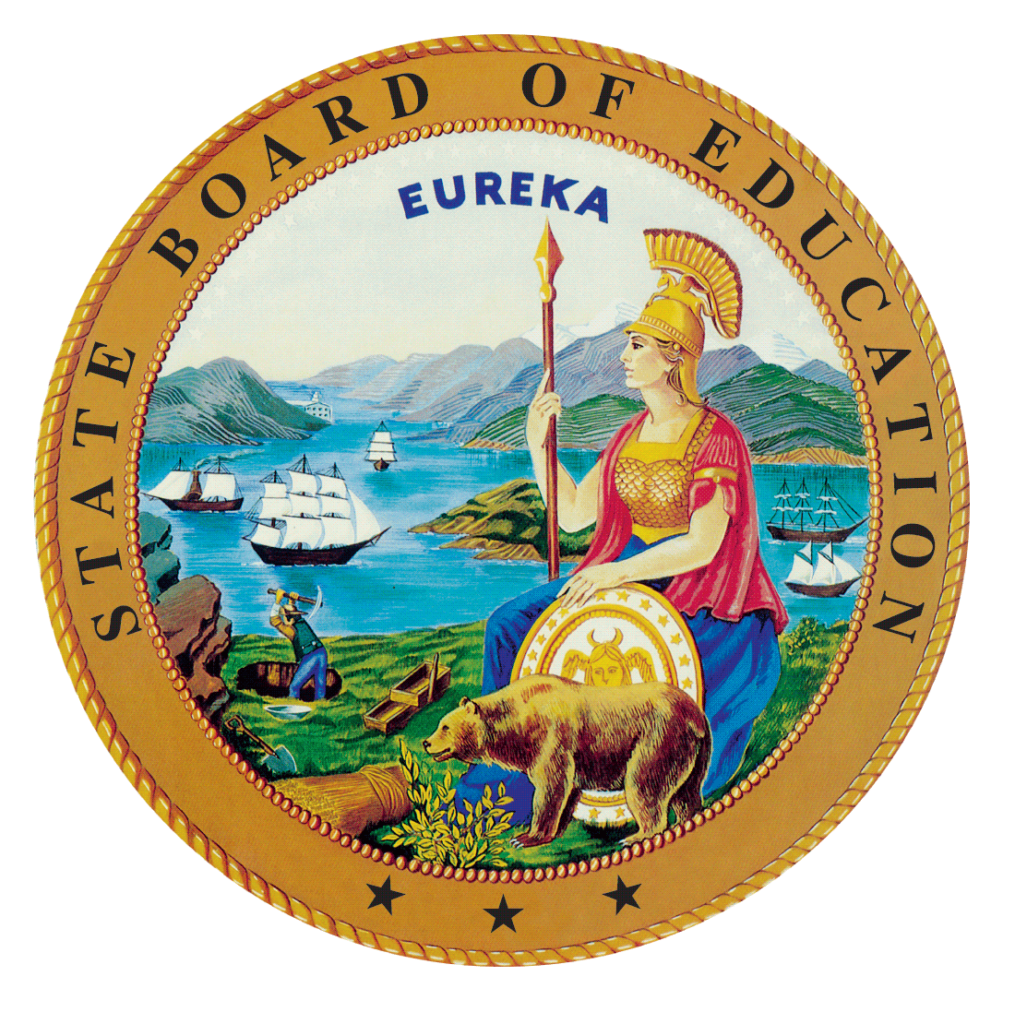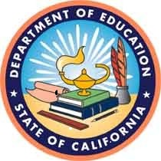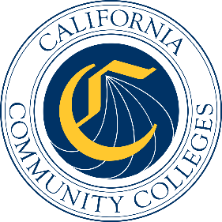

California Workforce Pathways
Joint Advisory Committee
November 2019
Agenda Item 02
Posted by the California Department of Education

Subject
Proposed Revisions to the Guiding Policy Principles to Support K–14+ Pathways (Guiding Policy Principles), as approved by the California Workforce Pathways Joint Advisory Committee (CWPJAC) in 2019, to strengthen business and industry partnerships.

Type of Action
Action, Information

Summary of the Issue(s)
This item is to share with CWPJAC members proposed revisions to the Guiding Policy Principles in order to strengthen business and industry partnerships based on feedback received from the California State Plan for Career Technical Education (CTE) stakeholder meetings and the September and October CWPJAC meetings.

Recommendation
Staff of the CWPJAC recommends that the CWPJAC review, provide feedback, and approve the proposed changes to the Guiding Policy Principles document.

Brief History of Key Issues
The CWPJAC reconvened in March, 2017. After several meetings of obtaining information about career technical education programs throughout California’s kindergarten through grade twelve and California community college systems, staff of the CWPJAC drafted the Guiding Policy Principles document to help focus the committee’s work, the CWPJAC approved the document at the March and May 2018 meetings.
May 2019, CWPJAC members approved a revision to the Guiding Policy Principles document to include more student-centered language, renaming the document the Guiding Policy Principles to Support Student-Centered K–14+ Pathways.

Summary of Previous California Workforce Pathways Joint Advisory Committee Discussion(s) and Action(s)
September/October 2019: Public feedback from the Perkins V stakeholder meetings and CWPJAC meetings indicated a need to elevate the importance of business and industry support and involvement in CTE pathways and programs.
May 2019: A review of proposed language additions from the March 2019 CWPJAC meeting to include more student-centered language. Members approved the proposed additions.
March 2019: A review of proposed language additions from the February 2019 CWPJAC meeting to include more student centered language throughout the document. Members provided additional feedback.
February 2019: A review of all the public feedback comments received were provided to the CWPJAC. To include more student centered language in the document, Member Costa provided staff with some suggested additions.
January 2019: A summary of the public feedback received was presented to the CWPJAC. Some of the committee members requested to review all of the feedback as a way to determine if revisions were necessary.
March/May 2018: The CWPJAC approved the Guiding Policy Principles to Support K–14+ Pathways document, and requested that staff obtain public feedback on the Guiding Policy Principles to Support K–14+ Pathways document. Subsequently, staff developed a survey to collect public comments which opened on August 24, 2018 and closed on November 30, 2018. Staff also conducted a public meeting to obtain feedback on August 22, 2018. On September 7, 2018, Chair Sun, and Vice Chair Haynes presented the Guiding Policy Principles to Support K–14+ Pathways document to the State Board of Education.

Attachment(s)
The supporting materials (e.g., attachments, addendums, CWPJAC commentary, or related reports) will be listed below as they become available electronically.
Attachment 1: Proposed Changes to the Guiding Policy Principles to Support K–14+ Pathways

