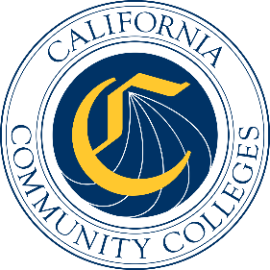

California Workforce Pathways
Joint Advisory Committee
October 2019
Agenda Item 01
Posted by the California Department of Education

Subject
California Career Technical Education (CTE) Initiatives: Overview of K12 Strong Workforce Program (K12 SWP) Metrics.

Type of Action
Information

Summary of the Issue(s)
This item is to present the California Workforce Pathways Joint Advisory Committee (CWPJAC) with previously requested information regarding an update/overview on the following items:
- Update on the Data Sharing MOU between CCCCO & CDE
- A review of the K12 Student Level, Community College Post-secondary Level Metrics

Recommendation
Staff from the California Department of Education (CDE) and California Community Colleges Chancellor’s Office (CCCCO) recommend that the CWPJAC receive the presentation on the K12 SWP metrics development, and provide any feedback as deemed necessary.

Brief History of Key Issues

Summary of Previous California Workforce Pathways Joint Advisory Committee Discussion(s) and Action(s)
The CWPJAC, per Education Code sections 53071 and 88828, has the annual responsibility for making recommendations regarding the use of metrics for the CTEIG and the K12 SWP.
September 19, 2019: CDE and the CCCCO staff presented information about common planning for both programs and key objectives for moving both programs forward. Staff reinforced the previous CWPJAC recommendation to keep all metrics with the exception of metric (i) High School Cohort Graduation Rate. Staff reported a change to this metric in the CTEIG language to be consistent with the language in the same K12 SWP metric and rename the metric as the following: (i) High School Graduation Rate.

July 12, 2019: The CWPJAC received information regarding the common planning, and objectives from the CTEIG and K12 SWP teams. The first full set of data from the 2017–18 CTEIG was presented to the CWPJAC. Both the CTEIG and K12 SWP metrics were reviewed.

Attachment(s)
Slides 1: California Career Technical Education (CTE) Initiatives: Overview of K12 Strong Workforce Program (K12 SWP) Metrics.

