*Mathematics Framework*

Adopted by the State Board of Education on July 12, 2023

Page 1 of

# Mathematics Framework Chapter 4: Exploring, Discovering, and Reasoning With and About Mathematics

Mathematics Framework Chapter 4: Exploring, Discovering, and Reasoning With and About Mathematics 1

Introduction 3

The Importance of the Mathematical Practices 3

Habits of Mind and Habits of Interaction 5

Instructional Design: Drivers of Investigation, Mathematical Practices, and Content Connections 8

Exploring and Reasoning With and About Mathematics: How Three SMPs Interrelate and Progress Through the Grades 10

Abstracting, Generalizing, Argumentation 19

Progressions in the Mathematical Practices 20

Teaching Practices for the Development of SMPs 24

Kindergarten Through Grade Five Progression of SMPs 3, 7, and 8 28

Discovering Regularity in Repeated Reasoning and Structure 31

Abstracting or Generalizing from Observed Structure and Regularity 32

Reasoning and Communicating to Share and Justify 33

Grades Six Through Eight Progression of SMPs 3, 7, and 8 33

Exploring Authentic Mathematical Contexts 34

Discovering Regularity in Repeated Reasoning and Structure 35

Abstracting and Generalizing from Observed Regularity and Structure 35

Reasoning and Communicating to Share and Justify 36

Grades Nine Through Twelve Progression of SMPs 3, 7, and 8 38

Exploring Authentic Mathematical Contexts 39

Discovering Regularity in Repeated Reasoning and Structure 43

Abstracting and Generalizing from Observed Regularity and Structure 47

Reasoning and Communicating to Share and Justify 49

Conclusion 53

Long Descriptions of Graphics for Chapter 4 54

## Introduction

The upcoming chapters six, seven, and eight discuss how the big ideas approach to mathematics teaching unfolds throughout elementary, middle, and high school. As important background for that discussion, this chapter goes more deeply into California’s Standards for Mathematical Practice (SMPs), which embed the habits of mind and habits of interaction that form the basis of math learning—for example, persevering in problem solving, explaining one’s thinking, and constructing arguments. Using three interrelated SMPs for illustration, the chapter demonstrates how key mathematical practices, integratedwith each other, can help teachers across grade levels create powerful math experiences centered on exploring, discovery, and reasoning—thus enabling students to develop and deepen those skills, in relation to progressions in math content, as they move through the grades.

## The Importance of the Mathematical Practices

The goal of the California Common Core State Standards for Mathematics (CA CCSSM) is to prepare students to be powerful users of mathematics, equipped to understand and affect their worlds in whatever life path they choose. Proficient students expect mathematics to make sense. They take an active stance in solving mathematical problems. When faced with a nonroutine problem, they have the courage to plunge in and try something, and they have the procedural and conceptual tools to follow through. They are experimenters and inventors who can think strategically and adapt known strategies to new problems (authors of the CA CCSSM; quoted in Swan and Burkhardt, 2014).

As noted in previous chapters, the CA CCSSM include two types of standards. Content standards describe for each grade the mathematical expertise, skills, and knowledge that students should develop. Practice standards—the SMPs—describe the ways of interacting with mathematics, individually and collaboratively, that form the basis of math learning.

While content standards are different for each grade level, the SMPs are the same for all grades and span the entirety of kindergarten through grade twelve (K–12). They develop in relation to progressions in mathematics content. At the elementary level, students work with numbers they are familiar with and begin to explore the structure of place value, patterns in the base-10 number system (such as even and odd numbers), and mathematical relationships (such as different ways to decompose numbers or relationships between addition and multiplication). Through these explorations, young students conjecture, explain, express agreement and disagreement, and come to make sense of data, number, and shapes.

#### Standards for Mathematical Practice

SMP.1: Make sense of problems and persevere in solving them

SMP.2: Reason abstractly and quantitatively

SMP.3: Construct viable arguments and critique the reasoning of others

SMP.4: Model with mathematics

SMP.5: Use appropriate tools strategically

SMP.6: Attend to precision

SMP.7: Look for and make use of structure

SMP.8: Look for and express regularity in repeated reasoning

Students in middle school build on these early experiences to deepen their interactions with mathematics and with others as they do mathematics together. During the elementary grades, students typically draw on contexts and on concrete manipulatives and representations to engage in mathematical reasoning and argumentation. At the middle-school level, students continue to reason with such concrete referents and also begin to draw on symbolic representations (such as expressions and equations), graphs, and other representations that have become familiar enough that students experience them as concrete. Middle-school students deepen their opportunities for sense-making as they move into ratios and proportional relationships, expressions and equations, geometric reasoning, and data.

In high school, students continue to build on earlier experiences as they make sense of functions and ways of representing functions, relationships between geometric objects and their parts, and data arising in contexts of interest. As students grow, through years of making sense of and communicating about mathematics with one another and the teacher, the same practices that cut across grades K–12 emerge at developmentally and mathematically appropriate levels.

The sections that follow begin with an overview of the habits of mind and habits of interaction that are embedded in the practices and form the basis for math learning. We then describe the instructional design approach that enables students to experience learning the big ideas of mathematics by conducting authentic investigations—that is, investigations of real-world situations or questions about which students actually wonder. Finally, the balance of the chapter focuses on three interrelated SMPs to illustrate how the mathematics practices are integrated with each other, how they develop across the grade bands—elementary, middle, and high school—in relation to progressions in math content, and how, together, the SMPs form an anchor for classroom experiences that center exploring, discovering, and reasoning with and about mathematics.

## Habits of Mind and Habits of Interaction

The SMPs are designed to instill the habits of mind and habits of interaction that the field increasingly recognizes are essential for the kind of deep learning of mathematics that students require for their lives and careers and to better interpret and understand their world. Over the past several decades, there has been a national push in mathematics education to focus on these habits. Habits of mind include making or using mathematical representations, attending to mathematical structure, persevering in solving problems, and reasoning, with the latter including the processes of inferencing, conjecturing, generalizing, exemplifying, proving, arguing, and convincing (Jeannotte and Kieran, 2017). Habits of interaction are linguistic processes and include such things as explaining one’s thinking, justifying a solution, listening to and making sense of the thinking of others, and raising worthy questions for discussion.

Both kinds of habits are fundamentally tied to language development and linguistic processes. To support reasoning processes and habits of interactions, teachers need to support language development as students engage in these disciplinary practices. By the time California’s students graduate from high school, they should be comfortable engaging in many mathematical practices, including those that are central to the SMPs highlighted in this chapter: exploration, discovery, description, explanation, generalization, and justification (including proof, examples, and non-examples).

This framework situates mathematics learning in the context of *investigations* that allow students to experience mathematics as a set of lenses for understanding, explaining, predicting, and affecting authentic contexts (as defined in chapter one). In the early grades, meaningful contexts might come from everyday activities that children engage in at home, at school, and within their community. These might include imagined play or familiar celebrations with friends or family, and familiar places such as a park, playground, zoo, or school itself. Meaningful contexts are also those that center notions of fairness and justice, such as issues related to the environment, social policies, or particular problems faced in the community. As teachers get to know their students and their students’ communities, the contexts that matter to young children come to the fore.

In the middle grades, the contexts relevant to students continue to include—but increasingly go beyond—local, everyday activities and interactions. Middle-school students might begin to explore publicly available datasets on current events of interest, use familiar digital tools to explore the mathematics around them, and explore mathematical topics within everyday contexts like purchasing snacks with friends, playing or watching sports, or saving money. By the time they reach high school, students have a wide array of contexts available to explore, increasingly understanding society and the world around them through explorations in data, number, and space.

For all of us, the capacity to use mathematics to understand the world influences every aspect of our lives, from advocating for just policies in our communities to outlining personal finances to completing tasks like cooking and gardening. For example, an understanding of fractions, ratios, and percentages is crucial to questions of fairness and justice in areas as diverse as incarceration, environmental and racial justice, and housing and education policy.

Being able to reason with and about the mathematics embedded in real-world situations (including using ideas such as recursion, shape of curves, and rate of change) empowers people to make important and consequential decisions not only for their own lives but also for the lives of others in their communities. Making sense of the mathematics underlying data-based claims about the benefits or dangers of particular foods, for example, empowers everyday decision making. (Chapter five addresses the importance of this practice of reasoning about the world using data.)

The ability to reason is also a foundational skill for understanding the impact of stereotypes. Humans are quick to generalize from a small number of examples and to construct causal stories to explain observed phenomena. In many situations, this tendency serves us well: people learn from very few examples that a stove might be painfully hot, and a Copernican model of a sun-centered universe enabled astronomers to predict the movement in the sky of planets and stars with reasonable accuracy.

There are, however, many situations in which humans are poorly served by such generalizations, especially those that lead to inequities or the unjust treatment of people based on characteristics that call forth internalized stories about expected capacities, motivation, behavior, or background. Such stories are often emotional, based on little evidence, and socially buttressed. Action based on these stories does great harm to school communities and individual students.

This tendency to assume, without adequate justification, that generalizations are valid is reinforced by many poorly constructed math assessment questions—for example, “What is the next term in this sequence: 1, 2, 4, 8, …?” instead of the more informative and reasoning-reinforcing question, “What rule or pattern might generate a sequence that begins 1, 2, 4, 8, ...? According to your rule, what is the next term?” Mathematics education must prepare students to use mathematics to comprehend and respond to their world by deepening their understanding of mathematics and of the issues that affect their lives. The goal is that students learn to “use mathematics to examine…various phenomena both in one’s immediate life and in the broader social world and to identify relationships and make connections between them” (Gutstein, 2003, 45).

### Instructional Design: Drivers of Investigation, Mathematical Practices, and Content Connections

As described in chapters one and two, instructional activities should be experienced as intriguing investigations designed to elicit questions about authentic, real-world contexts. Designed around the mathematical big ideas, these investigations are framed by a conception of the why, how, and what of math—a conception that makes connections across different aspects of content and also connects content with mathematical practices.

Three Drivers of Investigation (DIs)—sense-making, predicting, and having an impact—provide the “why” of an activity. They elicit curiosity and provide motivation. The eight SMPs provide the “how.” Four types of Content Connections (CCs)—which ensure coherence throughout the grades—provide the “what.” Figure 4.1 maps out the interplay at work when this conception is used to structure and guide student investigations.

Figure 4.1 The Why, How, and What of Mathematics

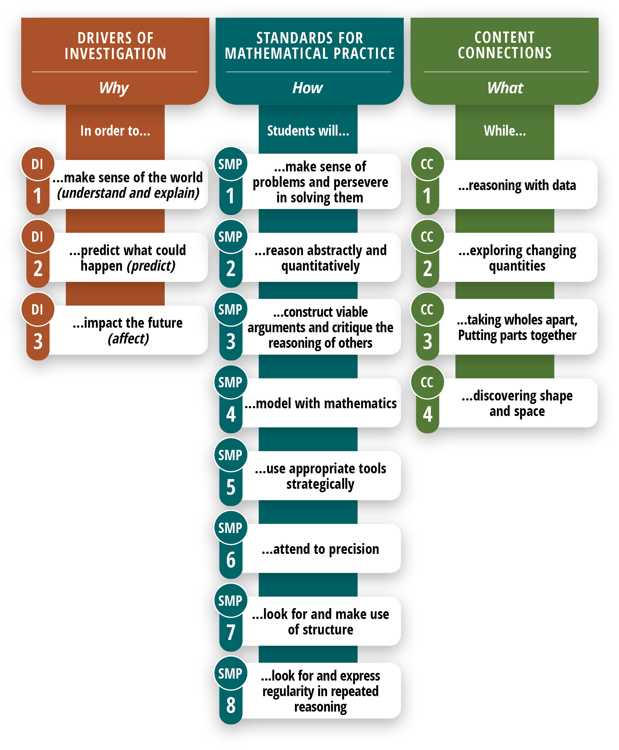

Long description of figure 4.1

These three dimensions— the DIs, the SMPs, and the CCs—guide instructional design. For example, students can make sense of the world (DI1) by exploring changing quantities (CC2) through classroom discussions wherein students have opportunities to construct viable arguments and critique the reasoning of others (SMP.3).

### Exploring and Reasoning With and About Mathematics: How Three SMPs Interrelate and Progress Through the Grades

The SMPs are designed to instill habits and behaviors that reflect a deep conceptual and procedural understanding. Thus, over the course of K–12 learning, the SMPs equip students for success in college-level mathematics and in jobs that require an application of mathematical skills to novel situations. Unlike the content standards, the SMPs are the same for all grades, K–12 (with one addition in high school; see SMP.3.1, below). As students progress through mathematical content, their opportunities to deepen their knowledge of and skills in the SMPs should increase.

#### Deeper Practice or More Content Topics?

Mastering high school-level mathematics content to acquire the knowledge needed to understand the world can empower students who will continue on to tertiary institutions where they will be expected to engage in career- and college-level mathematics. Despite this, there is a well-documented, persistent disconnect between the beliefs of high school mathematics teachers versus those of college instructors about the high school math content that is most important for students’ success in college.

The ACT’s National Curriculum Survey (widely administered every three to five years) reported in 2006 that high school mathematics teachers gave more advanced topics greater importance than did their postsecondary counterparts. By contrast, postsecondary mathematics instructors rated “a rigorous understanding of fundamental underlying mathematics skills and processes” as more important than exposure to more advanced mathematics topics (ACT, 2007, 5, see also ACT, 2020).

High school teachers’ misunderstanding about the types of experiences that best prepare students for college mathematics success too often produces high school graduates who enter college with a superficial grasp of superfluous procedures and little conceptual framework. To rectify this problem, the goal of K–12 mathematics should be to impart a deep but flexible procedural knowledge that helps students understand important concepts, and deep conceptual knowledge that helps students make sense of and connect procedures and ideas. The learning of procedural knowledge, in other words, “should be structured in a way that emphasizes the concepts underpinning the procedures in order for conceptual knowledge to improve concurrently” (Maciejewski and Star, 2016). For example, a “standard” algorithm for adding multidigit whole numbers should be encountered by students as a way to encode place-value-based and decomposing/recomposing-based ways of thinking about addition, supported by physical or visual models.

Every SMP is crucial, and most worthwhile classroom mathematics activities require engagement in each to varying degrees throughout the year. This chapter illustrates the possibilities by focusing on how the following three SMPs might interrelate:

* SMP.3: Construct Viable Arguments and Critique the Reasoning of Others (includes the California-specific high school SMP.3.1 regarding proof)
* SMP.7: Look for and Make Use of Structure
* SMP.8: Look for and Express Regularity in Repeated Reasoning

(The choice to highlight SMPs 3, 7, and 8 does not reflect any position about their value relative to other SMPs nor does it suggest that these SMPs must go together or that other combinations of SMPs are less feasible. All SMPs are important and can interrelate through classroom activities.)

These practices do not develop without careful attention across all grade levels and in relation to mathematical content. The following sequence of four processes is a useful guide for designing mathematical investigations that integrate multiple content and practice standards at the lesson or unit level (see chapters six, seven, and eight for more grade-level guidance on mathematical investigations):

1. Exploring authentic mathematical contexts
2. Discovering regularity in repeated reasoning and structure
3. Abstracting and generalizing from observed regularity and structure
4. Reasoning and communicating with and about mathematics in order to develop mathematical meaning and to share and justify conclusions

A classroom where students are engaged in these processes might look different to a visitor (or to the teacher!) than math classes portrayed in popular media. While these processes focus on communication as sharing and justifying mathematical ideas, mathematical investigations involve multiple communicative processes for connecting and interacting with others and mathematics. Evidence of SMPs 3, 7, and 8 (among others) might include the following:

* Students trying multiple examples and comparing (SMP.1 and SMP.7). Example: “I tried 6; what did you do?”
* Students challenging each other (SMP.3). Example: “I see why you think that from what you tried. I don’t think that always works because….”
* Predictions being shared (often these reflect early noticing of repeated reasoning and structure, SMP.7 and SMP.8). Example: “I think that when we try with a hexagon, we’ll get….”
* Students justifying their predictions (SMPs 3, 7, and 8). Example: “No matter what number we use, it will always be true that….”

In short, a classroom with evidence of SMPs 3, 7, and 8 will include students using their own understanding to reason about authentic mathematical contexts and to share that reasoning with others.

#### Supporting Linguistically Diverse Students to Explore and Reason

As is clear from the descriptions above, engagement in SMPs 3, 7, and 8 involves significant language demands for the purpose of understanding others’ ideas and communicating one’s own. The California English Language Development Standards (CA ELD Standards) describe linguistic processes and resources that are developed as students build their English language proficiency (CDE, 2014). The CA ELD Standards, used in parallel with the SMPs and content standards, describe expectations for students’ ability to use language to engage in the practice of mathematics.

For each grade, the CA ELD Standards are organized in three parts: “Interacting in Meaningful Ways,” “Learning About How English Works,” and “Using Foundational Literacy Skills.” Parts I and II, shown below, have a common numbering structure across the grades. This chapter highlights connections to these standards using this numbering—for example (CA ELD I.A.3: Collaborative—Offering opinions and negotiating with or persuading others).

##### **Part I: Interacting in Meaningful Ways**

1. **Collaborative** (engagement in dialogue with others)
   1. *Exchanging information and ideas* via oral communication and conversations
   2. *Interacting via written English* (print and multimedia)
   3. *Offering opinions* and negotiating with or persuading others
   4. *Adapting language choices* to various contexts
2. **Interpretive** (comprehension and analysis of written and spoken texts)
3. *Listening actively* and asking or answering questions about what was heard
4. *Reading closely* and explaining interpretations and ideas from reading
5. *Evaluating how well writers and speakers use language* to present or support ideas
6. *Analyzing how writers use vocabulary* and other language resources
7. **Productive** (creation of oral presentations and written texts)
8. *Expressing information* and ideas in oral presentations
9. *Writing literary and informational texts*
10. *Supporting opinions or justifying arguments* and evaluating others’ opinions or arguments
11. *Selecting and applying varied and precise vocabulary* and other language resources

##### **Part II: Learning About How English Works**

1. **Structuring Cohesive Texts**
   1. *Understanding text structure* and organization based on purpose, text type, and discipline
   2. *Understanding cohesion* and how language resources across a text contribute to the way a text unfolds and flows
2. **Expanding and Enriching Ideas**
3. *Using verbs and verb phrases* to create precision and clarity in different text types
4. *Using nouns and noun phrases* to expand ideas and provide more detail
5. *Modifying to add details* to provide more information and create precision
6. **Connecting and Condensing Ideas**
7. *Connecting ideas* within sentences by combining clauses
8. *Condensing ideas* within sentences using a variety of language resources

Note the high degree of alignment between the evidence of engagement in SMPs 3, 7, and 8 and these CA ELD Standards: I.A.1: Collaborative—Exchanging information and ideas via oral communication and conversations; 1.A.3: Collaborative—Offering opinions and negotiating with or persuading others; I.B.5: Interpretive—Listening actively and asking or answering questions about what was heard; I.B.7: Interpretive—Evaluating how well writers and speakers use language to present or support ideas; I.C.11: Productive—Supporting opinions or justifying arguments and evaluating others’ opinions or arguments.

Just as the CA CCSSM are not a design for instruction but rather a definition of goals, so too the CA ELD Standards do not prescribe instruction that will help students achieve the CA ELD Standards. For tools to design instruction, referenced here and throughout the chapter are tools from *Principles for the Design of Mathematics Curricula: Promoting Language* and *Content Development* (Zwiers et al., 2017). This framework, referred to as the *Understanding Language* *(UL) Framework*, sets out four design principles and eight Mathematical Language Routines (referenced, for example, as UL DP2 or UL MLR5.)

##### **Understanding Language: Design Principles**

1. Support sense-making: Scaffold tasks and amplify language so students can make their own meaning.
2. Optimize output: Strengthen the opportunities and supports for helping students to describe clearly their mathematical thinking to others, orally, visually, and in writing.
3. Cultivate conversation: Strengthen the opportunities and supports for constructive mathematical conversations (pairs, groups, and whole class).
4. Maximize linguistic and cognitive meta-awareness: Strengthen the “meta-” connections and distinctions between mathematical ideas, reasoning, and language.

##### **Understanding Language: Mathematical Language Routines**

See the *Understanding Language* document (Zwiers et al., 2017) to learn about these routines and see examples:

* 1. Stronger and Clearer Each Time
  2. Collect and Display
  3. Critique, Correct, and Clarify
  4. Information Gap
  5. Co-Craft Questions and Problems
  6. Three Reads
  7. Compare and Connect
  8. Discussion Supports

For many students, working in small groups to conduct the investigations, critiques, and reasoning in their preferred or home language can support and strengthen understanding. Designated ELD time helps prepare English learners in the language of critiquing, reasoning, generalizing, and arguing to support their engagement in the SMPs and the mathematical content. This framework’s approach integrates SMPs 3, 7, and 8 in the context of mathematical investigations to highlight ways that mathematical practices can come together through exploration and reasoning. This approach also supports attainment of the CA ELD Standards, when instruction incorporates the UL Design Principles and Mathematical Language Routines.

#### Standards for Mathematical Practice 3, 7, and 8

It is important to revisit these SMPs as they appear in the CA CCSSM:

* SMP.3: Construct viable arguments and critique the reasoning of others.

Mathematically proficient students understand and use stated assumptions, definitions, and previously established results in constructing arguments. They make conjectures and build a logical progression of statements to explore the truth of their conjectures. They are able to analyze situations by breaking them into cases, and can recognize and use counterexamples. They justify their conclusions, communicate them to others, and respond to the arguments of others. They reason inductively about data, making plausible arguments that take into account the context from which the data arose.

Mathematically proficient students are also able to compare the effectiveness of two plausible arguments, distinguish correct logic or reasoning from that which is flawed, and—if there is a flaw in an argument—explain what it is. Elementary students can construct arguments using concrete referents such as objects, drawings, diagrams, and actions. Such arguments can make sense and be correct, even though they are not generalized or made formal until later grades. Later, students learn to determine domains to which an argument applies. Students at all grades can listen to or read the arguments of others, decide whether they make sense, and ask useful questions to clarify or improve the arguments. CA 3.1 (for higher mathematics only): Students build proofs by induction and proofs by contradiction.

Notably, neither “argument” nor “critique” has negative connotations in this context—neither word implies disagreement. In the sense used here, “argument” is “a reason or set of reasons given in support of an idea, action or theory,” and “critique” means “evaluate (a theory or practice) in a detailed and analytical way” (Oxford, 2019). Thus, “critiquing” includes *making sense of* the reasoning of others, as well as noticing important ideas and connections, wondering about unjustified claims, and offering alternative ideas. Everyday notions of the terms “argument” and “critique” can inadvertently invite students to interpret mathematics classroom discussions as competitions for status; expressing disagreement can feel like an insult rather than an invitation for reasoning (Langer-Osuna and Avalos, 2015).

Building a classroom culture in which students can become proficient at constructing and critiquing arguments requires rich contexts and problems in which multiple approaches and conclusions can arise, creating a need for generalization and justification. Teaching for the development of SMPs, especially SMP.3, includes developing classroom norms for discussions that focus on examining the “truthiness” (i.e., validity) of the mathematical ideas themselves, rather than evaluating the student offering ideas in what Boaler (2002, drawing on Pickering, 1995) referred to as the “dance of agency.” According to *Principles to Actions: Ensuring Mathematical Success for All*, “Effective teaching of mathematics facilitates discourse among students to build shared understanding of mathematical ideas by analyzing and comparing student approaches and arguments” (NCTM, 2014, 12).

Suggested Math Class Norms:

1. Everyone can learn math to the highest levels.
2. Mistakes are valuable for learning.
3. Questions are important.
4. Math is about creativity and making sense.
5. Math is about connections and communicating.
6. Depth is more important than speed.
7. Math class is about learning with understanding.
8. Everyone has the right to share their thinking.
9. We learn more when we attend to and make sense of the thinking of others.
10. All cultures reflect histories of important mathematical thinking and applications.

It is possible to prompt this culture by valuing the role of skepticism—using purposeful and probing questions, removing or delaying teacher validation of reasoning in favor of class-negotiated acceptance, and explicitly and frequently reminding students that mathematicians prove claims by reasoning (Boaler, 2019). Classroom norms must set the expectation that students respectfully attend to and make sense of the thinking of others so that they can learn from their classmates’ perspectives and deepen their own thinking. Students must experience a classroom environment in which teachers and all students have the right to share their thinking and are supported in doing so. Such norms are especially important with respect to differences in mathematical ideas, cultural experiences, and linguistic expressions. These norms are valuable beyond learning math; they help students learn to be contributing members of teams.

* SMP.7: Look for and make use of structure.

Mathematically-proficient students look closely to discern a pattern or structure. Young students, for example, might notice that three and seven more is the same amount as seven and three more, or they may sort a collection of shapes according to how many sides the shapes have. Later, students will see 7 × 8 equals the well-remembered 7 × 5 + 7 × 3, in preparation for learning about the distributive property. In the expression x2 + 9x + 14, older students can see the 14 as 2 × 7 and the 9 as 2 + 7. They recognize the significance of an existing line in a geometric figure and can use the strategy of drawing an auxiliary line for solving problems. They also can step back for an overview and shift perspective. They can see complicated things, such as some algebraic expressions, as single objects or as being composed of several objects. For example, they can see 5 – 3(x – y)2 as 5 minus a positive number times a square and use that to realize that its value cannot be more than 5 for any real numbers x and y.

* SMP.8: Look for and express regularity in repeated reasoning.

Mathematically proficient students notice if calculations are repeated, and look both for general methods and for shortcuts. Upper elementary students might notice when dividing 25 by 11 that they are repeating the same calculations over and over again, and conclude they have a repeating decimal. By paying attention to the calculation of slope as they repeatedly check whether points are on the line through (1, 2) with slope 3, middle school students might abstract the equation (y – 2)/(x – 1) = 3. Noticing the regularity in the way terms cancel when expanding (x – 1)(x + 1), (x – 1)(x2 + x + 1), and (x – 1)(x3 + x2 + x + 1) might lead them to the general formula for the sum of a geometric series. As they work to solve a problem, mathematically proficient students maintain oversight of the process, while attending to the details. They continually evaluate the reasonableness of their intermediate results.

Patterns in SMP.7 might be numeric, geometric, algebraic, or a combination. Structure is “the arrangement of and relations between the parts or elements of something complex” (Oxford, 2019). SMP.7 and SMP.8 are key to abstracting—stepping back from concrete objects to consider, all at the same time, a class of objects in terms of some set of identical properties and generalizing, extending a known result to a larger class. Reasoning abstractly and developing, testing, and refining generalizations are essential components of doing mathematics, including solving problems (National Governors Association Center for Best Practices and Council of Chief State School Officers, 2010).

### Abstracting, Generalizing, Argumentation

Bringing all three SMPs together—abstracting, generalizing, and argumentation—empowers teachers to use classroom discussions and other collaborative activities where students make sense of mathematics together. Teacher facilitation of high-quality mathematics discourse with attention to language development is the key to unlocking these practices for students and bringing them holistically into practice. Historically, proficiency in mathematics has been defined as an individual, cognitive construct. However, the past three decades of mathematics classroom research has revealed the ways in which learning and doing mathematics are rooted in social activity (Lerman, 2000; National Academies of Sciences, Engineering, and Medicine, 2018).

Still, merely asking students to talk to each other in math class is insufficient. The facilitation of high-quality discourse needs to be intentional, especially with regard to language development. Assignments for student interactions that lack intention could hinder or prevent high-quality math discourse. For example, primary language grouping can support effective interactions, and communication is important. Another option is to consider assigning a student to serve as a bilingual broker for each small group of English learners and English-only students. This student is given extra practice in providing the language support needed so that each group member understands and appreciates everyone's thinking.

In the following progressions through the grade bands, the framework illustrates ways that students might progress in the SMPs through such classroom discourse activity, based on thoughtful whole- and small-group activities where students access opportunities to grapple with and discuss mathematical ideas and problems through engagement in the SMPs—especially SMPs 3, 7, and 8. Intentional patterns of grouping, such as primary language grouping to support effective interactions and communication, can be effective at supporting multilingual students’ engagement and access.

Such strategies must be used carefully, however, since some strategies for setting up groups can have serious pitfalls. The example here is specific to developing language for math discourse. But grouping by perceived “ability” can be the first step in a system of tracking if “similar ability” students are grouped together (see chapter nine) or can unintentionally communicate beliefs about who is capable—as when groups are intentionally stratified according to perceived “ability” so that students soon understand who is the “high kid” and who is the “low kid” in the group. Aside from language development considerations and any safety concerns, randomizing group assignments can convey to each student that everyone has something to offer the group’s learning and something to learn from the thoughts of others.

### Progressions in the Mathematical Practices

Young learners begin to engage with mathematical ideas through real-world contexts. As students access domains of mathematics, they increase their ability to explore purely mathematical contexts. For instance, even young learners who have become comfortable with the natural numbers—as a context in which reasoning can occur—can explore patterns in even and odd numbers and use shared definitions to reason about them. Yet even as students increasingly explore mathematical worlds, opportunities to mathematize the real world continue to be important from the early grades into adulthood (as illustrated in both chapters three and five).

While the practice standards remain the same across grade levels, the ways in which students engage in the practices progress and develop through experience and opportunity. In early grades, mathematical reasoning is primarily representation-based. When justifying a claim about even and odd numbers, students will typically refer to some representation like countable objects, a story, or a number line or other drawing. Representational and visual thinking remains important through high school and beyond.

As students become comfortable in additional mathematical contexts and develop more shared understanding, they might reason within these purely mathematical contexts as they rely on mathematical definitions and prior understanding. However, teachers should recognize the importance of concrete ways of making and justifying conjectures to avoid unduly privileging more abstract reasoning. Moving too early to abstract reasoning—before all students have an adequate base of representations (physical, visual, contextual, or verbal) with which to reason—can lead many students to experience mathematical arguments as meaningless, abstract manipulation.

Ample mathematical reasoning and argumentation with concrete representations (such as appropriate manipulatives and visual representations), with already-understood mathematical settings, and with contextual examples help to foster a classroom learning environment that provides access for all students and builds their understanding. (Note that *concrete* is used here not in the sense of tangible and physical, but in the sense of making sense; see Gravemeijer, 1997; Van Den Heuvel-Panhuizen, 2003.) For example, before attempting in grade two to build competence in the use of any particular algorithm to add two-digit numbers, students must have some flexible strategies that involve place value and decomposing/recomposing—supported by physical and/or visual representations such as base-ten blocks, place-value drawings, or number-line diagrams. Then, students can understand that an algorithm (such as the “standard” algorithm) is a useful tool that encodes a process that makes sense to them.

The principle of learning an abstract idea by accessing concrete representations and examples does not apply only to students in younger grades; it is needed any time students encounter new concepts. For example, students in grades five and six, working on their understanding of percentage, benefit from a bar representation that is used in increasingly abstract ways, finally simplifying to a double number line (Van Den Heuvel-Panhuizen, 2003). The use of representations and visuals provides scaffolding that English learners and others may use to connect the academic language to their conceptual understanding.

Consider a sixth-grade class that is using such a bar representation to explore percentages. Different students will see different uses of the representation and will use it to reason in different ways. Some may quickly generalize calculation patterns that they observe (SMP.7) and begin to calculate without reference to the bar representation: “If the price after a 25 percent discount is $96, then $96 is three parts and I need to figure out the missing fourth part, so I just divide that by three and add it to $96 to get the original price of $128.”

This realization can be used productively, both to help these students to connect their method to the sense-making bar representation (SMP.8) and to help other students understand their classmates’ ideas. One useful routine for this is carefully selecting, sequencing, and connecting student work as described in *5 Practices for Orchestrating Productive Mathematics Discussions* (Smith and Stein, 2018). However, it is easy—even when attempting to implement the 5 Practices routine—to hold up the work of students who have moved beyond the concrete representation as the preferred method (because it might appear to be quicker, more generalized, or closer to a final understanding teachers hope all students will reach). This can create the false notion that reliance on sense-making representations is an indication of weakness. Therefore, it is important for teachers to support all students to make sense of each other’s approaches by building connections between them.

Evidence from neuroscience suggests that some of the most effective understandings come about when connections are made between visual/physical and numerical or symbolic representations of ideas (see figure 4.2). When students relate numbers to visual representations and, more broadly, develop multiple ways to think about mathematical concepts, they become more effective users of those ideas. See the Connecting Representations instructional routine (Kelemanik and Lucenta, n.d.) for an example of a classroom practice to build these connections.

Figure 4.2 Connections Between Representations of Ideas

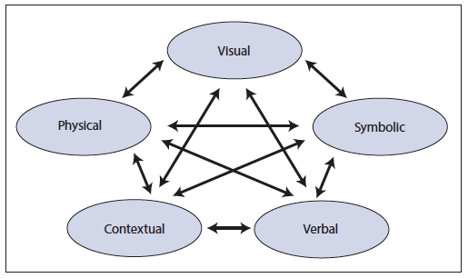

Source: NCTM, 2014

At all grades, students should have ample experience in all of the processes above (exploring authentic contexts, discovering regularity and structure, abstracting and generalizing, and reasoning and communicating). As with the modeling cycle (see chapter eight), some of these processes are historically emphasized far more than others, contributing to many students’ loss of a belief in mathematics as a sense-making activity. Classroom activities that are designed to engage students in these processes therefore must be sufficiently open ended to allow students room to explore, must give access to the regularity and structure that is present, and must allow generalization to broader settings.

### Teaching Practices for the Development of SMPs

*Principles to Action: Ensuring Mathematical Success for All* (NCTM, 2014) outlines eight “Mathematics Teaching Practices”:

1. Establish mathematics goals to focus learning.
2. Implement tasks that promote reasoning and problem solving.
3. Use and connect mathematical representations.
4. Facilitate meaningful mathematical discourse.
5. Pose purposeful questions.
6. Build procedural fluency from conceptual understanding.
7. Support productive struggle in learning mathematics.
8. Elicit and use evidence of student thinking.

Some of these items are especially relevant in developing SMPs, especially SMPs 3, 7, and 8. First, mathematical goals (Teaching Practice 1) must include SMPs as central drivers of activity design that goes beyond the sentiment that rich tasks naturally engage students in all eight SMPs. Second, posing purposeful questions (Teaching Practice 5) is crucial in establishing students’ inclination to engage in the SMPs as they encounter mathematical situations. Reprinted in figure 4.3 is a framework for teacher question types (NCTM, 2014). All question types are important; type 1 (Gathering information) is traditionally over-represented while types 2, 3, and 4 help make clear that students are expected to engage in the SMPs—these types also help to develop language facilities beyond recall. Chapter two offers guidance in inclusive teaching approaches that foster SMPs as well. The table has been augmented in the “Description” column with a note about the Depth of Knowledge (DOK) levels (Webb, 2002) that are most likely to be probed by the given teacher question type.

Figure 4.3 Framework for Teacher Question Types

| **Teacher Question Type** | **Description** | **Examples** |
| --- | --- | --- |
| * + - 1. Gathering information | Students recall facts, definitions, or procedures.  DOK Level 1 (Recall)  CA ELD: I.A.1, I.C.9 | When you write an equation, what does the equal sign tell you?  What is the formula for finding the area of a rectangle?  What does the interquartile range indicate for a set of data? |
| * + - 1. Probing thinking | Students explain, elaborate, or clarify their thinking, including articulating the steps in solution methods or the completion of a task.  Usually DOK Level 3 (Strategic Thinking); possibly Level 2 (Skill/Concept)  CA ELD: I.A.1, I.C.9, I.C.11 | As you drew that number line, what decisions did you make so that you could represent 7 fourths on it?  Can you show and explain more about how you used a table to find the answer to the Smartphone Plans task?  It is still not clear how you figured out that 20 was the scale factor, so can you explain it another way? |
| * + - 1. Making the mathematics visible | Students discuss mathematical structures and make connections among mathematical ideas and relationships.  DOK Level 3 (Strategic Thinking) and/or Level 4 (Extended Thinking)  CA ELD: I.A.1, I.B.5, I.C.9, I.C.12, II.B.3, II.B.4, II.B.5, II.C.6 | What does your equation have to do with the band concert situation?  How does that array relate to multiplication and division?  In what ways might the normal distribution apply to this situation? |
| * + - 1. Encouraging reflection and justification | Students reveal deeper understanding of their reasoning and actions, including making an argument for the validity of their work.  DOK Level 4 (Extended Thinking)  CA ELD: I.A.3, I.A.4, I.B.5, I.B.7, I.B.8, I.C.11, I.C.12, II.B.3, II.B.4, II.B.5 | How might you prove that 51 is the solution?  How do you know that the sum of two odd numbers will always be even?  Why does plan A in the Smartphone Plans task start out cheaper but become more expensive in the long run? |

Source: NCTM, 2014

Finally, figure 4.4, which is from Barnes and Toncheff, 2016, with slight modifications, helps to connect the mathematical teaching practices (MTPs) above with all of the SMPs.

Figure 4.4 Connecting MTPs with SMPs

| **Standards for Mathematical Practice (SMPs)** | **Teacher Action Connections** | **Mathematics Teaching Practices (MTPs)** |
| --- | --- | --- |
| **SMP.1** Make sense of problems and persevere in solving them.  **SMP.2** Reason abstractly and quantitatively.  **SMP.3** Construct viable arguments and critique the reasoning of others.  **SMP.4** Model with mathematics.  **SMP.5** Use appropriate tools strategically.  **SMP.6** Attend to precision.  **SMP.7** Look for and make use of structure.  **SMP.8** Look for and express regularity in repeated reasoning. | Mathematics lessons align to the big ideas, which teachers clearly communicate to students (MTP1). Lessons include complex tasks (MTP2), opportunities for visible thinking (MTP8 and MTP4), and intentional questioning (MTP5) to promote deeper mathematical thinking (MTP6). Teachers design lessons from the student’s perspective to provide multiple opportunities to make sense of the mathematics (MTP7).  To build SMP.1, teachers focus on MTP2 and MTP7.  To build SMP.2, teachers focus on MTP2 and MTP3.  To build SMP.3, teachers focus on MTP4 and MTP5.  To build SMP.4, teachers focus on MTP3 and MTP8.  To build SMP.5, teachers focus on MTP2 and MTP3.  To build SMP.6, teachers focus on MTP2 and MTP4.  To build SMP.7 and SMP.8, teachers focus on tasks (MTP2). | **MTP1** Establish mathematics goals to focus learning.  **MTP2** Implement tasks that promote reasoning and problem solving.  **MTP3** Use and connect mathematical representations.  **MTP4** Facilitate meaningful mathematical discourse.  **MTP5** Pose purposeful questions.  **MTP6** Build procedural fluency from conceptual understanding.  **MTP7** Support productive struggle in learning mathematics.  **MTP8** Elicit and use evidence of student thinking. |

Source: Adapted from Barnes and Toncheff, 2016

## Kindergarten Through Grade Five Progression of SMPs 3, 7, and 8

Imagine a teacher puts the number 36 on the board and asks students to determine all the ways they can make 36. In the context of an open problem such as this, young learners conjecture, notice patterns, use the structure of place value, notice and make use of properties of operations, and make sense of the reasoning of others. These practices often occur together as part of classroom discussions that focus on argumentation and reasoning through engaging mathematical contexts. The choice of number here makes a big difference; a grade-three teacher might choose 36 to build multiplication ideas; a kindergarten teacher might use 12 to both formatively assess and work to strengthen students’ emerging operation understanding.

Consider, for example, the following first-grade snapshot of a number talk activity. Number talks are brief, daily activities that support number sense.

#### Snapshot: Number Talks for Reasoning, Grade One

Big Idea: Tens and ones

CA ELD Standards: I.A.3, I.B.5, I.C.11

Prior to the lesson, the teacher understands that presenting a question or problem to the whole class and asking for individual responses may create challenges for some students, especially students who are still gaining proficiency in English. In the designated ELD lessons prior to this whole-group lesson, the teacher practices the discourse needed to explain mathematical thinking and problem solving so that multilingual students have the language they need to participate in the whole-class lesson.

The teacher introduces the problem to be discussed by placing the problem 7 + 3 on the board, waiting patiently as silent thumbs pop up, communicating that students are ready to offer an answer and the strategy they used to figure it out. The teacher selects a first student, Iggy, to share.

Teacher: Iggy, how did you figure out 7 + 3?

Iggy: I knew 7 + 2 is 9 and 9 + 1 is 10.

The teacher records Iggy’s thinking on the board and revoices Iggy’s response, then probes Iggy further: Iggy, where did the 2 and the 1 come from?

Iggy: That number.

Teacher: Which number? Who can add on to Iggy’s strategy? How did Iggy know to add 2 more and then 1 more? Sam?

Sam: 2 and 1 are both in 3. Iggy broke down 3.

Teacher: You noticed that 2 + 1 is 3. Iggy, is that what you did? Did you think, let me break down 3 because I know 7 + 2 is 9 and 9 + 1 is 10?

Iggy: Yes

Teacher: I heard Alex sharing a different way with his group. Alex, please share your thinking.

Alex: Counting on? I did like, I started with 7 and then I counted 8, 9, 10.

The teacher records Alex’s thinking and revoices his response, then adds: So that’s a different strategy? (Alex nods.) Did anyone else count on like Alex?

The teacher selects other students who share their own strategies and make sense of their peers’ reasoning, all based in a relatively straightforward computation problem. This approach supports mathematical sense-making and communication. While students certainly arrive at the answer (10), the focus of the activity is making sense of the addition problem, thinking flexibly and creatively about a range of ways to solve it, communicating one’s thinking, and making sense of the reasoning of others. This 10-minute activity that explores one addition problem deeply is more effective at developing students’ sense-making and strategies for addition than spending 10 minutes doing a worksheet of routine problems.

(*end snapshot)*

SMPs 3, 7, and 8 describe ways of exploring mathematical contexts such as numerical patterns, geometry, and place-value structure. Relevant activities might involve multiple visual representations, such as fractions represented in area models, e.g., partitioned circles, or linear models, e.g., number lines. Allowing students to explore the same mathematical ideas and operations using multiple representations and strategies is crucial for enabling students to develop flexible ways of thinking about numbers and shapes (e.g., Rule of Four [San Francisco Unified School District, n.d.]). Students at all grade levels should engage in opportunities to create important brain connections through seeing mathematical ideas in different ways.

At the elementary level, students work with familiar numbers. This may mean they generalize in ways that will be revisited and revised in the later grades as new numbers and mathematical principles are introduced. For example, at the early elementary level, students may appropriately generalize about the behavior of positive whole numbers in ways that are revisited at the later elementary grades with the introduction of fractions (later called rational numbers), and then again later at advanced grades with the introduction of imaginary or irrational numbers.

Students may also use everyday contexts and examples to make arguments. For example, a student might offer a story about two friends sharing cookies to demonstrate that an odd number, when divided by two, has a remainder of one. This example further outlines ways that everyday contexts can become generative for learning and doing mathematics together.

Authentic: An authentic problem, activity, or context is one in which students investigate or struggle with situations or questions about which they actually wonder. Some principles for authentic problems include 1) Problems have a real purpose; 2) They have relevance to learners and their world; 3) Doing mathematics adds something; and 4) Problems foster discussion (Özgün-Koca et al., 2019).

Culturally Responsive-Sustaining Education: Education that recognizes and builds on multiple expressions of diversity (e.g., race, social class, gender, language, sexual orientation, religion, ability) as assets for teaching and learning (NYSED 2019).

Importantly, contexts should be authentic to students (see box)—not the hypothetical contexts used in many textbooks that require students to suspend their common sense to engage with the intended mathematics (see Boaler, 2009). Mathematical contexts also need to be culturally relevant to ensure that diverse student experiences are considered and to possibly make connections with students’ families. (See chapter two for examples of culturally relevant contexts for learning mathematics.) Engaging students’ families, cultures, and communities in mathematics learning is an important strategy to ensure the cultural relevance of mathematics lessons and to enhance students’ mathematical identities.

### Discovering Regularity in Repeated Reasoning and Structure

Students at the elementary level may notice and use structures such as place value, properties of operations, and attributes about shapes to make conjectures and solve problems. Additionally, students notice and make use of regularity in repeated reasoning. At the elementary level, students may notice, through repeatedly multiplying with the number four, that it always results in the same product as doubling twice. Students might also notice a pattern in the change of a product when the factor is increased by one. For example, since 7 × 8 = 56, then 7 × 9 will be 7 more than 56. These regularities may lead to claims about general methods or the development of shortcuts based on conceptual reasoning.

A variety of reasoning activities support students in thinking flexibly about operations with numbers and relationships between numbers. In number talks and dot talks, students share and connect multiple strategies by explaining why the strategies work or comparing advantages and disadvantages (UL MLR7). In the vignette [*Number Talk with Addition, Grade Two* students](http://staging.cde.ca.gov/ci/ma/cf/documents/mathfwappendixc.docx) work on doubles posed as addition problems. In the vignette, students share strategies to solve 13 + 13. Many of the strategies make use of place-value structure and counting strategies. As students in the vignette offer approaches and consider the ideas shared by their peers, some students revise their answers.

In a “Collect and Display” activity (UL MLR2; CA ELD I.A.1, I.B.6, I.C.9, II.B.5), teachers can scribe student responses (using students’ exact words whenever possible and attributing authorship) on a graphic organizer on the board during the whole-class discussion comparing two mathematical ideas, such as expressions and equations. In a “Compare and Connect” activity (UL MLR7; CA ELD I.A.3, I.B.8, II.B.5, II.C.7), students relate the expressions to the diagrams by asking specific questions about how two different-looking representations could possibly mean the same thing. For example, a teacher might ask, “Where is the 2w in this picture?” or “Which term shows this line on the rectangle?”

### Abstracting or Generalizing from Observed Structure and Regularity

Young learners might explore place-value structure through manipulatives like ten frames. Using 10-frame pictures, students offer various strategies used to figure out the quantity shown. Implementing a “Compare and Connect” routine (UL MLR7) can support students’ language development as they engage in the mathematics. Students also attend to and discern patterns and structure as they construct and critique arguments. A student might notice that four sets of six gives the same total as six sets of four, and that this applies to three sets of seven and seven sets of three, and so on, to conjecture about the commutative property during a number talk.

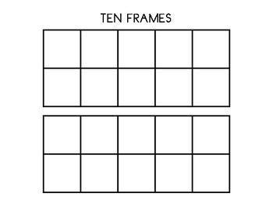

### Reasoning and Communicating to Share and Justify

Part of constructing mathematical arguments includes understanding and using previously established mathematical assumptions, definitions, and results. For example, an elementary-aged student might conjecture that two different shapes have equal area because, as the class has already recognized and agreed upon, the shapes are each half of the same rectangle. The student draws on prior knowledge that has already been demonstrated mathematically to make their argument.

Constructing and critiquing mathematical arguments includes exploring the truth of particular conjectures through cases and counterexamples, and results in successively stronger and clearer arguments (UL MLR 1). At the elementary level, a student may use, for example, a rhombus as a counterexample to the conjecture that all quadrilaterals with four equal sides are squares. Students may use multiplication with fractions, decimals, one, or zero to counter the conjecture that multiplying always leads to a larger number.

## Grades Six Through Eight Progression of SMPs 3, 7, and 8

Students in middle school build on early experiences to deepen their interactions with mathematics and with others as they do mathematics together. During the elementary grades, students typically draw on concrete manipulatives and representation to engage in mathematical reasoning and argumentation. At the middle-school level, students may rely more on symbolic representations, such as expressions and equations, in addition to concrete referents (such as algebra tiles and area models for algebraic expressions, physical or drawn examples of geometric objects, and computer-generated simulation models of data-generating contexts).

Differing forms of math talk are useful at the middle-school level and offer a range of opportunities for students to build on their experience in the elementary grades to make sense of mathematical ideas with peers. For example, number strings are a series of related problems designed to build toward big mathematical ideas (see Fosnot and Dolk, 2002). Teachers can create such sequences to highlight the learning progression for a given math topic. Consider the grade seven vignette [*Estimating Using Structure*](http://staging.cde.ca.gov/ci/ma/cf/documents/mathfwappendixc.docx)wherein a seventh-grade teacher uses a number string to offer students the opportunity to notice their own errors without the teacher’s evaluation, make sense of the problems at hand in multiple ways, reflect on their own thinking, make connections, and revise their own thinking.

### Exploring Authentic Mathematical Contexts

Middle-school students become increasingly sophisticated observers of their everyday worlds as they develop new interests in understanding themselves and their communities. These budding interests can become engaging, authentic contexts for mathematizing. An authentic problem, activity, or context is one in which students investigate or struggle with real-world situations or questions about which they actually wonder. (See chapter one.) *Chapter 5, Mathematical Foundations for Data Science*, offers examples of middle-school students exploring data about the world around them.

Mathematical contexts to explore, in addition to those carrying forward from earlier grades (number patterns and two-dimensional geometry), include the structure of operations, more sophisticated number patterns, proportional situations and other linear functions, and patterns in computation.

### Discovering Regularity in Repeated Reasoning and Structure

Students at the middle-school level may build on their knowledge of place-value structure and expand their use of structures, properties of operations, and attributes about shapes to make conjectures and solve problems. For example, middle-school students might draw on tables of equivalent ratios to conjecture about underlying multiplicative relationships.

### Abstracting and Generalizing from Observed Regularity and Structure

Students might notice during a mathematical discussion that interior angle sums regularly increase in relation to the number of sides in a polygon and use this repeated reasoning to conjecture a rule for the sum of interior angles in any polygon. In a “Compare and Connect” activity (UL MLR7; CA ELD I.A.3, I.B.8, II.B.5, II.C.7), students compare and contrast two mathematical representations (e.g., place-value blocks, number line, numeral, words, fraction blocks) or two solution strategies together (e.g., finding the eleventh tile pattern number recursively—”There were four more tiles each time, so I just added four to the four starting tiles, ten times”—compared to noticing a relationship between the figure number and the number of tiles—“I noticed that each side is always one more than the figure number, so I did four times the figure number plus one. And then I had to take away four because I counted the corners twice.”). As a whole class, students might address the following questions:

* Why did these two different-looking strategies lead to the same results?
* How do these two different-looking visuals represent the same idea?
* Why did these two similar-looking strategies lead to different results?
* How do these two similar-looking visuals represent different ideas?

The reference (Inside Mathematics, n.d.) includes a grade-eight illustration (with video) of SMP.7 from the South San Francisco Unified School District.

It illustrates students noticing mathematical structure in a concrete context—namely, water flowing in a closed system from one container into another. After observing the relationship between the two quantities (the water level in each container), they note constant rates of change and starting value. Students then apply the structure they discover to recognize graphs corresponding to different systems—evidence of abstracting. Teacher actions that support student investigation include modeling of academic language, building on and connecting student ideas, restating student ideas, and more.

The Education Development Center (2016) has built student dialogue snapshots to illustrate the SMPs. The grade six through seven example, “Consecutive Sums,” illustrates students working on the problem “In how many ways can a number be written as a sum of consecutive positive integers?” They work many examples, notice a pattern to their calculations, and connect that pattern to some structure of the numbers they are working with. They are then able to generalize that structure and develop a general strategy for writing integers as sums of consecutive integers.

### Reasoning and Communicating to Share and Justify

Part of constructing mathematical arguments includes understanding and using previously established mathematical assumptions, definitions, and results. Students might conjecture that the diagonals of a parallelogram bisect each other, after having experimented with a representative selection of possible parallelograms. Like in the elementary grades, where students may conjecture about shapes and area, students at the middle-school level continue this practice with mathematical content that builds on foundational ideas.

Constructing and critiquing mathematical arguments includes exploring the truth of particular conjectures through cases and counterexamples. In middle school, numerical counterexamples are used to identify common errors in algebraic manipulation, such as thinking that 5 – 2*x* is equivalent to 3*x*.

For example, a summer math camp for middle-school students emphasizes reasoning as a crucially important part of mathematics. Students are told that scientists build evidence for theories by making predictions and then performing experiments to check their predictions; mathematicians, on the other hand, prove their claims by reasoning. Students are also told that it is important to reason well and to be convincing and that there are three levels of being convincing: 1) It is easiest to convince yourself of something; 2) it is a little harder to convince a friend; and 3) the highest level is to convince a skeptic. Students are asked to be really convincing and also to be skeptics.

An exchange between a convincer and a skeptic might include:

Jackie: I think that the difference between even and odd numbers is that when you divide them into two equal groups, even numbers have no left overs and odd numbers always have one left over.

Soren: How do you know it’s always one left over?

Jackie: Because, like, if you divide any odd number in half, like—take the number five, it would be two groups of two and then one left over. Or the number seven, it would be two groups of three and then one left over. There is always one left over.

Soren: Can you prove it? Maybe it just works for five and seven.

Jackie: Well, it’s kind of like, it will always be one left over because if it was two left over, they would just go in each of the groups, or if it was three left over, two would go in each of the groups. So, there’s always only one left over.

Evidence from prior implementations of the summer camp indicates that students loved being skeptics, and when others were presenting, they learned to ask questions of each other such as: “How do you know that works?” “Why did you use that method?” and “Can you prove it to us?” (Boaler, 2019). In essence, students were learning to construct viable arguments and critique the reasoning of others (SMP.3).

There are many routines that help support students in being the skeptic, including tools to support English learners and others to develop the necessary language. In a “Critique, Correct, Clarify” activity (UL MLR3; CA ELD I.B.6, I.B.7, I.C.11, II.A.1, II.B.5), students are provided with teacher-made or curated ambiguous or incomplete mathematical arguments (e.g., “1/2 is the same as 3/6 because you do the same to the top and bottom” or “2 hundreds is more than 25 tens because hundreds are bigger than tens”). Students practice respectfully making sense of, critiquing, and suggesting revisions together. In a “Three Reads” activity (UL MLR6; CA ELD I.B.6, I.C.12, II.A.1, II.B.3, II.B.4), students make sense of word problems and other mathematical texts by reading a mathematical context or problem three times, focusing on: 1) the context of the situation, 2) relevant quantities (things that can be counted or measured) and the relationships between them, and 3) what mathematical questions they might ask about the context and its quantities, along with possible solution methods.

## Grades Nine Through Twelve Progression of SMPs 3, 7, and 8

In high school, students build on their earlier experiences in developing their inclination and ability to explore, discover, generalize and abstract, and argue. It is important that high-school teachers understand when designing student activities that the SMPs are as important as the content standards and must be developed together. The University of California, California State Universities, and California Community Colleges have a joint Statement on Competencies in Mathematics Expected of Entering College Students (ICAS, 2013) that makes this clear, with expectations for students such as:

“A view that mathematics makes sense—students should perceive mathematics as a way of understanding, not as a sequence of algorithms to be memorized and applied.” (3)

“…students should be able to find patterns, make conjectures, and test those conjectures; they should recognize that abstraction and generalization are important sources of the power of mathematics; they should understand that mathematical structures are useful as representations of phenomena in the physical world; they should consistently verify that their solutions to problems are reasonable.” (3)

“Taken together the Standards of Mathematical Practice should be viewed as an integrated whole where each component should be visible in every unit of instruction.” (7)

See the vignette [*Number String on an Open Number Line, High School*](http://staging.cde.ca.gov/ci/ma/cf/documents/mathfwappendixc.docx) herein a teacher uses this activity early in the school year to simultaneously develop the content standards and SMPs. The activity reinforces structural thinking about the real number system and also begins to establish a class culture of shared exploration, conjecture, noticing, justifying, and communicating.

### Exploring Authentic Mathematical Contexts

An authentic problem, activity, or context is one in which students investigate or struggle with situations or questions about which they actually wonder. (See chapter 1.) By high school, students have a wide array of authentic contexts available for exploration. They continue to explore nonmathematical contexts in the real world, such as puzzles. chapter five addresses one set of tools for exploring such contexts, and mathematical modeling represents another (overlapping) set. Often, data and modeling approaches yield mathematical contexts that then can be explored in the manner discussed here.

SMPs 7 and 8 afford opportunities to explore mathematical contexts and situations. Numerical patterns, geometry, and place-value-based structure in the early grades, supplemented by structure and properties of operations in upper elementary and middle school, expand in high school to focus on algebraic, statistical, and geometric structure and repeated reasoning.

Important objects in algebraic settings include variables (letters or other symbols representing arbitrary elements of some specified set of numbers; distinct from unknowns and constants), graphs (often but not always graphs of functions), equations, expressions, and functions (often given by algebraic expressions—formulas—or implied by tables or graphs).

One very important skill in working with functions is to move fluently between contextual, graphical, symbolic, and numerical (e.g., table of values) representations of a function. Thus, activities that induce a need to switch representations are crucial (UL DP4). The exercise of moving from a formula (symbolic representation) to a graph is vastly overrepresented in most students’ experience, often via sample values (numerical representation) and connecting dots. Examples of other pairings are described here.

An engaging and important way to introduce patterns, expressions, and functions is through the context of visual or physical patterns (an easy-to-understand context). Students can first be asked to describe the growth of such a pattern with words (CA ELD I.C.9) and then move to symbolic representations. In this way, students can learn that algebra is a useful tool for describing the patterns in the world and for communication. Figures 4.5, 4.6, and 4.7 present patterns for this type of work.

Figure 4.5 Shapes Task: How Do You See the Shapes Growing?

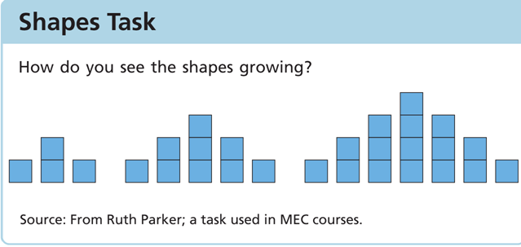

Source: Mathematics Education Collaborative, n.d.

Figure 4.6 Multiple Methods for Describing Growth Patterns

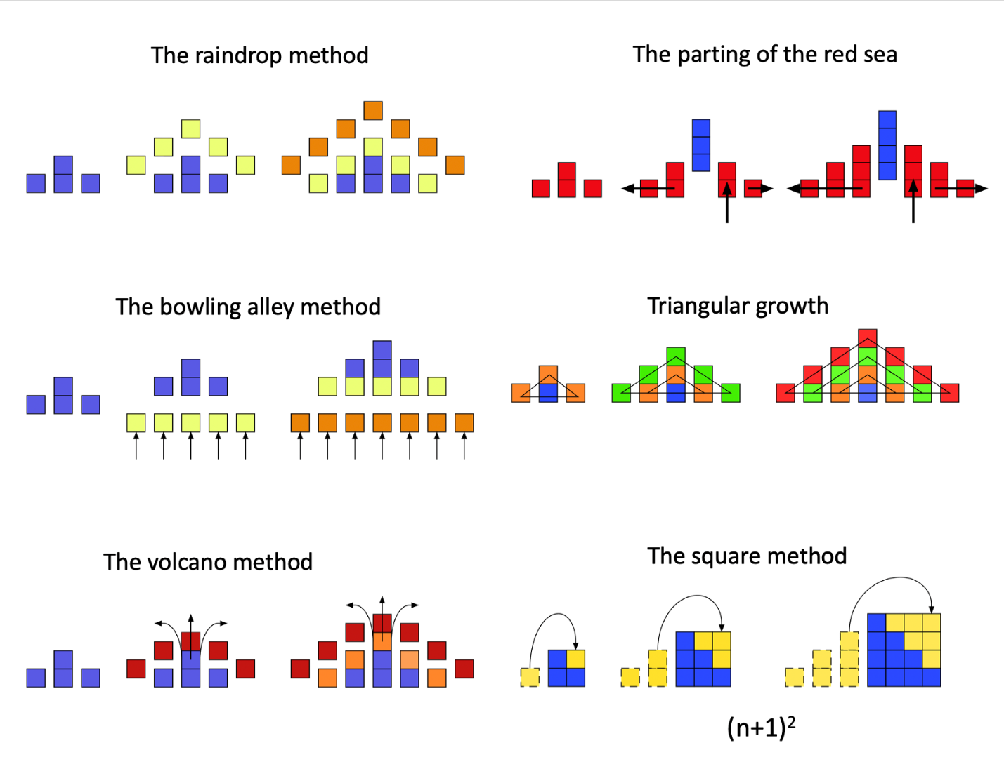

Long description of Figure 4.6

Figure 4.7 Build This Graph: $g\left(x\right)=-3x^{2}$, $h\left(x\right)=\sin\left(9x\right)$, and $f\left(x\right)=-3x^{2}+\sin\left(9x\right)$

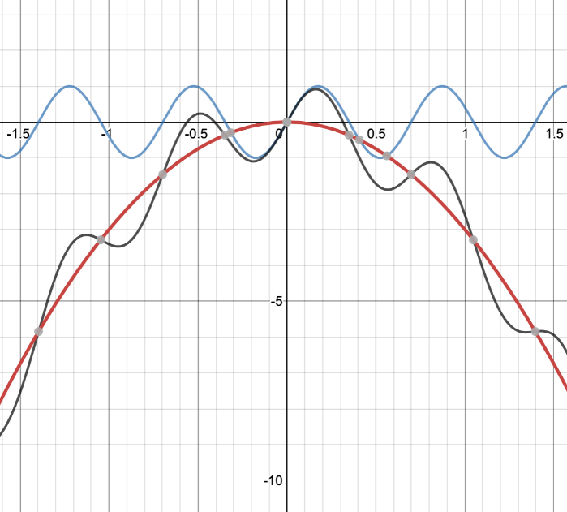

“Guess My Rule” games (with student-generated sequences) require students to attempt to move from numerical representations to formulas. Students often can find a recursive formula first. “Find the 100th Term”-type questions force students to attempt to move to a formula in terms of the sequence number. It is important that students have some experience with “Guess My Rule” games whose rule does not match the most obvious formula, as any finite set of initial values cannot determine an infinite sequence. As an example, the sequence 1, 2, 4, 8 is generated nicely by the function $f\left(n\right)=\left(n-1\right)\left(n-2\right)\left(n-3\right)\left(n-4\right)+2^{n-1}$; the next term is 40, not 16! However, in many instances (including most applications), the “simplest” rule that fits the given data is a good one to explore first.

In the other direction, “Build This Graph” activities require student teams to try to build given graphs (perhaps visually modeling real-world data) from graphs of well-understood “simple” functions—perhaps monomials such as $ax^{b}$, perhaps also $\sin\left(x\right)$ and $\cos\left(x\right)$ or whatever set of “parent” functions is already understood. Figure 4.7 contains the graphs of $g\left(x\right)=-3x^{2}$ and $h\left(x\right)=\sin\left(9x\right)$, together with their sum $f\left(x\right)=-3x^{2}+\sin\left(9x\right)$. This type of decomposition of a (graph of a) function is very important in many applied settings, in which, for example, different causal factors might act on very different time scales.

### Discovering Regularity in Repeated Reasoning and Structure

To explore a context with an eye for algebraic structure is to consider the parts that make up or might make up an algebraic object such as a function, visual representation, graph, expression, or equation, and to try to build some understanding of the object as a whole from knowledge about its parts. Noticing regularity in repeated reasoning in an algebraic context often leads to discoveries that similar reasoning is required for different parameter values (e.g., comparing the processes of transforming the graph of $x^{2}$ into the graphs for the functions $3x^{2}+2$, $\frac{1}{2}x^{2}-4$, and $-2x^{2}+1$, leading to general statements about graphing functions of the form $ax^{2}+b$).

In a geometric context, structural exploration (SMP.7) examines the relationships between objects and their parts: polyhedra and their faces, edges, and vertices; circles and their radii, perimeters, and areas; areas in the plane and their bounding curves. Repeated reasoning occurs when exploring the sum of interior angles for polygons with different numbers of sides, discovering Euler’s formula *V* – *E* + *F* = 2 (see figure 4.8), exploring possible tilings of the plane with regular polygons, and more.

Figure 4.8 Euler’s PolyhedronFormula

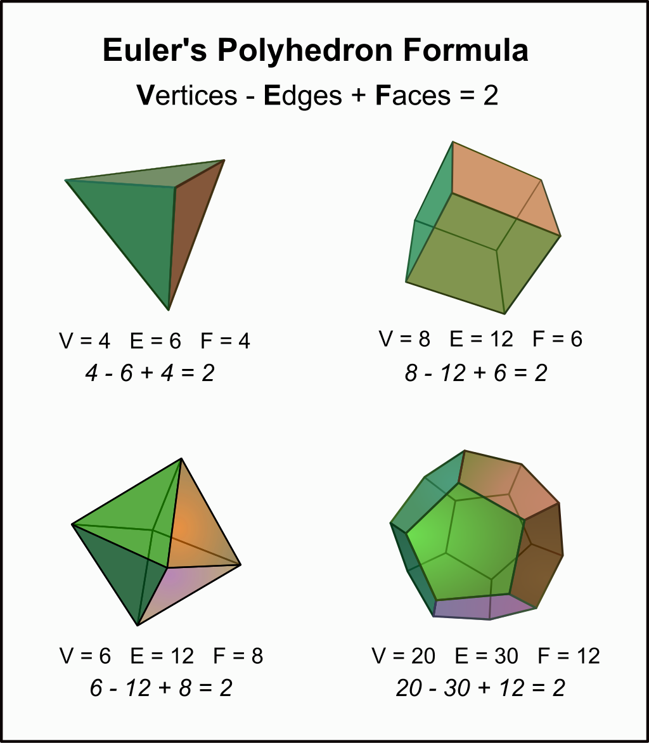

Long description for figure 4.8

Source: Wikimedia Commons, 2014.

For instance, a “Guess My Rule” game for the sequence –6, –13, –26, –45, ..., followed by “predict the 100th number in the sequence” can lead to a rich exploration of quadratics and the meaning and impact of the quadratic, linear, and constant terms—and eventually to the quadratic function $f\left(x\right)=-3x^{2}+2x-5$. (See figure 4.9 for an example of using “Guess My Rule” to understand quadratic functions.) Carefully designed prompts and/or a series of “Guess My Rule” constraints can help student teams discover the relationship between the coefficient $x^{2}$ and the constant second difference of a sequence (here, the constant second difference of the sequence is –6, so the coefficient of $x^{2}$ is –3). Further exploration, perhaps graphical, can uncover the idea of finding a linear function to add to $-3x^{2}$ so that the sum generates the original sequence for whole-number inputs.

Figure 4.9 Using the “Guess My Rule” Game to Understand Quadratic Functions

.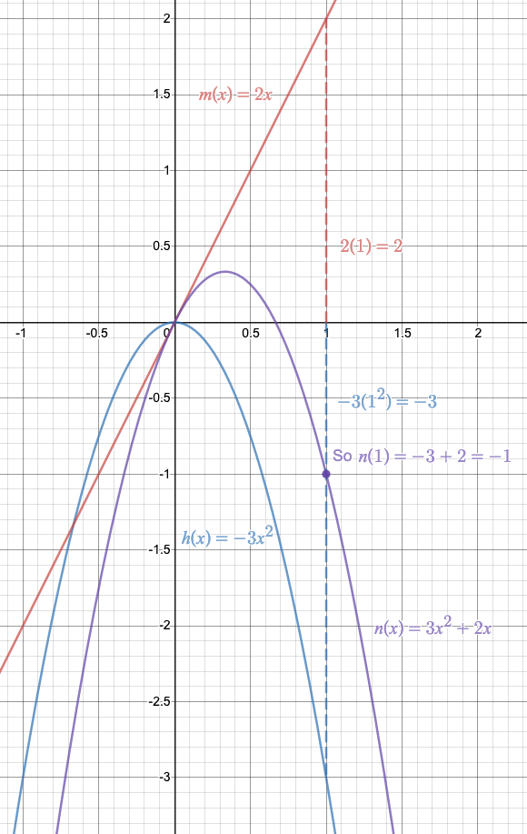

Exploring the general behavior of $f\left(x\right)$ could be motivated by comparing sequences, using questions like, “Which sequence will have a higher value in the long run? How do you know?”

To try to predict the general behavior (that is, the shape of the graph) of $f\left(x\right)$, student teams should consider the known shape of the graph of $g\left(x\right)=x^{2}$, explore what happens to the graph if they multiply every output value by 3 and then take the opposite of every output, then perhaps sketch the two functions $h\left(x\right)=-3x^{2}$ and $m\left(x\right)=2x$ on a plane and add the output values for many sample values for x, to get a sense for the shape of $n\left(x\right)=-3x^{2}+2x$. Sharing strategies and being accountable for understanding and using other teams’ strategies ensures that students have ample opportunities to connect across approaches and are prepared to notice patterns and repeated reasoning when tackling similar problems.

It is important to note that producing by hand a reasonably accurate graph of a function given by a formula is not a goal in its own right. Instead, it can be a means toward the end of deeply and flexibly understanding the meaning of a graph and the relationship between a function, its graph, the points on the graph, and the context that generated the function.

Every student should also have easy access and frequent opportunities to use computer algebra systems to graph functions, thus focusing mental energy on interpretation and connection.

Playing the “Guess My Rule” game several times (perhaps with a constraint of constant second differences) encourages students to notice the similarity in what they must do each time. The point is not to become fast at sketching the graph of a quadratic but to first notice, and then understand, the ways in which the different parts of the formula can be considered separately to help understand the whole. In other words, noticing repeated reasoning leads to the revealing of structure.

The “Build This Graph” example in the previous section may seem at first glance to be more difficult than understanding the structure of $f\left(x\right)$, since the parts are not necessarily as apparent as they are in the formula for $f\left(x\right)$. However, consider figure 4.10. If asked to describe the behavior of this function, students will offer ideas like “as x gets bigger, the function values generally get bigger; it wiggles up and down and generally goes up.” A student team offering such a description has noted the two “parts” of this function’s behavior, and thus discovered some of its structure. They are well on their way to using graphing software in identifying $k\left(x\right)=3x+\sin\left(9x\right)$ as a likely formula for this function.

Figure 4.10 Build This Graph: $k\left(x\right)=3x+\sin\left(9x\right)$

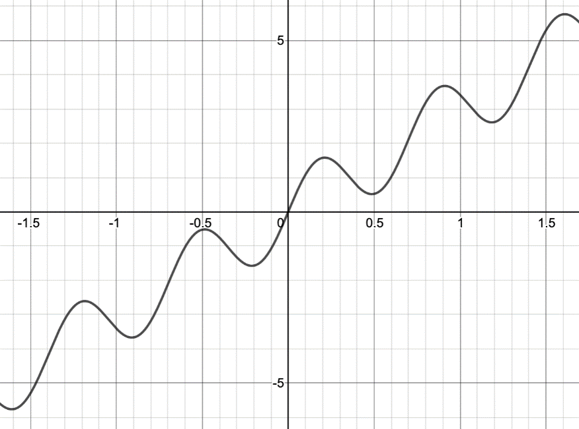

### Abstracting and Generalizing from Observed Regularity and Structure

Observing repetition in reasoning naturally leads to questions such as, “Do we have to keep doing the same thing with different numbers?” and, “What is the largest set of examples that we could apply this reasoning to?” Exploring either question involves examining structure. Students abstract an argument when they phrase it in terms of properties that might be shared by a number of objects or situations—thus paying attention to the structure of the objects or situations. They generalize when they extend an observation or known property to a larger class.

Several rounds of explorations such as the “Guess My Rule” example above could lead to any of the following abstractions and generalizations:

* The quadratic term in a quadratic function always dominates over time; that is, graphs of functions of the form $g\left(x\right)=ax^{2}+bx+c$, where *a, b*, and *c* are real numbers with a ≠ 0, always have the shape of a parabola, and the parabola opens up or down depending on the sign of [a](https://www.codecogs.com/eqnedit.php?latex=a%250).
* If [g](https://www.codecogs.com/eqnedit.php?latex=g%250) is as above and you compare $g\left(x\right)$, $g\left(x+1\right)$, and $g\left(x+2\right)$, then the difference $g\left(x+2\right)-g\left(x+1\right)$ is $2a$ more than the difference $g\left(x+1\right)-g\left(x\right)$ (generalizing to noninteger “second differences”).
* To determine a quadratic function, you need to know at least four points on the graph because with just three you cannot decide whether the second differences are constant (note that this conjecture is not true, which means it raises a good opportunity for exploring possible justifications or critiques).
* When adding two functions, the *steepness (slope)* of the new function at each input value is also the sum of the two slopes (at that input) of the functions being added.
* When comparing two quadratics, the one with the faster-growing quadratic term (the larger a) always will be larger for large enough values of *x*, no matter what the linear and constant terms are.
* When comparing two polynomials of the same degree, the one with the faster-growing quadratic term always wins in the long run (generalizing to polynomials from the smaller class of quadratics).

The “Build This Function” tasks above might lead to abstractions that are more along the lines of heuristics for understanding the structure of functions presented graphically:

* When trying to break down a graph, look at the largest-scale pattern you can see. If the graph generally goes in a straight line, like the $k\left(x\right)=3x+\sin\left(9x\right)$ example, try to find that straight line and subtract it out.
* When trying to break down a graph, look at the most important pattern—the one that causes the biggest ups and/or downs (like the parabolic shape of the $f\left(x\right)=-3x^{2}+2x-5$ example). Try to figure out the shape of that pattern and subtract it out.
* If there is a periodic up-and-down in the graph, there’s probably a $\sin\left(ax\right)$ or $\cos\left(ax\right)$ in the formula.

### Reasoning and Communicating to Share and Justify

In many respects, mathematical knowledge and content understanding is developed and demonstrated socially; it is of little value to find a correct “solution” to a problem without having the ability to communicate to others the validity and meaning of that solution. Thinking also can be clarified through exchange with others. SMP.3 includes these aspects of the development of arguments: “They justify their conclusions, communicate them to others, and respond to the arguments of others.” To create an environment that makes mathematical practices such as SMP.3 accessible to all students, teachers should develop routines with students that support their ability to communicate their thoughts and ideas, as well as work socially in a classroom of mixed language and math knowledge. Chapter two offers examples of such routines, including reflective discussions, peer revoicing routines, as well as teacher behaviors that support the creation of a mixed-language mathematics community. It is therefore of utmost importance that teachers create environments and routines that provide access for all students to communicate their thoughts and ideas with each other and with the teacher. The Math Language Routines, developed by Understanding Language at the Stanford Center for Assessment, Learning, and Equity, provide teachers with a set of robust routines to foster student participation while simultaneously building math language, practices, and content.

An important (implicit) aspect of SMP.3 is a recognition that the authority in mathematics lies within mathematical reasoning itself. Students come to own their understanding through constructing and critiquing arguments, and through this process they increase their confidence and their sense of agency in mathematics. Classroom routines in which students must justify—or at least give evidence for—their abstractions or generalizations, and in which other students are responsible for questioning justifications and evidence, help to build the “Am I convinced?” and “Could I convince a reasonable skeptic?” meta-thinking that is at the heart of SMP.3. An example would be a mathematical implementation of the classroom routine “Claim, Evidence, and Reasoning (CER),” which is popular in science and writing instruction (McNeil and Martin, 2011). Here, the different elements of an argument when investigating a problem are

* stating a claim;
* giving evidence for that claim; and
* producing mathematical reasoning to support the claim.

It is important to note that the mathematical reasoning here is of a different sort than scientific reasoning when CER is used in science. In science, the reasoning is for the purpose of connecting the evidence to the claim, explaining *why* the evidence supports the claim. On the other hand, the *mathematical* reasoning in the CER routine is expected to explain why (making use of structure) something is true *in general* (thus also explaining why the examples used as evidence are valid).

It is useful to name “giving evidence” and “producing reasoning” as separate processes to distinguish between the noticing of pattern and structure (evidence) and the reasoning to support a general claim. For instance, in exploring a growth pattern, students might notice that the sum of three consecutive integers always seems to be divisible by three. A student might then formulate this as a claim: “I think that whenever you add three numbers in a row, the answer is always a multiple of three.” When it’s clear the student means three consecutive *integers*, other students might check additional examples and contribute additional evidence. But the reasoning step requires something more: A numerical fluency argument (“If you take away one from the third number and add it to the first number, then you just have three times the middle number”), an algebraic argument (such as “if *a* is an integer, then $a+\left(a+1\right)+\left(a+2\right)=3a+3=3\left(a+1\right)$”), or some other general argument.

Carefully chosen number talks—well known in the elementary math classroom—can be implemented in high school as a way of enabling students to compare ideas and approaches with others in a low-stakes environment. They help to build SMP.1 and SMP.3. Well-chosen routines or tasks, such as number strings, can help build SMP.7 and SMP.8 by building from specific examples to thinking in terms of structure (abstraction) or larger classes (generalization).

For example, open number lines (blank, with no numbers marked), used with multiplication or division, can provide problems for number talks or strings that lead often to overgeneralization—a great thing to happen, as it creates skepticism and forces a reevaluation of evidence and a search for convincing justification. (See the vignette [*Number String on an Open Number Line, High School*](http://staging.cde.ca.gov/ci/ma/cf/documents/mathfwappendixc.docx)).

Additional types of activities can create in students the need to reason and communicate to support their explanations and justifications. These include producing reports, videos, or materials to model for others (for example, to parents or to a younger class); prediction and estimation activities; and creating contexts. The last—creating real-life or puzzle-based contexts generating given mathematics such as a given function type—helps students cultivate meta-thinking about structure (What are the parts of a quadratic function and how might I recreate them in a puzzle or find them in a real-life setting?) Creating contexts also helps students develop a way of seeing the world through the lens of mathematics.

The CA CCSSM identify two particular proof methods in SMP.3.1 (a high school-only addition to SMP.3): Proof by contradiction and proof by induction. The logic of proof by contradiction is straightforward to students: “No, that can’t be, because if it were true, then….” The standard high school examples are proofs that $\sqrt{2}$ is irrational (generalizing to the irrationality of $\sqrt{2}$) and that there are infinitely many prime integers. These are both clear examples. Although the second of these two does not actually require a proof by contradiction, the following proof is most easily understood when worked out through the contradiction framework: “What would happen if there were only finitely many primes?”

The difficulty is to embed such proofs in a context that prompts a wondering, a need to know, on the part of students, and then to uncover the steps of the argument in such a way so as not to seem pulled out of thin air. Some approaches attempt to motivate with historical contexts, others with patterns. For example, suppose the class already has established that every natural number greater than 1 is either prime or is a product of two or more prime factors. “Maybe 2, 3, 5, 7, 11, and 13 are all the primes we need to make all integers! No? Well, maybe if we add 17 to the set we have them all?” When students get tired of the repeated reasoning of finding an integer that is not a product of the given primes, either students or the teacher can ask whether there might always be a way of finding an integer that is not a product of integers in the given finite set. This provides an opening for a proof by contradiction: “Let’s pretend (assume) that there are only finitely many primes—let’s say *n* of them. Why don’t we call them $p_{1},p_{2},p_{3,…, }p_{n}$. Can you write down an expression for a natural number that is not divisible by any of these primes?” To eventually arrive at a proof requires constructing an integer that can’t possibly be divisible by any of $p_{1},p_{2,}…,p_{n}$—Euclid’s choice (call it s) was the product of all of them, plus 1: $s=p_{1}⋅p_{2}⋅… ⋅p_{n}+1$. Once an argument is found that s is not divisible by any of $p_{1},p_{2},p_{3,…, }p_{n}$, then since s must be divisible by a prime not in the list $p_{1},p_{2},p_{3,…, }p_{n}$, we have found a contradiction to our initial assumption that $p_{1},p_{2},p_{3,…, }p_{n}$ contains all primes. Thus, the list of primes cannot be finite.

The logic of proof by induction is also straightforward when described informally: The first case is true, and whenever one case is true, the next one is true as well. Thus, the chain goes on forever. Such chains of statements, and student wondering about whether they go on forever, might be easier to elicit from patterns than proof by contradiction. For instance, students might notice, in the context of exploring quadratic functions, that whenever they substitute an odd integer in for *x* in the function $f\left(x\right)=x^{2}-1$, they obtain an output that is a multiple of 8. This naturally leads to the questions, “Is this really true for all odd integers *x*?” and, “Could I use the fact that it’s true for $x=5$ to show that it’s true for $x=7$?” The formalism of representing “the next odd number” after x as $x+2$ follows relatively naturally, and “using one case to prove the next” can proceed. This example should be accompanied by the question, “Why doesn’t the argument work for even integers?”

As described here, “proof” in high school does not originate with purely mathematical claims put forth by curriculum or by the teacher (“Prove that alternate interior angles are congruent”), nor with formal axioms and rules of logic. Rather, proof originates, like all mathematics, with a need to understand—in the case of proof, a need to understand why an observed phenomenon is true and that it is true for a defined range of cases. It is not enough that the curriculum writer or the teacher understands and wishes for students to understand. The need to understand—and to understand why—must be authentic to students for learning to be deep and lasting. Thus, it is important that students’ experiences with constructing and critiquing arguments (SMP.3)—including their experiences with formal proof—be embedded as much as possible within a process beginning with wonder about a context and ending with a social and intellectual need to understand and justify:

1. Exploring authentic mathematical contexts
2. Discovering regularity in repeated reasoning and structure
3. Abstracting and generalizing from observed regularity and structure
4. Reasoning and communicating with and about mathematics in order to share and justify conclusions

## Conclusion

This chapter discusses key ideas that bring the SMPs to life. It focuses on three interrelated practices: 1) Constructing viable arguments and critiquing the reasoning of others, 2) Looking for and making use of structure, and 3) Looking for and expressing regularity in repeated reasoning. Considered together, these three practices are the foundation for classroom experiences that center exploring, discovering, and reasoning with and about mathematics. While this chapter illustrates the integration of three of the SMPs, *all* SMPs must be taught in an integrated way throughout the year. This vision for teaching and learning mathematics has emerged from a national push over the last several decades in mathematics education to pay more attention to supporting K–12 students in becoming powerful users of mathematics to help make sense of their world.

## Long Descriptions of Graphics for Chapter 4

### Figure 4.1. The *Why, How* and *What* of Learning Mathematics (accessible version)

| **Why**  **Drivers of Investigation** | **How**  **Standards for Mathematical Practice** | **What**  **Content Connections** |
| --- | --- | --- |
| In order to…   1. Make Sense of the World (Understand and Explain) 2. Predict What Could Happen (Predict) 3. Impact the Future (Affect) | Students will…   1. Make Sense of Problems and Persevere in Solving them 2. Reason Abstractly and Quantitatively 3. Construct Viable Arguments and Critique the Reasoning of Others 4. Model with Mathematics 5. Use Appropriate Tools Strategically 6. Attend to Precision 7. Look for and Make Use of Structure 8. Look for and Express Regularity in Repeated Reasoning | While…   1. Communicating Stories with Data 2. Exploring Changing Quantities 3. Taking Wholes Apart, Putting Parts Together 4. Discovering Shape and Space |

Return to figure 4.1 graphic

### Figure 4.6. Multiple Methods for Describing Growth Patterns

Six solution methods for describing growth patterns for a series of three shapes that grow from left to right. The first shape in the series shows four squares represented in three columns, with one in the first column, two in the second column, and one in the third column. The second shape in the series shows nine squares represented in five columns, with one in the first column, two in the second column, and three in the third column, two in the fourth column, and one in the fifth column. The third shape in the series shows 16 squares represented in seven columns, with one in the first column, two in the second column, and three in the third column, four in the fourth column, three in the fifth column, two in the sixth column, and one in the seventh column.

The “raindrop method” shows growth from the first to the second shape by adding one square to the top of each column, which visually is similar to raindrops dropping from the sky. Similarly, growth from the second to the third shape is shown by adding one additional square to the top of each column.

The ”parting of the red sea” method visually looks like the middle column arriving between the columns to the left and right of it in the second and third shapes in the series. For example, in the second shape in the series (where the first two columns are similar to the first two columns of the first shape in the series), the third column of three squares visually drops in to the right of them. This new added third column pushes the second to the last and last columns of squares (which are similar to the second to the last and last column of squares from the previous shape) to the right.

The “bowling alley method,” similar to the raindrop method, shows growth from the first to the second shape by adding one square to the bottom of each column, which visually looks like a new line of arriving pins in a bowling alley, creating a larger triangular shape with each additional row. Similarly, growth from the second to the third shape is shown by adding one additional square to the bottom of each column.

With the ”triangular growth” method, the growth pattern across the three shapes can be seen as increasingly larger triangles. For example, the first shape shows a triangle with a base of three squares and a height of two squares, with one square at each of the three vertices. The second shape shows a triangle with a base of five squares and a height of three squares. The third shape shows a triangle with a base of seven squares and a height of four squares.

In the “volcano method,” the middle column of squares grows high and squares are added to the other columns like lava erupting from a volcano cone and flowing down the sides of the volcano to cover the columns to the left and right. This is similar to the raindrop method, starting the growth from the middle column.

Finally, the “square method” shows how the squares distributed across columns in each shape can be rearranged as a square in each new shape in the series. The first shape in the series can be rearranged to show a 2 x 2 square. The second shape can be rearranged to show a 3 x 3 square. The third shape can be rearranged to show a 4 x 4 square.

Return to figure 4.6 graphic

### Figure 4.8. Euler’s Polyhedron Formula

Demonstrates the formula Vertices – Edges + Faces = 2 with four polyhedrons. The first polyhedron is a tetrahedron, and the features of the tetrahedron are shown beneath it: four vertices, six edges, and four faces. Underneath that is the calculation showing Euler’s formula for the tetrahedron of 4 – 6 + 4 = 2. Three additional polyhedrons are also included in the image, with features and Euler’s formula for each. The next figure is a hexahedron or cube, with eight vertices, 12 edges, and six faces where Euler’s formula is 8 – 12 + 6 = 2. Next is an octahedron, with six vertices, 12 edges, and eight faces where Euler’s formula is 6 – 12 + 8 = 2. The last figure is a dodecahedron with 20 vertices, 30 edges, and 12 faces where Euler’s formula is 20 – 30 + 12 = 2.

Return to figure 4.8 graphic

California Department of Education, October 2023