Mathematics Framework
Adopted by the State Board of Education on July 12, 2023
Page 1 of 79

Mathematics Framework
Chapter 8: Mathematics: Investigating and Connecting, High School
Mathematics Framework Chapter 8: Mathematics: Investigating and Connecting, High School 1
The Crucial Mathematics of High School 3
Planning Instruction to Drive Investigation and Make Connections 5
Drivers of Investigation 8
Standards for Mathematical Practice 10
Content Connections 12
The Importance of a Renewed Focus on Secondary School Mathematics 21
Designing Instruction for Equitable and Engaging High School Mathematics 23
Five Components of Equitable and Engaging Teaching 23
The Need for Integration in High School Mathematics 25
Definition of Integration 25
Motivation for Integration 26
Designing Instruction with Integration in Mind 26
Pathways in Grades Nine Through Twelve 27
The Starting Point for High School Coursework 28
Structuring High School Pathway 30
Third- and Fourth-Year Courses 32
College Expectations and Sample Student Pathways 33
Course Content in the Grades Nine Through Twelve Pathways 38
The Traditional High School Pathway 38
The Integrated Mathematics Pathway 55
Conclusion 72
Long Descriptions for Chapter 8 73

The Crucial Mathematics of High School
The California Common Core State Standards for Mathematics (CA CCSSM) describe mathematics learning objectives for California high school students. During high school, students develop more maturity from which to exercise choice about their futures, and accordingly they have more opportunities to make choices that reflect their interests and aspirations. The CA CCSSM include: content standards—the learning goals for all students, which include, at the high school level, “plus” standards for students whose interests and aspirations lead them during high school to a more intensive specialization in mathematics and related fields—and practice standards, which embed the habits of mind and habits of interaction that form the basis of math learning.
Content standards. The CA CCSSM’s “Higher Mathematics” (high school) content standards are organized in Conceptual Categories. These learning goals are described beginning on page 120 of the CA CCSSM.
- Number and Quantity
- Algebra
- Functions
- Modeling (the Modeling standards all appear within the other Conceptual Categories)
- Geometry
- Statistics and Probability
Practice standards. The Higher Mathematics Standards for Mathematical Practice (SMPs) are the same as for kindergarten through grade eight:
SMP.1. Make sense of problems and persevere in solving them.
SMP.2. Reason abstractly and quantitatively.
SMP.3. Construct viable arguments and critique the reasoning of others.
SMP.4. Model with mathematics.
SMP.5. Use appropriate tools strategically.
SMP.6. Attend to precision.
SMP.7. Look for and make use of structure.
SMP.8. Look for and express regularity in repeated reasoning.
As a carefully-constructed collection of learning goals, the CA CCSSM were never intended to be a design for instruction.
The framework’s role is to guide implementation of the CA CCSSM, not to simply restate or explicate its standards (learning goals). An instructional perspective requires careful consideration of many issues in addition to learning goals: motivation, coherence, students’ and teachers’ cultural and linguistic assets, access and equity, context, sustainability, and many more.
In order to build from the CA CCSSM’s learning goals (many of which are necessarily of small scale) to a description of mathematics to guide instruction—that is, a description that incorporates the many issues of instruction in addition to assessable mathematics content learning goals—this section integrates content and practice to illustrate the mathematical understandings, skills, and dispositions expected of all graduating students. It provides additional notes about students who aspire to pursue a college degree in STEM and quantitative fields, including computer science, data science, and finance.
For consistency across the entire transitional kindergarten through grade twelve span, the expected understandings, skills, and dispositions of graduates are organized by Content Connection (CC).
- Reasoning with Data (CC1)
- Exploring Changing Quantities (CC2)
- Taking Wholes Apart, Putting Parts Together (CC3)
- Discovering Shape and Space (CC4)
The important cross-cutting areas of Modeling and Reasoning and Justification cannot be understood as separate areas of content and practice; rather, the expected understandings, skills, and dispositions in these areas are discussed through all four Content Connections.

Planning Instruction to Drive Investigation and Make Connections
Since motivating students to care about mathematics is crucial to forming meaningful content connections, this framework identifies three Drivers of Investigation (DIs), which provide the “why” of learning mathematics; eight Standards for Mathematical Practice focus on the “how” of learning and doing mathematics; and four Content Connections (CCs) provide the “what” of mathematics (the high school CA CCSSM content standards) to be learned in an activity. So, the Drivers of Investigation propel the learning of the content framed in the Content Connections.
Figure 8.1 The Why, How, and What of Learning Mathematics
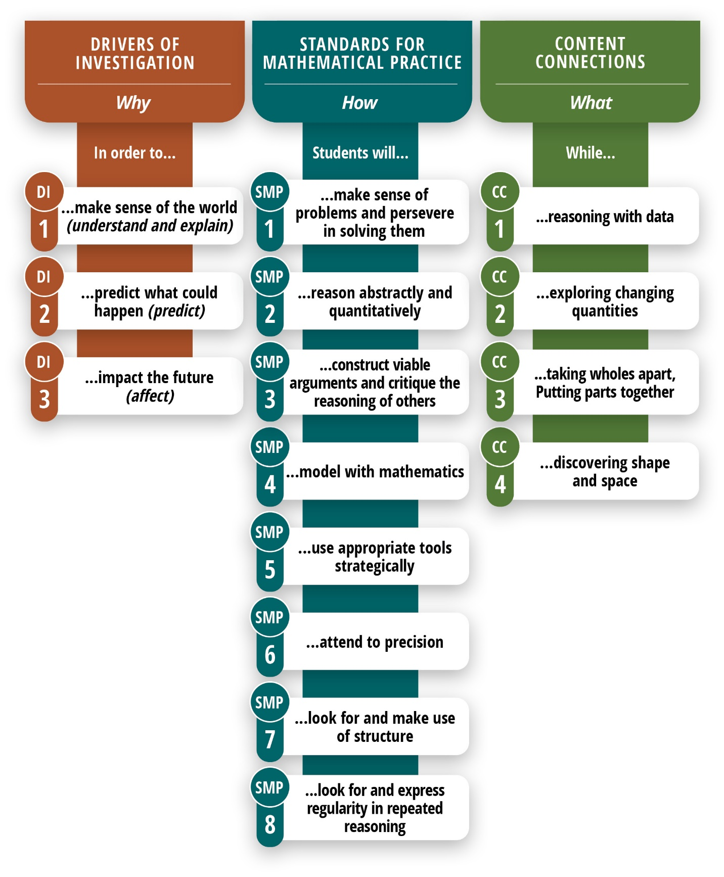
Note: The activities in each column can be combined with any of the activities in the other columns.
Long description of figure 8.1
The following diagram is another illustration of the ways that the Drivers of Investigation relate to Content Connections and Mathematical Practices as crosscutting themes. Any Driver of Investigation can be matched with any Mathematical Practice(s) and Content Connection(s); the diagram should not be interpreted to imply that each possible DI-SMP-CC combination should have activities designed around it. The table below is a simple way to begin planning instructional activities:
Figure 8.2: Drivers of Investigation, Standards for Mathematical Practices, and Content Connections
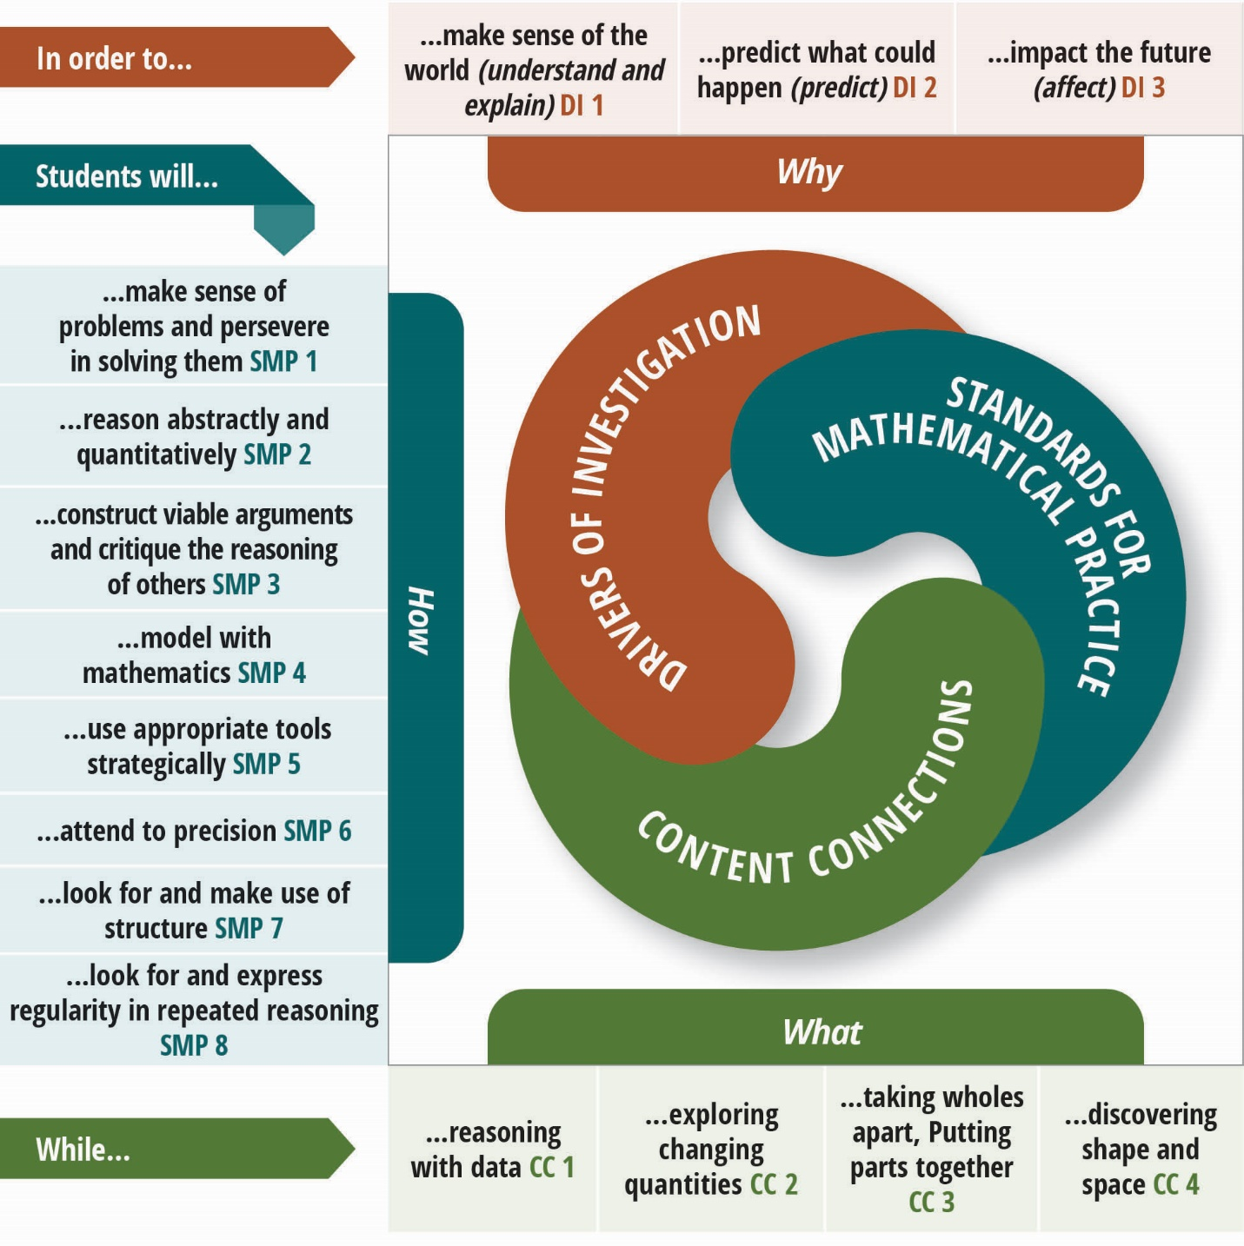
Long description of figure 8.2

Drivers of Investigation
The four CCs listed in the previous section, which provide mathematical coherence through the grades, should be developed through investigation of questions in authentic contexts; these investigations will naturally fall into one or more of the following DIs. The DIs are meant to serve a purpose similar to that of the Crosscutting Concepts in the California Next Generation Science Standards (CA-NGSS), as unifying reasons that both elicit curiosity and provide the motivation for deeply engaging with authentic mathematics. In practical use, teachers can use these to frame questions or activities at the outset for the class period, the week, or longer; or refer to these in the middle of an investigation (perhaps in response to the “Why are we doing this again?” questions that often crop up); or circle back to these at the conclusion of an activity to help students see “why it all matters.” Their purpose is to pique and leverage students’ innate wonder about the world, the future of the world, and their role in that future in order to foster a deeper understanding of the Content Connections and grow into a perspective that mathematics itself is a lively, flexible endeavor by which students can appreciate and understand so much of the inner workings of our world. The DIs are:
- Driver of Investigation 1: Make Sense of the World (Understand and Explain)
- Driver of Investigation 2: Predict What Could Happen (Predict)
- Driver of Investigation 3: Impact the Future (Affect)
One fundamental use of mathematics is to model real-world situations, for example the costs of different cellphone plans, the changing values of used cars, or the different sizes and comparative costs of different pizzas. What all these situations have in common is that the objects and relationships between them can be expressed in mathematical terms, often with one such object being expressible as a function of another. Once a situation has been described in that way, it can be analyzed mathematically to discover relationships, find patterns, and make predictions.
As students progress through the secondary curriculum, they encounter increasingly complex mathematical functions and relationships and increasingly sophisticated ways to represent and analyze data. They begin by working with linear functions, sets of linear functions, and some polynomial families of functions (for example quadratics). Later on they encounter logarithmic, exponential, and trigonometric functions. The mathematical objects or analytic methods they encounter may be new––but the processes of mathematizing and sensemaking are the same. The goal, whether for applications or the study of mathematical objects and relations in their own right, is to develop robust understandings and habits of sensemaking, with an increasingly large toolkit of concepts and functions.

Standards for Mathematical Practice
In addition to the areas of content to be covered, the practice of mathematics is described in the CA CCSSM through the Standards for Mathematics Practice (SMPs), shown in the previous section and described more fully in earlier chapters (chapter 4 is focused on a discussion of the SMPs). Designing instructional time so that students are engaging and building proficiency in these practices is crucial. To support teachers in this regard, later sections of this chapter include tables that provide examples of how they might integrate the SMPs into their coursework.
Lesson ideas that drive design of instructional activities will link one or more SMPs with one or more Content Connections in the context of a Driver of Investigation, so that students can (for example) Model with Mathematics while Reasoning with Data in order to Predict What Could Happen. Or students can Reason Abstractly and Quantitatively while Exploring Changing Quantities in order to Impact the Future. The aim of the Drivers of Investigation is to ensure that there is always a reason to care about mathematical work—and that investigations allow students to make sense, predict, and/or affect the world.
Instructional materials should primarily involve tasks that invite students to make sense of these big ideas, elicit wondering in authentic contexts, and necessitate mathematical investigation. Big ideas in math are central to the learning of mathematics, link numerous mathematical understandings into a coherent whole, and provide focal points for students’ investigations. An authentic activity or problem is one in which students investigate or struggle with situations or questions about which they actually wonder. Lesson design should be built to elicit that wondering. For example, environmental observations and issues on campus and in students’ local community provide rich contexts for student investigations and mathematical analysis. Such discussions will concurrently help students develop their understanding of California’s Environmental Principles and Concepts.
Within each Content Connection, students’ experiences should first emerge out of exploration or problems that incorporate student problem-posing (Cai and Hwang, 2019). Meaningful student engagement in identifying problems of interest helps increase engagement even in subsequent teacher-identified problems. Identifying contexts and problems before solution methods are known makes explorations seem like real problems for students to solve, as opposed to simply exercises to practice previously learned exercise-solving paths.
A well-known example of the difference between a stereotypical use of problems in high school mathematics classrooms and the use of problems as described in this framework is described in Dan Meyer’s TED Talk (Meyer, 2010): Meyer considers a standard textbook problem about a cylindrical tank filling from a hose at a constant rate. The textbook provides several sub-steps (area of the base, volume of the tank) and the final question “How long will it take to fill the tank?” The task appears at the end of a chapter in which all the mathematical tools to solve the problem are covered; thus, students experience the task as an exercise, not an authentic problem.
In the problem-based technique advocated here, the tank-filling context is presented prior to any introduction of methods or a general class of problems, in some way that authentically raises the question, “How long will it take to fill?” and preferably in a way that has a meaningful answer available for a check (e.g., a video of the entire tank-filling process, as in the TED Talk). After the question has been raised (hopefully by students), students make some estimates, and then the development of the necessary mathematics is seen as having a purpose. Employing the framing above, we might say that in this activity, students are being asked to reason abstractly and quantitatively (SMP.2), construct and critique arguments (SMP.3), and model with mathematics (SMP.4) while exploring changing quantities (CC2) in order to predict what could happen (DI2). Viewing the end of the video prompts meta-thinking about process (Why is our answer different than the video shows?) much more effectively than a “check your work” prompt or a comparison with the answer in the back of the book. This tank-filling problem could occur in Mathematics I or Algebra I. Note that the problem integrates linear function and geometry standards.
As this example shows, the problem-embedded learning envisioned in this framework does not imply a curriculum in which all learning takes place in the context of large, multi-week projects, though that is one approach that some curricula pursue. Problems and activities that emphasize a big idea-based approach as outlined here can also be incorporated into instruction in short time increments, such as 45-minute lessons or even in shorter routines such as Think-Pair-Share, or Math Talks (see chapter 3). There are a number of lesson plan formats which take a problem-embedded approach, including one from Los Angeles Unified School District which adopts a three-phase lesson structure incorporating student question-posing, solving, and reflecting stages (LAUSD, n.d.).
Because mathematical ideas and tools are not neatly partitioned into categories, many clusters of standards appear in multiple Content Connections. For example, the Quantities cluster Reason quantitatively and use units to solve problems (Q.A) is a set of standards that will be built and reinforced in many investigations based in data and varying quantities; hence this cluster is included in both Content Connection 1 (Reasoning with data) and Content Connection 2 (Exploring changing quantities).
A more extensive investigation that cuts across several Content Connections is illustrated in the vignette Exploring Climate Change. Other vignettes illustrate CC2 (Drone Light Show), CC3 (Blood Insulin Levels), and CC4 (Finding the Volume of a Complex Shape). Below, we provide additional information about the expected understandings, skills, and dispositions for each of the four Content Connections.

Content Connections

CC1: Reasoning with Data
Most quantitative situations that graduates will encounter in their lives involve reasoning about and with data. While this Content Connection is discussed in great depth across grade levels in chapter 5 (Data Science), in this chapter, we draw stronger connections to the steps of the statistical problem-solving process that high school graduates must understand and in which they should develop skills.
Figure 8.3. The Statistical Problem-solving Process (GAISE II)
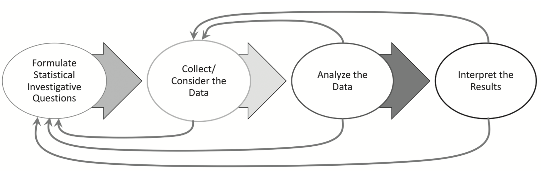
Long description of figure 8.3
Building on years of earlier instruction, by graduation, students should understand the important roles that investigating, questioning, and problem-solving play in the process of doing mathematics.
Formulate statistical investigative questions: Graduates should be able to formulate statistical investigative questions for the purposes of describing, comparing, and predicting, and propose ways to gather data to help answer those questions. Questions may involve several variables of interest and may concern questions of association (correlation) and causality.
Collect/Consider the Data: Graduates should propose ways to validly collect data to answer statistical investigative questions. Validity in the data collection depends on students being able to anticipate variability and understand that random processes can produce data that varies in predictable ways in the aggregate (and thus understand that meaningful relationships between varying quantities might be discernible even from data that has been corrupted, distorted, or has a low signal-to-noise ratio).
They understand the difference between various data collection methods (e.g., surveys, observational studies, and experiments) and can choose the option(s) best suited to the question of interest. They discuss possible sources of bias in surveys and in study design and understand privacy and other ethical issues that accompany data collection and analysis. They understand the role that randomness plays in the ability to generalize (to a larger population) findings from surveys, observations, or experiments. For secondary data, graduates can ask questions about the origin of the data and its ability to help answer the statistical investigative question, including possible sources of bias.
Students whose interests and aspirations lead them to a more focused study of data science in high school will, in addition, know good practices for designing surveys, studies, and experiments—including issues of sample size and methods for random sampling and assignment. They will also understand practices for cleaning, organizing, and handling data.
Analyze the data: All graduates should be able to identify appropriate summaries (graphical displays, tables, summary statistics) for quantitative or categorical data, and to generate those summaries for some data sets using technology. For a relationship between two quantitative variables, they should be able to use appropriate technology to generate a correlation coefficient and a least-squares regression line, and then to interpret both in the context of the data. They understand that statistical claims about populations are based on probability.
Data collection and analysis activities (as well as CC2) require that graduates understand the mathematics of measurement, including conversion between different units, the use of units that are rates (such as km/hr or people per square mile), and when it does or does not make sense to combine quantities (adding length and area makes no sense; dividing kilometers by hours might express something useful). In these measurement contexts, graduates use proportional reasoning and understand percentages and ratios as ways to express multiplicative comparisons and relationships between quantities.
In a data science or statistics course, students may learn more advanced techniques for describing and representing relationships between variables, and considerably more of the probabilistic underpinning of statistical claims. This equips them to construct and interpret confidence intervals and p-values. They have developed the habit of using dimensional analysis to make sense of computations and can manipulate ratios, percentages, and scientific notation in order to understand and express results.
Interpret results: Graduates can interpret the results of their analysis in the context of the statistical investigative question, using data summaries to consider how to interpret findings and communicate mathematical understandings. They can explain the meaning of population estimates or other results and discuss in general terms possible sources of error such as missing data and imperfect data collection. They are introduced to the concepts of margins of error and confidence intervals graphically, practicing correct probabilistic understanding. They can communicate their results via writing, speaking, and visual representations.
Students in a data science or statistics course can interpret p-values, demonstrating an understanding of the probabilistic claim that an observed result is not plausible under a particular set of assumptions. They use technology to decide the most important predictor variables for a variable of interest in a multivariable situation. This summary of expected learning for students specializing in quantitative areas is consistent with “Level C” expectations in the Pre-K–12 Guidelines for Assessment and Instruction in Statistics Education II (GAISE II) from the American Statistical Association and National Council of Teachers of Mathematics. Along with an understanding of statistical methods, those who aim to enter a data science major in college should also have experience with programming.

CC2: Exploring Changing Quantities
Mathematics frequently involves recognizing quantities in situations; translating relationships between them from natural language, visual, or other forms into mathematical forms (often equations, but also graphs, tables, and more); working with and moving between these mathematical forms to understand or answer questions about the relationships; and interpreting findings back in the original context. All students should develop this inclination and ability to a significant degree. Most standards in the Functions conceptual category are included here; some regarding building functions are discussed in CC 1. Most Modeling work involves this process of identifying and relating quantities in a situation.
Noticing and naming quantities in situations is key for students to understand that mathematics arises in—and helps to understand, explain, and solve problems in—situations that they wonder about (SMP.1). Students should all develop this ability to recognize and name quantities throughout their transitional kindergarten through grade twelve experiences, so that the high school task is to maintain and expand, rather than rediscover and redevelop, this inclination and ability. Graduates should be able to notice and name quantities in situations ranging across science, social science, mathematics, everyday life, and more.
Describing relationships between quantities in mathematical forms, and being able to flexibly work with and move between those forms, is central to using mathematics to reason about situations and questions of interest (SMP.4). To describe a relationship, especially in order to predict one quantity from one (or more) other quantities, often requires that a function of one (or, eventually, more than one) quantity be expressed. Understanding the concept of a function and interpreting functions in context is a major outcome of high school mathematics.
During high school, all students should learn to recognize and represent linear, exponential, and logarithmic relationships in multiple forms (graphs of functions, algebraic formulas, scatter plots, tables, recursive rules, and verbal descriptions), to use appropriate technology, and to move flexibly between these representations as necessary to understand, explain, or solve problems in the situation. Students should also be able to use and recognize quadratic functions as models for important physical phenomena, such as motion under the force of gravity, and to describe properties of quadratic functions that differ from those linear and exponential functions.
Students should also be able to recognize periodic phenomena and to adjust the period, amplitude, horizontal shift, and vertical shift of a trigonometric function (perhaps experimentally, via a computer algebra system) to represent simple periodic relationships. More discussion of modifying functions in this way is in Taking Wholes Apart, Putting Parts Together below. Graduates should also understand trigonometric functions as ways to describe the ratios between different side lengths in right triangles, and that these ratios are invariant under similarity.
Much of the power of mathematics as a lens for understanding authentic contexts and problems lies in the fact that the same mathematics (when abstracted from the particular quantities in the current context) applies to such varied situations. Thus, when students understand exponential functions, they can use them to reason about population growth, interest-bearing monetary accounts, and radioactive decay, to name just a few.
All high school graduates should be able to apply reasoning about linear, quadratic, and exponential functions across a variety of contexts and interpret that abstract reasoning in the particular quantities of those contexts (SMP.2). Students should understand abstraction as a way to reason similarly across different contexts (SMP.8). For example, the contexts of population growth, interest-earning accounts, and radioactive decay were not designed to be applications of exponential functions; rather, exponential functions are noticed, described, defined, and studied because of the observed similarity in reasoning about these (and many more) contexts.
Students whose interests and aspirations lead them to a more focused study of mathematics during high school are expected to develop both a larger vocabulary of familiar function types and more depth and flexibility in using them to model phenomena and solve problems (often using technology). In particular, they can use and manipulate trigonometric functions to represent and explore periodic phenomena, and rational functions to represent ratios between two varying quantities (rates). Most college-level study in mathematics will expect considerable familiarity and comfort with manipulating algebraic expressions and equations and modeling with functions in order to solve problems and make certain features of functions apparent.

CC3: Taking Wholes Apart, Putting Parts Together
The Conceptual Categories Algebra and Number and Quantity largely fall into this Content Connection, along with portions of the Functions and Geometry Conceptual Categories that involve relating a mathematical object to its constituent parts or building a new object from others.
Across many contexts and typically-separated areas of mathematical content, students must develop the inclination and ability to see the component parts of complex situations, functions, geometric objects, etc.; to investigate those components; and to assemble observations about the components into understanding about the original setting. CC3 can also be seen as assembling and communicating the steps in a solution, in justifying a claim or answer in a learning group, or in forming hypotheses from observations. In these ways, students develop their ability to reason logically. Logical reasoning is at the heart of mathematical discovery, communication, and connection, and students’ initial understanding of the role of proofs, as ways to explain the validity of facts, is predicated upon their ability to reason visually, symbolically, concretely and abstractly.
The Conceptual Category Algebra (as distinct from Functions, in CC2 above) describes graduates’ expected abilities to see structure in expressions (considering the contributions of, and interpreting, different parts such as terms and factors), create equations to describe relationships (often by separately representing different contributions to varying quantities, and combining those contributions into one equation), and reason with equations (and inequalities) in order to understand situations and solve problems. Manipulating expressions and equations are tools for reasoning with equations and inequalities. Familiarity with arithmetic properties, used in decomposing and composing numerical quantities in earlier grades, provides the foundation upon which students can understand the purpose and import of algebraic properties, not as arbitrary laws to be memorized, but as distillations of ideas already familiar to them.
The high school Number and Quantity standards include extending properties of exponents from natural number exponents to rational exponents and extending the concept of number to include complex numbers. Graduates should understand that properties encoding observations in one system (such as ${\left(a^{b}\right)}^{c}=a^{\left(bc\right)}$, for a real number a and whole numbers b and c) can be used to define the meaning of similar symbols in other systems (such as $5^{\left(1∕3\right)}$, with a non-integer number exponent). Similarly, extending the real numbers to the complex numbers is accomplished by extending desired properties from the real numbers to a larger set (one in which $x^{2}=-1$ has a solution).
In both Geometry and Functions, graduates understand the many ways that functions are built up from simpler ones or from defining properties—for example, rigid transformations from translations, rotations, and reflections (add dilations for similarity transformations); linear (resp. exponential) functions from a starting value (y-intercept) and a constant additive (resp. multiplicative) rate of change. Modifying functions via horizontal and vertical shifts, vertical and horizontal reflections, and vertical and horizontal compression/stretching are further examples; graduates should be able to identify the effects of the various algebraic replacements and choose appropriate one(s) (e.g., in graphing software) to produce functions with desired characteristics (e.g., to model data).
In Geometry, understanding the whole from its parts plays more roles: informal arguments for the area and volume of various objects by dissection arguments; relationships between three-dimensional objects and one- or two-dimensional figures (cross-sections, faces, edges).
Students who specialize in mathematics may also understand that vectors and matrices are additional objects that can name new types of quantities and can be manipulated to understand those quantities, using operations similar (but not identical) to those of real numbers.

CC4: Discovering Shape and Space
This Content Connection contains the bulk of the Geometry Conceptual Category, as well as some trigonometric functions standards in Functions.
Graduates should understand congruence and similarity of plane figures in terms of transformations of the plane and understand that measurement-based criteria for congruence—such as angle-side-angle for triangles—follow from the transformation definitions. They should understand why all length measures scale by the same factor under a similarity transformation. They understand that these definitions of congruence can be used to prove many facts about lines, angles, and shapes; and they connect tools of formal constructions with rigid motions to establish the validity of constructions.
Ratios of corresponding sides of triangles should be understood to be preserved by similarity transformations. For right triangles, then, these trigonometric ratios are properties of the angles in the triangle (since one of the acute angles defines a right triangle up to similarity). Graduates should be able to identify similar right triangles in applied settings and use trigonometric ratios and the Pythagorean Theorem to find unknown measurements in right triangles in terms of known sides and angles. They know that the domains of the functions sin(x), cos(x), and tan(x) can be extended to all real numbers using the unit circle, giving periodic functions that can be used to model phenomena (see CC2 above).
Students should understand that all circles are similar and know that relationships between various angle measures and length measures in a circle can be used to find others.
The coordinate plane must be understood as a tool for connecting geometry and algebra by providing equations that describe geometric objects, as well as geometric objects that describe (the solutions to) equations in two variables. Graduates know that some geometric facts are most easily established using algebraic representations, and that geometric observations can lead to better understanding in the algebraic context.
Students whose interests and aspirations lead to more focused mathematics work in high school may also extend their tools for analyzing triangles to non-right triangles by deriving the Laws of Sines and Cosines, and a formula for the area of a general triangle in terms of side and angle measures and using these to find unknown measurements in triangles.

The Importance of a Renewed Focus on Secondary School Mathematics
As described in chapter 2, California students' demonstration of deep mathematical learning on local and state assessments continues to be a concern and a priority for districts. This includes the importance of high levels of mathematics understanding for college and career preparedness. Additionally, both the National Assessment of Educational Progress (NAEP) and the Programme for International Student Assessment (PISA) provide compelling data supporting a renewed focus on mathematics education. These assessments, administered to students in grades four and eight, provide a window on elementary and middle school mathematics experiences that all too often poorly prepare high school students for success in rigorous mathematics courses. Since 2000, US math performance has steadily declined in both absolute and relative terms on the international PISA exams sponsored by the Organization for Economic Cooperation and Development. The US now ranks 32nd in the world, far below the average. (See chapter 1.) In contrast to the highest achieving countries, US performance is lower for both high and low achievers and shows wider achievement gaps associated with students’ socioeconomic status. As a consequence, calls for reform in mathematics education have been widespread.
Mathematics in the highest-achieving countries is typically taught in heterogenous classrooms prior to tenth grade, and, in high school, in an integrated fashion with domains of mathematical study combined to allow for more robust conceptualization and problem solving, rather than in a sequence in which Algebra I, Geometry, Algebra II/Trigonometry are taken separately, one by one. For example, in Japan, the highest-scoring country on the most recent PISA exams, Mathematics I, II, and III each combine elements of algebra, geometry, measurement, statistics, and trigonometry. The focus is on taking time for students to intently discuss and collaboratively solve complex problems that integrate the content—often just one complex problem in a class period—rather than memorizing formulas and applying rote procedures to multiple problems that isolate the mathematical ideas and challenge students’ deep understanding (Okano and Tsuchiya, 1999, Stigler and Hiebert, 1997). Reforms over the last decade have focused more intently on experiential and project-based learning and applications to real-world problems by adding data uses to each grade level (Ministry of Education, 2010). When differentiation occurs at tenth grade to add greater challenge to the courses of advanced students, the curriculum remains similar, and both lanes allow students to reach advanced courses like calculus.
A similarly integrated curriculum is used in Korea, the second ranked country on PISA, where a “learner-centered” approach advanced by the Ministry of Education has focused mathematics on active engagement in problem solving. There, too, students take the same integrated set of courses through grade ten (each of which integrates content from six domains: 'Numbers and Operations', 'Geometric Figures', 'Measuring', 'Probability and Statistics', 'Letters and Expressions', and 'Patterns and Functions,' with basic and enriched content within each course to meet students’ interests and needs). They choose “electives” in eleventh and twelfth grade, such as additional integrated courses or statistics, calculus, discrete mathematics, or practical mathematics (Paik, 2004).
In Estonia, the third ranked and most rapidly improving country, the curriculum integrates arithmetic and measurement along with geometric, algebraic, and statistical concepts throughout the grades and has a strong focus on modeling and solving word problems in all domains, including with algebraic tools (see National Center on Education and the Economy, n.d.; and Hemmi, Brating, and Lepik, 2020). A set of reforms over the last decade has focused intensely on the use of computers and descriptive statistics for data analysis throughout the grades, and the use of real-world problems to organize mathematical inquiry (Hoim, Hommik, and Kikas, 2016).
In Finland, also one of the highest performing countries on PISA, students work in heterogenous classes on a common curriculum during the first nine years of their education, using an approach that teaches mathematics as a set of big ideas and connections in ways that value student ideas and curiosity (Sahlberg, 2021). Finnish students outperform US students by a considerable margin: 15.3 percent of Finnish 15-year-old students score at the highest levels in Programme for International Student Assessment (PISA) mathematics tests compared to only 8.8 percent of students in the United States (OECD/PISA, 2012).
As noted in chapter 1, these curriculum approaches are consonant with what researchers are learning about effective practices for supporting mathematical understanding, such as using multiple representations, productive inquiries, and connections to real-world problems that are engaging and allow a more integrated approach to problem solving. These approaches also inform this framework, as described below.

Designing Instruction for Equitable and Engaging High School Mathematics

Five Components of Equitable and Engaging Teaching
This framework’s chapter 2 (Teaching for Equity and Engagement) is structured around five components of equitable and engaging teaching, which are briefly revisited here. The components should inform high school instructional design as much as earlier grades. For much fuller discussions, refer to chapter 2.
- Plan Teaching Around Big Ideas: Mathematics is a subject made up of important ideas and connections. Curriculum standards and textbooks tend to divide the subject into smaller topics, but it is important for teachers and students to think about the big ideas that characterize mathematics at their grade level and the connections between them. The big ideas for high school are set out later in this chapter.
- Use Open, Engaging Tasks: Open tasks allow all students to work at levels that are appropriately challenging for them using a range of strategies within the content of their grade.
- Teach Toward Social Justice: Teachers can take a justice-oriented perspective while broadening access to and interest in math at any grade level, kindergarten through grade twelve, by: a) creating opportunities for students to both see themselves, as well as people from all backgrounds, as capable and successful doers of mathematics; and b) empowering learners with tools to highlight inequities and address important issues in their lives and communities through mathematics.
- Invite Student Questions and Conjectures: One of the most important yet neglected mathematical acts in classrooms is that of students asking or posing mathematical questions. These are not questions to help students move through a problem; they are questions that are sparked by wonder and intrigue (Duckworth, 2006). Students’ questions should be valued and students should be given time to explore them. Questions are important in the service of creating active, curious mathematical thinkers.
- Center Reasoning and Justification: Reasoning is fostered when students have the opportunity to talk about mathematics with each other. Through the acts of reasoning and justifying, more students can begin to see mathematics as a tool to ask questions about and make sense of their world, rather than as a static set of rules. When students have opportunities to reason and justify while engaging with open tasks, their engagement in math increases and they strengthen their identities as members of the mathematics community.
These components of instruction remain important at the high school level, and for many high school educators they will represent a change from their own high school experience.

The Need for Integration in High School Mathematics
Young people are naturally curious about their world and the environment in which they live, and this curiosity fuels their desire to wonder, describe, understand, and ask questions. Mathematics provides a set of lenses for viewing, describing, understanding, and analyzing phenomena and for solving problems—such as local issues related to environmental and social justice, business, and personal finance through engineering design practices (CA NGSS HS-ETS1-2)—which might occur in the “real world” or in abstract settings such as within mathematics itself. For instance, finance, the environment, and science all offer phenomena, such as recurrent patterns or atypical cases, which are better understood through mathematical tools. Such phenomena also arise within mathematics—for example, high school students may explore number patterns in Pascal’s Triangle or investigate the impact of changing the leading coefficient of a polynomial on the shape of its graph. By experiencing the ways in which mathematics can answer natural questions about their world, both in school and outside of it, a student’s perspectives on both mathematics and their world are integrated into a connected whole. As Fawn Nguyen, a junior high mathematics teacher in the Mesa Union School District, put it, “Critique the effectiveness of your lesson not by what answers students give but by what questions they ask.”

Definition of Integration
There are multiple contexts for which the term integrated has been used in connection with mathematics education. In this chapter, “integrated” refers both to the connecting of mathematics with students’ lives and their perspectives on the world (Gutstein, 2006, 2008) and to the connecting of mathematical concepts to each other within and across courses regardless of whether a school has adopted a traditional (Algebra I, Geometry, Algebra II) or integrated (Mathematics I, Mathematics II, Mathematics III) curriculum (House, 2003; Usiskin, 2003). This reference to both can result in a more coherent understanding of mathematics. Integrated tasks, activities, projects, and problems are those which invite students to engage in both of these aspects of integration. Both the traditional and integrated pathways described later in this chapter can incorporate both aspects of integration: opportunities that are relevant to students and their experiences, and opportunities to connect different mathematical ideas.
As described more fully in chapter 2, researchers have found that the integration of mathematical topics through authentic problems that draw from different areas of mathematics can increase engagement and achievement (Grouws et al., 2013; Tarr et al., 2013).

Motivation for Integration
In keeping with the thrust of this framework, all high school curriculum and instruction can benefit from thoughtful approaches which leverage relevance to students with opportunities to reveal fundamental connections among related topics. A guiding question for measuring these two aspects in classroom activities, in any course, is “Can I see evidence that students wonder about questions that will help to motivate learning of mathematics and that connect this learning to other knowledge?”

Designing Instruction with Integration in Mind
The primary challenge for the design of any high-school pathway is to bridge the gap between the CA CCSSM’s lists of critical content goals and the difficult tasks teachers face every day when providing instruction that casts mathematics as a subject of connected, meaningful ideas that can empower students to understand and affect their world.
As described in chapter 2 and discussed above, it is important that exploration and question-posing occur prior to teachers telling students about questions to explore, methods to use, or solution paths. A compelling experimental research study compared students who learned calculus actively, when they were given problems to explore before being shown methods, to students who received lectures followed by solving the same problems as the active learners (Deslauriers et al., 2019). The students who explored the problems first learned significantly more (see also Schwartz and Bransford, 1998). However, despite the increased understanding of the exploratory learners, students in both groups believed that the lecture approach was more effective—as the active learning condition caused them to experience more challenge and uncertainty. The study not only showed the effectiveness of students exploring problems before being taught methods, but the value of sharing with students the importance of struggle and of thinking about mathematics problems deeply.
In a similar vein, different conceptions and unfinished learning add value to classroom discussions when they can be made visible and used thoughtfully. Activities should be designed to elicit common mis- or alternative conceptions, not to avoid them. This requires that teachers work through tasks before using them in classes, in order to anticipate common responses and plan ways to value contributions and use them to build all students’ understanding. The goal of mathematics class must be deeper understanding and more flexibility in using and connecting ideas—not quicker answer-getting (Daro, 2013).
Other research examines beliefs and attitudes such as utility value (belief that mathematics is relevant to personal goals and to societal problems), and this research shows a severe drop off in utility value during high school (Chouinard and Roy, 2008). However, teaching methods that increase connections between course content and students’ lives, and that include careful focus on effective groupwork, can significantly increase utility value for students (Cabana, Shreve, and Woodbury, 2014; Hulleman et al., 2017).

Pathways in Grades Nine Through Twelve
Pathways of mathematics courses in grades nine through twelve provide opportunities for students to develop a disposition toward reasoning and communication in mathematics, knowledge of mathematical ideas and skills, and the ability to think both critically and creatively in solving problems. In either of the pathways supported in California, the approach of integration amongst topics, described in detail in the prior section, is highly valued, as are the other recurrent themes of this framework: focusing on big ideas and active investigation. Illustrations of these types of investigations are provided through the vignettes Exploring Climate Change, Drone Light Show, Blood Insulin Levels, and Finding the Volume of a Complex Shape.

The Starting Point for High School Coursework
The two potential pathways outlined in the framework begin with the foundation of the California Common Core 6, 7 and 8 courses—established in the 2013 framework as the most comprehensive middle school preparation for many students—with grade eight offering algebra content integrated with challenging content in other areas of mathematics that strengthen and deepen students’ foundation for more advanced mathematics.
Some students will be ready to accelerate into Algebra I or Mathematics I in eighth grade, and, where they are ready to do so successfully, this can support greater access to a broader range of advanced courses for them. At the same time, successful acceleration requires a strong mathematical foundation. Research indicates that in the era in which California policy encouraged all students to take Algebra in eighth grade, success for many students was undermined; widespread acceleration did not enable students to progress as expected to subsequent courses. The authors of one study found that many students had to repeat Algebra I in ninth grade and did not extend their course taking to advanced courses. The authors concluded that: “encouraging more students to take eighth-grade algebra does not by itself lead to significantly more students taking advanced mathematics in high school, nor does it lead to substantial increases in performances in higher mathematics CST.” (Liang, Heckman, and Abedi, 2012, 338). Other studies found mixed effects of this policy across districts of different kinds and for different types of students (Domina et al. 2014; Domina et al. 2015).
These challenges are no doubt a function of students’ curricular readiness—whether they have mastered the right foundations—and the quality of teaching both before and during the course itself. One racially and economically diverse New York middle school that successfully accelerated all of its students offers an example of the conditions that enabled stronger outcomes. The school ended tracking in mathematics and gave all students access to the more advanced three-year curriculum sequence that had previously been reserved to a smaller number. This sequence included in eighth grade the Mathematics I integrated course normally offered in ninth grade. Researchers followed three cohorts in the earlier tracked sequence and three cohorts in the more rigorous untracked sequence. They found that both the initially lower and higher achieving students who learned in the later heterogeneous courses took more advanced math, enjoyed math more and passed the state Regents test in New York sooner than previously. This success was supported by a carefully revised curriculum in grades six through eight, creation of alternate-day support classes, known as mathematics workshops, to assist any students needing extra help, and establishment of common planning periods for mathematics teachers so they could develop stronger pedagogies together (Burris, Heubert, and Levin, 2006).
For schools that offer an eighth grade Algebra course or a Mathematics I course as an option in lieu of Common Core Math 8, both careful plans for instruction that links to students’ prior course taking and an assessment of readiness should be considered. Such an assessment might be coupled with supplementary or summer courses that provide the kind of support for readiness that Bob Moses’ Algebra Project has provided for many years for underrepresented students tackling Algebra (Moses and Cobb, 2002).
One consideration in sequencing mathematics courses is the desire to enable students who would like to reach Calculus by the end of high school to do so. Currently, most high schools require courses in Algebra, Geometry, Algebra II, and Pre-calculus before taking a course in Calculus, or a pathway of Mathematics I, II, III, then Precalculus. This sequence means that students cannot easily reach Calculus in high school unless they have taken a high school algebra course or Mathematics I in middle school.
An alternative to eighth grade acceleration would be to adjust the high school curriculum instead, eliminating redundancies in the content of current courses, so that students do not need four courses before Calculus. As enacted, Algebra II tends to repeat a significant amount of the content of Algebra I, and Precalculus repeats content from Algebra II. While recognizing that some repetition of content has value, further analysis should be conducted to evaluate how high school course pathways may be redesigned to create more streamlined pathways that allow students to take three years of middle school foundations and still reach advanced mathematics courses such as calculus. Schools may also organize supplemental course taking in summer programs, to allow students who start Algebra or Mathematics I in ninth grade to be able to take Calculus in high school if they choose. (See chapter 9 for other possible strategies high schools can adopt.)

Structuring High School Pathway
Schools are free to organize their mathematics pathways in different ways. By completing Algebra I and Geometry or Mathematics I and II, students will satisfy the requirements of California Assembly Bill 220 of the 2015 legislative session that requires students to complete two mathematics courses in order to receive a diploma of graduation from high school, with at least one course meeting the rigor of Algebra I. Depending upon their post-secondary goals, students may choose different third- and fourth-year courses, and all college-intending students should complete four years of mathematics in high school to meet California State University and University of California recommendations.
Figure 8.4 below indicates possible pathways for high school coursework, reflecting a common experience for the first two years (launched in middle or high school), and a broader array of options in subsequent years relevant to students’ interests. Some of these courses will qualify for Area C credit in the UC/CSU admissions process (see discussion below). High schools will typically offer either the Integrated or Traditional pathway during students’ first two or three years as well as an array of more advanced courses. The Integrated and Traditional pathways are alternative sequences through the same content stipulated in the California math standards. (Although some educators have recommended a separate data science pathway, this framework recognizes that data science can and should be integrated into math instruction across the grade levels, from elementary school through high school, regardless of which pathway a school has selected. See chapter 5.) Choices made by students after their first two years should not lock them into any particular path: third-year courses should prepare students for fourth-year courses to enable students’ access to higher level mathematics as their interests and efforts develop. Whichever pathway is selected by a school, advanced students may complete that pathway in an accelerated fashion to access additional advanced mathematics courses, or, as described in chapter 9, they may be offered additional or supplemental challenges within or beyond the courses they take in their pathway. Descriptions of the pathways’ courses and a discussion of the concepts that should be included for students intending to major in a STEM field of study in college are included later in this chapter.
Figure 8.4: High School Pathways to STEM and Non-STEM Careers

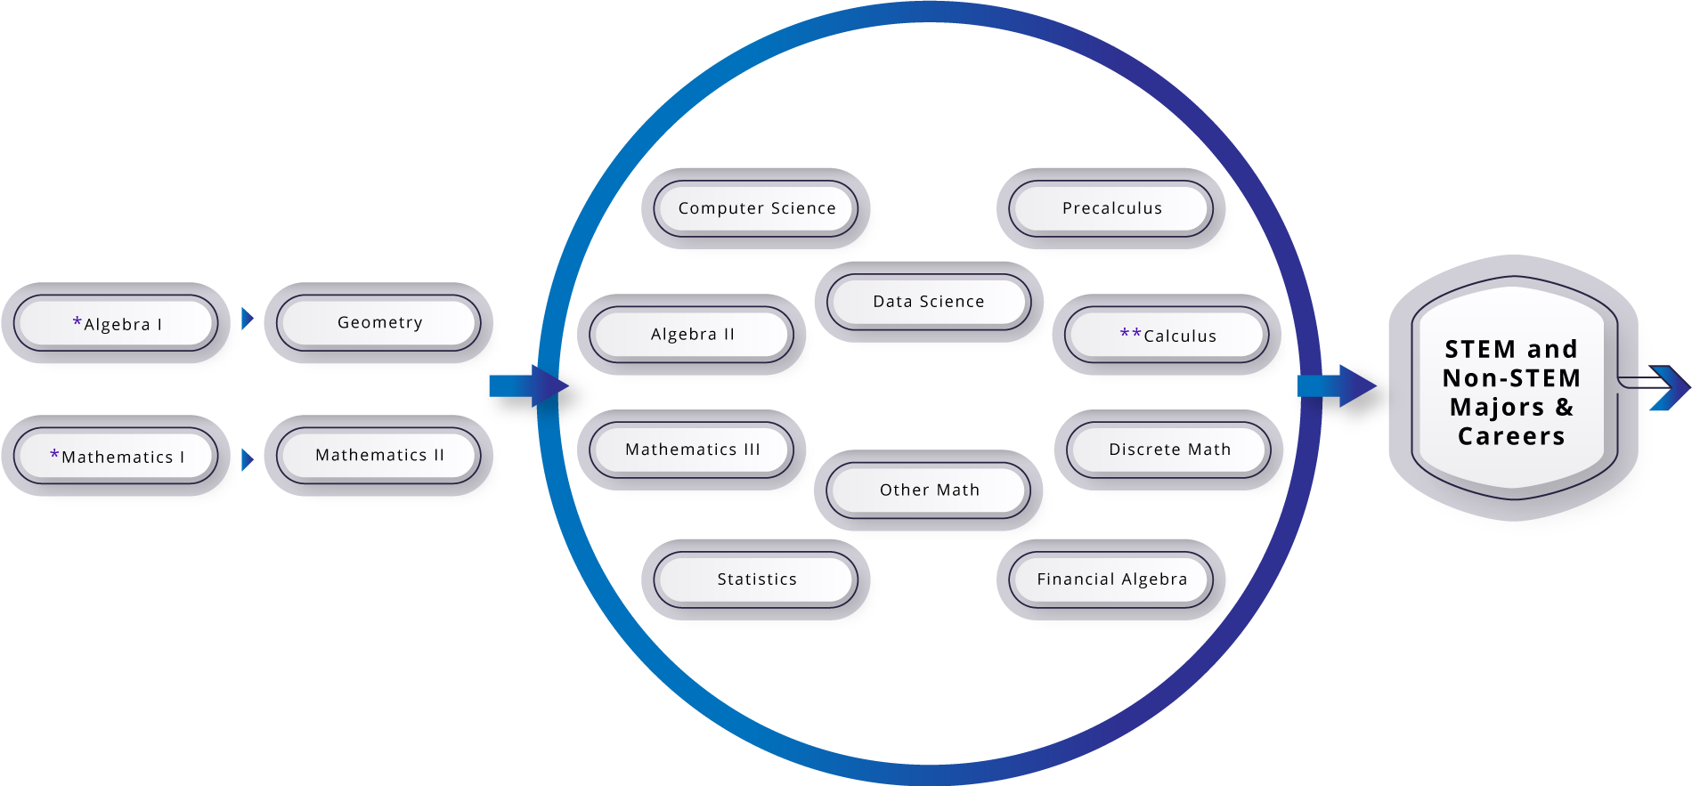
Long description of figure 8.4
* Students may take Algebra I or Mathematics I in middle school.
** Calculus, which can be taken during or after high school, is an important course to support student selection of a STEM career.
Figure Note: Many of the third- and fourth-year high school courses included in the figure such as financial algebra, data science, statistics with algebra, or other math will require prerequisite knowledge of Mathematics I and Mathematics II, or Algebra I and Geometry, depending on district policy. See the following section.

Third- and Fourth-Year Courses
In addition to offering Mathematics III or Algebra II, districts have the flexibility to offer other third-year and fourth-year courses. One example that is already offered by some districts (and is University of California A–G approved) is Financial Algebra. In this course, students engage in mathematical modeling in the context of personal finance (this course is comparable in rigor to a Mathematics III or Algebra II course; it is not the same as a “Consumer Math” or “Accounting and Finance” class currently offered by some schools, which are not UC A–G approved). Through this modeling lens, they develop understanding of mathematical topics from advanced algebra, statistics, probability, precalculus, and calculus. Instead of simply incorporating a finance-focused word problem into each Algebra II lesson, this course incorporates the mathematics concept when it applies to the financial concept being discussed. For example, the concept of exponential functions is explored through the comparison of simple and compound interest; continuous compounding leads to a discussion of limits; and tax brackets shed light on the practicality of piecewise functions. In this way, the course ignites students' curiosity and ultimately their engagement. The scope of the course covers financial topics, such as taxes, budgeting, buying a car/house, (investing for) retirement, and credit, and develops algebra and modeling content wherever it is needed. “Never has mathematics seemed so relevant to students as it does in this course,” says one teacher.
Another third-year course currently offered by several districts is a Data Science course. Data science courses usually have a broader focus on reasoning with data. Because data science is still an emerging field with changing implications in the K–12 landscape, some data science courses are constructed to develop elements of Mathematics III content within the course, while others might require students to already have encountered the full Mathematics I–III content.
Any of these third-year courses could lead to a range of fourth-year options as set out in the course diagram above (figure 8.4). If students take another third-year course (besides Mathematics III or Algebra II), they should be made aware that they are leaving the usual pathway for taking Calculus in high school or in their first semester of college (as is expected in some universities for STEM majors). While many colleges and universities accept a wide range of mathematical backgrounds and provide pathways for students in STEM majors to complete Calculus in their first year, others expect to see incoming STEM majors having completed the content of Mathematics III/Algebra II followed by a precalculus and/or calculus course.

College Expectations and Sample Student Pathways
Giving students a choice of pathways through their last two years of high school can elevate a student’s real-world application of mathematics understanding. The variety of pathways reflect the many different interests and aims of students, such as those seeking employment directly after high school; others whose objective is a career requiring a university degree in a quantitative field (including STEM and data science) or a social science field that heavily uses statistics (such as sociology, psychology, economics, or political science); others who are interested in a university degree in a non-quantitative intensive major; and the many students who are still deciding upon post-high school ambitions while they are in high school. The following scenarios illustrate a small sample of the different pathways students may take:
- Josef is planning to work in a fabrication shop after graduation, so he chooses to follow the first two years of integrated mathematics with a course in modeling and CAD to gain an understanding of the mathematics of die-casting and three-dimensional printing.
- Roscoe’s family has a business in which Roscoe plans to work after high school. In talking with a counselor, Roscoe realizes that an accounting degree would enable Roscoe to oversee the business finances in the future. After Algebra I, Geometry, and Algebra II, Roscoe takes a Financial Algebra course, which enables a solid start on understanding the underlying principles in the introductory finance courses at the collegiate level.
- Yesenia is planning to study political science, so she chooses a Data Science course in the third year (one which has Mathematics I and II or Algebra I and Geometry as prerequisites) and an Advanced Placement (AP) Statistics course in her fourth year. This preparation serves her well, as she better understands the mathematics behind polling, apportionment, and gerrymandering from her Data Science course, as well as being well-equipped to understand the research methods in her political science courses from the Statistics course. In addition, since the Statistics course has an AP designation, she is well on her way to completing the General Education quantitative reasoning requirement for her university coursework.
- Ash is interested in working construction after high school but is also aware that his local community college offers a two-year certificate in construction management. Although he doesn’t pass Algebra I as a freshman, fortunately, his high school offers a support course, and with the extra time and attention, Ash passes Algebra I as a sophomore. His counselor advises him to take Geometry as a junior, since the study of shapes, angles, and measurement is beneficial for his career. Also, he could then take Algebra II as a senior, which provides the background to take trigonometry at the community college, a required course for the certificate.
- Inez likes digital photography, so she was planning on majoring in graphic design at a university, a degree not requiring calculus. As Inez is completing her third-year course in Data Science, however, she found herself enjoying using the software and various applications to work with the data sets and create captivating data displays. This, combined with her interest in creating mods (i.e., customizing modifications) for her favorite video game, has her now thinking about pursuing computer science coursework at a university. So, in her fourth year, she enrolls in her school’s precalculus class, along with a half-semester support class her school offers for students whose interest in mathematics grows late in their high school time. She enters her university well-prepared to take freshman calculus and the programming classes she hopes to pursue alongside additional work in data science.
- Kai is interested in robotics engineering and was able to take Mathematics I and II in junior high and Mathematics III during the first year of high school. By completing Precalculus in the second year, Kai is able to take AP Calculus in the third year. This enables multiple options for Kai’s fourth year, such as taking her school’s data science course, or a programming and data science course at the local community college, multivariable calculus, or other college courses.
Like Inez, students who decide to switch pathways (at high schools that offer multiple paths) can take advantage of the increasing flexibility afforded to those planning to enter a university upon graduation in terms of which courses count for admission. In October 2020, the University of California (UC) system updated the mathematics (area C) course criteria and guidelines for the 2021–22 school year and beyond (University of California, 2020). The update includes the allowance of courses in advanced mathematics to serve as the required third (or recommended fourth) year of mathematics coursework. The entire revised UC mathematics (area C) course criteria are located at https://hs-articulation.ucop.edu/guide/a-g-subject-requirements/c-mathematics/.
Key highlights of the policy updates:
- Courses that substantially align with Common Core (+) standards (see chapters on Higher Mathematics Courses: Advanced Mathematics and Higher Mathematics Standards by Conceptual Category and the Standards for Mathematical Practice [SMPs] in the California Common Core State Standards: Mathematics [2013]), and are intended for eleventh- and/or twelfth-grade levels are eligible for area C approval and may satisfy the required third year or recommended fourth year of the mathematics subject requirement if approved as an advanced mathematics course.
- Courses eligible for UC honors designation must integrate, deepen, and support further development of core mathematical competencies. Such courses will address primarily the (+) standards of Common Core-aligned advanced mathematics (e.g., statistics, precalculus, calculus, or discrete mathematics).
The California State University (CSU) system has developed several courses for the fourth year of high school (and some for earlier grades) which meet the area C (Mathematics) requirement for admission to the CSU. The CSU Bridge Courses page (bridgecourses.calstate.edu) lists mathematics/quantitative courses and projects working within the CSU system focused on supporting mathematics and quantitative reasoning readiness among K–12, CSU, and community-college educators. The courses emphasize subjects such as modeling, inference, voting, informatics, financial decision making, introduction to basic calculus concepts, connections among topics, theory of games, cryptography, combinatorics, graph theory, and connecting statistics with algebra. These courses have been adopted throughout the state in coordination with district and school initiatives to increase the variety of rich high-school mathematics coursework at the upper-grade levels.
There is a growing recognition that deep conceptual understanding should be the goal of high school mathematics taking, so that doors are open for additional successful study of mathematics in college, focused on students' emerging interests and career goals. The Mathematical Association of America (MAA) and National Council of Teachers of Mathematics (NCTM) issued a statement (2012) to urge that “the ultimate goal of the K–12 mathematics curriculum should not be to get into and through a course of calculus by twelfth grade, but to have established the mathematical foundation that will enable students to pursue whatever course of study interests them when they get to college.”
The UC Board of Admissions and Relations with Schools (BOARS) made a similar statement:
BOARS commends the Common Core's goal of deeper understanding of the mathematical concepts taught at each K–12 grade level. A strong grasp of these ideas is crucial for college coursework in many fields, and students should be sure to take enough time to master the material. Choosing an individually appropriate course of study is far more important than rushing into advanced classes without first solidifying conceptual knowledge. Indeed, students whose math classes are at a mismatched level—either too advanced or too basic—often become frustrated and lose interest in the topic. (BOARS, 2016).
This statement encouraging students to choose an individually appropriate course of study reinforces the value of a range of mathematics courses as pathways to college and careers. For some students—particularly those intending to major in mathematics, engineering and other STEM fields, a strong pathway to calculus in high school or the first year of college is valuable. Many other students with different future intentions, such as social science or business degrees, may undertake a pathway that leads to statistics or financial algebra. Such courses should be designed so that they can also lead to a possible future in STEM. They are inherently mathematical and can be designed to include the topics enumerated at the beginning of this chapter and the competencies described as desired for entering college students:
- Modeling mathematical thinking
- Solving Problems
- Developing analytic ability and logic
- Experiencing mathematics in depth
- Appreciating the beauty and fascination of mathematics
- Building confidence
- Communicating
- Becoming fluent in mathematics
These competencies are reflected in the approach of this framework. Modeling is central to data science (see chapter 5), and all of the competencies are developed through the mathematics approach described in other chapters. Colleges and universities point out that in developing fluency, the goal is understanding, through which fluency can develop, a message that is also underlined in this framework. As described in the section below, deep understanding and fluency are best acquired when students can approach mathematics in a coherent manner that allows them to make connections across mathematical domains and with their lives, while accessing a range of tools to solve problems.

Course Content in the Grades Nine Through Twelve Pathways
The next sections describe the individual courses within the traditional and integrated high school pathways in detail. For the first and second courses in each pathway, network maps are included that visually demonstrate the ways in which the Big Ideas of the course connect. As students explore and investigate with the Big Ideas, they will likely encounter many different content standards and note the connections between them. For the first and second courses in the pathways, readers will also find tables that show how Big Ideas (left column) relate to the Content Connection (middle column) and the CA CCSSM content standards (right column). This organization is meant to help readers identify conceptual connections to support coherence of mathematical ideas within and across the course pathway, rather than focusing on the order in which standards are taught or on standards as topics to be checked off after being covered in isolated units of instruction. For each course in the two pathways, tables intended to help teachers identify the ways in which their instruction might integrate the SMPs are included. Appendix A includes the key mathematical ideas that students need to be exposed to during their kindergarten through grade twelve school years to be successful in introductory university courses in quantitative fields.

The Traditional High School Pathway
Most of us are familiar with the Algebra I–Geometry–Algebra II sequence of high school mathematics courses, as it has been the most common pathway for decades. The standards for this Traditional pathway, delineated by the three courses, begin on page 59 of the CA CCSSM (CDE, 2013). Underlying these standards are the six conceptual categories for the CA CCSSM at the high school level: Number and Quantity, Algebra, Functions, Modeling, Geometry, and Statistics and Probability.

Algebra I
The main purpose of Algebra I is to develop students’ understanding of and fluency with linear, quadratic, and exponential functions, and their use to model real-world phenomena. The critical areas of instruction involve deepening and extending students’ understanding of linear and exponential relationships by comparing and contrasting those relationships and by applying linear models to data that exhibit a linear trend. In addition, students engage in methods for analyzing, solving, and using exponential and quadratic functions. Some of the overarching elements of the Algebra I course include the notion of function, solving equations, rates of change and growth patterns, graphs as representations of functions, and modeling.
Figure 8.5 Big Ideas Map for Algebra I
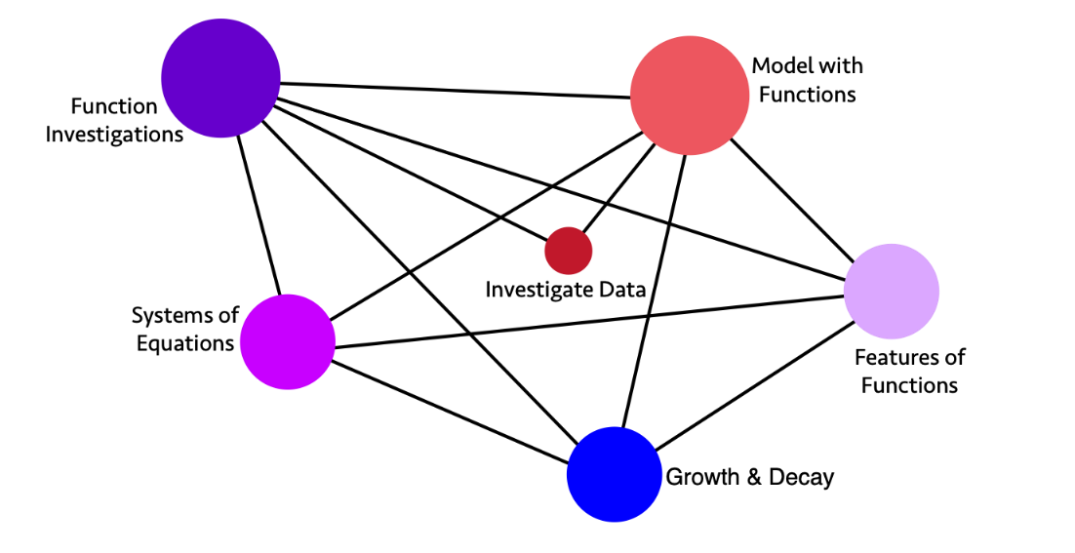
Long description of figure 8.5
Figure 8.6 below illustrates the relationships between Content Connections and Big Ideas for Algebra I and shows which content standards best lend themselves to each big idea. Figure 8.7 that follows includes examples of how teachers might integrate the SMPs into their Algebra I instruction.
Figure 8.6 High School Algebra I Big Ideas, Content Connections, and Content Standards
Big Ideas | Content Connection | Algebra I Content Standards
Investigate Data | Reasoning with Data  and  Discovering Shape and Space | S-ID.1, S-ID.2, S-ID.3, S-ID.6: Represent data from two or more data sets with plots, dot plots, histograms, and box plots, comparing and analyzing the center and spread, using technology, and interpreting the results. Interpret and compare data distributions using center (median, mean) and spread (interquartile range, standard deviation) through the use of technology.  - Students have opportunities to explore and research a topic of interest and meaning to them, using the statistical methods, tools, and representations.  - Have students consider how different, competing interpretations can be made from different audiences, histories, and perspectives.  - Allow students to develop follow-up questions to investigate, spurred by the original data set.
Model with Functions | Reasoning with Data  and  Discovering Shape and Space | F-IF.1, F-IF.2, F-IF.4, F-IF.5, F-IF.6, F-IF.7, F-IF.8, F-IF.9, F-BF.1, F-BF.2, F-BF.4, F-LE.1, F-LE.2, S-ID.5, S-ID.6, S-ID.7, S-ID.8, S-ID.9: Investigate data sets by table and graph and using technology; fit and interpret functions** to model the data between two quantities. Interpret information from the functions, noticing key features* and symmetries. Develop understanding of the meaning of the function and how it represents the data that it is modeling; recognizing possible associations and trends in the data - including consideration of the correlation coefficients of linear models.  - Students can disaggregate data by different characteristics of interest (populations for example), and compare slopes to examine questions of fairness and bias among groups.  - Students have opportunities to consider how to communicate relevant concerns to stakeholders and/or community members.  - Students can identify both extreme values (true outliers) and data errors, and how the inclusion or exclusion of these observations may change the function that would most appropriately model the data.  *intercepts, slope, increasing or decreasing, positive or negative  ** functions include linear, quadratic and exponential
Systems of Equations | Exploring Changing Quantities | A-REI.1, A-REI.3, A-REI.4, A-REI.5, A-REI.6, A-REI.7, A-REI.10, A-REI.11, A-REI.12, NQ.1, A-SSE.1, F-LE.1, F-LE.2: Students investigate real situations that include data for which systems of 1 or 2 equations or inequalities are helpful, paying attention to units. Investigations include linear, quadratic, and absolute value. Students use technology tools strategically to find their solutions and approximate solutions, constructing viable arguments, interpreting the meaning of the results, and communicating them in multidimensional ways.
Function investigations | Exploring Changing Quantities | F-IF.1, F-IF.2, F-IF.4, F-IF.5, F-IF.6, F-IF.7, F-IF.8, F-IF.9, F-BF.1, F-BF.2, F-BF.4, S-ID.5, S-ID.6, S-ID.7, S-ID.8, S-ID.9, F-LE.1, F-LE.2: Students investigate data sets by table and graph and using technology; such as earthquake data in the region of the school; they fit and interpret functions to model the data between two quantities and consider the meaning of inverse relationships. Students interpret information from the functions, noticing key features* and symmetries. Students develop understanding of the meaning of the function and how it represents the data that it is modeling; they recognize possible associations and trends in the data - including consideration of the correlation coefficients of linear models.  *one to one correspondence, intercepts, slope, increasing or decreasing, positive or negative
Features of Functions | Exploring Changing Quantities | A-SSE.3, F-IF.3, F-IF.4, F-LE.1, F-LE.2, F-LE.6: Students investigate changing situations that are modeled by quadratic and exponential forms of expressions and create equivalent expressions to reveal features* that help understand the meaning of the problem and situation being investigated. (driver of investigation 1, making sense of the world)  Investigate patterns, such as the Fibonacci sequence and other mathematical patterns, that reveal recursive functions.  *Factored form to reveal zeros of a quadratic function, standard form to reveal the y-intercept, vertex form to reveal a maximum or minimum.
Growth and Decay | Taking Wholes Apart, Putting Parts Together | F-LE.1, F-LE.2, F-LE.3, F-LE.5, F-LE.6, F-BF.1, F-BF.2, F-BF.3, F-BF.4, F-IF.4, F-IF.5, F-IF.9, NQ.1, A-SSE.1: Investigate situations that involve linear, quadratic, and exponential models, and use these models to solve problems. Recognize linear functions grow by equal differences over equal intervals; exponential functions grow by equal factors over equal intervals, and functions grow or decay by a percentage rate per unit interval. Interpret the inverse of functions, and model the inverse in graphs, tables, and equations.
Figure 8.7 Standards for Mathematical Practice—Explanation and Examples for Algebra I
Standards for Mathematical Practice  Students… | Examples of each practice in Algebra I
SMP.1  Make sense of problems and persevere in solving them. | Students learn that patience is often required to fully understand what a problem is asking. They discern between what information is useful, and what is not. They expand their repertoire of expressions and functions that can used to solve problems.
SMP.2  Reason abstractly and quantitatively. | Students extend their understanding of slope as the rate of change of a linear function to understanding that the average rate of change of any function can be computed over an appropriate interval.
SMP.3  Construct viable arguments and critique the reasoning of others. | Students reason through the solving of equations, recognizing that solving an equation is more than simply a matter of rote rules and steps. They use language such as “if… then...” when explaining their solution methods and provide justification.
SMP.4  Model with mathematics. | Students also discover mathematics through experimentation and examining patterns in data from real world contexts. Students apply their new mathematical understanding of exponential, linear and quadratic functions to real-world problems.
SMP.5  Use appropriate tools strategically. | Students develop a general understanding of the graph of an equation or function as a representation of that object, and they use tools such as graphing calculators or graphing software to create graphs in more complex examples, understanding how to interpret the result. They construct diagrams to solve problems.
SMP.6  Attend to precision. | Students begin to understand that a rational number has a specific definition, and that irrational numbers exist. They make use of the definition of function when deciding if an equation can describe a function by asking, “Does every input value have exactly one output value?”
SMP.7  Look for and make use of structure. | Students develop formulas such as ${\left(a±b\right)}^{2}=a^{2}±2ab+b^{2}$ by applying the distributive property. Students see that the expression $5+{\left(x-2\right)}^{2}$ takes the form of “5 plus ‘something’ squared,” and so that expression can be no smaller than 5.
SMP.8  Look for and express regularity in repeated reasoning. | Students see that the key feature of a line in the plane is an equal difference in outputs over equal intervals of inputs, and that the result of evaluating the expression $\frac{y_{2}-y_{1}}{x_{2}-x_{1}}$ for points on the line is always equal to a certain number $m$. Therefore, if (x, y) is a generic point on this line, the equation $\left(y-y_{1}\right)=m\left(x-x_{1}\right)$ or $y=mx+\left(y_{1}-mx_{1}\right)$ will give a general equation of that line.

What Students Learn in Algebra I
The standards in the Algebra I course come from the conceptual categories of Modeling, Functions, Number and Quantity, Algebra, and Statistics and Probability. In Algebra I, students use reasoning about structure to define and make sense of rational exponents and explore the algebraic structure of the rational and real number systems. They understand that numbers in real-world applications often have units attached to them—that is, the numbers are considered quantities.
Students’ work with numbers and operations throughout elementary and middle school leads them to an understanding of the structure of the number system; in Algebra I, students explore the structure of algebraic expressions and polynomials. They see that certain properties must persist when they work with expressions that are meant to represent numbers—which they now write in an abstract form involving variables. When two expressions with overlapping domains are set as equal to each other, resulting in an equation, there is an implied solution set (be it empty or non-empty), and students not only refine their techniques for solving equations and finding the solution set, but they can clearly explain the algebraic steps they used to do so.
Students began their exploration of linear equations in middle school, first by connecting proportional equations to graphs, tables, and real-world contexts, and then moving toward an understanding of general linear equations $y=mx+b$, $m≠0$ and their graphs. In Algebra I, students extend this knowledge to work with absolute value equations, linear inequalities, and systems of linear equations. After learning a more precise definition of function in this course, students examine this new idea in the familiar context of linear equations—for example, by seeing the solution of a linear equation as solving for two linear functions.
Students continue to build their understanding of functions beyond linear types by investigating tables, graphs, and equations that build on previous understandings of numbers and expressions. They make connections between different representations of the same function. They also learn to build functions in a modeling context and solve problems related to the resulting functions. Note that in Algebra I the focus is on linear, simple exponential, and quadratic equations.
Finally, students extend their prior experiences with data, using more formal means of assessing how a model fits data. Students use regression techniques to describe approximately linear relationships between quantities. They use graphical representations and knowledge of the context to make judgments about the appropriateness of linear models. With linear models, students look at residuals to analyze the goodness of fit.

Geometry
The fundamental purpose of the geometry course is to introduce students to formal geometric proofs and the study of plane figures, culminating in the study of right-triangle trigonometry and circles. Students begin to formally prove results about the geometry of the plane by using previously defined terms and notions. Similarity is explored in greater detail, with an emphasis on discovering trigonometric relationships and solving problems with right triangles. The correspondence between the plane and the Cartesian coordinate system is explored when students connect algebra concepts with geometry concepts. Students explore probability concepts and use probability in real-world situations. The major mathematical ideas in the geometry course include geometric transformations, proving geometric theorems, congruence and similarity, analytic geometry, right-triangle trigonometry, and probability. Producing a proof should not be seen as a way to meet abstract requirements regarding the ways that mathematical claims should be presented, but rather as the end product of reasoning and sensemaking, organized and presented in ways that make it easier to convey the resulting understandings.
Figure 8.8 Big Ideas Map for Geometry
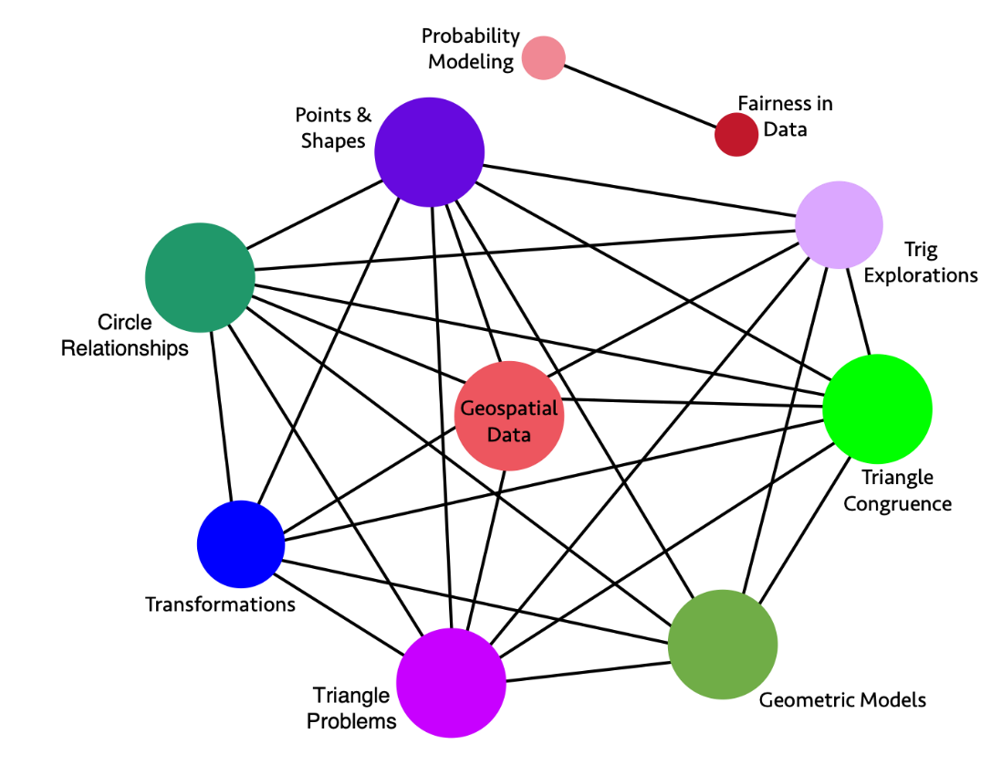
Long description for figure 8.8
Figure 8.9 High School Geometry Big Ideas, Content Connections, and Content Standards
Big Idea | Content Connection | Geometry Content Standards
Probability Modeling | Reasoning with Data | S-CP.1, S-CP.2, S-CP.3, S-CP.4, S-CP.5, S-IC.1, S-IC.2, S-IC.3, S-MD.6, S-MD.7: Explore and compare independent and conditional probabilities, interpreting the output in terms of the model. Construct and interpret two-way frequency tables of data as a sample space to determine if the events are independent and use the data to approximate conditional probabilities. Examples of topics include product and medical testing, and player statistics in sports.
Fairness in Data | Reasoning with Data | S-MD.6, S-MD.7: Determine fairness and make decisions based on evaluation of outcomes. Allow students to explore fairness by researching topics of interest, analyzing data from two-way tables. Provide opportunities for students to make meaningful inference, and communicate their findings to community or other stakeholders.
Geospatial Data | Reasoning with Data | G-MG.1, G-MG.2, G-MG.3, F-LE.6, G-GPE.4, G-GPE.6, G-SRT.5, G-CO.1, G-CO.2, G-CO.12, G-C.2, G-C.5: Explore geospatial data that represent either locations (e.g., maps) or objects (e.g., patterns of people’s faces, road objects for driverless cars), and connect to geometric equations and properties of common shapes. Demonstrate how a computer can measure the distance between two points using geometry, and then account for constraints (e.g., distance and then roads for directions) and multiple points with triangulation. Model what shapes and geometric relationships are most appropriate for different situations.
Trig Explorations | Exploring Changing Quantities | G-SRT.1, G-SRT.2, G-SRT.3, G-SRT.5, G-SRT.9, G-SRT.10, G-SRT.11, G-GPE.7. G-C.2, G-C.4: Investigate properties of right triangle similarity and congruence and the relationships between sine, cosine, and tangent; explore the relationship between sine and cosine of complementary angles, and apply that knowledge to problem solving situations. Students recognize the role similarity plays in establishing trigonometric functions, and they use trigonometric functions to investigate situations. Using dynamic geometric software students investigate similarity and trigonometric identities to derive the Laws of Sines and Cosines and use the laws to solve problems.
Triangle Problems | Exploring Changing Quantities | G-SRT.4, G-SRT.5, G-SRT.6, G-SRT.8, G-C.2, G-C.4, G-CO.12: Understand and use congruence and similarity when solving problems involving triangles, including trigonometric ratios. Use trigonometric ratios and the Pythagorean Theorem to solve right triangles in applied problems using dynamic geometric software.
Points and Shapes | Exploring Changing Quantities | G-GPE.1, G-GPE.2, G-GPE.4, G-GPE.5, G-GPE.6, G-GPE.7, G-CO.1, G-CO.12, G-C.2, G-C.4: Solve problems involving geometric shapes in the coordinate plane using dynamic geometric software to apply the distance formula, Pythagorean Theorem, slope, and similarity rules in solving problems.  - Investigate equations of circles and how coefficients in the equations correspond to the location and radius of the circles.  Find areas and perimeters of triangles and rectangles in the coordinate plane.
Transformations | Taking Wholes Apart, Putting Parts Together  and  Discovering Shape and Space | G-CO.1, G-CO.3, G-CO.4, G-CO.5, G-CO.12: Understand rotations, reflections, and translations of regular polygons, quadrilaterals, angels, circles, and line segments. Identify transformations, through investigation, that move a figure back onto itself, using that process to prove congruence.
Triangle Congruence | Discovering Shape and Space  and  Exploring Changing Quantities  and  Taking Wholes Apart, Putting Parts Together | G-CO.1, G-CO.2, G-CO.7, G-CO.8, G-CO.9, G-CO.10, G-CO.11, G-CO.12, G-CO.13, G-SRT.5: Investigate triangles and their congruence over rigid transformations verifying findings using triangle congruence theorems (ASA, SSS, SAS, AAS, and HL) and other geometric properties, including vertical angles, angles created by transversals across parallel lines, and bisectors.
Circle Relationships | Exploring Changing Quantities  and  Discovering Shape and Space | G-C.1, G-C.2, G-C.3, G-C.4, G-CO.1, G-CO.12, G-CO.13, G-GPE.1: Investigate similarity in circles and relationships between angle measures and segments, including inscribed angles, radii, chords, central angles, inscribed angles, circumscribed angles, and tangent lines using dynamic geometric software.
Geometric Models | Discovering Shape and Space | G-GMD.1, G-GMD.3, G-GMD.4, G-GMD.5, G-MG.1, G-MG.2, G-MG.3, G-SRT.5, G-CO.12, G-C.2, G-C.4: Apply geometric concepts in modeling situations to solve design problems using dynamic geometric software.  - Investigate 3-D shapes and their cross sections.  - Use volume, area, circumference, and perimeter formulas.  - Understand and apply Cavalieri’s principle.  - Investigate and apply scale factors for length, area, and volume.
Figure 8.10 Standards for Mathematical Practice—Explanation and Examples for Geometry
Standards for Mathematical Practice  Students… | Examples of each practice in Geometry
SMP.1  Make sense of problems and persevere in solving them. | Students construct accurate diagrams of geometry problems to help make sense of them. They organize their work so that others can follow their reasoning, e.g., in proofs.
SMP.2  Reason abstractly and quantitatively. | Students understand that the coordinate plane can be used to represent geometric shapes and transformations and therefore connect their understanding of number and algebra to geometry.
SMP.3  Construct viable arguments and critique the reasoning of others. | Students construct proofs of geometric theorems. They write coherent logical arguments and understand that each step in a proof must follow from the last, justified with a previously accepted or proven result.
SMP.4  Model with mathematics. | Students apply their new mathematical understanding to real-world problems. They learn how transformational geometry and trigonometry can be used to model the physical world.
SMP.5  Use appropriate tools strategically. | Students make use of visual tools for representing geometry, such as simple patty paper or transparencies, or dynamic geometry software.
SMP.6  Attend to precision. | Students develop and use precise definitions of geometric terms. They verify that a specific shape has certain properties justifying its categorization (e.g., a rhombus as opposed to a quadrilateral).
SMP.7  Look for and make use of structure. | Students construct triangles in quadrilaterals or other shapes and use congruence criteria of triangles to justify results about those shapes.
SMP.8  Look for and express regularity in repeated reasoning. | Students explore rotations, reflections and translations, noticing that certain attributes of different shapes remain the same (e.g., parallelism, congruency, orientation) and develop properties of transformations by generalizing these observations.

What Students Learn in Geometry
The standards in the traditional geometry course come from the conceptual categories Modeling, Geometry, and Statistics and Probability. Although there are many types of geometry, school mathematics is devoted primarily to plane Euclidean geometry, studied both synthetically (without coordinates) and analytically (with coordinates). In the higher mathematics courses, students begin to formalize their geometry experiences from elementary and middle school, using definitions that are more precise and developing careful proofs. The standards for grades seven and eight call for students to see two-dimensional shapes as part of a generic plane (i.e., the Euclidean plane) and to explore transformations of this plane as a way to determine whether two shapes are congruent or similar, as illustrated below:
Figure 8.11 Geometric Transformations
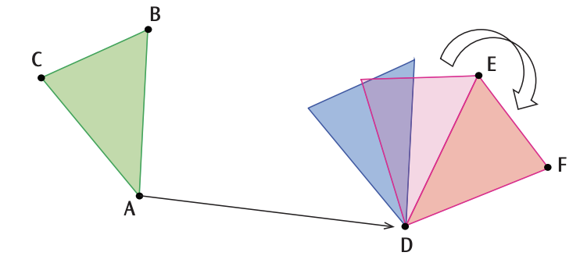
Long description of figure 8.11
These concepts are formalized in the geometry course, and students use transformations to prove geometric theorems. The definition of congruence in terms of rigid motions provides a broad understanding of this means of proof, and students explore the consequences of this definition in terms of congruence criteria and proofs of geometric theorems.
Students investigate triangles and decide when they are similar—and with this newfound knowledge and their prior understanding of proportional relationships, they define trigonometric ratios and solve problems by using right triangles. They investigate circles and prove theorems about them. Connecting to their prior experience with the coordinate plane, they prove geometric theorems by using coordinates and describe shapes with equations. Students extend their knowledge of area and volume formulas to those for circles, cylinders, and other rounded shapes. Finally, continuing the development of statistics and probability, students investigate probability concepts in precise terms, including the independence of events and conditional probability.

Algebra II
Algebra II course extends students’ understanding of functions and real numbers and increases the tools students have for modeling the real world. Students in Algebra II extend their notion of number to include complex numbers and see how the introduction of this set of numbers yields the solutions of polynomial equations and the Fundamental Theorem of Algebra. Students deepen their understanding of the concept of function and apply equation-solving and function concepts to many different types of functions. The system of polynomial functions, analogous to integers, is extended to the field of rational functions, which is analogous to rational numbers. Students explore the relationship between exponential functions and their inverses, the logarithmic functions. Trigonometric functions are extended to all real numbers and their graphs and properties are studied. Finally, students’ knowledge of statistics is extended to include understanding the normal distribution and students are challenged to make inferences based on sampling, experiments, and observational studies.
Figure 8.12 Standards for Mathematical Practice—Explanation and Examples for Algebra II
Standards for Mathematical Practice  Students… | Examples of each practice in Algebra II
SMP.1  Make sense of problems and persevere in solving them. | Students apply their understanding of various functions to real-world problems. They approach complex mathematics problems and break them down into smaller-sized chunks and synthesize the results when presenting solutions.
SMP.2  Reason abstractly and quantitatively. | Students deepen their understanding of variable, for example, by understanding that changing the values of the parameters in the expression $A\sin\left(Bx+ C\right)+D$ has consequences for the graph of the function. They interpret these parameters in a real-world context.
SMP.3  Construct viable arguments and critique the reasoning of others. | Students continue to reason through the solution of an equation and justify their reasoning to their peers. Students defend their choice of a function to model a real-world situation.
SMP.4  Model with mathematics. | Students apply their new mathematical understanding to real-world problems, making use of their expanding repertoire of functions in modeling. Students also discover mathematics through experimentation and examining patterns in data from real world contexts.
SMP.5  Use appropriate tools strategically. | Students continue to use graphing technology to deepen their understanding of the behavior of polynomial, rational, square root, and trigonometric functions.
SMP.6  Attend to precision. | Students make note of the precise definition of complex number, understanding that real numbers are a subset of the complex numbers. They pay attention to units in real-world problems and use unit analysis as a method for verifying their answers.
SMP.7  Look for and make use of structure. | Students see the operations of the complex numbers as extensions of the operations for real numbers. They understand the periodicity of sine and cosine and use these functions to model periodic phenomena.
SMP.8  Look for and express regularity in repeated reasoning. | Students observe patterns in geometric sums, e.g., that the first several sums of the form $\sum_{k=0}^{n}{2^{k}}$ can be written:  $1=2^{1}-1$;  $1+2=2^{2}-1$;  $1+2+4=2^{3}-1$;  $$1+2+4+8=2^{4}-1$$  and use this observation to make a conjecture about any such sum.

What Students Learn in Algebra II
The standards in the Algebra II course come from the conceptual categories of Modeling, Functions, Number and Quantity, Algebra, and Statistics and Probability. Building on their work with linear, quadratic, and exponential functions, students in Algebra II extend their repertoire of functions to include polynomial, rational, and radical functions.
Students work closely with the expressions that define the functions and continue to expand and hone their abilities to model situations and to solve equations, including solving quadratic equations over the set of complex numbers and solving exponential equations using the properties of logarithms. Based on their previous work with functions, and on their work with trigonometric ratios and circles in geometry, students now use the coordinate plane to extend trigonometry to model periodic phenomena. They explore the effects of transformations on graphs of diverse functions, including functions arising in applications, in order to abstract the general principle that transformations on a graph always have the same effect regardless of the type of underlying function. They identify appropriate types of functions to model a situation, adjust parameters to improve the model, and compare models by analyzing appropriateness of fit and making judgments about the domain over which a model is a good fit.

The Integrated Mathematics Pathway
Many schools and districts in California have implemented a conceptually integrated mathematics pathway according to the course outlines in the CA CCSSM. The courses in the Integrated pathway follow the structure introduced in the kindergarten through grade eight levels of the CA CCSSM; they present mathematics as a coherent subject and blend standards from different conceptual categories. In recognition of this investment, this framework continues to support these pathways, as the field strives to develop truly integrated approaches (in the sense of the definition of integration, as described earlier in the chapter) to the teaching and learning of higher mathematics content. The standards for the Integrated pathway, delineated across the three Mathematics I, II, and III courses, begin on page 85 of the CA CCSSM (CDE, 2013). These courses are described below.

Mathematics I
The fundamental purpose of the Mathematics I course is to formalize and extend students’ understanding of linear functions and their applications. The critical topics of study deepen and extend understanding of linear relationships—in part, by contrasting them with exponential phenomena and, in part, by applying linear models to data that exhibit a linear trend. Mathematics I uses properties and theorems involving congruent figures to deepen and extend geometric knowledge gained in prior grade levels.
Figure 8.13 Big Ideas Map for Mathematics I
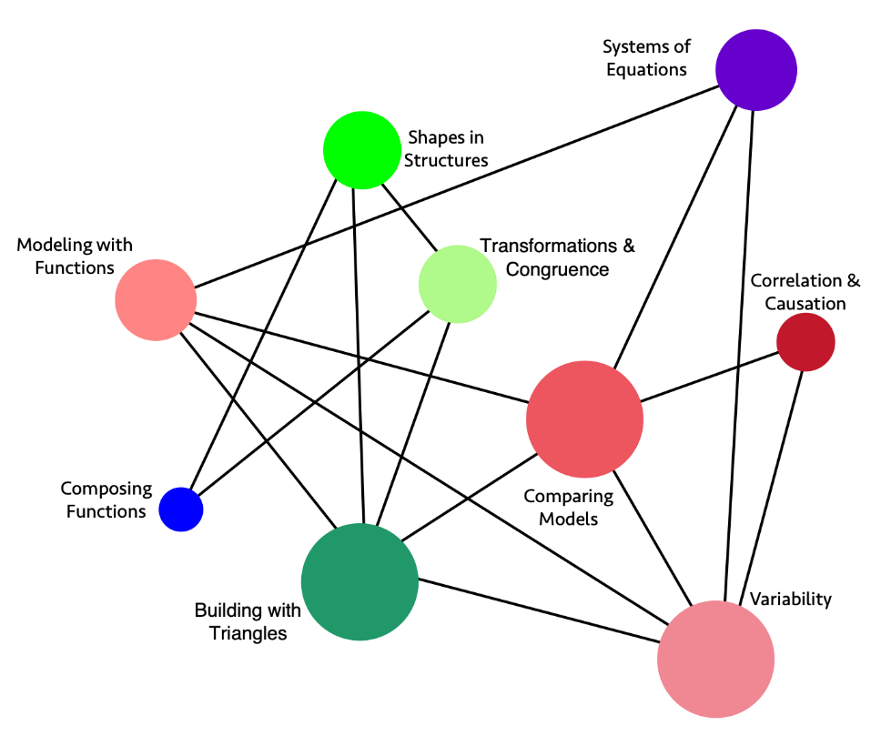
Long description of figure 8.13
Figure 8.14 High School Mathematics I Big Ideas, Content Connections, and Content Standards
Big Ideas | Content Connection | Mathematics I Content Standards
Modeling with Functions | Reasoning with Data  and  Exploring Changing Quantities | N-Q.1, N-Q.2, N-Q.3, A-CED.2, F-BF.1, F-IF.1, F-IF.2, F-IF.4, F-LE.5, S-ID.7, A-CED.1, A-CED.2, A-CED.3, A-SSE.1: Build functions that model relationships between two quantities, including examples with inequalities; using units and different representations. Describe and interpret the relationships modeled using visuals, tables, and graphs.
Comparing Models | Reasoning with Data  and  Exploring Changing Quantities | F-LE.1, F-LE.2, F-LE.3, F-IF.4, F-BF.1, F-LE.5, S-ID.7, S-ID.8, A-CED.1, A-CED.2, A-CED.3, A-SSE.1: Construct, interpret, and compare linear, quadratic, and exponential models of real data, and use them to describe and interpret the relationships between two variables, including inequalities. Interpret the slope and constant terms of linear models, and use technology to compute and interpret the correlation coefficient of a linear fit.
Variability | Reasoning with Data  and  Exploring Changing Quantities | S-ID.5, S-ID.6, S-ID.7, S-ID.1, S-ID.2, S-ID.3, A-SSE.1: Summarize, represent, and interpret data. For quantitative data, use a scatter plot and describe how the variables are related. Summarize categorical data in two-way frequency tables and interpret the relative frequencies.
Correlation and Causation | Reasoning with Data | S-ID.9, S-ID.8, S-ID.7: Explore data that highlights the difference between correlation and causation. Understand and use correlation coefficients, where appropriate. (See resource section for classroom examples).
Systems of Equations | Exploring Changing Quantities  and  Taking Wholes Apart, Putting Parts Together | A-REI.1, A-REI.3, A-REI.5, A-REI.6, A-REI.10, A-REI.11, A-REI.12, NQ.1, A-SSE.1: Students investigate real situations that include data for which systems of 1 or 2 equations or inequalities are helpful, paying attention to units. Investigations include linear, quadratic, and absolute value. Students use technology tools strategically to find their solutions and approximate solutions, constructing viable arguments, interpreting the meaning of the results, and communicating them in multidimensional ways.
Composing Functions | Taking Wholes Apart, Putting Parts Together | F-BF.3, F-BF.2, F-IF.3: Build and explore new functions that are made from existing functions, and explore graphs of the related functions using technology. Recognize sequences are functions and are sometimes defined recursively.
Shapes in Structures | Taking Wholes Apart, Putting Parts Together  and  Discovering Shape and Space | G-CO.6, C-CO.7, C-CO.8, G-GPE.4, G-GPE.5, G.GPE.7, F.BF.3: Perform investigations that involve building triangles and quadrilaterals, considering how the rigidity of triangles and non-rigidity of quadrilaterals influences the design of structures and devices. Study the changes in coordinates and express the changes algebraically.
Building with Triangles | Taking Wholes Apart, Putting Parts Together  and  Discovering Shape and Space | G-GPE.4, G-GPE.5, GPE.7, F-LE.1, F-LE.2, A-CED.2: Investigate with geometric figures, constructing figures in the plane, relating the distance formula to the Pythagorean Theorem, noticing how areas and perimeters of polygons change as the coordinates change. Build with triangles and quadrilaterals, noticing positions and movement, and creating equations that model the changing edges using technology.
Transformations and Congruence | Discovering Shape and Space | G-CO.1, G-CO.2, G-CO.3, G-CO.4, G-CO.5, G-CO.12, G-CO.13, G-GPE.4, G-GPE.5, G.GPE.7, F-BF.3: Explore congruence of triangles, including quadrilaterals built from triangles, through geometric constructions. Investigate transformations in the plane. Use geometry software to study transformations, developing definitions of rotations, reflections, and translations in terms of angles, circles, perpendicular lines, and parallel lines. Express translations algebraically.
Figure 8.15 Standards for Mathematical Practice—Explanation and Examples for Mathematics I
Standards for Mathematical Practice  Students… | Examples of each practice in Mathematics I
SMP.1  Make sense of problems and persevere in solving them. | Students persevere when attempting to understand the differences between linear and exponential functions. They make diagrams of geometric problems to help make sense of the problems.
SMP.2  Reason abstractly and quantitatively. | Quantitative reasoning entails habits of creating a coherent representation of the problem at hand; considering the units involved; attending to the meaning of quantities, not just how to compute them; and knowing and flexibly using different properties of operations and objects.
SMP.3  Construct viable arguments and critique the reasoning of others. | Students reason through the solving of equations, recognizing that solving an equation involves more than simply following rote rules and steps. They use language such as “If …, then …” when explaining their solution methods and provide justification for their reasoning.
SMP.4  Model with mathematics. | Students apply their mathematical understanding of linear and exponential functions to many real-world problems, such as linear and exponential growth. Students also discover mathematics through experimentation and by examining patterns in data from real-world contexts.
SMP.5  Use appropriate tools strategically. | Students develop a general understanding of the graph of an equation or function as a representation of that object, and they use tools such as graphing calculators or graphing software to create graphs in more complex examples, understanding how to interpret the results.
SMP.6  Attend to precision. | Students use clear definitions in discussion with others and in their own reasoning. They state the meaning of the symbols they choose, including using the equal sign consistently and appropriately. They are careful about specifying units of measure and labeling axes to clarify the correspondence with quantities in a problem.
SMP.7  Look for and make use of structure. | Students recognize the significance of an existing line in a geometric figure and can use the strategy of drawing an auxiliary line for solving problems. They also can step back for an overview and shift perspective. They can see complicated things, such as some algebraic expressions, as single objects or as being composed of several objects.
SMP.8  Look for and express regularity in repeated reasoning. | Students see that the key feature of a line in the plane is an equal difference in outputs over equal intervals of inputs, and that the result of evaluating the expression $\frac{y_{2}-y_{1}}{x_{2}-x_{1}}$ for points on the line is always equal to a certain number m. Therefore, if (x, y) is a generic point on this line, the equation $\left(y-y_{1}\right)=m\left(x-x_{1}\right)$ or $y=mx+\left(y_{1}-mx_{1}\right)$ will give a general equation of that line.

What Students Learn in Mathematics I
The standards in the integrated Mathematics I course come from the conceptual categories of Modeling, Functions, Number and Quantity, Algebra, Geometry, and Statistics and Probability. Students in Mathematics I continue their work with expressions and modeling and analysis of situations. In previous grade levels, students informally defined, evaluated, and compared functions, using them to model relationships between quantities. In Mathematics I, students learn function notation and develop the concepts of domain and range. Students move beyond viewing functions as processes that take inputs and yield outputs and begin to view functions as objects that can be combined with operations (e.g., finding). They explore many examples of functions, including sequences. They interpret functions that are represented graphically, numerically, symbolically, and verbally, translating between representations and understanding the limitations of various representations. They work with functions given by graphs and tables, keeping in mind that these representations are likely to be approximate and incomplete, depending upon the context. Students’ work includes functions that can be described or approximated by formulas, as well as those that cannot. When functions describe relationships between quantities arising from a context, students reason with the units in which those quantities are measured. Students build on and informally extend their understanding of integer exponents to consider exponential functions. They compare and contrast linear and exponential functions, distinguishing between additive and multiplicative change. They also interpret arithmetic sequences as linear functions and geometric sequences as exponential functions.
Students who are prepared for Mathematics I have learned to solve linear equations in one variable and have applied graphical and algebraic methods to analyze and solve systems of linear equations in two variables. Mathematics I builds on these earlier experiences by asking students to analyze and explain the process of solving an equation and to justify the process used in solving a system of equations. Students develop fluency in writing, interpreting, and translating between various forms of linear equations and inequalities and using them to solve problems. They master solving linear equations and apply related solution techniques and the laws of exponents to the creation and solving of simple exponential equations. Students explore systems of equations and inequalities, finding and interpreting solutions. All of this work is based on understanding quantities and the relationships between them.
In Mathematics I, students build on their prior experiences with data, developing more formal means of assessing how a model fits data. Students use regression techniques to describe approximately linear relationships between quantities. They use graphical representations and knowledge of the context to make judgments about the appropriateness of linear models. With linear models, they look at residuals to analyze the goodness of fit.
At previous grade levels, students were asked to draw triangles based on given measurements. They also gained experience with rigid motions (translations, reflections, and rotations) and developed notions about what it means for two objects to be congruent. In Mathematics I, students establish triangle congruence criteria based on analyses of rigid motions and physical constructions. They solve problems about triangles, quadrilaterals, and other polygons. They apply reasoning to complete geometric constructions and explain why the constructions work. Finally, building on their work with the Pythagorean Theorem in the grade-eight standards to find distances, students use a rectangular coordinate system to verify geometric relationships, including properties of special triangles and quadrilaterals and slopes of parallel and perpendicular lines.

Mathematics II
The Mathematics II course focuses on quadratic expressions, equations, and functions and on comparing the characteristics and behavior of these expressions, equations, and functions to those of linear and exponential relationships from Mathematics I. The need for extending the set of rational numbers arises, and students are introduced to real and complex numbers. Links between probability and data are explored through conditional probability and counting methods and involve the use of probability and data in making and evaluating decisions.
The study of similarity leads to an understanding of right-triangle trigonometry and connects to quadratics through Pythagorean relationships. Circles, with their quadratic algebraic representations, finish out the course.
Figure 8.16 Big Ideas Map for Mathematics II
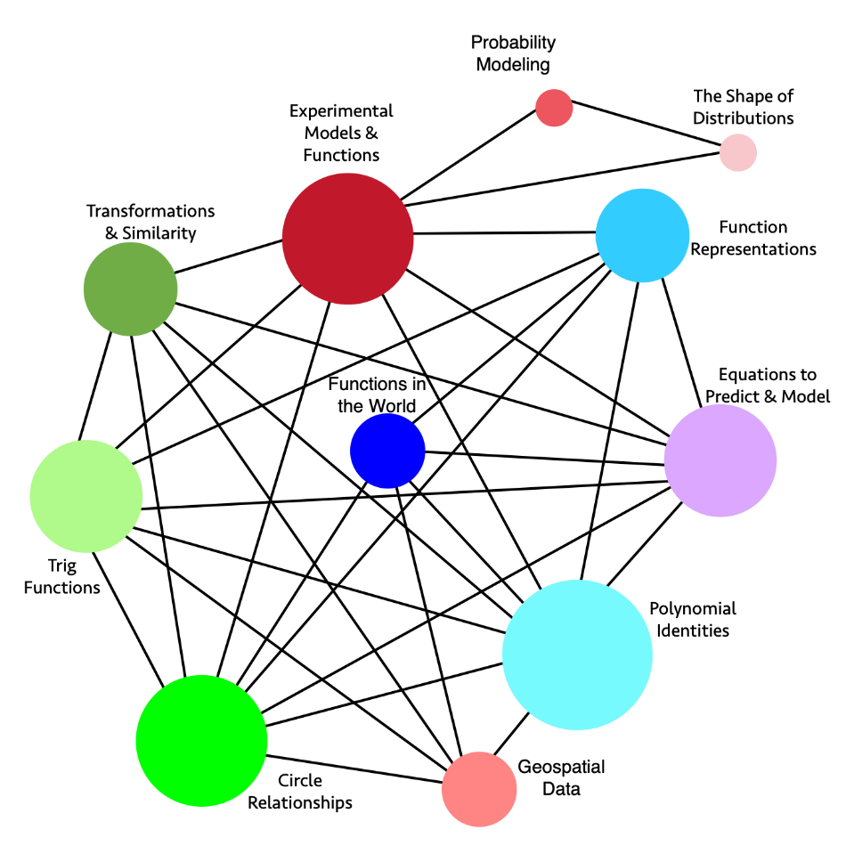
Long description of figure 8.16
Figure 8.17 High School Mathematics II Big Ideas, Content Connections, and Content Standards
Big Idea | Content Connection | Mathematics II Content Standards
Probability Modeling | Reasoning with Data | S.CP.1, S.CP.2, S.CP.3, S.CP.4, S.CP.5, S-IC.1, S-IC.2, S-IC.3, S.MD.6, S.MD.7: Explore and compare independent and conditional probabilities, interpreting the output in terms of the model. Construct and interpret two-way frequency tables of data as a sample space to determine if the events are independent, and use the data to approximate conditional probabilities. Examples of topics include product and medical testing, and player statistics in sports.
The shape of distributions | Reasoning with Data | S-IC.1, S-IC.2, S-IC.3, S-ID.1, S-ID.2, S-ID.3, S-MD.1, S-MD.2: Consider the shape of data distributions to decide on ways to compare the center and spread of data. Use simulation models to generate data, and decide if the model produces consistent results.
Experimental Models and Functions | Reasoning with Data  and  Exploring Changing Quantities | S-ID.1, S-ID.2, S-ID.3, S- ID.6, S-ID.7, S-IC.1, S-IC.2, S-IC.3, A-CED.1, A-REI.1, A-REI.4, F-IF.2, F-IF.3, F-IF.4, F-BF.1, F-LE.1, F-TF.2, A-APR.1: Conduct surveys, experiments, and observational studies - drawing conclusions and making inferences. Compare different data sources and what may be most appropriate for the situation. Create and interpret functions that describe the relationships, interpreting slope and the constant term when linear models are used. Include quadratic and exponential models when appropriate, and understand the meaning of outliers.
Geospatial Data | Reasoning with Data | G-MG.1, G-MG.2, G-MG.3, F-LE.6, G-GPE.4, G-GPE.6, G-SRT.5, G-CO.1, G-CO.2, G-CO.12, G-C.2, G-C.5: Explore geospatial data that represent either locations (e.g., maps) or objects (e.g., patterns of people’s faces, road objects for driverless cars) and connect to geometric equations and properties of common shapes. Demonstrate how a computer can measure the distance between two points using geometry and then account for constraints (e.g., distance and then roads for directions) and multiple points with triangulation. Model what shapes and geometric relationships are most appropriate for different situations.
Equations to Predict and Model | Exploring Changing Quantities | A-CED.1, A-CED.2, A-REI.4, A-REI.1, A-REI.2, A-REI.3, F.IF.4, F.IF.5, F.IF.6, F.BF.1, F.BF.3, A-APR.1: Model relationships that include creating equations or inequalities, including linear, quadratic, and absolute value. Use the equations or inequalities to make sense of the world or to make predictions, understanding that solving equations is a process of reasoning. Make sense of the real situation, using multiple representations, such as graphs, tables, and equations.
Functions in the World | Taking Wholes Apart, Putting Parts Together | F-LE.3, F-LE.6, F-IF.9, N-RN.1, N-RN.2, A-SSE.1, A-SSE.2:  Apply quadratic functions to the physical world, such as motion of an object under the force of gravity. Produce equivalent forms of the functions to reveal zeros, max and min, and intercepts. Investigate how functions increase and decrease, and compare the rates of increase or decrease to linear and exponential functions.
Polynomial Identities | Taking Wholes Apart, Putting Parts Together | A-SSE.1, A-SSE.2, A-APR.1, A-APR.3, A-APR.4, G-GMD.2, G-MG.1, S-IC.1, S-MD.2: Prove polynomial identities, and use them to describe numerical relationships, using a computer algebra system to rewrite polynomials. Use the binomial theorem to solve problems, appreciating the connections with Pascal’s triangle.
Functions Representations | Taking Wholes Apart, Putting Parts Together | F-IF.4, F-IF.5, F-IF.6, F-IF.7, F-IF.8, F-IF.9, N-RN.1, N-RN.2, F-LE.3, A-APR.1: Interpret functions representing real world applications in terms of the data understanding key features of graphs, tables, domain, and range. Compare properties of two functions each represented in different ways (algebraically, graphically, numerically, in tables or by written/verbal descriptions).
Transformations and Similarity | Discovering Shape and Space  and  Exploring Changing Quantities | G-SRT.1, G- SRT.2, G-SRT.3, A-CED.2, G-GPE.4, F-BF.3, F-IF.4, A-APR.1: Explore similarity and congruence in terms of transformations, noticing the changes dilations have on figures and the effect of scale factors. Discover how coordinates can be used to describe translations, rotations, and reflections, and generalize findings to model the transformations using algebra.
Circle Relationships | Discovering Shape and Space | G-C.1, G-C.2, G-C.3, G-C.4, G-C.5, G-GPE.1, A-REI.7, A-APR.1, F-IF.9: Investigate the relationships of angles, radii, and chords in circles, including triangles and quadrilaterals that are inscribed and circumscribed. Explore arc lengths and areas of sectors using the coordinate plane. Relate the Pythagorean Theorem to the equation of the circle given the center and radius, and solve simple systems where a line intersects the circle.
Trig Functions | Discovering Shape and Space | G-TF.2, G-GPE.1, G-GMD.2, G-MG.1, A-APR.1: Model periodic phenomena with trigonometric functions. Translate between geometric descriptions and the equation for a conic section. Visualize relationships between 2-D and 3-D objects.
Figure 8.18 Standards for Mathematical Practice—Explanation and Examples for Mathematics II
Standards for Mathematical Practice  Students… | Examples of each practice in Mathematics II
SMP.1  Make sense of problems and persevere in solving them. | Students persevere when attempting to understand the differences between quadratic functions and linear and exponential functions studied previously. They create diagrams of geometric problems to help make sense of the problems.
SMP.2  Reason abstractly and quantitatively. | Quantitative reasoning entails habits of creating a coherent representation of the problem at hand; considering the units involved; attending to the meaning of quantities, not just how to compute them; and knowing and flexibly using different properties of operations and objects.
SMP.3  Construct viable arguments and critique the reasoning of others. | Students construct proofs of geometric theorems based on congruence criteria of triangles. They understand and explain the definition of radian measure.
SMP.4  Model with mathematics. | Students apply their mathematical understanding of quadratic functions to real-world problems. Students also discover mathematics through experimentation and by examining patterns in data from real-world contexts.
SMP.5  Use appropriate tools strategically. | Students develop a general understanding of the graph of an equation or function as a representation of that object, and they use tools such as graphing calculators or graphing software to create graphs in more complex examples, understanding how to interpret the result.
SMP.6  Attend to precision. | Students begin to understand that a rational number has a specific definition and that irrational numbers exist. When deciding if an equation can describe a function, students make use of the definition of function by asking, “Does every input value have exactly one output value?”
SMP.7  Look for and make use of structure. | Students apply the distributive property to develop formulas such as ${\left(a±b\right)}^{2}=a^{2}±2ab+b^{2}$. They see that the expression $5+{\left(x-2\right)}^{2}$ takes the form of “5 plus ‘something’ squared,” and therefore that expression can be no smaller than 5.
SMP.8  Look for and express regularity in repeated reasoning. | Students apply the distributive property to develop formulas such as ${\left(a±b\right)}^{2}=a^{2}±2ab+b^{2}$. Students notice that consecutive numbers in the sequence of squares 1, 4, 9, 16, and 25 always differ by an odd number. They use polynomials to represent this interesting finding by expressing it as ${\left(n+1\right)}^{2}-n^{2}=2n+1$.

What Students Learn in Mathematics II
The standards in the integrated Mathematics II course come from the conceptual categories of Modeling, Functions, Number and Quantity, Algebra, Geometry, and Statistics and Probability. In Mathematics II, students extend the laws of exponents to rational exponents and explore distinctions between rational and irrational numbers by considering their decimal representations. Students learn that when quadratic equations do not have real solutions, the number system can be extended so that solutions exist, analogous to the way in which extending whole numbers to negative numbers allows $x+1=0$ to have a solution. Students explore relationships between number systems: whole numbers, integers, rational numbers, real numbers, and complex numbers. The guiding principle is that equations with no solutions in one number system may have solutions in a larger number system.
Students consider quadratic functions, comparing the key characteristics of quadratic functions to those of linear and exponential functions. They select from these functions to model phenomena. Students learn to anticipate the graph of a quadratic function by interpreting various forms of quadratic expressions. In particular, they identify the real solutions of a quadratic equation as the zeros of a related quadratic function. Students also learn that when quadratic equations do not have real solutions, the graph of the related quadratic function does not cross the horizontal axis. Additionally, students expand their experience with functions to include more specialized functions—absolute value, step, and other piecewise-defined functions.
Students in Mathematics II focus on the structure of expressions, writing equivalent expressions to clarify and reveal aspects of the quantities represented. Students create and solve equations, inequalities, and systems of equations involving exponential and quadratic expressions.
Building on probability concepts introduced in the middle grades, students use the language of set theory to expand their ability to compute and interpret theoretical and experimental probabilities for compound events, attending to mutually exclusive events, independent events, and conditional probability. Students use probability to make informed decisions, and they should make use of geometric probability models whenever possible.
Students apply their earlier experience with dilations and proportional reasoning to build a formal understanding of similarity. They identify criteria for similarity of triangles, use similarity to solve problems, and apply similarity in right triangles to understand right-triangle trigonometry, with particular attention to special right triangles and the Pythagorean Theorem. In Mathematics II, students develop facility with geometric proof. They use what they know about congruence and similarity to prove theorems involving lines, angles, triangles, and other polygons. They also explore a variety of formats for writing proofs.
In Mathematics II, students prove basic theorems about circles, chords, secants, tangents, and angle measures. In the Cartesian coordinate system, students use the distance formula to write the equation of a circle when given the radius and the coordinates of its center, and the equation of a parabola with a vertical axis when given an equation of its horizontal directrix and the coordinates of its focus. Given an equation of a circle, students draw the graph in the coordinate plane and apply techniques for solving quadratic equations to determine intersections between lines and circles, between lines and parabolas, and between two circles. Students develop informal arguments to justify common formulas for circumference, area, and volume of geometric objects, especially those related to circles.

Mathematics III
In the Mathematics III course, students expand their repertoire of functions to include polynomial, rational, and radical functions. They also expand their study of right-triangle trigonometry to include general triangles. And, finally, students bring together all of their experience with functions and geometry to create models and solve contextual problems.
Figure 8.19 Standards for Mathematical Practice—Explanation and Examples for Mathematics III
Standards for Mathematical Practice  Students… | Examples of each practice in Mathematics III
SMP.1  Make sense of problems and persevere in solving them. | Students apply their understanding of various functions to real-world problems. They approach complex mathematics problems and break them down into smaller problems, synthesizing the results when presenting solutions.
SMP.2  Reason abstractly and quantitatively. | Students deepen their understanding of variables—for example, by understanding that changing the values of the parameters in the expression has consequences for the graph of the function. They interpret these parameters in a real-world context.
SMP.3  Construct viable arguments and critique the reasoning of others. | Students continue to reason through the solution of an equation and justify their reasoning to their peers. Students defend their choice of a function when modeling a real-world situation.
SMP.4  Model with mathematics. | Students apply their new mathematical understanding to real-world problems, making use of their expanding repertoire of functions in modeling. Students also discover mathematics through experimentation and by examining patterns in data from real-world contexts.
SMP.5  Use appropriate tools strategically. | Students continue to use graphing technology to deepen their understanding of the behavior of polynomial, rational, square root, and trigonometric functions.
SMP.6  Attend to precision. | Students make note of the precise definition of complex number, understanding that real numbers are a subset of complex numbers. They pay attention to units in real-world problems and use unit analysis as a method for verifying their answers.
SMP.7  Look for and make use of structure. | Students understand polynomials and rational numbers as sets of mathematical objects that have particular operations and properties. They understand the periodicity of sine and cosine and use these functions to model periodic phenomena.
SMP.8  Look for and express regularity in repeated reasoning. | Students observe patterns in geometric sums, e.g., that the first several sums of the form $\sum_{k=0}^{n}{2^{k}}$ can be written:  $1=2^{1}-1$;  $1+2=2^{2}-1$;  $1+2+4=2^{3}-1$;  $$1+2+4+8=2^{4}-1$$  and use this observation to make a conjecture about any such sum.

What Students Learn in Mathematics III
The standards in the integrated Mathematics III course come from the conceptual categories of Modeling, Functions, Number and Quantity, Algebra, Geometry, and Statistics and Probability. In Mathematics III, students understand the structural similarities between the system of polynomials and the system of integers. Students draw on analogies between polynomial arithmetic and base-ten computation, focusing on properties of operations, particularly the distributive property. They connect multiplication of polynomials with multiplication of multi-digit integers and division of polynomials with long division of integers. Students identify zeros of polynomials and make connections between zeros of polynomials and solutions of polynomial equations. Their work on polynomial expressions culminates with the Fundamental Theorem of Algebra. Rational numbers extend the arithmetic of integers by allowing division by all numbers except 0. Similarly, rational expressions extend the arithmetic of polynomials by allowing division by all polynomials except the zero polynomial. A central theme of working with rational expressions is that the arithmetic of rational expressions is governed by the same rules as the arithmetic of rational numbers.
Students synthesize and generalize what they have learned about a variety of function families. They extend their work with exponential functions to include solving exponential equations with logarithms. They explore the effects of transformations on graphs of diverse functions, including functions arising in an application, in order to abstract the general principle that transformations on a graph always have the same effect, regardless of the type of the underlying functions.
Students develop the Laws of Sines and Cosines in order to find missing measures of general (not necessarily right) triangles. They are able to distinguish whether three given measures (angles or sides) define 0, 1, 2, or infinitely many triangles. This discussion of general triangles opens up the idea of trigonometry applied beyond the right triangle—that is, at least to obtuse angles. Students build on this idea to develop the notion of radian measure for angles and extend the domain of the trigonometric functions to all real numbers. They apply this knowledge to model simple periodic phenomena.
Students see how the visual displays and summary statistics they learned in previous grade levels or courses relate to different types of data and to probability distributions. They identify different ways of collecting data—including sample surveys, experiments, and simulations—and recognize the role that randomness and careful design play in the conclusions that may be drawn.
Finally, students in Mathematics III extend their understanding of modeling: they identify appropriate types of functions to model a situation, adjust parameters to improve the model, and compare models by analyzing appropriateness of fit and by making judgments about the domain over which a model is a good fit. The description of modeling as “the process of choosing and using mathematics and statistics to analyze empirical situations, to understand them better, and to make decisions” (National Governors Association Center for Best Practices, Council of Chief State School Officers [NGA/CCSSO], 2010) is one of the main themes of this course. The discussion about modeling and the diagram of the modeling cycle that appear in this chapter should be considered when students apply knowledge of functions, statistics, and geometry in a modeling context.

Conclusion
Recent findings from state, national, and international assessments reaffirm the need for students to attain high levels of mathematics understanding to prepare them for college and career. This chapter outlines a vision for high school mathematics curriculum and instruction that draws from approaches used by more academically successful nations and is consonant with what researchers are learning about effective practices for supporting mathematical understanding.
In this vision, lessons begin with authentic problems of interest to students. Students learn solution methods as they work to solve those intriguing problems, rather than learning facts and processes unconnected to real world application. Teachers’ instructional design incorporates the five components of equitable, engaging teaching: plan teaching around big ideas; use open, engaging tasks; teach toward social justice; invite student questions and conjectures; and center reasoning and justification. Teachers ensure that the math concepts being taught connect with each other within and across courses, as well as connecting with students’ lives and their perspectives on the world.
To ensure that the vision for mathematics classrooms connects across students’ high school course-taking experiences, this chapter has also outlined two potential pathways typically used in California high school coursework. Both pathways reflect a common ninth and tenth grade experience, with a broader array of options in eleventh and twelfth grades. The framework acknowledges that in most high schools the current course sequence means that students cannot reach Calculus in high school unless they have taken a high school algebra course or Mathematics I in middle school. But in light of studies showing that California’s past encouragement of middle school acceleration undermined success for many students, this framework proposes instead that school districts adjust the high school curriculum by eliminating redundancies in the content of current courses. Doing so would streamline the number of courses students would need to take before Calculus and remove the need for all students to take algebra in eighth grade to reach higher math levels by high school graduation.

Long Descriptions for Chapter 8

Figure 8.1 The Why, How, and What of Learning Mathematics
Drivers of Investigation  Why | Standards for Mathematical Practice  How | Content Connections  What
In order to…  - Make Sense of the World (Understand and Explain)  - Predict What Could Happen (Predict)  - Impact the Future (Affect) | Students will…  - Make Sense of Problems and Persevere in Solving them  - Reason Abstractly and Quantitatively  - Construct Viable Arguments and Critique the Reasoning of Others  - Model with Mathematics  - Use Appropriate Tools Strategically  - Attend to Precision  - Look for and Make Use of Structure  - Look for and Express Regularity in Repeated Reasoning | While…  - Reasoning with Data  - Exploring Changing Quantities  - Taking Wholes Apart, Putting Parts Together  - Discovering Shape and Space
Return to figure 8.1 graphic

Figure 8.2: Drivers of Investigation, Standards for Mathematical Practices, and Content Connections
A spiral graphic shows how the Drivers of Investigation (DIs), Standards for Mathematical Practice (SMPs) and Content Connections (CCs) interact. The DIs are the “Why,” described as, “In order to...”: DI1, Make Sense of the World (Understand and Explain); DI2, Predict What Could Happen (Predict); DI3, Impact the Future (Affect). The SMPs are the “How,” listed under “Students will...”: SMP1, Make sense of problems and persevere in solving them; SMP2, Reason abstractly and quantitatively; SMP3, Construct viable arguments and critique the reasoning of others; SMP4, Model with mathematics; SMP5, Use appropriate tools strategically; SMP6, Attend to precision; SMP7, Look for and make use of structure; SMP8, Look for and express regularity in repeated reasoning. Finally, the CCs are the “What,” listed under, “While...”: CC1, Reasoning with Data; CC2, Exploring Changing Quantities; CC3, Taking Wholes Apart, Putting Parts Together; CC4, Discovering Shape and Space. Return to figure 8.2 graphic

Figure 8.3: The Statistical Problem-solving Process (GAISE II)
The statistical problem-solving process is represented as a series of ovals connected by large arrows pointing to the next one on the right, with smaller arrows leading back from the right ovals to the earlier ones. From left to right, the ovals include the following text: 1. Formulate statistical investigative questions; 2. Collect/consider the data; 3. Analyze the data; 4. Interpret the results. Return to figure 8.3 graphic

Figure 8.4: High School Pathways to STEM and Non-STEM Careers
Diagram indicating two pathways of courses indicating a variety of course offerings for Years 3 and 4 in high school. The preparatory courses are Algebra I and Mathematics I, followed by Geometry and Mathematics II. The later course options include Algebra II, Mathematics III, Computer Science, Statistics, Data Science I, II, Precalculus, Calculus, Discrete Math, Financial Algebra, and Other Math. All of these options lead to STEM and Non-STEM Majors and Careers. Return to figure 8.4 graphic

Figure 8.5: Big Ideas Map for Algebra I
The graphic illustrates the connections and relationships of some high school algebra mathematics concepts. Direct connections include the following:
- Model with Functions directly connects to: Features of Functions, Growth & Decay, Investigate Data, Systems of Equations, Function Investigations
- Features of Functions directly connects to: Growth & Decay, Systems of Equations, Function Investigations, Model with Functions
- Growth & Decay directly connects to: Features of Functions, Model with Functions, Function Investigations, Systems of Equations
- Systems of Equations directly connects to: Growth & Decay, Features of Functions, Model with Functions, Function Investigations
- Function Investigations directly connects to: Model with Functions, Features of Functions, Growth & Decay, Investigate Data, Systems of Equations
- Investigate Data directly connects to: Model with Functions, Function Investigations
Return to figure 8.5 graphic

Figure 8.8: Big Ideas Map for Geometry
The graphic illustrates the connections and relationships of some high school geometry mathematics concepts. Direct connections include the following:
- Probability Modeling directly connects to: Fairness in Data
- Fairness in Data directly connects to: Probability Modeling
- Trig Explorations directly connects to: Triangle Congruence, Geometric Models, Triangle Problems, Geospatial Data, Circle Relationships, Points & Shapes
- Triangle Congruence directly connects to: Geometric Models, Triangle Problems, Transformations, Geospatial Data, Circle Relationships, Points & Shapes, Trig Explorations
- Geometric Models directly connects to: Triangle Problems, Transformations, Circle Relationships, Points & Shapes, Trig Explorations, Triangle Congruence
- Triangle Problems directly connects to: Geometric Models, Triangle Congruence, Transformations, Geospatial Data, Circle Relationships, Points & Shapes, Trig Explorations
- Transformations directly connects to: Geometric Models, Triangle Problems, Triangle Congruence, Geospatial Data, Circle Relationships, Points & Shapes
- Circle Relationships directly connects to: Geometric Models, Triangle Problems, Transformations, Geospatial Data, Triangle Congruence, Points & Shapes, Trig Explorations
- Points & Shapes directly connects to: Geometric Models, Triangle Problems, Transformations, Geospatial Data, Circle Relationships, Triangle Congruence, Trig Explorations
- Geospatial Data: Triangle Problems, Transformations, Triangle Congruence, Circle Relationships, Points & Shapes, Trig Explorations
Return to figure 8.8 graphic

Figure 8.11 Geometric Transformations
The image illustrates the effects of translations, rotations, and reflections on two-dimensional figures using coordinates––part of an eighth-grade geometry standard. The image illustrates the reasoning that corresponding parts being congruent implies triangle congruence, in which point A is translated (i.e., shifted to the right) to D, the resulting image of ΔABC is rotated at point D so as to place B onto E, and finally (as shown by an arrow), the image is then reflected along line segment DE to match point C to F. Return to figure 8.11 graphic

Figure 8.13: Big Ideas Map for Mathematics I
The graphic illustrates the connections and relationships of some high school integrated mathematics concepts. Direct connections include the following:
- Systems of Equations directly connects to: Variability, Comparing Models, Modeling with Functions
- Correlation & Causation directly connects to: Variability, Comparing Models
- Variability directly connects to: Correlation & Causation, Comparing Models, Systems of Equations, Modeling with Functions, Building with Triangles
- Building with Triangles directly connects to: Variability, Comparing Models, Transformations & Congruence, Shapes in Structures, Modeling with Functions
- Composing Functions directly connects to: Transformations & Congruence, Shapes in Structures
- Modeling with Functions directly connects to: Building with Triangles, Variability, Comparing Models, Systems of Equations
- Shapes in Structures directly connects to: Transformations & Congruence, Building with Triangles, Composing Functions
- Transformations & Congruence directly connects to: Building with Triangles, Composing Functions, Shapes in Structures
- Comparing Models directly connects to: Correlation & Causation, Variability, Building with Triangles, Modeling with Functions, Systems of Equations
Return to figure 8.13 graphic

Figure 8.16: Big Ideas Map for Mathematics II
The graphic illustrates the connections and relationships of some high school integrated mathematics concepts. Direct connections include the following:
- Function Representations directly connects to: Equations to Predict & Model, Polynomial Identities, Circle Relationships, Functions in the World, Trig Functions, Experimental Models & Functions
- Equations to Predict & Model directly connects to: Polynomial Identities, Circle Relationships, Trig Functions, Functions in the World, Transformations & Similarity, Experimental Models & Functions, Function Representations
- Polynomial Identities directly connects to: Geospatial Data, Circle Relationships, Trig Functions, Transformations & Similarity, Functions in the World, Experimental Models & Functions, Function Representations, Equations to Predict & Model
- Geospatial Data directly connects to: Polynomial Identities, Functions in the World, Transformations & Similarity, Trig Functions, Circle Relationships
- Circle Relationships directly connects to: Geospatial Data, Polynomial Identities, Trig Functions, Transformations & Similarity, Functions in the World, Experimental Models & Functions, Function Representations, Equations to Predict & Model
- Trig Functions directly connects to: Geospatial Data, Circle Relationships, Polynomial Identities, Transformations & Similarity, Experimental Models & Functions, Function Representations, Equations to Predict & Model
- Transformations & Similarities directly connects to: Geospatial Data, Circle Relationships, Trig Functions, Polynomial Identities, Experimental Models & Functions, Equations to Predict & Model
- Experimental Models & Functions directly connects to: Circle Relationships, Trig Functions, Transformations & Similarity, Polynomial Identities, Function
Return to figure 8.16 graphic
California Department of Education, October 2023

Note that the second course (beyond Algebra I or Mathematics I) can be any mathematics course of the student’s choosing.
Portions of the following section were adapted from the California Digital Learning Integration and Standards Guidance (CDE, 2021).”

