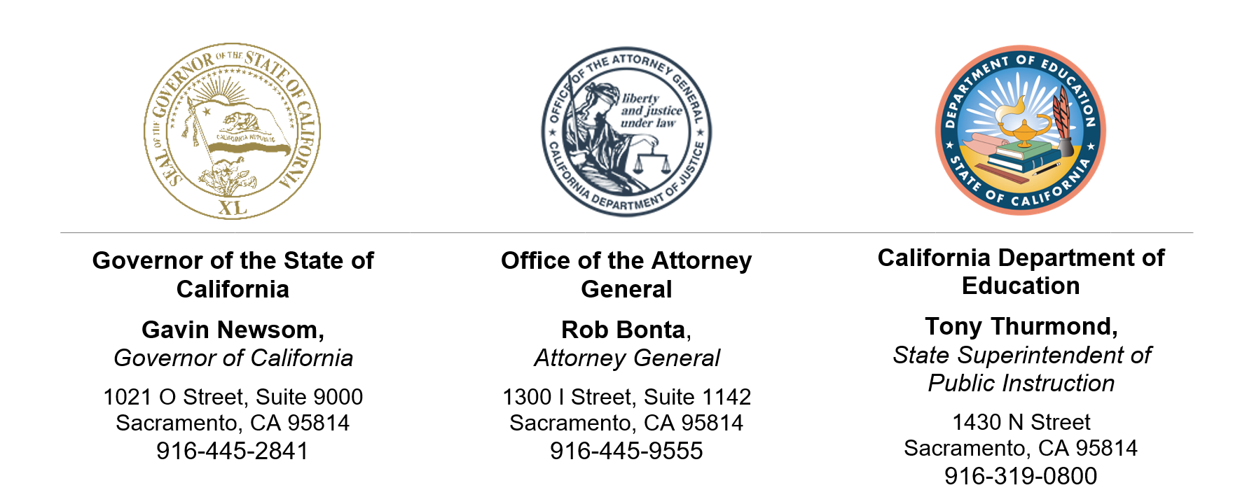
June 1, 2023
Dear California County and District Superintendents and Charter School Administrators and School Principals:

Educational Rights and Requests to Remove Instructional Materials
As we close this school year and look to the next, communities across California and the nation are being confronted with threats that invoke a darker past. In the first half of the 2022–23 school year alone, 1,477 books were banned nationally, with teachers and librarians threatened with prison time for shelving the wrong book. As state leaders elected to represent the values of all Californians, we offer our response in one shared voice: Access to books—including books that reflect the diverse experiences and perspectives of Californians, and especially those that may challenge us to grapple with uncomfortable truths—is a profound freedom we all must protect and cultivate.
This letter outlines key considerations to assist you with fielding requests within your community while you continue to support your students and their educational rights.

I. The Constitution Restricts the Removal of Books From Libraries and Curricula
As the Supreme Court stated over 50 years ago: “It can hardly be argued that … students … shed their constitutional rights to freedom of speech or expression at the schoolhouse gate.” Freedom of speech includes the right to receive information and ideas, including those that are controversial, unpopular, or offensive to some. “[T]he function of books and other literary materials, as well as of education itself, is to stimulate thought, to explore ideas, [and] to engender intellectual exchanges.”
While local educational agencies “have broad discretion in the management of school affairs,” this discretion “must be exercised in a manner that comports with the transcendent imperatives of the First Amendment.” Therefore, while a local educational agency or administrator may remove books and other materials from a school library because of their educational suitability, pervasive vulgarity or profanity, or factual inaccuracies, it “may not remove books from school library shelves simply because [officials] dislike the ideas contained in those books… .”
For example, “If a Democratic school board, motivated by party affiliation, ordered the removal of all books written by or in favor of Republicans, few would doubt that the order violated the constitutional rights of the students denied access to those books.” Similarly, students’ rights would also be violated “if an all-white school board, motivated by racial animus, decided to remove all books authored by [people of color] or advocating racial equality and integration.”
These principles also apply to decisions about school curricula. Curricular decisions must be based on legitimate pedagogical interests and not an attempt at “rigid and exclusive indoctrination”; “to prescribe what shall be orthodox in politics, nationalism, religion, or other matters of opinion”; or because of ideological opposition. And removing materials from curricula or libraries may also violate the First Amendment, even when prompted by complaints from parents or threats of lawsuits.
“Our Constitution does not permit the official suppression of ideas,” yet that appears to be what is happening here. “[I]f we are not to strangle the free mind at its source and teach youth to discount important principles of our government as mere platitudes,” then local educational agencies and school officials must abide by the First Amendment.

II. Education and Exposure to Various World Views Are Vital for our Youth
Education is essential to prepare our youth for civic participation and to instill the values needed to maintain our democracy. As California’s own Constitution recognizes, the “diffusion of knowledge and intelligence [is] essential to the preservation of the rights and liberties of the people… .” Moreover, since before the days of Brown v. Board of Education, formal education has played an essential role in the struggle for civil rights and in building understanding of differences as well as shared values. Schools “bring together members of different racial and cultural groups and, hopefully, help them to live together ‘in harmony and mutual respect.’”
“Those who choose the books and literature that will influence the minds and hearts of our nation’s youth and those who teach young people in our schools bear an awesome responsibility.” This responsibility must neither be taken lightly nor used for inappropriate, political, or partisan ends.

III. California Education Code Requires Local Educational Agencies to Provide a Representative and Unbiased Curriculum and Protects a Student’s Right to Freedom of Speech
Local educational agencies must provide students a representative social sciences curriculum that provides instruction on “the role and contributions of both men and women, Native Americans, African Americans, Mexican Americans, Asian Americans, Pacific Islanders, European Americans, lesbian, gay, bisexual, and transgender Americans, persons with disabilities, and members of other ethnic and cultural groups” to the development of California and the United States and “the role of these groups in contemporary society.” Any instructional materials adopted by a local educational agency must “accurately portray the cultural and racial diversity of our society,” including the roles and contributions of these groups.
Schools may not adopt textbooks or other materials or provide or sponsor instruction or activities that promote discriminatory bias against or that reflect adversely on persons on the basis of race, ethnicity, nationality, gender, gender identity, gender expression, religion, disability, sexual orientation, immigration status, or any other protected characteristic. California law strictly prohibits discrimination on any of these bases. A local educational agency’s removal of materials on the basis that the materials discuss or reflect these characteristics and identities may constitute unlawful discrimination. A complaint of discrimination based on a protected characteristic may be filed with a local educational agency and appealed to the California Department of Education (CDE).
California law also prohibits instructional materials that contain any “sectarian or denominational doctrine” or other propaganda.
In addition to requiring local educational agencies to provide a representative and unbiased curriculum in these ways, the Education Code provides robust protections for student speech, including protections beyond those guaranteed by the Constitution. California students:
... have the right to exercise freedom of speech and of the press including, but not limited to, the use of bulletin boards, the distribution of printed materials or petitions, the wearing of buttons, badges, and other insignia, and the right of expression in official publications, whether or not the publications or other means of expression are supported financially by the school or by use of school facilities.
Only expression that is obscene, libelous, or slanderous or that “so incites pupils as to create a clear and present danger of the commission of unlawful acts on school premises or the violation of lawful school regulations, or the substantial disruption of the orderly operation of the school” may be prohibited. Prior restraint of any other type of expression violates the law, including in “material prepared for official school publications,” like school newspapers. Furthermore, local educational agencies must “adopt rules and regulations in the form of a written publications code, which shall include reasonable provisions for the time, place, and manner” of speech activities.
For further guidance, please refer to the CDE’s recent publication, “Guidance on Removal of Instruction or Instructional Materials,” which is available on the CDE Curriculum Frameworks and Instructional Resources web page at https://www.cde.ca.gov/ci/cr/cf/index.asp.

IV. Possible Requests for Information
If your local educational agency does remove or ban instructional materials from classrooms or libraries, you may be requested to provide the Attorney General’s Office with materials to allow it to analyze your agency’s actions and procedures. These materials may include the following:
- All policies and procedures related to the First Amendment and freedom of speech;
- All policies and procedures for the assessment of instructional materials, library books, and other materials for students, including assessments of their suitability for students;
- All policies and procedures related to the removal or discontinuation of instructional materials or the removal of any books or other materials from school libraries and/or classrooms;
- All documents and communications related to the materials, including those reflecting the basis for their removal or assessments of their suitability for students; and
- Any complaints received related to the materials.
Please be prepared to respond to requests for information in the event the Attorney General’s Office reaches out.
Sincerely,

GAVIN NEWSOM
Governor

ROB BONTA
Attorney General

TONY THURMOND
State Superintendent of Public Instruction

https://pen.org/report/banned-in-the-usa-state-laws-supercharge-book-suppression-in-schools/
Tinker v. Des Moines Independent Community School Dist. (1969) 393 U.S. 503, 506.
Board of Educ., Island Trees Union Free School Dist. No. 26 v. Pico (1982) 457 U.S. 853, 866–867 (“The right of freedom of speech and press ... necessarily protects the right to receive it. … It would be a barren marketplace of ideas that had only sellers and no buyers.”) (internal citations omitted); Monteiro v. Tempe Union High School Dist. (9th Cir. 1998) 158 F.3d 1022, 1029–1032.
Monteiro v. Tempe Union High School Dist., supra, at p. 1032.
Ed. Code, § 56026.3.
Board of Educ., Island Trees Union Free School Dist. No. 26 v. Pico, supra, 457 U.S. at p. 864.
Id. at p. 872; McCarthy v. Fletcher (1989) 207 Cal.App.3d 130, 144.
Board of Educ., Island Trees Union Free School Dist. No. 26 v. Pico, supra, 457 U.S. at p. 871.
Ibid.
McCarthy v. Fletcher, supra, 207 Cal.App.3d at p. 146; Monteiro v. Tempe Union High School Dist., supra, 158 F.3d at p. 1029 fn. 8.
Monteiro v. Tempe Union High School Dist., supra, 158 F.3d at p. 1029 (“[A] student’s First Amendment rights are infringed when books that have been determined by the school district to have legitimate educational value are removed from a mandatory reading list because of threats of damages, lawsuits, or other forms of retaliation.”).
Board of Educ., Island Trees Union Free School Dist. No. 26 v. Pico, supra, 457 U.S. at p. 871 (emphasis in original); see also West Virginia State Board of Education v. Barnette (1943) 319 U.S. 624, 642 (“If there is any fixed star in our constitutional constellation, it is that no official, high or petty, can prescribe what shall be orthodox in politics, nationalism, religion, or other matters of opinion… .”).
West Virginia State Board of Education) v. Barnette, supra, 319 U.S. at p. 637.
See Board of Educ., Island Trees Union Free School Dist. No. 26 v. Pico, 457 U.S. at p. 864 (quoting Ambach v. Norwick (1979) 441 U.S. 68, 76–77).
Cal. Const., art. IX, § 1.
Brown v. Board of Ed. of Topeka, Shawnee County, Kan. (1954) 347 U.S. 483.
Hartzell v. Connell (1984) 35 Cal.3d 899, 908 (internal citations omitted).
Monteiro v. Tempe Union High School Dist., supra, 158 F.3d at p. 1032.
Ed. Code, § 51204.5.
Ed. Code, § 60040.
Ed. Code, §§ 51500, 51501, 60044. Section 51500 also prohibits teachers from providing instruction “which reflects adversely upon persons because of their race, sex, color, creed, handicap, national origin, or ancestry.”
Ed. Code, § 220.
Ed. Code, § 33315, subd. (a).
Ed. Code, § 60044.
Ed. Code, § 48907, subd. (a).
Ibid.
Id., subd. (d).
Id., subd. (b).

