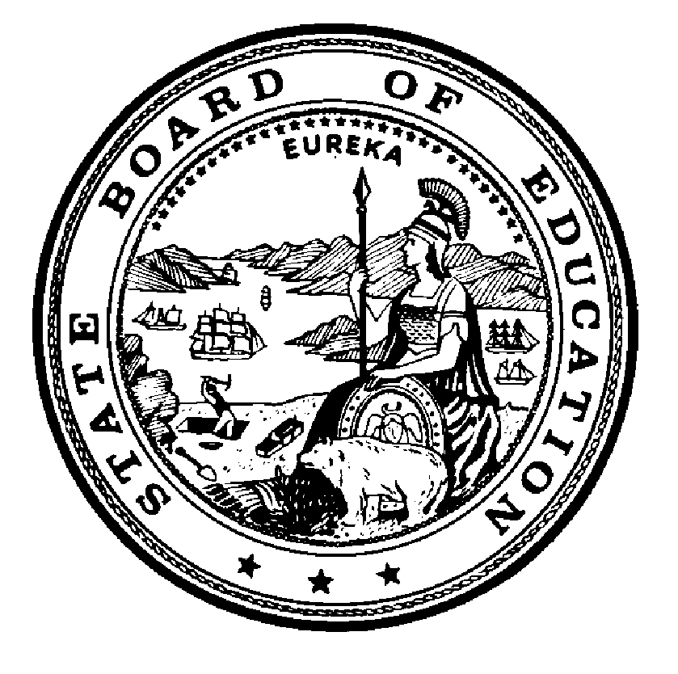

California State Board of Education
Policy # 00-03
Date: May 2000

Waiver Guidelines:
Non Public School/Agency Certification (Annual Renewal Application Deadline)

References:
Education Code (EC) sections 56101 and 56366.1

Historical Notes:
None

EC Section 56366.1(h):
The Superintendent shall annually review the certification of each nonpublic, nonsectarian school and agency. For this purpose, a certified school or agency shall annually update its application between August 1 and October 31, unless the board grants a waiver pursuant to Section 51601. The superintendent may conduct an onsite review as part of the annual review.

Background
Nonpublic schools and agencies (NPS/NPA) are required to update their applications annually. EC Section 56366.1(h) establishes the period during which the California Department of Education (CDE) accepts and evaluates these applications. Occasionally, an individual NPS/NPA will inadvertently miss the deadline. When there is an urgent need to renew the certification (e.g., when special education students are currently being provided with services by the NPS/NPA), a local education agency (LEA) submits a waiver request to the State Board for approval.
Requests to waive the deadline (October 31) for submission of an annual renewal application have been routinely approved by the State Board in the past. Approval of such requests allows CDE Special Education Division staff to review the renewal application beyond the statutory deadline.

Evaluation Guidelines
A school district, county office of education, or Special Education Local Plan Area (SELPA) requesting a waiver of the deadline for renew certification by an NPS/NPA must justify the request by indicating:
- Why the NPS/NPA missed the deadline; and
- How the waiver will benefit the students being served.
California State Board of Education
1430 N Street, Room 5111
Sacramento, California 95814
916-319-0827
916-319-0176 (fax)

