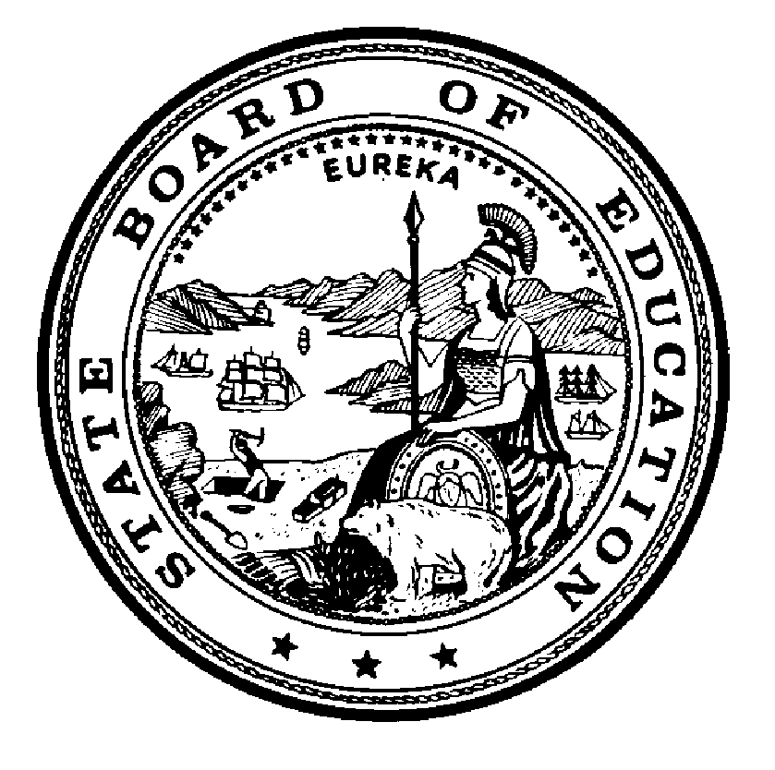

California State Board of Education
Policy #
Date: December 11, 1992

Waiver Guidelines:
Guidelines for Evaluation Requests for Waivers of State Meal Mandate for Saturday School Sessons

References:

Education Code (EC) sections 33050 and 49550

Historical Notes:
None
Statutory Provision/Regulation Involved: EC 49550
This section requires that each school district and county superintendent of schools maintaining any kindergarten or any of grades one to twelve to provide one nutritionally adequate meal each school day to each needy child.
Background
During the 1992-93 school year the California Department of Education (CDE) processed seven requests to waive the requirement to feed needy students during the Saturday session. In August 1992, the Nutrition Services Division (NSD) conducted a survey of school districts to ascertain their understanding of compliance with EC Section 49550. The survey results disclosed that many districts were unaware of the requirement to feed students during Saturday sessions. Waiver requests for Saturday school are now being submitted; therefore, the number of waiver requests for the 1993-94 school year is expected to increase significantly.
Since there are no guidelines for Saturday school, each request must be considered individually by the State Board of Education (SBE). If guidelines are adopted, program staff will ensure that waivers comply with the guidelines before coming to the Board on consent.
The NSD requests that the SBE adopt the guidelines specified below for Saturday school. Local educational agencies requesting a waiver of EC Section 49550 must meet two of the following criteria to be considered for approval:
- The Saturday school session is less than four hours in duration and is completed by noon, allowing pupils to go home during the lunch period.
- Less than ten percent of the needy pupils attending the Saturday school session are at the school site for more than three hours per day.
- The Saturday school site does not have proper refrigeration facilities to enable meals to be prepared on Friday and served on Saturday.
- Serving meals during the Saturday school session would result in a financial loss to the school district, documented by the district, in an amount equal to one-third of the food service net cash resources.
California State Board of Education
1430 N Street, Room 5111
Sacramento, California 95814
916-319-0827
916-319-0176 (fax)

Formerly known as the Child Nutrition and Food Distribution Division (CNFDD)

