Desired Results Developmental Profile-Revised

User’s Guide

March 2008

Acknowledgments
The following groups contributed to the development of this DRDP-R User’s
Guide: California Institute on Human Services, Sonoma State University;
Berkeley Evaluation and Assessment Research center, UC Berkeley; WestEd;
California Department of Education, Child Development Division.

Table of Contents
Page
Preface ------------------------------------------------------------------------------------------- 5
Chapter 1
Introduction to Desired Results for Children and Families ------------------------- 6
Background of Desired Results for Children and Families --------------- 6
Components of the DR system -------------------------------------------------- 7
How the Components of the DR system Work Together ----------------- 9
Chapter 2
Using the DRDP-R -------------------------------------------------------------------------- 10
Overview ------------------------------------------------------------------------------ 10
Preparing to Use the DRDP-R -------------------------------------------------- 10
Structure and Components of the DRDP-R --------------------------------- 12
Figure 1: Sample Measure from the DRDP-R, I/T ---------------- 13
Figure 2: Sample Measure from the DRDP-R, PS --------------- 13
Figure 3: Sample Measure from the DRDP-R, SA --------------- 14
How the Components Work Together ---------------------------------------- 16
Completing the DRDP-R --------------------------------------------------------- 17
Before You Begin --------------------------------------------------------- 17
Steps in Completing the DRDP-R ------------------------------------ 17
Figure 4: DRDP-R, I/T Measure showing rating bubbles ------- 23
Figure 5: DRDP-R, PS Measure showing rating bubbles ------- 24
Figure 6: DRDP-R, SA Measure showing rating bubbles ------- 24
Review: Steps in Completing the DRDP-R ---------------------------------- 27
Chapter 3
Additional Information for Family Child Care Home Education Networks ------ 28
Chapter 4
Using Information from the DRDP-R ---------------------------------------------------- 31
Informing program planning and development ------------------------------- 31
Communicating with families about children’s progress ------------------- 32
Reporting Group-level Data to CDD -------------------------------------------- 32
DRDPtech ----------------------------------------------------------------------------- 32
Resources
Infant/Toddler -------------------------------------------------------------------------------- 33
Preschool ------------------------------------------------------------------------------------- 34
Early Childhood Special Education----------------------------------------------------- 35
School-Age ----------------------------------------------------------------------------------- 35
Environmental Rating Scales ------------------------------------------------------------ 37
Appendix A
DRDP-R, I/T: Indicators and Measures for each Desired Result for Children -- 37
DRDP-R, PS: Indicators and Measures for each Desired Result for Children -- 39
DRDP-R, SA: Indicators and Measures for each Desired Result for Children -- 41
Appendix B
Developmental Levels of the DRDP-R --------------------------------------------------- 43
Appendix C
DRDP-R Terms and Definitions ------------------------------------------------------------ 44
DRDP-R Indicator Acronyms --------------------------------------------------------------- 45

Preface
Beginning in 2000, the use of the Desired Results Developmental Profile (DRDP) has been required in all publicly funded center-based programs and Family Child Care Home Education Networks of the California Department of Education (CDE), Child Development Division (CDD). In the fall of 2006, CDD implemented a revised set of instruments: Desired Results Developmental Profile–Revised (DRDP-R). This revision represents substantial improvement in the interpretability of assessment for individual children.

The primary purpose of this User’s Guide is to assist program practitioners in completing the DRDP-R. The Guide provides information about how to observe, assess, and report on children’s development using the DRDP-R system.

The guide will assist assessors to:
  - Observe, document, and reflect upon children’s development.
  - Use the DRDP-R to improve program practices and curriculum, including planning for individual abilities and interests.
  - Share children’s progress with families.
  - Report DRDP-R data to program administrators, school boards, and advisory committees.

Chapter 1 includes an overview of the Desired Results system (DR system). Chapter 2 provides information about how to use the DRDP-R instrument in center-based programs and Family Child Care Home Education Networks. Chapter 3 presents additional information for Family Child Care Home Education Networks. Chapter 4 describes how the information from the DRDP-R can be used for improving program practices and curriculum and sharing children’s progress with families. Additionally, this guide gives numerous references to websites and other associated materials about the DRDP-R.

Chapter 1

Introduction to Desired Results for Children and Families

Background of Desired Results for Children and Families
Desired Results are defined as conditions of well-being for children and families. The Desired Results system (DR system) implemented by the California Department of Education (CDE) is a comprehensive approach that facilitates the achievement of Desired Results for Children and Families.

The DR system includes six Desired Results – four child Desired Results and two family Desired Results.

The Desired Results for Children and Families
DR1: Children are personally and socially competent
DR2: Children are effective learners
DR3: Children show physical and motor competence
DR4: Children are safe and healthy
DR5: Families support their child’s learning and development
DR6: Families achieve their goals

The DR system supports the development of children from birth through age twelve by providing key information that enables practitioners to further improve their child development programs and services. The Desired Results Developmental Profile-Revised (DRDP-R) is a central component of the CDE’s DR system. DRDP-R is a system of assessment instruments based on teacher observation that measures children’s developmental progress toward the Desired Results for children.

The California Department of Education/Child Development Division (CDE/CDD) developed the DR system in collaboration with CDE’s Special Education Division (SED). The development of the DRDP-R involved the participation of practitioners, program administrators and experts from the fields of assessment, program evaluation, child development, and K-12 education. Contributions were also made by experts in each of the content areas covered by the DRDP-R, including language, literacy, and mathematics, as well as experts and practitioners for each of the following age groups: infant/toddler, preschool-age, and school-age.

The purpose of the DR system is to promote high-quality programs for children. To meet this goal, the DR system is designed to facilitate program improvement by helping programs determine effective strategies for continuous improvement. First and foremost, the DR system provides rich information for teachers to use within their programs for curriculum planning for program improvement and to support the growth and development of individual children. Additionally, the DR system produces summarized data that can inform policymakers and the public of the benefits and necessity of high quality programs. As a clear statement of CDE/CDD's support of quality programs, all state-funded center-based programs and Family Child Care Home Education Networks are required to use the DR system. Additionally, all preschool age children who receive special education services through CDE /SED are required to be included in the Desired Results Developmental Profile component of the DR system.

The CDE values the dedication of staff and practitioners in child development programs and acknowledges their efforts in supporting children toward achievement of the Desired Results. The CDE also recognizes that this achievement can only be accomplished through the combined efforts of families and programs. A child’s development is based on many factors, including growth that results from participating in a high-quality child development program.

The DR system has been designed to be sensitive to the cultural and linguistic diversity of the families served throughout California. Issues of diversity were considered by the developers of the DRDP-R in the descriptions of children’s development. The DR system was also designed to be inclusive and appropriate for children with disabilities. The descriptions of the behaviors to be observed in the DRDP-R are written to be inclusive of all children.

Components of the DR System

The DR system has four components:
1. Ongoing Program Self Evaluation Tool (OPSET)
2. Desired Results Developmental Profile
3. Desired Results Family Survey
4. The Harms and Clifford Environment Rating Scales

This section briefly describes each of the components. For additional information on any of these components, please refer to the CDE/CDD website at http://www.cde.ca.gov/sp/cd/ci/desiredresults.asp and to the Desired Results Training and Technical Assistance Project’s website at http://www.desiredresults.us.

1. Ongoing Program Self Evaluation Tool (OPSET)
The OPSET was developed to promote high-quality programs and the achievement of the Desired Results. They provide a foundation for developing and maintaining programs that will facilitate this achievement for children and families. The OPSET addresses: family and community involvement; governance and administration; funding; standards, assessment, and accountability; staffing and professional growth; opportunity and equal educational access; and approaches to teaching and learning. Program quality and compliance with Program Quality Dimensions are assessed through the required program self-evaluation, conducted annually, and the Consolidated Program Monitoring (CPM) process every four years for Local Education Agencies or Contract Monitoring Review (CMR) process every three years for other programs.

2. Desired Results Developmental Profile—Revised (DRDP-R)
The DRDP-R is an observation-based assessment instrument used to assess children’s developmental progress in the areas encompassed in the Desired Results for children: personal and social competence, effective learning, physical and motor competence, and safety and health. The DRDP-R is designed to guide program staff in making and recording observations and tracking individual progress towards the achievement of Desired Results.

Different versions of the DRDP-R were developed for the following three age groups:
- Infant Toddler (I/T) - Birth to 36 months
- Preschool (PS) – Three years to Kindergarten entry
- School Age (SA) - Kindergarten through twelve years

These three instruments are designed to capture the natural progression of children’s development from birth through twelve years. Each DRDP-R has direct and indirect links with the instrument that covers the preceding and/or subsequent age level. The different links between Measures in adjacent DRDP-R instruments reflect both qualitative and quantitative changes that naturally occur during children's development.

To provide consistency between in-school learning and after-school learning, the School Age instrument is aligned with the CDE Curriculum Frameworks and Academic Content Standards. The first four domains of the Preschool Learning Foundations have been developed and the Infant/Toddler Learning and Development Foundations are currently being finalized. In the future, the Preschool instrument will align with the Preschool Learning Foundations and the Infant/Toddler instrument will align with the Infant/Toddler Learning and Development Foundations.

The Desired Results Developmental Profile access (DRDP access) was developed for use with preschool aged children with IEPs. The DRDP access allows for a wider range of development for children who are three to five years of age with disabilities. It is designed to accommodate preschool aged children with disabilities whose developmental progress may not be adequately assessed with an instrument that begins at a developmental age of three years. In the future, the DRDP access will be aligned with the Infant/Toddler Learning and Development Foundations and the Preschool Learning Foundations. For additional information on the DRDP access and preschool age children with disabilities, visit the Desired Results access website at http://www.draccess.org.

3. Desired Results Family Survey
The purpose of the Desired Results Family Survey is to help programs gather information from families about their perceptions of the family’s progress toward achieving the two Desired Results for families and their satisfaction with their child’s program and how it supports the child’s growth and development. Families in the program are asked to complete the Family Survey once a year and return it to their classroom. Families complete this survey anonymously to ensure that their opinions and concerns are kept confidential.

4. Environment Rating Scale
The Environment Rating Scales (ERS) are instruments used to measure the quality of the program environment (e.g., child-teacher interactions, children’s interactions and activities, use of language, health and safety practices, space, and materials). The ERS is a required instrument for yearly program self-evaluation and the CPM or CMR process.

The following versions of the ERS are used for different age groups and programs:
- Infant/Toddler programs: Infant/Toddler Environment Rating Scale-Revised Edition (ITERS-R; Harms, Cryer, & Clifford, 2003)
- Preschool programs: Early Childhood Environment Rating Scale – Revised Edition (ECERS-R; Harms, Clifford, & Cryer, 2005)
- After school programs: School-Age Care Environment Rating Scale (SACERS; Harms, Jacob, & Romero, 1995)
- Family Child Care Home Education Networks: Family Child Care Environment Rating Scale – Revised Edition (FCCERS-R; Harms, Cryer, & Clifford, 2007).

How the Components of the DR System Work Together

The four components of the DR system (Program Quality Dimensions, DRDP-R, Desired Results Family Survey, and ERS) work together to inform and facilitate activities aimed at promoting high quality programs for children in California. Program Quality Dimensions are designed to ensure program quality. The DRDP-R provides a systematic method to assess children’s progress toward the four Desired Results for children and to identify ways of supporting the developmental needs of individual children. The ERS, used along with the DRDP-R, reveals areas for program improvement that can be addressed by program staff and administrators. The DR Family Survey provides critical input from families on how programs are meeting their needs and the needs of their children. The state monitors the local agency’s use of the DR system for continuous program improvement. This enables CDE to provide support and technical assistance to increase program quality and to identify broad trends for statewide policy considerations.

At the program level, practitioners use the Desired Results system to determine the extent to which children and families are demonstrating progress toward achieving the Desired Results. In addition, DRDP-R results for individual children and classrooms are used by the teachers, family members, and program administrators to support their internal process of improving the experience of each child in their care and to improve the overall quality of their program. This enables programs to implement quality improvement activities that are targeted to directly and effectively benefit participants.
Chapter 2

Using the DRDP-R
Overview
The Desired Results Developmental Profile-Revised (DRDP-R) is an observation assessment instrument that is designed to assess development as it is reflected in children’s day-to-day activities and interactions, based on observations by familiar adults in familiar environments.

This chapter describes how to use the DRDP-R in CDE/CDD funded center-based programs and Family Child Care Home Education Network programs. The purposes of this chapter are to:

- Outline the basic requirements and guidelines for using the DRDP-R, I/T, DRDP-R, PS, and DRDP-R, SA.
- Describe the structure and components of each of the age-group instruments.
- Provide information about best practices in the observation of children.
- Provide detailed instructions on how to complete the DRDP-R, I/T.

Preparing to use the DRDP-R

Which children should be observed with the DRDP-R?
The DRDP-R should be completed for all children who attend a CDE/CDD funded center-based program (including before/after school programs) or a Family Child Care Home Education Network program for at least ten hours per week between the hours of 6 AM and 8 PM. Please note that if the child has an IFSP or IEP, a DRDP-R or the DRDP access should be completed even if the child attends the program for less than ten hours per week. Please see Page 11 for more information on using the DRDP-R with a child who has an IEP or IFSP.

- The DRDP-R, I/T should be completed for infants and toddlers who are not yet three years of age.
- The DRDP-R, PS should be completed for preschool children from three years of age to kindergarten entry.*
- The DRDP-R, SA should be completed for schoolchildren from kindergarten through twelve years of age.

*Although the specified age range for the DRDP-R, PS begins at three years, children who are not yet three years of age may be observed on the DRDP-R, PS if they have entered a preschool program, are at least two years and seven months of age, and will turn three on or before December 2.

When is the DRDP-R to be completed?
The first DRDP-R must be completed within 60 calendar days of the child’s first day of enrollment in the program. Thereafter, it must be completed at the following intervals: infants, every three months; toddlers, every four months; preschoolers, every six months; and school-agers, every six months.

Infant/toddler programs are required to complete the DRDP-R more frequently because development is rapid in the earliest years. Preschool and school-age programs are required to complete the DRDP-R every six months so that each child’s development is assessed on the DRDP-R twice a year.

Finalizing the rating of a child’s development on the DRDP-R Measures is usually completed within a two-week period. However, teachers are expected to record observations and gather evidence on an ongoing basis.

Who is responsible for completing the DRDP-R?
The person who is designated as the child’s teacher is responsible for completing the DRDP-R. Teachers are encouraged to consult and collaborate with others, including assistant teachers and family members, who have ongoing contact with the child. The observations and insights of families and others who know the child well are an important source of information about the child’s development.

In Family Child Care Home Education Network (FCCHEN) settings, agency staff persons who are designated as teachers are responsible for completing the DRDP-R with input from the family child care provider. Because designated teachers may work at several sites, it is especially important that child care providers, who have day-to-day contact with the children and their families, are involved in this observation assessment process. (For additional information concerning FCCHEN programs and the DRDP-R, see Chapter 3 “Additional Information for Family Child Care Home Education Network Programs” at the end of this chapter.)

Using the DRDP-R with the child who has an IEP or IFSP
Infants and toddlers: If an infant or toddler has an Individualized Family Service Plan (IFSP), the regular infant care teacher completes the DRDP-R, I/T. It is recommended that the person who completes the DRDP-R consult with the child’s early intervention service coordinator.

Preschool-age children: If a preschooler has an Individualized Education Program (IEP), the child’s IEP Team determines which instrument (DRDP-R, PS or the DRDP access) is used. The special education service provider is also responsible for completing the assessment with collaboration from the regular preschool teacher, parents, and other adults in the child’s life. For detailed information on policies and procedures for using the DRDP with children with disabilities, visit the Desired Results access website at http://www.draccess.org.

School-age children: If a school age child has an IEP the regular teacher completes the DRDP-R, SA. It is recommended that the teacher consult with the child’s special education service provider to complete the DRDP-R, SA.

All children with an IFSP or IEP: If the child has an IFSP or IEP, a DRDP-R should be completed even if the child attends the program for less than ten hours per week.
It is critical that the IEP Teams and child care and development teachers work closely together to ensure that children with IFSPs and IEPs are assessed and reassessed in a timely manner and that the results of the assessment are shared soon after completion of each assessment. When this is done, the child development staff can modify curriculum, lesson plans, and programs to meet the needs of children with disabilities and support their progress in meeting the development and educational goals set for them.

Using the DRDP-R with children who are English Learners
The teacher who completes the DRDP-R should speak the child's home language or have assistance from another adult, such as an assistant teacher, director, or family member, who does speak the child’s home language. A Spanish version of the DRDP-R is now available and can be downloaded from the Desired Results website at http://www.desiredresults.us.

DRDP-R Training and Support
Numerous training opportunities are available for practitioners who are using and learning to use the DRDP-R. These include in-person training sessions and a variety of online training options. Information on these training opportunities and how to access them can be found at http://www.desiredresults.us. A wide range of materials to support teachers and program administrators’ use of the DRDP-R are available at the Desired Results website at http://www.desiredresults.us, including downloadable versions of the DRDP-R and this User’s Guide.

Structure and Components of the DRDP-R
This section describes the structure and components of the DRDP-R and how the components work together to assess children’s progress toward the Desired Results.

The DRDP-R measures specific Indicators of progress toward the four Desired Results for children. The Indicators correspond to areas or domains of development. Each Indicator is reflected in a set of Measures, which are the observational items on the DRDP-R.

Sample Measure pages from the DRDP-R, I/T, DRDP-R, PS, and DRDP-R, SA are shown in Figures 1 (I/T), 2 (PS), and 3 (SA). The following seven components of the DRDP-R are labeled to highlight the page structure.

- Desired Results
  - Indicators
    - Measure Names
    - Definitions
      - Developmental Levels
      - Descriptors of Levels
      - Examples of Levels
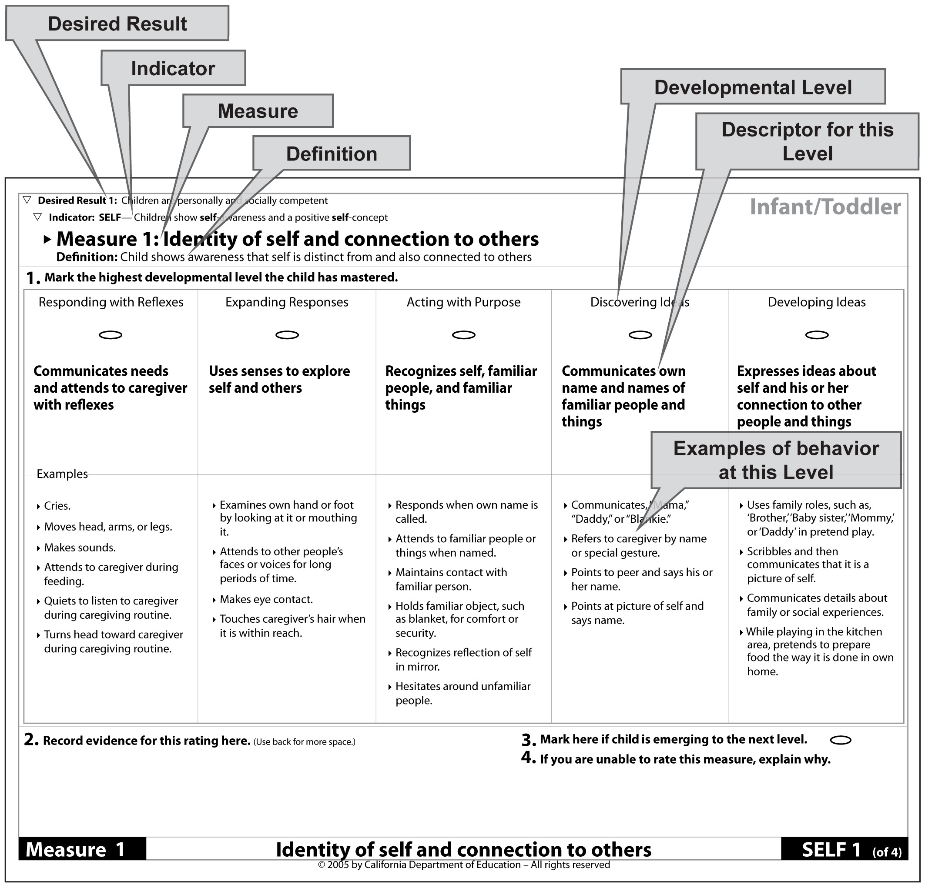

Figure 1. Sample Measure page from the DRDP-R, I/T.

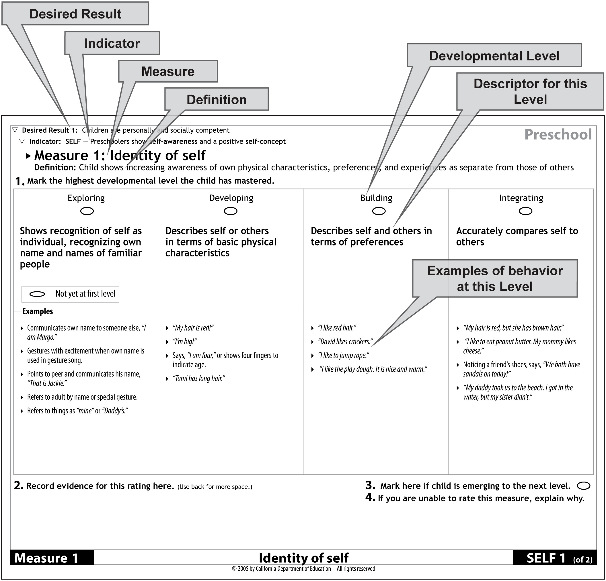

Figure 2. Sample Measure page from the DRDP-R, PS.

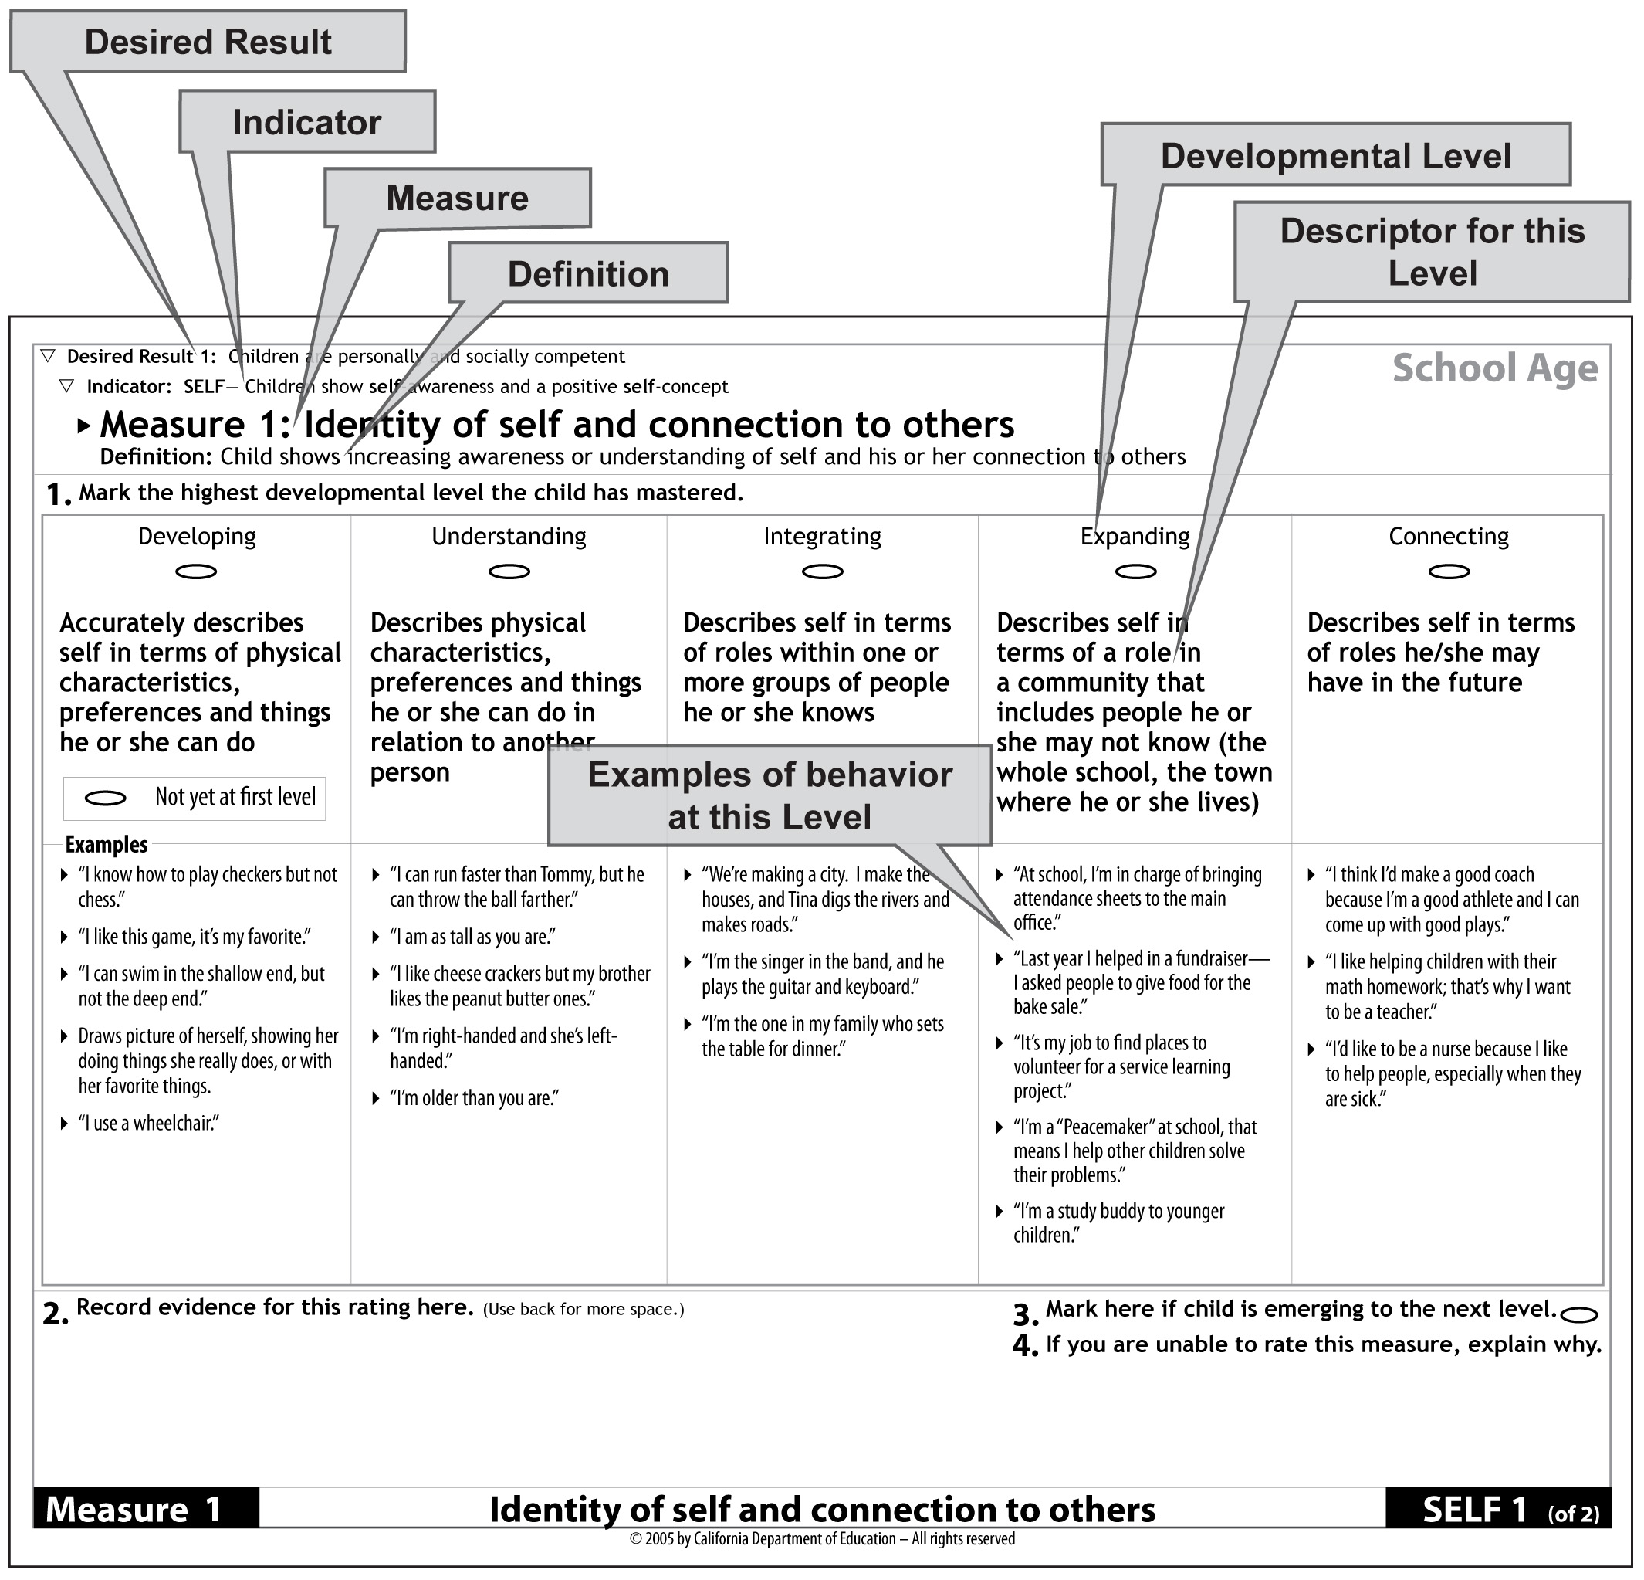

Figure 3. Sample Measure page from the DRDP-R, SA.

These seven labeled components of a DRDP-R Measure are defined and illustrated below.

- A Desired Result (DR) is a condition of well-being for children and families. Each DR defines a single overall outcome. Each of the Indicators and Measures in the DRDP-R is part of one of the four Desired Results for children.

The samples shown in Figures 1, 2, and 3 are part of the first Desired Result for children (DR1): Children are personally and socially competent.

- An Indicator is a specific measurable developmental dimension within the overall Desired Result. Each one is an indicator of progress toward a particular Desired Result.

The first Indicator for DR1 is Children show self-awareness and a positive self-concept (abbreviated SELF).

Practitioners who serve different age groups will find that most of the Indicators are the same across each of the different age-level versions of the DRDP-R.

- A Measure is a specific developmental continuum along which a child’s observed behavior is assessed. Measures are the individual observational items on the DRDP-R. An Indicator is made up of several Measures, each covering one aspect of development within that Indicator.

I/T: On the DRDP-R, I/T, the Indicator SELF has four Measures. Identity of self and connection to others (SELF1) is shown in Figure 1.

PS: On the DRDP-R, PS, the Indicator, SELF has two Measures. Identity of self (SELF1) is shown in Figure 2.

SA: On the DRDP-R, SA, the Indicator, SELF has two Measures. Identity of self and connection to others (SELF1) is shown in Figure 3.

Complete listings of the Indicators and Measures for each Desired Result for the DRDP-R, I/T, the DRDP-R, PS, and the DRDP-R, SA are given in Appendix A.

- The Definition of a Measure specifies the developmental achievement (knowledge or skill) that is being measured.

I/T: The Definition for DRDP-R, I/T SELF1 is Child shows awareness that self is distinct from and also connected to others.

PS: The Definition for DRDP-R, PS SELF1 is Child shows increasing awareness of own physical characteristics, preferences, and experiences as separate from those of others.

SA: The Definition for DRDP-R, SA SELF1 is Child shows increasing awareness or understanding of self and his or her connection to others.
- A Developmental Level is one point along the developmental progression defined for a particular Measure.

I/T: The first Developmental Level for DRDP-R, I/T SELF1 is Responding with reflexes. All the Measures on the DRDP-R, I/T have five Developmental Levels except those for Language and Motor Skills, which have six.

PS: The first Developmental Level for DRDP-R, PS SELF1 is Exploring. All DRDP-R, PS Measures have four Developmental Levels.

SA: The first Developmental Level for DRDP-R, SA SELF1 is Developing. Most of the DRDP-R, SA Measures have five developmental levels; LANG, MATH, and LIT have six; SH has four.

The names of the Developmental Levels on each of the instruments are listed in Appendix B. Developmental Levels are discussed in greater detail later in this chapter in the section “Rating the Measures.”

- Each Developmental Level has a Descriptor that defines the behaviors that would be observed if a child were at that Developmental Level.

I/T: The Descriptor for SELF 1 Responding with reflexes is Communicates needs and attends to caregiver with reflexes.

PS: The Descriptor for SELF 1 Exploring is Shows recognition of self as individual, recognizing own name and names of familiar people.

SA: The Descriptor for SELF 1 Developing is Accurately describes self in terms of physical characteristics, preferences and things he or she can do.

- Each Descriptor is illustrated with several Examples of behaviors that are consistent with that Developmental Level. An Example is one way, but not the only way, a child might demonstrate a particular Developmental Level.

I/T: One Example for SELF 1 Responding with reflexes is Turns head toward caregiver during caregiving routine.

PS: One Example for SELF 1 Exploring is Refers to things as “mine” or Daddy’s.”

SA: One Example for SELF 1 Developing is “I know how to play checkers but not chess.”

How the Components Work Together to Ensure the Usefulness of the DRDP-R
Each DRDP-R Indicator provides a useful and interpretable measurement of a child’s growth and development within a particular area of development. Because there are multiple Measures (observational items) for each Indicator, a completed DRDP-R provides enough information to support reliable measurement for an individual child. The key to DRDP-R assessment is that every Measure is defined in terms of the typical sequence in which a child’s development is expected to progress. These sequences of development are derived from research in child development so that the DRDP-R measures a child’s progress in reaching these typical developmental criteria. The measurements on all of the Indicators, taken together, provide a profile of development for the whole child, in terms of progress toward all four Desired Results. This is the child’s Desired Results Developmental Profile. Repeated DRDP-R assessment details how a child’s entire developmental profile has progressed over time.
Completing the DRDP-R
This section outlines the requirements and guidelines for completing the DRDP-R, including detailed instructions on how it should be completed.

Before You Begin
Your knowledge of the instrument, what is included and how the sequences of development are described, should guide your observations.
- Read and become familiar with all the Indicators and Measures in the DRDP-R you are using.
- Be sure to arrange to be trained to use DRDP-R, if you have not already done so (http://www.desiredresults.us).
- Consult the videos and written materials available at http://www.desiredresults.us.
- Discuss with the other practitioners and administrators in your program on the proper strategies for using DRDP-R.
- Determine how English Learners’ communication in their home language will be observed and documented. If you do not speak the child’s home language, explore community and other resources to get assistance from someone who does.

Steps in Completing the DRDP-R
- Collect Documentation
- Complete the Information Page
- Rate the Measures
- Finalize the Assessment

Step A. Collect Documentation

Strategies for Observing and Documenting Children’s Development
Plan ahead. Devote enough time for observations. Plan to observe during activities that do not require your full assistance. Arrange activities in a way that will allow children’s conversations to be heard. Do not let observations get in the way of your interactions with children.

Observe behaviors as they occur. Observe and document the child’s behavior, with minimal interruptions, during the course of the day. All of the children’s indoor and outdoor activities (e.g., playing, interacting with other children or adults, routines such as diapering/toileting and feeding/eating, small or large group activities, and drop off/pick-up time) should provide observations useful for completing the DRDP-R.
Do not set up tasks or artificial situations to “test” the child. Rather, think about opportunities where you would be most likely to observe the Measures.

For example:
DRDP-R, I/T: Engaging an infant or toddler in a simple game of “peek-a-boo” can provide opportunities to observe the child’s development on several Measures of the DRDP, I/T, including Interaction with Adults (Soc 2), Attention Maintenance (REG 5), and Memory (COG 1).

DRDP-R, PS: When an assistant teacher reads a book about farm animals to a group of preschool children and leads a discussion about it, this can provide opportunities to observe one or more children’s development on several Measures of the DRDP-R, PS, including Building cooperative relationships with adults (SOC 2), Expresses self through language (LANG 3), and Interest in Literacy (LIT 1).

DRDP-R, SA: A group of school age children playing basketball can provide opportunities to observe one or more children’s development on several Measures of the DRDP-R, SA, including Self-esteem (SELF 2), Conflict negotiation (SOC 4), Movement and coordination (MOT 1), and Exercise and fitness (SH 4).

Creating environments or situations that invite children to participate in activities and interactions in the areas covered by the DRDP-R can facilitate your observations and create learning opportunities for children.

Observe for variety and consistency. Observe children over time and in as many different settings as possible (e.g., in the classroom, on the playground, during group time, during free play, with family during drop-off/pick-up). Consider the consistency of the child’s behavior and how particular observations fit within the child’s overall performance.

Observe strategically. Keep the DRDP-R Indicators and Measures in mind when observing and recording your observations. An observation can provide evidence for several Measures, as in the examples, above. You may also be able to gather information on more than one child in the same observation, for example when two children are interacting or playing side-by-side.

Observe objectively and record factually. Focus on observing and recording what the child does, not what you think the child is doing or what you think the child can do. Avoid using labels or qualitative descriptors such as “shy,” “helpful,” or “happy.” Instead, describe what you actually observe.

For example:
DRDP-R, I/T: Statements like “he cried when his mother left” or “she smiled” describe observable behaviors. Statements such as “he was sad when his mother left” or “she was happy” are based on the observer’s interpretation.
DRDP-R, PS: “She ran away from Leticia” or “he picked up a book” are observable behaviors. Statements such as “she was afraid of Leticia” or “he wanted to have someone read to him” reflect the observer’s interpretation.
DRDP-R, SA: “He threw down his pencil” or “she smiled” describe observable behaviors. Statements such as “he was frustrated” or “she was happy” are based on the observer’s interpretation.

Observe daily. When observations are gathered daily, children become accustomed to being observed and seeing notes being recorded.

Record sooner not later. Record your observations as soon as possible. Details are important and might be easily forgotten.

Keep it confidential. Remember that your documentation is confidential. Keep the DRDP-R instrument including notes in a secure location to ensure confidentiality for each child.

Tips for Documenting Children’s Development
- Consider ways to document children’s behavior throughout the day.
- Use a variety of documenting techniques. Documentation may include anecdotal notes, photographs, audio or video documentation, and work samples.
- Date each piece of evidence so you know how recent it is.
- Set aside a regular time each day to organize your documentation records and other forms of evidence.
- Portfolios are a good way to keep your documentation organized. Store portfolios in a secure place that is also easily accessible to you.
- Review records weekly. If there are particular areas of development that have not been observed for an individual child, take steps to fill in these gaps.
- Remember, over time and with practice, recording observations becomes easier, and the benefits of using the DRDP-R become clearer.
- The following materials may be helpful for observing and documenting.
  - “Sticky notes”
  - Pre-printed labels with child’s name
  - Charts
  - Checklists or worksheets
  - Clipboard, paper, pens, and pencils
  - Photo/video camera
  - Tape-recorder
  - “Mini-Measures” (Small note cards with Measures and Developmental Levels printed on them.) http://www.desiredresults.us

You can access and download a variety of observation and documentation resources on the Desired Results website at http://www.desiredresults.us. These include the DRDP-R Tool Kit, Portfolio Documentation Records, Observation Worksheets, Anecdotal Note Organizers, and DRDP-R Documentation samples.

You are required to keep the documentation on which your DRDP-R ratings are based while the child is in your program. When a child leaves your program, you are required to keep the DRDP-R instrument a minimum of five years as part of the basic Family Data file, but not the child’s portfolio or other forms of documentation.

Gathering Additional Sources of Evidence – Collaborating with Others
In addition to documenting your observations of the child’s development, plan to seek input from other individuals, including teacher assistants and families, who have ongoing contact with the child and know the child well. The observations and insights of family members, as well as other program staff and providers, are an important source of information about the child’s typical day-to-day behaviors. Including others in the assessment process will enable you to obtain the most complete and accurate picture of the child’s developmental progress.

Step B. Complete the Information Page
Fill out an Information Page for the appropriate version of the DRDP-R each time that you complete a child’s assessment. Read the instructions that are provided in the DRDP-R instrument and complete ALL the information that is requested. (If you are unsure of any of this information, please consult your Program Administrator.)

The date you record as the DRDP-R Date of assessment should be the last day you made a comment or marked a Developmental Level on the DRDP-R for this child. CDE/CDD funded programs must complete the first DRDP-R within 60 calendar days of the child’s first day of enrollment in the program. Thereafter, it must be completed at the following intervals: infants, every three months; toddlers, every four months; preschoolers, every six months; and school-agers, every six months.

Tips for Completing the Information Page
- Do not use nicknames. Where names are requested, use only legal names. Check the child’s enrollment information if you are not certain of the child’s legal name.
- If the child has had multiple enrollment dates, write the date the child first enrolled in the program.
- Each time you complete the DRDP-R, complete an Information Page. The DRDP-R, I/T Information Page includes a question regarding whether the person completing the assessment is the child’s primary caregiver in the child care setting. The primary caregiver is the person who is mainly responsible for this child’s care, including carrying out routines such as diapering, feeding, naptime and record keeping. If you are not the primary caregiver, please note your relationship to this child.

Step C. Rate the Measures
Reviewing and Reflecting
It is a good idea to have a system to keep track of your documentation to ensure you have a complete picture of the child. Halfway through the documentation period you may want to check for which Measures of the DRDP-R you have documentation. Then plan to observe the child at times when you can document the remaining Measures.

When you are ready to rate the Measures of the DRDP-R for a child, review the observations and documentation of the child’s development that you have collected (portfolio with work samples, anecdotal comments, photographs, video tapes, etc.). Reflect on what this evidence tells you about the child’s development across the Indicators and Measures of the DRDP-R.

If you find that your documentation does not provide a clear picture of the child’s development in one or more areas, determine how to gather additional evidence. Plan for other opportunities to observe the child’s behavior. You will also again want to talk with family members, staff, and others who know this child to ensure that you have the most complete and accurate picture of the child’s skills and abilities.

Determining the Child’s Level of Mastery
Your ratings should indicate the highest Developmental Level that the child has mastered, based on the child’s typical behavior. A child has mastered a Developmental Level if the child typically demonstrates the behaviors in that level's Descriptor.

Behaviors are considered typical if the child demonstrates them
- easily and confidently
- consistently over time
- in different settings

As you rate each of the Measures, carefully read the Definition for the Measure and the Descriptors for each of the Developmental Levels so that you have a clear understanding of the intent of the Measure. Read the Examples to clarify your understanding of the Descriptor. Keep in mind that the examples are not meant to be used as a checklist. Many of the behaviors you observe in determining a child’s Developmental Level will not be listed as Examples.

To determine the child’s level of mastery, consider which Descriptor is most consistent with your observations and other documentation of the child’s typical behavior. A child may occasionally behave at an earlier or later Developmental Level, but in general the child demonstrates behaviors representative of one level. Note that children in all age groups can demonstrate mastery of a Developmental Level in their home language.

The Developmental Levels have the same names across most of the different Measures within each of the age-group instruments (see Appendix B). However, a child is not expected to be at the same Developmental Level on all the Measures since development does not generally proceed at the same rate in all areas.

Optional: Determining if the child is emerging to the next Developmental Level
If the child has mastered a Developmental Level, but is also demonstrating some of the behaviors described for the next level (although not yet easily or consistently across settings), the child may be emerging to the next level. You may indicate this on the Measure page or Rating Record you are using. (Rating Records are described below.)

You must rate the Developmental Level the child has mastered before indicating that the child is emerging to the next level. Emerging is not a Developmental Level. Indicating that the child is “emerging” to the next Developmental Level is an option that may be helpful to you and other program staff in planning curriculum. However, it does not affect the Measure rating. Note that “emerging” is not an option if the child has mastered the highest Developmental Level on that Measure.

If you are unable to rate a Measure
In some rare instances, you may be unable to rate a child’s Developmental Level on a particular Measure. For example, if the child’s attendance is extremely inconsistent, there may be limited opportunities to observe the child’s behavior. Of course, you should make every effort to rate all the Measures. If it is not possible to rate a Measure indicate this on the Measure page or Rating Record. Document the circumstances and reasons for not rating the Measure. It is expected that the entire DRDP-R will be completed most of the time.

Recording Ratings for the Measures
Complete the Measure ratings by marking the highest Developmental Level that the child has mastered. Ratings can be recorded directly on the pages of the DRDP-R or on one of the DRDP-R Rating Records. For the first assessment, you should record your ratings on the DRDP-R. For the second assessment, you may find it convenient to use one of the Rating Records. However, best practice is to complete the ratings on the actual DRDP-R each time. Sample Measure pages, with rating bubbles and other related sections labeled, are shown in Figure 4 (DRDP-R, I/T), Figure 5 (DRDP-R, PS) Figure 6 (DRDP-R, SA).

The Rating Record is available in two formats: a one-page horizontal Rating Record and a three-page vertical Rating Record. Both Rating Records list the Measure names and provide spaces, which correspond to the Developmental Levels, for marking the ratings. The three-page vertical Rating Record also has a column for recording comments. Rating Records can be downloaded from the Desired Results website at http://www.desiredresults.us.

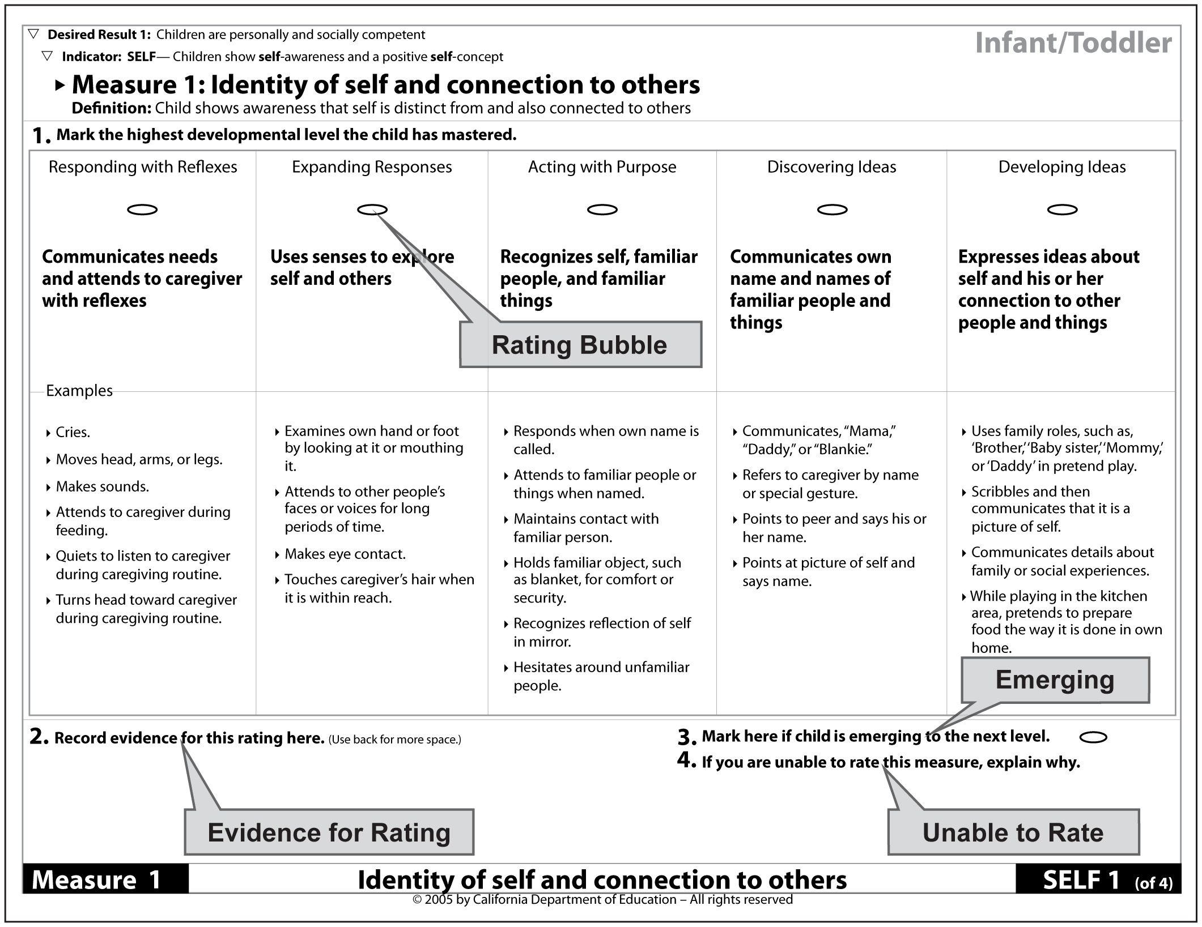

Figure 4. Sample Measure page from the DRDP-R, I/T showing rating bubbles.

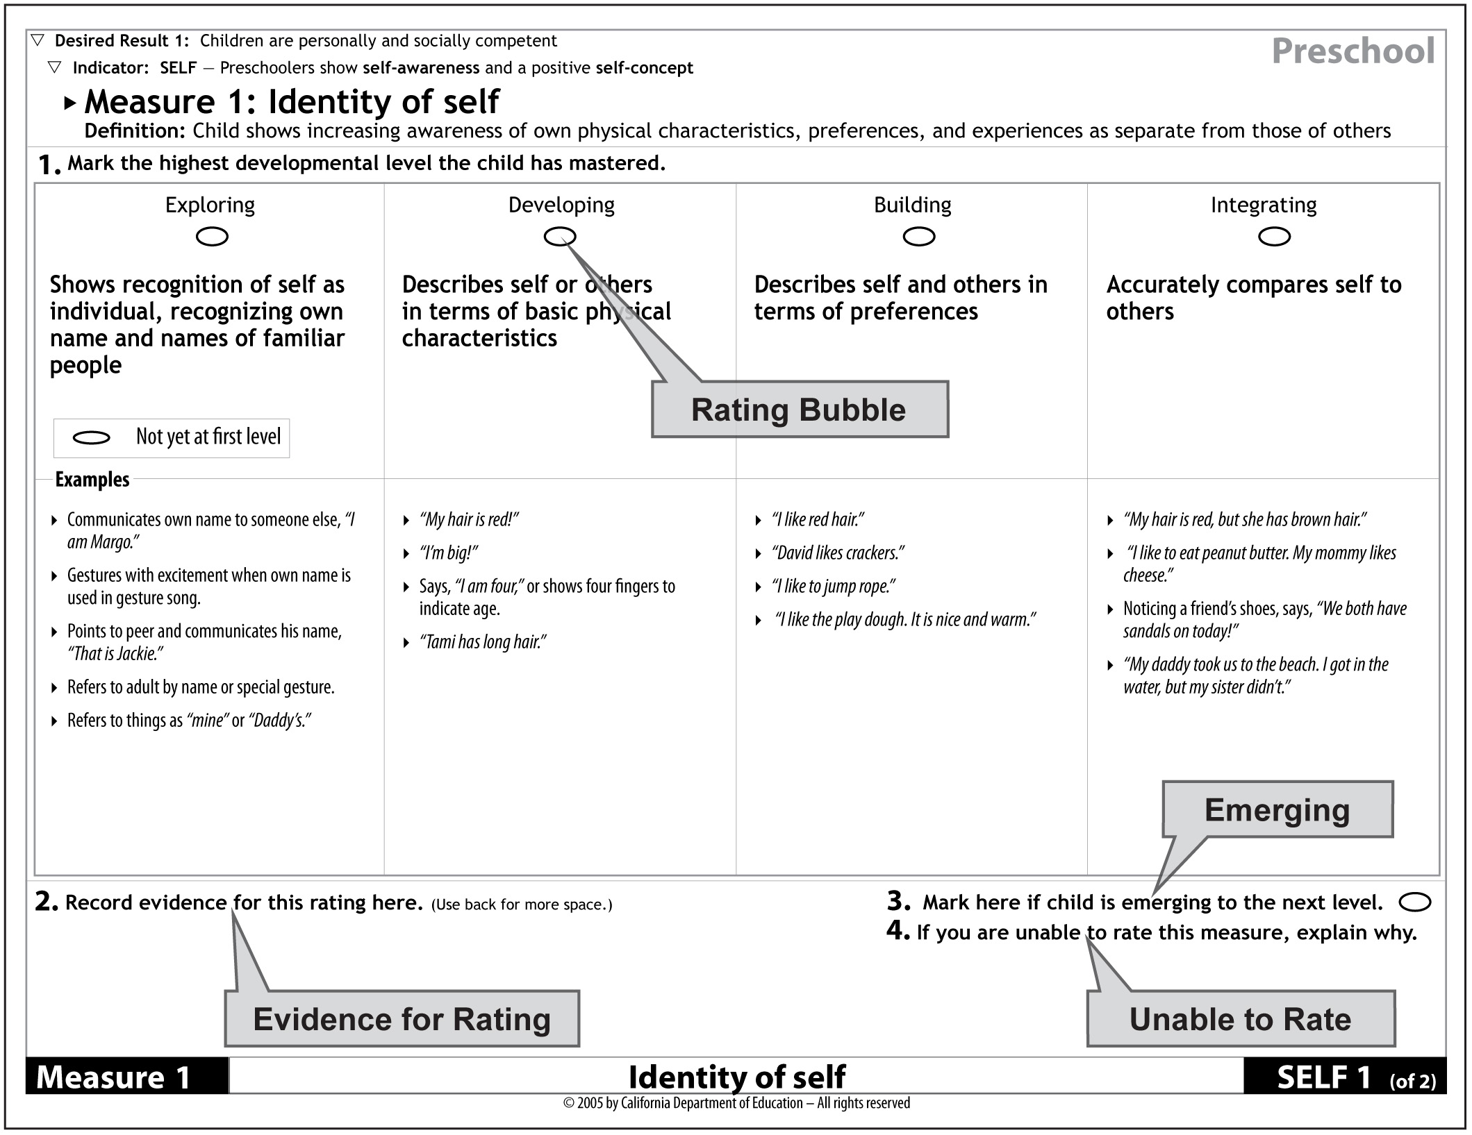

Figure 5. Sample Measure page from the DRDP-R, PS showing rating bubbles.

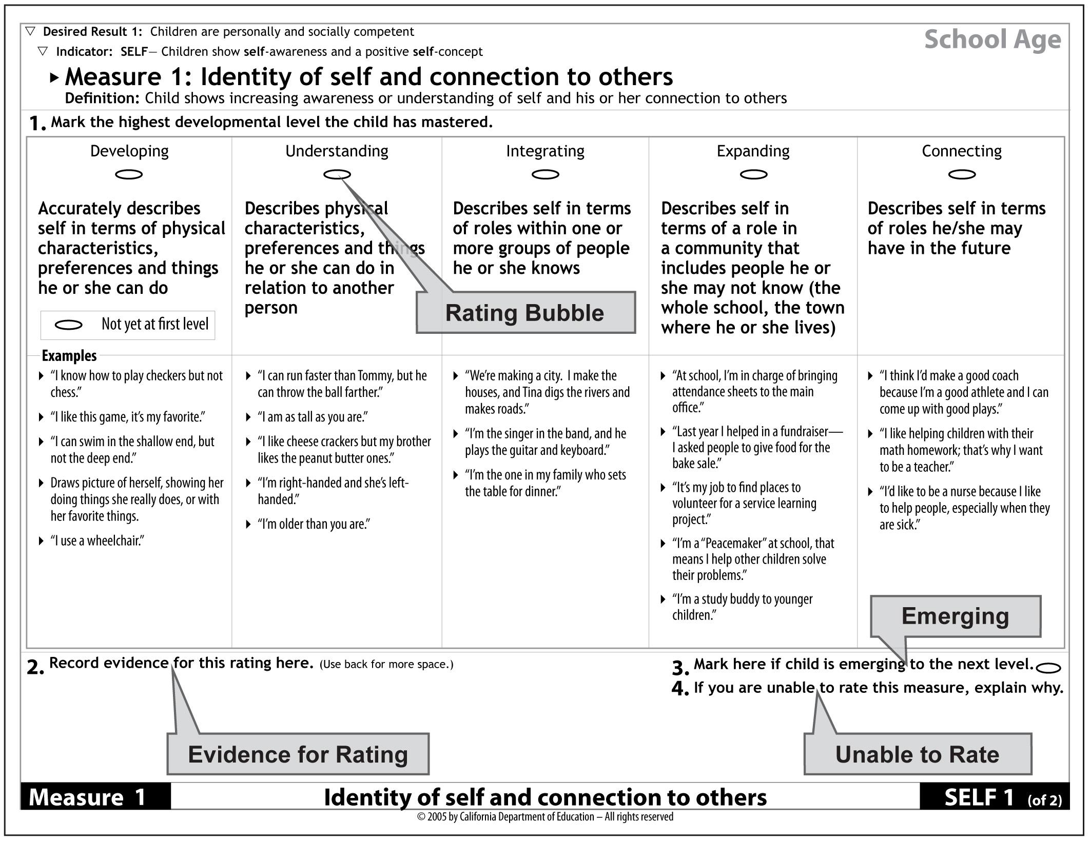

Figure 6. Sample Measure page from the DRDP-R, SA showing rating bubbles.
The Rating Records are not intended to be used independently of the DRDP-R. If you record your ratings on one of the Rating Records, you should have a blank instrument with you, open to the Measure you are rating. You will still need to read the Measure Definition and Descriptors in order to determine your ratings.

Regardless of which recording format you use, you should conduct the second assessment with “fresh eyes.” Do not review the child’s earlier DRDP-R ratings before or while conducting the assessment, as this could influence your ratings.

Recording ratings on the DRDP-R (See Figures 4, 5, and 6.)
- Mark the bubble corresponding to the Developmental Level the child has mastered.
- Optional: If the child is emerging to the next level, indicate this by marking the bubble in the lower right hand corner of the page (“3. Mark here if the child is emerging to the next level.”).
- If you are unable to rate a Measure, document the circumstances and reason for no rating in the lower right hand corner of the page (“4. If you are unable to rate this measure, explain why.”).

Recording ratings on the Rating Record (horizontal or vertical)
- Fill out the information at the top of the page.
- Mark the column corresponding to the Developmental Level the child has mastered.
- Optional: If the child is emerging to the next level, indicate this by marking the column labeled “EM” on the Rating Record.
- If you are unable to rate a Measure, mark the column labeled “UR.” If you are using the vertical Rating Record, record the reason for no rating in the “Comments” column. If you are using the horizontal Rating Record, record this information on the back of the page or on a separate page and attach it to the Rating Record.

Recording Your Evidence
Evidence used to rate each of the Measures should be documented. You may do this by making a note at the bottom of the DRDP-R Measure page. Alternately, you may record your notes on the 3-page vertical Rating Record in the “Comments” section or on a separate piece of paper that you attach to it or to the horizontal Rating Record. Observation worksheets for recording your evidence can be found in the DRDP-R Tool Kit at http://www.desiredresults.us.

A note recording your evidence can be as simple as “see portfolio.” Or, you can describe the specific behavior(s) the rating was based on.

For example:
DRDP-R, I/T Measure 24 -- Number
“10/5 – Bobby asked for one more cracker at snack; 10/13 – When asked how old he was, held up two fingers.”

DRDP-R, PS Measure 22 – Number sense: Understands Quantity and Counting
“10/5 – Jose lines up 8 dinosaurs and counts them. 10/13 – Counted 6 train cars.”

DRDP-R, SA Measure 27 -- Measurement
“10/5 – Lucy used a ruler to measure length of the game shelf; 10/13 – L. measured the circumference of a pumpkin with a tape measure.”

Keep in mind that you should have enough evidence for the rating of each Measure to be confident that you have accurately determined a child’s level of mastery.

Step D. Finalize the Assessment
Review the DRDP-R and make sure that all the Measures have been rated and that all the related information is complete.

Review the Information Page. Make sure all items on the Information Page are complete and up-to-date. Record the date you finished marking your ratings on the DRDP-R for this assessment period.

Attach the Information Page to the DRDP-R. If you are completing the second or subsequent assessment for the child this year, attach the newly prepared Information Page to the new DRDP-R or Rating Record.

Review: Steps in Completing the DRDP-R

Gathering evidence of children’s growth and development
- Read the entire DRDP-R before beginning.
- For children who do not speak English, determine how the children’s responses will be translated and/or documented.
- Collect documentation for the DRDP-R by observing children and recording observations; collect evidence of children’s learning such as children’s work and photographs; use teacher-made tools such as journals and checklists. Date each piece of evidence.
- As you observe and document the child’s behavior, consider the DRDP-R Measures and how your observations provide evidence for rating one or more of the Measures.
- Continue to collect documentation over time during the course of the child’s day.
- Organize your documentation in the child’s portfolio.
Completing the DRDP-R
- Fill out the Information Page completely and accurately.
- If you are using a Rating Record, fill in the requested information at the top of the Rating Record.
- Review and reflect on the child’s portfolio, teacher records, and any other evidence you have. Remember to collaborate with others.
- Read the Measure Definition and Descriptors and mark the highest Developmental Level the child has mastered.
- Optional: If the child is emerging to the next Developmental Level, indicate this after marking the level the child has mastered.
- Record the evidence for the Measure rating (e.g., “See photo of Susie, 10/1/07, – portfolio.”).
Final steps in completing the DRDP-R
- Review the DRDP-R and make sure all the information and Measures are completed.
- Make sure that the Information Page is completed and attached to the DRDP-R.
- If you are completing the second or subsequent DRDP-R for this child this year, attach a new Information page to the new DRDP-R or Rating Record.
Chapter 3

Additional Information for Family Child Care Home Education
Network Programs
Overview
This section provides information for practitioners who use the DRDP-R in Family Child Care Home Education Network (FCCHEN) programs funded by CDE/CDD. The goal is to provide a summary of essential guidelines for implementing the DRDP-R assessment in these programs. It is not meant to substitute for the detailed information that is included in the previous sections. You will still need to read the information in this User’s Guide that describes how the assessment should be completed.

Basic Requirements for Using the DRDP-R
Family Child Care Home Education Network (FCCHEN) programs are expected to complete the DRDP-R following the same requirements and guidelines as other CDE/CDD funded programs.

The DRDP-R must be completed for state-subsidized children who attend a FCCHEN program for at least ten hours per week between the hours of 6 AM and 8 PM. Additionally, all infants and toddlers who have an Individualized Family Service Plan (IFSP) and preschool and school age children with an Individualized Education Program (IEP) who attend FCCHEN programs must be included in the DRDP-R assessment, even if they attend the program for less than 10 hours a week, as further described on Page 30.

- Although only state-subsidized children are required to have a DRDP-R, most programs find it beneficial to use it for the entire group of children.
- The first DRDP-R is completed within 60 calendar days of the child’s enrollment in the program.
- Thereafter, it must be completed at the following intervals: infants, every three months; toddlers, every four months; preschoolers, every six months; and school-agers, every six months.
- The DRDP-R should be completed by the agency staff person designated as the child’s teacher.

Roles and Responsibilities of the Designated Agency Teacher and the Home Child Care Provider in the DRDP-R Assessment
The person responsible for completing the DRDP-R assessment is the FCCHEN agency staff person who is designated as the child’s teacher. These are not the same people as the home child care providers. The designated teacher is the person who is responsible for visiting the child care homes. Some agencies call this person a Child Development Specialist, but your agency may use a different title. This person is referred to as the designated teacher for the purposes of this guide.

Designated teachers generally work at several sites, so they do not have day-to-day contact with the children they serve or their families. Therefore, it is especially important that they collaborate with the child care providers to collect evidence of the child’s growth and progress. The provider’s knowledge of the child should inform the teacher’s DRDP-R ratings. Working closely with the child care provider in the assessment process will enable you to obtain the most complete and accurate picture of the child’s skills and abilities.

Some DRDP-R Assessment Details for FCCHEN
- The DRDP-R should be completed by the designated teacher with input from providers and families.
- The designated teacher schedules and conducts observation visits for the DRDP-R. At least one observation on each child is required as part of the DRDP-R process. However, most teachers conduct multiple visits/observations.
- The child care provider may be asked to collect information to help the designated teacher complete the DRDP-R.
- The designated teacher is responsible for completing the ratings on the DRDP-R Measures in consultation with the child care provider and other sources as needed.
- The DRDP-R results are used by the teacher and provider to help document children’s progress and to help set goals and strategies to support children’s development.
- The DRDP-R results are also used to share information with families about their children’s progress – for example, during family conferences.
- Twice a year, the designated teacher summarizes the DRDP-R results by home or groups of homes, as designated by the agency. The summary goes to the agency to give them information for their annual report

Determining Which Instrument to Use
FCCHEN programs may include children who range in age from infancy to school-age. Use the following age-range definitions to identify which instrument is appropriate to rate a child’s development.

Age ranges for each of the DRDP-R instruments:
- Infant Toddler (I/T) - Birth to 36 months
- Preschool (PS) – three years to Kindergarten entry
- School Age (SA) - Kindergarten through twelve years

Read and become familiar with all the DRDP-R instruments that you will be using. Chapter 2 of this User’s Guide contains detailed information and instructions for using the DRDP-R, including specific information for using the DRDP-R, I/T, the DRDP-R, PS, and the DRDP-R, SA.
Using the DRDP-R with Children with Individualized Family Service Plans or Individualized Education Programs in FCCHEN Settings
All infants and toddlers who have an IIFSP and preschool and school age children with an IEP who attend FCCHEN programs are included in the DRDP-R assessment.
Children with an IFSP or IEP are included, even if they attend the program for less than 10 hours a week. Procedures for completing the DRDP-R vary somewhat for the different age groups. Read the following summaries carefully to ensure that you understand the DRDP-R requirements for these children.

It is critical that the IEP Teams, family child care providers, and the designated teachers work closely together to ensure that children with IFSPs and IEPs are assessed and reassessed in a timely manner and that the results of the assessment are shared soon after completion of each assessment. When this is done, the designated teachers can work with the family child care providers to modify curriculum, lesson plans, and programs to meet the needs of children with disabilities and support their progress in meeting the development and educational goals set for them.

Infants and Toddlers with an IFSP
The development of an infant or toddler with an IFSP is assessed with the DRDP-R, I/T. The designated teacher is responsible for completing the instrument in consultation with the child care provider. It is recommended that the teacher also consult with the child’s early intervention service coordinator to complete the assessment.

Preschool Age Children with an IEP
If a preschooler has an Individualized Education Program (IEP), the child’s IEP Team determines which instrument (DRDP-R, PS or the DRDP access) is used to assess the child’s development. The special education service provider is also responsible for completing the assessment in collaboration with the designated teacher, parents, and other adults in the child’s life. For detailed information on policies and procedures for using the DRDP with children with disabilities, visit the Desired Results access website at http://www.draccess.org.

School Age Children with an IEP
The development of a school age child with an IEP is assessed with the DRDP-R, SA. The designated teacher is responsible for completing the instrument in consultation with the child care provider. It is recommended that the teacher also consult with the child’s special education provider to complete the assessment.

Chapter 4

Using Information from the DRDP-R

When used on an ongoing basis, the DRDP-R will provide program staff with information that will benefit children, families, and programs. This chapter describes how information from the DRDP-R can be used.

Informing program planning and development
Information from the DRDP-R can be reviewed and analyzed at the level of the individual child. In addition, DRDP-R results can be summarized to provide information on groups of children. Teachers and other program staff will review, share and analyze the DRDP-R assessment results in their classroom, and use their conclusions in program planning and development.
Because the DRDP-R provides opportunities to observe and document children’s behavior systematically across many areas of development, the information it yields can be used to identify areas of development that may need to be addressed and supported, either for a specific child or group of children.
At the classroom or program level:
- Each CDE/CDD funded center based and Family Child Care Home Education Network program uses the DRDP-R data collected within the program to plan for improvement at the classroom and program level. Staff members summarize the DRDP-R information, and complete the DRDP-R Summary of Findings for a classroom. (Forms and directions on how to do this can be found at http://www.desiredresults.us). Agencies, then, summarize the data for all children in their agency, and write a program DRDP-R Summary of Findings.
- The DRDP-R data collected within a classroom or program may indicate a need to change or add activities in a specific area covered by the DRDP-R, such as math or literacy. The DRDP-R Summary of Findings also contributes to the Program Action Plan, which each program develops and submits to CDD.
At the level of the individual child:
- The DRDP-R Indicators are the level of reliable measurement that provides a child’s Desired Results Developmental Profile each time the DRDP-R ratings are recorded and documents a child’s progress over time. Program staff may also find it useful to interpret a child’s ratings on individual DRDP-R Measures. DRDP-R results may indicate that the child might benefit from additional support in one or more specific areas of development, such as fine motor skills and number sense. This information, together with other sources of information about the child’s development, can be used to plan curriculum tailored to the child’s needs.
- Information from the DRDP-R can also be a basis for sharing information with families about the child’s development.

Thus, the results from the DRDP-R can assist program staff in supporting the healthy growth and development of individual children as well as in overall program improvement. For additional resources on program improvement, please see the Resources section at the end of this guide.

Communicating with families about children’s progress
To achieve the Desired Results for children, it is vital that programs work in partnership with families to foster children's development. This requires ongoing and meaningful two-way communication. Family members should be involved in the DRDP-R assessment process from the beginning. Program staff members who observe and document the child’s behaviors and rate the DRDP-R Measures are encouraged to seek input from families. Input from family members about the child’s behavior and development can enrich and complement evidence collected by staff.

The DRDP-R includes a Child Developmental Progress Form that summarizes the results from the assessment. Teachers and family members can use this summary as a tool for sharing information about the child’s development during family conferences. Teachers should go over the Child Developmental Progress Form with the family and verify with them that their input is accurately reflected in the summary. This information can be used to generate ideas about ways in which the family and the program can work together to support the child’s development both at home and in the program or family child care setting.

Reporting Group-level Data to CDD
Once a year, programs compile and tally the data collected from the DRDP-R, the ERS, and DR Family Surveys, and write a Summary of Findings for each of these components. Programs use this information for self-evaluation and to define goals and action steps for program improvement. The trends that are revealed in these summaries and the program’s plans for improvement are written into a Program Action Plan, which is submitted to CDD. Complete information and instructions for completing this process and submitting the Program Action Plan and Environment Rating Scales summary to CDD can be found at the CDE/CDD website at http://www.cde.ca.gov/sp/cd/ci/desiredresults.asp and to the Desired Results Child and Family Project’s website at http://www.desiredresults.us

DRDPtech
DRDPtech is the computerized version of DRDP-R. It is expected to be available to programs within the next year. DRDPtech will allow teachers to record DRDP-R ratings on a computer screen with a mouse click. It will have the capacity to generate reports on DRDP-R results for individual children or groups of children. In the future it will be possible to visit the DRDPtech website for a complete online demonstration of DRDPtech’s features.

Resources

The following list includes a sample of CDE publications relevant to the DRDP-R. To order, visit the CDE website: http://www.cde.ca.gov/re/pn/rc.

Resources: Infant/Toddler

The Program for Infant/Toddler Care (PITC)
Note: PITC materials are available in English and Spanish, except where noted.

Module I: Social-Emotional Growth and Socialization

Audiovisual Materials
- First Moves: Welcoming a Child to a New Caregiving Setting, 1988.
- Flexible, Fearful, or Feisty: The Different Temperaments of Infants and Toddlers, 1990.
- Getting in Tune: Creating Nurturing Relationships with Infants and Toddlers, 1990.

Printed Materials
- Module I Trainer’s Manual, 1993
- Infant/Toddler Caregiving: A Guide to Social-Emotional Growth and Socialization, 1990.

Module II: Group Care
Audiovisual Materials
- Space to Grow: Creating a Child Care Environment for Infants and Toddlers, 2004.
- It’s Not Just Routine: Feeding, Diapering, and Napping Infants and Toddlers, Second edition, 2000.
- Together in Care: Meeting the Intimacy Needs of Infants and Toddlers in Groups, 1993.
- Respectfully Yours: Magda Gerber’s Approach to Professional Infant/Toddler Care, 1988.

Printed Materials
- Infant/Toddler Caregiving: A Guide to Routines, Second edition, 2002
- Module II Trainer’s Manual, 1993.
- Infant/Toddler Caregiving: A Guide to Setting Up Environments, 1990.

Module III: Learning and Development
Audiovisual Materials
- The Next Step: Including the Infant in the Curriculum, 2001
- Early Messages: Facilitating Language Development and Communication, 1999.
- Discoveries of Infancy: Cognitive Development and Learning, 1993.
- The Ages of Infancy: Caring for Young, Mobile, and Older Infants, 1990.

Printed Materials
- Infant/Toddler Caregiving: A Guide to Cognitive Development and Learning, 1995.
- Module III Trainer’s Manual, 1993.
- Infant/Toddler Caregiving: A Guide to Language Development and Communication, 1992.

Module IV: Culture, Family, and Providers

Videos and Video Magazines
- Talking Points for Protective Urges: Videoclips for Group Discussions, 1998. (Only available in English)
- Talking Points for Essential Connections: Videoclips for Group Discussions, 1998. (Only available in English)
- Protective Urges: Working with the Feelings of Parents and Caregivers, 1996.
- Essential Connections: Ten Keys to Culturally Sensitive Child Care, 1993.

Printed Materials

Infant/Toddler Caregiving: A Guide to Culturally Sensitive Care, 1995.
- Module IV Trainer’s Manual, 1993.
- Infant/Toddler Caregiving: A Guide to Creating Partnerships with Families, 1990.

Other PITC Infant/Toddler Resources
- In Our Hands, 1997. (Only available in English)

Other CDE/CDD Infant/Toddler Resources
1. Infant/Toddler Learning and Development Program Guidelines, 2006. (Only available in English)
- New Perspectives on Infant/toddler Learning, Development, and Care, 2006. (Only available in English)

For more information about PITC materials and activities, visit the PITC website: http://www.pitc.org.
Resources: Preschool
Materials are available only in English, except where noted.

Audiovisual Materials
- A World Full of Language: Supporting Preschool English Learners, 2007.
- Prekindergarten Learning and Development Guidelines Companion Videos: Parents and Teachers, 2003; Teachers on Teaching, 2003.
- Taking Charge: Coping with Disaster, 1996.
- Taking Charge: Preparing for Disaster, 1996.
- Ingredients for a Good Start, 1994. (Available in English and Spanish)

Printed Materials
- California Preschool Learning Foundations (Volume 1), 2007.
- Preschool English Learners: Principles and Practices to Promote Language, Literacy, and Learning, 2007.
- Prekindergarten Learning and Development Guidelines, 2000.
- First Class: A Guide for Early Primary Education, Preschool-Kindergarten-First Grade, 1999.
- California Department of Education Early Start Program Guide, 1998.
- Observing Preschoolers: Assessing First and Second Language Development, 1998.
- Ready to Learn – Quality Preschools for California in the 21st Century: The Report of the Superintendent’s Universal Preschool Task Force, 1998.
- Taking Charge: A Disaster Preparedness Guide or Child Care and Development Centers, 1996.
- Today’s Special: A Fresh Approach to Meals for Preschoolers, 1996.
Resources: Early Childhood Special Education
Materials are available only in English, except where noted.

- Assessing Children with Disabilities who are English Learners: Guidance for the DRDP access and the PS DRDP-R for Children with IEPs, 2007.
- Handbook on Transition from Early Childhood Special Education Programs, 2005.
- Handbook on Developing and Implementing Early Childhood Special Education Programs and Services, 2001.
- Handbook on Developing Individualized Family Service Plans and Individualized Education Programs in Early Childhood Special Education Programs, 2001Handbook on Administration of Early Childhood Special Education Programs, 2000.
- Handbook on Assessment and Evaluation in Early Childhood Special Education Programs, 2000.
- Handbook on Family Involvement in Special Education Programs, 1999.
- California Department of Education Early Start Program Guide, 1998.
- Every little bite counts: Supporting Young Children with Special Needs at Mealtime, 1998.
- Project EXCEPTIONAL: A Guide for Training and Recruiting Child Care Providers to Serve Young Children with Disabilities, Volume 1, 1996.
- Project EXCEPTIONAL: A Guide for Training and Recruiting Child Care Providers to Serve Young Children with Disabilities, Volume 2, 1996.
Resources: School-Age
Materials are available only in English, except where noted.

- History-Social Science Framework for California Public Schools, Kindergarten through Grade Twelve, 2004. Updated Edition with New Criteria for Instructional Materials, 2004.
- Science Framework for California Public Schools, Kindergarten through Grade Twelve, with New Criteria for Instructional Materials, 2004.
- Visual and Performing Arts Framework for California Public Schools, Kindergarten through Grade Twelve, 2004.
- Health Framework for California Publics Schools, Kindergarten through Grade Twelve, 2003.
- Foreign Language Framework for California Public Schools, Kindergarten through Grade Twelve, 2003
- College Students Working in After-School and School-Age Care Programs: A Guide for College Faculty, 2002.
- College Students Working in After-School and School-Age Care Programs: A Guide for Administrators, 2002.
- English-Language Development Standards for California Public Schools, Kindergarten through Grade Twelve, 2002.
- College Students Working in After-School and School-Age Care Programs: A Guide for College Students, 2001.
- Taking Center Stage: A Commitment to Standards-Based Education for California's Middle Grades Students, 2001.
- Visual and Performing Arts Content Standards for California Public Schools, Prekindergarten through Grade Twelve, 2001.
- History-Social Science Content Standards for California Public Schools, Kindergarten through Grade Twelve, 2000.
- Science Content Standards for California Public Schools, Kindergarten through Grade Twelve, 2000.
- Content Standards on CD-ROM, Includes English-Language Arts, History-Social Science, Mathematics, and Science, 2000.
- Mathematics Framework for California Public Schools, Kindergarten through Grade Twelve, 2000.
- Mathematics Content Standards for California Public Schools, Kindergarten through Grade Twelve, 1999.
- Reading/Language Arts Framework for California Public Schools, Kindergarten through Grade Twelve, 1999.
- First Class: A Guide for Early Primary Education. Sacramento: California Department of Education, 1999.
- English-Language Arts Content Standards for California Public Schools, Kindergarten through Grade Twelve, 1998.
- Kids’ Time: Planning School-Age Care Activities (Video; Also available in Spanish), 1996.
- Kids’ Time: A School-Age Care Program Guide, 1994.

Environment Rating Scales

Harms, Thelma; Richard M. Clifford; and Debby Cryer. Early Childhood Environment
Rating Scale-Revised (ECERS-R). New York: Teachers College Press, 2005.
Harms, Thelma; Debbie Cryer; and Richard M. Clifford. Family Child Care Environment
Rating Scale (FCCERS-R). New York: Teachers College Press, 2007.
Harms, Thelma; Debby Cryer; and Richard M. Clifford. Infant/toddler Environment
Rating Scale-Revised (ITERS-R). New York: Teachers College Press, 2003.
Harms, Thelma; Ellen V. Jacob; and Donna Romano. School-age Care Environment
Rating Scale-Revised (SACERS). New York: Teachers College Press, 1995.

Appendix A

DRDP-R, I/T: Indicators and Measures for each Desired Result for Children

Desired Result 1: Children are Personally and Socially Competent
Indicator Measure
Self Concept (SELF) 1 Identity of self and connection to others
2 Recognition of ability
3 Self expression
4 Awareness of diversity

Social Interpersonal Skills (SOC) 5 Empathy
6 Interactions with adults
7 Relationships with familiar adults
8 Relationships with familiar peers
9 Interactions with peers

Self Regulation (REG) 10 Impulse control
11 Seeking other’s help to regulate self
12 Responsiveness to other’s support
13 Self comforting
14 Attention maintenance

Language (LANG) 15 Language comprehension
16 Responsiveness to language
17 Communication of needs, feelings, and interests
18 Reciprocal communication

Desired Result 2: Children are Effective Learners
Indicator Measure
Cognitive (COG) 19 Memory
20 Cause and effect
21 Problem solving
22 Symbolic play
23 Curiosity

Math (MATH) 24 Number
25 Space and size
26 Time
27 Classification and matching

Literacy (LIT) 28 Interest in literacy
29 Recognition of symbols

Desired Result 3: Children Show Physical and Motor Competence
Indicator Measure
Motor Skills (MOT) 30 Gross motor
31 Fine motor
32 Balance
33 Eye-hand coordination

Desired Result 4: Children are Safe and Healthy
Indicator Measure
Safety and Health (SH) 34 Personal care routines
35 Safety

DRDP-R, PS: Indicators and Measures for each Desired Result for Children

Desired Result 1: Children are Personally and Socially Competent
Indicator Measure
Self Concept (SELF) 1 Identity of self
2 Recognition of own skills and accomplishments

Social Interpersonal Skills (SOC) 3 Expressions of empathy
4 Building cooperative relationships with adults
5 Developing friendships
6 Building cooperative play with other children
7 Conflict negotiation
8 Awareness of diversity in self and others

Self Regulation (REG) 9 Impulse control
10 Taking turns
11 Shared use of space and materials

Language (LANG) 12 Comprehends meaning
13 Follows increasingly complex instructions
14 Expresses self through language
15 Uses language in conversation

Desired Result 2: Children are Effective Learners
Indicator Measure
Learning (LRN) 16 Curiosity and initiative
17 Engagement and persistence

Cognitive (COG) 18 Memory and knowledge
19 Cause and effect
20 Engages in problem solving
21 Socio-dramatic play

Math (MATH) 22 Number sense: understands quantity and counting
23 Number sense: math operations
24 Shapes
25 Time
26 Classification
27 Measurement
28 Patterning

Literacy (LIT) 29 Interest in literacy
30 Letter and word knowledge
31 Emerging writing
32 Concepts of print
33 Phonological awareness

Desired Result 3: Children Show Physical and Motor Competence
Indicator Measure
Motor Skills (MOT) 34 Gross motor movement
35 Fine motor skills
36 Balance

Desired Result 4: Children are Safe and Healthy
Indicator Measure
Safety and Health (SH) 37 Personal care routines
38 Personal safety
39 Understanding healthy lifestyle

DRDP-R, SA: Indicators and Measures for each Desired Result for Children

Desired Result 1: Children are Personally and Socially Competent
Indicator Measure
Self Concept (SELF) 1 Identity of self and connection to others
2 Self-esteem

Social Interpersonal Skills (SOC) 3 Empathy
4 Interactions with adults
5 Friendship
6 Conflict negotiation
7 Awareness of diversity: appreciation of differences and similarities

Self Regulation (REG) 8 Impulse control
9 Follows rules
Language (LANG) 10 Comprehension of oral language
11 Expression of oral language

Desired Result 2: Children are Effective Learners
Indicator Measure
Learning (LRN) 12 Pursuit of understanding
13 Task persistence

Cognitive (COG) 14 Memory / knowledge
15 Cause and effect relationships
16 Problem-solving
17 Demonstrates inventiveness / inventive play

Math (MATH) 18 Number sense: basic math skills (operations)
19 Shapes
20 Time
21 Measurement

Literacy (LIT) 22 Interest in literacy
23 Decoding (word recognition and use)
24 Writing
25 Comprehension of written materials

Desired Result 3: Children Show Physical and Motor Competence
Indicator Measure
Motor Skills (MOT) 26 Movement and coordination (gross motor skills)
27 Dexterity (fine motor skills)

Desired Result 4: Children are Safe and Healthy
Indicator Measure
Safety and Health (SH) 28 Personal care routines
29 Safety
30 Understanding healthy lifestyle
31 Exercise and fitness

Appendix B

Developmental Levels on the DRDP-R

DRDP-R, I/T
Developmental Levels for SELF, SOC, REG, LANG, COG, MATH, LIT, SH
- Responding with Reflexes
- Expanding Responses
- Acting with Purpose
- Discovering Ideas
- Developing Ideas
- Connecting Ideas (LANG only)

Developmental Levels for MOT
- Moving with Reflexes
- Combining Simple Movements
- Coordinating Simple Movements
- Exploring Complex Movements
- Making Complex Movements
- Expanding Complex Movements

DRDP-R, PS
- Exploring
- Developing
- Building
- Integrating

DRDP-R, SA
- Developing
- Understanding
- Integrating
- Expanding (highest Level for SH)
- Connecting
- Applying (LANG, MATH, and LIT, only)

Appendix C

DRDP-R Terms and Definitions
Desired Result | A condition of well being for children and families.
Desired Results Developmental Profile Revised (DRDP-R) | Observation-based assessment instrument used by teachers and Family Child Care Home Education Network specialists in state-sponsored programs to determine how each child is developing towards achieving the four Desired Results for children.
DRDP-R, Infant/Toddler | Assessment instrument used to measure the development of children from birth to 36 months of age.
DRDP-R, Preschool | Assessment instrument used to measure the development of children in preschool, from 3 years of age to kindergarten entry.
DRDP-R, School Age | Assessment instrument used to measure the development of children in kindergarten through 12 years of age in school age programs.
DRDP access | Assessment instrument for preschool age children with disabilities that covers a developmental range from birth to five years. Use determined by child’s IEP team. Implemented Spring, 2007.
Indicator | A specific measurable developmental dimension within the overall Desired Result. Each of these is an Indicator of progress toward the Desired Result.
Measure | The developmental continuum along which a child’s observed behavior is assessed. Measures are the individual assessment items in the DRDP-R.
Definition | A statement that defines a Measure by specifying the developmental achievement (knowledge, skill) that is being measured.
Developmental Level | A point along a developmental progression for a particular Measure.
Descriptor | A description that defines the behaviors that would be observed for a child at that Developmental Level.
Example | Specific behaviors you might see that would demonstrate that a child has mastered a particular Developmental Level. The examples provided in the DRDP-R are not the only way a child can demonstrate mastery.
Mastered Developmental Level | A Developmental Level is mastered if a child typically demonstrates the behaviors described in that level's Descriptor. Behaviors are considered typical if the child demonstrates them:  - easily and confidently  - consistently overtime  - and in different settings
Emerging | Describes a child’s growth and development towards the next developmental level; child demonstrates behaviors described for the next developmental level, but not typically or consistently.
Documentation | A record of a behavior or skill that serves as a basis for determining a child’s Developmental Level. This can include notes, anecdotal records, pictures, videotape, audiotape, or any other evidence that documents behaviors, knowledge, and skills.
Observation | Intentional watching and recording of children’s behaviors and skills in their daily activities.
Observation system | A structure for observing, documenting and storing evidence of children’s developmental progress.
Portfolio | A collection of children’s work samples, anecdotal notes, photos and any other evidence of a child’s growth.
Curriculum | Educational subjects and activities provided support children’s learning in the program.

DRDP-R Indicator Acronyms
SELF | Self Awareness & Self Concept
SOC | Social Interpersonal Skills
REG | Self Regulation
LANG | Language
LRN * | Learning (* in Preschool & School-age DRDP-R)
COG | Cognitive Competence
MATH | Math
LIT | Literacy
MOT | Motor Skills
SH | Safety and Health

California Department of Education
March 2008

