California Department of Education
February 2023

California State Preschool Program (CSPP) Enrollment for Children with Exceptional Needs
The diagram in Figure 1 below indicates how to enroll children with exceptional needs dependent on whether the set aside is filled or not.

Figure 1: CSPP Enrollment for Children with Exceptional Needs
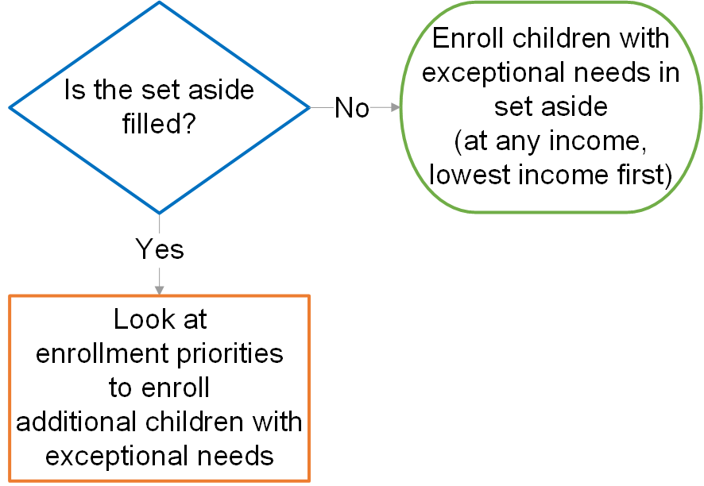

Long description of Figure 1
The diagram uses a depiction of three shapes with connecting arrows to indicate how to enroll children with exceptional needs based on whether the set aside is filled or not. A diamond with a blue outline in the upper left of the visual contains a question asking if the set aside is filled. It indicates with an arrow leading from the blue diamond to a rectangle with an orange outline beneath it that if the answer is yes, the contractor should look at enrollment priorities to enroll additional children with exceptional needs. It indicates with an arrow leading from the blue diamond to an oval with a green outline to the right that if the answer is no, the contractor should enroll the child with exceptional needs at any income in the set aside, enrolling children with the lowest income first.

