CompreheNsive needs assessment
Report of Initial Findings
California Department of Education
Migrant Education Office
Sacramento, 2017

Table of Contents
List of Figures iii
List of Tables v
Acknowledgments vi
Executive Summary viii
Section I: Overview 1
Purpose and Scope 1
California Migrant Education Program 1
Section II: Methodology 5
Comprehensive Needs Assessment Structure, Planning and Data Collection Process and Stakeholder Activities 5
Structure 5
Planning and Data Collection Process 5
Stakeholder Activities 10
Data Limitations 12
Section III: Migrant Student Profile 13
Demographics 13
Academic Achievement 16
English-Language Arts 18
Mathematics 22
California English Language Development Test Results 25
High School Graduation and Dropout Rates 26
Out-of-School Youth 27
Health 29
Data Limitations 30
Section IV: Results and Findings 32
Outcome-based Focus Areas 32
English Language Arts 33
Mathematics 39
English Language Development 45
High School Graduation and Dropout Prevention 48
Output-based Focus Areas 51
School Readiness 51
Out-of-School Youth 55
Health 58
Parent and Family Engagement 60
Student Engagement 63
Appendix A – Calendar of Activities for Development of the Comprehensive Needs Assessment 67
Appendix B – Complete List of Concern Statements 69

List of Figures
Figure 1. Trend in Number of Migratory Children in California, Age 3 to 21 Years, 2011–12 to 2015–16 2
Figure 2. Number of Migratory Children Recruited in California, by Originating Location, 2013–14 4
Figure 3. Trend in Number of Migratory Children in California, by Age Group, 2010–11 to 2014–15 14
Figure 4. Percent Distribution of 2015–16 CAASPP ELA Achievement Levels for Migratory Students, Migratory PFS Students, All Students, and SED Students, Grades 3–8 and 11 22
Figure 5. Percent Distribution of 2015–16 CAASPP ELA Claim 1—Reading Achievement Levels for Migratory Students, Migratory PFS Students, All Students, and SED Students, Grades 3–8 and 11 23
Figure 6. Percent Distribution of 2015–16 CAASPP ELA Claim 2—Writing Achievement Levels for Migratory Students, Migratory PFS Students, All Students, and SED Students, Grades 3–8 and 11 24
Figure 7. Percent Distribution of 2015–16 CAASPP ELA Claim 3—Listening Achievement Levels for Migratory Students, Migratory PFS Students, All Students, and SED Students, Grades 3–8 and 11 24
Figure 8. Percent Distribution of 2015– 16 CAASPP ELA Claim 4—Research/Inquiry Achievement Levels for Migratory Students, Migratory PFS Students, All Students, and SED Students, Grades 3–8 and 11 21
Figure 9. Percent Distribution of 2015–16 CAASPP Math Achievement Levels for Migratory Students, Migratory PFS Students, All Students, and SED Students, Grades 3–8 and 11 22
Figure 10. Percent Distribution of 2015–16 CAASPP Math Claim 1—Concepts and Procedures Achievement Levels for Migratory Students, Migratory PFS Students, All Students, and SED Students, Grades 3–8 and 11 23
Figure 11. Percent Distribution of 2015–16 CAASPP Math Claim 2—Problem Solving and Modeling Achievement Levels for Migratory Students, Migratory PFS Students, All Students, and SED Students, Grades 3–8 and 11 24
Figure 12. Percent Distribution of 2015–16 CAASPP Math Claim 3—Communicating Reasoning Achievement Levels for Migratory Students, Migratory PFS Students, All Students, and SED Students, Grades 3–8 and 11 24
Figure 13. Percent Distribution of 2013–14 and 2014–15 Overall CELDT Scores for Migratory and Non-migratory Students, All Grades 25
Figure 14. Trend in Graduation Rates for Migratory Students and All Students, 2010–11 to 2014–15 27
Figure 15. Trend in Dropout Rates for Migratory Students and All Students, 2010–11 to 2014–15 27

List of Tables
Table 1. Number of Migratory Student Classified as Priority for Service, 2010–11 to 2014–15 3
Table 2. Number of Migratory Children in California, by Age, 2010–11 to 2014–15 15
Table 3. Home Languages for California’s Migratory Students, 2010–11 to 2014–15 16
Table 4. Migrant Education Program Health Service Types and Activities 30

Acknowledgments
Preparation for the development of this statewide Comprehensive Needs Assessment (CNA) began in August 2016. Many dedicated individuals assisted the California Department of Education (CDE) Migrant Education Office (MEO) at different phases throughout this process.
We are indebted to the members of the Management and Data Team of the CDE for designing, implementing and coordinating the development of the 2017 CNA. Team members include:
Celina Torres, Administrator, MEO, CDE
Chunxia Wang, Education Research and Evaluation Consultant, MEO, CDE
Melissa Mallory, Project Lead, Education Programs Consultant, MEO, CDE
Veronica Aguila, Director, English Learner Support Division (ELSD), CDE
The California Comprehensive Center (CA CC) at WestEd provided technical assistance and support throughout the project. Colleagues include:
Debra T. Benitez, Director of Research and Impact Assessment Services, CA CC, WestEd
Glenn Miller, Senior Research Associate, CA CC, WestEd
Lisa Severino, Research Associate, CA CC, WestEd
Laurel Groff, Research Associate, Comprehensive School Assistance Program
Marisela Sifuentes, Research Assistant, WestEd
Meena Kaur, Data Analyst, Comprehensive School Assistance Program
Nane Zadouri, Research Associate, Comprehensive School Assistance Program
Scott Vince, Research Associate, Comprehensive School Assistance Program
To ensure the statewide CNA provided meaningful information as a basis for program development and for the State Service Delivery Plan (SSDP), collecting stakeholder input was essential. The CNA/SSDP Stakeholder Committee utilized small and large group settings to analyze data, develop concerns, and identify migratory student needs. Members include:
Alejandra Mora, Migrant Education Program Advocate, San Diego County Office of Education
Ana Avila, Out-of-School Youth Outreach, San Diego County Office of Education
Esmeralda Perez, Migrant Education Outreach Specialist, Pajaro Valley Unified School District
Gabriela Beas, Migrant Education Program Advocate, San Diego County Office of Education
Giselle Perry, School Counseling Specialist, Migrant Education Advisor Program, Sonoma State University
Herlinda Hurtado, Parent, Bakersfield County Office of Education
Javier Mendoza-Sanchez, Program Manager I, San Joaquin County Office of Education
Jose Morales, Director, Kern County Office of Education
Julio Salazar, Parent/Former State Parent Advisory Council President, Santa Clara County Office of Education
Katherine Scheler, Program Specialist, Bakersfield County Office of Education
Laura Jimenez Trevino, Parent, Fresno County Office of Education
Manuel Nunez, Director, San Joaquin County Office of Education
Margarita Zaske, Director, Santa Maria Bonita School District
Rosa Briones, Parent, Butte County Office of Education
Ruben Castillo, Director, Fresno County Office of Education
Zaida Garcia, Coordinator II, Los Angeles County Office of Education
Additional CDE staff provided invaluable support via facilitation and notetaking during the CNA/SSDP Stakeholder Committee meetings, including:
Elvia McGuire, Education Programs Consultant, MEO, CDE
Flori Huitt, Education Programs Consultant, MEO, CDE
Jamie Contreras, Education Programs Consultant, MEO, CDE
John Oses, Education Programs Assistant, MEO, CDE
Noelia Hernandez, Education Programs Consultant, MEO, CDE
Susie Watt, Education Programs Consultant, MEO, CDE
Finally, special appreciation is due to the administrative and fiscal staff who assisted with the development of this project:
Barbara Garcia, Executive Secretary, ELSD, CDE
Jennifer Cordova, Associate Government Program Analyst, Fiscal Support Office, CDE
Silvia Sataray, Office Technician, MEO, CDE
Zenaida Gutierrez, Administrative Assistant, WestEd
Thank you to these individuals for their vital contributions to this project and report.

Executive Summary
The California Department of Education strives to provide the best possible education for all students within California. Through policy and programmatic activities, the California Department of Education employs a continuous improvement model to refine various aspects of the Migrant Education Program with a focus on student academic, emotional, physical and social success. Development of this statewide comprehensive needs assessment is a necessary step in the continuous improvement of California’s Migrant Education program. The statewide comprehensive needs assessment provides insight into the academic, health, and social-emotional needs of migratory children enrolled in the California MEP. By assessing the needs of migratory children, the state and local Migrant Education Programs are better prepared to provide targeted services to address the unique educational needs for this population.
Preparation for the development of this statewide Comprehensive Needs Assessment began in
August 2016. Regional and state data as well as the Every Student Succeeds Act provide a clear indication of the focus areas that need to be address to assist in increasing migratory students’ academic, emotional, physical, and social success. The nine focus areas discussed in this report include:
- English Language Arts
- English Language Development
- Mathematics
- School Readiness
- High School Graduation and Dropout Prevention
- Out-of-School Youth
- Health
- Parent and Family Engagement
- Students Engagement
The Comprehensive Needs Assessment /State Service Delivery Plan stakeholder committee reviewed the data to develop the following key decision points for each focus area identified within the Results and Findings section of this report: concern statements, need statements, and selecting initial strategies to address the unique educational needs of migratory children. This executive summary highlights a few of the needs identified by the stakeholder committee in key focus areas:
English Language Arts
- An additional 22 percent of Migratory Students need to score Near or Above Standard in reading achievement.
- An additional 21 percent of Migratory Students will move from Below Standard to Near or Above Standard in writing achievement.
English Language Development
- An additional 15 percent of Migratory English learners in Grades 1–3 need to score at the Early Advanced and Advanced levels.
Mathematics
- An additional 21 percent of Migratory Students need to move up a standard level to Near or Above Standard to close the overall mathematics achievement gap.
High School Graduation and Dropout Prevention
- Increase the percent of Migratory Students graduating high school by 1.6 percent.
The last chapter of this report addresses next steps in the continuous improvement cycle for the next iteration of the comprehensive needs assessment and the state service delivery plan process. Improving data collection processes and procedures will further assist the MEP in providing tailored, high-quality services to address the unique educational needs of California’s migratory children.

Section I: Overview

Purpose and Scope
The Elementary and Secondary Education Act, as reauthorized by the Every Student Succeeds Act (20 U.S.C. 6396, 34 CFR § 299.19) requires each state education agency MEP receiving Title I, Part C federal funds to ensure that the state and local operating agencies identify and address the unique educational needs of migratory children through the development of a statewide CNA and SSDP. Every three years, the CDE will develop a statewide CNA that identifies the needs and initial strategies to address those needs of California’s migratory children. The CNA is the foundation for the SSDP, which guides the MEP in planning and service delivery at the state, regional, and local levels.
The CDE conducted a majority of the activities for the development of a new CNA beginning in
August 2016 although the initial process began in 2014–15 with the implementation of local CNAs developed by California’s 20 subgrantees (discussed in detail in Chapter II). The scope of this work included:
- Evaluating migratory student data to guide key decision-making points in the development of the CNA.
- Identifying and examining the unique educational needs of California’s migratory children given the distinctive barriers that the migratory population faces.
- Proposing initial, evidence-based strategies to address the needs of migratory children.
Additionally, the CDE Management and Data Team and CNA/SSDP stakeholder committee focuses on the following migratory populations: pre-K children (ages 3–5), K–12 students, OSY, and migratory parents. This report summarizes the methodology and key decisions of the development of the CNA as well as the initial action steps to assist in the development of the SSDP. The following section provides more detail on the California MEP.

California Migrant Education Program
The California MEP is a federally funded program authorized under Title I, Part C, of the Elementary and Secondary Education Act. The MEP is designed to support high-quality supplemental and comprehensive educational programs for migrant children to help reduce the educational disruption and other problems that result from repeated moves.
California continues to have the largest migratory student population, as it is the leading state in cash farm receipts in the country. California provides over a third of the country’s vegetables and approximately two-thirds of the country’s fruits and nuts. The California Department of Food & Agriculture notes that California’s leading exports in 2015, by value, were almonds, dairy products, walnuts, wine, and pistachios. Due to the high need for agricultural labor, the state’s migratory population is more than twice that of Texas, which is home to the second largest migratory population in the country. In 2014–15, the U.S. Department of Education (ED) reported 102,348 migratory children eligible for services (31 percent of the national total), while Texas reported 42,276 migratory children eligible for services (13 percent of the national total). However, similar to other Title I, Part C funded programs; California’s migratory population has been on the decline for the past several years.
While California’s migratory population remains the largest in the nation, California’s migratory child count decreased to 96,750 in 2015–16, a decrease of nearly 7 percent compared to the numbers identified in 2014–15. This downward trend is consistent across all age groups of migratory children, with the largest population declines among OSY ages 19 to 21 years. Figure 1 shows the downward trend in migratory children population size between 2011–12 and 2015–16.

Figure 1. Trend in Number of Migratory Children in California, Age 3 to 21 years 2011–12 to 2015–16
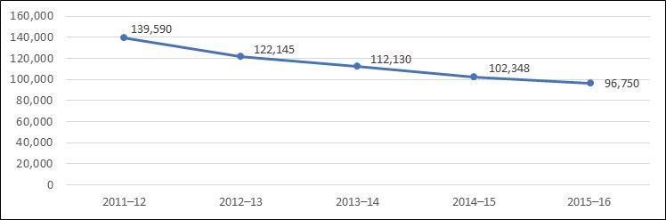
Source: Consolidated State Performance Report, 2011–12 to 2015–16.
The California MEP recruits migratory students who come primarily from different parts of California, Mexico, and several states within the United States. Most of California’s migratory children make intrastate qualifying moves. In 2013–14, California recruited 77,808 migratory children who made a qualifying move within California. The second largest group of migratory children, approximately 36,500 migratory children, made a qualifying move from Mexico. Washington, Oregon, and Arizona also share a good number of migratory children with California. Figure 2 shows the number of children recruited in California by originating location.

Figure 2. Number of Migratory Children Recruited in California, by Originating Location, 2013–14
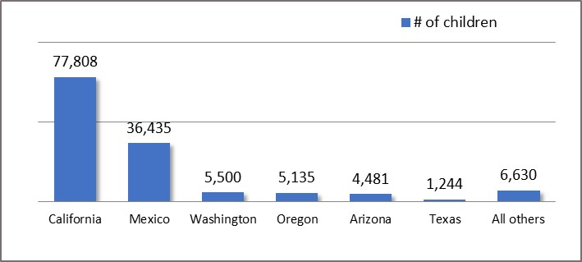
Source: MSIN Databases for the MEP, 2013–14.
Migratory students who made a qualifying move within the previous year and who are failing, or most at risk of failing, to meet the State’s challenging academic standards, or who have dropped out of school, are classified as priority for service (PFS). Local MEPs have the responsibility to ensure that these students are prioritized for MEP services. In 2014–15, the California MEP had a total of 5,231 PFS students, which is an increase of 147 students from 2013–14. Table 1 identifies the number of eligible migratory students classified as PFS for year 2010–11 through 2014–15.

Table 1. Number of Migratory Student Classified as Priority for Service, 2010–11 to 2014–15
2010–11 | 2011–12 | 2012–13 | 2013–14 | 2014–15
6,256 | 6,054 | 6,088 | 5,084 | 5,231
Source: Ed Data Express, 2010–11 to 2014–15.
In California, the MEP is primarily operated based on a regional structure where funding flows directly to county offices of education where a large concentration of migratory workers are found; however, the CDE does fund a few districts directly. In 2016–17, the CDE funded 15 multidistrict regional subgrantees and 5 direct-funded single-district subgrantees. The 15 regional subgrantees work directly with approximately 212 school districts through mutually agreed-on service agreements or Memoranda of Understanding. The California MEP focuses primarily on the following service and assistance areas that are aligned with the Goal Areas identified by the Office of Migrant Education (OME) at ED:
- English Language Arts
- English Language Development
- Mathematics
- High School Graduation/Dropout
- School Readiness
- Parent and Family Engagement
- Out-of-School Youth
California’s MEPs have a range of services during the regular school year and intersession periods dedicated to improving migratory students’ academic achievement.

Section II: Methodology

Comprehensive Needs Assessment Structure, Planning and Data Collection Process, and Stakeholder Activities
The complete CNA process is broadly documented in this section. High-level CNA activities are noted as well as the structure, planning process and stakeholder activities utilized in developing the statewide CNA (see Appendix A for a timeline of major activities). The roles of the Management and Data Team, CNA/SSDP Stakeholder Committee and CNA/SSDP Subcommittees are discussed next.

Structure

Management and Data Team
The primary group responsible for developing, implementing and reporting on the CNA is the Management and Data Team. This group works closely with staff at the CA CC at WestEd and MEP stakeholders. This team made final decisions on key elements included in this report, as rich stakeholder discussion yielded numerous concern and need statements in many of the focus areas.

Comprehensive Needs Assessment/State Service Delivery Plan Stakeholder Committee
ED guidelines indicate that the CNA/SSDP Stakeholder Committee should consist of a broad range of individuals, including parents, with knowledge and experience in determining the needs of migratory children. Each member should have an adequate understanding of the MEP, OME goal areas, data collection and analysis, and promising practices with at-risk youth.
As previously noted, the primary tasks of the CNA/SSDP Stakeholder Committee were to review the statewide migratory children data, develop major areas of concern, identify and prioritize needs, review evidence-based practices and select initial strategies, review and comment on the draft CNA, make recommendations regarding program priorities, and strategies to address the unique needs of migratory children.

Comprehensive Needs Assessment Stakeholder Subcommittees
To ensure the CNA/SSDP Stakeholder Committee met the objectives, stakeholders split into subcommittees facilitated by CDE MEO staff. The subcommittees worked independently, but cooperatively as the larger stakeholder committee. Once the subcommittee completed their tasks, the entire CNA/SSDP Stakeholder Committee reconvened to review the work of each subcommittee offering suggestions and reaching consensus on the decisions made by the subcommittees.

Planning and Data Collection Process
The purpose of the CNA is to identify the statewide unique educational needs of migratory children that must be met for those children to participate effectively in school and to meet California’s challenging state academic standards (34 Code of Federal Regulations 200, Section 200.83). In 2014–15, each of California’s 20 federally funded MEPs implemented local CNAs to identify the needs of the migratory population within their regions. After receipt of the 20 local CNA reports, the MEO launched the statewide CNA development process by establishing a Management and Data Team to oversee the development of the statewide CNA and the SSDP.
The development of the statewide CNA was a multiple step process consisting of careful planning, data collection and analysis, and collaboration with stakeholders. The CDE Management and Data Team followed the broad steps identified below:

Step 1: Planning
With guidance from OME, the CDE identified the process for developing the CNA and SSDP. The following key elements were completed during the planning phase of the CNA/SSDP process:
- Reviewed all CNA and SSDP guidance and resources from OME.
- Designed CNA and SSDP process and timelines complete with milestones.
- Established the CNA/SSDP Stakeholder Committee.

Step 2: Data Collection
Developing appropriate outcomes, measurable performance objectives, performance targets and soliciting authentic stakeholder input are dependent on reliable data. Data for the CNA and SSDP was gathered from multiple sources. Step 2 in the process included the following actions:
- Completed a meta-analysis of the 20 local CNAs administered by MEP subgrantees.
- Developed the Migrant Student Profile.
- Reviewed literature on best practices to address deficiencies for identified focus areas.

Step 3: Gathering Stakeholder Input
The CNA/SSDP Stakeholder Committee participated in a collaborative process to identify key elements of the CNA and SSDP. In Step 3 of the process, stakeholders:
- Reviewed findings from the meta-analysis and the Migrant Student Profile with CNA/SSDP Stakeholder Committee.
- Reviewed evidence-based practices to improve achievement in all areas.
- Made key decisions points for the three major areas of the CNA:
  - Develop and prioritize concern statements
  - Identify and prioritize need statements
  - Select initial strategies to address specific needs
  - Identify areas in which data collection can improve

Step 4: Transitioning to a State Service Delivery Plan
Transitioning from identifying needs in the CNA to developing the appropriate performance targets for the SSDP included:
- Developed the final draft of the statewide CNA.
- Shared the draft statewide CNA with stakeholders, including the State Parent Advisory Council (SPAC), for input and feedback.
- Used CNA as the starting point to initiate the SSDP process.
- Presented the draft performance targets to stakeholders, including the SPAC for input and feedback.
The CDE laid out the plan for developing the CNA and SSDP beginning in August 2016. Focus areas contained in the CNA and SSDP were identified after conducting a meta-analysis of 20 local CNAs implemented by the subgrantees. Additionally, data collection, the development of the Migrant Student Profile and research on best practices for identified focus areas were all conducted prior to relevant stakeholder meetings. With the assistance of interpreters, the CNA/SSDP Stakeholder Committee met four times to review the Migrant Student Profile, deliberated on their concerns about migratory students, and identified migratory student needs. Findings from the CNA/SSDP collaborative process are identified in the next section.
Diagram 1 outlines the process for developing the statewide CNA and SSDP.

Diagram 1. Process for Developing the Statewide Comprehensive Needs Assessment and State Service Delivery Plan
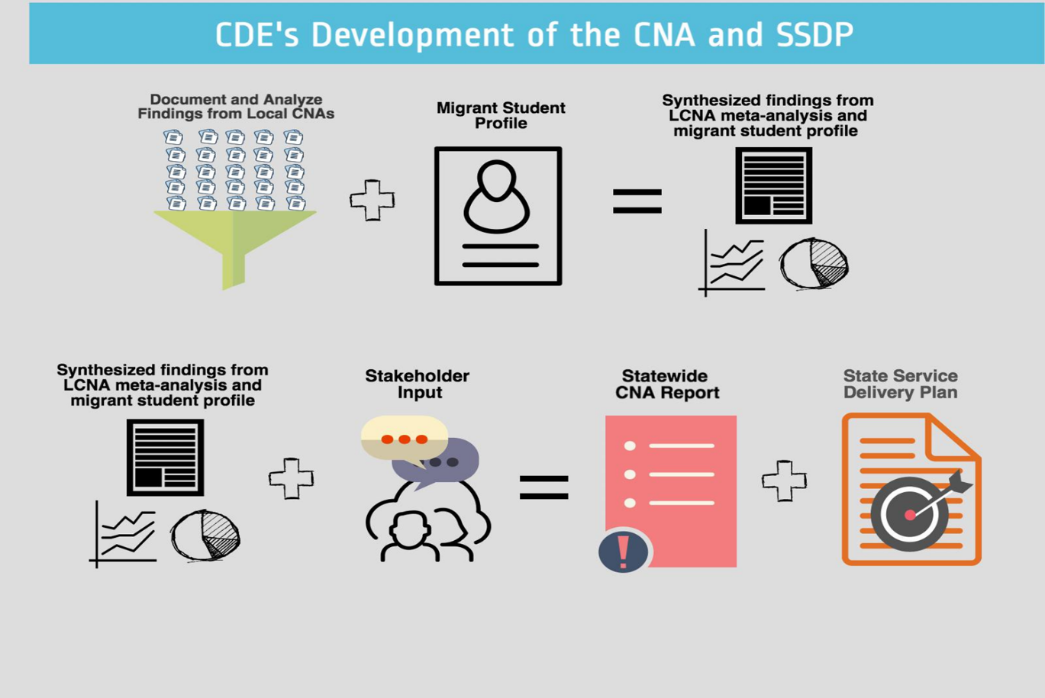
The process for developing the statewide CNA required continued collaboration between the California MEP, MEP subgrantees, and the CA CC at WestEd. In 2014–15, California’s 20 MEP subgrantees each contracted with an independent contractor to develop a local CNA for their region. The independent researchers reviewed student achievement data and collected stakeholder input through focus groups, surveys, and interviews. The local CNAs identify migratory student needs, and in some cases programmatic needs, and strategies to address those needs, and measurable outcomes. When the 20 local CNAs were submitted to the State in 2016, the CDE Management and Data Team developed a meta-analysis based on the data from 20 local CNAs.
The CDE, with technical assistance support from the CA CC at WestEd, analyzed 20 local CNAs conducted in 2014–15 by each of California’s MEP subgrantees, thus initiating step two in the process. The meta-analysis identified common, or reoccurring, themes across the regions. First, the CDE read each of the 20 local CNA reports and documented the following:
- Clearly articulated needs
  - Whether they were priority needs or not
- Clearly articulated solutions
- Clearly articulated measurable outcomes
- Clearly articulated best practices
The items noted above were labeled the local CNA findings and recorded so that each need was clearly linked to its solutions, measurable outcomes, and best practices; and identified by region.
There were 23 focus areas identified based on the analysis of the 20 local CNAs. A few factors played a role in helping the Management and Data Team narrow the number of categories to include in the statewide CNA. Factors included the frequency in which each category was identified by the local CNAs, whether it was a program versus student category, and the requirements within the Every Student Succeeds Act (ESSA) and the Local Control Funding Formula. Additionally, the CDE’s new accountability system, a key element of the Local Control Funding Formula, contains eight state priorities approved by the Legislature in 2013. Among the priorities are student achievement, student engagement, school climate, and parent engagement. With this in mind, the CDE included student engagement as well as parent engagement as focus areas in the CNA and SSDP. The nine focus areas discussed in this CNA and addressed in the SSDP include: English language arts, English language development, mathematics, high school graduation/dropouts, school readiness, Out-of-School youth, health, student engagement, and parent engagement. Diagram 2 illustrates how CDE grouped information through a categorization process.

Diagram 2: Categorization Process for the Local Comprehensive Needs Assessment Meta-analysis
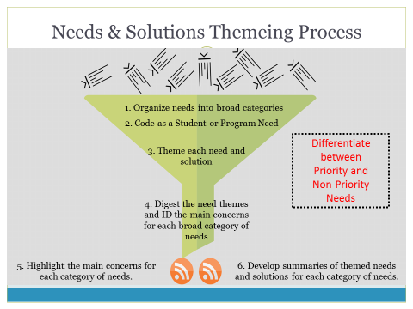
During this time, the CDE, with technical assistance from CA CC, developed the Migrant Student Profile and resources on evidence-based practices to address migratory student needs for all nine focus areas. With all the data gathered and analyzed, the CDE initiated Step 3, Gathering Stakeholder Input. The CNA Stakeholder Committee split into subcommittees who met four times to complete four key objectives for each focus area: 1) review statewide data and local CNA findings, 2) develop concern statements, 3) identify and prioritize needs, and 4) review best practices and select initial strategies to address the identified needs. These key decisions points were then discussed and finalized by the Management and Data Team, ultimately becoming the basis for the development of the CNA.

Stakeholder Activities

Developing Concern Statements
In preparation for the CNA/SSDP Stakeholder Committee meetings, the CDE prepared the Migrant Student Profile, which included quantitative and qualitative data for the following nine focus areas identified by the Management and Data Team to be included in this report:
- English Language Arts
- English Language Development
- Mathematics
- School Readiness
- High School Graduation and Dropout Rates
- Out-of-School Youth
- Health
- Parent and Family Engagement
- Student Engagement
The purpose of the Migrant Student Profile was to provide stakeholders with data on migratory children to inform the CNA work. After the initial orientation meeting, facilitators facilitated discussion on and the findings from the meta-analysis and common understand of key evaluation vocabulary. Stakeholders also participated in guided practice for completing the clearly identified tasks within their subcommittees to: 1) review statewide data, 2) develop concern statements, 3) identify and prioritize needs, and 4) review evidence based practices and select initial strategies to address specific needs. Facilitators guided focus area specific subcommittees first in a review of the demographic and then focus area specific data within the Migrant Student Profile to assist stakeholder subcommittees in developing and selecting concern statements for each of the nine focus areas based on consensus of the subcommittee members (see the complete list of concern statements in Appendix B). Concern Statements were prioritized by the following criteria: 1) whether the concern directly related to student achievement, 2) feasibility of addressing the concern given limited resources, and 3) program purpose. The priority concern statements were the foundation for developing the need statements. Measurable program objectives developed in coordination with the process of producing the statewide CNA, are reported in the SSDP along with the outcomes, outputs, and performance targets.

Establishing Need Statements
Once concern statements were developed and prioritized, the CNA Stakeholder Committee began the task of developing need statements. Guided by the concern statements, data, and local expertise, stakeholders identified the present need as the difference between “what is” and “what should be” for the specific concern. Utilizing guidance from ED, the CDE adopted the following criteria for developing need statements:
- Derived from a participatory process
- Considers the magnitude of the gap
As numerous concern statements were developed, subcommittees developed need statements for only the priority concerns identified for each focus area.

Data Collection and Analysis
The CDE revised the previous iteration of the CNA data collection process to streamline the CNA development process. This shift in the data collection process reorganized the structure by which the CDE developed the statewide CNA. Instead of completing a majority of the data collection and analysis while meeting with stakeholders at the state level, data collection, including soliciting stakeholder input, began early on in the process.
Data collection and analysis commenced in 2014–15 with the implementation of the 20 local CNAs at the subgrantee level. Subgrantees were allocated additional funding to hire an independent research firm to conduct a comprehensive needs assessment within their regions. While each final report submitted to the CDE varied in methodology, most needs assessments included a review of student achievement data and gathering stakeholder input from MEP staff, parents, students, and community members through surveys, interviews, and focus groups. These local CNAs identified the needs, strategies (or solutions) to address these needs, and measurable outcomes for their program areas. Submitted in April 2016, the CDE then conducted a meta-analysis organizing the material for stakeholder use as described earlier in this chapter.
The CDE Management and Data Team did much of the data collection with the assistance of the CA CC prior to the first CNA Stakeholder Meeting. The meta-analysis, Migrant Student Profile and resources on evidence-based practices to improve outcomes identified by the research in specific focus areas, were provided to stakeholders and reviewed during the first four stakeholder meetings. To ensure the Migrant Student Profile contained the most recent and relevant data, the CDE Management and Data Team worked to craft a specific Migrant Student Profile data request to answer very specific research questions identified for each focus area (please see the Migrant Student Profile for more detail). Although most of the data was collected prior to the meeting, additional data was collected based on review of the Migrant Student Profile and questions that arose during stakeholder discussions.

Data Limitations
The CDE faced a few challenges when collecting and analyzing data such as data reliability with regard to the local CNAs, data reliability, and data availability. While the CDE was able to gain important information from the local CNAs, there were some notable limitations to these reports. First, the evaluation language used within each report varied a great deal. For example, outcome and output were used interchangeably. This made the categorization process slightly challenging at times. Additionally, stakeholders (e.g., MEP staff, parents, students, etc.) who participated in the local CNA interviews and focus groups may have had limited knowledge of the needs assessment process and its specific vocabulary; thus providing solutions when asked to identify priority needs, and vice versa, reporting needs when asked to identify solutions. Similarly, many of the measurable outcomes were either not measurable or were actually an output. This variance identifies the need for additional training for MEP subgrantees on implementing a local needs assessment within the subgrantees’ program areas to ensure consistency and fidelity of data collection and reporting.
Additionally, the California Healthy Kids (CHKS) report can provide insights into the migrant students' feelings and perceptions towards school but might not be claimed as the exact representation of the general student population, or the migrant subgroup. As the report indicates, the validity and representativeness of the results will be adversely affected if the student response rate is lower than 60 percent. For the Core Module survey, the CHKS sample was surprisingly high, at 11,102. The migrant population of middle and high school students was 34,671 for 2014-15 year and thus the response rate of 32 percent, even though not even close to 60 percent, is much higher than the state in general. For the School Climate Module, the migrant response rate was low, only 8 percent (2704 out of 34,671) due to a smaller sample schools, average 200 schools compared to 700 schools for the Core Module.
Data limitations, or lack of data in some focus areas, prevented the stakeholders from further developing specific concern and needs statements. Currently, the CDE is in the process of developing a plan to collect more robust data where feasible. Plans for meeting future data needs are further discussed in the Results and Findings section of this report. Data limitations for the Migrant Student Profile are identified in the Migrant Student Profile chapter.

Section III: Migrant Student Profile
For the purposes of this report, the CDE included an abridged version of the Migrant Student Profile. The Migrant Student Profile was designed to assist stakeholders in understanding the demographic characteristics and unique educational needs of California’s MEP-eligible children. It provides awareness of migratory children’s population size, age, home language, and educational outcomes. It also explores characteristics of California’s migratory OSY population, and migratory children’s school readiness, parent involvement, health service needs, and engagement in school. Stakeholders utilized this profile as they identified migratory student needs. The CNA briefly reviews student achievement data, English language proficiency, high school graduation and dropout rates as well as OSY demographics and MEP health service data. For more information on parent and family engagement, student engagement and school readiness, please see the complete Migrant Student Profile.

Demographics

Population Size and Trends
In 2014–15, California identified 102,348 migratory children, a decrease of nearly 36 percent compared to the numbers identified in 2010–11. This downward trend is consistent across all age groups of migratory children, with the largest population declines among OSY ages 19 to 21 years. Figure 3 shows the downward trend in migratory children population size, by age group between 2010–11 and
2014–15. Table 2 details changes in the migratory child population size by age over the five-year period.

Figure 3. Trend in Number of Migratory Children in California, by Age Group, 2010–11 to 2014–15
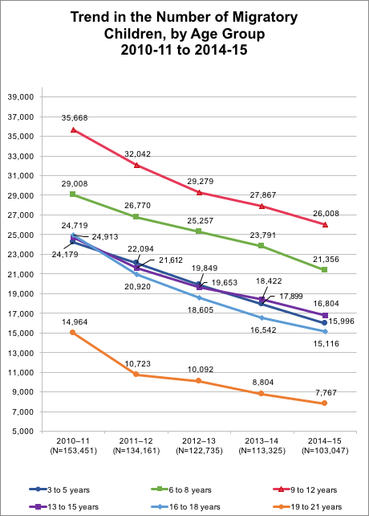
Source: MSIN Databases for the MEP, 2010–11 to 2014–15.

Table 2. Number of Migratory Children in California, by Age, 2010–11 to 2014–15
Age | 2010-11 | 2011-12 | 2012-13 | 2013-14 | 2014-15 | Percent Change Over 5 Years
3 years | 6,497 | 5,749 | 5,126 | 4,833 | 4,230 | -35%
4 years | 8,309 | 7,568 | 6,699 | 5,977 | 5,513 | -34%
5 years | 9,373 | 8,777 | 8,024 | 7,089 | 6,253 | -33%
6 years | 9,925 | 8,957 | 8,569 | 7,891 | 6,885 | -31%
7 years | 9,650 | 9,176 | 8,387 | 8,107 | 7,212 | -25%
8 years | 9,433 | 8,637 | 8,301 | 7,793 | 7,259 | -23%
9 years | 9,006 | 8,183 | 7,658 | 7,557 | 6,922 | -23%
10 years | 9,213 | 7,950 | 7,435 | 7,029 | 6,801 | -26%
11 years | 8,979 | 8,076 | 7,122 | 6,838 | 6,204 | -31%
12 years | 8,470 | 7,833 | 7,064 | 6,443 | 6,081 | -28%
13 years | 8,364 | 7,244 | 6,904 | 6,320 | 5,743 | -31%
14 years | 8,464 | 7,197 | 6,520 | 6,319 | 5,610 | -34%
15 years | 7,891 | 7,171 | 6,229 | 5,783 | 5,451 | -31%
16 years | 8,390 | 7,034 | 6,433 | 5,756 | 5,295 | -37%
17 years | 8,703 | 7,353 | 6,378 | 5,786 | 5,257 | -40%
18 years | 7,820 | 6,533 | 5,794 | 5,000 | 4,564 | -42%
19 years | 5,140 | 3,869 | 3,384 | 3,077 | 2,543 | -51%
20 years | 4,732 | 3,597 | 3,269 | 2,813 | 2,562 | -46%
21 years | 5,092 | 3,257 | 3,439 | 2,914 | 2,662 | -48%
Total | 153,451 | 134,161 | 122,735 | 113,325 | 103,047 | -33%
Source: MSIN Databases for the MEP, 2010–11 to 2014–15.

Home Language
Statewide, approximately a quarter of all students are ELs, yet among migratory students there are far greater concentrations of ELs. In grade levels kindergarten through five, migratory students are at least twice as likely as all students to be classified as an EL, and those in grade levels six through twelve are at least three times as likely. Approximately half of all migratory students are classified as ELs, with a higher concentration in early elementary grades (74 to 81 percent).
Between 2010–11 and 2014–15, California’s migratory children reported at least 31 different home languages. For the 2014–15 program year, Spanish was the most prevalent home language (97 percent), followed by Mixteco (2 percent), then Punjabi (less than 1 percent). The distribution of home languages among California’s migratory students has remained consistent during the past five years. Table 3 details the prevalence of the most common home languages reported for California’s migratory children over the past five program years.

Table 3. Home Languages for California’s Migratory Students, 2010–11 to 2014–15
Home Language¹ | 2010–11  (N=75,115) | 2011–12  (N=67,231) | 2012–13  (N=55,391) | 2013–14  (N=45,217) | 2014–15  (N=35,915)
Spanish | 95.85% | 96.42% | 96.90% | 96.76% | 96.98%
Mixteco | 1.66% | 1.55% | 1.60% | 1.77% | 1.61%
Punjabi | 0.02% | 0.59% | 0.59% | 0.58% | 0.60%
Hmong | 1.50% | 0.98% | 0.43% | 0.38% | 0.34%
Cantonese | 0.08% | 0.08% | 0.09% | 0.08% | 0.06%
English | 0.03% | 0.04% | 0.03% | 0.04% | 0.04%
Vietnamese | 0.03% | 0.03% | 0.04% | 0.03% | 0.03%
Korean | 0.02% | 0.02% | 0.02% | 0.02% | 0.02%
Urdu | 0.01% | 0.02% | 0.02% | 0.02% | 0.02%
Filipino  (Pilipino or Tagalog) | 0.01% | 0.02% | 0.02% | 0.02% | 0.01%
Portuguese | 0.53% | 0.01% | 0.01% | 0.00% | 0.01%
Other non–English languages | 0.22% | 0.20% | 0.22% | 0.26% | 0.26%
¹This table includes home languages that represented at least 0.01 percent of migratory students in program year 2014–15. Reported languages with percent distributions less than 0.01 percent in that program year include: Arabic, Armenian, Burmese, Cebuano (Visayan), Chaozhou (Chiuchow), French, German, Hindi, Ilocano, Khmer (Cambodian), Lahu, Lao, Marshallese, Mien (Yao), Pashto, Polish, Samoan, Somali, and Thai. Source: CDE CELDT Data Files, 2010–11 to 2014–15.

Academic Achievement
To explore migratory students’ academic needs, the CDE compared migratory students’ 2014–15 and 2015–16 California Assessment of Student Performance and Progress (CAASPP) scores to that of migratory PFS students, all students and socioeconomically disadvantaged (SED) students. The CDE also examined migratory ELs’ performance on the CELDT and compared it to that of non-migratory ELs.
The following section details several key findings:
- On the 2014–15 and 2015–16 CAASPP, Migratory Students performed below All Students and SED students across all grade levels in English language arts (ELA) measures. Migratory Students were consistently less likely than All Students and SED students to perform near or above the standard, and consistently more likely to perform below the standard.
- Migratory PFS Students performed below all student groups in both ELA and math standards on the 2014–15 and 2015–16 CAASPP.
- Migratory EL students are less likely than non-migratory EL students to score Advanced or Early Advanced on CELDT measures, and more likely to score Beginning or Early Intermediate. These gaps are more pronounced for students in grade levels one through three.

California Assessment of Student Performance and Progress Results
Beginning with the 2013–14 school year, CAASPP replaced the Standardized Testing and Reporting (STAR) system which has been in place since 1998. The CAASPP’s Smarter Balance ELA and Mathematics assessments reflect California’s state-adopted academic standards. The CAASPP allows students to demonstrate analytical writing, critical thinking, and problem-solving skills along with their knowledge of content knowledge in ELA and Mathematics.
Student scores are reported on overall achievement and by claims that focus on specific knowledge and skills. Overall ELA or math achievement levels consist of Level 1 – Standard Not Met, Level 2 – Standard Nearly Met, Level 3 – Standard Met and Level 4 – Standard Exceeded. The three scoring levels for the claim data include: Below Standard, Near Standard and Above Standard.
In 2015–16, there were 96,750 migratory students enrolled in the Migrant Education Program. Of these students, 80,402 students attend Grades K–12. Migratory students participating in California’s alternate assessments will not take the Smarter Balance Summative Assessment for ELA and math. Similarly, migratory students who are designated as ELs and who are in their first 12 months of attending a school in the United States will only take the summative assessment in math. Since the CAASPP only tests students in Grades 3–8, and 11, between 33,000 and 35,000 students took the CAASPP test.

English-Language Arts
Based on the 2015–16 CAASPP, Migratory Students performed below All Students and SED Students on overall ELA achievement with Migratory PFS Students performing at lower levels than all populations with one exception – Migratory PFS Students were one percent more likely than the whole migratory student population to score at Standard Nearly Met. Additionally, half of the Migratory Students scored at Standard Not Met compared to 28 percent of All Students. Similarly, 60 percent of Migratory PFS Students’ overall ELA achievement was identified as Standard Not Met. Although 49 percent of All Students met or exceeded the standard, only 24 percent of Migratory Students and 11 percent of Migratory PFS Students did so. Therefore, Migratory Students, especially Migratory PFS Students, are consistently less likely to meet or achieve ELA achievement standards, and more likely to not meet the standards. Figure 4 shows the percent distribution of ELA achievement for Migratory, Migratory PFS, All, and SED Students on the 2015–16 CAASPP.

Figure 4. Percent Distribution of 2015–16 CAASPP ELA Achievement Levels for Migratory Students, Migratory PFS Students, All Students, and SED Students, Grades 3–8 and 11
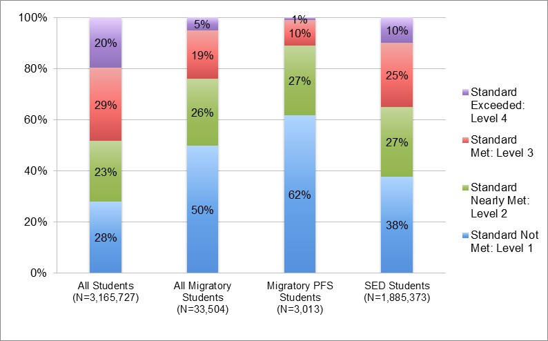Sources: CDE CAASPP P2 Data File, 2015–16; MSIN Data Files, 2015–16.
Students’ CAASPP scores are also categorized by claims. As a reminder, the claims for ELA are:
- Claim 1 - Reading
- Claim 2 - Writing
- Claim 3 - Speaking and Listening
- Claim 4 - Research and Inquiry
Based on their assessment performance, students are assigned one of three claim achievement levels: Below Standard, Near Standard, or Above Standard.
Across the four ELA claims, Migratory Students were consistently less likely than All Students and SED Students to perform Near or Above Standard, and consistently more likely to perform Below Standard. While there were a handful of instances in which Migratory Students were more likely than All Students to perform at Near Standard on all the claim data at specific grade levels, the gap was relatively small and the trend of Migratory Students being less likely to outperform All Students when reviewing grade level claim scores at Above Standard remained consistent. Figures 5 through 8 show the percent distribution for all claim data for Migratory, Migratory PFS, All, and SED Students.

Figure 5. Percent Distribution of 2015–16 CAASPP ELA Claim 1 - Reading Achievement Levels for Migratory Students, Migratory PFS Students, All Students, and SED Students, Grades 3–8 and 11
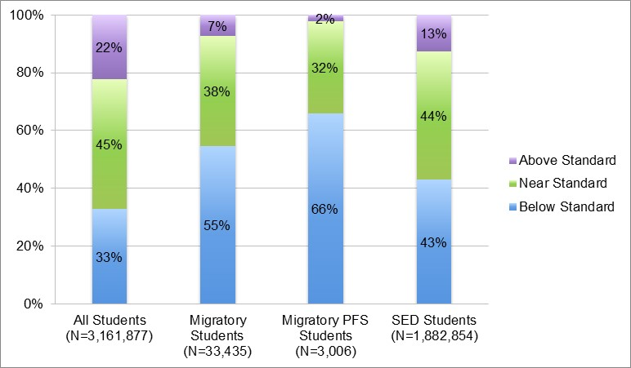Sources: CDE CAASPP P2 Data File, 2015–16; MSIN Data Files, 2015–16.

Figure 6. Percent Distribution of 2015–16 CAASPP ELA Claim 2 - Writing Achievement Levels for Migratory Students, Migratory PFS Students, All Students, and SED Students, Grades 3–8 and 11
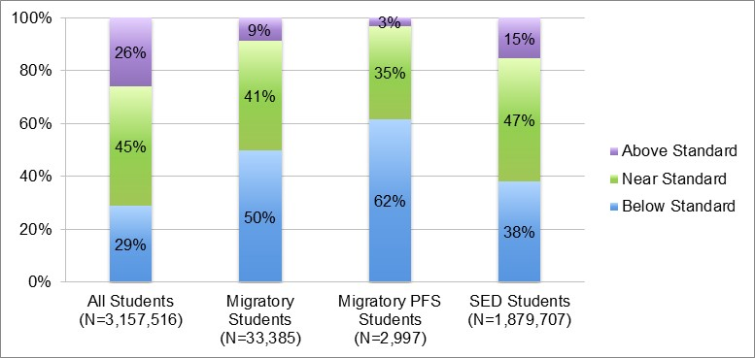Sources: CDE CAASPP P2 Data File, 2015–16; MSIN Data Files, 2015–16.

Figure 7. Percent Distribution of 2015–16 CAASPP ELA Claim 3 - Listening Achievement Levels for Migratory Students, Migratory PFS Students, All Students, and SED Students, Grades 3–8 and 11
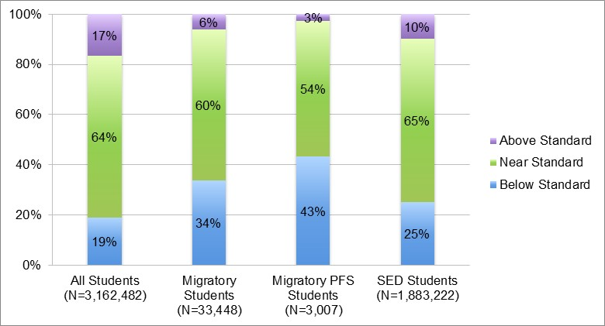Sources: CDE CAASPP P2 Data File, 2015–16; MSIN Data Files, 2015–16.

Figure 8. Percent Distribution of 2015– 16 CAASPP ELA Claim 4 - Research/Inquiry Achievement Levels for Migratory Students, Migratory PFS Students, All Students, and SED Students, Grades 3–8 and 11
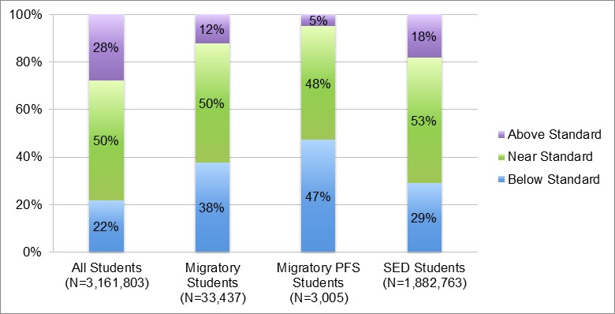Sources: CDE CAASPP P2 Data File, 2015–16; MSIN Data Files, 2015–16.

Mathematics
Similar to the results on the 2015–16 ELA Achievement results, Migratory Students were more likely to perform below All Students and SED Students on math achievement with Migratory PFS Students performing at lower levels than all populations on the 2015–16 CAASPP Math achievement. Thirty-seven percent of All Students met or exceeded the standard for overall math achievement compared with only 16 percent of Migratory Students who met or exceeded the standard; only five percent of Migratory PFS Students met the standard and none of them exceeded the standard. Moreover, Migratory and Migratory PFS Students were more likely to score at Below Standard when compared to All and SED Students at all grade levels on claims 1–3. Figure 9 shows the percent distribution of 2015–16 CAASPP math achievement levels for Migratory Students, Migratory PFS Students, All Students, and SED Students.

Figure 9. Percent Distribution of 2015–16 CAASPP Math Achievement Levels for Migratory Students, Migratory PFS Students, All Students, and SED Students, Grades 3–8 and 11
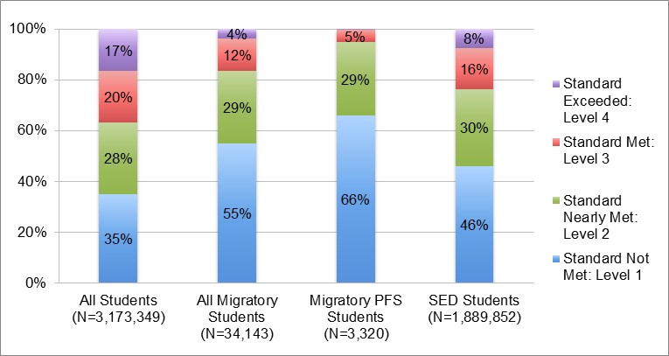Sources: CDE CAASPP P2 Data File, 2015–16; MSIN Data Files, 2015–16.
Students’ CAASPP mathematics scores are also categorized by claims. As a reminder, the claims for mathematics are:
- Claim 1 - Concepts and Procedures
- Claim 2 - Problem Solving
- Claim 3 - Communicating Reasoning
Based on their performance, students are assigned one of three claim achievement levels: Below Standard, Near Standard, or Above Standard. Figures 10 through 12 illustrate the percent distribution of 2015–16 CAASPP data for each of the three mathematics claims.

Figure 10. Percent Distribution of 2015–16 CAASPP Math Claim 1 - Concepts and Procedures Achievement Levels for Migratory Students, Migratory PFS Students, All Students, and SED Students, Grades 3–8 and 11
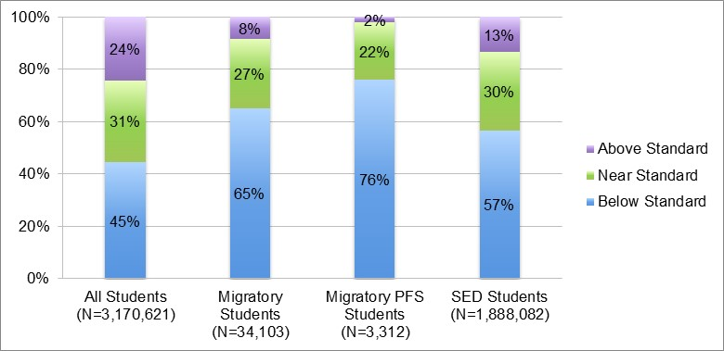Sources: CDE CAASPP P2 Data File, 2015–16; MSIN Data Files, 2015–16.

Figure 11. Percent Distribution of 2015–16 CAASPP Math Claim 2 - Problem Solving and Modeling Achievement Levels for Migratory Students, Migratory PFS Students, All Students, and SED Students, Grades 3–8 and 11
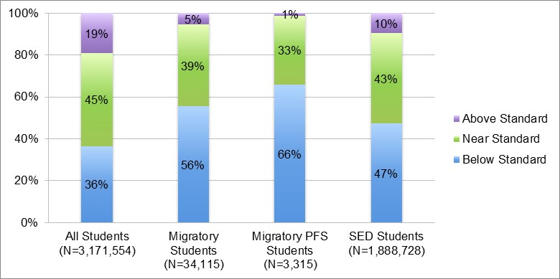Sources: CDE CAASPP P2 Data File, 2015–16; MSIN Data Files, 2015–16.

Figure 12. Percent Distribution of 2015-16 CAASPP Math Claim 3 - Communicating Reasoning Achievement Levels for Migratory Students, Migratory PFS Students, All Students, and SED Students, Grades 3–8 and 11
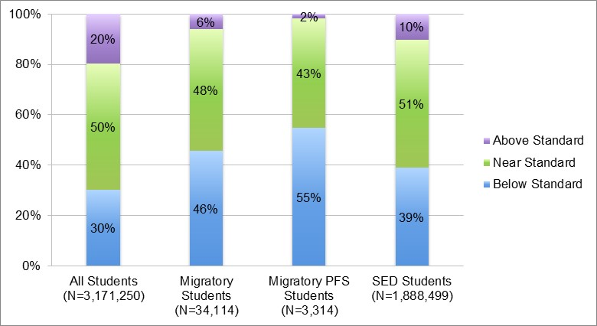Sources: CDE CAASPP P2 Data File, 2015–16; MSIN Data Files, 2015–16.

California English Language Development Test Results
In California, students in grade levels kindergarten through twelve, whose home language is not English, are required by law to be assessed in English language proficiency (ELP). California uses the California English Language Development Test (CELDT) as the ELP assessment. The CELDT measures a student's ELP in listening, speaking, reading, and writing, and scores students on a five-point scale, ranging from Beginning to Advanced.
To identify migratory student gaps in ELP, the CDE analyzed differences in the annual CELDT assessment scores for migratory and non-migratory students in 2013–14 and 2014–15 identified as English learners (ELs). The annual assessment is administered in the fall of each year, and differs from the student’s initial assessment, which is administered to students who are new to public education or who are new to a district and have no previous CELDT results.
In both 2013–14 and 2014–15, Migratory EL students were 10 percentage points less likely than Non-migratory EL students to score as Advanced or Early Advanced on the overall CELDT measure, and 10 percentage points more likely to score as Beginning or Early Intermediate. Similar gaps are found across all grade spans. Figure 11 shows the percent distribution of Migratory and Non-migratory students’ overall ELP on the 2013–14 and 2014–15 CELDT. For detailed exploration of Migratory and Non-migratory students’ CELDT performance by grade in both 2013–14 and 2014–15, see the complete Migrant Student Profile.

Figure 13. Percent Distribution of 2013–14 and 2014–15 Overall CELDT Scores for Migratory and Non-migratory Students, All Grades
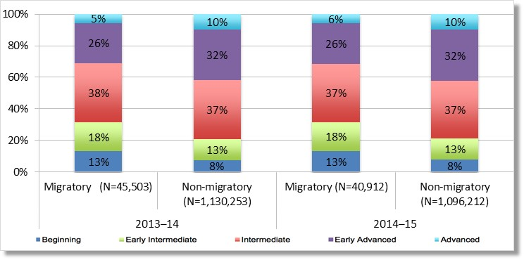Source: CDE CELDT Data Files, 2013–14 to 2014–15.

High School Graduation and Dropout Rates
The CDE reviewed the four-year adjusted cohort graduation and dropout data for two focus areas: high school graduation and dropout prevention and as an indicator of student engagement. Examining the trends in Migratory and All Students’ graduation and dropout rates revealed one key finding:
- Although California’s migratory student population is less likely than all students to graduate and more likely to drop out of school, migratory students appear to be closing these gaps. Between 2013–14 and 2014–15, the graduation rate gap decreased from six percentage points to one percentage point; and between 2012–13 and 2014–15, the dropout rate gap declined from four percent to half a percentage point.
Between 2010–11 and 2014–15, Migratory Students’ high school graduation rates trailed the graduation rates of All Students. During that same time period, migratory students were more likely than all students to drop out of school.
Migratory students appear to be closing these graduation and dropout rate gaps. Migratory Students’ graduation rates increased by eight percentage points over the five-year period (from 73 percent to 81 percent), while the graduation rate for All Students increased by only five percentage points (to 82 percent). Meanwhile, Migratory Students’ dropout rates decreased by six percentage points from 17 percent to 11 percent, while that of All Students dropped by four percentage points. Figure 12 shows the trend in graduation and rates for Migratory and All Students between 2010–11 and 2014–15. Figure 13 shows the trends in dropout during the same time period.

Figure 14. Trend in Graduation Rates for Migratory Students and All Students, 2010–11 to 2014–15
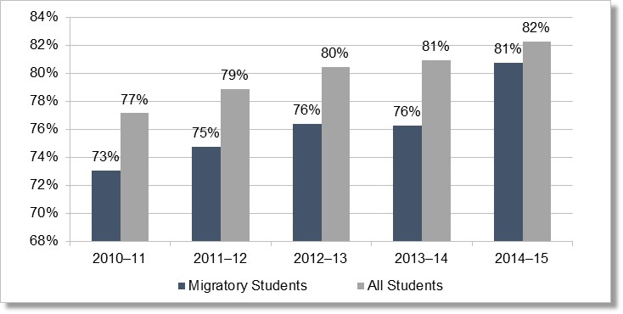Source: CDE, DataQuest, https://dq.cde.ca.gov/dataquest/

Figure 15. Trend in Dropout Rates for Migratory Students and All Students, 2010–11 to 2014–15
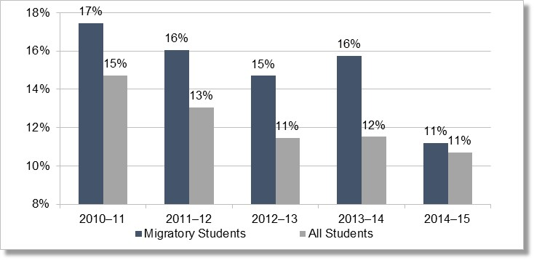
Source: CDE, DataQuest, https://dq.cde.ca.gov/dataquest/

Out-of-School Youth
California’s migratory Out-of-School Youth, or OSY, are youth up through age 21 who are currently not enrolled in a K–12 school, and have not graduated from high school, or passed a high school equivalency examination. Migratory OSY may include youth who have dropped out of school, are working on credit recovery outside of a K–12 school, or are here-to-work. Here-to-work OSY are youth who have moved to the United States with the primary purpose of working, many of whom are traveling and working without a guardian.
The CDE examined trends in California’s migratory OSY population size between 2010–11 and 2014–15; and for a sample of OSY from program year 2015–16, explored their home languages, referral needs, access to transportation, and here-to-work versus credit recovery status.
The following section details several key findings:
- California’s migratory OSY population has declined by nearly 50 percent over the past five years from 18,302 to 9,293.
- Sixteen percent, or 1,519, of California’s OSY population is under the age of 18 years.
To gain a better understanding of California’s migratory OSY population, the CDE collected just over 200 OSY Independent Needs Assessments (INA) and Migrant Learning Action Plan (MLAP) from 11 subgrantees. Due to data limitations, the CDE reviewed a sample of 100 OSY INAs and MLAPs from five of California’s 20 MEP subgrantees for the 2015–16 program year. This review provided a limited view of OSY’s home languages, referral needs, access to transportation and whether the youth were here-to-work or in credit recovery status. Although this review provides context to the needs of California’s OSY, these findings should not be extrapolated to the overall OSY population in California as the sample size was small and the CDE is not aware of local sampling practices used to select the INAs. Rather, this sample provides the CDE a basis for developing a process of collecting detailed OSY data from MEP subgrantees.
- Among a sample of 100 2015–16 migratory OSY:
  - Spanish is the most common home language, but nearly seven percent, or 7 out of the 100 OSY INAs/MLAPs sampled, speak an indigenous language;
  - Nearly 60 percent were here-to-work, and a quarter have no access to transportation;
  - OSY’s most common need-based referrals were for high school graduation services (62 percent), followed by English as a Second Language services (47 percent), and health services (14 percent).
The students included in 2015–16 OSY sample were served in five MEP program areas and ranged in age from 13 years to 21 years. Nearly 85 percent of the sample was age 18 or over, and 83 percent reported that their home language was Spanish. Seven percent of the OSY sample reported speaking an indigenous language at home, including Mixteco, Triqui, and Chatino Bajo.

Health
The CDE explored the patterns of health services provided to California’s Migrant children as an indicator for their priority health needs. Using an MSIN data file with MEP health service records for a subset of California’s migratory children, the CDE examined the distribution of health services provided each year between 2010–11 and 2014–15, as well as how the types of health services were distributed among different age spans of migratory children. This analysis revealed several key findings:
- The relative frequency of health support services has increased each year, by a total of 16 percentage points between 2010–11 and 2014–15, while the relative frequency of health education has decreased by 11 percentage points and that of referral services by 6 percentage points.
- Among referral services, the frequency of dental referrals/follow-up and medical referrals/follow-up declined by 36 percent and 24 percent, respectively, between 2010–11 and 2014–15. During the same time period, the frequency of vision referrals/follow-up increased by more than 200 percent.
- Among support services, advocacy and coordination activities experienced an 11-fold increase between 2010–11 and 2014–15, while dental and vision screenings each increased more than 200 percent. During the same time period, the frequency of dental treatments declined by 66 percent, and medical screenings and treatments by 48 and 40 percent, respectively.

Health Services and Activities
The CDE categorized MEP health services into four broad service types: Referral Services, Support Services, Health Education, and Other Instructional. Each of these service types includes one or more discreet health service activities. Table 4 shows the MEP health service types and activities used to explore the possible health needs of California’s migratory children.

Table 4. Migrant Education Program Health Service Types and Activities
Service Type | Activities
Referral Services | - Dental Referral and Follow-up  - Hearing Referral and Follow-up  - Medical Referral and Follow-up  - Vision Referral and Follow-up
Support Services | - Advocacy/Coordination of Services  - Dental Screening  - Dental Treatment  - Hearing Screening  - Hearing Treatment  - Medical Screening  - Medical Treatment  - Nutrition  - Vision Screening  - Vision Treatment
Health Education | - Health education
Other Instructional | - Assessment
Between 2010–11 and 2014–15, the average number of health services provided per migratory child increased from 1.6 services in 2010–11 to 1.9 services in 2014–15. Over the same time period, the most frequently provided service type was Support Services, comprising 77 percent of all MEP health services in 2014–15. Other Instructional Assessment was the least provided service, with only two instances on record in
2014–15.
The relative frequency of support services has increased each year, by a total of 16 percentage points over the five-year period, while the relative frequency of health education has decreased by 11 percentage points, and that of referral services by 6 percentage points.

Data Limitations
The CDE’s INA/MLAP review provides a limited view of OSY’s home languages, referral needs, access to transportation, and whether the youth were here-to-work or in credit recovery status. Although this review provides context to the needs of California’s migratory OSY, these findings should not be extrapolated to the overall OSY population in California, as the sample size was small and the CDE is not aware of local sampling practices used to select the INAs.
Other focus areas, such as Parent Involvement, Student Engagement, and Health, also had data limitations as minimal data is currently available for migratory students statewide. The CDE is in the process of developing data collection tools and procedures to ensure that this information is available for the next cycle of the CNA. More information on these limitations are discussed within the specific sections.

Section IV: Results and Findings
This section of the statewide CNA identifies the outputs developed by the CNA/SSDP Stakeholder Committee, subcommittees and the CDE Management and Data Team for each of the nine focus areas. Stakeholders split into subcommittees and were charged with developing the following outputs for their specific focus areas:
- Concern Statements based on statewide data
- Data summaries that highlight the data findings relative to the original concern statement
- Need statements that establish a numerical gap (when possible) of “what is” and “what should be”
- Initial strategies to address specifically identified needs
Due to the numerous focus areas, and availability of statewide data, the CDE Management and Data Team divided the focus areas into two categories: outcome-based and output-based focus areas. While some identified needs lent themselves to measuring outcomes (i.e., a change in skills, knowledge, behavior, etc.), other specified needs were better suited to be measured by outputs (i.e., what the program produces through services). Criterion used to prioritize the focus areas were determined by the areas of focus within ESSA and OME’s Goal Areas. Outcome-based focus areas required by the state of its subgrantees consist of: 1) ELA, 2) Math, 3) ELD, and 4) High School Graduation and Dropout Prevention. The output-based focus areas, which are encouraged by the state, include the remaining focus areas: 5) School Readiness, 6) OSY, 7) Health, 8) Parent and Family Engagement, and 9) Student Engagement; however, the SSDP will contain both outcomes and outputs for high school graduation and school readiness as identified needs required outcome and output-based measures.

Outcome-based Focus Areas
The outcome-based focus areas will be the fundamental target areas for the SSDP. These target, or focus, areas will to guide the MEP in the planning and service delivery at the state, regional and local levels. As noted above, the primary focus areas are ELA, mathematics, ELD and high school graduation and dropout. The SSDP will identify specific outcomes, measurable performance objectives, and performance targets for these focus areas based on the needs developed in this CNA.
The discussion of the first outcome-based focus area, ELA, illustrates the process that took place as the subcommittee reviewed data to develop concern and need statements as well as selected initial strategies. In addition to the narrative of the process, key decision points are outlined in tables for ease of review. Subsequent focus areas begin by identifying the key data points discussed at the stakeholder subcommittee meetings and key decision points for each focus area are summarized in Tables 7 through 34.

English Language Arts
The 2015 English Language Arts and English Language Development Framework for California Public Schools Kindergarten through Grade Twelve (Framework) emphasis the need to develop both literacy and language to increase readiness for college, careers and civic life. As noted in the Framework, reading, writing, speaking, listening, and language are interdependent. Reading allows children to gain, revise, or expand their knowledge, while writing is a way to express understanding of concepts or to communicate ideas. Children verbally express their opinions, clarify information, collaborate on projects, and engage in the learning process. Utilization of language arts throughout the content areas develops language at all grade levels.
To develop the key decision points for ELA included in this report, the ELA Subcommittee reviewed statewide 2014–15 CAASPP and the CST data for 2009–13 from the Migrant Student Profile that compared student achievement data of migratory students and other comparison groups. During the last two sessions, the 2015–16 CAASPP data was made available; therefore, the group was able to use the most recent data to help identify current student needs. Through discussion, the ELA Subcommittee identified two priority concern statements addressed in this section of the CNA. Subcommittee members then developed the needs statements and selected initial evidence-based strategies to address those needs as reported in the tables within this section. A review of the data is necessary to understand the selection of these particular concerns.

Key Data Points from Stakeholder Discussions
Identifying migratory student needs in ELA included stakeholder review of the overall ELA achievement levels and then specific ELA claim data from the CAASPP 2014–15 data. Claim data for the CAASPP includes four areas: 1) reading, 2) writing, 3) listening, and 4) research/inquiry. Below are the key data points discussed while reviewing the CAASPP data.
Figure 4. (p. 17) Percent Distribution of 2015–16 CAASPP ELA Achievement Levels for Migratory Students, Migratory PFS Students, All Students, and SED Students shows that:
    - Seventy-six percent of Migratory Students did not meet state standards.
    - Fifty percent of Migratory Students and 62 percent of Migratory PFS Students scored at Level 1: Standard Not Met.
    - SED group outperformed Migratory Students in ELA.
    - Standard Nearly Met scoring is consistent across all populations.
    - Forty-nine percent of All Students were at or above standard (i.e., Level 3: Standard Met or Level 4: Standard Exceeded).
      - Twenty-four percent of Migratory Students met or exceeded the standard. There is a 25 percentage point difference between Migratory and All Students who are proficient.
      - Eleven percent of Migratory PFS Students met or exceeded the standard. There is a 15 percentage point gap between Migratory PFS and all Migratory Students; the gap between Migratory PFS and All Students is 38 percentage points.
      - Twenty-five percent of SED students met or exceeded the standard.
Figure 5. (p. 18) Percent Distribution of 2015–16 ELA Claim 1 – Reading Achievement Levels for Migratory Students, Migratory PFS Students, All Students and SED Students illustrates the following data points:
    - Fifty-five percent of Migratory Students, compared with 33 percent of All Students, were Below Standard in reading.
    - Forty-five percent of Migratory Students and 34 percent of Migratory PFS Students are Near or Above Standard compared with 57 percent of SED Students.
    - Ninety-three percent of Migratory Students are Near or Below Standard in reading.
Figure 6. (p. 18) Percent Distribution of 2015–16 ELA Claim 2 – Writing Achievement Levels for Migratory Students, Migratory PFS Students, All Students, and SED Students illustrates these key data points:
- Migratory Students scored the lowest in reading and writing.
- SED Students scored better than Migratory Students at all levels.
- Ninety-one percent of Migratory Students are not at standard.
  - Fifty percent are Below Standard while 41 percent are Near Standard.
- Nine percent of Migratory Students are Above Standard.
- Sixty-two percent of Migratory PFS Students scored at Below Standard while 35 percent scored at Near Standard. Only three percent of Migratory PFS Students are Above Standard.
- Twenty-nine percent of All Students scored Below Standard.
  - Migratory Students are 21 percent more likely to score at Below Standard than All Students.
This data lead to the ELA Subcommittee generating the following priority concerns. Given that almost half of California’s migratory students are ELs, and that writing is the last skill acquired in English language acquisition, the CDE and stakeholders decided to include three priority concerns for ELA to support ELD as well as overall academic achievement.

English language arts: Concern Statement #1 and Key Stakeholder Decision Points
The ELA Subcommittee was concerned about the gap in reading performance between Migratory, All and SED Students. This concern was expressed as:
We are concerned that the majority of Migratory Students are performing at Below Standard in overall ELA achievement.
The ELA Subcommittee reasoned that migratory students might fall behind in ELA overall achievement, due to limited English proficiency, struggling with grade level material, lack of explicit writing instruction, limited access to academic English and minimal opportunities to practice writing for different genres. Additionally, a few stakeholders advised the committee that migratory students might not have the technology skills to seamlessly take an online exam, as the CAASPP is administered exclusively online.

Needs Statement
As mentioned previously, the present need is defined as the gap between “what is” and “what should be.” In 2015–16, 24 percent of Migratory Students, compared with 49 percent of All Students, met or exceeded the ELA achievement standards demonstrating a 25 percent gap. The ELA Subcommittee articulated the need statement as such:
An additional 25 percent of Migratory Students need to meet or exceed the ELA standards.
MEPs need to focus on targeting ELA services towards migratory students in moving from Below Standard to proficiency, and supporting ELA proficient migratory students to increase their knowledge and skillset to exceed the ELA standards.

Initial Strategies to Address Need
Based on the CAASPP data, CTS data and research provided to the stakeholders, the ELA subcommittee suggested the following strategies to improving overall ELA achievement:
- Provide supplementary ELA services for migratory students with targeted intervention for students who are scoring Below Standard or Standard Nearly Met in ELA achievement.
  - Instruction should be differentiated and meet students at their readiness levels.
  - Explicitly teach academic vocabulary and provide numerous opportunities for students to engage with the vocabulary.
  - Group students according to independent skill levels to target intervention.
  - Develop a timeline to address deficiencies in ELA skills and abilities (e.g., reading comprehension, fluency, academic language, grammar, writing, etc.) for specific groups for each service.
- Provide migratory students with opportunities to read various types of expository texts (e.g., description, comparison, cause and effect, problem and solution).
- Provide staff development opportunities that prepares MEP teachers and instructional assistants on evidence-based instructional practices for ELA (review CDE’s ELA/ELD Framework).

English language arts: Concern Statement #2 and Key Stakeholder Decision Points
The ELA Subcommittee was concerned about the gap in reading performance between Migratory, All and SED Students. They noted that the lowest scoring areas for migratory students were in reading and writing. This concern was expressed as:
We are concerned the majority of migratory students are performing Below Standard in reading.
Similar to the first concern, the ELA Subcommittee inferred that migratory students might lag behind in reading, and therefore overall ELA achievement, due to limited English proficiency, struggling with grade level material, lack of explicit instruction at an appropriate reading level, limited access to academic English and minimal opportunities to practice at their independent reading level. As noted previously, a few stakeholders advised the committee that migratory students might not have the technology skills necessary to seamlessly take an online exam as the CAASPP is administered exclusively online.

Needs Statement
In 2015–16, 45 percent of Migratory Students, compared with 67 percent of All Students, scored Near or Above Standard in reading demonstrating a 22 percentage point difference between Migratory Students and the All Students comparison group. The ELA Subcommittee articulated the needs statement as such:
An additional 22 percent of Migratory Students need to score Near or Above Standard in reading achievement.
MEPs need to focus their ELA services, in this case reading instruction, on assisting migratory students in moving from Below Standard to Near Standard, and moving migratory students scoring at the Near Standard level to the Above Standard level.

Initial Strategies to Address Need
Based on the CAASPP data, CTS data and reading materials provided to the stakeholders, the ELA subcommittee suggested the following strategies to improving reading achievement:
- Provide supplementary ELA services for migratory students with targeted intervention for students who are scoring Below or Near Standard in reading.
  - Instruction should be differentiated and meet students at their achievement level.
  - Explicitly teach academic vocabulary and provide numerous opportunities for students to engage with the vocabulary.
  - Group students according to independent reading levels to target intervention.
  - Develop a timeline to address deficiencies in reading skills and abilities for specific groups for each service.
- Provide migratory students with opportunities to read various types of expository texts (e.g., description, comparison, cause and effect, problem and solution).
- Provide staff development opportunities that prepare MEP teachers and instructional assistants on evidence-based instructional practices for ELA.

English language arts: Concern Statement #3 and Key Stakeholder Decision Points
The ELA Subcommittee expressed interest in the students scoring below proficiency in writing due to the gap in performance between Migratory, Migratory PFS, SED, and All Students. This concern was specifically expressed as:
We are concerned the majority of migratory students are performing Below Standard in writing.
The subcommittee reasoned that migratory students might be behind their peers in writing due to limited English proficiency, struggles with grade level material, lack of explicit instruction in writing in different genres and limited opportunities to practice writing across genres at their independent writing level.

Needs Statement
Fifty percent of Migratory Students, compared with 29 percent of All Students, are Below Standard in writing creating a 21 percentage point difference at this level between migratory students and the All Students comparison group. Targeted intervention needs to be provided to move migratory students from Below Standard to Near or Above Standard in writing to close the achievement gap. The ELA Subcommittee articulated the needs statement as such:
An additional 21 percent of Migratory Students will move from Below Standard to Near or Above Standard in writing.
MEPs need to either develop new, or focus current, ELA instructional writing services on targeted intervention to assist migratory students in closing the achievement gap in Near or Above Standard achievement levels.

Initial Strategies
After a review of the student achievement data and literature on evidence-based practices, the ELA Subcommittee suggested the following strategies to improve student writing achievement:
- Provide supplementary writing services for migratory students with targeted intervention for students who are scoring below or near standard in writing.
  - Instruction should be differentiated and meet students at their readiness level.
  - Explicitly teach the development of rich language and the structure of writing in different genres.
    - Narrative – personal narrative, personal narrative memoir, fictional narrative
    - Expository – description, sequence, comparison, cause and effect, problem and solution
  - Provide a rubric for students that outlines the elements required by the genre to write a proficient example and identifies what is needed for different levels of writing proficiency.
- Provide migratory students with opportunities to write with various contexts. Integrate explicit writing instruction for most program services. For example, supplementary science technology engineering and mathematics services should have a strong writing component focusing on expository genres.
- Provide coaching in writing instruction during staff development workshops to ensure that migratory teachers and instruction aides provide clear, structured writing instruction.

Mathematics
Mathematics is essential to living in and understanding the world. As the Mathematics Framework for California Public Schools: Kindergarten Through Twelve (Framework) notes, we apply mathematics when we check our wallets to make a purchase, measure ingredients when we cook or evaluate the evidence in a debate on local government spending. Students who learn mathematics based on the California Common Core State Standards Mathematics (CA CCSSM) now face increased language demands during mathematics instruction that reflect the skills necessary to fully participate in today’s world. Students are asked to engage in discussions about mathematics topics, explain their reasoning, demonstrate their understanding and listen to and critique the reasoning of others. These increased language demands may pose challenges for all students and even greater challenges for migratory students, especially those who are ELs, and students who perform below grade level in reading and writing.
The CA CCSSM that call for students to describe, explain, demonstrate and understand mathematical content also require students to engage in speaking and writing about mathematics at all grade levels. Thus, learning how to connect mathematical content to language is imperative.
Instruction must take into account the students’ mathematical knowledge and skillset as well as their proficiency in English and/or their primary language. Moschkovich (2012) cautions that communication through mathematics is more than learning vocabulary. Students must also be able to participate in discussions about mathematical ideas, make generalizations, and support their claims.
Even students with good conversational English skills may lack the academic language necessary to fully access mathematics curriculum (Francis et al. 2006). Francis et al. (2006) examined research on instruction and intervention in mathematics for ELs. The consensus among the researchers was that a lack of development of academic language is a primary cause of ELs’ academic difficulties and that more attention needs to be paid to the development of academic language. Like Moschkovich, Francis et al. (2006) notes that understanding and using academic language involves many skills, which include using increasingly complex words, correctly using sentence structures and syntax, understanding text organization and producing grade, and content, appropriate writing.

Key Data Points from Stakeholder Discussions
Figure 9. (p. 20) Percent Distribution of 2015–16 CAASPP Mathematics Achievement Levels for Migratory Students, Migratory PFS Students, All Students and SED Students demonstrate that:
- Migratory Students are 21 percentage points less likely to meet or exceed the math standards overall than All Students.
- Migratory PFS Students are 31 percentage points less likely to meet or exceed the math standards overall than All Students.
Figure 10. (p. 21) Percent Distribution of 2015–16 Mathematics Claim 1 – Concepts and Procedures Achievement Levels for Migratory Students, Migratory PFS Students, All Students, and SED Students show that:
- Migratory Students are 20 percentage points more likely to score at Below Standard compared to All Students on Claim 1.
  - Migratory PFS Students are 31 percentage points more likely to score at Below Standard compared to All Students on Claim 1.
- Need for early intervention in 4th and 5th grade students to reduce the gap in the upper grades.
- Migratory Students are 16 percentage points less likely, when compared to All Students, to exceed the standard.
  - Migratory PFS Students are 22 percentage points less likely, when compared to All Students, to exceed the standard.
  - SED students are 5 percentage points more likely to exceed the standard compared to Migratory Students.
Figure 11. (p. 22) Percent Distribution of 2015–16 Mathematics Claim 2 – Problem Solving and Modeling Achievement Levels for Migratory Students, Migratory PFS Students, All Students, and SED Students reports that:
- Migratory Students are 14 percent less likely than All Students to perform at the Above Standard level.
- Migratory Students are 20 percent more likely to score Below Standard on Claim 2 when compared to All Students.
  - Migratory PFS Students are 30 percent more likely to score Below Standard on Claim 2 when compared to All Students. Only one percent of Migratory PFS Students scored Above Standard on Claim 2.
Figure 12. (p. 22) Percent Distribution of 2015–16 Mathematics Claim 3 – Communicating and Reasoning Achievement Levels for Migratory Students, All Students, and SED Students show that:
- Migratory Students are 16 percent less likely to score Near or Above Standard compared to All Students on Claim 3.
  - Migratory PFS Students are eight percent less likely than SED Students and 18 percent less likely than All Students to score Near or Above Standard on Claim 3.
- Migratory Students are 16 percent more likely to score Below Standard on Claim 3 when compared to All Students.
- The gaps between all groups for the three math claims were the smallest on Claim 3.

Math: Concern Statement #1 and Key Stakeholder Decision Points
The Math Subcommittee noted the students scoring below proficiency in overall math achievement due to the gap in performance between Migratory, Migratory PFS, SED, and All Students. Subcommittee members expressed their concern as the following:
We are concerned the majority of migratory students are performing Below Standard in overall math achievement.
The subcommittee believe the implementation of Common Core State Standards and the requirement to explain your reasoning behind solving problems through English may negatively affect migratory EL students.

Needs Statement
Sixteen percent of Migratory Students, compared with 37 percent of All Students, scored Below Standard in math creating a 21 percentage point difference. When comparing Migratory PFS and All Students, the gap widens to 32 percentage points. Targeted intervention needs to be provided to move migratory students from Below Standard to Near or Above Standard to close the achievement gap in math. The Math Subcommittee articulated the needs statement as such:
An additional 21 percent of Migratory Students need to meet or exceed the math standards.
MEPs need to either develop new, or focus current, math services on targeted intervention to assist migratory students in closing the achievement gap in Near or Above Standard achievement levels.

Initial Strategies
Once a review of the student achievement data and literature on evidence-based practices was completed, the Math Subcommittee suggested the following strategies to improve student overall math achievement:
            - Offer supplemental math services with a focus on claims for students scoring Below Standard.
            - Provide training to MEP staff on student needs in math based on achievement data.
            - Offer Math Family Nights focused on math CCSS and learning strategies to use at home.
            - Provide professional development opportunities for MEP staff to increase their knowledge and skill set for teaching communicating and reasoning in mathematics.
              - Careful planning/monitoring
              - Targeted intervention
              - Connecting mathematical content to language
              - Teaching academic language

Math: Concern Statement #2 and Key Stakeholder Decision Points
Once 2015–16 CAASPP math data was released, the Math Subcommittee identified a significant decrease in student scoring on Claim 1 – Mathematical Concepts and Procedures and decided to revise their Concern Statements for math. Subcommittee members expressed their concern as the following:
We are concerned that almost half of migratory student lack knowledge and skills in mathematical concepts and procedures.
The subcommittee believe the implementation of Common Core State Standards and the requirement to explain your reasoning behind solving problems through English may negatively affect migratory EL students.

Needs Statement
In 2015–16, 35 percent scored at Near or Above Standard on Claim 1 which is an 18 percent decrease from 2014–15. Migratory Students are 20 percent less likely to score at Near or Above Standard level than the All Student group in mathematical concepts and procedures. Migratory PFS Students are 31 percentage points less likely to score Near or Above Standard when compared to All Students. The Math Subcommittee expressed the following need:
Twenty percent of Migratory Students need to move their scores to the Near or Above Standard levels.
MEPs need to restructure their current math intervention services to include instruction on concepts and procedures to assist migratory students in closing the achievement gap in Near or Above Standard achievement levels.

Initial Strategies
Once a review of the student achievement data and literature on evidence-based practices was completed, the Math Subcommittee suggested the following strategies to improve student math concepts and procedures:
- Offer supplemental math services with a focus on mathematical concepts and procedures for students scoring Below Standard.
- Provide training to MEP staff on student needs in math based on achievement data.
- Offer Math Family Nights focused on math CCSS and learning strategies to use at home.
- Provide professional development opportunities for MEP staff to increase their knowledge and skill set for teaching communicating and reasoning in mathematics.
- Careful planning/monitoring
- Targeted intervention
- Connecting mathematical content to language
- Teaching academic language

Math: Concern Statement #3 and Key Stakeholder Decision Points
In reviewing the 2015–16 Math CASSPP data, the Math Subcommittee identified Claim 2 – Problem Solving and Modeling Data as the second area with the largest achievement gap between Migratory and ALL Students. Subcommittee members expressed their concern as the following:
We are concerned that migratory students are underperforming in problem solving and modeling data.

Needs Statement
Migratory Students are 20 percentage points less likely to score at the Near or Above Standard level than All Students in problem solving and modeling data. Migratory PFS Students are 29 percentage points less likely to score at the Near or Above Standard levels when compared with All Students. The Math Subcommittee expressed the following need:
Twenty percent of Migratory Students need to move their scores to the Near or Above Standard levels.
MEPs need to restructure their current math intervention services to include instruction on concepts and procedures to assist migratory students in closing the achievement gap in Near or Above Standard achievement levels.

Initial Strategies
As previously noted, the subcommittee believe the implementation of Common Core State Standards and the requirement to explain your reasoning behind solving problems through English may negatively affect migratory EL students and therefore included additional strategies to address Claim 3 – Communicating and Reasoning.
Once a review of the student achievement data and literature on evidence-based practices was completed, the Math Subcommittee suggested the following strategies to improve student problem solving and modeling data:
- Offer supplemental math services with a focus on problem solving and data modeling for students scoring at Below Standard.
- Hire or identify a math coach to provide professional development and support classroom teachers for all learning activities.
- Consider using multicultural, or culturally relevant, mathematics as part of the supplemental math curriculum.
- Provide professional development opportunities for MEP staff to increase their knowledge and skill set for teaching communicating and reasoning in mathematics.
              - Careful planning/monitoring
              - Specific scaffolding for mathematical communication skills
              - Targeted intervention
              - Connecting mathematical content to language
              - Teaching academic language

English Language Development
The purpose of ELD is to learn and acquire the English language to a level of proficiency that minimizes the language barriers when engaging in the academic content. As ELs progress through school, the language they come across in texts, both oral and written, becomes increasingly complex. Their continuing development of academic uses of English depends on highly skilled teachers who understand how to identify and address the particular language learning needs of their EL students. They build confidence and proficiency in demonstrating their content knowledge through oral presentations, writing and creating, collaborative conversations and using multimedia. In addition, when teachers support children’s development of language awareness, or knowledge of how English works in different situations, EL children gain an understanding of how language functions as a complex, dynamic and social resource for making meaning. ¹⁸ Daily and across subject matter, EL children develop proficiency in understanding and using increasingly advanced levels of English through intellectually rich practices and activities.

Key Data Points from Stakeholder Discussions
Stakeholders serving on the ELD Subcommittee reviewed the California English Language Development Test (CELDT). As stated in the abridged Migrant Student Profile, the CELDT measures a student's English language proficiency in listening, speaking, reading, and writing, and scores students on a five-point scale ranging from Beginning to Advanced. The ELD Subcommittee analyzed the overall CELDT levels and then specific data on the four CELDT domains for Migratory ELs and Non-migratory ELs. The key data points discussed while reviewing the CELDT data were:
Figure 11. (p. 23) Percent Distribution of 2013–14 and 2014–15 Overall CELDT Scores for Migratory and Non-migratory Students, by Grade Span shows that:
- There was a five percentage point difference between Migratory ELs and Non-migratory ELs scoring at the Beginning band in both years.
- In year 2013–14, 31 percent of Migratory ELs scored Early Advanced and Advanced. Forty-two percent of Non-migratory ELs scored at Early Advanced and Advanced indicating an 11 percentage point gap between the two groups.
  - In 2014–15, there was a difference of 10 percentage points between Migratory and Non-migratory ELs scoring at Early Advanced and Advanced.
- In 2014–15, 40 percent of Migratory ELs scored at the Beginning and Early Intermediate levels.
- Twenty-five percent of Non-migratory ELs scored at the Beginning and Early Intermediate levels.
- There is a 14 percentage point gap in Grades 1–3, and 12 percent gap for Grades 10–12, for Migratory and Non-migratory ELs scoring at Early Advanced and Advanced.
Figure 21. Percent Distribution of 2014–15 CELDT Reading Scores for Migratory and Non-migratory Students, by Grade Span illustrate the following:
- In Grades 7–9, 39 percent of Migratory ELs scored at the Beginning and Early Intermediate levels in reading achievement.
- In Grades 10–12, 44 percent of Migratory ELs scored at the Beginning and Early Intermediate levels in reading achievement.
- Migratory 10–12th graders were eight percentage points more likely to score at Beginning or Early Intermediate levels than Non-migratory ELs.

English language development: Concern Statement #1 and Key Stakeholder Decision Points
Although the English language proficiency test is transitioning from the CELDT to the English Language proficiency Assessment for California (ELPAC) in 2018–19, the CDE still wanted MEP staff to review CELDT data to identify migratory EL student needs to support MEP service development. Subcommittee members expressed their concern as the following:
We are concerned that the majority of migratory students in Grades 1–3 have limited English language proficiency.

Needs Statement
Twenty-one percent of Migratory ELs scored at the Early Advanced and Advanced levels. Thirty-five percent of non-Migratory Students in Grades 1–3 score at the Early Advanced or Advanced levels. There was a 14 percentage point gap between Migratory and Non-migratory ELs (Grades 1–3) scoring at the Early Advanced and Advanced levels. The ELD Subcommittee identified the following need:
An additional 14 percent of Migratory ELs in Grades 1–3 need to score at the Early Advanced and Advanced levels.
MEPs need to evaluate their program services and instructional practices to ensure that teachers provide the language support necessary to improve students’ English language proficiency.

Initial Strategies
Once a review of the student achievement data and literature on evidence-based practices for ELD was completed, the Subcommittee proposed the following strategies to improve student English proficiency:
            - Provide supplementary ELD services for migratory students with targeted intervention for students who are scoring at Beginning through Intermediate.
  - Instruction should be differentiated and meet students at their readiness level.
  - Teach academic vocabulary to assist students in engaging with content.
  - Explicitly teach the development of rich language and the structure of writing in different genres.
    - Narrative – personal narrative, personal narrative memoir, fictional narrative
    - Expository – description, sequence, comparison, cause and effect, problem and solution
            - Integrate meaningful ELD instruction into all instructional services: ELA, science, technology, engineering and math.
            - Provide professional development opportunities for MEP staff to increase their knowledge and skill set of best practices for ELD.

English language development: Concern Statement #2 and Key Stakeholder Decision Points
Although the English language proficiency test is transitioning from the CELDT to the English Language proficiency Assessment for California (ELPAC) in 2018–19, the CDE still wanted MEP staff to review CELDT data to identify migratory EL student needs to support MEP service development. Subcommittee members expressed their concern as the following:
We are concerned by the decrease in the percent in migratory students who scored at the Early Advanced and Advanced in Grades 10–12.

Needs Statement
There is a five percentage point gap between Migratory ELs and All Student EL group who scored at Early Advanced and Advanced levels in Grades 7–9. Additionally, there is a 12 percent gap between migratory ELs and All student EL group who scored at Early Advanced and Advanced levels in Grades 10–12. The gap in achievement levels increased from Grades 7–9 to Grades 10–12. The ELD Subcommittee identified the following need:
To keep the gap consistent, an additional eight percent of Migratory ELs need to score at Early Advanced and Advanced levels in Grades 10–12.
MEPs need to evaluate their program services and instructional practices to ensure that teachers provide the language support necessary to improve students’ English language proficiency especially at the high school level.

Initial Strategies
Once a review of the student achievement data and literature on evidence-based practices for ELD was completed, the Subcommittee suggested the following strategies to improve student English proficiency in order to reduce the gaps between grade levels:
            - Have a designated time for ELD instruction.
              - Incorporate reading and writing, but emphasize listening and speaking.
              - Emphasize academic and conversational language.
            - Utilize interactive activities can be productive if carefully planned and implemented.
            - ELD instruction should explicitly teach elements of English (e.g., vocabulary, syntax, grammar, conventions).
            - ELD instruction should provide students with corrective feedback.
            - Use of English during ELD instruction should be maximized; the student’s native language should be used strategically.

High School Graduation and Dropout Prevention
Research suggests that children in the U.S. with low third-grade reading test scores were less likely to graduate from high school than children with higher reading scores (Hernandez, 2011). Third grade is a pivotal year as there is a shift from “learning to read” to “reading to learn.” Interventions for struggling readers after third grade are seldom as effective as those interventions implemented in the early years. Hernandez (2011) reports that “one in six children who are not reading proficiently in third grade do not graduate from high school on time, a rate four times greater than that for proficient readers (p. 5).” The rates are highest for the low, below-basic readers: 23 percent of these children drop out or fail to finish high school on time, compared to 9 percent of children with basic reading skills and 4 percent of proficient readers. Therefore, efforts on early intervention should be a focus when trying to improve high school graduation rates.
The High School Graduation Subcommittee reviewed statewide high school graduation rates and dropout rates included in the Migrant Student Profile, which provided data for Migratory and All Students (including migratory students). Subcommittee members then developed the needs statements and selected initial evidence-based strategies to address those needs as reported later in this section. A review of the high school graduation and dropout data is necessary to understand the selection of these particular concerns.

Key Data Points from Stakeholder Discussions
Stakeholders reviewed trend data for graduation and dropout rates from 2010–11 through 2014–15. With limited data, several concerns were identified through local expertise during conversations on high school graduation and dropout prevention measures.
Figure 12. (p. 25) Trend in Graduation Rates for Migratory Students and All Students, 2010–11 to 2014–15 shows that:
- The gap in high school graduations rates for 2010–11 through 2013–14 was stable at approximately five percent with All Students graduating at slightly higher rates.
- Migratory Students closed the high school graduation gap in school year 2014–15 to a one percent gap.
Figure 13. (p. 25) Trend in Dropout Rates for Migratory Students and All Students, 2010–11 to 2014–15 illustrate the following data points:
- According to CDE’s DataQuest, dropout rates for Migratory Students decreased approximately six percent over the identified five-year period.
- In 2014–15, there was a 0.5 percent gap between Migratory Students and All Students who dropped out of high school.
Discussions during the subcommittee meeting, and review of key high school student data, lead the High School Graduation Subcommittee to generate the following two priority concerns, needs and initial strategies to address those needs.

High School Graduation: Concern Statement #1 and Key Stakeholder Decision Points
High school graduation is an area where Migratory and All Students are fairly consistent with one another with only a small gap separating the two groups. Subcommittee members expressed their concern as the following:
We are concerned migratory students are not graduating at the same rate as their non-migratory peers.

Needs Statement
Approximately 82 percent graduated high school in 2015–16. Roughly, 83 percent graduated high school in 2015–16. There is a 1.6 percentage point difference between Migratory and All Students graduating high school. The High School Subcommittee identified the following need:
Increase the number of Migratory Students graduating high school by 1.6 percentage points.

Initial Strategies
Once a review of the student achievement data and literature on evidence-based practices for high school graduation was completed, the Subcommittee suggested the following strategies to improve migratory students’ graduation rate:
- Ensure credit accrual/recovery services target students needing credits to graduate.
- Establish early warning systems to identify students at risk of failing in school for MEP school site advocates.
  - Attendance monitoring
  - Train parents on how to use technology to access student data (e.g., attendance, test results, teacher notes)
- Develop positions for school site advocates for MEP.
- Improve/build relationship with migratory parents or guardians and schools.
- Establish MEP practitioners PLCs (statewide/regional professional learning communities) to communicate/improve best practices.

High School Dropout Rate: Concern Statement #2 and Key Stakeholder Decision Points
Similar to the high school graduation rate, the dropout rate is also an area where Migratory and All Students are fairly consistent with one another with only a small gap separating the two groups. Subcommittee members expressed their concern as the following:
We are concerned that migratory students are more likely to drop out of school than non-migratory students.

Needs Statement
Migratory Students’ dropout rate has steadily decreased since 2010–11. 10.4 percent dropped out of high school in 2015–16. There is a 0.6 percentage point gap between Migratory and All Students dropping out of high school. The High School Subcommittee identified the following need:
Decrease the number of migratory students graduating high school by six-tenths of a percentage.

Initial Strategies
Once a review of the student achievement data and literature on best practices to reduce the high school dropout rate was completed, the Subcommittee suggested the following strategies which are similar to improving the high school graduation rate:
- Ensure credit accrual/recovery services target students needing credits to graduate.
- Establish early warning systems to identify students at risk of failing in school for MEP school site advocates.
  - Attendance monitoring
  - Train parents on how to use technology to access student data (e.g., attendance, test results, teacher notes)
- Develop positions for school site advocates for MEP.
- Improve/build relationship with migratory parents or guardians and schools.
- Establish MEP practitioners PLCs (statewide/regional professional learning communities) to communicate/improve best practices.

Output-based Focus Areas
The output-based focus areas are additional target areas included in the SSDP. These target, or focus, areas will to guide the MEP in the planning and service delivery at the state, regional and local levels. The identified needs described in this section were better suited to be measured by outputs (i.e. what the program produces through services) than outcomes. The output-based focus areas, which are encouraged by the state, include the remaining five focus areas: 1) School Readiness, 2) OSY, 3) Health, 4) Parent and Family Engagement, and 5) Student Engagement; however, the SSDP will contain both outcomes and outputs for high school graduation and school readiness as identified needs required outcome and output-based measures. The SSDP will identify specific outputs, measurable performance objectives, and performance targets for these focus areas based on the needs developed in this CNA.

School Readiness
The CDE’s Preschool Learning Foundations identified the following domains as necessary elements of school readiness programs and to assist in closing the achievement gap:
- Social-emotional Development
- Language and Literacy
- English Language Development (for ELs)
- Mathematics
Together, these domains represent crucial areas of learning and development for young children.
As noted by the CDE, children also need to possess social and emotional skills to prepare them for formal education. Webster-Stratton and Reid (2004) state that “the ability of young children to manage their emotions and behaviors and to make meaningful friendships is an important prerequisite for school readiness and academic success (p. 96).” The article adds, “socially competent children are also more academically successful and poor social skills are a strong predictor of academic failure (p. 96).”
As ESSA requires the MEP to provide services to preschool migratory children, the MEP’s current primary responsibility is to ensure that students have access to high-quality center-based preschool programs. If there is no room, or parents cannot enroll their children in these programs, the MEP offers various school readiness services, which include center-based programs, and Family Biliteracy services.

Key Data Points from Stakeholder Discussions
Due to statewide data limitations, much of the discussion regarding achievement centered on stakeholder expertise of on local part and full-time school readiness services in addition to student and parent participation data.
The School Readiness Subcommittee identified the following discussion points:
  - Sixty percent decline in the number of children and parents served over the last 4 years.
  - Decline in the percentage of children and parents served is larger than the decline in the overall migratory student population.
  - Concerned that parents are not participating; is it that they don’t know about the services? Barriers to participation: transportation, child care, long work hours, or lack of information about available services.
  - Local needs include literacy skills. There is a growing indigenous population (e.g., Mixteco and three other indigenous populations tripled in the last 8 years). This population may not send children to school until age seven. Recruiters encourage parents to enroll children earlier, which has lowered student ages at time of kindergarten enrollment.
  - Need to explore dual language supports in early education programming.
  - Assessments—would like standardized assessments for parents and children to track longitudinally and compare with students in other early childhood programs.
  - Increase family awareness of available early childhood programming in the district.
The information below identifies the School Readiness Subcommittee’s top three concerns and the needs of migratory children (age 3–5 years old) as it relates to school readiness. Initial strategies are also identified.

School Readiness: Concern Statement #1 and Key Stakeholder Decision Points
Rich discussions on school readiness took place during the School Readiness Subcommittee meeting as there is no statewide data around school readiness programs for the MEP. Parents are unaware of the communication strategies they can use to help develop the children’s primary and English language (e.g., developing vocabulary, using complete sentences). The largest ELP need for migratory first graders is in reading and writing. Subcommittee members expressed their concern as the following:
We are concerned that most migratory children age 3–5 lack adequate primary and English language development for school readiness.

Needs Statement
Students lack primary language development and therefore transferring vocabulary to English is more difficult. Migratory children (ages 3-5) are less likely to be prepared for kindergarten due to the lack of primary and English language development. Students should receive primary and English language development instruction. The School Readiness Subcommittee identified the following need:
Migratory children need additional primary and English language development in order to be better prepared for kindergarten.

Initial Strategies
After the discussion and reviewing evidence-based practices for school readiness services, the Subcommittee recommended including the following strategies in the State Service Delivery Plan:
- Offer services for dual language learners (during a time when parents are available to participate).
- Provide parent workshops to increase awareness of school readiness skills including the importance of and strategies to develop primary language skills and support early learning at home.
- Targeted language development services for migratory children.
- Parents need training to learn how to expand their children’s primary and English language development.

School Readiness: Concern Statement #2 and Key Stakeholder Decision Points
Another point that was discussed during the stakeholder subcommittee meetings for school readiness centered on the need to develop the migratory pre-k children’s social emotional maturity. Subcommittee members expressed their concern as the following:
We are concerned that most migratory children ages 3-5 lack the social emotional maturity to be ready for Kindergarten.

Needs Statement
Many students are not developmentally ready to start Kindergarten. Students need to learn how to engage within the school structure and processes. Students need to know the proper behavior and communication to engage with school staff and peers. The School Readiness Subcommittee identified the following need:
Migratory children need to enter Kindergarten with the social emotional behaviors that contribute to school success.

Initial Strategies
After the discussion and reviewing evidence-based practices for school readiness services, the Subcommittee identified the following strategies to increase social emotional development for migratory pre-k children:
- Provide school readiness services that focus on social emotional development.
- Deliver instruction with primary language supports.
- Following multi-step directions.
- Develop fine motor skills.
- Ensure that parents learn how to support school readiness at home (e.g., concepts of print, increasing vocabulary in primary language, communicating with their children frequently).
- Provide a safe and positive learning environment, rich with learning opportunities, to master social and emotional behaviors.

Out-of-School Youth
Little research has been found that directly relates to migratory OSY. However, the Public Policy Institute of California (PPIC) and the Graduation and Outcomes for Success for OSY (GOSOSY) has a few suggestions to support OSY. Hill and Hayes (2007) from the PPIC note that MEPs should target services to OSY. Many Spanish-speaking OSY desire to further their education, especially in English, and GED or high school diploma services should be considered for OSY with higher levels of English. ELs whose home language is an indigenous one should consider course work in developing literacy in Spanish or taking the Spanish language GED.
The OSY population faces additional challenges to migratory students who are enrolled in school. While some OSY live with family members, many do not have a family support system. Financial responsibilities, lack of transportation and long work hours make it difficult for OSY to continue their education. Some of the young adults who are migratory workers have limited schooling, have limited English proficiency, and have dropped out of school for various reasons. If OSY do not have a sibling in the school system, they can also be difficult to identify and recruit for MEP services. To assist MEPs, the GOSOSY report identifies key strategies to assist migratory OSY:
- Understanding adult learners with limited educational experiences or backgrounds
- Using effective strategies to teach basic reading and writing to adults with low literacy skills.
- Understanding second language acquisition and teaching methods to work with beginning middle and advanced language learners
- Helping disengaged youth learners to re-engage in education
- Helping OSY make career and educational goals
The OSY Subcommittee reviewed limited statewide OSY demographic and referral data from the Migrant Student Profile. Through discussion, the OSY Subcommittee identified and prioritized a list of concerns (see Appendix B). Tables 26 through 29 capture the key decision points on the specific concern and need statements based on data and lists evidence-based practices, and successful regional strategies, to address the specific need.

Key Data Points from Stakeholder Discussions
The OSY Subcommittee examined trends in California’s migratory OSY population size between 2010–11 and 2014–15; and for a sample of OSY from program year 2015–16, explored their home languages, referral needs, access to transportation and here-to-work versus credit recovery status.
The OSY Subcommittee discussed the following key findings:
- California’s migratory OSY population declined by nearly 50 percent over the past five years from 18,302 to 9,293.
- Sixteen percent of California’s OSY population is under the age of 18 years.
Subcommittee members also reviewed data from Sample OSY Demographics (Migrant Student Profile, p. 32). Due to the small sample size, the concerns generated from this data were excluded from this report, as any findings from this sample should not be extrapolated to the larger OSY population and the CDE is not aware of the local sampling practices used to select the INAs and MLAPs; however, the concerns were noted in Appendix B. Although not included in this CNA, the data from the sample gave the CDE an improved understanding of current data and data training needs that will be built into the next three years of programmatic work in alignment with the CNA and SSDP.
The information below details the key decision points made by the OSY Subcommittee including their major concerns, migratory OSY needs, and initial strategies selected to address this need.

Out of School Youth: Concern Statement #1 and Key Stakeholder Decision Points
As with many of the output-based focus areas, statewide data for OSY is limited; therefore much of the information was gathered during stakeholder meetings. Two major themes were brought up including OSY unmet health needs. The OSY Subcommittee members communicated their concern as:
We are concerned about meeting the health needs of migratory OSY; they are underrepresented due to accessibility and outreach.

Needs Statement
Challenges to outreach and accessing MEP services include being highly mobile, language barriers, and long work hours. OSY have an increased risk of health issues due to lack of education and resources to health maintenance needs including sex education, mental health, hygiene, dental, drugs and alcohol, and nutrition. OSY have no access to school-based advocates and support systems that would address some of these issues. Additionally, stakeholders noted that living conditions for OSY are not ideal. The OSY Subcommittee acknowledged the following need:
There is a need to offer services that meet the unique health needs of migratory OSY.
Migratory OSY’s health needs are insufficiently met. Stakeholders noted gaps in OSY knowledge, understanding, education, and resources in the areas of heath. For this reason, health services for OSY need to be expanded.

Initial Strategies
After the discussion, analyzing programmatic data, and reviewing evidence-based practices for OSY, the Subcommittee suggested the following strategies to increase OSY access to health services:
- Implementation of a state standardized assessment to ID health needs.
- Provide professional development opportunities specific to the health needs of OSY on physical education, health education, nutrition services, and health, mental health and social services staff members, as well as staff members who supervise recess, cafeteria time and programs outside of regular school hours.
- Provide students with health, mental health, and social services, including referrals, to address healthy eating, physical activity, and related chronic disease prevention.
- Collaborate with parents and the local community to promote the health and well-being of each student.
- Increase OSY participation in English language/life skills classes.

Out of School Youth: Concern Statement #1 and Key Stakeholder Decision Points
As previously noted, statewide data for OSY is limited; therefore much of the information was gathered during stakeholder meetings. The second need noted by stakeholders were OSY literacy rates. The OSY Subcommittee members identified the following concern:
We are concerned about the low literacy levels of OSY students.

Needs Statement
For the OSY population, working is a priority and they face numerous challenges to attending program services. OSY have a wide range of literacy levels and the program lacks resources for targeted individual instruction. Many stakeholders noted that OSY arrive late in the school year and have additional social/emotional challenges. Therefore the OSY Subcommittee communicated the following need:
There is a need to offer services that meet the primary and secondary language literacy needs of migratory OSY.
Similar to OSY health needs, migratory OSY’s literacy needs are insufficiently met. Stakeholders noted gaps in OSY knowledge, understanding, education, and resources in the areas of heath. For this reason, health services for OSY need to be expanded.

Initial Strategies
After discussion, analyzing programmatic data, and reviewing evidence-based practices for OSY, the Subcommittee identified the following strategies to increase OSY access to literacy services:
- Assess literacy levels using standardized statewide assessment (pre/post).
- Develop resources (e.g., a flow chart) determine appropriate programs and services for individual students.
- Collaborate with community resources for career pathways and GED programs.
- Develop MEP GED, primary and secondary language literacy, ELD and ESL services.
- Collaboration with high schools and community colleges on meeting the needs of these students.
- Develop and provide life skills programs based on student need.
- Staff development regarding OSY characteristics and needs.
- Improved communication and collaboration with high schools to identify students at risk.

Health
Students who are healthy are better learners in school. In the report, Health and Academic Achievement (2014), the Centers for Disease Control and Prevention (CDC) discusses the evidence linking dietary and physical activity behaviors with academic achievement. The consumption of healthy foods as well as ensuring that students do not skip meals (especially breakfast) is associated with increased academic performance. The CDC also notes that poor oral health can have a detrimental effect on children’s school performance, attendance, and quality of life. Tooth decay, or cavities, is one of the most common chronic childhood conditions in the U.S. If left untreated, poor oral health can negatively affect students’ confidence, ability to participate and learn at school, and overall health. If unmanaged, other chronic conditions such as arthritis, diabetes, asthma, and food allergies can have a huge impact on student overall well-being and academic achievement. Students with good health behaviors arrive at school ready to engage in learning.

Key Data Points from Stakeholder Discussions
The Health Subcommittee reviewed the Migrant Student Profile data, which broadly identified the activity type, frequency and referral type identified within MEP health services (see Migrant Student Profile, p. 41–51). For future iterations of the CNA, the CDE will need to collect data that provides further detail about the specific services provided. The following discussion points were noted during the meeting:
- The MEP is providing more services despite decline in population.
  - Number of MEP health services provided increased by 12 percent from 2010–11 to 2014–15.
  - Average number of services per child increased from 1.6 in 2010–11 to 1.9 in 2014–15.
- Support services are the largest type of health services provided, but it encompasses many different activities (see Table 4).
- Except for medical screenings, health screenings (i.e., dental, vision and hearing) increased significantly over the five-year timespan while all types of treatment activities, as well as medical screenings (e.g., dental, medical, etc.) have decreased.
- Advocacy/coordination activities have increased dramatically over the five-year period.
The section below identifies key decision points for the top health concern identified by the Health Subcommittee. While there were concerns surrounding data availability and reliability, the Management and Data Team chose to incorporate those decision points into the program improvement cycle to improve data collection for the next cycle of the CNA.

Health: Concern Statement #1 and Key Stakeholder Decision Points
Much of the data the MEP has for health is programmatic data and does not identify outcomes for student health in various areas; therefore stakeholder discussion, especially items noted by migratory parents, were an important aspect for this focus area. The Health Subcommittee members identified the following concern:
We are concerned that there is a growing need for mental health services (e.g., depression, behavior modification, family stress, students’ academic process, etc.).

Needs Statement
The MEP staff noted increased parental requests for referrals and services (anxiety, depression) as well as increased stress and anxiety among the migratory student population (e.g., deportation, fear of loss of parents). Within the general student population, students are acting on increased levels of stress. Additionally, staff stated that they have limited access to staff training and mental health resources. Finally, stakeholders communicated that migratory parents lack awareness of mental health issues. Based on this information, the Health Subcommittee communicated the following need:
Migratory students with mental health issues need responsive identification, referral, and ongoing support.
The initial strategies included for this focus area strive to provide a new focus on mental health issues facing migratory students.

Initial Strategies
After discussion, analyzing programmatic data, and reviewing evidence-based practices for health, the Subcommittee suggested including the following strategies:
- Employ qualified mental health personnel.
- Implement a standardized state health assessment to identify migratory children’s health needs.
- Partner with community organizations to develop referral mechanisms to mental health and behavioral support services.
- Use available communication outlets to promote mental health awareness and provide information about available mental health services.
  - Invite health insurance providers to present options at PAC meetings
- Implement health education that provides migratory children and parents with the knowledge, attitudes, skills, and experiences needed for lifelong health (Family Health Nights).
- Ensure health education curriculum and instruction support the health and well-being of each student by addressing the physical, mental, emotional, and social dimensions of health.
- Provide professional development opportunities on physical education, health education, nutritional services, mental health, and social services for all certificated and classified staff.

Parent and Family Engagement
Research shows that parent involvement is positively related to student achievement. Parents are their children’s first educators; therefore, it is important that they be engaged with their children’s education from pre-k through high school and beyond. , Schools and districts have a responsibility and incentive to implement sustainable, comprehensible partnerships with students’ parents or guardians. According to a report by the Southwest Educational Development Laboratory, which synthesizes research from 51 studies, students who have a parent or guardian who are involved in the students’ academic life benefit in many ways:
- Attend school regularly
- Obtain better grades and enroll in higher-level programs
- Promote, pass classes and earn credits
- Show improved behavior
- Adapt well to school
- Graduate and enroll in post-secondary education

Key Data Points from Stakeholder Discussions
As the data for parent and family engagement is extremely limited, the Parent and Family Engagement Subcommittee discussed their own experiences as MEP staff and migratory parents in different reasons. Here are a few key points from the conversation:
- Many subgrantees support their parents, but unfortunately, that does not happen in all regions. We have great parent leaders; however, if parents are not trained on the importance of parent engagement, or how we can help our children, then parents are not building their capacity to participate in their children’s education.
- Parents do not feel properly utilized; the state requests parent participation but districts limit participation. We have an RAC but we are not free to give our opinions beyond that group. More support is needed for parents in the regions where there is no infrastructure to support us.
- Programs need to coordinate so that other district events (e.g., sporting event) are not competing with the MEP events (e.g., speech and debate).
- Directors should work with staff to develop meaningful parent trainings. Parents need to learn what services are provided by the subgrantee and the teamwork and effort needed to deliver the service. If parents understand how they can positively impact the program, then they will be more involved.
- Regions need to find ways to increase participation. For example, we have a migrant parent meeting nearby and only five parents would participate at the district. We moved our meetings to the migrant camp and 47 parents attended.
- If we want parents to feel respected and inclusive of the feedback process, then we need support. Parents need training on how to read their children’s assessment data. Parents cannot comment on improving student achievement without knowing how to read the data.
The information below identifies the concern, migratory parent priority need, and the initial strategies to address this need to increase parent and family engagement.

Parent and Family Engagement: Concern Statement #1 and Key Stakeholder Decision Points
Although there is limited data on parent and family engagement within the MEP outside of parent attendance at district and regional parent advisory council meetings, migratory parents participating in the CNA/SSDP Stakeholder Committee provided insight to parental needs that allow for an even more supportive environment for their children. The Parent and Family Engagement Subcommittee members articulated the following concern:
We are concerned that parents do not have the capacity to participate at the school and regional level.

Needs Statement
Parent should receive training to build their capacity to support their children at school and at home; however parent training varies by region. Some parents do not know about MEP services. To show parents how much their involvement matters, parents need training on the impact of parent involvement on student achievement. In order to develop parent capacity, subcommittee members identified the following need:
There is a need to build parent capacity so that parents can support their children and participate at the school and at the regional level.
The initial strategies included for this focus area focus on building parent capacity to aid parents in supporting students at school and at home.

Initial Strategies
After discussion and reviewing evidence-based practices for parent engagement, the Parent and Family Engagement Subcommittee suggested the following strategies:
  - Provide appropriate trainings on how to read and understand student achievement data.
  - CDE Family Engagement Framework: Build Capacity
  - Identify and integrate resources and services from the community to strengthen school programs, family practices and student learning and development.
  - Ensure staff and family access to training in effective school, family, and community partnerships.
  - Train parents to successfully participate in curricular and budgetary decision-making.
  - Provide a variety of workshops for parents including:
- Parent engagement evidence-based strategies
- Supporting your child in obtaining a high school diploma
- Understanding the U.S. school system
- Learning about career technical education
- Local based workshops (e.g., Migrant Education Program services)
- Learning educational vocabulary (i.e., acronyms, A–G requirements, parent homework dictionary, and educational glossary).

Student Engagement
Student engagement is not as attribute of the student, but rather an alterable state of being that is highly influenced by the capacity of school, family and peers, to provide consistent expectations and supports for learning (Reschly & Christenson, 2006a, 2006b)., As discussed earlier, parent and family engagement is critical to student achievement and has been shown to have a positive relationship with student engagement. Similarly, teacher-student relationship and peer support are essential to student engagement.
Teacher-student and student-student relationships are an important factor in determining student engagement. Students reported both that they would learn more if their teachers cared about them personally and that such connections are rare (Public Agenda, 1997). Research also shows that when teachers make an effort connect with students, they can dramatically enhance student engagement and emotional health outside of school (Roeser, Eccles, & Sameroff, 1998; Skinner, Zimmer-Gembeck, & Connell, 1998)., Teacher efforts to support students’ social and emotional functioning in the classroom through positive teacher-student and peer interactions are key elements of effective classroom practice (Pianta, Hamre & Allen, 2012).
When interviewed about reasons for dropping out, one out of four youth reported that they did not belong at school (U.S. Department of Education, Center for Education Statistics, 1993). Generally, stronger associations were documented in schools serving the most economically disadvantaged families, suggesting that school belonging might be particularly important for students from disadvantaged homes (Juvonen, Espinoza & Knifsend, 2012). Increased sense of school belonging happens through building long-term friendships with well-rounded peers and actively participating in extracurricular activities. Peer rejection is commonly defined as peers’ social avoidance of or dislike of student. Therefore, rejection by classmates may threaten school belonging even more than lack of friends, in as much as rejection affects group membership at the classroom level (Furman & Robbins, 1985). Sampling an ethnically diverse group of seventh through twelfth grade students, Brown and Evans (2002) showed that extracurricular participation was significantly associated with greater school connection, which was measured with school belonging as one of its main dimensions.

Key Data Points from Stakeholder Discussions
The Local Control Funding Formula lists graduation rate and chronic absenteeism (not available until fall 2018) as the state indicators for student engagement. Since chronic absenteeism data is currently unavailable, the CDE reviewed high school graduation and dropout rates as well as data on school climate and connectedness from the California Healthy Kids Survey.
Key data points discussed were as follows:
  - The presence of the migrant staff/counselor is key to build the tie between the migrant students and the school.
  - Student engagement through academic access and qualified teachers
  - Migrant program needs to provide more access to curriculum.
  - Even though MEP students graduate, most MEP students may not be “college-ready.” The need to build self-efficacy and independence. Build “mega skills.”
  - State should provide best practices for adoption at the local level for ensuring that the services are working.
  - Important to validate MEP students’ concerns and needs.
  - Important to track and create an “alumni” group of migrant students, to help the younger generations.
  - Due to new immigration policies, many MEP students are being detained.
  - California Healthy Kids Survey:
    - Survey has limitations
      - MEP students not sufficiently represented.
      - All regions are not represented in the report.
      - The school climate module response rate is eight percent (2704 out of 34,671).
      - Higher rate of drug and alcohol use.
The information below identifies the key decision points to address the stakeholders’ main concern on student engagement. While there were additional concerns identified, current data limitations make it so that the CDE is unable to address certain concerns. However, the CDE added action steps to improve the migratory student representation for the California Healthy Kids Survey as requested by stakeholders.

Student Engagement: Concern Statement #1 and Key Stakeholder Decision Points
Student Engagement is a new focus area to be included in the SSDP. In order to address some of the items in the California Healthy Kids Survey, or CHKS, (e.g., connection to school), the SSDP will include this focus area. The Student Engagement Subcommittee members acknowledged the following concern:
We are concerned that there is limited emphasis on supporting students and parents in developing self-confidence and cultural pride, starting at the elementary years, to empower migratory families.

Needs Statement
Based on the data presented in the CHKS, migratory students have a stronger negative perception of themselves, and school in general, compared to non-migratory students. Therefore the Student Engagement Subcommittee communicated the following need:
All MEP students and parents need to develop self-confidence and cultural pride, starting at the elementary years, to empower the migrant families.
MEP staff should strive to assist student and parents in developing social, emotional, and/or cultural skills as appropriate. This may occur by incorporating student engagement strategies within current program services.

Initial Strategies
After discussion and reviewing evidence-based practices for student engagement, the Student Engagement Subcommittee proposed the following strategies:
- Offer migratory students services that have a self and cultural pride component.
- Provide school-based family centers; allow the family liaison to reach out to the student and the family.
- Hold parent-student workshops teaching various strategies to improve teamwork.
- Increase migrant high school students’ sense of belonging through mentoring opportunities.
- Provide professional development on increasing student engagement to teachers:
  - Teacher attitude cultivation
  - Building the teacher-student relationship
  - Peer support

Appendix A – Calendar of Activities for Development of the Comprehensive Needs Assessment
The major activities conducted during the development of the statewide CNA are listed below according to the following calendar:
Timeline | Activity
2014–15 Program Year | Implementation of 20 local CNAs; gathering local stakeholder input
Apr. 2016 | CDE receives final drafts of the 20 local CNA reports
Aug. 2016 | Establishment of CNA/SSDP Management and Data Team
Aug.–Jan. 2016 | CNA/SSDP Bi-monthly Planning Meetings
Sept. 2016 | MEP Directors’ Meeting: CNA Update
Sept. 2016 | Meta-analysis of 20 local CNAs completed
Sept.–Nov. 2016 | Intensive data collection period
Sept.–Dec. 2016 | Review research on evidence-based practices for specific focus areas
Oct. 2016 | Webinar: Findings from the CNA Meta-analysis
Nov. 2016 | Application for participation on the CNA/SSDP Stakeholder Committee sent to MEP staff
Dec. 2016 | Migrant Student Profile finalized
Dec. 2016 | MEP Directors’ Presentation: Findings from the CNA Meta-analysis
Dec. 2016 | Participants for the CNA/SSDP Stakeholder Committee are selected
Feb. 2017 | Held four CNA Stakeholder Committee and Subcommittee meetings
Mar. 2017 | Development of draft statewide CNA
Mar. 2017 | Development of draft outcomes, outputs, measurable performance objectives and performance targets for SSDP
Apr. 2017 | CNA Stakeholder Committee provides input on draft statewide CNA
Apr. 2017 | Fifth and sixth SSDP Stakeholder Committee meeting; review 2015–2016 statewide ELA and Math data
Apr. 2017 | Present CNA and SSDP findings to SPAC; collect input from SPAC
Apr.–May 2017 | Finalize draft statewide CNA
May 2017 | MEP Directors’ Presentation: California’s Statewide CNA
Jun.–Jul. 2017 | Development of draft SSDP
Sept.–Oct. 2017 | Presentations and Webinars: California’s Statewide CNA and SSDP
Nov.–Jan. 2018 | Three Local Trainings: Aligning MEP services and application with the SSDP

Appendix B – Complete List of Concern Statements

English Language Arts
Theme: Academic Achievement
- We are concerned that just over half of migratory students scored at Level 1 – Standard Not Met.
- We are concerned that most migratory students are below the standard in overall ELA achievement.
- We are concerned most migratory students are performing below standard in reading.
- We are concerned most migratory students are performing below standard in writing.
- We are concerned that students are not developing the skills (e.g., language, content knowledge, computer skills) needed to show their knowledge and skills in this assessment.
- We are concerned that if we do not close the achievement gap in reading it will continue to negatively impact writing and other academic content areas.
- We are concerned that the gap widens in 11th grade for the listening assessment.
- We are concerned that CAASPP is not a reliable assessment for our migrant students.
- We are concerned that we do not have a tool that we can use to conduct an assessment for grades 9-10 to monitor and respond to areas of need.

English Language Development
Theme: English Language Proficiency
- We are concerned that most migratory students who are ELs in Grades 1–3 have limited English language proficiency.
- We are concerned by the decrease in the percent in migratory EL students scoring in the Early Advanced and Advanced in Grades 10–12.
- We are concerned that if migratory EL students do not redesignate in elementary school that it will be more difficult to do so in high school due to the lack of support at the secondary level.
- We are concerned about the decrease in the percent of migratory EL students scoring at Early Advanced and Advanced in Grades 7–12.
- We are concerned that migratory EL students are not showing enough progress in English language proficiency.
- We are concerned that migrant student long term ELS are weak in both L1 and L2.

Mathematics
Theme: Academic Achievement
- We are concerned the migratory students overall are performing below All student in mathematics achievement.
- We are concerned with the non-correlation between Math Claim 3 data as compared to EL CELDT outcomes.
- We are concerned that migratory students are 14 percent less likely to score Above Standard when compared to the All student group in Problem-solving and Modeling Data Analysis.
- We are concerned that almost half of migratory student lack knowledge and skills in mathematical concepts and procedures.
- We are concerned that migratory students are 15 percent more likely to score Below Standard than the All student group on Claim 1 – Concepts and Procedures.
- We are concerned that migrant students in grades 4–6 have the highest percentage of students not meeting the standard in all math claims.
Theme: Transportation
- We are concerned about the students’ access to transportation and the planning necessary if the MEP provides transportation.
Theme: Interagency Coordination
- We are concerned with the lack of collaboration between the count offices of education and school districts.
Theme: Teacher Availability and Professional Development
- We are concerned about the availability of teachers as many teachers burn out or have other assignments afterschool.
- We are concerned staff do not have the resources to support Common Core State Mathematic Standards.
- We are concerned with the lack of targeted professional development for math.
Theme: Access to Technology
- We are concerned with the lack of online course for migratory students before or after school, at lunch or on Saturdays.
- We are concerned with migratory students’ lack of access to technology (e.g., internet, computers, iPads, printers, etc.).
Theme: Student Participation
- We are concerned by lower than expected number of students attending services.

High School Graduation and Dropout Prevention
Theme: Data Reliability and Availability
- We are concerned that there is not enough data to exactly pinpoint the things that contribute to migratory students dropping out of high school or graduating from high school.
- We are concerned that the dropout data can vary due to the different reporting methodology (as interpreted by each district/school).
- We are concerned that there is not a uniform and consistent system to measure program effectiveness and student growth for MEP credit recovery services.
Theme: Academic/Social Emotional Support
- We are concerned that migratory students are not graduating at the same rate as their non-migratory peers.
- We are concerned that the MEP is too focused on credit accrual/recovery services for high school migratory students.
- We are concerned that students (e.g., long term ELs, AB540) are not getting enough support to meet their unique academic needs.
- We are concerned that many students do not have the necessary social emotional skills to persevere to be resilient to overcome challenges (i.e., drugs, gangs, goal setting, and self-discipline).
- We are concerned that students are unable to take AP classes if they move.
Theme: Law/Policy
- We are concerned that the focus (in law/policy) on how students are served at the secondary level is too narrow.
- We are concerned about compliance with summer school hours/days as outlined in Ed. Code. Statutes are counterproductive to serving students according to their actual needs (i.e., some students are only in the area for two weeks before they move at that time of the year).
- We are concerned that the number of graduation-eligible migrant students has decreased and will impact program funding.
Theme: Professional Development
- We are concerned that there is a lack of training to support migratory children that may have experienced trauma.
Theme: Parent Involvement
- We are concerned that parents do not understand the impact of the assertive role they can take in their children’s high school academic success.
- We are concerned parents are not communicating to their children how to apply life skills (e.g., budgeting, saving).

Student Readiness
Theme: Data Reliability and Availability
- We are concerned that we do not have access to standardized quantitative and qualitative data to measure student growth and program impact.
- We are concerned that there is a lack of data identifying the percentage of students served going to kindergarten.
- We are concerned about the lack of available resources supporting migrant school readiness.
Theme: Student/Parent Participation
- We are concerned that the decline in the number of children and parents served over the last 4 years is larger than the decline in the overall migratory student population.
- We are concerned that there is enough information about available early childhood services.
Theme: Qualified Staff and Professional Development
- We are concerned there is no regular opportunity to network statewide and receive professional development on MESRP.
- We are concerned about the lack of qualified teachers who can provide MESRP services; there is high burnout among this teacher population.
- We are concerned about the lack of professional development for instructors who need training on supporting student learning at home.
Theme: Quality Materials and Resources
- We are concerned that we will not be able to hire qualified staff due to limited funding and teacher salaries for these positions.
- We are concerned there is insufficient technology and books for preschool teachers.
- We are concerned about the lack of high quality materials to support learning at home (e.g., dual language books to send home with parents).
- We are concerned by the lack of options for school readiness curricula.
- We are concerned that language development in pre-k does not adequately prepare them for kindergarten.

Out-of-School Youth
Theme: Data Reliability and Availability
- We are concerned about the lack of a statewide standardization for OSY needs assessment, including parent/guardian, holistic health needs, (drug use, etc.).
- Based on the 58% here to work population, we are concerned of the lack of consistency in reporting life skills as a service.
Theme: Curriculum
- We are concerned about the lack of a standardized statewide curriculum for OSY and options for program services.
Theme: Educational Continuity
- We are concerned about the lack of a web-based tracking system for OSY.
Theme: Statewide Guidance and Collaboration
- We are concerned about the lack of statewide technical assistance and collaboration for OSY best practices, such as for the transforming OSY population (Guatemalan, Honduran, Hmong, and Oaxcacans).
- Since 16% of OSYs are under the age of 18, we are concerned about the legal guidance for the recruitment and identification of school-aged OSY.
Theme: Transportation
- Since 26% of OSYs report no stable transportation, we are concerned about the lack transportation for OSY.
- To better identify and address student needs, we need standardized reporting requirements and practices to ensure we have uniform data across all migratory students.
Theme: Student Supports
- We are concerned that there is a growing need for mental health services (e.g., depression, behavior modification, family stress, students’ academic process).
- We are concerned about meeting the health needs of migratory OSY; they are underrepresented due to accessibility & outreach.
- We are concerned that parents of migratory children with unique needs or disabilities think their children cannot participate.
- We are concerned with the decrease in dental screenings and treatments.
- We are concerned with the decline in health education participation.

Health
Theme: Student Supports (continued)
- We are concerned that migratory parents’ health needs are not being met and therefore affecting the child(ren) is some way (e.g., if parent is sick, the child may have to make their own dinner or go without food).
- We are concerned that our migrant student’s health is not a priority until it is critical.
- We are concerned that our migrant families do not all have insurance.
Theme: Statewide Guidance
- Concern that definition of medical and dental emergencies needs clarification: current emergency vs. imminent emergencies (those identified by medical and dental professionals that will become an emergency if not quickly addressed).
- We are concerned about the MEPs ability to meet the needs of migratory students with disabilities who participate in the programs.

Parent and Family Engagement
Theme: Parent Motivation and Participation
- We are concerned that parents do not have the capacity to participate at the school and regional level.
- We are concerned that parents are not motivated to participate and as a result, children are not receiving needed services.
- We are concerned that the regions do not have specific training for parents on how to read and use data to help their students.
- We are concerned that lack of parent participant impacts the number of students who receive services.
- We are concerned that the apathy shown by some MEP staff deters migratory parents from participating in the program.
Theme: Local MEP Stakeholder Coordination and Communication
- We are concerned about the lack of quality communication between parents, districts, and regions.
- We are concerned that school and MEP events are not being coordinated; thus events are competing for attendance.
Theme: Data Availability
- We are concerned about the lack of qualitative or quantitative data being collected on parent engagement.
- We are concerned that the MEP does not have a standard parent needs assessment and tools to assess the impact of parent programs.

Student Engagement
Theme: College and Career Readiness
- We are concerned that migratory students are not sufficiently college and career ready with the appropriate social-emotional and academic skills.
- While graduation rate is high, MEP students do not have sufficient exposure to high-quality academic content, targeted/individualized instruction, multicultural competent teachers and administrators.
Theme: Student Supports
- We are concerned that limited emphasis has been given to supporting students and parents in developing self-confidence and cultural pride, starting at the elementary years, to empower the migrant families.
- Currently there is limited statewide consistency of best migrant support practices and evaluation tools across K-12.
- We are concerned that parent’s cultural experiences hinder migrant student’s needs in our educational system.
- We are concerned about the lack of opportunity for participation for migrant students in academically appropriate supplemental services.
Theme: Data Reliability and Accessibility
- We are concerned that we cannot evaluate the Healthy Kids Survey, as it is not a full representation of MEP students.

California Department of Food and Agriculture. 2015. 2015 Crop Year Report. Sacramento, California: California Department of Food and Agriculture. https://www.cdfa.ca.gov/statistics/
The OME’s Goal Areas are reading achievement; math achievement high school graduation; school dropouts; and school readiness, if established by the state, and any other performance targets the state has established for migratory children.
The CDE Management and Data Team was responsible for planning, implementing and evaluating the various aspects of the CNA and SSDP development.
The Migrant Student Profile compiled all available migratory children data for the nine focus areas into one report that the CNA/SSDP Stakeholder Committee and CDE Management and Data Team used to identify student needs and guide program development.
The CNA/SSDP Stakeholder Committee included migratory parents.
A standard methodology for collecting data, including stakeholder input, was not used by the various independent contractors. Results for the different outputs collected (i.e., identified needs, strategies and outcomes) varied. Many identified needs were actually strategies and many measurable outcomes were not measurable.
The Migrant Student Profile is a standalone document and can be found at https://www.cde.ca.gov/sp/me/mt/
The complete Migrant Student Profile contains both 2014–15 and 2015–16 CAASPP data.
CAASPP: Understanding Your Student Score Report, CDE
Migratory Students includes all students identified as MEP-eligible during the testing year. Migratory Priority For Service (PFS) Students includes MEP-eligible students who were also identified as PFS during the testing year. All Students includes all students who were not identified as MEP-eligible nor Priority for Service during the testing year. SED Students includes all socio-economically disadvantaged students who were not identified as also being MEP eligible nor PFS during the testing year.
Migratory Students includes all students identified as MEP-eligible during the testing year. Migratory PFS Students includes MEP-eligible students who were also identified as Priority for Service during the testing year. All Students includes all students who were not identified as MEP-eligible nor Priority for Service during the testing year. SED Students includes all socio-economically disadvantaged students who were not identified as also being MEP eligible nor Priority for Service during the testing year.
The four-year adjusted cohort forms the basis for calculating graduation rates and dropout rates. https://data1.cde.ca.gov/dataquest/cohortrates/CohortOutcomeDefinitions2016_8_22.pdf
Students who earn a Special Education Certificate of Completion or a California High School Equivalency Certificate are not counted as receiving a regular high school diploma.
In 2014–15, Migrant Students’ dropout rate was closer to 11.5 percent which accounts for the slight variation in Figure 15.
The INA is a needs inventory used by the MEP subgrantees to learn about specific individual needs, while the MLAP is a learning action plan that details the services and referrals provided to the OSY.
The health service data file contained data between 37 percent (2010–11 data) and 55 percent (2013–14 data) of the state’s Migrant child population, depending on the program year.
California Department of Education. 2015. English Language Arts/English Language Development Framework for California Public Schools Kindergarten through Grade Twelve, Sacramento: California Department of Education, pg.
Due to the implementation of Common Core Standards and the transition to the CAASPP standardized test, the CNA/SSDP Stakeholder Committee chose not to spend a lot of time looking at the CST data.
Student scores are reported on overall achievement and by claims that focus on specific knowledge and skills. Overall ELA and math achievement levels consist of: Level 1 – Standard Not Met, Level 2 – Standard Nearly Met, Level 3 – Standard Met and Level 4 – Standard Exceeded. The three scoring levels for the claim data include: Below Standard, Near Standard and Above Standard.
California Department of Education. 2013. Mathematics Framework for California Public Schools Kindergarten through Grade Twelve, Sacramento: California Department of Education.
Moschkovich, Judit. 2012. “Mathematics, the Common Core, and Language: Recommendations for Mathematics Instruction for ELs Aligned with the Common Core.” Understanding Language: Commissioned Papers on Language and Literacy Issues in the Common Core State Standards and Next Generation Science Standards, April 5, 2012.
Francis, David J., Mabel Rivera, Nonie Lesaux, Michael Kieffer, and Hector Rivera. 2006. Practical Guidelines for the Education of English Language Learners: Research-Based Recommendations for Instruction and Academic Interventions. Portsmouth, NH: RMC Research Corporation, Center on Instruction.
California Department of Education. 2015. English Language Arts/English Language Development Framework for California Public Schools Kindergarten through Grade Twelve, Sacramento: California Department of Education.
Hernandez, Donald J. 2011. Double Jeopardy: How Third Grade Reading Skills and Poverty Influence High School Graduation. Foundation for Child Development. The Annie E. Casey Foundation.
California Department of Education. 2008. California Preschool Learning Foundations, Volume 1. Sacramento, California: California Department of Education.
Webster-Stratton, Carol and M. Jamila Reid. 2004. Strengthening Social and Emotional Competence in Young Children–The Foundation for Early School Readiness and Success: Incredible Years Classroom Social Skills and Problem-Solving Curriculum. Infants and Young Children 17, no. 2:96-113.
Hill, Laura E. and Hayes, Joseph M. 2007. Out-of-School Immigrant Youth. Public Policy Institute of California. San Francisco, CA. http://www.ppic.org/content/pubs/report/R_407LHR.pdf (accessed on November 14, 2016).
Graduation and Outcomes for Success for OSY. OSY Literature Review Update. Strategies Opportunities Services for Out-of-School Youth.
Holt K, Barzel R. 2013. Oral Health and Learning: When Children’s Oral Health Suffers, So Does Their Ability to Learn (3rd ed.). Washington, DC: National Maternal and Child Oral Health Resource Center.
Caspe, Margaret, M. Elena Lopez, and Cassandra Wolos. 2007. “Family Involvement in Elementary School Children’s’ Education.” Family Involvement Makes a Difference. Cambridge: Harvard Family Research Project, Harvard Graduate School of Education.
Kreider, Holly, Margaret Caspe, Susan Kennedy, and Heather Weiss. 2007. “Family Involvement in Middle and High School Students’ Education.” Family Involvement Makes a Difference. Cambridge: Harvard Family Research Project, Harvard Graduate School of Education.
Henderson, Anne T., and Karen Mapp. 2002. A New Wave of Evidence: The Impact of School, Family, and Community Connections on Student Achievement. Southwest Education Development Laboratory.
Reschly, A., & Christenson, S. L. 2006a. “Prediction of Dropout Among Students with Mild Disabilities: A Case for the Inclusion of Student Engagement Variables.” Remedial and Special Education 27: 276–292.
Reschly, A., & Christenson, S. L. 2006b. “Promoting School Completion.” In Children’s needs III: Understanding and Addressing the Developmental Needs of Children, edited by G. Bear, & K. Minke. Bethesda, MD: National Association of School Psychologists.
Public Agenda. 1997. Getting by: What American Teenagers Really Think about Their Schools. New York: Public Agenda.
Roeser, R. W., Eccles, J. S., & Sameroff, A. J. 1998. Academic and Emotional Functioning in Early Adolescence: Longitudinal Relations, Patterns, and Prediction by Experience in Middle School. Development and Psychopathology 10(2): 321–352.
Skinner, E. A., Wellborn, J. G., & Connell, J. P. 1990. What it Takes to do well in School and Whether I’ve got it: The Role of Perceived Control in Children’s Engagement and School Achievement. Journal of Educational Psychology 82: 22–32.
Pianta, R.C., Hamre, B. K., & Allen, J. P. 2012. “Teacher-Student Relationships and Engagement: Conceptualizing, Measuring, and Improving the Capacity of Classroom Interactions.” In Handbook of Research on Student Engagement, edited by S.L. Christenson, A. L. Reschly, & C. Wylie. New York, NY: Springer Science + Business Media.
Juvonen, J., Espinoza, G., & Knifsend C. 2012. “The Role of Peer Relationships in Student Academic and Extracurricular Engagement.” In Handbook of Research on Student Engagement, edited by S.L. Christenson, A. L. Reschly, & C. Wylie. New York, NY: Springer Science + Business Media.
Brown, R., & Evans, W. P. 2002. “Extracurricular Activity and Ethnicity: Creating Greater School Connection among Diverse Student Populations.” Urban Education 37: 41–58.

