California Department of Education  Executive Office  SBE-003 (REV. 06/2008)  clab-aaad-jan10item04 |  | ITEM #17
 | CALIFORNIA STATE BOARD OF EDUCATION  JANUARY 2010 AGENDA
SUBJECT  Proposed Changes to the Title III Accountability System Required by the Notice of Final Interpretations Released by the U.S. Department of Education in October 2008. |  |  |  | Action
 |  |  |  | Information
 |  |  |  | Public Hearing

RECOMMENDATION

The California Department of Education (CDE) recommends that the State Board of Education (SBE) approve the following changes to the Title III accountability system to comply with the Notice of Final Interpretations (NOFI) issued by the U.S. Department of Education (ED) in October 2008.

- When computing annual measurable achievement objective (AMAO) 1, allow the prior year California English Language Development Test (CELDT) score to come from a year other than the immediately preceding year. The prior year score should be from the most recent year in which the student was tested. The prior year score cannot be from a year prior to 2006–07 CELDT.

- When calculating AMAO 2, assign a weight of one-tenth (0.1) to those initial testers classified as English learners (ELs) who have been in language instruction educational programs for less than one year.

- Establish two cohorts for AMAO 2: (1) ELs who have been in language instruction educational programs for less than five years, and (2) ELs who have been in language instruction educational programs for five years or more.

- Adopt the proposed target structure for AMAO 2.

SUMMARY OF PREVIOUS STATE BOARD OF EDUCATION DISCUSSION AND ACTION

Adjustments have been made many times by the SBE as federal requirements change. The most recent change was made in September 2007, the SBE approved adjustments to the targets for AMAOs 1 and 2 that were necessary due to changes in the performance levels and the establishment of a common scale for the CELDT.

In 2003, the SBE defined the AMAOs and targets for the Title III accountability system as required by the No Child Left Behind (NCLB) Act of 2001 as follows:

- AMAO 1 measures the percent of ELs meeting their annual growth targets in learning English

- AMAO 2 measures the percent of ELs that attain the English proficient level on the annual CELDT

- AMAO 3 measures whether the EL subgroup has met the Title I Adequate Yearly Progress (AYP) targets in English-language arts and mathematics as measured by approved NCLB assessments.

SUMMARY OF KEY ISSUES

The NOFI related to Title III accountability was published in the Federal Register (Volume 73, Number 202) on October 17, 2008, and can be accessed at http://edocket.access.gpo.gov/2008/E8-24702.htm (Outside Source). The ED expects states to implement the interpretations for the 2009–10 AMAO determinations. Ten interpretations were released by the ED. California’s Title III accountability system, established in 2003–04, is consistent with all of the interpretations, except for the cohort measurements of AMAO 1 and AMAO 2, wherein the state must include more students. However, the June 2009 monitoring visit by the ED’s Title III State Consolidated Grant Group of the Student Achievement and School Accountability Programs Office, noted that the cohort for AMAO 2 does not include all Title III served students and is not in compliance with the NOFI. The proposed changes to the accountability system as a result of the NOFI need to be submitted to the ED, as an amendment to the Title III portion of the State Consolidated Plan, for approval by January 15, 2010.

AMAO 1

AMAO 1 measures the percent of ELs in each Title III LEA or consortium who are meeting their annual growth target in learning English. The NOFI will require a minor change to AMAO 1. The NOFI requires the inclusion of all ELs with two test results from the state’s English language proficiency test, even if the two test results are not from consecutive years.

SUMMARY OF KEY ISSUES (Cont.)

Therefore, beginning in 2009–10, the CDE is recommending that prior-year CELDT score from a year other than the immediately preceding year be used when calculating AMAO 1. However, California will not be able to use results prior to the 2006–07 CELDT administration as earlier results are not comparable due to changes to the performance levels and the formation of the common scale. Students for whom matched CELDT scores are unavailable will not be included in the AMAO 1 calculation.

AMAO 2

AMAO 2 measures the extent to which ELs are attaining the English proficient level on the CELDT. California has determined an EL to be English proficient on the CELDT when their overall CELDT score is early advanced or advanced and all of the domain scores (reading, writing, listening, and speaking) are at the intermediate level or above. When AMAO 2 was developed in 2003, the cohort for AMAO 2 was specifically selected to include only those ELs who could reasonably be expected to reach the English proficient level on the annual CELDT for the year examined. The cohort was selected to hold LEAs accountable for ELs who have been in U.S. schools for more than 4 years and those that were at the intermediate level or above in the prior year, who had not yet reached the English proficient level. ELs who had reached the English proficient level the prior year were excluded from the cohort for the next year. This was done so that LEAs would not be provided a disincentive to reclassify students as fluent-English-proficient (RFEP).

Under the NOFI, all ELs taking the state's English language proficiency test are required to be included in AMAO 2. Prior year scores and grade levels can not be used to identify cohorts or to exclude students from being included in the cohort for AMAO 2. The NOFI, however, does allow states to define cohorts by the amount of time students have spent in language instruction educational programs. If states choose to define multiple cohorts, the state and subgrantees must meet all AMAO targets applied to each cohort in order to meet the AMAO.

As defined by Title III, language instruction educational programs encompass the full range of services and programs delivered to ELs, including English language development (ELD), structured English immersion, specially designed academic instruction in English (SDAIE), and alternative programs. According to state and federal requirements, all pupils identified as ELs should be receiving ELD and instruction that provides access to the grade-level academic content.

In order to be consistent with the NOFI, the following changes to AMAO 2 are recommended:

- Include initial testers in the AMAO 2 calculation

- Establish cohorts based on the length of time in language instruction educational programs

SUMMARY OF KEY ISSUES (Cont.)

- Modify the target structure for AMAO 2 to reflect changes to the AMAO 2 cohort.

Several options for complying with the NOFI were presented to and discussed by the CELDT Technical Advisory Group and by selected members of the Technical Design Group of the Public Schools Accountability Act Advisory Committee. The CDE recommendations are based, in part, on the advice of those technical experts.

Inclusion of Initial Testers in AMAO 2 Calculation

Interpretation four of the NOFI states that any Title III EL student who participates in one administration of the state's English language proficiency (ELP) test must be included in the AMAO 2 calculation. In California, a student’s first administration of the ELP assessment is the initial assessment of the CELDT. This assessment is administered
prior to or within 30 days of enrolling in a California school and is used to determine if the student is an EL or is initially fluent English proficient (IFEP).

CDE staff expressed concerns to the ED that the use of the initial CELDT test in California would include students who had not yet received specialized services as an EL. ED staff indicated that these EL students’ initial test results would need to be included in the cohort for AMAO 2, even though they were assessed before they had received services.

In order to minimize the adverse effects of including the scores of initial testers and to more accurately reflect the achievement of new students, the CDE recommends that initial testers who received EL services for less than one year be given a weight of 0.1. The CDE believes that this is a reasonable rate for these students and provides a balance by including them as required by the NOFI but weighting the results less than other students because these students have had limited, if any, services as an EL.

There were a total of 286,223 initial testers during the annual testing window of July 1 to October 31, 2008. Of those, 53,333 met the CELDT criterion for English proficiency and were considered to be IFEP for AMAO 2 purposes; the remaining 232,890 were considered to be EL. Of those, 84 percent of these students were reported as receiving services for less than one year. In addition to the initial testers, there were 1,333,117 annual testers during the testing window of July 1 to October 31, 2008.

Establishment of Cohorts Based on the Length of Time in Language Instruction Educational Programs

As a first step in establishing cohorts, a determination needs to be made as to how to measure time in language instruction educational programs. The date an EL was first enrolled in a U.S. school is the only data element that is collected as part of the CELDT administration and could be used to determine time in language instruction educational programs. This data element has been collected since the 2006–07 administration and is used in other state and federal accountability reporting. These data will also be

SUMMARY OF KEY ISSUES (Cont.)

collected via the California Longitudinal Pupil Achievement Data System (CALPADS). The difference between the date the CELDT administration was completed and the date first enrolled in U.S. schools was used to derive the time in language instruction educational programs. This assumes that all students are receiving specialized EL services as required by state and federal law as soon as they enroll in U.S. schools.

Several analyses were conducted to provide information on the establishment of cohorts for AMAO 2. Figures 1a and 1b show the total number of EL testers and the number who were English proficient on the CELDT by the length of time in language instruction educational programs for 2007 and 2008. Students classified as RFEP are not included in these figures. Figure 1a includes only annual testers and Figure 1b includes both annual testers and students who took the initial test during the annual testing window and whose scores did not meet the CELDT criterion for English proficiency. The initial testers who were ELs are given a weight of 0.1 as is described in the previous section. Both figures show that the largest proportion of ELs has been enrolled in language instruction educational programs for less than five years. This is consistent with the fact that EL enrollment is much greater in the elementary grades than at the secondary level.

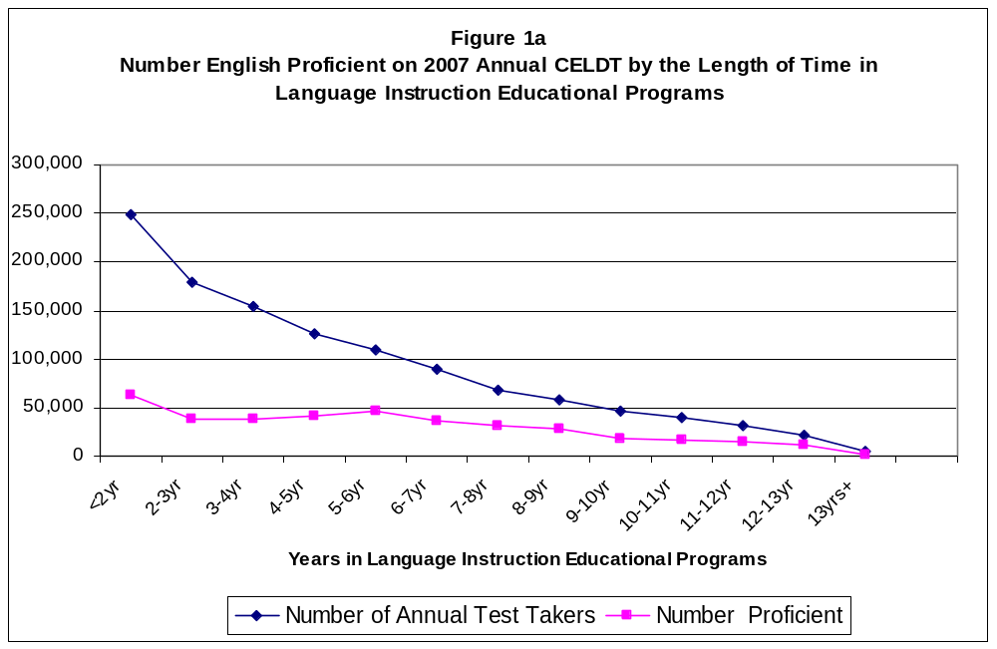

SUMMARY OF KEY ISSUES (Cont.)

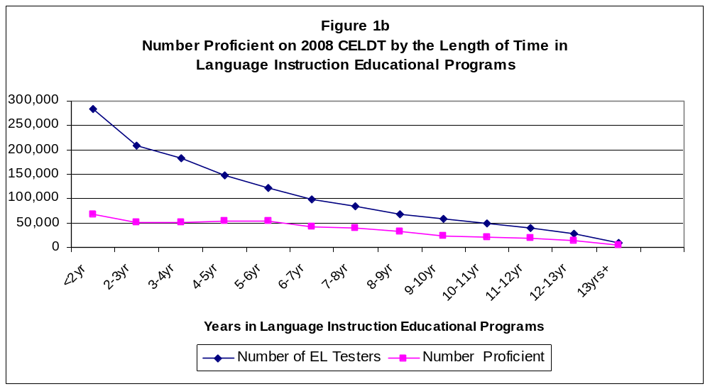

Figures 2a and 2b show the percent of ELs who met AMAO 2 by the length of time they have been in language instruction educational programs for 2007 and 2008. Figure 2a includes only annual testers and Figure 2b includes both 2008 annual testers and students who took the initial test during the annual testing window whose scores did not meet the CELDT criterion for English proficiency. The initial testers who were ELs are given a weight of 0.1 as is described in the previous section. Generally, ELs who have been in language instruction educational programs for longer periods of time are more likely to reach the English proficient level on the CELDT. Students classified as RFEP are not included in these figures.

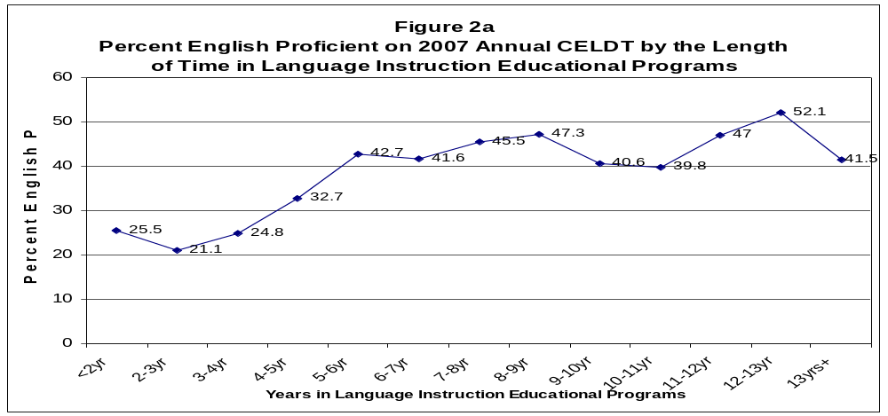

SUMMARY OF KEY ISSUES (Cont.)

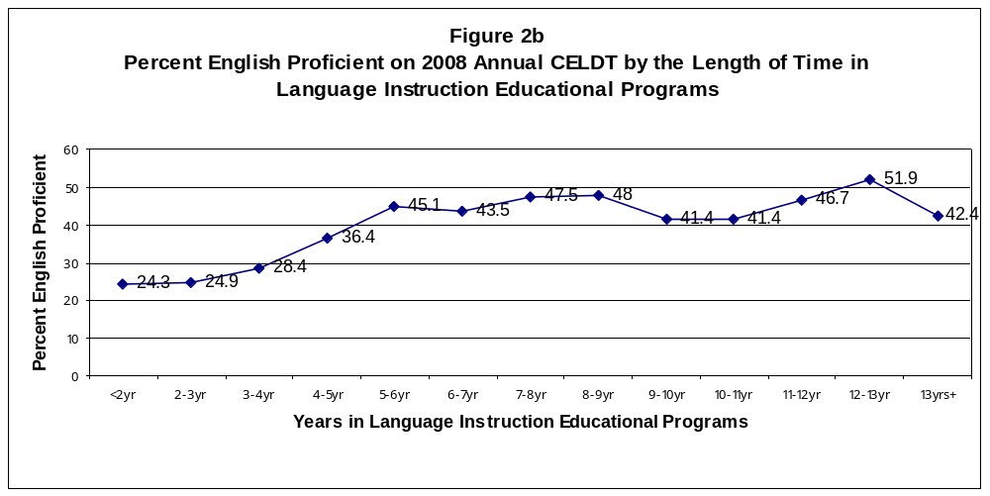
Based upon the information provided in Figures 1a and 1b and 2a and 2b, three options were considered when developing possible cohorts for AMAO 2.

Option 1: One cohort of all ELs tested during the annual testing window of July 1 to October 31.

Option 2: Two cohorts: (1) ELs who have been in language instruction educational programs for less than five years, and (2) ELs who have been in language instruction educational programs for five years or more.

Option 3: Three cohorts: (1) ELs who have been in language instruction educational programs for less than four years; (2) annual test takers who have been in language instruction educational programs for at least four years but less than five years; and (3) ELs who have been in language instruction educational programs for five years or more.

Option 1 would put all students, regardless of the length of time they have spent in a language instruction educational program, in one cohort. Specifically, this option may be biased in favor of Title III LEAs and consortia that have a large proportion of students who have been in language instruction educational programs for longer periods of time. It may also be biased against Title III LEAs and consortia that have a large proportion of recent immigrants and younger students who have been in language instruction educational programs for shorter periods of time.

Option 3 provides the greatest amount of differential expectations based on the length of time in language instruction educational programs and best reflects actual performance on the CELDT as shown in Figure 2. However, the cohort of 4 to 5 years is small and includes only about 11 percent of test takers and under a three
SUMMARY OF KEY ISSUES (Cont.)

cohort model, all three cohorts would need to be met. Therefore, more Title III LEAs and consortia would likely miss AMAO 2 because of the increased difficulty of meeting targets for all three groups.

Therefore, the CDE is recommending Option 2, the use of two cohorts with a break at five years because it has the following advantages:

- Provides different expectations for ELs based on the length of time in language instruction educational programs.

- Provides a focus on those ELs that have been in language instruction educational programs for five years or more.

- Is consistent with the expectation for AMAO 1 that ELs progress approximately one performance level annually until they reach the English proficient level on the CELDT.

The disadvantage of using two groups is that Title III subgrantees will be required to meet the target for each cohort in order to meet AMAO 2. This has been taken into consideration in the proposed target structure for AMAO 2.

Proposed Target Structure for AMAO 2

The proposed target structure for AMAO 2 was developed to maintain the percent of Title III subgrantees meeting the AMAO 2 target. This approach has the advantage of holding Title III subgrantees harmless for the changes due to the NOFI. Based on the 2008–09 data, 80.9 percent of Title III subgrantees met the AMAO 2 target. Therefore, the proposed target structure was set so that 80.9 percent of Title III subgrantees would meet the new target structure if they were applied in 2008–09. This concept of holding subgrantees harmless is consistent with the method used when the targets needed to be adjusted in 2007 due to the changes in performance levels and the establishment of a common scale for the CELDT. Under the NOFI, the ED is requiring states to include all ELs in the cohort for AMAO 2 but provides flexibility to states to set the target structures and encourages the use of decisions based on data.

The targets were set so that the ending point ten years from now, in 2018–19, is the 75th percentile of the LEA distribution. This is consistent with how the target structure was set by the SBE in 2003–04, where the ending target ten years later was set at the 75th percentile of the LEA distribution. In order to be consistent with previous documents, the proposed target structure is shown through 2013–14. In addition, this analysis assigned a weight of 0.1 to all initial CELDT takers whose scores did not meet the CELDT criterion for English proficiency and who have been receiving EL services for less than one year.

SUMMARY OF KEY ISSUES (Cont.)

As the number of cohort groups increase, the likelihood of an LEA or consortium meeting the multiple targets will decrease. The targets were adjusted so that 80.9 percent of each cohort is making the targets in 2008–09. The proposed targets are shown in Figure 3.

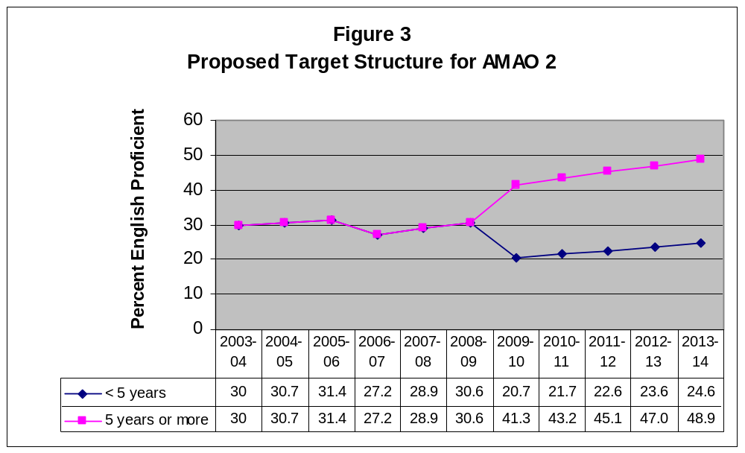

FISCAL ANALYSIS (AS APPROPRIATE)

Fiscal impact would be minimal. All expenses related to the Title III accountability system and would be included in the CDE’s Academic Accountability and Awards Division’s budget.

ATTACHMENT(S)

None.

In California, AYP is based upon results from the California Standards Test (CST) in grades two through eight, the California Alternate Performance Assessment (CAPA) in grades two through eight, the California Modified Assessment (CMA) in grades two through eight (grades two through seven in mathematics) and the California High School Exit Examination (CAHSEE) in grade ten.

