California Department of Education  Executive Office  SBE-003 (REV. 06/2008)  ftab-sfsd-may10item03 |  | ITEM #26
 | CALIFORNIA STATE BOARD OF EDUCATION  MAY 2010 AGENDA
SUBJECT  Appeal of a decision by the San Mateo County Committee on School District Organization to Disapprove a Petition to Transfer Territory from the Ravenswood City School District to the Menlo Park City School District in San Mateo County. |  |  |  | Action
 |  |  |  | Information
 |  |  |  | Public Hearing

RECOMMENDATION

The California Department of Education (CDE) recommends that the California State Board of Education (SBE) affirm the action of the San Mateo County Committee on School District Organization (County Committee) by adopting the proposed resolution in Attachment 2, thereby denying the appeal.

SUMMARY OF PREVIOUS STATE BOARD OF EDUCATION DISCUSSION AND ACTION

The SBE has not heard this specific matter previously. However, the appellants claim identity with the “Willows” neighborhood of the City of Menlo Park. The SBE has addressed territory transfer issues from this neighborhood in the past. It approved a request to transfer a portion of the “Willows” neighborhood from the Ravenswood City School District (CSD) to the Menlo Park CSD in 1983, and overturned a County Committee decision to disapprove a transfer of territory (which made similar claims of identity with the “Willows” neighborhood) from the Ravenswood CSD to the Menlo Park CSD in June 1992.

SUMMARY OF KEY ISSUES

The County Committee received a petition to transfer 25 townhomes (in the “Willows” neighborhood) from the Ravenswood CSD to the Menlo Park CSD. At the time the petition was submitted, no school-age children resided in the townhomes. The County Committee, after holding two public hearings and considering the findings of a consultant hired to study the effects of the proposed transfer (see Attachment 4), disapproved the transfer on a 5 to 3 vote despite finding that all required conditions of California Education Code (EC) Section 35753 were substantially met. Both the Ravenswood CSD and the Menlo Park CSD oppose the proposed transfer of territory.

SUMMARY OF KEY ISSUES (Cont.)

This proposed transfer of territory is the most recent of a number of events affecting school attendance in the area of the “Willows” neighborhood. On July 14, 1983, the SBE approved a request to transfer territory in this area, which included 287 school-age children, from the Ravenswood CSD to the Menlo Park CSD. The Ravenswood CSD opposed the transfer partly on the grounds that removing an area that was 72 percent nonminority out of a district that was over 98 percent minority (Ravenswood CSD) and into a district that was over 90 percent nonminority (Menlo Park CSD) increased the racial and ethnic isolation of the minority students remaining in the Ravenswood CSD. The district subsequently filed a petition for writ of mandate challenging the SBE action to approve the transfer. The SBE action ultimately was upheld by the appellate court.

On March 15, 1986, the Superior Court of the State of California, County of San Mateo, ruled on legal action that had been filed against the school districts in this area (including Ravenswood CSD and Menlo Park CSD) in part to address the racial isolation of students served by these school districts (Tinsley v. Palo Alto Unified School District [1979] 91 Cal.App.3d 871, 880 [Tinsley]). The Settlement Order issued by the Superior Court established that:
...to the extent reasonable and feasible, to further equal opportunities for all students in all respondent districts by (1) reducing minority racial isolation among or between the students of the respondent districts' elementary schools, (2) improving the educational achievement in Ravenswood, and (3) enhancing inter-district cooperative efforts.

The Settlement Order included a Voluntary Transfer Plan (VTP) that allows minority students from the Ravenswood CSD to transfer into eight other area school districts (including Menlo Park CSD). Non-minority students from these other districts may transfer into the Ravenswood CSD. The Tinsley VTP still is in effect.

On June 11, 1992, the SBE heard an appeal of a County Committee decision to deny a request to transfer 27 homes from the Ravenswood CSD to the Menlo Park CSD. No students in this transfer area attended public school. The appellants in this case claimed to be part of the “Willows” neighborhood previously transferred by the SBE, and they further claimed that it was the intent of the SBE to transfer their community in 1983. The County Committee determined that the proposed territory transfer failed to meet four of the required conditions for approval (including “the proposal primarily was for the purpose of increasing property values”). The CDE recommended that the SBE affirm the County Committee action, finding that the transfer was “directly contrary” to the Tinsley VTP and would have an adverse effect on the duty of the governing board of each of the districts affected to adopt and implement a plan for the alleviation of segregation of minority pupils. Despite the findings of the County Committee and the recommendation of the CDE, the SBE overturned the decision of the County Committee and allowed the territory transfer.

The current appeal (Attachment 3) has many similarities to the 1992 appeal in that the proposal is to transfer 25 townhouses from the Ravenswood CSD to the Menlo Park
CSD and no school-age children reside in the proposed transfer area. Petitioners claim
SUMMARY OF KEY ISSUES (Cont.)

identification with the “Willows” neighborhood, and further claim that had their townhouses been constructed in 1983, the SBE would have transferred their property at that time. As with the 1992 appeal, the County Committee denied the current territory transfer request on May 7, 2007. A map of the area is included as Attachment 5.

Chief petitioners or affected school districts may appeal a County Committee decision on territory transfers for issues of noncompliance with the provisions of EC sections 35705, 35706, 35709, 35710, and 35753(a). On May 11, 2007, the chief petitioners (appellants) initiated the appeal process and, on May 24, 2007, submitted their appeal to the San Mateo County Superintendent of Schools (County Superintendent). The County Superintendent subsequently transmitted the appeal, along with the complete administrative record of the County Committee action, to the SBE.

The appellants claim that the County Committee abused its discretion by denying the territory transfer petition without substantial evidence in the record. According to the appellants, the County Committee denied the proposed transfer after overwhelmingly voting that the proposed transfer of territory met all nine required conditions pursuant to EC Section 35753. (See Attachment 3.)

The CDE finds no support for the appellants’ claims. The County Committee, as with the SBE, is subject to the legislative intent cited in EC Section 35500, that “local educational needs and concerns shall serve as the basis for future reorganization of districts in each county.” The County Committee clearly considered substantial evidence to support its decision to deny the territory transfer proposal. The County Committee raised a number of local educational concerns during its consideration of the proposed transfer at the May 7, 2007, meeting. These concerns include:

- The proposal would take “more affluent, perhaps better educated families, out of a district that really needs more affluent, better educated families to help integrate the student body.”

- Over the last 20-plus years, the trend has been to remove territory from the Ravenswood CSD. Carving up the district this way is a disservice to the district because it sends the message that homes built in the district are subject to be “siphoned off” to other districts and diminishes the district’s ability to build an educational community that is “a place where people want to be as opposed to want to flee.”

- It appears to be an issue of racial segregation when a group of mostly white parents want to remove their children from a district that (1) is less than one percent white and (2) has a school literally next door to the parents’ homes.

Attachment 6 contains a complete transcript of the County Committee discussion during the May 7, 2007, meeting at which the County Committee disapproved the transfer,

SUMMARY OF KEY ISSUES (Cont.)

Further, approval of any school district reorganization proposal by a county committee (or the SBE) is a discretionary action. Although the County Committee determined that all required conditions of EC Section 35753 were substantially met, the County Committee was under no obligation to approve the transfer and would have needed to
identify “local educational needs” as rationale for approval of the proposal, especially in
light of the previously stated concerns expressed by the County Committee. The County Committee did not identify a compelling reason to approve the transfer. The CDE also finds no “local educational needs” to serve as compelling reasons for recommending approval of the appeal.

Finally, the CDE, in contrast to the County Committee, finds that the proposed transfer of territory fails to substantially meet the following required condition:

The proposed reorganization is primarily designed for purposes other than to significantly increase property values. (EC Section 35753[a][8]).

The CDE recommends that the SBE deny the appeal and affirm the decision of the County Committee based on determinations that (1) the County Committee acted appropriately in denying the proposal, (2) the County Committee identified local educational concerns sufficient to justify denial, (3) there are no compelling “local educational needs” to justify approval of the territory transfer, and (4) the proposed transfer of territory does not substantially meet all nine conditions of EC Section 35753. A proposed resolution detailing this recommendation is included as Attachment 2.

FISCAL ANALYSIS (AS APPROPRIATE)

If the territory is transferred, there would be no significant financial effects on either affected school district.

ATTACHMENT(S)

Attachment 1: Analysis of Statement of Reasons and Factual Evidence (12 pages)

Attachment 2: Proposed Resolution (1 page)

Attachment 3: Argument in Support of Appeal: In the Matter of the Petition to Transfer Territory Consisting of the Pacific Parc Complex of 25 townhomes at 600 Willow Road in Menlo Park from the Ravenswood City Elementary School District to the Menlo Park City Elementary School District (5 pages)

Attachment 4: Report on the Conditions for the Transfer of Territory from the Ravenswood Elementary School District to the Menlo Park City School District (7 pages)

Attachment 5: Map of Transfer Area (1 page)
ATTACHMENT(S)

Attachment 6: Special Meeting Minutes, May 7, 2007 (13 pages)

ANALYSIS OF STATEMENT OF REASONS AND FACTUAL EVIDENCE

Appeal of a Decision of the San Mateo County Committee
on School District Organization to Disapprove a Transfer of Territory from the Ravenswood City School District to the Menlo Park City School District
in San Mateo County

RECOMMENDATION

The California Department of Education (CDE) recommends that the California State Board of Education (SBE) affirm the action of the San Mateo County Committee on School District Organization (County Committee) by adopting the proposed resolution in Attachment 2, thereby denying the appeal of the County Committee’s decision to disapprove a petition to transfer territory from the Ravenswood City School District (CSD) to the Menlo Park CSD.

BACKGROUND

There have been a number of events over the past 25 to 30 years that have contributed to issues related to this particular territory transfer request. Following is a brief discussion of these events.

On July 14, 1983, the SBE approved a request to transfer a portion of the “Willows” neighborhood, which included 287 school-age children, from the Ravenswood CSD to the Menlo Park CSD (The SBE had responsibility for approving all territory transfers during this time period; thus, there was no appeal process). The Ravenswood CSD opposed the transfer partly on the grounds that removing an area that was 72 percent nonminority out of a district that was over 98 percent minority (Ravenswood CSD) and into a district that was over 90 percent nonminority (Menlo Park CSD) increased the racial and ethnic isolation of the minority students remaining in the Ravenswood CSD. The district subsequently filed a petition for writ of mandate challenging the SBE action to approve the transfer. The SBE action ultimately was upheld by the appellate court.

On March 15, 1986, the Superior Court of the State of California, County of San Mateo, considered legal action that had been filed against the school districts in this area (including Ravenswood CSD and Menlo Park CSD) in part to address the racial isolation of students served by these school districts (Tinsley v. Palo Alto Unified School District [1979] 91 Cal.App.3d 871, 880 [Tinsley]). In addition to the affected school districts, the County Superintendents of Schools for San Mateo and Santa Clara counties, the County Committees on School District Organization for both counties, the CDE, and the SBE were named respondents to the legal action. The Superior Court issued a Settlement Order in response to this legal action—all respondents in the legal action agreed to this Order. The major goals of the Settlement Order are:
...to the extent reasonable and feasible, to further equal opportunities for all students in all respondent districts by (1) reducing minority racial isolation among or between the students of the respondent districts' elementary schools, (2) improving the educational achievement in Ravenswood, and (3) enhancing inter-district cooperative efforts.

The Settlement Order included a Voluntary Transfer Plan (VTP) that allows minority students from the Ravenswood CSD to transfer into eight other area school districts (including Menlo Park CSD). Nonminority students from these other districts may transfer into the Ravenswood CSD. The Tinsley VTP remains in effect. For the 2008-09 school year, more than 1,000 minority students from the Ravenswood CSD currently were enrolled in other districts under the Tinsley VTP—184 of these students were in the Menlo Park CSD.

In the Settlement Order, the Court specifically charged the SBE with responsibility for monitoring compliance with the Order either “by itself or by delegation to the County Superintendents of Education of Santa Clara and San Mateo counties.” Although the SBE chose to delegate compliance monitoring duties to the County Superintendents, it still retains overall responsibility for these actions.

On June 11, 1992, the SBE heard an appeal from a County Committee decision to deny a request to transfer 27 homes from the Ravenswood CSD to the Menlo Park CSD. No students in this transfer area attended public school. The appellants in this case claimed to be part of the “Willows” neighborhood previously transferred by the SBE, and they further claimed that it was the intent of the SBE to transfer their community in 1983. The County Committee determined that the proposed territory transfer failed to meet four of the required conditions for approval (including [1] the proposed transfer would promote segregation and [2] the proposal primarily was for the purpose of increasing property values). The CDE recommended that the SBE affirm the County Committee action, finding that the transfer was “directly contrary” to the Tinsley VTP and would have an adverse effect on the duty of the governing board of each of the districts affected to adopt and implement a plan for the alleviation of segregation of minority pupils. Despite the findings of the County Committee and the recommendation of the CDE, the SBE overturned the decision of the County Committee and allowed the territory transfer.

The current appeal (Attachment 3) has many similarities to the 1992 appeal. The proposal is to transfer 25 townhouses from the Ravenswood CSD to the Menlo Park CSD. There are no school-age children residing in the proposed transfer area. Petitioners claim identification with the “Willows” neighborhood, and further claim that had their townhouses been constructed in 1983 the SBE would have transferred their property at that time. A map of the area is included as Attachment 4.

ACTION OF THE COUNTY COMMITTEE

The County Committee held two public hearings for the proposed transfer of territory—February 6, 2007, in the Ravenswood CSD and February 13, 2007, in the Menlo Park CSD. The County Committee also contracted with an outside consultant to prepare a “Report of the Conditions for the Transfer of Territory from the Ravenswood Elementary School District to the Menlo Park City School District” (County Committee Report). Portions of this report are contained in Attachment 4.

The County Committee considered the findings of the County Committee Report, and information presented by the affected districts and the petitioners, at a special meeting held on May 17, 2007. Both the Ravenswood CSD and the Menlo Park CSD oppose the proposed transfer of territory.

Under the California Education Code (EC), the County Committee had the following options:

- If the County Committee determined that all nine conditions of EC Section 35753(a) are substantially met, it could approve the petition (though not required to do so), and would notify the Superintendent of Schools to call an election on the proposed transfer (an election is required when an affected district opposes an approved transfer of territory petition).

- The County Committee could disapprove the petition to transfer territory for other concerns even if it finds that all nine conditions of EC Section 35753(a) have been met.

- If the County Committee determined that all nine conditions of EC Section 35753(a) are not substantially met, it would be required to disapprove the petition to transfer territory.

The County Committee determined that all nine required conditions were substantially met. However, the County Committee then voted 5 to 3 to disapprove the proposal, primarily based on “public policy concerns” (Attachment 6). A discussion of these concerns is presented in section 6.1 of this attachment.

Chief petitioners or affected school districts may appeal a County Committee decision on territory transfers for issues of noncompliance with the provisions of EC sections 35705, 35706, 35709, 35710, and 35753(a). The chief petitioners (appellants) submitted such an appeal dated May 24, 2007, to the San Mateo County Superintendent of Schools (County Superintendent). The County Superintendent subsequently transmitted the appeal, along with the complete administrative record of the County Committee action, to the SBE.

POSITIONS OF AFFECTED SCHOOL DISTRICTS

Both affected districts are opposed.

  - Menlo Park CSD
The Menlo Park CSD gave the following reasons for opposing the transfer:
- Menlo Park CSD is experiencing substantial growth in enrollment (16 percent growth is expected by 2011), while Ravenswood CSD is experiencing a decline in student enrollment. The transfer would exacerbate these trends.
- Menlo Park CSD already enrolls from 24 to 30 additional students from the Ravenswood CSD each year through the Tinsley VTP program.
- The area proposed for transfer is directly adjacent to the Willow Oak School of the Ravenswood CSD. If the territory were to transfer to Menlo Park CSD, the closest schools would be one and a half miles for grades K-2, two and a half miles for grades 3-5, and four miles for grades 6-8. The district does not provide bus service, so attendance at these schools would necessitate automobile transportation.
- The cumulative effect of this transfer with new residential development and other circumstances affecting enrollment growth will significantly affect school housing availability and costs. The Menlo Park CSD has already cited cumulative effects on enrollment as an impact in the environmental impact reports for several residential developments within the district.
- As a basic aid school district, the primary source of funding for the Menlo Park CSD is property taxes. The district will not receive any property tax revenue from the area proposed for transfer because it is located within the Menlo Park City Redevelopment Agency. Any new property tax revenue would be diverted to the Redevelopment Agency.

  - Ravenswood CSD

The Ravenswood CSD opposes the transfer because:

- The territory transfer will be a contributing factor to declining enrollment at the Ravenswood CSD.

- The property directly abuts both the Willow Oaks and Menlo Oaks schools of the Ravenswood CSD.

- The transfer will further racially isolate the students of Ravenswood CSD from students of neighboring districts.

- The transfer would result in an increase in state aid to Ravenswood CSD since its assessed valuation (and, subsequently, property tax revenue) would be reduced.

- The territory transfer, in combination with ongoing declining enrollment, would jeopardize the Ravenswood CSD’s ability to participate in the State School Facilities Program.

- The Ravenswood CSD is skeptical of the appellants’ statements that the primary motivation for the transfer is to allow children in the affected territory to attend the relatively more distant schools attended by children in neighboring properties.

- The removal of property from Ravenswood CSD will result in a reduction of assessed valuation (which decreases the districts bonding capacity) as well as a reduction in the number of parcels of land (which reduces the district’s parcel tax revenue).

- REASONS FOR THE APPEAL

The appellants claim (Attachment 3) that the County Committee abused its discretion by denying the territory transfer petition without substantial evidence in the record. According to the appellants, the County Committee denied the proposed transfer after overwhelmingly voting that the proposed transfer of territory met all nine required conditions (EC Section 35753).

CALIFORNIA DEPARTMENT OF EDUCATION RESPONSE TO THE APPEAL

Chief petitioners or affected school districts, pursuant to EC Section 35710.5, may appeal a County Committee decision on territory transfers for issues of noncompliance with the provisions of EC sections 35705, 35706, 35709, and 35710. The courts (San Rafael School District v. State Board of Education [1999] 73 Cal.App.4th 1018, 1027) [San Rafael]) also have determined that provisions of EC Section 35753 are subject to review in any territory transfer appeal.

CDE staff review of the issues in the appeal follows.

  - The County Committee denied the petition without substantial evidence.

Appellants claim that the County Committee denied the territory transfer petition without substantial evidence to support its action. However, the appellants themselves list a number of issues considered by the County Committee (Attachment 3), including (1) future development and continued erosion of territory from the Ravenswood CSD, (2) proximity of the transfer area to Ravenswood CSD schools, (3) concerns about transportation to more distant schools in the Menlo Park CSD, and (4) overcrowded schools in the Menlo Park CSD. These issues (and the evidence supporting these issues) were not only discussed in the public hearings held by the County Committee, but also are contained in the County Committee Study (Attachment 4) and other documents submitted by the affected school districts.

Moreover, review of the minutes of the meeting where the County Committee took action to deny the appeal (Attachment 6) indicates that the County Committee engaged in considerable discussion regarding the merits of the proposed transfer of territory. It was suggested during this discussion that issues of public policy, for the County Committee, were more a factor in determining how to vote on the proposed transfer of territory than were the EC Section 35753(a) conditions. Public policy points raised during the discussion include:

- The proposal would take “more affluent, perhaps better educated families, out of a district that really needs more affluent, better educated families to help integrate the student body.”

- Over the last 20-plus years, the trend has been to remove territory from the Ravenswood CSD. Carving up the district this way is a disservice to the district because it sends the message that homes built in the district are subject to be “siphoned off” to other districts and diminishes the district’s ability to build an educational community that is “a place where people want to be as opposed to want to flee.”

- It appears to be an issue of racial segregation when a group of mostly white parents want to remove their children from a district that (1) is less than one percent white and (2) has a school literally next door to the parents’ homes.

The trend to remove territory from the Ravenswood CSD deserves further consideration. A significant portion of the city of Menlo Park is within the Ravenswood CSD. In 2008-09, according to the County Superintendent, 579 students from this city attended the Ravenswood CSD. Thus, further efforts to align the boundaries of the city of Menlo Park with the boundaries of the Menlo Park CSD have the potential to increase enrollment in the Menlo Park CSD by almost 25 percent.

It is the opinion of CDE that the County Committee’s decision to deny the territory transfer was based on the merits of the proposal and grounded in sound public policy.

  - The County Committee overwhelmingly voted that the proposal met all nine required conditions (EC Section 35753).

The County Committee unanimously voted that conditions 1, 3, 4, 5, 6, 7, and 9 in EC Section 35753 are substantially met by the proposed transfer of territory. The County Committee subsequently voted 7 to 1 that condition 2 (districts retain community identity) is substantially met, and voted 5 to 3 that condition 8 (primary reason of the transfer is for purposes other than to increase property values) is substantially met. CDE staff agrees that the County Committee voted to find that the proposed transfer substantially met all nine required conditions—although staff does not agree that the County Committee overwhelmingly voted that way. There were significant concerns raised by County Committee members during the close vote on condition 8 (i.e., the primary reason of the transfer is for purposes other than to increase property values).

Although CDE staff agrees that the County Committee approved all required conditions, the court (Hamilton v. State Board of Education [1981] 117 Cal.App.3d; 172 Cal.Rprt. 748) has found that EC Section 35753 contains “minimal threshold” conditions and there is no requirement to approve a petition which substantially meets those conditions. EC Section 35753 is permissive, providing minimum standards, and does not preclude the SBE or the County Committee from rejecting petitions or proposals even when all nine “minimal threshold” conditions are substantially met. The SBE and the County Committee can consider other local educational needs or concerns when exercising this discretionary authority—in fact, legislative intent established in EC Section 35500 is that “local educational needs and concerns shall serve as the basis for future reorganization of districts in each county.” The County Committee clearly considered other local educational needs and concerns (see 6.1 above) before deciding to disapprove the territory transfer.

  - EC Section 35753(a)(8): The proposed reorganization is primarily designed for purposes other than to significantly increase property values.

San Rafael authorizes the SBE “to conduct a de novo review of the issue whether the facts supporting a transfer satisfy the conditions of section 35753.” After conducting this review, CDE staff disagrees with the County Committee findings that all of the required conditions are substantially met. The CDE finds that the EC Section 35753(a)(8) condition (The proposed reorganization is primarily designed for purposes other than to significantly increase property values) is not substantially met.

Data contained in the County Committee Report (Attachment 4) suggests that, on a cost per square foot basis, property values in the Menlo Park CSD are higher than property values in the Ravenswood CSD. The County Committee Report states that the “notion that the children in the townhouse complex have made friends with other children in the neighborhood could be considered somewhat disingenuous since the children are no more than three years of age.” This report further states that the “fact that three year old children play with residents of Menlo Park says more about the community of interest of their parents than a compelling educational consideration.” Although calling into question the motivation of the petitioners and suggesting that property values would increase if the transfer were to be approved, the County Committee Report makes no specific recommendation regarding whether this condition is substantially met.

Although a number of concerns were expressed by members of the County Committee regarding this condition, the County Committee voted 5 to 3 that the condition was substantially met (Attachment 6).

CDE staff examined the stated reasons for initiating the territory transfer. In their petition, petitioners for the territory transfer listed two reasons for wanting to change the boundaries of the school district: (1) They want their children to attend schools with the friends they are now making, and (2) They claim they are a small island of the Ravenswood CSD surrounded by Menlo Park CSD.

CDE staff finds no evidence to support the appellants’ claim that the motivation for wanting to transfer territory is to ensure that their children attend schools with other children with whom they are making friends. First, CDE agrees with the County Committee Report that the friendships of children three years of age or younger are more a product of the parents’ community of interest than the children’s interests. It is speculative to assume that these are the friendships that would develop when the children reach school-age. Second, and more importantly, no student from these townhomes has ever attended the Ravenswood CSD; nor has any student from these townhomes ever requested an interdistrict transfer to the Menlo Park CSD (according to information provided by the County Superintendent). These townhomes, which were constructed over ten years ago, do not appear to produce public school students. Even if any school age children did reside in the townhomes over the past ten years, there was no demonstrated desire on the part of the parents or students to attend schools with other neighborhood children.

CDE staff also does not find the claim that the townhomes are surrounded by Menlo Park CSD territory to be relevant. As far as CDE is aware, no students ever have attended or attempted to attend the Menlo Park CSD. The townhomes are within the city of Menlo Park, and, as stated previously, a significant portion of that city is within the boundaries of the Ravenswood CSD. Over 650 students residing within the city attend the Ravenswood CSD; thus, this townhome community is not the only “city of Menlo Park community” that is within the Ravenswood CSD. Moreover, the townhomes are adjacent to schools of the Ravenswood CSD. This fact struck at least one County Committee member as “strange that children who grow up looking out a window at children playing in school did not contribute to their feeling of community identity” (Attachment 6).

Given the lack of evidence to support the merits of the appellants’ stated reasons for transferring the territory, and given evidence in the County Committee Report suggesting that property values of the townhomes will increase as result of the transfer, CDE finds that this condition is not substantially met.

  - Summary

CDE staff finds no support for the appellants’ claims that the County Committee denied the territory transfer petition without sufficient evidence in the record. Since this is the reason for the appeal, that finding is itself sufficient to support denial of the appeal. However, staff has further determined, contrary to County Committee findings, that the proposal fails to substantially meet all of the required conditions of EC Section 35753.

STAFF RECOMMENDED AMENDMENTS TO THE PETITION

The SBE has authority to amend or add certain provisions to any petition for reorganization. One of the provisions the SBE must add is the area of election if the SBE reverses the action of the County Committee by approving the appeal.

Area of Election

Determination of the area in which the election for a reorganization proposal will be held is one of the provisions under EC Article 3 (commencing with Section 35730) that the SBE may add or amend. EC Section 35710.5(c) also indicates that, following the review of an appeal, if the petition will be sent to an election, the SBE must determine the area of election.

The plans and recommendations to reorganize districts may specify an area of election, but specification of an election area is not required (EC Section 35732). If a plan does not specify the area of election, the statute specifies that “the election shall be held only in the territory proposed for reorganization.” Thus, the area proposed for reorganization is the “default” election area. The SBE may alter this area, but the alterations must comply with the “Area of Election Legal Principles” below. In this case, the County Committee disapproved the territory transfer, and the chief petitioners appealed the County Committee’s decision. Therefore, following review of the appeal, if the petition will be sent to election, the SBE must, pursuant to EC Section 35756, determine the territory in which the election will be held.

Area of Election Principles

In establishing the area of election, the CDE and SBE follow the legal precedent set by the California Supreme Court in Board of Supervisors of Sacramento County, et al. v. Local Agency Formation Commission (1992) 3 Cal. 4th 903 (the “LAFCO” decision). LAFCO holds that elections may be confined to within the boundaries of the territory proposed for reorganization (the “default” area), provided there is a rational basis for doing so. LAFCO requires we examine (1) the public policy reasons for holding a reorganization election within the boundaries specified; and (2) whether there is a genuine difference in the relevant interests of the groups that the election plan creates (in this situation, the analysis examines the interests of voters in the territory to be transferred from the Ravenswood CSD, those that will remain in the Ravenswood CSD, and those in the district that would receive the territory—the Menlo Park CSD). The proposed transfer, in the opinion of the CDE, does not reflect any genuinely different interests between voters in the transfer area and voters in either of the affected school districts.

A reduced voting area has a fair relationship to a legitimate public purpose. State policy favors procedures that promote orderly school district reorganization statewide in a manner that allows for planned, orderly, community-based school systems that adequately address transportation, curriculum, faculty, and administration.

Finally, discussion of other judicial activity in this area is warranted. In a case that preceded LAFCO, the California Supreme Court invalidated an SBE reorganization decision that approved an area of election that was limited to the newly unified district. As a result, electors in the entire high school district were entitled to vote (Fullerton Joint Union High School District v. State Board of Education [1982] 32 Cal. 3d 779 [Fullerton]). The Fullerton court applied strict scrutiny and required demonstration of a compelling state interest to justify the exclusion of those portions of the district from which the newly unified district would be formed.

The Fullerton case does not require that the SBE conduct a different analysis than that described above. The LAFCO decision disapproved the Fullerton case, and held that absent invidious discrimination, the rational basis approach to defining the election area applied. In this matter, no discrimination, segregation, or racial impacts were identified. Accordingly, the LAFCO standard and analysis applies.

  - Recommended Area of Election

CDE staff finds that the transfer of territory would have no significant effect on the voters in either the remaining Ravenswood CSD or the receiving Menlo Park CSD. Therefore, if the SBE reverses the action of the County Committee by approving the appeal, the CDE recommends the SBE establish the 25 townhomes in the area proposed for transfer as the area of election.

STATE BOARD OF EDUCATION OPTIONS

The SBE has four general options:

- Find the proposed transfer of territory fails to substantially meet all nine conditions of EC Section 35753(a) and deny the appeal, which affirms the County Committee’s decision to disapprove the transfer.

- Find the proposed transfer of territory substantially meets all nine conditions of EC Section 35753(a) and deny the appeal on other grounds (e.g., there is no compelling reason to overturn the County Committee decision).

- Find the proposed transfer of territory substantially meets all nine conditions of EC Section 35753(a), approve the appeal, and reverse the County Committee’s decision to disapprove the transfer. Under this option the SBE must determine the election area for the reorganization.

- Find the proposed transfer of territory fails to substantially meet all nine conditions of EC Section 35753(a); approve the appeal; reverse the County Committee’s decision to disapprove the transfer; and determine pursuant to EC Section 35753(b) that “it is not practical or possible to apply the criteria of this section literally, and that the circumstances with respect to the petition provide an exceptional situation sufficient to justify approval.” Under this option, the SBE also must determine the election area for the reorganization.

RECOMMENDED ACTION

The CDE recommends that the SBE deny the appeal and affirm the decision of the County Committee based on determinations that (1) the County Committee acted appropriately in denying the proposal, (2) the County Committee identified local educational concerns sufficient to justify denial, (3) there are no compelling “local educational needs” to justify approval of the territory transfer, and (4) the proposed transfer of territory does not substantially meet all nine conditions of EC Section 35753. A resolution detailing this recommendation is included as Attachment 2.
CALIFORNIA STATE BOARD OF EDUCATION
May 2010

PROPOSED RESOLUTION

Appeal from a Decision of the San Mateo County Committee
on School District Organization Denying a Petition to
Transfer Territory from the Ravenswood City School District to the Menlo Park City School District in San Mateo County

WHEREAS, in accordance with California Education Code Section 35710.5, the California State Board of Education received an appeal on or about June 14, 2007, from the May 7, 2007, action of the San Mateo County Committee on School District Organization disapproving a transfer of territory from the Ravenswood City School District to the Menlo Park City School District; and

WHEREAS, pursuant to California Education Code Section 35710.5, the California State Board of Education finds that the San Mateo County Committee on School District Organization acted appropriately and exercised its legal authority to deny the petition; and

WHEREAS, pursuant to California Education Code Section 35500, the California State Board of Education recognizes that it is the intent of the California State Legislature that “local educational needs and concerns shall serve as the basis for future reorganization of districts in each county”; therefore be it

RESOLVED, that the California State Board of Education has determined that the aforementioned transfer of territory fails to substantially meet all required conditions contained in California Education Code Section 35753; and be it

RESOLVED further, that the California State Board of Education, pursuant to California Education Code Section 35753(b), finds no exceptional circumstance to justify approving the proposal to transfer territory; and be it

RESOLVED further, that the California State Board of Education, pursuant to California Education Code Section 35710.5, affirms the action of the San Mateo County Committee on School District Organization; and be it

RESOLVED further, that the Secretary of the California State Board of Education shall notify, on behalf of said Board, the San Mateo County Superintendent of Schools, the San Mateo County Committee on School District Organization, the chief petitioners, and the affected school districts of the action taken by the California State Board of Education.

Date: May 24, 2007
From: Maria Kaval, Rob Ultan, Kelly Blythe
To: San Mateo County Committee on School District Organization
Attn: Dr. Jean Holbrook, San Mateo County School Superintendent
Subject: Argument in Support of Appeal

Argument in Support of Appeal:
In the Matter of the Petition to Transfer Territory Consisting of the Pacific Parc Complex of 25 townhomes at 600 Willow Road in Menlo Park from the Ravenswood City Elementary School District to the Menlo Park City Elementary School District.
On September 23, 2006, a Petition was filed with the County Superintendent of Schools of San Mateo County to transfer 25 townhomes at the Pacific Parc complex at 600 Willow Road in the City of Menlo Park from the Ravenswood City School District to the Menlo Park City School District. On May 7,2007, the San Mateo County Committee on School District Organization voted overwhelmingly that we substantially meet all nine of the criteria the Board of Education recommends as guideposts to whether a petition for territory transfer merits approval. However, by a vote of 5 to 3, the County Committee voted to disapprove the Petition. On May 11, 2007, the Petitioners filed a Notice of Appeal with the County Committee for School District Organization and the County School Superintendent pursuant to the provisions of Section 35710.5 of the California Education Code. This argument is filed by the Petitioners in support of that Appeal.
The territory proposed for transfer is comprised of 25 townhome residences, called Pacific Parc, located in the City of Menlo Park. Pacific Parc currently has no children of school age and no children eligible to attend school in the next school year; there has never been any child in the territory proposed for transfer who attended Ravenswood School District. However, there are several young children (age 3 and under) currently residing at Pacific Parco The parents of these children desire that their kids be able to go to school with the children from the neighboring homes, all of which are part of the Menlo Park School District.
The Pacific Parc townhome complex is essentially a "residential island" in the Menlo Park City School District. Every home within a 1/2 mile radius of the Pacific Parc complex - over 1000 homes - is in the Menlo Park City School District, while our complex is in the Ravenswood City School District. Neighboring homes on all four sides of the townhouse complex reside in the Menlo Park City School District. To our knowledge, there does not exist anywhere else in the State of California a situation such as this where a small group of homes is assigned to a different elementary school district than all of the homes that surround them.

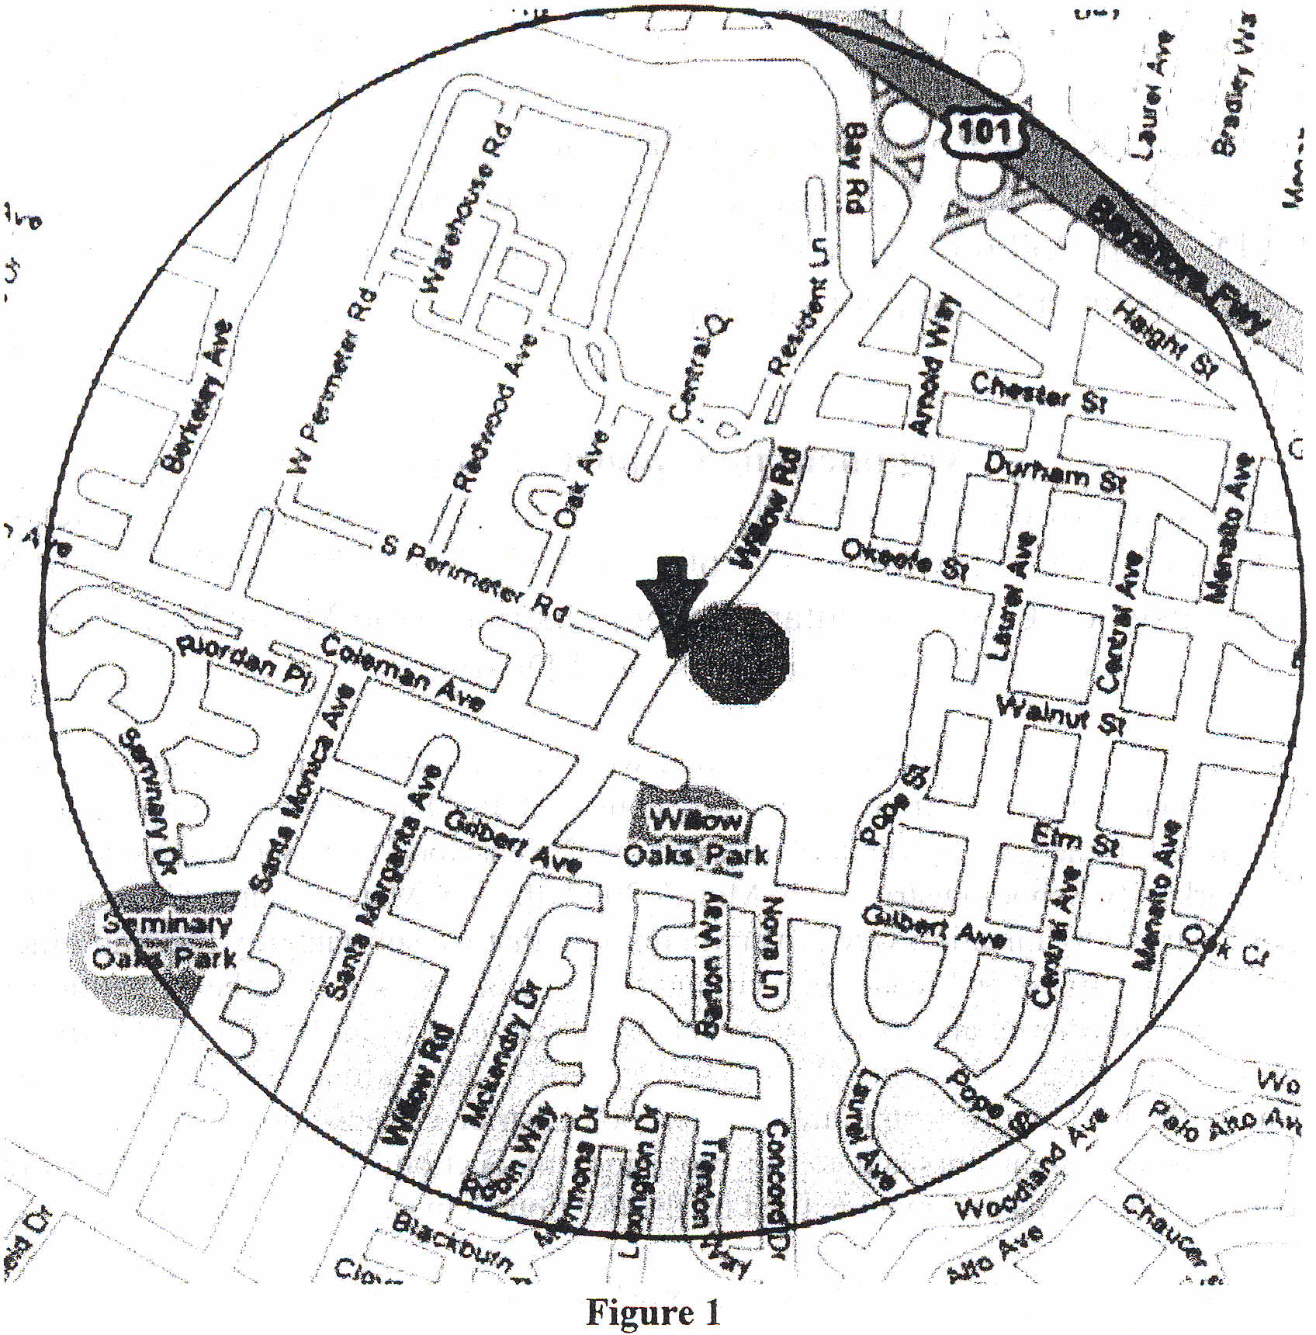

LEGEND:
• (green circle) Pacific Parc Townhouse Complex
Shaded circular area is the ½ mile radius around the Pacific Parc townhouse complex.
All residential properties within the shaded circular area are in the Menlo Park City School District except for the Pacific Parc Townhouse Complex

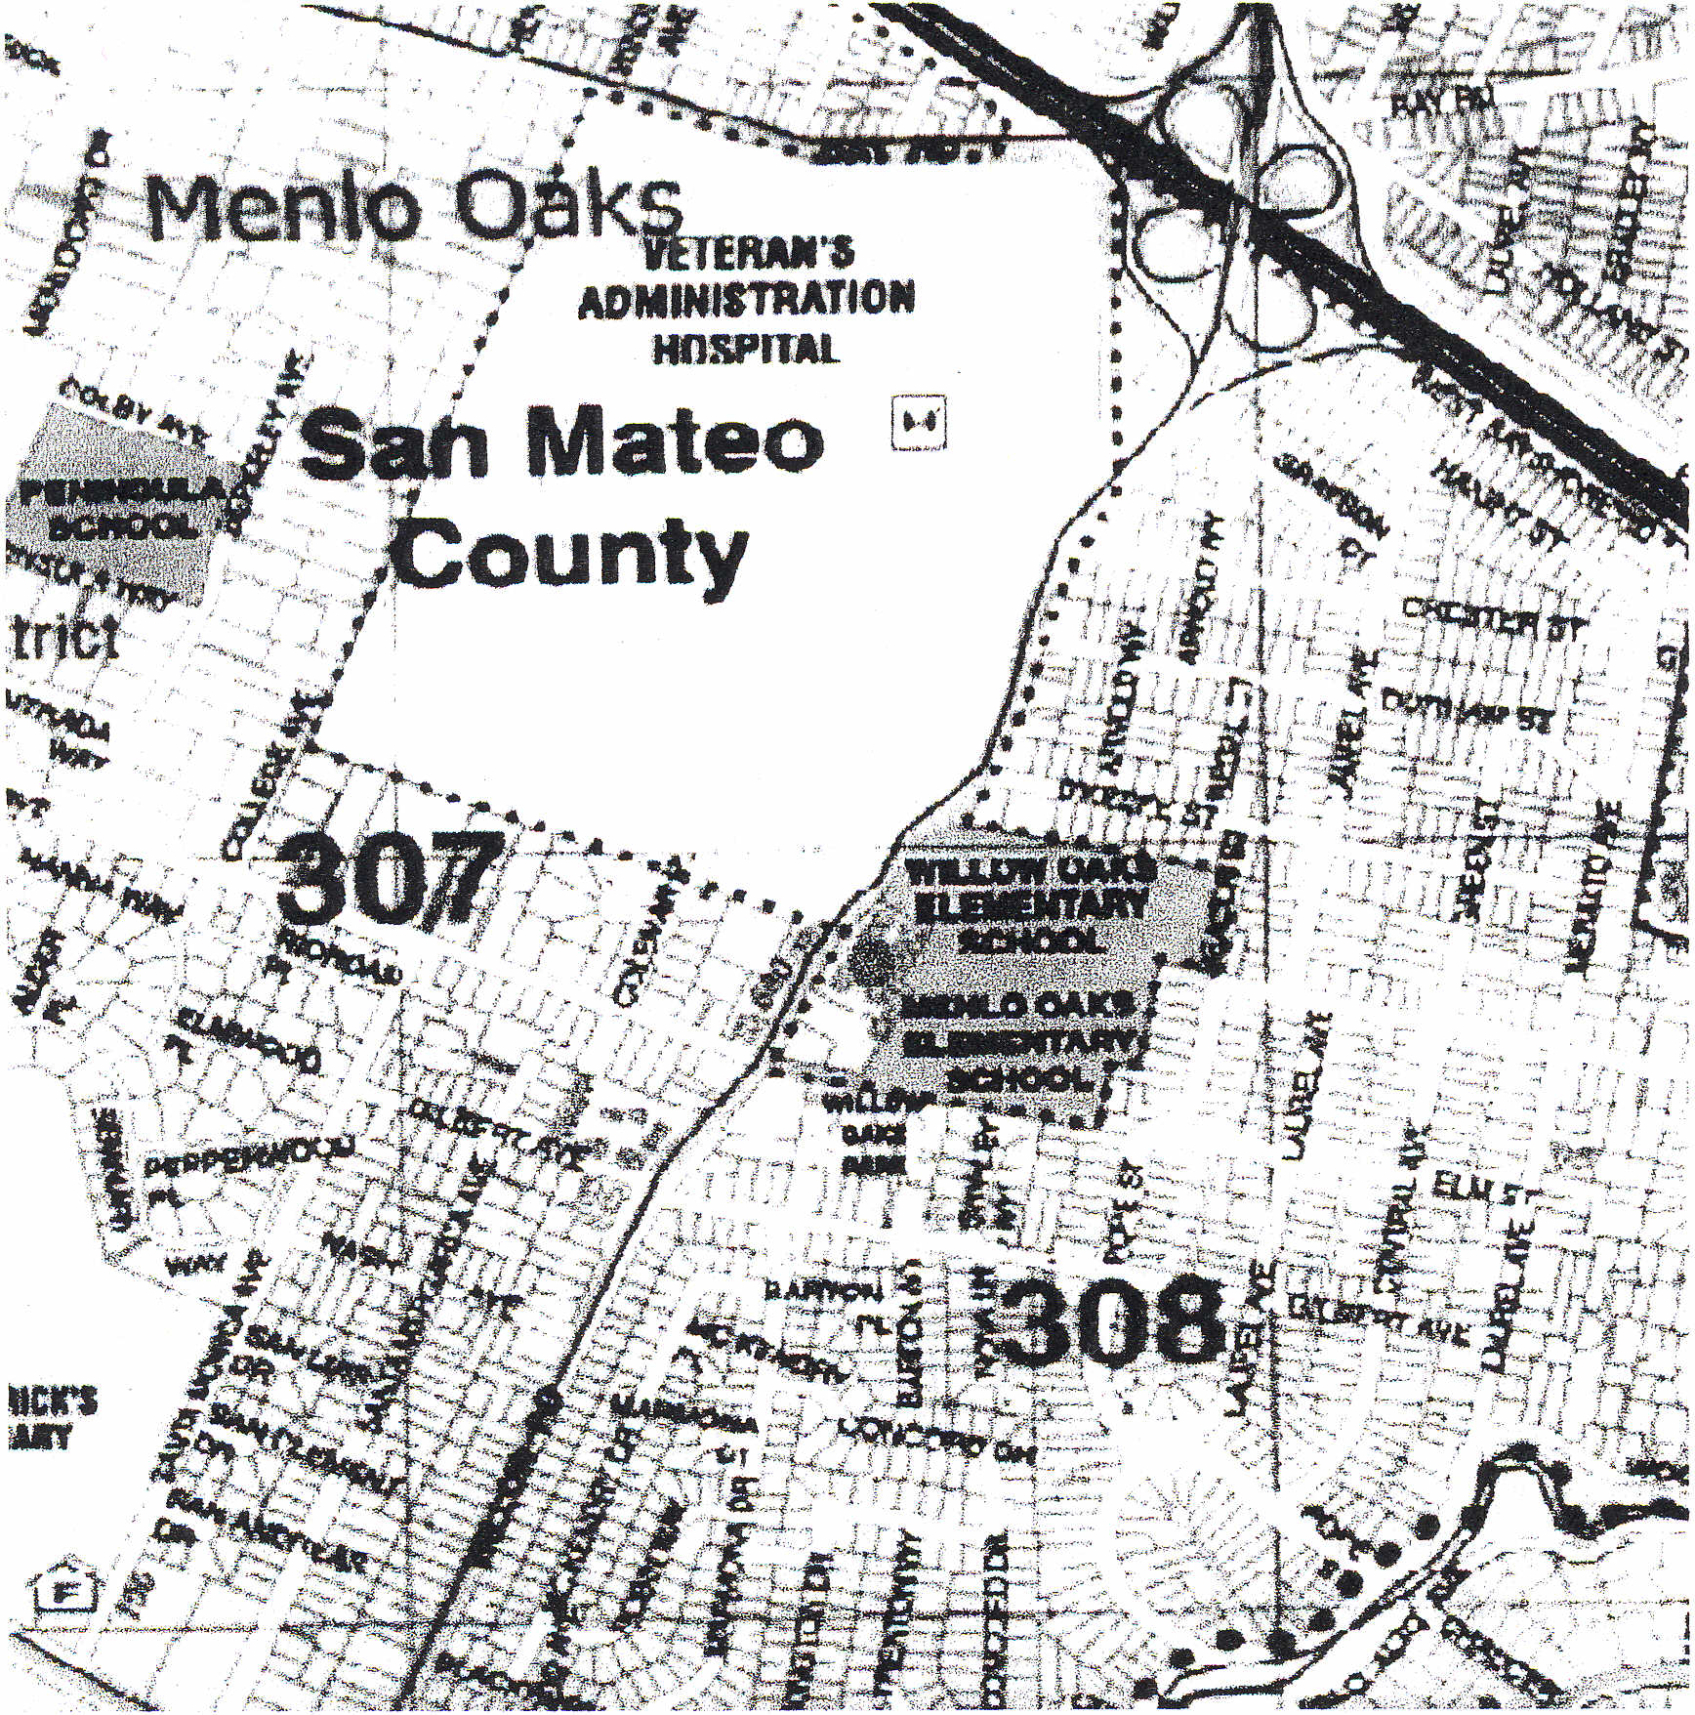
Figure 2

LEGEND:
• (green circle) Pacific Parc Complex
.... (small blue dots) Border of Ravenswood City School District Pink - city of Menlo Park
Grey - unincorporated city of Menlo Park Peach - city of East Palo Alto
The 25 townhome residences in question are part of a subdivision in the City of Menlo Park known as "The Willows". In 1982, a petition was filed to transfer the residential properties in the Willows subdivision from the Ravenswood School District to the Menlo Park School District. That petition was to transfer approximately 2200 households.

However, three commercial properties - 600 Willow Road (an abandoned dairy and the future site of our townhouse complex), one Federal property (Veterans Affairs Hospital) and the school property belonging to the Ravenswood District - were not part of the transfer. The petition was approved by the State Board of Education in 1984, and the residences became part of the Menlo Park City School District. We contend that had the parcel of land where the Pacific Parc townhouse complex now stands been residential at the time of the 1982 petition, it too would have been transferred into the Menlo Park City School District.
It is difficult to discern the specific reasons for the disapproval of our petition by the County Committee. All nine of the criteria were substantially met per vote by the County Committee. It is the position of the· Petitioners that the voters of the County Committee are lacking evidentiary support for their actions. The vote of the County Committee denies the Petitioners the equal protection of the law and constitutes arbitrary and capricious action.
Based on the Petitioners' understanding of the action taken by the County Committee, it appears the petition was primarily denied because of fear by the County Committee of a potential domino effect. The potential domino effect discussed by the County Committee related to whether or not at some distant time the Veteran’s Hospital on federal land or the schools on district land would be converted to residential zoning. There is no such discussion going on in the cities at this time, and this potential action is purely speculative by the committee members. Also, if this land would be converted to residential zoning at some time in the future, that decision would require lengthy public debate, and would in no way dictate that the 1and would necessarily need to change school districts. Future petitions would need to come before the County Committee of District Organization, and they would evaluate each petition on its' own merits. Highly speculative considerations should not have been the deciding factor in denying our valid petition. The County 'Committee's decision was therefore lacking in evidentiary support.
Another point brought up by the County Committee was that our property borders two schools belonging to the Ravenswood School District (one of which is the Willow Oaks School) and therefore the Willow Oaks School is our community's school. However, there are over 30 other homes which also border the school property, and all of those homes are in the Menlo Park City School District.
Transportation was also a concern of the Committee. However, as noted in the report by the independent consultant to the County Committee, all the children who attend the Willow Oaks School, which borders our townhomes, need transportation to get to school; they all live on the other side of the freeway - not one student from the neighborhood surrounding the Willow Oaks School is a student there. Furthermore, all the students in the Willows area currently travel to Menlo Park City School District school sites throughout Menlo Park.
The Menlo Park School District argued that their schools are overcrowded. However, with the recent passage of Measure U in 2006, over $91.1 million of bonds was approved
to ease school overcrowding in the Menlo Park City School District. Furthermore, Menlo Park City School District has over 2,100 students; even by their own calculations, only 7 students are projected to come from the townhouse complex, with a statistically insignificant effect. In fact, we believe the number of children will be less, since in general there are fewer school-age children coming from townhouse units than single family homes. In any case, by the time our children are old enough to attend Menlo Park School District schools, the overcrowding problem will be resolved.
The Petitioners submit that the San Mateo County Committee of School District Organization abused its discretion by denying the Petition for the transfer of the Pacific Pare townhouse complex without substantial evidence in the record. For this reason, the Petitioners respectfully request that the State Board of Education accept jurisdiction of the instant appeal, reverse the Action of Denial by the County Committee, and determine that the Petition should be granted.
Respectfully submitted,

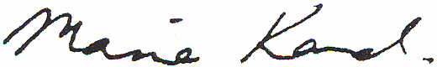
Maria Kaval Chief Petitioner

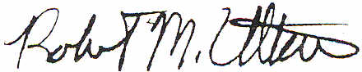
Rob Ultan Chief Petitioner

k1~J(
Kelly Blythe Chief Petitioner

Report on the Conditions
for the
Transfer of Territory
from the
Ravenswood Elementary School District
to the
Menlo Park City School District
April 7, 2007
for the
San Mateo County Committee on School District Organization
Prepared by:
Thomas M. Griffin, J.D., Ph.D. Thomas M. Griffin Law Offices
1242 - 58th Avenue Sacramento, California, 95831
(916) 421-0170

INTRODUCTION
On or about October 25, 2006, a Petition was filed in the office of Dr. Jean Holbrook, San Mateo County Superintendent of Schools calling for the transfer of territory, described below, from the Ravenswood (Elementary) School District to the Menlo Park City (Elementary) School District. The Petition was signed by at least twenty-five percent (25%) of the registered voters as required by Education Code Section 35700(a). The County Superintendent determined the Petition to be sufficient and forwarded the Petition to the San Mateo County Committee on School District Organization for analysis and hearing.
The territory to be transferred consists of the Pacific Pare townhouse complex, a townhouse complex consisting of 25 residential units located at 600 Willow Road, Menlo Park, California. The 25 units are currently occupied and, at the present time, are home to two children both of whom are of preschool age. The townhouse complex is on the East side of Willow Road and is immediately adjacent to the Willow Oaks Elementary School, a school of Ravenswood School District. If this Petition is granted, it would constitute a "finger" of territory surrounded on three sides by the Ravenswood School District. Its sole connection to the Menlo Park City School District is the veteran's hospital across the street.
On or about February 1, 2007, the Ravenswood School District, by and through its attorney Deputy County Counsel Timothy Fox, submitted comments and argument in opposition to the Petition for Transfer of Territory.
On or about February 2, 2007, by and through its Superintendent Kenneth J. Ranella, the Menlo Park City School District submitted its comments and argument also in opposition to the Petition for Transfer of Territory.
On or about March 1, 2007, the Office of the San Mateo County Superintendent of Schools contracted with the Thomas M. Griffin Law Offices to prepare an analysis of the criteria and conditions for reorganization set forth in Education Code Section 35753. This report is designed to provide such analysis for the petitioners and the general public as required by Education Code Section 35705.5(b).
It should be pointed out that the determination or alteration of boundaries of school districts, including the actions of the County Committee as well as the State Board of Education, constitute a legislative act that is based upon public policy and is not a judicial act that must be based upon the record before the County Committee. The criteria set forth in the Education Code for the consideration of the Committee are guidelines to be considered in the formulation of its determination. It is not a case where all nine conditions must be satisfied in order for the Petition to be granted nor is it required that the County Committee approve the Petition even if it determines that all nine conditions are satisfied.

3
There are two factors which should be considered by the County Committee which are not set forth in the Education Code that are matters of equity and educational policy. These are, first whether the petitioners have set forth an adequate rationale for changing the boundaries of the existing school districts and, second whether the approval of the Petition would contribute to a "domino effect" and create a precedent for efforts to transfer individual parcels of property which happen to be situated on the boundary of the two districts.
Most of the conditions for approval of the Petition set forth in Section 35753 are worded in the negative such as condition 4 which requires that the reorganization not result in racial discrimination or segregation. Recently, however, the State Board of Education in its consideration of petitions for reorganization also looks to whether the petitioners have demonstrated a sound educational basis for the proposal. It is noted that in many cases the school districts in question have provided an education and have governed the schools for many decades, sometimes in excess of 100 years. The State Board has taken the position that before school districts that have a history of governing schools and serving children over a long period of time is changed, the reasons for doing so should be grounded in. sound educational policy, not just the whims or desires of the immediate residents of the territory. The County Committee can consider whether the reasons stated by the petitioners as the basis for the Petition constitute sufficient public policy to alter the boundaries of the school districts, in addition to considering whether the conditions are met or not met.
The second factor to be considered by the County Committee is the possibility for cumulative petitions to be filed each seeking the transfer of small amounts of territory. It is noted that the Ravenswood School District has boundaries which are not the same as the boundaries of the City of East Palo Alto. It is our understanding that the Ravenswood School District was formed many years prior to the incorporation of the city and changes in city boundaries, through the process set forth in the Government Code, have not been accompanied by similar changes to the Ravenswood School District. As a result, the Ravenswood School District has irregular boundaries and borders school districts such as Menlo Park City School District which is more affluent than either Ravenswood or East Palo Alto. The districts fear that the approval of this Petition will encourage other homeowners and landowners whose property is on the Ravenswood side of the boundary between the two districts to petition 'to transfer their territory on a one-at-a-time basis. Because a petition to transfer a relatively small amount of territory (in comparison to the district as a whole) with no or Very few children of school age, it is very difficult for a condition not to be met. Small transfers of territory and school age pupils, taken individually, will almost never have a significant impact on either the losing or the gaining district. Nevertheless, the County Committee is entitled to consider whether this "domino effect" is a real possibility and, if so, whether it constitutes grounds for denying this petition.
The following chapters set forth the recommendations of the consultant to the County Committee based on his experience with school district reorganizations. They are, however, recommendations only for the consideration of the Committee; the Committee must make its own determination as to whether each condition is met.
4
CONDITION 8 HOUSING VALUES
INTRODUCTION
Education Code Section 35753(a)(8) requires that:
"(8) The proposed unification is not primarily designed to result in a significant increase in property values causing financial advantage to property owners."
ANALYSIS
This is a somewhat difficult condition to apply because it depends upon two different factors. First, it apparently requires that there be, in fact, a reasonable expectation of an increase in property values as a result of the reorganization. Second, it apparently requires not only an increase in property values but a determination that such an increase is the primary motivation of the petitioners.
The determination of the intent of the petitioners is very subjective. On the one hand, they state in the Petition that their intention is to provide that their children will go to school with other children in the neighborhood who will attend Menlo Park City schools. In the absence of other statements by the petitioners to the contrary, one almost has to take their word for what their intentions are.
On 'the other hand, there is a presumption {hat one intends the natural consequences of his or her actions. If in fact a significant increase in property values will occur as a result of the reorganization, one can infer that this consequence was intended by-the petitioners. The County Committee can consider whether the stated intent of the petitioners really makes sense. The notion that the children in the townhouse complex have made friends with other children in the neighborhood could-be considered somewhat disingenuous since the children are no more than three years of age. To the extent that they make friends at all, they make friends chosen by the parents. It may be true that such children will attend Menlo Park City schools or, upon becoming school age, may attend private schools. The fact that three year old children play with residents of Menlo Park says more about the community of interest of their parents than a compelling educational consideration.
We have conducted an analysis of the sales price of single family homes in the area to determine whether there is a significant difference between the sales price of such homes East of Willow Road and situated in the Ravenswood School District as compared with similar homes in the Menlo Park City School District.
24
Our research of sales in the area yielded the following information:

Table 8-1
Sales Price of Single Family Units

 |  | - - .. -- - - . ---- - -- - - - -_ .•.... ----
Date Sold | Address | Sale Price $ | Sq. Ft. | Cost/Sq.Ft. $
2/1 0/05 | 600 Willow Road, #3 | 710,000 | 1,410 | 504.00
3/4/05 | 20 Willow Road, #35 | 637,500 | 1,151 | 554.00
3/31/05 | 595 Willow Road, #2 | 750,000 | 1,717 | 437.00
5/2/05 | 600 Willow Road, #11 | 909,000 | 1,780 | 506.00
5/20/05 | 20 Willow Road, #23 | 670,000 | 1,111 | 603.00
6/15/05 | 20 Willow Road, #41 | 710,000 | 1,441 | 493.00
8/16/05 | 600 Willow Road, #25 | 805,000 | 1,544 | 521.00
10/19/05 | 600 Willow Road, #16 | 830,000 | 1,544 | 538.00
7/20/06 | 20 Willow Road, #3 | 669,888 | 1,050 | 638.00
8/15/06 | 20 Willow Road, #29 | 680,000 | 1,041 | 653.00
Average |  | 737,138.80 |  | 544.70

25

Table 8-2 indicates the sale price of single family units located in the Menlo Park School District.
Table 8-2
Sales Price of Single Family Units Menlo Park School District

Date-Sold | Address | Sale Price $ | Sq. Ft. | Cost/Sq.Ft. $
7/12/06 | 260 Santa Monic Ave. | 1,300,000 | 1,590 | 817.61
7/21/06 | 815 Bay Road | 780,000 | 1,595 | 489.02
7/25/06 | 411 Durham St. | 1,021,000 | 1,220 | 836.88
8/3/06 | 354 McKendry Place | 1,050,000 | 1,240 | 846.77
9/29/06 | 340 Marmona Drive | 875.00 | 1,220 | 717.21
10/14/06 | 385 McKendry Drive | 960,000 | 980 | 979.59
1/5/07 | 219 Santa Margarita Ave. | 1,120,000 | 1,190 | 941.17
1/26/07 | 209 Durham St. | 900,500 | 1,300 | 692.69
Average |  | 1,000,812.50 |  | 790.12
A comparison of Table 8-1 with Table 8-2 indicates that there is a substantial difference in the sales price of homes between those in the townhouse complex and those elsewhere in Menlo Park, even on a square foot basis. However, the Committee should consider that the sales listed in Table 8-2 were in 2006 while most of the sales in Table 8-1 were in 2005. Moreover, the sales in Table 8-2 were of single family detached home with substantially more land than in the case of the sales in Table 8-1. Since land would appear to be a premium in the area, we would expect that a single family detached home with a substantial lot would cost more per square foot of development than a townhouse development with a much smaller fee interest in land. Nevertheless, the Committee should consider whether a townhouse owner could reasonably expect to sell their property at a higher price if it were in the Menlo Park District rather than in Ravenswood.
If the County Committee finds that the townhouses will not increase significantly in value as a result of the transfer or if it finds that any increase in property values of the townhouse complex is not a significant motivation of the petitioners, we recommend that the Committee find that this condition is substantially met. If not, the Committee could find that this condition is not substantially met.

26

CONCLUSION
We have discussed each requirement condition and have provided information and a recommendation for consideration of the County Committee. Condition 8, Housing Values, can be considered by the Committee as either met or not met depending upon the Committee's analysis of the intent of the petitioners.
The County Committee has the discretion to grant or deny the petition to transfer the territory, as it sees fit. Even if the Committee finds that all nine conditions are met, it may nevertheless deny the petition to transfer. Similarly, even if it finds that most or all of the conditions are not met, it may nevertheless grant the petition.
Ultimately, the County Committee must consider the petition in the light of its determination of sound public and educational policy. Since the change in school district boundaries is essentially a quasi-legislative act, the County Committee must ultimately decide whether the proposed district boundaries are "better" than the status quo.

29
Map of Transfer Area
Map includes boundaries of affected districts and boundaries of incorporated areas (Atherton, East Palo Alto, Menlo Park, and Palo Alto).

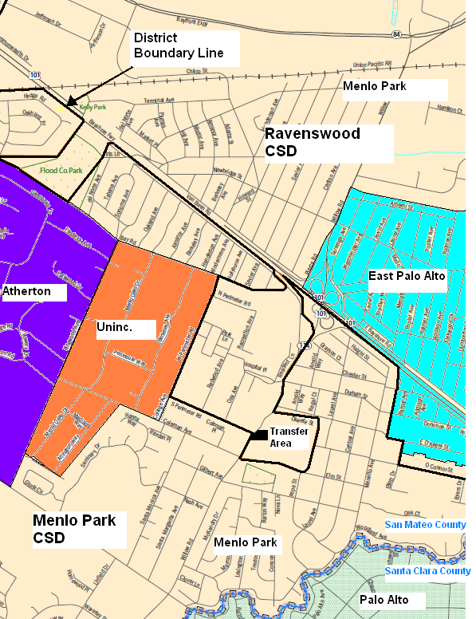

Source map from U.S. Census Bureau: http://ftp2.census.gov/geo/sd2009_rev/st06_california/maps/

SPECIAL MEETING MINUTES

Date: May 7, 2007
Place: San Mateo County Office of Education 101 Twin Dolphin Drive
Redwood City, CA 94065
Pine and Oak Rooms
Present: Jack Coyne Emanuele Damonte Carolyn Livengood Heather McAvoy Dave Pine
George Robinson
Robert Stelzer, chair
Melchior Thompson
Aimee Armsby, Deputy County Counsel
Paulette Johnson, Secretary to County Committee Lisa Marie Garcia, Staff Secretary
Absent: Lois Frontino
Rudie Tretten

Others Present: Thomas Griffin, Consultant Kelly Blythe, Petitioner
Maria Kavel, Petitioner
Robert Ultan, Petitioner
Tim Fox, Deputy County Counsel, Ravenswood District Representative
Jacqueline Wallace Greene, County Committee Member, Ravenswood

Robert Stelzer called the meeting to order at 7:02 p.m. He then asked for a motion to approve the agenda.
Emanuele Damonte moved to approve the agenda. Heather McAvoy seconded the motion.
The motion carried.
Robert Stelzer welcomed all in attendance. He reminded everyone that the public hearing portion of this process has been completed. He stated that the committee would take the information it had received earlier along with additional information obtained this evening for the deliberation process. He stated that there was no set process for taking additional testimony. He added that if questions arose during the
process of reviewing information and a representative of either the petitioner or respondent is present in the audience, they may be called upon for clarification or additional information.
He then invited Paulette Johnson to give the Secretary's Report.
Paulette Johnson stated that copies of all the materials generated so far by this petition were available on the back table.
She stated that at the March 20th meeting, the Committee asked for some information. She had informed them at that time that an independent consultant had been hired to conduct, for the Committee, an unbiased review of the criteria and make a report. Part of her presentation this evening would be for the Committee to hear that report. Also to give members of the Committee time to ask questions of Mr. Thomas Griffin, the consultant who prepared the report.
Also on March'20th, Committee members requested maps. None of the maps presented up to that point were sufficient. With the assistance of the County Assessor's Office, she put together maps that should meet the needs of the Committee. Copies of the maps were also available on the back table. She then used a computer and display screen to show the maps.
The first map is an overview. The Committee asked for a single map that showed both districts, the cities and where schools were located. She pointed out key areas in the map. The second map shows the Willows area. The third map shows the O'Connor Street area.
Heather McAvoy asked about the annexation on November 9,1982.
Paulette Johnson stated that there was an attempt to move that section from the Ravenswood City School District to Menlo Park. The annexation was denied. O'Connor School was transferred to Menlo Park
Robert Stelzer asked if there were any questions about the maps.
There were none.
Paulette Johnson then introduced Tom Griffin, the independent consultant, and explained that he would go through the criteria point by point.
Robert Stelzer asked if there were any questions for Paulette Johnson or requests for more information before continuing.
There were none.

Robert Stelzer stated that legal council would address some legal issues before the Committee began deliberations.
Aimee Armsby stated that given that the Committee has thoroughly discussed the legal framework, the most sense would be for her to be available for questions during deliberations and allow the Committee to go forward. It wasn't necessary to go over what had already been covered and Committee members had the Handbook. She asked if that was acceptable.
Robert Stelzer agreed. He then asked the Committee if they were ready to go forward with deliberations on the petition.
They were.
Robert Stelzer stated that typically the process has been that the Committee will take an individual vote on each of the criteria. The charge is to make a determination as to whether the proposal put forward substantially meets the criteria.
The Committee would go through each criteria. If there were any additional questions, concerns or comments that individual members want to make this is the time to do so.
At the end of that the Committee would take a vote on the petition as a whole.
He then asked the Committee to vote on condition 1.
Paulette Johnson stated that condition 1 is the size of the district. She asked if there were questions or comments from Committee members.
Robert Stelzer stated that, the condition is: Each district will be adequate in terms of number of pupils enrolled. He added that Mr. Griffin reported that this criteria was substantially met.
Jack Coyne asked if he could make a suggestion. He stated that being new to the Committee he hated to change or modify a process. However, the Committee had been through many meetings by this point and had much discussion. For the most part, he did not agree that all 9 criteria have been met but the overall feeling of the Committee are that substantially the 9 criteria are met. The issue is not going to be around the 9 criteria. The issue is going to be around the other factors coming into consideration.
He continued that with this in mind he wanted to attempt something which the chair may overrule. He moved to approve the vote to recognize that all 9 criteria are substantially or basically met.
Robert Stelzer stated that he had asked, initially, the question that he had just to see if this option was acceptable in terms of process.
He asked Aimee Armsby to respond.
Aimee Armsby stated that this was absolutely acceptable.
Paulette Johnson added that it is acceptable as long as the full Committee is in agreement that this is how they want to address the 9 basic criteria.
Robert Stelzer asked the Committee to consider, to go in another direction. Is there any criteria that someone would like to pull out and not have as an en mass vote, but address that particular criteria individually?
Heather McAvoy replied yes. There were two. Number 2, community identity and number 8, housing values.
Robert Stelzer then stated that the chair was open to entertaining a motion to approve items 1, 3,4, 5,6, 7 and 9, while eliminating any further discussion of those criteria if the Committee feels that these have all been substantially met and are prepared to vote.
Dave Pine made the motion.
Emanuele Damonte seconded the motion.
Robert Stelzer then asked the Committee to vote on items 1, 3,4, 5, 6, 7 and 9 in regards to the Committee making a finding that the petition does substantially meet those criteria.
He asked all in favor to say aye.
All approved.
He asked all opposed, same sign.
None opposed.
Robert Stelzer then confirmed those criteria have been met.
He then asked the Committee to address the second criteria, community identity.
Emanuele Damonte stated that he'd read that the children at Willow Oaks School are bussed in from all other areas. He asked if no one living in the area goes to that school, they're all bussed in?
Paulette Johnson confirmed that the students lived in East Palo Alto.
Emanuele Damonte stated that there was some mention about associating with people with whom you go to school. In this case there wouldn't be any association after school because they're bussed in and bussed out.
Robert Stelzer asked if Mr. Damonte would like clarification from the district about that.
Emanuele Damonte stated he would like clarification.
Tim Fox stated that Ravenswood has a policy of open enrollment throughout the district. So students from each of the district's schools come from all over the entire district.
The clarification that he wished to offer is that the students do not come exclusively from East Palo Alto. As the Committee may recall from the district's factual presentation at the hearing, there is an entire neighborhood of Menlo Park that is still part of the Ravenswood City School District. Some of those Menlo Park residents also attend the Willow Oaks School.
Heather McAvoy asked to make an observation. She visited the site on a school day after school. She observed that there were substantial numbers of children doing after school activities, sports and the like. The impression that at 3 o'clock all these children disappear is clearly not true. They are congregating and participating in activities at this school after school hours.
Robert Stelzer thanked her and asked for any other clarifications or observations.
Heather McAvoy continued that she had given a lot of consideration to this particular item because when the Committee was first presented with the petition, the petitioners' commented that their children were making friends in the Willows neighborhood and that they would want them to continue to go to school with those friends. As we had further discussion we discovered that these two children are actually 1 and 3.
Maria Kaval asked to clarify the factual number of children. There were 7, between the ages of 10 months and 3 years, with one more on the way.
Heather McAvoy commented that the petitioners had all along claimed two children, but it sounds like 6 or 7. All age 3 and under. Children of that age are not making meaningful friendships. Which is why when this particular condition was discussed, she was repeatedly concerned by the assertion that the children were making friends. Children make friends in school. That's well established child development. She had gone on the American Pediatrics website and they state that between the ages of 5 and 12 making friends is the most important mission of middle childhood. School age children are more ready to form complex relationships. These children will make friends with the children they go to school with, when they become school age. She was concerned that the petitioners felt that their community identity was defined by their children who were not at the appropriate age to make meaningful friendships, or making friendships in their neighborhood.
Robert Stelzer added that friendships made at that age are not necessarily not meaningful, they may not be the same as school age friendships that get established. And there is always an opportunity to have continuing friendships. But families do get together and at young ages kids develop friendships with other families. It may not be based on location, but they certainly are long term friendships.
Heather McAvoy agreed. She clarified her view stating at this age group, children do make friends with children their parents find for them. When they go to school they make their own friends with people they connect with. She felt that hanging the whole community identity hat on that notion didn't ring true.
Robert Stelzer thanked her for her comments and asked if anyone else had comments.
Melchior Thompson stated that he had a background in site location research for retail. Even though it's only a small part of the group of things the Committee reviews, he did take a 5 minute drive time zone around the petitioners' central address. This is the primary trade area for a supermarket.
Robert Stelzer offered copies of Mr. Thompson's findings.
Melchior Thompson continued that purely in economic terms, the community of interest would be much more with Menlo Park than East Palo Alto. He stated in his note to the chair that this is just one small facet of the entire situation.
Robert Stelzer thanked him for the materials.
Carolyn Livengood asked for someone to briefly review the issues of the two districts since both are opposed to the transfer. What was their overall summary?
Emanuele Damonte stated that the superintendent of Menlo Park stated that he was opposed.
Carolyn Livengood recalled that as well, but not why.
Paulette Johnson stated that the Ravenswood District is opposed because they are in declining enrollment and they felt that this would create a domino effect. Menlo Park is in increasing enrollment and are having trouble housing the students that they have. They also felt that this will create a domino effect.
Carolyn Livengood thanked Paulette Johnson.
Robert Stelzer asked if there were any further comments.
Heather McAvoy stated that in her site visit she observed that the second story windows of the Pacific Pare townhouses overlook these schools. It struck her as somewhat
strange that children who grow up looking out a window at children playing in school did not contribute to their feeling of community identity.
Robert Stelzer asked if there were any other comments.
There were none.
Robert Stelzer called for a vote on this item.
He asked all in favor of stating the petition has substantially met this criteria to say aye.
Jack Coyne, Emanuele Damonte, Carolyn Livengood, Dave Pine, George Robinson, Robert Stelzer and Melchior Thompson approved.
He asked all opposed.
Heather McAvoy opposed.
Robert Stelzer asked that the record note Heather McAvoy opposed.
He then asked the Committee to address the last criteria. Number 8 home value. He asked for questions or concerns.
Heather McAvoy stated that she was disappointed that the Committee didn't get the kind of analysis that they had requested as far as a comparative analysis of home values. She is basing on real estate practice in this area. Homes in districts with higher API scores are considered to be more valuable. But we didn't get an apples to apples comparison from an impartial source.
Robert Stelzer asked if the Committee might indulge his personal analysis based on 23 years as a real estate broker in Palo Alto and Menlo Park. The reality is, this is not an assessment of what motivates the petitioners. The practical reality is when the Willows was separated out from Ravenswood, that provided a significant increase in value for those homes relative to the kinds of increases that were there prior to their moving from Ravenswood to Menlo Park. The same is true again, anecdotally, for properties along Flood Park. When that transfer was made there was a significant increase in value for those properties. Given the nature of the communities that we live in on the midpeninsula, communities that have school districts within their bounds that have test scores and the perception that there is one form of education compared to another, it does have significant, substantial impact on housing values. Rightly, wrongly, fairly, whatever, it's been his experience that this is the case in terms of public perception, again, rightly or wrongly.
He asked if there were any other requests.
Emanuele Damonte stated that Mr. Stelzer made a good point of stating that many people pick their new homes according to how good the district is.
Robert Stelzer stated that it might just be the district that it's in.
Dave Pine asked about the petitioners' intent, the main petitioners.
Aimee Armsby asked if he was questioning the distinction of the chief petitioners and the petitioners.
He confirmed.
Aimee Armsby stated that the petitioners are everyone who signed the petition.
Robert Stelzer stated that was the list that they had. The chief petitioners represent that group.
Dave Pine stated that there was no doubt in his mind that the chief petitioners are motivated by their educational concerns.
Robert Stelzer asked if there were any other questions or comments.
There were none.
He asked if the Committee was ready to vote.
Aimee Armsby read the criteria: The proposed unification is not primarily designed to result in significant increase in property values causing financial advantage to property owners.
Robert Stelzer asked all in favor of stating this criteria has been met to say aye.
Jack Coyne, Emanuele Damonte, Carolyn Livengood, Robert Stelzer and Melchior Thompson approved.
He asked all opposed.
Dave Pin, Heather McAvoy and George Robinson opposed.
Robert Stelzer asked that the record reflect the split vote.
Robert Stelzer stated that the charge of the Committee at this point is to make a decision with regards to the petition as a whole. As has been clarified by both legal counsel and Mr. Griffin, the Committee's charge is to look at the total petition, all of the potential consequences of approving the petition and to take a vote on that as a whole.

He stated the Committee was open to any additional comments or questions for clarification with regards to that. If Committee members wished to share why they are voting the way they are voting now would be the time to do so.
The chair then recognized those who wished to address the Committee.
Heather McAvoy stated that there was a lot of information for the Committee to digest. She felt the State of California has made it clear that they are interested in school districts that are equitably divided and equal opportunity is an important criteria. It seems that this petition is going in the wrong direction. Pulling more affluent, perhaps better educated families, out of a district that really needs more affluent, better educated families to help better integrate the student body and bring everybody up. She felt very strongly that as a matter of public policy that this is not the direction that the State of California would like school districts to be going.
Robert Stelzer asked for other comments.
Emanuele Damonte commented that with No Child Left Behind within a district, if a parent feels that their child isn't getting a proper education in certain schools they can opt to go to another school in that district that is, in their mind, providing a better education.
Heather McAvoy added that this was provisional to adequate space.
Dave Pine stated he had a series of comments for both sides of the issue that he wished to share. He found it a tough call because he was able to see strong merits on both sides. First to support the petitioners, it does seem like a small island of homes in the Ravenswood District that are otherwise surrounded by Menlo Park residences. It does stand out as a kind of historical accident. It is clear that in the past everything else was moved over. Of course there weren't homes at that time in this particular spot. But to look at it, it's just this dot of homes.
He didn't feel the children there would go to Ravenswood. He wished he was wrong. But he did not think they will go. To the extent that the petition is not supported, is pretty much saying the children will go to private school. He hoped he was wrong if the petition is not accepted.
He stated that on one level he was not certain what the short term impact is to Ravenswood since they are not losing any kids. These kids are not going to go there. So in the short term it would seem there isn't an adverse effect to Ravenswood. He added it was good to encourage people to buy town homes.
He continued that the flip side of this petition is the domino effect. He didn't see it happening in the short term, but the long term. He worried about sending a message that Ravenswood isn't good enough. His greatest concern is that when he looks at the property there is a lot of potential for building. Since Ravenswood is a declining enrollment district, it doesn't seem far fetched that the elementary school there behind Pacific Parc could be closed and the whole area built up. Certainly the area immediately beside it on Willow Road might change. Or the Veteran's property could potentially become residential. Taking the longer view, it becomes more complicated.
Robert Stelzer thanked Dave Pine. He stated he shared exactly the same level of concern. One of the realities is the reason the map looks the way it does, properties that have already been taken out of Ravenswood. Often the Committee is called to make corrections to things that were done by accident. To correct something that was somewhat inadvertent.
The fact that that parcel was developed at a much later date indicates to him that this was not an accident. When it was built, it was very clear what district it was a part of. The fact that there is a possibility of continued development, especially the way land
use issues are on the peninsula, there's no telling that at some point in time the entire Veteran's Hospital may not be subject to developing. To say that Ravenswood does not have the right to expect, to be able to have homes built in its community because if they are they will be siphoned off, he felt that was a great disservice.
Robert Stelzer stated that he had the same kind of trepidations in terms of short term and long term. He felt there was a potential concern that right next door to the school, something has been carved out and put into someone else's district. To in a sense continue to condemn Ravenswood who has made significant strides in regards to reconstituting the kinds of educational opportunities that are there, does them a disservice. To continue to allow lands within the district to be taken away from them and not give them the chance to work towards building a place where people want to be as opposed to want to flee. This leaves him with the same level of concern with regards to public policy as opposed to necessarily the criteria being met or not. This is not an easy cookie cutter decision to be made. There are significant ramifications in the long term. The reason that we're dealing with it is because of other things that have happened in the past. Decisions that have been made to take things away from them.
Melchior Thompson asked if, in what the Committee has gone over, has there been an approximate estimate of the population involved in parcels that might come up for review in the next 5 years or so, the so called domino effect? Does anyone have any idea?
Robert Stelzer stated that all the Committee can do is look at what has happened over the last 20-plus years. The trend has been to decrease property sites from Ravenswood at their expense to increase others. This is one more of an effect that has been in existence now for a while. He wondered if we (the Committee) were looking at the potential for a future domino effect or were living a domino effect right now.
Melchior Thompson stated that he shared many of the concerns that Mr. Pine and Mr. Stelzer shared. From the public policy point of view the issues raised are valid. At the
same time, this individual micro-situation, there's nothing really on the face of it that would say that it should be denied. It is indeed a puzzlement.
Jack Coyne stated that the criteria is not going to playas much of a factor as public policy. The questions of domino effect, when looking at this property and the maps, what the Committee is faced with is a situation that has been created by past decisions. The Committee is not charged with fixing all the past decisions, and they can't. However this got to the point where Ravenswood had a school complex stranded in the middle of another district, the people who approved those should have been shot. This is absurd to have a boundary that works like this where you have your schools sitting so far away from your students that they only way to get there is to be transported in. The Committee can't fix that. To deny a group that says all the folks around them, anyone living there, not coming there to work or going to the hospital, is part of a different district. I don't see where holding them in Ravenswood does anyone any good. There have been the comments made that odds are they won't attend Ravenswood if they stay. That's their personal choice. We aren't going to change that either with the decision here.
He stated he was inclined to support the petition because the way this whole boundary works out is a travesty. The Committee isn't going to fix it or make it any worse with addressing this one piece of residential property.
He continued that what he reacts very negatively to is the concept that the Committee should not approve this because others will then ask and there will be a domino effect.
If people cannot have the integrity to look at requests for the merit of the request and the appropriateness of making that decision, then they shouldn't sit on this committee or maybe this committee shouldn't exist in the way it works. The Committee is not going to have to approve a whole block saying they want to move across between districts because the Committee approved this one island. Yes we can make the case that it's not an island. Maybe it's a peninsula. It is surrounded on three sides by Ravenswood. Three sides of a school and commercial property. That's not surrounded by the other district. There aren't people there. You take a block, that's not the same situation. You would need to evaluate that request separately and for it's merit and for it's impact. There is no strength to that argument to decline this petition.
Robert Stelzer asked if there were any other comments.
Heather McAvoy mentioned one other issue of public policy is racial segregation. This is occurring in our districts across the state in that people are making choices like this. People who have the resources and education to bring these kinds of processes into play to in essence recarve the school districts so that they can be in the districts that they wish that their home had been in when they purchased it. She did not feel that to be what the State of California intends. The Committee did not discuss the criteria about racial segregation. When one looks at the fact that there are 24 white children in the Ravenswood City School District and we have a group of mostly, the elephant in the room, non-Hispanic white parents who would like to remove their children from the district when right next door to them is a school. She is very uncomfortable with that as a matter of public policy.
Robert Stelzer stated that he takes somewhat of an issue in regards to the matter of integrity. In terms of denying something. He stated he can look at this petition and see a parcel of land that is right next to its local school. In order to go someplace else, they are going to have to go a significant distance to even get to another school. What is the message that is there when we are saying that, now this is part of a school. We're not creating districts out of nothing. We are taking a parcel that is already within a district and saying that the school right next to you is inappropriate. And that it makes more sense for you to go to some other school at a further distance. You take exception to looking at a bigger picture as something that raises concerns over the integrity of that decision-making process.
Carolyn Livengood stated that she had a lot of sympathy for the many things being said. Mr. Coyne said something about not being concerned with the domino effect. But to her that's looking to the future. She feels that looking around, the County the Committee can see a lot of transportation problems in some communities where no one looked to the future and what would be happening. In many times, transportation has been related to a domino effect too. She sees many areas in the County where it's really sad because they never bothered to think beyond the moment. She didn't feel she totally agreed with Mr. Coyne's remark on the domino effect. But she is looking at it from a future effect. Not exactly the way he explained it.
Emanuele Damonte mentioned transportation also. In many districts when they reconfigure their attendance lines, a child can live across the street from a school and still have to go blocks away to another school in that district.
Robert Stelzer stated that he was speaking about an existing school and an existing neighborhood .. Not a district deciding it needs to readjust itself. He didn't feel it was inappropriate for the Committee and it was the reason he asked for clarification with regards to the intent of the legislature as to the kinds of issues that this Committee has the charge to look at. The charge of this Committee is to look at the entire process of school districts within the bounds of the County, not just a parcel by parcel basis. While that is what the Committee often deals with, their obligation is to look at the larger picture as well. He continued that this petition is not an easy one. There were issues that the Committee would continue to struggle with. He asked if members were ready to take a vote.
All replied in the affirmative.
Robert Stelzer asked for a roll call.
Emanuele Damonte asked jf a motion was needed.
Robert Stelzer replied that it was not necessary. This is what the Committee needed to do.
Robert Stelzer stated in the matter of the petition before the Committee, yes means that members are in favor of approving the petition. No means that you are not in favor of approving the petition.
Jack Coyne: Yes
Emanuele Damonte: Yes
Carolyn Livengood: No
Heather McAvoy: No
Dave Pine: No
George Robinson: No
Robert Stelzer: No
Melchior Thompson: Yes
5 members responded No. 3 members responded Yes.
Robert Stelzer announced that based upon the votes the petition had been denied. He stated that the petitioners can make use of the appeal process. Paulette Johnson would have information on that.
Melchior Thompson asked if the Committee's decision went to the State and the State makes the final decision.
Both Paulette Johnson and Robert Stelzer stated this was not the case. Paulette Johnson stated the Committee has made the decision. The State only handles the appeal.
Robert Stelzer stated that there is an appeal process if that is something the petitioners wish to do. He added that Paulette Johnson is the contact.
He then thanked the Committee for all their efforts. Adding that this was one of the more difficult petitions they'd faced.
Paulette Johnson stated that there was an additional meeting scheduled for May 21st in the event the deliberation needed to continue. That meeting would be cancelled.
Robert Stelzer asked if there was anything on the calendar for the next meetings.

