CALIFORNIA DEPARTMENT OF EDUCATION

GENERAL WAIVER REQUEST First Time Waiver: _X__
GW-1 (Rev. 10-2-09) http://www.cde.ca.gov/re/lr/wr/ Renewal Waiver: ___

Send Original plus one copy to: Send Electronic copy in Word and
Waiver Office, California Department of Education back-up material to: waiver@cde.ca.gov
1430 N Street, Suite 5602
Sacramento, CA 95814
 |  |  |  |  | CD CODE
 |  |  |  | 1 | 9 | 6 | 4 | 3 | 9 | 4
Local educational agency:  Claremont Unified School District on behalf of  Oakmont Elementary School |  | Contact name and Title:  Mike Lawshe  Director Special Projects & Programs |  |  |  | Contact person’s e-mail address:mlawshe@cusd.claremont.edu
Address: (City) (State) (ZIP)  170 West San Jose Ave Claremont CA 91711 |  |  |  | Phone (and extension, if necessary):  909-399-1718  Fax Number: 909-624-7190
Period of request: (month/day/year)  From: July 1, 2010 To: June 29, 2012 | Local board approval date: (Required)  October 21, 2010 |  | Date of public hearing: (Required)  October 21, 2010

LEGAL CRITERIA
- 1. Under the general waiver authority of Education Code 33050-33053, the particular Education Code or California
- Code of Regulations section(s) to be waived (number): EC 48352 Circle One: EC or CCR

Topic of the waiver: Removal of Oakmont Elementary from the Open Enrollment List of Low-Achieving Schools
2. If this is a renewal of a previously approved waiver, please list Waiver Number: __N/A___ and date of SBE Approval______

Renewals of waivers must be submitted two months before the active waiver expires.
3. Collective bargaining unit information. Does the district have any employee bargaining units? __ No _X_ Yes If yes,
please complete required information below:

Bargaining unit(s) consulted on date(s): October 15, 2010

Name of bargaining unit and representative(s) consulted: Claremont Faculty Association: Deborah Page & Natalie Taylor
CSEA: Rosie Bister

The position(s) of the bargaining unit(s): __ Neutral _X_ Support __ Oppose (Please specify why)

Comments (if appropriate): In complete support of the Waiver

4. Public hearing requirement: A public hearing is not simply a board meeting, but a properly noticed public hearing held
during a board meeting at which time the public may testify on the waiver proposal. Distribution of local board agenda does
not constitute notice of a public hearing. Acceptable ways to advertise include: (1) print a notice that includes the time,
date, location, and subject of the hearing in a newspaper of general circulation; or (2) in small school districts, post a formal
notice at each school and three public places in the District.

How was the required public hearing advertised?

___ Notice in a newspaper __X_ Notice posted at each school _X__ Other: District office showcases, City Hall, Library
- Advisory committee or school site councils. Please identify the council(s) or committee that reviewed this waiver:
SSC Members: Marcia Rodgers, Julie Elliott, Theresa Caravalho, Louis Cabot, Greg Regaignor, Adriana Garrett, Imetra Joiner, Barbara Carlson, Coral Sieber, Rosie Bister

Date the committee/council reviewed the waiver request: October 18, 2010

Were there any objection(s)? No _X__ Yes ___ (If there were objections please specify)
CALIFORNIA DEPARTMENT OF EDUCATION

GENERAL WAIVER REQUEST
GW-1 (10-2-09)

- Education Code or California Code of Regulations section to be waived. If the request is to waive a portion of a section, type the text of the pertinent sentence of the law, or those exact phrases requested to be waived (use a strike out key).

Please see attached

- Desired outcome/rationale. Describe briefly the circumstances that brought about the request and why the waiver is necessary to achieve improved student performance and/or streamline or facilitate local agency operations. If more space is needed, please attach additional pages.

This General Waiver EC 33050 seeks exemption from Education Code Section 48352, which is the formula in the statute identifying Oakmont Elementary as an Open Enrollment School.
Unfortunately the formula selects only a limited number of schools in each grade span and is limited to only 10 percent of the schools from each district. This results in a list targeting many high achieving schools, while excluding a large number of truly low-achieving schools. California School Boards Association (CSBA) cited its example of high achieving schools (as it relates to the Open Enrollment Act) as schools with an API in the high 700’s or over 800. Oakmont Elementary School improved 28 points for a total API score of 771 on the 2010 California Standards Test (CST) demonstrating it is a high achieving school and should not be included on the Open Enrollment list for 2011-2012 school-year.
The period of request would be effective from July 1, 2010 to June 29, 2012.

- Demographic Information:
Oakmont Elementary School has a student population of __308__ and is located in a suburban setting in the city of Claremont within the eastern end of Los Angeles County.

Is this waiver associated with an apportionment related audit penalty? (per EC 41344) No X Yes
(If yes, please attach explanation or copy of audit finding)

Has there been a Categorical Program Monitoring (CPM) finding on this issue? No X Yes
(If yes, please attach explanation or copy of CPM finding)
District or County Certification – I hereby certify that the information provided on this application is correct and complete. Claremont Unified School District

Signature of Superintendent or Designee:  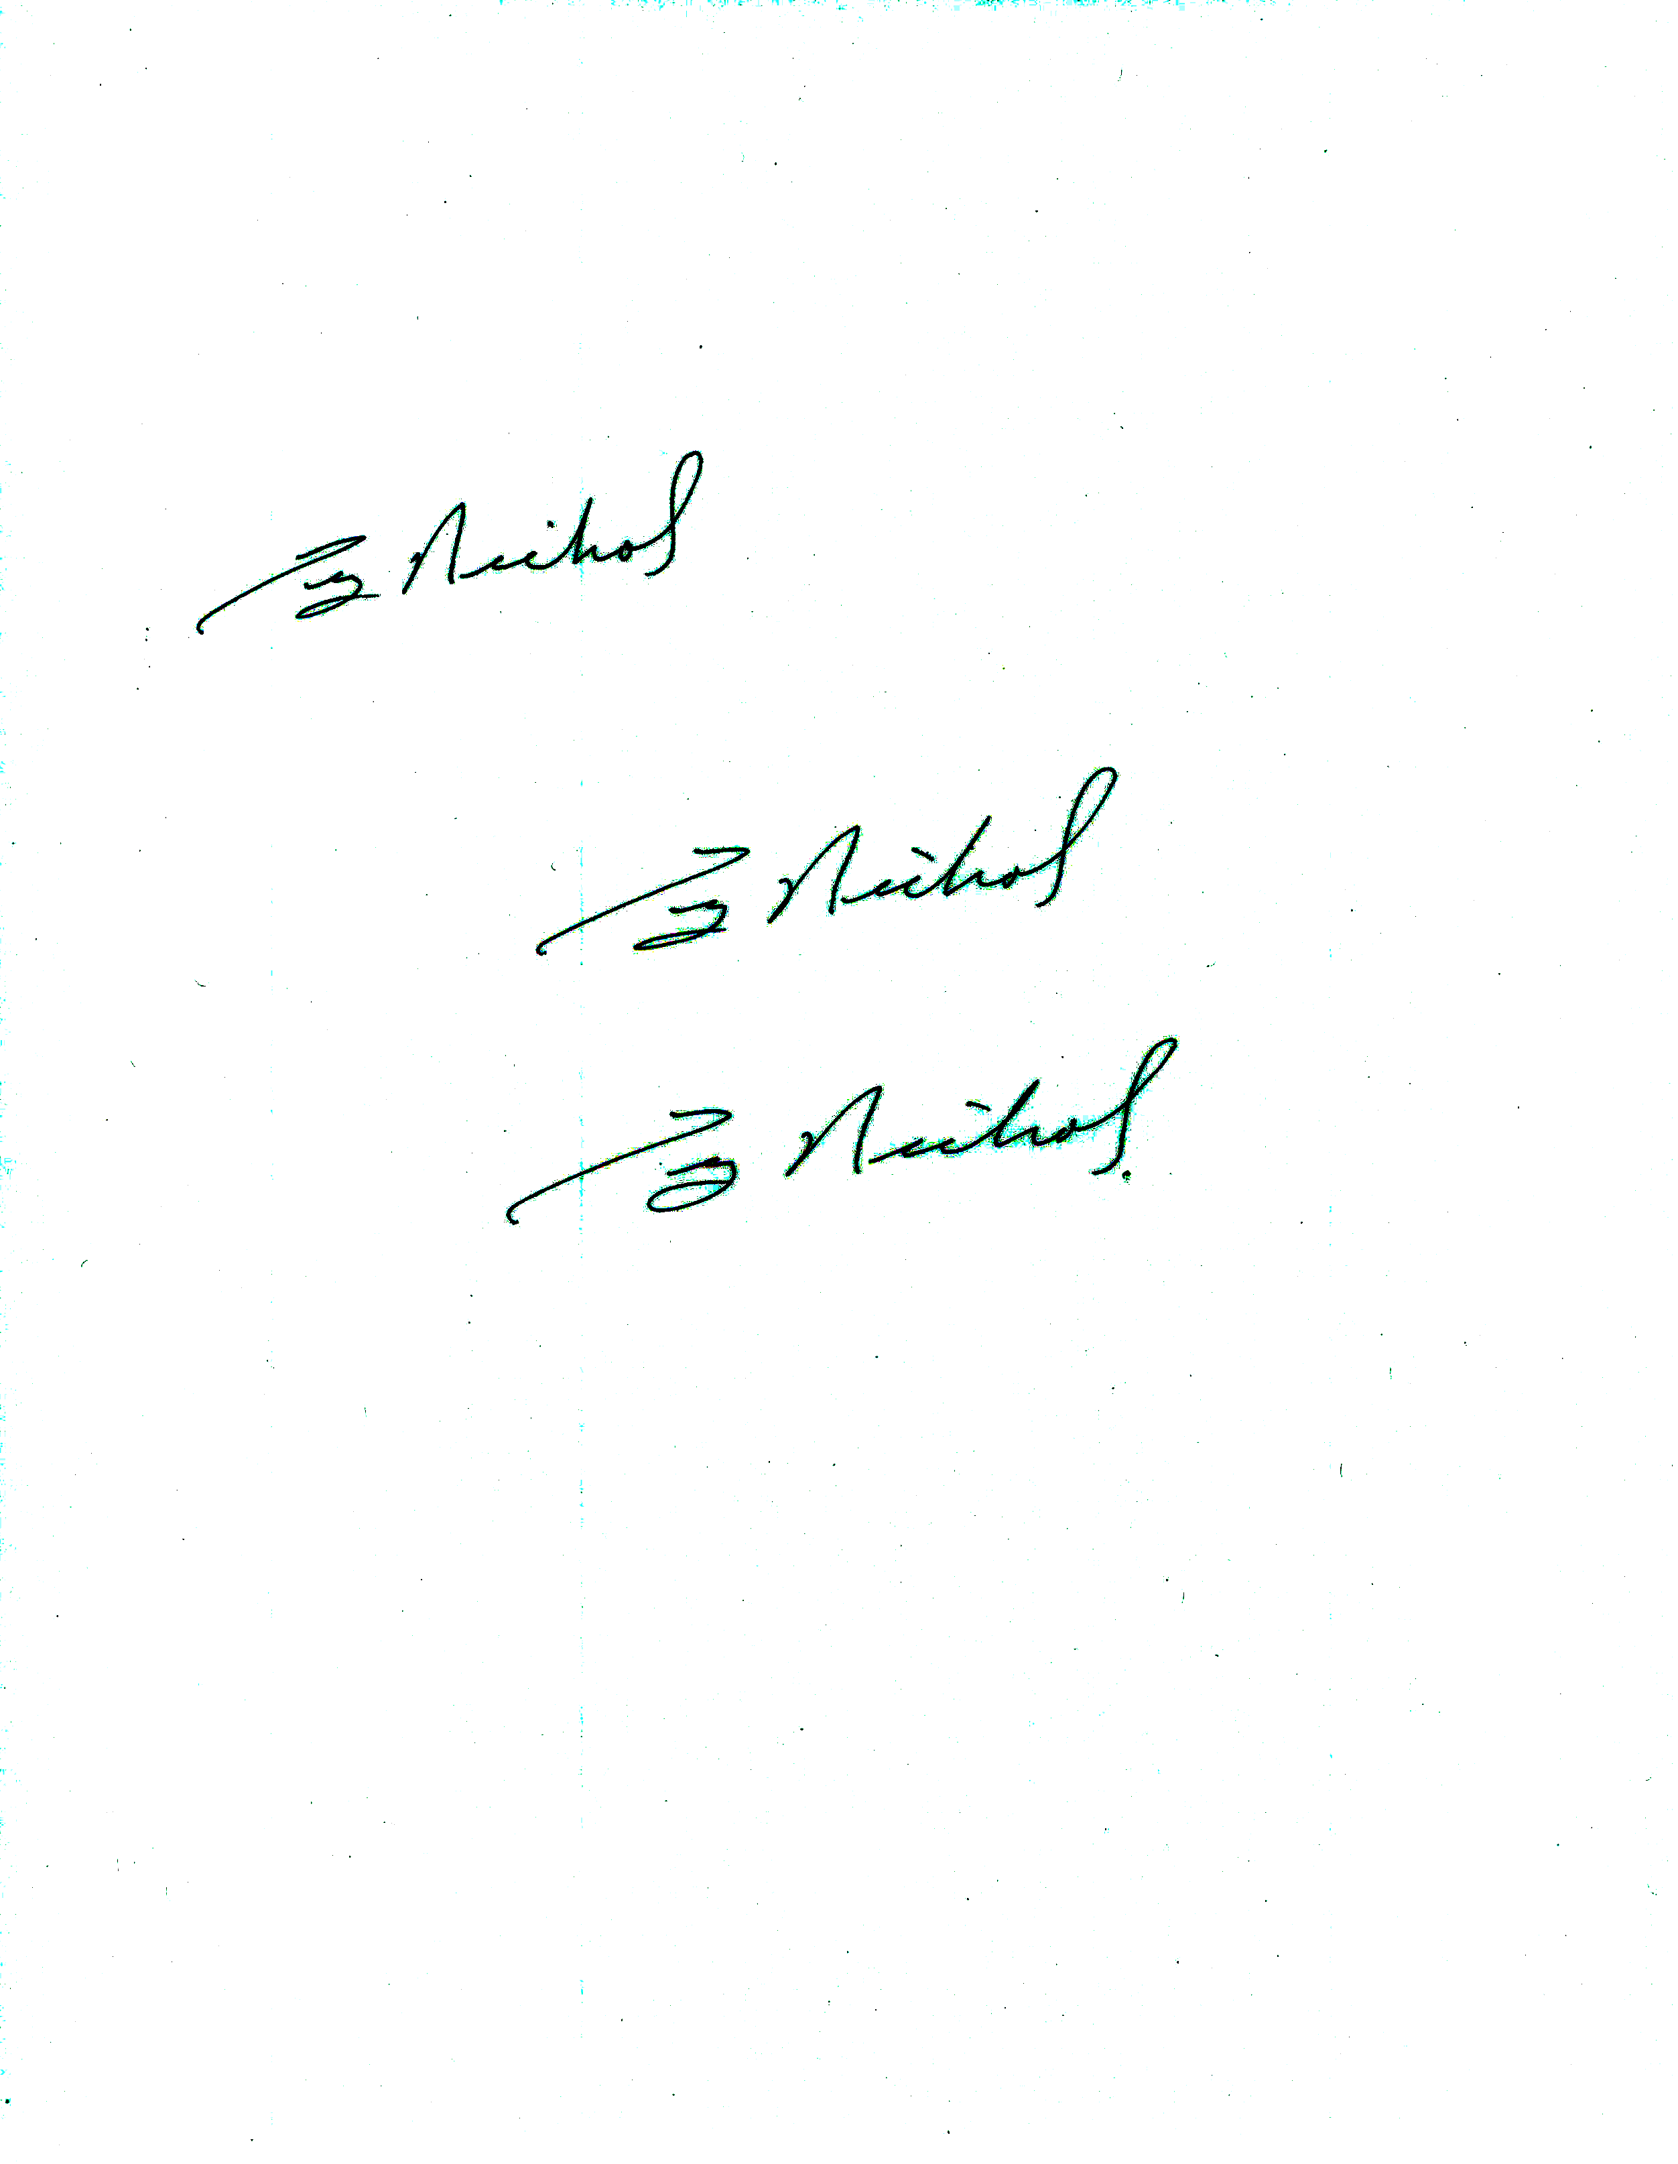 | Title:  Superintendent | Date:  October 22, 2010

FOR CALIFORNIA DEPARTMENT OF EDUCATION USE ONLY
Staff Name (type or print): | Staff Signature: | Date:
Unit Manager (type or print): | Unit Manager Signature: | Date:
Division Director (type or print): | Division Director Signature: | Date:
Deputy (type or print): | Deputy Signature: | Date:

