CALIFORNIA DEPARTMENT OF EDUCATION

GENERAL WAIVER REQUEST First Time Waiver: _x_
GW-1 (Rev. 11-30-10) http://www.cde.ca.gov/re/lr/wr/ Renewal Waiver: ___

Send Original plus one copy to: Send Electronic copy in Word and
Waiver Office, California Department of Education back-up material to: waiver@cde.ca.gov
1430 N Street, Suite 5602
Sacramento, CA 95814
 |  |  |  |  | CD CODE
 |  |  | 5071290
Local educational agency:  Sylvan Union Elementary School District |  | Contact name and Title:  Name: Marti Reed  Title: Director of Categorical Programs |  | Contact person’s e-mail address:  mreed@sylvan.k12.ca.us
Address: 605 Sylvan Ave.  City: Modesto  State: California  ZIP: 95354 |  |  |  | Phone (and extension, if necessary):  209-574-5000, ext. 209  Fax Number: 209-524-2672
Period of request: (month/day/year)  From: February 1, 2011 To: April 1, 2011 | Local board approval date: (Required)  1/18/11 |  |  | Date of public hearing: (Required)  January 18, 2011

LEGAL CRITERIA
- 1. Under the general waiver authority of Education Code 33050-33053, the particular Education Code or California
- Code of Regulations section(s) to be waived (number): Circle One: EC or CCR
35256(c) & 35258
Topic of the waiver: Extension of SARC posting February 1 timeline
2. If this is a renewal of a previously approved waiver, please list Waiver Number: _____ and date of SBE Approval______
Renewals of waivers must be submitted two months before the active waiver expires.
3. Collective bargaining unit information. Does the district have any employee bargaining units? __ No _x_ Yes If yes,
please complete required information below:

Bargaining unit(s) consulted on date(s): December 10, 2010

Name of bargaining unit and representative(s) consulted: Sylvan Educators Association, Christopher Aguilar, President
The position(s) of the bargaining unit(s): __ Neutral _x_ Support __ Oppose (Please specify why)
Comments (if appropriate):

Name of bargaining unit and representative(s) consulted: California State Employees Association, Isa Wiechmann, President
The position(s) of the bargaining unit(s): ___ Neutral _x_ Support ___ Oppose (Please specify why)
Comments (if appropriate):

4. Public hearing requirement: A public hearing is not simply a board meeting, but a properly noticed public hearing held
during a board meeting at which time the public may testify on the waiver proposal. Distribution of local board agenda does
not constitute notice of a public hearing. Acceptable ways to advertise include: (1) print a notice that includes the time,
date, location, and subject of the hearing in a newspaper of general circulation; or (2) in small school districts, post a formal
notice at each school and three public places in the district.

How was the required public hearing advertised?

_x_ Notice in a newspaper ___ Notice posted at each school ___ Other: (Please specify)
- Advisory committee or school site councils. Please identify the council(s) or committee that reviewed this waiver: School Site Councils at thirteen (13) Sylvan Union School District school sites.

Date the committee/council reviewed the waiver request: Elementary Site Councils: CF Brown (1/6/11); Sherwood (1/11/11); Standiford (12/10/10); Stockard Coffee (1/7/11); Sylvan (1/5/11); Woodrow (1/10/11); Orchard (1/7/11); Freedom (1/11/11); Sanders (1/7/11); Crossroads (12/14/10). Middle School Sites: Somerset (1/11/11); Ustach (12/14/10); Savage (12/14/10).

Were there any objection(s)? No _X_ Yes ___ (If there were objections please specify)

GENERAL WAIVER REQUEST
GW-1 (11-30-10)

- Education Code or California Code of Regulations section to be waived. If the request is to waive a portion of a section, type the text of the pertinent sentence of the law, or those exact phrases requested to be waived (use a strike out key).
35256. School Accountability Report Card
(c) The governing board of each school district annually shall issue a School Accountability Report Card for each school in the school district, publicize those reports, and notify parents or guardians of pupils that a hard copy will be provided upon request. Commencing with the 2008-09 school year, each school district shall make hard copies of its annually updated report card available, upon request, on or before February 1 of each year.
35258. Commencing with the 2008-09 school year, each school district connected to the Internet shall make its annually updated report card available on the Internet on or before February 1 of each year.
(b) Commencing with the 2008-09 school year, each school district not connected to the Internet shall make hard copies of its annually updated School Accountability Report Card available, pursuant to subdivision (c) of Subsection 35256, on or before February 1 of each year.
- Desired outcome/rationale. Describe briefly the circumstances that brought about the request and why the waiver is necessary to achieve improved student performance and/or streamline or facilitate local agency operations. If more space is needed, please attach additional pages.

On behalf of its schools, the District takes seriously its responsibilities under state and federal law to communicate the various aspects of performance covered by the School Accountability Report Card (SARC). The District seeks to ensure that our parents and community members have an accurate, complete, and up-to-date SARC from which they can understand each school’s performance and make decisions on behalf of their students.

At its November 2010 meeting, the State Board of Education approved the 2010-11 School Accountability Report Card template and, at the same time, received a report from the California Department of Education that, due to budget and staffing reductions, the department would not be able to fill in some of the data that typically is provided to districts as they prepare their SARCs. This shift of responsibility for that data collection and reporting to each district (and school) now requires districts and school sites to take on additional duties just as the holidays approach.

Because of the lateness in approving the template and the necessity for school districts to assume responsibility for manually gathering and inputting some of the data required for the 2010-11 SARC posting on February 1, the district and its schools are seeking a 60-day extension from the statutorily-required posting date of February 1.
- Demographic Information:
Sylvan Union School District has a student population of 8,152 and is located in an urban area in Stanislaus County.

Is this waiver associated with an apportionment related audit penalty? (per EC 41344) No Yes
(If yes, please attach explanation or copy of audit finding)

Has there been a Categorical Program Monitoring (CPM) finding on this issue? No Yes
(If yes, please attach explanation or copy of CPM finding)
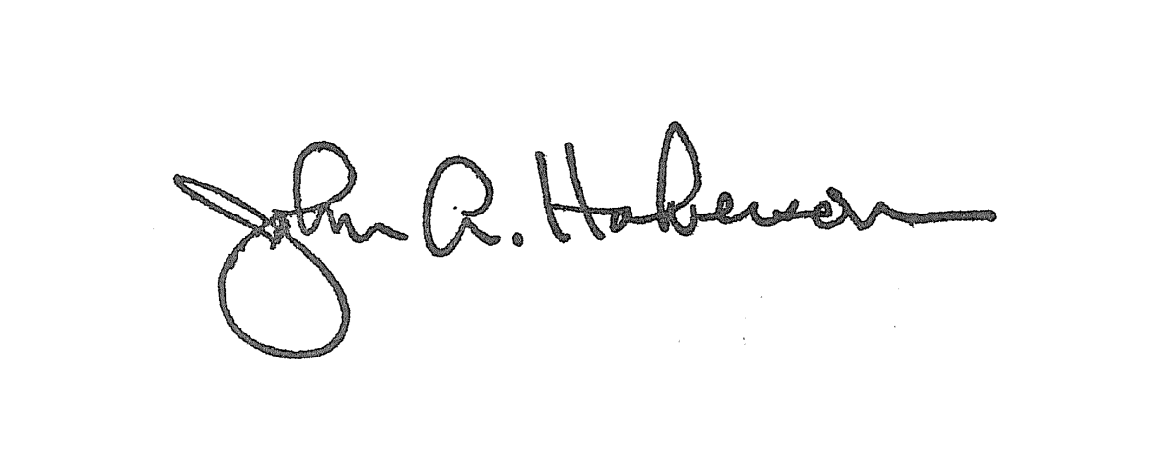
District or County Certification – I hereby certify that the information provided on this application is correct and complete.

Signature of Superintendent or Designee: | Title:  Superintendent | Date:  1/19/2011

FOR CALIFORNIA DEPARTMENT OF EDUCATION USE ONLY
Staff Name (type or print): | Staff Signature: | Date:
Unit Manager (type or print): | Unit Manager Signature: | Date:
Division Director (type or print): | Division Director Signature: | Date:
Deputy (type or print): | Deputy Signature: | Date:

