California Department of Education  Executive Office  SBE-003 (REV. 09/2011)  ssssb-sed-jan13item01 |  | ITEM #13
 | CALIFORNIA STATE BOARD OF EDUCATION  JANUARY 2013 AGENDA
SUBJECT  State Performance Plan and Annual Performance Report for Part B of the Individuals with Disabilities Education Act of 2004 Covering Program Year 2011–12. |  |  |  | Action
 |  |  |  | Information
 |  |  |  | Public Hearing

SUMMARY OF THE ISSUE(S)

The State Board of Education (SBE), as the state educational agency, reports annually to the public and the United States Department of Education’s Office of Special Education Programs (OSEP) on the performance of California’s local educational agencies (LEAs) with regard to the Individuals with Disabilities Education Act (IDEA). The State Performance Plan (SPP) contains performance targets and the Annual Performance Report (APR) contains data collected by the California Department of Education (CDE) for Federal Fiscal Year (FFY) 2011–12 regarding achievement towards those targets. The final SPP and APR are due to the OSEP on February 1, 2013. This item contains an attached executive summary of the FFY 2011 APR. The complete FFY 2011 SSP is available for viewing on the CDE Web site at http://www.cde.ca.gov/sp/se/qa/.

RECOMMENDATION

The Special Education Division (SED) of the CDE recommends that the SBE approve the FFY 2011 SPP and APR Executive summary, covering program year 2011–12, for submission to the OSEP on February 1, 2013.

BRIEF HISTORY OF KEY ISSUES

California is required to have in place a SPP to guide the state’s implementation of Part B of the IDEA and to describe how the state will improve implementation. California’s initial plan was submitted to the OSEP on December 2, 2005, as approved by the SBE and the State Superintendent of Public Instruction. Each year the SPP is updated to reflect changes in federal requirements and update improvement activities. The SPP remains current through FFY 2012, program year 2012–13.

In addition, California must report annually to the public on the performance of its LEAs. The APR documents and analyzes the progress of the LEAs and State toward meeting the targets and benchmarks identified in the SPP. It also summarizes the statewide activities associated with each of the SPP’s target indicators. The APR is presented to the SBE annually for review.

SUMMARY OF PREVIOUS STATE BOARD OF EDUCATION DISCUSSION AND ACTION

For FFY 2010, the APR reported on progress of the 2010–11 compliance and performance indicators as required by the IDEA. The APR and SPP also addressed some new federal reporting requirements, which included updates to reflect changes in the calculation methodology used to identify disproportionality for Indicator Four (Rates of Suspension and Expulsion), Indicator Nine (Disproportionality of Racial and Ethnic Groups in Special Education), and Indicator Ten (Disproportionality of Racial and Ethnic Groups in Specific Disability Categories). The SPP and APR, amended as described, were approved by the SBE at its January 2012 meeting. On February 1, 2012, the SPP and APR were submitted to the OSEP.

FISCAL ANALYSIS (AS APPROPRIATE)

There is no fiscal impact.

ATTACHMENT(S)

Attachment 1: Executive Summary of the FFY 2011 Annual Performance Report for Part B of the Individuals with Disabilities Education Act Covering Program Year 2011–12 (50 pages)

California Department of Education

Special Education Division

Individuals with Disabilities Education Act of 2004

State Annual Performance Report

Executive Summary

Federal Fiscal Year 2011 (Program Year 2011–2012)

January 2013
Table of Contents

Special Education in California 3

Accountability and Data Collection 3

Overview of Population and Services 4

2011−2012 Annual Performance Report Indicators 8

Indicator 1 Graduation Rates 10
Indicator 2 Dropout Rates 11
Indicator 3 Statewide Assessment 12
Indicator 4 Suspension and Expulsion by Ethnicity 15
Indicator 5 Least Restrictive Environment 19
Indicator 6 Preschool Least Restrictive Environment 21
Indicator 7 Preschool Assessment 22
Indicator 8 Parent Involvement 28
Indicator 9 Disproportionality Overall 29
Indicator 10 Disproportionality by Disability 30
Indicator 11 Eligibility Evaluation 31
Indicator 12 Part C to Part B Transition 33
Indicator 13 Secondary Transitions Goals 35
Indicator 14 Post School 37
Indicator 15 General Supervision 39
Indicator 16 Complaints 41
Indicator 17 Due Process 43
Indicator 18 Hearing Requests 45
Indicator 19 Mediation 47
Indicator 20 Timely and Accurate Reports 49

Tables and Figures

Table 1 California State Indicators 4
Table 2 Enrollment of Special Education Students by
Disability Type 5
Table 3 Enrollment of Special Education by Type of School 7
Table 4 Services Provided Special Education Students 8
Table 5 FFY 2011 Indicators, Targets, and Results 9

Figure 1 Ages of Students with Disabilities 2011–2012 5
Figure 2 2011–2012 Students in Special Education by
Race/Ethnicity 6
Figure 3 Rate of Special Education Students Compared to
Enrollment by Race/Ethnicity 6

Special Education in California

The California Department of Education (CDE) provides state leadership and policy direction for school district special education programs and services for students who have disabilities, newborn to 22 years of age. Special Education is defined as specially designed instruction and services, at no cost to parents, to meet the unique needs of children with disabilities. Special education services are available in a variety of settings, including day-care settings, preschool, regular classrooms, classrooms that emphasize specially designed instruction, the community, and the work environment.

Leadership includes providing families with information on the education of children with disabilities. The CDE works cooperatively with other state agencies to provide everything from family-centered services for infants and preschool children with disabilities to planned steps for transitions from high school to employment and quality adult life. The CDE responds to consumer complaints and administers the federal Individuals with Disabilities Education Act (IDEA) and the No Child Left Behind Act (NCLB) for students with disabilities in California.

Accountability and Data Collection

In accordance with the IDEA of 2004, California is required to report annually to the secretary of the U.S. Department of Education on the performance and progress under the State Performance Plan (SPP). This report is the State Annual Performance Report (APR). The APR requires the CDE to report on 20 indicators (Table 1) that examine a comprehensive array of compliance and performance requirements relating to the provision of special education and related services. The California Special Education Management Information System (CASEMIS) is the data reporting and retrieval system used at the CDE. CASEMIS provides the local education agencies (LEAs) a statewide standard for maintaining a common core of special education data at the local level that is used for accountability reporting and to meet statutory and programmatic needs in special education.

The CDE is required to publish the APR for public review. The current APR reflects data collected during Federal Fiscal Year (FFY) 2011, which is equivalent to California’s school year 2011–2012. Please note there are several indicators that are reported in lag years using data from school year 2010–2011. There are 11 performance indicators and 9 compliance indicators. All compliance indicator targets are set by the U.S. Department of Education at either 0 or 100 percent. Performance indicator targets were established based on the recommendations of the broad-based stakeholder group, Improving Special Education Services (ISES), and approved by the State Board of Education (Table 5).
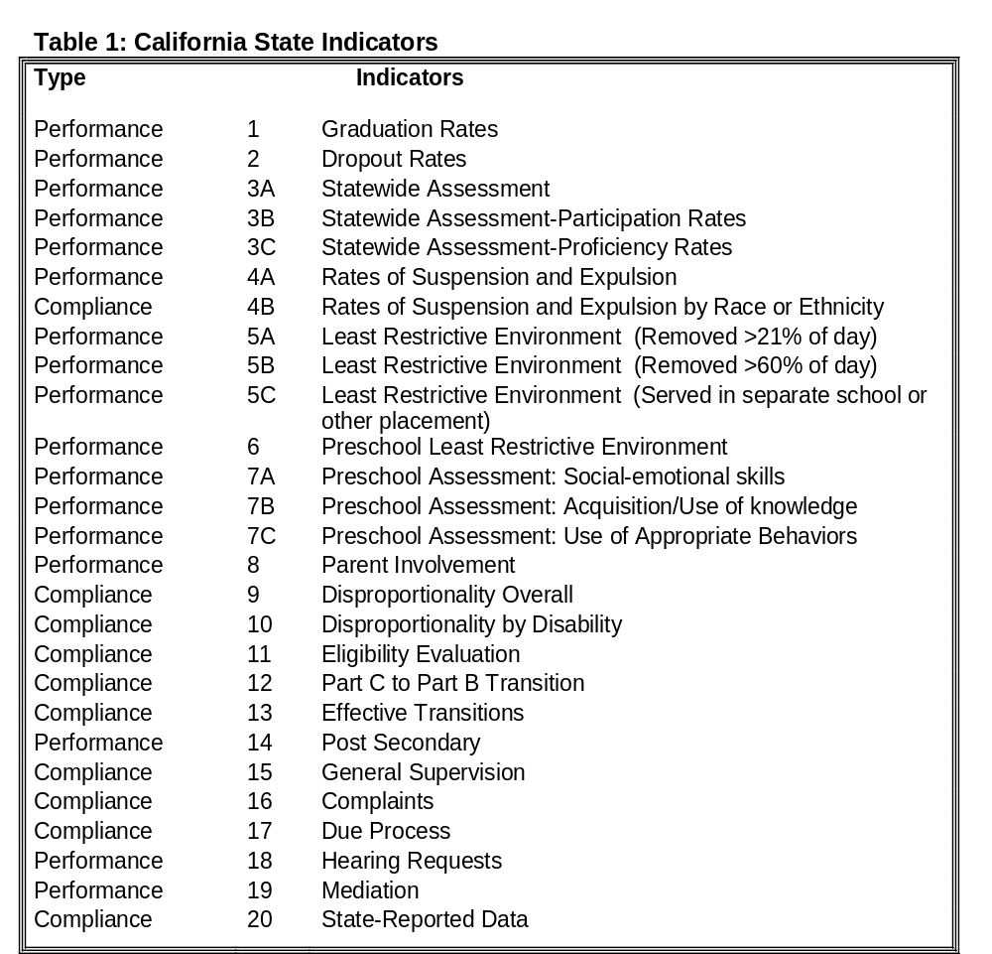CASEMIS Dec. 2011
Overview of Population and Services
During Fiscal Year (FY) 2011–2012, 686,352 students age 0–22 years, were enrolled in special education. Compared to the total student enrollment in California, special education students make up about 11 percent of total students. The average age of a special education student in California is 11 years of age. The median grade level is sixth grade. As shown in Figure 1, the majority of students with disabilities in California are between six and twelve years of age. The majority of special education students (67.5 percent) are male and 30.4 percent are English-language learners. All tables and figures are based on students 0 to 22 years of age. Figure one describes the number of students in special education by age as reported in December 2011. In December 2011, forty seven percent were age six to twelve, thirty nine percent were age thirteen to eighteen, eleven percent were age birth to five, and three percent were older than nineteen.

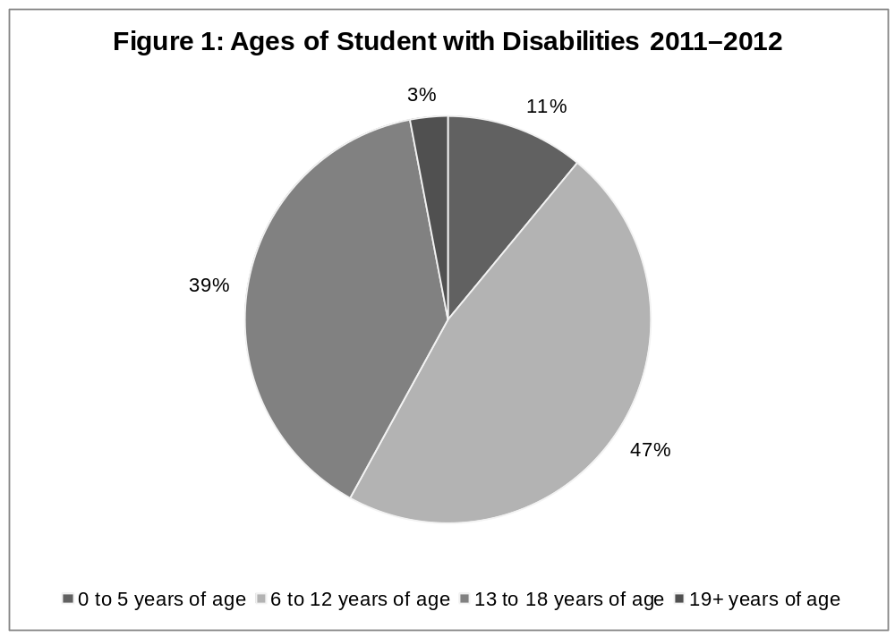
CASEMIS Dec.2011

California students diagnosed with at least one disability are eligible for services to meet those needs. There are 13 disability categories as identified in Table 2. The majority
(40 percent) of students are identified as having a “Specific Learning Disability” as their primary disability category. The second most common primary disability designation for students (24 percent) is a “Speech/Language Impairment”.

Table 2: Enrollment of Special Education Students by Disability Type
Intellectual Disability | 43,303 | 6.34% | Orthopedic Impairment | 14,261 | 2.14%
Hard of Hearing | 9,991 | 1.42% | Other Health Impairment | 61,309 | 8.91%
Deaf | 3,946 | 0.53% | Specific Learning Disability | 278,697 | 40%
Speech and Language | 164,600 | 24% | Deaf-Blindness | 160 | 0.02%
Visual Impairment | 4,327 | 0.61% | Multiple Disability | 5,643 | 0.82%
Emotional Disturbance | 25,984 | 3.82% | Autism | 71,825 | 10%
Traumatic Brain Injury | 1,771 | 0.22%
CASEMIS Dec.2011

Of all special education students in California, Hispanic youth represent the greatest numbers of students in need of services. However, when compared to total enrollment rates, African American students are the most highly represented population in special education. Figure 2 shows the total number of special education students by race/ethnicity. The figure describes the number of students in special education by race and ethnicity as reported in December 2011. In December 2011, 5,699 were Native American, 41,856 were Asian, 2,972 were Pacific Islander, 20,736 were Multi Ethnic, 355,702 were Hispanic, 66,241 were African American, and 193,146 were white. Figure 3 shows the rate of special education students to the total state student population within each race/ethnicity. This figure describes the percentage of special education students within the general education population for each ethnicity/race category; 13.4 percent were Native American, 7.8 percent were Asian, 1.8 percent were Pacific Islander, 15.9 percent were Multi-Ethnic,10.9 percent were Hispanic, 16.4 percent were African American, and 11.9percent were White.

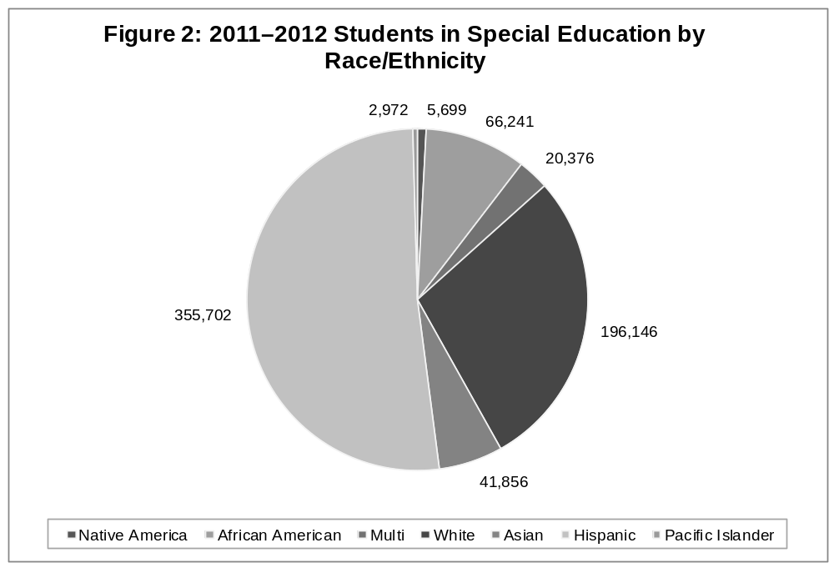
CASEMIS Dec.2011

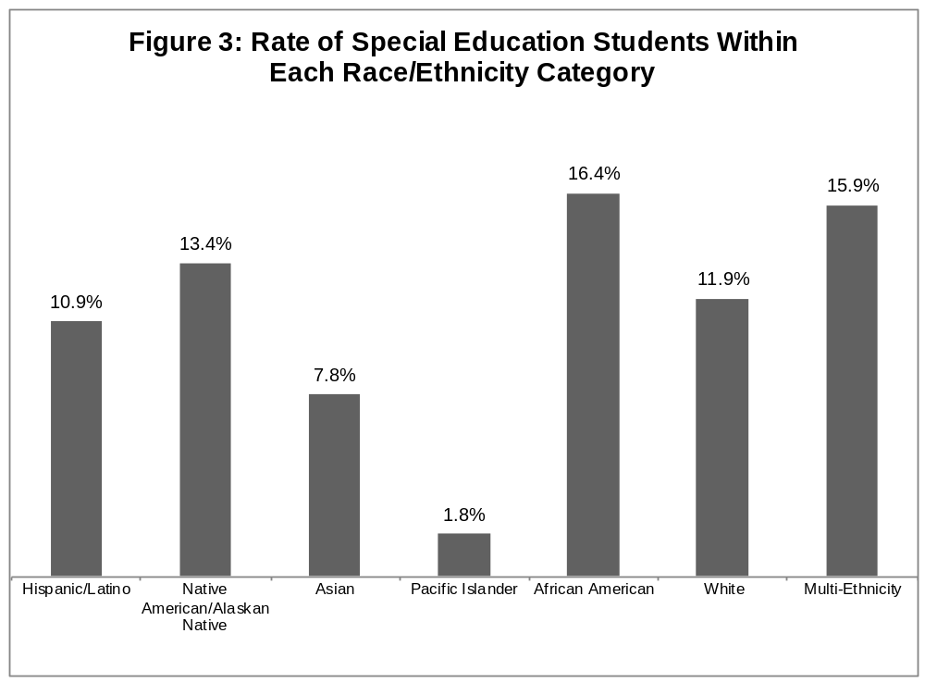
CASEMIS Dec.2011

The CDE also tracks the type of school or program in which special education students receive the majority of their instructional services. These include public schools, private schools, independent study, charter schools, community schools, correctional programs, higher education, and transition programs. Table 3 shows that the majority (86.8 percent) of special education students are enrolled in a public day school.

Table 3: Enrollment of Special Education by Type of School
No School (0−5 years) | 4,726 | 0.68% | Adult Education Program | 1,727 | 0.25%
Public Day School | 595,453 | 86% | Charter School | 20,025 | 2.93%
Public Residential School | 679 | 0.09% | Charter School District | 8,257 | 1.21%
SpEd Center or Facility | 10,269 | 1.44% | Head Start | 1,656 | 0.24%
Other Public School | 4,657 | 0.67% | Child Development/Care | 3,046 | 0.44%
Continuation School | 5,525 | 0.80% | State Preschool Program | 1,124 | 0.16%
Alternative Work Education Center/Facility | 955 | 0.13% | Non Public Residential School | 791 | 0.11%
Independent Study | 1,292 | 0.18% | Extended Day Care | 282 | 0.04%
Juvenile Court School | 1,721 | 0.25% | Non Public Day School | 11,844 | 1.74%
Community School | 3,484 | 0.50% | Private Preschool | 758 | 0.11%
Correctional Institution | 297 | 0.04% | Private Day School | 2,742 | 0.39%
Home Instruction | 2,229 | 0.32% | Private Residential School | 33 | 0.00%
Hospital Facility | 221 | 0.03% | Non Public Agency | 211 | 0.03%
Community College | 245 | 0.03% | Parochial School | 1,339 | 0.19%

CASEMIS Dec. 2011

Special education students in California receive a variety of services to address their unique needs. During 2011–2012, there were 1,413,812 services provided to California special education students. Table 4 describes the type of services provided to students. The most common service provided was Specialized Academic Instruction, followed by Language and Speech Services.

Table 4: Services Provided To Special Education Students
Specialized Services for Ages 0−2 years | 13,716 | 0.97% | Specialized Services/Low Incidence Disabilities | 6,299 | 0.44%
Specialized Academic Instruction | 549,715 | 39% | Services for Deaf Students | 18,752 | 1.33%
Intensive Individual Services | 10,035 | 0.71% | Services for Visually Impaired Students | 10,052 | 0.71%
Individual/Small Group Instruction | 9,617 | 0.68% | Specialized Orthopedic Services | 3,268 | 0.23%
Language/Speech | 318,399 | 22% | Recreation Services | 581 | 0.04%
Adapted Physical Education | 42,302 | 2.92% | Reader and Note Taking Services | 583 | 0.04%
Health and Nursing | 14,201 | 1.02% | College Preparation | 64,541 | 4.53%
Assistive Technology | 5,291 | 0.37% | Vocational/Career | 128,028 | 9.12%
Occupational Therapy | 58,545 | 4.13% | Agency Linkages | 9,101 | 0.64%
Physical Therapy | 9,856 | 0.70% | Travel Training | 2,175 | 0.15%
Mental Health Services | 96,011 | 6.84% | Other Transition Services | 27,825 | 1.91%
Day Treatment | 1,224 | 0.09% | Other Special Education Services | 12,829 | 0.90%
Residential Treatment | 866 | 0.06%

CASEMIS Dec. 2011

2011−2012 APR Indicators

During FFY 2011, California met (data is unavailable at this time) percent of the 20 target indicators. Table 5 identifies each indicator, its target, the FFY 2011 state results, and if the target was met. The pages following Table 5 provide an overview of each individual indicator, including a description of the indicator, the target, the data collected, the results, and a summary of improvement activities.

Table 5: FFY 2011 Indicators, Targets, and Results

Indicators | Target | Results | Met Target
1 Graduation Rate | 74.5% | 76.3% | Yes
2 Dropout Rate | Less Than 22.1% | 10.2% | Yes
3 Statewide Assessment  3A AYP  3B Participation  3C Elementary, High, and Unified Districts | 58%  95% ELA/Math  66.1/68.5% | 11.2%  97.3/97.8%  20.5/41.1% | No  Yes  No
4 Suspension and Expulsion Rate Overall | Less than 10.1% | 2.7% | Yes
4b Suspension and Expulsion Rate by Race/Ethnicity | 0% | 1.42 | No
5 Least Restrictive Environment
5a Percent Removed from Regular Class Less Than 21% of the Day | 76% | 52.3% | No
5b Percent Removed from Regular Class More Than 60% of the Day | Less than 9% | 22.1% | No
5c Percent served in separate schools | Less than 3.8% | 4.2 | No
- Preschool Least Restrictive Environment  6A. Regular Preschool  6B. Separate schools or classes | 32.1%  40.8% | 32.1%  40.8% | N/A  N/A
7 Preschool Assessment  7A (1 & 2)  7B (1 & 2)  7C (1 & 2) | 72.7/82.1%  70.0/82.5%  75/79% | 71.2/76.8%  71.7/74.4%  75/77.2% | No  No  No
8 Percent of Parents Reporting the Schools Facilitated Parental Involvement | 90% | 98.8% | Yes
9 Overall Disproportional Racial or Ethnic Groups in Special Education | 0% | 0.21% | No
10 Disproportional Racial or Ethnic Groups in Disability Categories | 0% | 0.87% | No
11 Eligibility Evaluation Completed within 60 Days of Parental Consent | 100% | 97.4% | No
12 Part C to Part B Transition by Third Birthday | 100% | 97.3% | No
13 Secondary Transition Goals and Services | 100% | 80.7% | No
14 Post-School Employment or Enrollment in Post-Secondary Education | 68% | 76.2% | Yes
15 General Supervision: System Corrects Noncompliance Within in One Year | 100% | 97.9% | No
16 General Supervision: Written Complaints Resolved in 60 Days | 100% | 100% | Yes
17 General Supervision: Due Process Hearings | 100% | 99.1% | No
18 General Supervision: Resolution Sessions | 55% | 12.3% | No
19 General Supervision: Number of Mediation Agreements | 85% | 63.1% | No
20 General Supervision: Timely and Accurate Reports | 100% | 100% | Yes

Indicator 1: Graduation

Description

This is a performance indicator. This measures the percent of youth with individual education programs (IEPs) graduating from high school with a regular diploma (20 U.S.C 1416 [a][3][A]). The calculation methods for this indicator were revised in 2008–09 and again in 2009–10, to align with reporting criteria under Title I of the Elementary and Secondary Education Act (ESEA). A new reporting methodology was implemented for the FFY 2011 APR. All California students are required to pass the California High School Exit Exam (CAHSEE) to earn a public high school diploma. State law provides an exemption from this testing requirement for students who otherwise meet the district requirement for graduation.

Target for 2011–12

- Have a 2011 graduation rate of at least 90 percent or
- Meet the 2011 fixed growth rate of 74.5 percent or
- Meet the 2011 variable growth rate of 69.8 percent

Measurement

The data are reported in lag years using the California Longitudinal Pupil Achievement Data System (CALPADS) data from the FFY 2011 (2011–2012). The calculation is based on data from California’s ESEA reporting.

Results for 2011−2012

The graduation rate for the FFY 2011: 76.3 percent of students with disabilities graduated with a high school diploma.

Target Met: Yes

Summary of Improvement Activities

- Provide technical assistance regarding: graduation standards, student participation in graduation activities, promotion/retention guidelines, and preparation for CAHSEE.

- Disseminate and promote the English-learners with Disabilities Handbook, which provides guidance on ways to support twelfth graders in meeting goals for graduation.

- Develop and disseminate training modules on standards-based IEPs that promote and sustain activities that foster special education and general education working together to meet the needs of all learners. Modules target service delivery, curriculum and instruction, and differentiated instruction.

Indicator 2: Dropouts

Description

This is a performance indicator. This measures the percent of youth with IEPs dropping out of high school (20 U.S.C 1416 [a][3][A]). The calculation methods for this indicator were revised in 2009–10 to create a more rigorous target and approved by the Office of Special Education Programs (OSEP) in April 2010. Dropout rates are calculated from data reported for grades nine through twelve. The CDE uses the annual (one-year) dropout rate and the four-year derived dropout rate. The four-year derived dropout rate is an estimate of the percent of students who would dropout in a four-year period based on data collected for a single year. California does not currently have benchmarks for dropout rates for the ESEA.

Target for 2011–2012

Less than 22.1 percent of students with disabilities will drop out of high school.

Measurement

The data are reported in lag years using the CALPADS data from the FFY 2010
(2010−2011). The calculation is based on data from the ESEA reporting.

Results for 2011−2012

For FFY 2011, Indicator 2 (Dropout Rates), are reported in lag years using data from 2010–2011. The four-year Derived Rate Formula rate was 10.2 percent.

Target Met: Yes

Summary of Improvement Activities

- Continue the Building Effective Schools Together (BEST) program, which provides training and technical assistance on positive behavioral supports.

- Disseminate and provide training based on Transition to Adult Living: A Guide for Secondary Education, a comprehensive handbook written for students’ parents and teachers, to support the transition of students with disabilities to adulthood and/or independent living.

- The CDE will continue to contract with the California Juvenile Court Schools to facilitate electronic transmission of records across public agencies, implement Response to Instruction and Intervention (RTI²), and improve academic achievement.

Indicator 3: Statewide Assessments

Description

This is a performance indicator and measures the participation and performance of children with IEPs on statewide assessments including: 1) Percent of the districts with a disability subgroup, that meets the State’s minimum “n” size, that meet the State’s Adequate Yearly Progress (AYP) for English-language Arts (ELA) and Mathematics targets for the disability subgroup; 2) Participation rate for children with IEPs; and 3) Proficiency rate for children with IEPs against grade-level, modified, and alternate academic achievement standards (20 U.S.C. 1416 [a][3][A]).

Target for 2011–2012

3A. The annual benchmarks and six-year target for the percent of districts meeting the State’s AYP objectives for progress for the disability subgroup is 58 percent.

3B. The annual benchmark and target for participation on statewide assessments in ELA and Math, 95 percent (rounded to nearest whole number), is established under ESEA.

3C. Consistent with the ESEA accountability framework, the 2011–2012 annual measurable objectives (benchmarks) for the percent proficient on statewide assessments are broken down by school subgroup.

- Elementary and Middle Schools/Districts | ELA= 89.2 percent | Math= 89.5 percent
- High Schools/Districts | ELA= 88.9 percent | Math= 88.7 percent
- Unified Districts, COE | ELA= 89.0 percent | Math=89.1 percent

Measurement

The AYP percent equals the number of districts with a disability subgroup that meets the State’s minimum “n” size, which meet the State’s AYP targets for the disability subgroup divided by the total number of districts that have a disability subgroup that meets the State’s minimum “n” size.

Participation rate percent equals the number of children with IEPs participating in the assessment (California Standards Test, California Alternate Performance Assessment, California Modified Assessment, and CAHSEE) divided by the total number of children with IEPs enrolled on the first day of testing, calculated separately for reading and math.

Proficiency rate percent equals number of children with IEPs enrolled for a full academic year scoring at or above proficient divided by the total number of children with IEPs enrolled for a full academic year, calculated separately for reading and math.

Results for 2011–2012

- In FFY 2011 for Target A the results are as follows:

Percent of Districts Meeting AYP for Disability Subgroup (3A)
Targets for  FFY 2011  (2011-12) | Actual Data for  FFY 2011  (2011-12) | Target Met
58 | 11.2 | No

- In FFY 2011 for Target B the results are as follows:

Percent of Participation for Students with IEPs (3B)
 | Targets for  FFY 2011 (2011–12) | Actual Data for  FFY 2011 (2011–12) | Target Met
ELA | 95 | 97.3 | Yes
Math | 95 | 97.8 | Yes

- In FFY 2011 for Target C the results are as follows:

Proficiency Targets and Actual Data in ELA and Math by Type of LEA (3C)
Type of LEAs | ELA Target Percent Proficient | ELA  Actual Percent Proficient | Target Met | Math Target Percent Proficient | Math  Actual Percent Proficient | Target Met
Elementary School Districts | 78.4 | 39.2 | No | 79 | 41.3 | No
High school Districts  (grades 9-12 only) | 77.8 | 20.5 | No | 77.4 | 21.1 | No
Unified School Districts, High School Districts, County Offices of Education (grades 2–8 and 9–12) | 78.0 | 35.6 | No | 78.2 | 37.3 | No

Target Met: No

Summary of Improvement Activities

- Provide technical assistance to schools focused on the implementation of programs to reform high poverty schools. Provide focused monitoring technical assistance at facilitated school sites to address participation and performance on statewide assessments.

- Develop and maintain an IDEA information Web page with links to important references and resources on the reauthorization of the IDEA, including statewide assessments.

- Collaborate with the CDE Program Improvement and Interventions Office to infuse special education indicators into the Academic Performance Survey and District Assistance Survey.

Indicator 4A: Suspension and Expulsion Overall

Description

This is a performance indicator. This measures percent of districts that have a significant discrepancy in the rate of suspensions and expulsions of greater than 10 days in a school year for children with IEPs (20 U.S.C. 1416[a][3][A] and 1412[a][22]). A district is considered to have a significant discrepancy if the districtwide rate for suspension and expulsion exceeds the statewide rate for suspension and expulsion. Districts identified to have a significant discrepancy are required to review their policies, procedures, and practices related to the development and implementation of IEPs, the use of positive behavioral interventions and supports, and procedural safeguards. The data reported here is from 2010–2011.

Target for 2011–2012

No more than 10.1 percent of districts will have rates of suspensions and expulsions of children with disabilities for greater than 10 days in a school year.

Measurement

The data are reported in lag years using the CALPADS data from the FFY 2010 (2010–2011). The percent is calculated by the number of districts that have a significant discrepancy in the rates of suspensions and expulsions of children with IEPs for greater than 10 days in a school year divided by the number of districts in the State times 100.

Results for 2011–2012

In FFY 2010, there were 25 districts (2.7 percent) whose rate of suspension and expulsion was greater than the statewide rate.

Target Met: Yes

Summary of Improvement Activities

- In collaboration with other divisions of the CDE, provide technical assistance to LEAs and schools on reinventing high schools to address suspension and expulsion.

- Provide technical assistance to schools focused on the implementation of reform programs that have been successful in high poverty schools.

- Work with special education local plan areas (SELPAs), LEAs, and County Offices of Education (COEs) to clarify responsibilities and improve behavior emergency and incident reporting.

- Promote the IDEA 2004 and Research for Inclusive Settings (IRIS) modules in behavior, diversity, and other content. This is a special project that includes training and technical assistance work.

- Promote the Culturally Responsive Teaching in California online training modules for the school site general and special educators dealing with utilizing positive behavior supports.

Indicator 4B: Suspension and Expulsion by Race or Ethnicity

Description:

This is a compliance indicator. This measures percent of districts that have:
(a) significant discrepancy, by race or ethnicity, in the rate of suspensions and expulsions of greater than 10 days in a school year for children with IEPs; and (b) policies, procedures, or practices that contribute to the significant discrepancy and do not comply with requirements relating to the development and implementation of IEPs, the use of positive behavioral interventions and supports, and procedural safeguards (20 U.S.C. 1416[a][3][A] and 1412[a][22]).

Target for 2011−2012

Zero percent of districts will have a significant discrepancy in the rates of suspensions and expulsions for greater than 10 days in a school year of children with disabilities by race.

Measurement

The data are reported in lag years using the CALPADS data from the FFY 2010 (2010–2011). This percent is calculated by the number of districts that have: (a) a significant discrepancy, by race or ethnicity, in the rates of suspensions and expulsions of greater than 10 days in a school year of children with IEPs; and (b) policies, procedures, or practices that contribute to the significant discrepancy and do not comply with requirements relating to the development and implementation of IEPs, the use of positive behavioral interventions and supports, and procedural safeguards divided by the number of districts in the State times 100.

Results for 2011−2012

In FFY 2011, there were 1.42 percent of districts with significant discrepancies, by race or ethnicity, in the rates of suspension or expulsion of greater than 10 days for students with IEPs and had findings of policies, procedures or practices that contribute to the significant discrepancy and do not comply with requirements relating to the development and implementation of IEPs, the use of positive behavioral interventions and supports, and procedural safeguards.

Target Met: 1.42%

Summary of Improvement Activities

- Provide technical assistance to schools focused on the implementation of reform programs that have been successful in high poverty schools.

- Work with SELPAs, LEAs, and COEs to clarify their responsibilities and improve behavior emergency and incident reporting.

- Work with SELPAs, LEAs, and COEs to update and improve monitoring items and instruments for reviewing policies, practices, and procedures related to this indicator.

- Provide BEST training and technical assistance on positive behavioral supports. Promote and distribute the IRIS modules in behavior, diversity, and other content. This is a special project that includes training and technical assistance work.

Indicator 5: Least Restrictive Environment

Description

This is a performance indicator. This measures percent of children with IEPs, ages six through twenty-one, served inside the regular class 80 percent or more of the day; inside the regular class less than 40 percent of the day, and are served in public or private separate schools, residential facilities, or homebound/hospital placement.

Target for 2011–2012

5a. Seventy-six percent or more of students will be removed from regular class less than 21 percent of the day;

5b. No more than nine percent will be removed from regular class more than 60 percent of the day; and

5c. No more than 3.8 percent are served in public or private separate schools, residential placements, or homebound or hospital placements.

Measurement

5a. The number of children with IEPs served inside the regular class 80 percent or more of the day divided by the total number of students aged 6 through 21 with IEPs.

5b. The number of children with IEPs served inside the regular class less than 40 percent of the day divided by the total the total number of students aged six through twenty-one with IEPs.

5c. The number of children with IEPs served in public or private separate schools, residential facilities, or homebound/hospital placements divided by the total number of students aged six through twenty-one with IEPs.

Results for 2011−012

California did not meet the targets for 5a (only 52.3 percent of students were in regular class less than 80 percent of the day or more); for 5b, (22.1 percent of students were in regular class less than 40 percent of the day); and for 5c, (4.2 percent were served in public or private separate schools and facilities).

Target Met: 5a No 5b No 5c No

Summary of Improvement Activities

- Continue implementing the Facilitated Focused Monitoring Project including the “scaling up” of focused monitoring activities that contain targeted technical assistance to LEAs related to Least Restrictive Environment (LRE) and improved academic outcomes.

- Conduct activities related to parent involvement, LRE, RtI², and secondary transition. The CDE promotes parental involvement by inviting their membership and participation in the ISES and CDE trainings. The CDE-supported trainings are posted on the Internet to increase parental access.

- In collaboration with the California Comprehensive Center, the CDE Special Education Division (SED) will develop and disseminate training modules on standards-based IEPs to promote and sustain activities that foster special education and general education collaboration.

Indicator 6: Preschool Least Restrictive Environment

Description

This is a performance indicator. This measures the percent of children with IEPs ages three through five, attending a:

- Regular early childhood program and receiving the majority of special education and related service in the regular early childhood program; and

- Separate special education class, separate school, or residential facility (20 U.S.C. 1416[a][3][A]).

Target for 2011−2012

Baseline data will be submitted in FFY 2011 and targets will be set for FFY 2012.

Measurement

- Percent = ([# of children ages three through five with IEPs attending a regular early childhood program and receiving the majority of special education and related services in the regular early childhood program] divided by the [total # of children ages three through five with IEPs]) times 100

- Percent = ([# of children ages three through five with IEPs attending a separate special education class, separate school, or residential facility] divided by the [total # of children ages three through five with IEPs]) times 100

Results for 2011–2012

- 32.1 percent of children ages three through five with IEPs attended a regular early childhood program and received the majority of special education and related services in the regular early childhood program

- 40.8 percent of children ages three through five with IEPs attended a separate special education class, separate school, or residential facility

Target Met: Baseline Year

Summary of Improvement Activities

- Prepare and disseminate general policy letter related to preschool LRE.

- Contact districts with outlying values to monitor policies, procedures, and practices, and to provide technical assistance.

- Work with preschool technical assistance contractors to prepare and disseminate technical assistance materials and services.

Indicator 7A: Preschool Assessment

Description

This is a performance indicator and measures the percent of preschool children with IEPs who demonstrate improvement in Outcome A: Positive social-emotional skills, including social relationships.

Target for 2011–2012

- Of those children who entered the program below age expectations in Outcome A, 72.7 percent substantially increased their rate of growth by the time they turned six years of age or exited the program.

- Of those children who were functioning within age expectations in Outcome A, 82.1 percent were functioning within age expectations by the time they turned six years of age or exited the program.

Measurement

Outcome A: Positive social-emotional skills, including social relationships:

- Number of preschool children who did not improve functioning divided by the number of preschool children with IEPs assessed X 100.

- Number of preschool children who improved functioning but not sufficient to move nearer to functioning comparable to same-aged peers divided by the number of preschool children with IEPs assessed X 100.

- Number of preschool children who improved functioning to a level nearer to same-aged peers but did not reach it divided by the number of preschool children with IEPs assessed X 100.

- Number of preschool children who improved functioning to reach a level comparable to same-aged peers divided by the number of preschool children with IEPs assessed X 100.

- Number of preschool children who maintained functioning at a level comparable to same-aged peers divided by the number of preschool children with IEPs assessed X 100.

Results for 2011–2012

For FFY 2011, for Outcome A, 71.2 percent of students substantially increased their rate of growth by the time they turned six years of age or exited the program, and 76.8 percent of students were functioning within age expectations by the time they turned six years of age or exited the program.

Target Met: No

Summary of Improvement Activities

- Provide on-going statewide technical assistance and training on Early Child Special Education (ECSE) and assist the CDE in monitoring and activities assessment.

- Continue the Train-the-Trainer training for SELPA teams to build local capacity for support, technical assistance, and mentoring for teachers.

- Develop Web-based modules for training and instruction related to the Desired Results Developmental Profile (DRDP) instruments and data reporting system to build local capacity for support, technical assistance, and mentoring.

Indicator 7B: Preschool Assessment

Description

This is a performance indicator and measures the percent of preschool children with IEPs who demonstrate improvement in Outcome B: Acquisition and use of knowledge and skills, including early language/communication and early literacy.

Target for 2011–2012

- Of those children who entered the program below age expectations in Outcome B, 70 percent substantially increased their rate of growth by the time they turned six years of age or exited the program.

- Of children who were functioning within age expectations in Outcome B, 82.5 percent were functioning within age expectations by the time they turned six years of age or exited the program.

Measurement

Outcome B: Acquisition and use of knowledge and skills, including early language/communication and early literacy:

- Number of preschool children who did not improve functioning divided by the number of preschool children with IEPs assessed X 100.

- Number of preschool children who improved functioning but not sufficient to move nearer to functioning comparable to same-aged peers divided by the number of preschool children with IEPs assessed X 100.

- Number of preschool children who improved functioning to a level nearer to same-aged peers but did not reach it divided by the number of preschool children with IEPs assessed X 100.

- Number of preschool children who improved functioning to reach a level comparable to same-aged peers divided by the number of preschool children with IEPs assessed X 100.

- Number of preschool children who maintained functioning at a level comparable to same-aged peers divided by the number of preschool children with IEPs assessed X 100.

Results for 2011–2012

In FFY 2011, for Outcome B, 71.7 percent of students substantially increased their rate of growth by the time they turned six years of age or exited the program; and 74.4 percent of students were functioning within age expectations by the time they turned six years of age or exited the program.

Target Met: No

Summary of Improvement Activities

- Provide on-going statewide technical assistance and training on ECSE and assist the CDE in monitoring and activities assessment.

- Continue the Train-the-Trainer training for SELPA teams to build local capacity for support, technical assistance, and mentoring for teachers.

- Develop Web-based modules for training and instruction related to the DRDP instruments and data reporting system to build local capacity for support, technical assistance, and mentoring.

Indicator 7C: Preschool Assessment

Description

This is a performance indicator and measures the percent of preschool children with IEPs who demonstrate improvement in Outcome C: Use of appropriate behaviors to meet their needs (20 U.S.C. 1416[a][3][A]).

Target for 2011–2012

- Of those children who entered the program below age expectations in Outcome C, 75 percent substantially increased their rate of growth by the time they turned six years of age or exited the program.

- Of those children who were functioning within age expectations in Outcome C, 79 percent were functioning within age expectations by the time they turned six years of age or exited the program.

Measurement

Outcome C: Use of appropriate behaviors to meet their needs:

- Number of preschool children who did not improve functioning divided by the number of preschool children with IEPs assessed X 100.

- Number of preschool children who improved functioning but not sufficient to move nearer to functioning comparable to same-aged peers divided by the number of preschool children with IEPs assessed X 100.

- Number of preschool children who improved functioning to a level nearer to same-aged peers but did not reach it divided by the number of preschool children with IEPs assessed X 100.

- Number of preschool children who improved functioning to reach a level comparable to same-aged peers divided by the number of preschool children with IEPs assessed X 100.

- Number of preschool children who maintained functioning at a level comparable to same-aged peers divided by the number of preschool children with IEPs assessed X 100.

Results for 2011–2012

In FFY 2011, for Outcome C, 75.0 percent of students substantially increased their rate of growth by the time they turned six years of age or exited the program; and 77.2 percent of students were functioning within age expectations by the time they turned six years of age or exited the program.

Target Met: No

Summary of Improvement Activities

- Provide on-going statewide technical assistance and training on ECSE and assist the CDE in monitoring and activities assessment.

- Continue the Train-the-Trainer training for SELPA teams to build local capacity for support, technical assistance, and mentoring for teachers.

- Develop Web-based modules for training and instruction related to the DRDP instruments and data reporting system to build local capacity for support, technical assistance, and mentoring.

Indicator 8: Parent Involvement

Description

This is a performance indicator. This measures the percent of parents with a child receiving special education services who report that schools facilitated parent involvement as a means of improving services and results for children with disabilities (20 U.S.C. 1416[a][3][A]). This data is one question in a survey distributed, collected, and reported by the SELPAs. The measure is the percentage of parents responding “yes” to the question: “Did the school district facilitate parent involvement as a means of improving services and results for your child?”

Target for 2011–2012

Ninety percent of parents will report that schools facilitated parent involvement as a means of improving services and results for children with disabilities.

Measurement

The number of respondent parents who report schools facilitated parent involvement as a means of improving services and results for children with disabilities divided by the total number of respondent parents of children with disabilities.

Results for 2011–2012

The result for Indicator 8 in FFY 2010 was 98.8 percent of parents with a child receiving special education services report that schools facilitated parental involvement.

Target Met: No

Summary of Improvement Activities

- Explore Web-based applications for all components of the monitoring system including parent involvement.

- Develop a Web-based survey process and a statewide data collection through CASEMIS to capture a universal sample of families to address the Parent Involvement Indicator.

- Conduct trainings and technical assistance related to parent involvement.

- The SED partners with Parent Training and Information Center, Family Resource Center, and Family Empowerment Center parents to provide statewide training and technical assistance. The SED will maintain a parent “hot line” to provide parents with information and assistance
Indicator 9: Disproportionality Overall

Description

This is a compliance indicator. This measures the percent of districts with disproportionate representation of racial and ethnic groups in special education and related services that is the result of inappropriate identification (20 U.S.C. 1416[a][3][C]). Currently, California combines the disparity measure with the e-formula in a race-neutral approach to identify which districts are disproportionate. The first test is to identify those districts that have a disparity that is higher than the annual benchmark. The second test, based on the e-formula, looks at the over representation of each ethnic group compared to the distribution of those ethnic groups in the general education population.

Target for 2011–2012

Zero percent of districts will have disproportionate representation of racial and ethnic groups in special education and related services that is the result of inappropriate identification.

Measurement

The number of districts with disproportionate representation of racial and ethnic groups in special education and related services that is the result of inappropriate identification divided by the number of districts in the State.

Results for 2011–2012: In 2011–2012 there were 9 districts identified as having disproportionate representation. Two (2) districts were found to have noncompliant policies, procedures, or practices as a result of inappropriate identification.

Target Met: No

Summary of Improvement Activities

- Work with the Western Regional Resource Center (WRRC) and other federal contractors to identify and disseminate research-based practices related to preventing disproportionate representation and to address the relationship between eligibility and disproportionality of racial and ethnic groups.

- Refine policies, procedures, and practices instruments to assist the LEAs in reviewing their policies, procedures, and practices in relation to disproportionality of racial and ethnic groups.

- Incorporate preliminary self-review and improvement planning modules, based on National Center for Culturally Responsive Educational Systems (NCCRESt), into monitoring software.

- Annually identify districts that are significantly disproportionate, using existing instruments and procedures.

Indicator 10: Disproportionality by Disability

Description

This is a compliance indicator. This measures the percent of districts with disproportionate representation of racial and ethnic groups in specific disability categories that is the result of inappropriate identification (20 U.S.C. 1416[a][3][C]). The calculation for Indicator 10 (Ethnicity by Disability) has been changed at the direction of the OSEP during their September 2010 verification visit. Effective FFY 2010, the CDE measures disproportionality using two measures: (1) the e-formula and (2) the Alternate Risk Ratio.

Target for 2011–2012

Zero percent of districts will have disproportionate representation of racial and ethnic groups in specific disability categories that are the result of inappropriate identification.

Measurement

The number of districts with disproportionate representation of racial and ethnic groups in specific disability categories, as identified by both the e-formula and Alternate Risk Ratio, which is the result of inappropriate identification divided by the number of districts in the State.

Results for 2011–2012: In FFF 2011 there were 70 districts identified as having disproportionate representation. Eight (8) districts were found to have noncompliant policies, procedures, or practices as a result of inappropriate identification.

Target Met: No

Summary of Improvement Activities

- Refine guidance for policies, procedures, and practices to assist the LEAs in reviewing their policies, procedures, and practices in relation to disproportionality by disability groups.

- Use refined procedures to identify districts with significant disproportionality and establish plans for supervision and technical assistance.

- Incorporate preliminary self-review and improvement planning modules, based on NCCRESt, into monitoring software.

- Annually identify districts that are significantly disproportionate, using existing instruments and procedures related to disability.

Indicator 11: Eligibility Evaluation

Description

This is a compliance indicator. This measures the percent of children who were evaluated within 60 days of receiving parental consent for initial evaluation or, if the state establishes a timeframe within which the evaluation must be conducted, within that timeframe (20 U.S.C. 1416[a][3][B]). These data were calculated using CASEMIS data fields related to parental consent date and initial evaluation date. Determination of eligibility was made using the data field which includes the type of plan a student has (IEP, Individualized Family Support Plan, Individual Service Plan), if the student is eligible, or no plan if the student is determined ineligible. If the parent of a child repeatedly failed or refused to bring the child for the evaluation, or a child enrolled in a school of another public agency after the timeframe for initial evaluations had begun, and prior to a determination by the child’s previous public agency as to whether the child is a child with a disability, then the child was eliminated from both the numerator and the denominator.

Target for 2011–2012

Eligibility determinations will be completed within 60 days for 100 percent of children for whom parental consent to evaluate was received.

Measurement

- The number of children for whom parental consent to evaluate was received.

- The number of children whose evaluations were completed within 60 days (or a state-established time line).

Results for 2011–2012

For FFY 2010, 97.4 percent of eligibility determinations were completed within 60 days for children whom parental consent to evaluate was received.

Target Met: No

Summary of Improvement Activities

- Explore Web-based applications for all components of the monitoring system including 60-day evaluation time line.

- Analyze data from compliance complaints and all monitoring activities to determine areas of need for technical assistance, in addition to correction of noncompliance.

- Prepare and install initial evaluation compliance reports into the CASEMIS software to enable districts and SELPAs to self-monitor.

- Prepare and send noncompliance-finding letters based on CASEMIS data to LEAs to reinforce the importance of correcting all noncompliant findings resulting from verification and self-review monitoring.

Indicator 12: Part C to Part B Transition

Description

This is a compliance indicator. Percent of children referred by Part C prior to age three, who are found eligible for Part B, and who have an IEP developed and implemented by their third birthdays (20 U.S.C. 1416[a][3][B]). These data were collected through CASEMIS and data from the Department of Developmental Services.

Target for 2011–2012

One hundred percent of children referred by the IDEA Part C prior to age three and who are found eligible for the IDEA Part B will have an IEP developed and implemented by their third birthday.

Measurement

- Number of children who have been served in Part C and referred to Part B (LEA notified pursuant to the IDEA section 637[a][9][A] for Part B eligibility determination).

- Number of those referred determined to be NOT eligible and whose eligibilities were determined prior to their third birthdays.

- Number of those found eligible who have an IEP developed and implemented by their third birthdays.

- Number of children for whom parental refusal to provide consent caused delays in evaluation or initial services.

Results for 2011–2012

For FFY 2011, 97.3 percent of children referred by Part C of IDEA prior to age three and who were found eligible for Part B of IDEA had an IEP developed and implemented by their third birthday.

Target Met: No

Summary of Improvement Activities

- Meet annually with SELPAs, LEAs, and regional centers to review data and plan for corrective action plans and technical assistance activities related to transition from Part C to Part B, based on APR data.

- Convene ISES stakeholder group to obtain input on aspects of Part C to Part B transition (e.g., moving from family focus to child focus).

- Revise CASEMIS to include separate referral and evaluation dates for Part B and Part C in accordance with the IDEA.

- Participate in the OSEP National Early Childhood Conference to stay abreast of national trends, research on transition from Part C to Part B, and new OSEP requirements.

- Participate in a joint Transition Project with the Department of Developmental Services (Part C lead agency), with the assistance of the WRRC.

Indicator 13: Secondary Transition Goals and Services

Description

This is a compliance indicator. Percent of youth with IEPs ages 16 and above with an IEP that includes appropriate measurable post-secondary goals that are annually updated and based upon an age appropriate transition assessment and transition services, including courses of study, that will reasonably enable the student to meet those post-secondary goals and annual IEP goals related to the student’s transition service’s needs. There also must be evidence that the student was invited to the IEP team meeting where transition services are to be discussed and evidence that, if appropriate, a representative of any participating agency was invited to the IEP team meeting with the prior consent of the parent or student who has reached the age of majority (20 U.S.C. 1416[a][3][B]).

Target for 2011–2012

One hundred percent of youth ages 16 and above with an IEP that includes appropriate measurable post-secondary goals that are annually updated and based upon an age appropriate transition assessment and transition services.

Measurement

Number of youth with IEPs ages 16 and above with an IEP that includes appropriate measurable post-secondary goals that are annually updated and based upon an age appropriate transition assessment and transition services divided by the number of youth with an IEP ages 16 and above.

Results for 2011–2012

For FFY 2011, 80.7 percent of students ages 16 and above with IEPs had all eight post-secondary goals included in their IEPs.

Target Met: No

Summary of Improvement Activities

- Use transition data collected through state-funded Workability I grant procedures to ensure programs include the provision of transition services.

- Provide CASEMIS training and on-going technical assistance to ensure reliable and accurate submission of data related to this indicator.

- Disseminate and provide training based upon Transition to Adult Living: A guide for Secondary Education, a comprehensive handbook written for students, parents, and teachers, offering practical guidance and resources to support the transition efforts for students with disabilities as they move into the world of adulthood and/or independent living.

- Provide regionalized training and technical assistance regarding elements of transition services, goals, and objectives.

Indicator 14: Post-school

Description

This is a performance indicator. This indicator measures the percent of youth, who are no longer in secondary school, had IEPs in effect at the time they left school, and were:

- Enrolled in higher education within one year of leaving high school;

- Enrolled in higher education or competitively employed within one year of leaving high school; or

- Enrolled in higher education or in some other post-secondary education or training program; or competitively employed or in some other employment within one year of leaving high school (20 U.S.C. 1416[a][3][B]). Data are collected and reported by SELPAs using the June 2011 CASEMIS submission.

Target for 2011–2012

Sixty-nine percent of youth who had IEPs who are no longer in secondary school will be reported to have been competitively employed, enrolled in some type of post-secondary school, or both, within one year of leaving high school.

Measurement

- The number of youth who are no longer in secondary school, had IEPs in effect when they left school, and were enrolled in higher education within one year of leaving high school divided by the number of respondent youth who are no longer in secondary school.

- Number of youth who are no longer in secondary school, had IEPs in effect when they left school, and were enrolled in higher education or competitively employed within one year of leaving high school divided by the number of respondent youth who are no longer in secondary school.

- Number of youth who are no longer in secondary school, had IEPs in effect when they left school, and were enrolled in higher education, or in some other post-secondary education or training program; or competitively employed or in some other employment divided by the number of respondent youth who are no longer in secondary school .

Results for 2011–2012:

Seventy-six percent of youth who had IEPs who are no longer in secondary school and reported their current status were competitively employed, enrolled in some type of post-secondary school, or both, within one year of leaving high school.

Target Met: Yes

Summary of Improvement Activities

- Provide CASEMIS training for SELPAs and on-going technical assistance to ensure reliable and accurate submission of data.

- Work with national and state experts on research and data approaches to address post-school outcomes data collection.

- Work with universities, colleges, and junior colleges to explain the importance of post-secondary education.

- Work with WorkAbility and other agencies and programs on the importance of employing people with disabilities at minimum wage or more.

- Use transition data in the state-funded Workability I grant procedures to ensure programs include the provision of transition services.

Indicator 15: General Supervision

Description

This is a compliance indicator. General supervision system (including monitoring, complaints, hearings, etc.) identifies and corrects noncompliance as soon as possible, but in no case later than one year from identification (20 U.S.C. 1416 [a][3][B]). The State also verified that each LEA with noncompliance corrected in FFY 2009:
1) Has corrected each individual case of noncompliance, unless the child is no longer within the jurisdiction of the LEA, consistent with the OSEP Memorandum 09-02, dated October 17, 2008 (OSEP Memo 09-02); and 2) Has ensured that (from last year’s APR) a more stringent level of follow-up review and reporting is required of districts that have previously corrected noncompliance related to this indicator. This is to ensure that LEAs are correctly implementing the specific regulatory requirements.

Target for 2011–2012

One hundred percent of noncompliance will be corrected within one year of identification.

Measurement

- Percent of noncompliance corrected within one year of identification

- Number of findings of noncompliance

- Number of corrections completed as soon as possible but in no case later than one year from identification

- Percent = (B) divided by (A) times 100

Results for 2011–2012

Ninety-seven percent of noncompliance findings identified and verified in 2010–11 were corrected within one year.

Target Met: No

Summary of Improvement Activities

- Develop and maintain the IDEA 2004 information Web page with links to important references and resources on the reauthorization of the IDEA. This activity constitutes public reporting/data and awareness/data utilized to reflect upon practice efforts as part of general supervision obligations under the IDEA 2004.

- Provide staff training for corrective actions, time lines, and sanctions. Incorporate notice of potential sanctions in monitoring correspondence.

- Recruit candidates and hold civil service examinations to fill vacancies with new staff, retired annuitants, or visiting educators. This activity is intended to ensure that the CDE maintains an adequate number of qualified staff to support the SED’s work and activities (monitoring and enforcement as part of general supervision).

Indicator 16: Complaints

Description

This is a compliance indicator and measures the percent of signed written complaints with reports issued that were resolved within a 60-day time line or a time line extended for exceptional circumstances with respect to a particular complaint, or because the parent (or individual or organization) and the public agency agree to extend the time to engage in mediation or other alternative means of dispute resolution, if available in the State (20 U.S.C. 1416[a][3][B]).

Target for 2011–2012

One hundred percent of written complaints resolved within a 60-day time line, including a time line extended for exceptional circumstances with respect to a particular complaint.

Measurement

- Percent = [(1.1(b) + 1.1(c)) divided by 1.1] times 100.

(1) Signed, written complaints total
(1.1) Complaints with reports issued
(a) Reports with findings
(b) Reports within time line
(c) Reports within extended time lines
(1.2) Complaints withdrawn or dismissed
(1.3) Complaints pending
(a) Complaints pending a due process hearing

Results for 2011–2012

For FFY 2010, 100 percent of signed written complaints were resolved within a 60-day time line or a time line extended for exceptional circumstances.

Target Met: YES

Summary of Improvement Activities

- Develop an integrated database to proactively identify upcoming corrective actions across all components of the monitoring system. This activity supports the continued effort to calculate and provide valid and reliable data for monitoring and enforcement as part of general supervision.

- Continue to cross-train for complaint investigations and other monitoring activities to focus on inter-rater reliability and consistency. This activity continues to improve the expertise of the CDE staff in monitoring and enforcement as part of general supervision.

- Participate in legal rounds with the Legal Audits and Compliance Division on legal issues related to special education legal issues, complaints, and noncompliance.

Indicator 17: Due Process

Description

This is a compliance indicator and measures the percent of adjudicated due process hearing requests that were adjudicated within the 45-day time line or a time line that is properly extended by the hearing officer at the request of either party or in the case of an expedited hearing, within the required time lines (20 U.S.C. 1416[a][3][B]).

Target for 2011–2012

One hundred percent of due process hearing requests will be fully adjudicated within the 45-day time line or a time line that is properly extended by the hearing officer at the request of either party

Measurement

- Percent = [(3.2(a) divided by 3.2(b)) divided by 3.2] times 100

(3) Total number of due process complaints filed
(3.1) Resolution meetings
(a) Written settlement agreements
(3.2) Hearings fully adjudicated
(a) Decisions with time line (including expedited)
(b) Decisions within extended time line
(3.3) Due Process complaints pending
(3.4) Due process complaints withdrawn or dismissed (including resolved without hearing)

Results for 2011–2012

For FFY 2010, 99.1 percent of due process hearing requests were fully adjudicated within the 45-day time line or a time line that was properly extended by the hearing officer at the request of either party.

Target Met: No

Summary of Improvement Activities

- Obtain data on resolution sessions and settlement agreements deriving solely from those sessions directly from school districts with due process fillings during 2010−2011.

- The Office of Administrative Hearings (OAH) will consult with its advisory group in areas such as revisions to the OAH Web site, forms, documents, scheduling procedures, staff training, training materials, parent procedure manual, consumer brochure, outreach to families and students, and proposed revisions to laws and rules.

- Conduct a records review at the OAH as part of the CDE's efforts to implement recommendations of the Bureau of State Audits (BSA) report of 2009−2010 to determine how it is handling oversight of the special education hearings and mediation process. This review is part of an on-going monitoring activity, as a result of the BSA report, and constitutes the final review.
Indicator 18: Hearing Requests

Description

This is a performance indicator and measures the percentage of hearing requests that went to resolution sessions that were resolved through resolution session settlement agreements (20 U.S.C. 1416[a][3][B]).

Target for 2011–2012

Fifty-five percent of hearing requests that went to resolution sessions were resolved through resolution session settlement agreements.

Measurement

- Percent = (3.1(a) divided by 3.1) times 100

(3.1) Resolution meetings
(a) Written settlement agreements
(3.2) Hearings fully adjudicated
(a) Decisions with time line (including expedited
(b) Decisions within extended time line
(3.3) Due Process complaints pending
(3.4) Due process complaints withdrawn or dismissed (including resolved without hearing)

Results for 2011–2012

There were 12.3 percent of hearing requests that went to resolution meetings and were resolved through resolution sessions settlement agreements

Target Met: No

Summary of Improvement Activities

- Obtain data on resolution sessions and settlement agreements deriving solely from those sessions, directly from school districts with due process filings during 2010−2011.

- The OAH will consult with its advisory group in areas such as revisions to the OAH Web site, forms, documents, scheduling procedures, staff training, training materials, parent procedure manual, consumer brochure, outreach to families and students, and proposed revisions to laws and rules.

- Conduct records review at the OAH, as part of the CDE's efforts to implement recommendations of the BSA on oversight of the special education hearings and mediation process.
Indicator 19: Mediation

Description

This is a performance indicator and measures the percentage of mediations held that resulted in mediation agreements (20 U.S.C. 1416[a][3][B]).

Target for 2011–2012

At least 85 percent of mediation conferences will result in mediation agreements.

Measurement

- Percent = (2.1(a)(i) + 2.1(b)(i)) divided by 2.1] times 100

(2) Total number of mediation request received through all dispute resolution processes

(2.1) Mediations held

(a) Mediations held related to due process complaints

(i) Mediation agreements related to due process complaints

(b) Mediations held not related to due process complaints

(i) Mediation agreements not related to due process complaints

(2.2) Mediations pending

(2.3) Mediations withdrawn or not held

Results for 2011–2012

For FFY 2010, 63.1 percent of mediation conferences resulted in mediation agreements.

Target Met: No

Summary of Improvement Activities

- Implement standards for the qualifications and supervision of the OAH/contractor staff functioning as mediators.

- The OAH will consult with its advisory group in areas such as revisions to the OAH Web site, forms, documents, scheduling procedures, staff training, training materials, parent procedure manual, consumer brochure, outreach to families and students, and proposed revisions to laws and rules.

- Conduct training sessions for staff and LEAs on dispute resolution and mediations on an on-going basis.

- Utilization of a monitoring system and letters to districts, as part of the on-going training agenda for staff involved in due process efforts at OAH.
Indicator 20: State Reported Data

Description

This is a compliance indicator to show that state reported data (618 and SPP APR) are timely and accurate (20 U.S.C. 1416[a][3][B]).

Target for 2011–2012

20a. One hundred percent of state-reported data, including 618 data and APRs, are submitted on time and are accurate.

20b. One hundred percent of the SELPAs will submit accurate data to the CDE in a timely manner.

Measurement

State reported data, including 618 data, SPP, and APR are:

- Accurate, including covering the correct year and following the correct measurement

- Submitted on or before due dates:
  - February 1 for child count, including race and ethnicity, and placement
  - February 1 for APRs and assessment
  - November 2 for exiting, discipline, personnel, and dispute resolution

Results for 2011–2012

OSEP will calculate Indicator 20 after the submission of the APR report in February and report the result to the state during the week of clarification in April.

Target Met: Yes

Summary of Improvement Activities

- Modify validation codes and develop prototype reports. This activity supports general IDEA 2004 requirements.

- Provide statewide CASEMIS training. This activity supports data collection through CASEMIS and provides training and technical assistance.

- Provide on-going technical assistance to ensure reliable and accurate submission of data. This activity supports data collection through CASEMIS and provides training and technical assistance.

- Improve and expand anomaly analysis and reporting.

