California Department of Education  Executive Office  SBE-003 (REV. 09/2011)  ilsb-plsd-may13item01 |  | ITEM #10
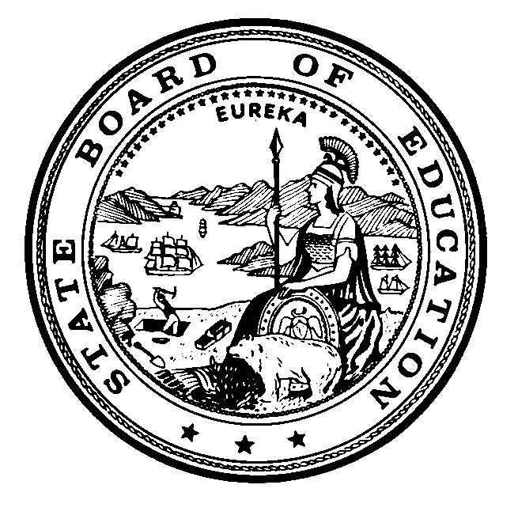 | CALIFORNIA STATE BOARD OF EDUCATION  May 2013 AGENDA
SUBJECT  Update on the public process to revise and adopt the Science Content Standards for California Public Schools, Kindergarten through Grade Twelve based upon the nationally developed Next Generation Science Standards as required by Education Code 60605.85. |  |  |  | Action
 |  |  |  | Information
 |  |  |  | Public Hearing

SUMMARY OF THE ISSUE(S)

This agenda item provides the State Board of Education (SBE) and the public information on the public process that the California Department of Education (CDE), in collaboration with the California Comprehensive Center (CA CC) at WestEd, intends to utilize to revise and adopt the Science Content Standards for California Public Schools, Kindergarten through Grade Twelve based upon the nationally developed Next Generation Science Standards as required by Education Code (EC) Section 60605.85.

RECOMMENDATION

The CDE recommends that the SBE take action as deemed necessary and appropriate but recommends no specific action at this time.

BRIEF HISTORY OF KEY ISSUES

EC Section 60605.85 required the State Superintendent of Public Instruction (SSPI) to submit a set of revised Science Content Standards for California Public Schools, Kindergarten through Grade Twelve to the SBE by July 31, 2013, and the adoption, rejection, or modification of those standards by November 30, 2013. The revised science standards for California must be based upon the nationally developed Next Generation Science Standards (NGSS).

The NGSS were released by Achieve, Inc. on April 9, 2013. The Standards as well as additional information is available on the NGSS Web site at http://www.nextgenscience.org/.

Stephen Pruitt, Ph.D., Vice President of Content, Research and Development with Achieve, Inc. will present an overview of the final NGSS and address the revisions that have been made from the last public version of standards that were released in January of 2013.

Upon this release of the final draft of the NGSS, the CDE, with support of the CA CC of WestEd, has continued to work on a process to recommend the Science Content Standards for California Public Schools, Kindergarten through Grade Twelve to the SBE. The process encompasses several steps involving the SRT and a panel of science experts who are representative of the SRT, referred to as the Science Expert Panel (SEP). With the release of the final draft of the NGSS, the CDE, with support from the CA CC, will conduct a survey of SRT members to seek their input regarding the final draft of the NGSS.

Included in this process were three regional public forums. These forums provided the public an opportunity to comment on the proposed standards for California. The regional public forums were scheduled as follows:

- April 29, 2013 – Sacramento County Office of Education
- April 30, 2013 – Santa Clara County Office of Education
- May 2, 2013 – Riverside County Office of Education

At these meetings, public stakeholders received background on the NGSS and the proposed California Science Standards. The public had an opportunity to provide input for consideration by the SEP.

The CDE and CA CC staff will compile and summarize public input and share the data with the SEP at its next meeting in late May 2013.

As a final step, the SEP will then reconvene and use the feedback from the SRT to draft a final proposal of new Science Content Standards for California Public Schools, Kindergarten through Grade Twelve. The SSPI will submit the proposed draft standards to the SBE in July of 2013 for its review.

SUMMARY OF PREVIOUS STATE BOARD OF EDUCATION DISCUSSION AND ACTION

March 2013: Phil Lafontaine, Director of the Professional Learning Support Division, shared an update of the NGSS development process.

November 2012: The CDE updated the SBE through an Information Memorandum on the development of NGSS.

May 2012: At its May 2012 meeting, The CDE staff presented on the progress and timeline of the development of the NGSS along with Dr. Stephen L Pruitt, Vice President for Content, Research, and Development at Achieve, Inc.

November 2011: The CDE’s presentation also provided information on the requirements of Senate Bill 300. Specifically, the SSPI was required to recommend science content standards–utilizing the NGSS as their basis–to the SBE by March 30, 2013. The SBE was required to adopt, reject, or modify those standards by July 30, 2013. Information regarding the state’s involvement in the national process for the development of the NGSS was discussed.

FISCAL ANALYSIS (AS APPROPRIATE)

Projected estimated costs for participating in the development of the NGSS are approximately $186,000. CDE is seeking foundation funding to cover the costs of required trips to Washington D.C, convening the California teams, and for staff to coordinate the logistics associated with the development of the draft NGSS standards for California.

ATTACHMENT(S)

Attachment 1: Timeline for the Development of the Next Generation of Science Standards (1 Page).

Attachment 2: CDE Timeline of Next Generation Science Standards Development
Process (1 Page).

Attachment 3: California Science Standards Review and Adoption Process (2 Pages).

Attachment 4: Final draft of the NGSS (Outside Source).
Timeline for the Development of the Next Generation Science Standards

The information provided below outlines the general development process and timeline and it is replicated from the Next Generation Science Standards (NGSS) Development Process Web page at http://www.nextgenscience.org/development-process.

The NGSS has been through several rounds of review with multiple stakeholder groups. Each group received draft standards at least twice throughout the development process.

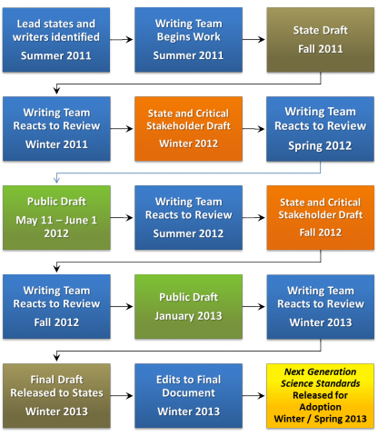

Next Generation Science Standards Development Process
November 2011: First Meeting of SRT comprised of Science Experts
July 2011: Framework for K-12 Science Education Released by National Research Council
May 2012: First Public Draft of NGSS Released
2011: Promotion of the NGSS and Conceptual Framework at Conferences and Workshops
October 2012: Third Meeting of SRT
February 2012: Second Meeting of SRT
April 9, 2013: Final Draft of NGSS Released
July 31, 2013: SSPI Presents to California SBE Recommended Science Standards Based on the NGSS
Spring 2013: Three Regional Public Forums
January 2013: Second Public Draft of NGSS Released
2014*: Implementation of New Science Standards
November 30, 2013: California SBE Adopts, Rejects, or Modifies Recommended Science Standards
September 2011: California Selected as Lead State in the Development of NGSS, Based on Framework

2011 | 2012 | 2013 | 2014

* Pending SBE’s action in November 2013

California Science Standards Review and Adoption Process

Context

The Next Generation Science Standards (NGSS) are designed to serve as high quality college and career-ready K-12 standards ready for state adoption. Twenty-six states, including California, have participated in the national development process facilitated by Achieve, Inc. The NGSS are based on the July 2011 National Research Council’s A Framework for K-12 Science Education: Practices, Crosscutting Concepts, and Core Ideas. The development process has engaged numerous stakeholders, including nationally-recognized leaders in science, science education, higher education, and industry. The NGSS have undergone multiple reviews, including two public drafts. As required by this national process, California selected a group of 80 science experts, known as the State Review Team (SRT) to conduct confidential reviews of the various drafts of the NGSS. The final version of the NGSS was released on April 9, 2013.

Purpose

For the NGSS to be used in California schools, they must be reviewed and adopted by the State Board of Education (SBE). Senate Bills 300 and 1200 require that by July 31, 2013, the Superintendent of Public Instruction (SSPI) submit new science standards to the SBE for review and consideration. Given that the final NGSS were released on April 9, 2013, this means that California must initiate a fast-paced process to engage key stakeholders in reviewing the NGSS so the SSPI is able to recommend set of standards for consideration and adoption by
July 31, 2013. Given the compressed timeline, the CDE will enlist the help of select members of the SRT, referred to as SEP, to review and analyze the NGSS, and develop a first draft for public review and comment by late April 2013. Below is the proposed process and timeline for engaging subject-matter experts and other science, education, business, and community stakeholders in this review.

Proposed Review Timeline:

Late January 2013

- Subject-area analysis groups analyze NGSS and current CA standards

April 9, 2013

- Final draft of NGSS released

May 2013

- SEP reviews the NGSS work group analysis and survey input

- SEP develops first draft of the CA Science Standards

- Regional public stakeholder forums and compilation of public input

- SEP reviews public input from stakeholder forums

- SEP develops second draft of CA Science Standards

- SRT reviews the latest draft of the CA Science Standards and submits comments to the SEP

- SEP reviews SRT comments and prepares final proposed CA Science Standards

June 2013

- SEP submits their final recommnendations to the SSPI

- The SSPI will review the SEP recommendations and submit a final set of standards to the State Board of Education (SBE) at its July 2013 meeting for consideration.

July 2013

- SBE review of proposed CA Science Standards for consideration of adoption. The SBE, by law, has until November 2013 to adopt, modify or reject the proposed standards.

