State Board of Education  SBE-003 (REV. 06/2008)  sbe-jul14-item01 | ITEM #12
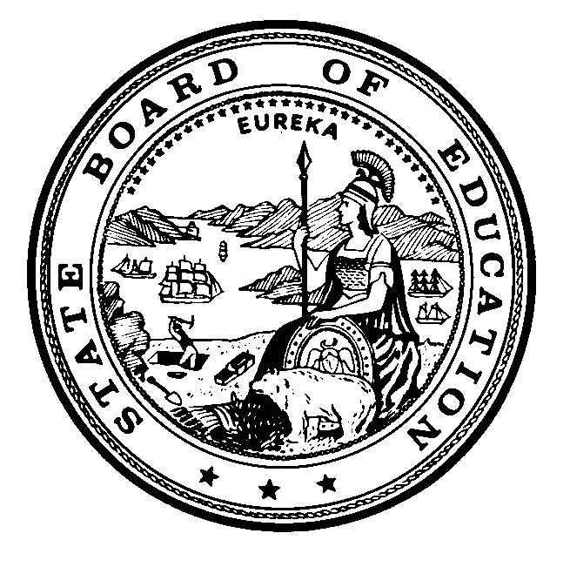

CALIFORNIA STATE BOARD OF EDUCATION

JULY 2014 AGENDA

SUBJECT  STATE BOARD PROJECTS AND PRIORITIES.  Including, but not limited to, future meeting plans; agenda items; and officer nominations and/or elections; State Board office budget, staffing, appointments, and direction to staff; declaratory and commendatory resolutions; Bylaw review and revision; Board policy; approval of minutes; Board liaison reports; training of Board members; and other matters of interest. |  |  | Action
 |  |  | Information
 |  |  | Public Hearing

SUMMARY OF THE ISSUE(S)

1. State Board of Education (SBE) Draft Preliminary Report of Actions/Minutes for the May 7-8, 2014 SBE Meeting

2. Board member liaison reports

RECOMMENDATIONS

The SBE staff recommends that the SBE:

- Approve the Preliminary Report of Actions/Minutes for the May 7-8, 2014 SBE meeting. (Attachment 1)

SUMMARY OF PREVIOUS STATE BOARD OF EDUCATION DISCUSSION AND ACTION

At each regular meeting, the SBE has traditionally had an agenda item under which to address “housekeeping” matters, such as agenda planning, non-closed session litigation updates, non-controversial proclamations and resolutions, bylaw review and revision, Board policy; Board minutes; Board liaison reports; and other matters of interest. The State Board has asked that this item be placed appropriately on each agenda.

FISCAL ANALYSIS (AS APPROPRIATE)

Not applicable.

ATTACHMENT(S)

Attachment 1: State Board of Education Draft Preliminary Report of Actions/Minutes for the May 2014 SBE meeting (29 Pages) may be viewed at the following link: Preliminary Report of Actions for May 7-8, 2014 (http://www.cde.ca.gov/be/mt/ms/documents/pra0708may2014.doc)

