Local Control Funding Formula: Evaluation Rubrics

Background
The vision of the Local Control Funding Formula (LCFF) is to refocus the educational system on improving student outcomes. LCFF works to align local budgets and resource allocations with local goals and state priorities to improve student learning, and allows the state to provide the support needed to drive continuous improvement. The system is intended to be simple, transparent and easily understood by educators, parents, and the public.
Local Educational Agencies (LEAs) are required to adopt Local Control and Accountability Plans (LCAPs) that prioritize goals, actions, and decisions at the local level. LCAPs must be aligned and consistent towards ensuring all students are ready for college and career, based on the needs of students and the local context and community. LEAs develop and implement the LCAPs based on state and local priorities and beginning in 2015, LEAs will also complete annual updates to the LCAPs. The annual updates provide a point of reflection to assess progress towards goals, future adjustments, and use of funds/resource alignment to achieve state and local priorities.
Figure 1. District Example of LCAP Planning, Development, and Evaluation
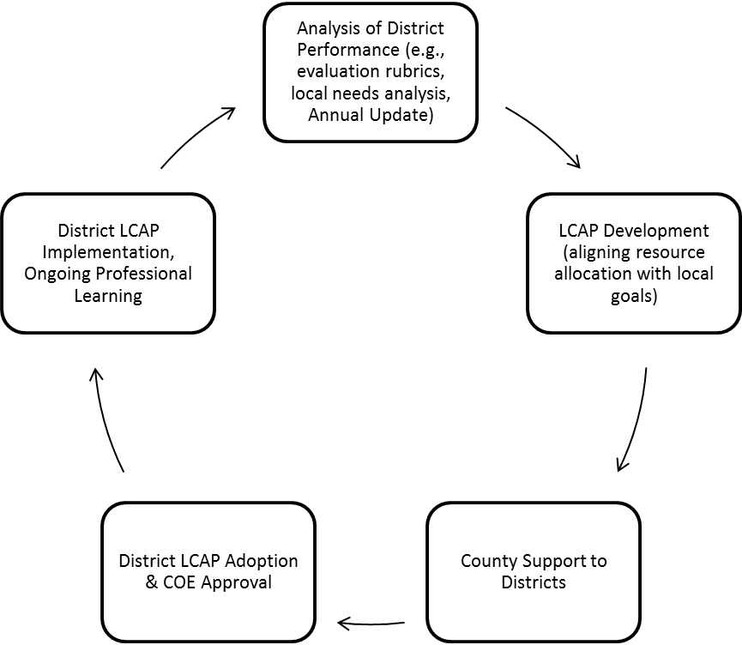

LEAs should be commended for the successful implementation of LCFF. Studies have shown that the first full year of implementation has yielded substantial progress towards this vision as well as collaborative efforts at every level of the public school funding and education system. While much work remains to be done, LEAs have begun to build the foundation for meaningful and sustained support to improve learning for all students, based around the LCFF design principles of student-focused, equity and transparency, and improving student outcomes.
California’s new accountability system will build on the foundations of LCFF, the LCAP, along with the Annual Update, the Evaluation Rubrics, and the California Collaborative for Educational Excellence (CCEE) support structure.
Under LCFF, the first level of accountability rests with local stakeholders, elected district and county boards of education, charter governing boards, and district administration and teachers through the development, implementation, and monitoring of LCAPs. The county superintendent of schools, as the intermediate agent between the state and the districts, is responsible for the oversight of the LCAP process in his or her county. Through the combined statutes of Assembly Bill (AB) 1200, which created the Fiscal Crisis and Management Assistance Team (FCMAT), and LCFF, the county superintendent of schools is responsible for a combination of fiscal and academic assistance that includes progressive interventions to school districts when needed.
Similar expectations of local accountability, planning, and oversight, apply to county offices of education developing their own LCAPs for the fiscal and academic review and assistance provided by the California Department of Education (CDE).
In addition, charter schools comply with a process that consistent with charter statutes details the regular oversight responsibilities provided by charter authorizers. For charter schools, the charter authorizer reviews the LCAP as part of the authorizer’s regular oversight of school performance and budget.
The development of the evaluation rubrics is situated in this larger context of LCFF implementation. Statute requires county superintendents, the Superintendent of Public Instruction (SPI), and the newly created California Collaborative for Educational Excellence (CCEE) to use the evaluation rubrics to determine whether districts need technical assistance, support and/or intervention. A continuously improving educational system is grounded in the concept of collective and reciprocal accountability – everyone must be responsible for the aspects of educational quality that is in their sphere of influence, “from the Capitol to the classroom.” (Darling-Hammond and Plank, 2015)

Figure 2. Relationship Between Evaluation Rubrics, Local Control and Accountability Plan, and Annual Update.
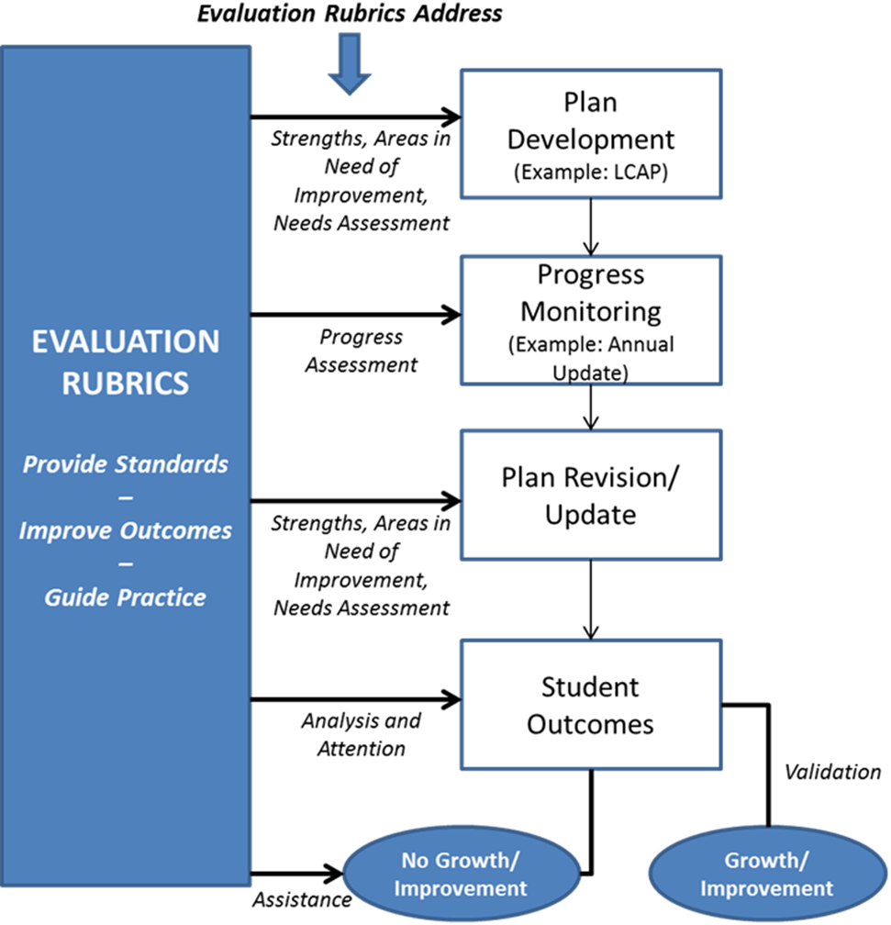
The multi-tiered systems of support and assistance envisioned by LCFF and the use of the LCFF evaluation rubrics are informed by a new theory of action or set of assumptions that tightly connect each of the state priorities to student performance, replacing the existing theory of action that measuring and reporting results alone will generate better results. Governing boards, leaders, educators, staff and community members must also have the capacity and tools needed to improve student achievement results.
Overview of the Local Control Funding Formula Evaluation Rubrics
The evaluation rubrics are an integral part of the LCFF performance and accountability system. Once developed, the rubrics will serve as tools to ensure LEAs are able to align resources to implement strategies that result in meaningful student outcomes. The rubrics will also direct attention to areas in need of additional support to meet the adopted standards for district and school performance relative to the state priorities.
California Education Code (EC) Section 52064.5 requires that the State Board of Education (SBE) adopt evaluation rubrics on or before October 1, 2015. The evaluation rubrics are to (1) assist local educational agencies (LEA) in evaluating their strengths, weaknesses, and areas that require improvement; (2) assist county superintendents of schools in identifying LEAs in need of technical assistance and focusing technical assistance; and (3) assist the Superintendent of Public Instruction in identifying districts for which intervention is warranted.

In March 2015, the SBE reviewed draft evaluation rubrics and provided comments to guide ongoing development efforts (http://www.cde.ca.gov/be/ag/ag/yr15/documents/mar15item06a3rev.pdf). The March version of the evaluation rubrics transitioned the SBE and members of the public from a concept to a concrete example of what the rubrics should include to measure strengths and weaknesses. There was consensus among the SBE members that the evaluation rubrics should support growth and improvement. Furthermore, that performance standards are important to provide a reference point for improvement, but that standards should not create a target that if not achieved, results in punitive consequences. Rather, the SBE requested that the notion of performance standards be grounded in the objectives of supporting continuous improvement, equity, and transparency as the next draft of the evaluation rubrics is developed.
Since the SBE’s March meeting, WestEd has engaged stakeholders through regional input sessions. In addition, the Rubric Design Group, which is comprised of educational leaders representing school districts, charter schools, and county offices of education, and schools, was asked to help process feedback to construct options to develop “standards for school district and individual school site performance, and expectations for improvement” that are part of an evaluation rubric that provides a “holistic, multidimensional school district and school performance” [EC 52064.5(b-c)].
A primary goal for the May SBE meeting is to request feedback and direction from the SBE regarding an approach to identifying performance standards for the evaluation rubrics as described in this attachment. Feedback and direction received as part of this item will be used to guide the development of a final draft of the evaluation rubrics that will be initially brought before the SBE in July 2015, with expectations for action at the September 2015 meeting.

Stakeholder Input

Based on the feedback from the SBE, WestEd organized and facilitated a process to gather input from experts and stakeholders regarding the draft of the evaluation rubrics from March 26 – April 2. These regional input sessions provided the third opportunity for members of the public and education stakeholders to provide feedback on the draft rubrics. A total of 113 individuals attended an input session. Participants included district, county, charter, and school leaders; teachers; students; parents; and community and state-level advocacy groups. Students actively participated in the Santa Clara location.

Location | Number Attending
Orange County Department of Education | 35
Kern County Superintendent of Schools | 13
Ventura County Office of Education | 14
Monterey County Office of Education | 6
Riverside County Office of Education | 14
Sacramento County Office of Education | 17
Santa Clara County Office of Education | 14

An additional 35 individuals representing state and regional associations and agencies provided input through a policy stakeholder input session. In addition, input was also gathered from small school districts, charter schools and county offices of education leaders.
At each session, participants were invited to provide feedback on three critical questions related to developing standards for the evaluation rubrics. These questions were:
- What? – Scope: For what metrics can, or may there be, statewide and/or local reference points?

- How? – Methodology: How will the performance standards/reference points be established?

- Why? – Productivity: How will the performance standards/reference points support and place emphasis on improvement and growth?

A summary of the feedback shared can be found at http://lcff.wested.org/regional-stakeholder-input-summary-marchapril-2015/ . The feedback reflected a range of ideas that included acknowledgment of the challenge that the rubrics include performance standards that draw attention to success and needs without setting a punitive tone. In addition, the sessions provided an opportunity to explore options for creating meaningful performance standards given that only some data pertaining to the metrics is available statewide while some metrics require local definition and collection.

Summary of Major Changes to the Draft Evaluation Rubrics

Based on the feedback provided by the regional input sessions, policy stakeholders, and Rubric Design Group members, the following major changes are proposed to the March 2015 draft evaluation rubrics:

- Simplify the evaluation rubrics to include only the data analysis section and shift the content related to outcome and practice reflection to complementary tools and resources.

- Further develop standards of performance for each priority area for schools and districts.

- Reflect a multidimensional approach to performance standards by creating displays and analysis for (1) outcomes relative to statewide and local performance reference points, (2) progress measured by statewide and local metrics, and (3) progress for subgroups.

- Use, to the extent possible, same or similar data files currently used in the School Accountability Report Card (SARC) to support alignment and reduce duplication.

Additional changes to the LCFF evaluation rubrics are provided in Appendix A.

Performance Standards – Proposed Change to Support Growth and Improvement

The California EC Section 52064.5 specifies that the rubrics shall provide standards for school district and individual school site performance and expectations for improvement in regard to the LCFF state priorities. For the purposes of the LCFF evaluation rubrics, the following definitions are proposed:

- A performance standard is defined as an expectation for growth on the metrics under the LCFF state priorities at the school, LEA, and subgroup levels;

- A reference point is a numeric value derived from the distribution of statewide or local data, that represents a rigorous performance goal; and

- A metric is a system of measurement that is used to evaluate performance under the LCFF state priorities.

Staff from the SBE and CDE, in consultation with WestEd will research possible methods for defining and calculating reference points. Specifically, an analysis of current state data and the identification of reference points adopted by other states along with the basis for setting these reference points (e.g., best practices, data simulations and recommended policy and research) will be reviewed by subject matter experts and stakeholders. Specific statewide reference points will be presented to the SBE in July 2015 for feedback.

For purposes of discussion and feedback from the SBE, the following is a proposed conceptual model that builds on the March draft for how the LEA and school level performance standards and expectations for improvement would be implemented:

- Evaluating Outcomes Relative to Performance Reference Points: To assist LEAs in evaluating their strengths, weaknesses, and areas that require improvement, the rubrics will assess performance at the LEA, school and subgroup levels using a combination of statewide and local performance metrics and reference points.

In priority areas such as pupil achievement where Education Code defines specific performance metrics, the rubrics will identify statewide reference points for those metrics if they use uniform statewide data definitions and statewide data is available. The reference points will be set to a percentile of the distribution of statewide performance data unless there are existing requirements for a higher level of performance, in which case statewide data is not a prerequisite for establishing a statewide reference point. For instance, current state law requires that 100% of teachers are appropriately assigned (an input measure), and therefore, the reference point would be 100%.

In priority areas where the statute does not define a pupil outcome or achievement metric, or the metrics do not use uniform data definitions, such as implementation of state standards, the state performance standard will require that LEAs use local metrics established and identified in their LCAPs that meet the general requirements described in statute for the rubrics. The anticipated metric selection tool that is proposed in conjunction with rubrics will provide vetted options for LEAs to consider. LEAs will then determine and identify related local performance reference points that represent rigorous goals in the rubrics.

Where there are defined metrics under a priority that use uniform data definitions, but no statewide data available, LEAs will determine and identify related local performance reference points that represent rigorous goals in the rubrics.

- Standards for Performance and Improvement: The evaluation rubrics will include data with color/symbol-based indicators to visually communicate progress on statewide and locally-determined metrics. Consistent with what was proposed in the March draft of the evaluation rubrics, the following color/symbol-based indicators are presented for discussion purposes:

  - Green – Represents progress based on a to be determined (TBD) amount of growth from prior year AND progressive improvement over two or more years.
  - Yellow – Represents an area in need of further consideration based on a TBD amount of growth from prior year OR progressive improvement over 2 or more years.

  - Red – Represents an area in need of improvement based on a TBD amount of limited to no growth from prior year NOR progressive improvement over 2 or more years.

  - Blue – Represents an area of strength based on current performance meeting or exceeding a proposed state or locally determined reference point.

  - Gray- Represents that the metric does not apply for the given LEA.

The data and displays for which a color/symbol-based indicator is applied will be determined based on data that is included in the evaluation rubric. In cases where data are collected and reported by the state through existing data systems, such as the California Longitudinal Pupil Achievement Data System (CALPADS) or reported through the online reporting tools such as DataQuest or the School Accountability Report Card (SARC), such data can be prepopulated into the evaluation rubrics.

Where statewide definitions do not exist or statewide data is not collected, generally it will be necessary to refer to locally defined, collected, and reported data. To the extent possible, statewide data will be prepopulated, but local data may be added and prepopulated data can be corrected by the LEA to support accuracy and completeness. The inclusion of state and local data allow for multiple dimensions to the performance standards to support focus on reasonable growth/improvement and equitable outcomes.

At the March 2015 meeting, the SBE received an overview of the data metrics and data availability as specified in EC Section 52060 (d). This overview classified the LCFF priorities as input, process, or outcome measures, and designated the priorities collected by the state at the LEA, subgroup, and school level (e.g., high school graduation is an outcome measure collected by the state at the LEA, subgroup, and school level).

Table 1 below is an expanded view of the potential LCFF priority metrics, including the proposed reference point and the data source. This table is organized by outcome measures, followed by process and input measures. As noted earlier, in cases where there are uniform data definitions and the state collects data, there will be proposed statewide reference points. In the absence of state defined and collected data, LEAs are encouraged to use locally determined metrics to establish local reference points to complement state performance standards.

Table 1. Proposed Statewide and Locally-Determined Performance Standards and Reference Points
Priority Area (#) | Input | Process | Outcome | Metric | Proposed Statewide Reference Point | Proposed Locally-Determined Reference Point | Data Source
Pupil Achievement (4)
 |  |  | X | For all LEAs- Statewide assessments administered pursuant to the California Assessment Student Performance Program (CAASPP) | X |  | CDE
 |  |  | X | Academic Performance Index (API) | X  NA for 2014-15 |  | CDE
 |  |  | X | For secondary - % of graduates with UC/CSU required coursework (A-G requirements) | X |  | CDE
 |  |  | X | For secondary- % of graduates with career technical education (CTE) sequences or programs that align with the CTE model practice standards | X |  | CDE/  Local
 |  |  | X | For all LEAs -  % of English learners making progress towards English proficiency (AMAO 2) | X |  | CDE
 |  |  | X | For all LEAs- % of English learners reclassified as English proficient (AMAO 3) | X |  | CDE
 |  |  | X | For secondary- % of 11th and 12th grade students enrolled in at least one Advanced Placement, International Baccalaureate, or dual credit course  % of students with a score of 3 or higher on an AP exam | X |  | CDE/  Local
 |  |  | X | For secondary - % of grade 11 students Assessment at Achievement Level 3 or higher designated as college ready on the Early Assessment Program (EAP) | X |  | CDE/  CSU
Priority Area (#) | Input | Process | Outcome | Metric | Proposed Statewide Reference Point | Proposed Locally-Determined Reference Point | Data Source
Other Pupil Outcomes (8)
 |  |  | X | Pupil outcomes in core subject areas | X |  | CDE/  Local
School Climate (6)
 |  |  | X | Suspension rate | X |  | CDE/  Local
 |  |  | X | Expulsion rate | X |  | CDE/  Local
 |  | X |  | Locally determined measurement of pupils, parents, and teachers on the sense of safety and school connectedness | X |  | Local/ Healthy Kids Survey or Local Survey
Pupil Engagement (5)
 |  |  | X | % of middle school students dropping out | X |  | CDE
 |  |  | X | % of high school students dropping out (cohort) | X |  | CDE
 |  |  | X | % of high school students graduating (cohort) | X |  | CDE
 |  | X |  | % attendance/ attendance rate |  | X | CDE/ Local
 |  | X |  | % of students chronically absent from school |  | X | Local
Parental Involvement (3)
 |  | X |  | Locally determined measurement of parental involvement |  | X | Local
 |  | X |  | Locally determined measurement of efforts made to seek parent input in making decisions for school district and each individual schoolsite |  | X | Local
 |  | X |  | Locally determined measurement of how district promotes parent participation in programs for unduplicated pupils and individuals with exceptional needs |  | X | Local
Priority Area (#) | Input | Process | Outcome | Metric | Proposed Statewide Reference Point | Proposed Locally-Determined Reference Point | Data Source
Course Access (7)
 |  | X |  | Course access in core academic areas |  | X | Local
Implementation of State Standards (2)
 |  | X |  | Locally determined measurement of implementation of state academic content and performance standards |  | X | Local
 |  | X |  | Locally determined measurement of how programs and services enable ELs to access common core standards and ELD standards and show performance progress |  | X | Local

Basic (1)
 | X |  |  | % of Teachers appropriately assigned | X |  | SARC
 | X |  |  | % of Teachers fully credentialed for subject area | X |  | SARC
 | X |  |  | % of Teachers fully credentialed for students they are teaching | X |  | SARC
 | X |  |  | % of Students with sufficient instructional materials | X |  | SARC
 | X |  |  | % of Schools with facilities in “good repair” | X |  | SARC

The Second and Third Purposes of the LCFF Evaluation Rubrics:
Helping Identify Where Technical Assistance or Intervention is Needed

State law requires that the evaluation rubrics serve three purposes. As discussed above, the evaluation rubrics are to be used by LEAs in evaluating strengths and weaknesses and as part of the continuous improvement process. The rubrics also are to be used to identify those LEAs in need of technical assistance and, ultimately, those LEAs in need of intervention.

During the input sessions and meetings of the Rubric Design Group (RDG), questions arose about the technical assistance aspect of the rubrics and how LEAs will be identified as needing technical assistance. For example, attendees asked how many “red” indicators would lead to technical assistance.

A summary of the statutory provisions regarding technical assistance and intervention is below, followed by some options for how the rubrics might indicate assistance or intervention is needed.

Technical Assistance

For school districts, EC Section 52071 specifies that the County Superintendent shall provide technical assistance, using the evaluation rubrics, to any district that “fails to improve pupil achievement across more than one state priority… for one or more pupil subgroup identified pursuant to Section 52052.”

For county offices of education, EC Section 52071.5 specifies that the SPI shall provide technical assistance, using the evaluation rubrics, to any county office that “fails to improve pupil achievement in regard to more than one state priority…for one or more pupil subgroups identified pursuant to Section 52052.”

For charter schools, EC Section 47607.3 specifies that the chartering authority shall provide technical assistance, using the evaluation rubrics, to the charter school if the charter school “fails to improve outcomes for three or more pupil subgroups identified pursuant to Section 52052, or, if the charter school has less than three pupil subgroups, all of the charter school’s pupil subgroups, in regard to one or more state or school priority identified in the charter pursuant to subparagraph (A) of paragraph (5) of subdivision (b) of Section 47605 or subparagraph (A) of paragraph (5) of subdivision (b) of Section 47605.6, in three out of four consecutive school years.”

The technical assistance may include, among other things, any of the following:
(1) Identification of LEA strengths and weaknesses in regard to the applicable state priorities, including a review of effective, evidence-based programs that apply to the LEA’s goals;
(2) Assignment of an academic expert or team of academic experts to assist the LEA in identifying and implementing effective programs designed to improve the outcomes for all pupil subgroups identified in EC Section 52052;
(3) Solicitation of another LEA to act as a partner to the LEA in need of technical assistance; and
(4) Request that the SPI assign the CCEE to provide advice and assistance to the LEA (or in the case of the SPI, assign the CCEE to advise and assist the COE).

Intervention

For school districts, EC Section 52072 specifies that the SPI may, with the approval of the SBE, identify school districts in need of intervention if a district meets both of the following criteria:

(1) The school district “did not improve the outcomes” for three or more pupil subgroups identified pursuant to EC Section 52052 or, if the school district has less than three pupil subgroups, all of the school district’s pupil subgroups, in regard to more than one state or local priority in three out of four consecutive school years.

(2) The CCEE has provided advice and assistance to the school district pursuant to EC Section 52071 and submits either of the following findings to the SPI:

(A) That the school district has failed, or is unable, to implement the recommendations of the CCEE.

(B) That the inadequate performance of the school district, based upon the evaluation rubrics, is either so persistent or acute as to require intervention by the SPI.

A parallel set of conditions is set forth for possible revocation of a charter school. (Education Code Section 47607.3)
How the Rubrics Might Indicate Assistance or Intervention is Needed

Notably, the technical assistance and intervention statutes focus on whether an LEA has improved pupil achievement and outcomes. The evaluation rubrics statute, in contrast, emphasizes “a holistic, multidimensional assessment” of performance that includes LEA and school-level performance standards and expectations for improvement in regard to all of the state priorities.

Over the next month, WestEd will reconvene the Rubric Design Group (RDG) and policy stakeholder committees to discuss the how the evaluation rubrics should appropriately indicate a need for technical assistance and intervention. For example, stakeholders will be asked for feedback regarding which priorities, metrics, or reference points are appropriate to consider in making these determinations, taking into account that not all the state priorities include achievement or outcome metrics.

Table 1 above provides an overview of the LCFF priorities and organizes the metrics by outcome measures, followed by process and input measures. Consistent with the theme of system coherence detailed in Attachment 2 and the technical assistance and intervention statutes, any determination that an LEA did not improve pupil achievement or outcomes for a pupil subgroup in regard to a state priority must rely on the metrics that measure pupil achievement or outcomes.

Among the options the SBE may wish to consider for using such metrics to determine that assistance or intervention is needed are the following:
- Failure to improve pupil achievement and outcomes for a pupil subgroup for a given priority would be indicated by a lack of growth (red indicators) on a specific number or percentage of state-defined achievement/outcome metrics under that priority;
- Failure to improve pupil achievement and outcomes for a pupil subgroup for a given priority would be indicated by a lack of growth (red indicators) on a specific number or percentage of state-defined and locally-defined achievement/outcome metrics under that priority; or
- Failure to improve pupil achievement and outcomes for a pupil subgroup for a given priority would be indicated by a lack of growth on a specific number or percentage of state-defined and locally-defined achievement/outcome metrics under that priority with additional weights for some of the metrics.
As the SBE weighs such options, it may consider how any technical assistance required by statute is situated in the broader context of accountability and system coherence, including the LCAP and Annual Update processes that are intended to ensure LEAs are able to align resources to implement strategies that result in meaningful student outcomes. The evaluation rubrics and supporting best practice guides will also direct LEA attention to areas in need of additional LEA-level support and resources to meet the adopted standards for district and school performance relative to the state priorities.
The evaluation rubrics will provide information for the LEAs to consider whether current goals address areas of need based on areas of strengths and areas requiring growth at the district, school, and subgroup levels. It may also be used by the LEA and/or a potential technical assistance provider to identify areas where action is needed that was not identified in current improvement plans or that was identified for which current strategies are not evidencing improvement. Technical assistance may also take the form of proactive, early assistance where the LEA requests technical assistance or a COE offers technical assistance. As the COE reviews the LCAP and Annual Updates from LEAs it may decide to review the evaluation rubrics for insights regarding whether spending regulations and sufficiency standards are met based on described activities and outcomes as captured in the evaluation rubrics. In all cases, the objective of technical assistance is to support growth and improvement, which are clearly identified and supported by the evaluation rubrics.
Appendix A: Additional Changes to the LCFF Evaluation Rubrics

Online Evaluation Rubric Development

To support transparency and meaningful analysis of state and local priority outcomes the evaluation rubrics will exist online. The SBE and CDE have asked the federally funded California Comprehensive Center at WestEd to assist with the development of a preliminary version of the online evaluation rubrics that would be available following the SBE’s adoption of the evaluation rubrics in September 2015. As noted in the March 2015 SBE item related to the evaluation rubrics, there will be a need to update the evaluation rubric content and website as state-level assessment data and the accountability system fully develops.

An inventory of data elements required for the evaluation rubrics compared against those included in the SARC. Based on this analysis it was determined that the current SARC dataset provides a reasonable starting point that may be augmented to address the data requirements foreseen for the evaluation rubrics. Given the relationship to between the data needed for the evaluation rubrics and SARC, the California Comprehensive Center engaged San Joaquin County Office of Education, the developer of the online SARC, as a strategic development partner. As a result of this partnership the online evaluation rubrics will take advantage of existing SARC design features and functionality such as sign-on capabilities, chart and display options, and local data entry/upload. CDE is working to compile data currently collected through CALPADS to augment the existing SARC files. This includes, but is not limited to data that are not reported in SARC such as A-G participation, Advanced Placement test participation and passage, attendance rates, and foster youth and students with disabilities subgroup data.

A test version of the online evaluation rubrics that meets state accessibility requirements will be available prior to the July 2015 meeting for user testing and feedback.

Will there be Changes to the Evaluation Rubrics?

The initial evaluation rubrics will be adopted in September 2015 but will continue to evolve and improve over time to ensure they align with developments in California’s accountability system, accommodate state and local data availability, and reflect learning from implementation experiences under LCFF. Following are proposed phases for the improvement and maturation of the evaluation rubrics:

 | Phase 1 (Fall 2015) | Phase 2 (Fall 2016, est.) | Phase 3 (Fall 2017, est.)
Data Analysis | - Basic data display with all available state maintained data for metrics at the LEA, student subgroup, and school levels with ability to add local metrics to supplement available state data. LEAs must include metrics for all state priorities.  - Data metric selection tool to facilitate section of local data metrics to fully address state priorities and locally identified priorities. | - Improve data display to add visual references for growth and performance relative to state and locally determined metrics, in cases where such data is available.  - If needed, update data metric selection tool to include expansion and/or refined criteria for suggestions.  - If needed, update data display to align with state accountability metrics (e.g., add or highlight metrics). | - If needed, update data metric selection tool to include expansion and/or refined criteria for suggestions.  - If needed, update data display for changes in state-level data availability and/or changes needed to align with state accountability processes.

Other Areas of Feedback and Proposed Changes to the LCFF Evaluation Rubrics

In addition to receiving feedback and proposing changes related to standards, there were several other areas of feedback around which changes to the draft are proposed. Following is a brief description of the feedback and proposed change to the evaluation rubrics.

Comment | Proposed Change
A range of comments were provided regarding the appropriateness, connection to data, and usefulness of the Outcome Analysis and Practice Analysis sections. There were specific concerns regarding the complexity of using the rubrics with three components (data, outcome, and practice analysis) and redundancy with the LCAP and Annual Update. | Focus the evaluation rubrics on data analysis by shifting the outcome analysis and practice analysis from elements of the rubrics to complementary resources.  Revise the outcome analysis to become “Outcome Reflection Tool” based on input received from stakeholders. Include a range of self-assessment tools to support effective practice including the existing practice analysis tool plus other tools developed to support effective planning, implementation, and support for all students.
The selection of local data metrics are important and information to identify and use local data is needed. It would be helpful if possible to suggest where local data can be found. | As noted in the draft evaluation rubrics, a Data Metric Selection Tool will be created with a wide range of suggested local metrics that takes into account local data availability and use practices. Based on the feedback, the data metric selection tool will add suggestions of where local data may be found (e.g., student information systems, state or regional reports, etc.). In addition, the online evaluation rubrics will include the ability to add local data.
In some cases it is difficult to identify data metrics and an explanation of the changes to a particular area would be helpful. | Add the ability for LEAs to add comments to any priority area or metric.
Attention to subgroups must be explicit and clear in the evaluation rubrics. | The standards apply equally to all subgroups.
The evaluation rubrics need to bring attention to Foster Youth, Students with Disabilities, and Parent Engagement. | State standards have been added to include explicit attention at the subgroup level to foster youth and students with disabilities. With regard to Parent Engagement, several metrics based on local data are proposed for inclusion in the evaluation rubrics.
Suspension and expulsion data are important, but local policies affect data and it can be hard to judge whether a change in the rates is a sign of improvement or decline. | Suspension and expulsion data will be included in the evaluation rubric and prepopulated with state reported data. However, given the concerns regarding data assessment, additional research is needed to determine if the performance reference points will be set at the state or local level using the Data Metric Selection Tool.
The state priorities and identified metrics are overwhelming related to high school. Metrics that focus on elementary and intermediate grades are needed. | Additional metrics based on local data will be proposed for inclusion in the evaluation rubrics using the Data Metric Selection Tool.
State standards include science and should be reflected in the metrics. | Additional metrics based on local data will be proposed for inclusion in the evaluation rubrics using the Data Metric Selection Tool.

LCFF Evaluation Rubrics Practice Guides and Other Complementary Resources

Practice Guides are under development to complement the evaluation rubrics. The practice guides provides information for LEAs to use when assessing, developing, or revising plans to impact outcomes in the state priority areas of Conditions for Learning, Pupil Outcomes, and Engagement. Within the guide are instructions on data analysis and goal development, as well as research and evidence-based actions and services that provide LEAs with specific strategies to improve outcomes. Also included in the guide are specific considerations for promoting equity, supporting individual school sites, and addressing the needs of low income, English Learner, and foster youth populations.

The information included in the practice guides drawn from resources that have undergone a rigorous review process to ensure that they represent current, research-based practices that have proven success in the field. The primary source for the practice guides come from practice guides developed by the Institute for Education Sciences (IES), which is a part of the National Center for Education Evaluation and Regional Assistance, a division of the United States Department of Education. The IES guides draw on the best available evidence and expertise to develop recommendations that address challenges encountered in the field of education. Each IES guide is written by a panel of experts and then vetted through a thorough peer review process. Links to the IES practice guides are embedded within this document. In addition, practice guides also include resources that CDE developed or identified resources such as the Family Engagement Framework, curriculum frameworks, and Quality Schooling Framework.

Following is a sample table of content for the Pupil Outcome Practice Guide:

- Introduction

- Domain and Priority Areas – explains the state priorities addressed in the practice guide

- Description of Metrics – provides an overview and explanation of LCFF metrics and options for equity focused metrics

- Strategies and Recommended Practices – organized by recommended practices including specific strategies as available for grade levels, English learners, foster youth, students with disabilities, and other subgroups.

4-24-15 [State Board of Education]

