California Department of Education  Executive Office  SBE-003 (REV. 09/2011)  ilsb-cctd-jan16item03 |  | ITEM #12
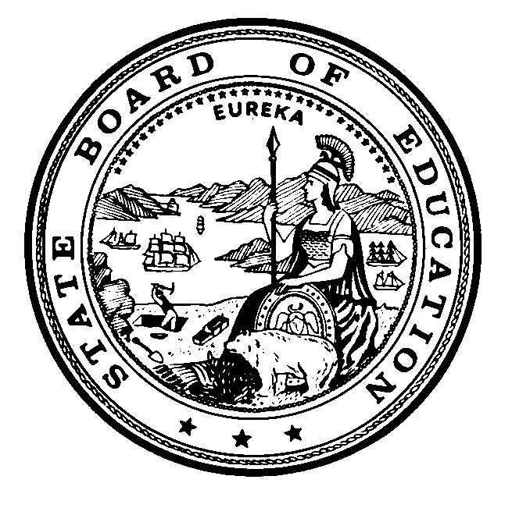 | CALIFORNIA STATE BOARD OF EDUCATION  JANUARY 2016 AGENDA
SUBJECT  Approval of the DRAFT “California’s Strategic Workforce Development Plan: Skills Attainment for Upward Mobility; Aligned Services for Shared Prosperity: California’s Workforce Development Plan Under the Workforce Innovation and Opportunity Act (WIOA) for Program Years 2016–2020.” |  |  |  | Action
 |  |  |  | Information
 |  |  |  | Public Hearing

SUMMARY OF THE ISSUE(S)

The federal Workforce Innovation and Opportunity Act (WIOA) of 2014 requires the Governor, via the California Workforce Development Board (CWDB), and in coordination with WIOA core federal programs overseen by the State Board of Education (SBE) and administered by the California Department of Education (CDE), the Employment Development Department (EDD), and the Department of Rehabilitation (DOR), to submit a unified state plan to the U.S. Department of Labor (DOL) and the U.S. Education Department (ED). The CWDB and WIOA core programs collaboratively developed the draft “California’s Strategic Workforce Development Plan: Skills Attainment for Upward Mobility; Aligned Services for Shared Prosperity: California’s Workforce Development Plan Under the Workforce Innovation and Opportunity Act (WIOA) for Program Years 2016–2020” (the State Plan). The draft State Plan reflects the following:

- Outlines a comprehensive four-year strategy for the investment of federal workforce training and employment services dollars in a manner that aligns, coordinates, and when appropriate, integrates service delivery for the six core programs funded under WIOA. These programs include Title I Adult, Dislocated Worker, and Youth programs; Title II Adult Basic Education and Basic Skills programs; Title III Wagner-Peyser Employment Services programs; and Title IV Vocational Rehabilitation services.

- Provides a framework for aligning other relevant state and federally funded workforce, education, and human services programs. To this end, the draft State Plan initiates the expansion of partnership beyond core programs to other relevant programs such as Temporary Assistance to Needy Families, Carl D. Perkins K–14 Career and Technical Education (CTE) programs, California’s Employment Training Panel incumbent worker training services, as well as state general-funded Adult Basic Education Block Grant (AEBG) programs administered by regional consortia under state statutes, and, as appropriate, state-funded CTE programs delivered through both the kindergarten through grade twelve (K–12) educational system and California’s community colleges.

The CDE K–12 division programs with responsibilities associated directly and/or indirectly with WIOA Titles I–IV provide services and support to WIOA target populations, including individuals with barriers to employment, as well as veterans, unemployed workers, and youth. These CDE K–12 program services and populations include the following:

- Adult Education Program - reaches hard-to-serve students, including emancipated youth, displaced homemakers, low income and homeless adults, incarcerated individuals, and a large immigrant population. Over half a million adults study basic skills, English as a second language (ESL), citizenship preparation, and take classes to earn a high school diploma or its equivalency under federal WIOA, Title II programs and related state-funded programs operated through the state’s 70 AEBG Consortia.

- CTE Programs - serve 970,000 secondary students and 59,000 adult CTE students.

- English Learner Programs - serve migrant farmworkers, seasonal farmworkers, out of school youth, English learners and immigrant students and their families. The goal of these programs is to provide students with access to the core academic content, and to overcome language barriers and other barriers caused by the migratory patterns of students.

- The CDE also provides transition services to 137,000 students with disabilities statewide, including 94,000 served by Workability 1 programs; 23,000 at-risk students are served through county run juvenile justice facilities and county community schools.

The draft State Plan may be accessed on the CWDB WIOA Unified Strategic Workforce Development Plan (Draft) Web page at http://www.cwdb.ca.gov/WIOA_Unified_Strategic_Workforce_Development%20_Plan.htm.

California state law requires the CWDB to collaborate with the CDE, the California Community College Chancellor’s Office (CCCCO), and other appropriate state agencies, and local workforce development boards to develop a comprehensive state plan that serves as a framework for public policy, fiscal investment and the operation of all state labor exchange, workforce education, and training programs.

- State law specifically directs the CWDB to develop a plan that fosters the building of regional alliances between workforce and education professionals and employers to develop programs that meet industry’s workforce needs.

- State planning requirements anticipate and are consistent with the policy directions prescribed in WIOA. The draft State Plan meets state requirements pertaining to coordination of services and investment in training in a manner that aligns with regional industry needs by making regional organizing efforts around career pathways aligned with regional labor market trends and industry needs, a key focus of the regional workforce plans required under WIOA Section 106.

- This draft State Plan is designed to meet both state and federal planning requirements while also providing a comprehensive framework for partnership between private industry sector leaders and the state’s publically-funded workforce and education systems.

The draft State Plan begins with the Governor’s vision, goals, and strategic policy orientation for the plan. The main areas of the plan are an overview of the general policy orientation informing the plan, and consideration of service delivery and program coordination strategies that will inform day-to-day operations at the state, local, and regional levels.

As mentioned, the draft State Plan under WIOA includes many elements for the K–12 programs. The SBE is responsible for establishing policy for K–12 programs as the designated State Education Agency while the CDE is the administrative and oversight body for K–12 programs, including adult education and literacy programs and CTE. Four divisions within the CDE have program responsibilities associated, directly and/or indirectly, with WIOA. These divisions include the Career and College Transition Division, the Special Education Division, the English Learner Support Division, and the Coordinated Student Support Division, located in two different branches.

Instruction and Learning Support Branch

Career and College Transition Division: Includes programs for adult education, including CTE. Specifically, the adult education programs in the state of California provide adult basic and secondary education skills including English, math, and ESL foundational competencies needed to enter postsecondary education and training as well as citizenship training. In addition to the K–12 adult schools, the CDE, through the WIOA, Title II grant, also funds libraries, community-based organizations, correctional institutions, and several community colleges for these programs.

CTE integrates core academic knowledge with technical and occupational knowledge to provide students with a pathway to postsecondary education and careers. The federal program to support CTE in California is the Carl D. Perkins Career and Technical Education Act of 2006 which the CDE jointly administers with the CCCCO.

English Learner Support Division: Oversees Every Student Success Act, English Learner Title III and Migrant Title I part C programs and funding for the state of California. The division coordinates K–12 state and federal efforts and programs to serve migrant farmworkers, seasonal farmworkers, out of school youth, English learners and immigrant students and their families. The goal of these programs is to provide students with access to the core academic content, and to overcome language barriers and other barriers caused by the migratory patterns of students. These programs are often supported through partnerships with Adult Education and WIOA. The parents of the K–12 migrant students, English learner students, immigrant students, and out of school youth benefit from the partnerships with Adult Education and WIOA.

Student Support and Special Services Branch

Special Education Division: Oversees programs operated by approximately 1,100 local educational agencies (LEAs) to provide students up to age 22, who receive services under an Individualized Education Program, with a free and appropriate public education. Students with disabilities age 16–22 must be provided needed transition services based on their assessed needs, strengths, preferences, and interests to facilitate movement from school to post school activities. These post school activities may include postsecondary education, training, competitive integrated employment, and independent living. Workability I is a state-funded grant program awarded to 280 LEAs to provide an array of transition services to middle and high school students, including work experience for high school students.

Coordinated Student Support Division: Oversees the state’s Educational Options programs which work with at-risk K–12 students, including those habitually truant or at risk of not graduating, students who have been expelled or have been placed in a juvenile court facility, those unable to attend school due to a medical problem, and foster youth. These students generally attend a county or district administered school structured to address the student’s individual challenges. The most common educational option school types include county community and juvenile court schools administered by a county office of education, and continuation, community day, and opportunity schools operated by school districts. For students where a classroom setting is not possible or appropriate, schools have a variety of programs available to meet these special needs including home and hospital instruction and independent study. For these schools and programs, the goal of providing students with the environment, curriculum, and supportive services they need to reach their full academic potential, graduating, and successfully transitioning to postsecondary education or employment is often supported through partnerships with WIOA Title I Youth Programs and community based organizations.

The draft State Plan is currently in the process of public comment until mid-January. Based on public comment, the plan will be revised in January 2016 and the final version submitted to the DOL and ED by March 3, 2016.

Failure to approve the draft State Plan may result in the loss or delay of an estimated $86 million in WIOA, Title II: Adult Education and Family Literacy Act (AEFLA) grant funds each year for the period 2016–2020.

RECOMMENDATION

The CDE recommends that the SBE approve the draft “California’s Strategic Workforce Development Plan: Skills Attainment for Upward Mobility; Aligned Services for Shared Prosperity: California’s Workforce Development Plan Under the Workforce Innovation and Opportunity Act (WIOA) for Program Years 2016–2020.”

BRIEF HISTORY OF KEY ISSUES

On July 22, 2014, the President signed into law the WIOA, which includes the reauthorization of Title II, the Adult Education and Family Literacy Act of 1998–2004. As a result of this reauthorization, states are required to submit a unified plan to transition from the Workforce Investment Act to the new WIOA. As the state agency designated by the Governor to manage many of the programs that are now incorporated within the WIOA, the CDE is required to submit any revisions to the SBE, including performance targets and the transition activities, necessary to prepare for the full implementation of WIOA in 2016–17. This new unified plan that includes core programs operated by the CDE, the EDD, and the DOR, must be approved and submitted to the DOL and the ED on March 3, 2016.

SUMMARY OF PREVIOUS STATE BOARD OF EDUCATION DISCUSSION AND ACTION

The SBE has approved annual revisions to the California State Plan for the previous federal programs under the Workforce Investment Act, Title II: Adult Education and Family Literacy Act. The most recent approval was in May 2015, when the SBE approved the California State Plan for the Workforce Investment Act, Title II: Adult Education and Family Literacy Act: Extension and Transition to Workforce Innovation and Opportunity Act, 2015–16, which included the 2015–16 performance goals and a one-year extension of the plan through June 30, 2016.

FISCAL ANALYSIS (AS APPROPRIATE)

As the largest state in the country with the largest population targeted by the programs within the WIOA, California averages approximately 20 percent of the funds allocated to these federal programs. The CDE’s responsibility, which includes most of the programs within the WIOA, requires full legal and fiduciary management to execute these programs flawlessly. This includes submitting all required documents and reports along with meeting the timelines established by the federal legislation. It demands the actions of over a hundred of CDE’s employees to monitor and provide technical assistance to thousands of educational agencies throughout the state that directly provide services to millions of California’s citizens. It is fiscally prudent that the SBE assist the CDE to meet its responsibility to the other state agencies working on this unified plan so that the draft State Plan can be submitted on time and not jeopardize California’s funding for these vital programs.
Failure to approve the draft State Plan may result in the loss or delay of an estimated $86 million in WIOA, Title II: AEFLA grant funds each year for the period 2016–2020.

ATTACHMENT(S)

None

