California Department of Education  Executive Office  SBE-003 (REV. 09/2011)  sbe-nov17item05 |  | ITEM #06
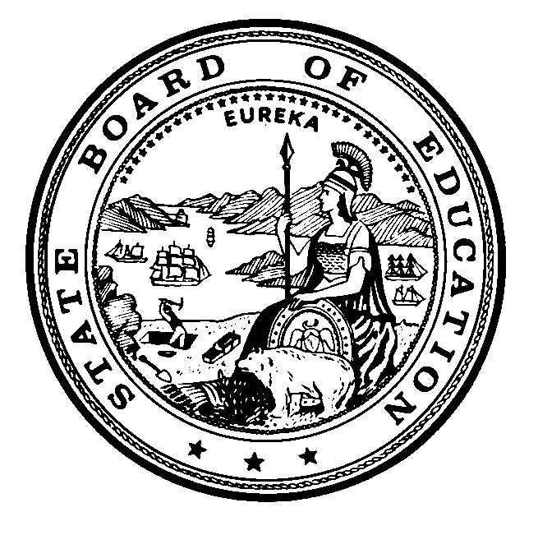 | CALIFORNIA STATE BOARD OF EDUCATION  NOVEMBER 2017 AGENDA
SUBJECT  Presentation by WestEd: California Standards Implementation -- What Educators Are Saying |  |  |  | Action
 |  |  |  | Information
 |  |  |  | Public Hearing

SUMMARY OF THE ISSUE(S)

Since 2015, with sponsorship from the California State Board of Education (SBE), WestEd has reported on surveys and focus groups with California educators about the ongoing implementation of the California Common Core State Standards in English language arts (ELA) and mathematics and associated supports. This presentation by WestEd's Reino Makkonen and Robert Sheffield will summarize findings from recent surveys administered to California teachers alongside lessons learned from related ongoing research and technical assistance initiatives. Key findings include increased site-based, collaborative professional learning and peer observation reported among California's teachers, as well as shifting approaches to standards-aligned materials among teachers and leaders.

RECOMMENDATION

This item is being presented for information only.

BRIEF HISTORY OF KEY ISSUES

In 2010, the SBE adopted new standards in mathematics and English language arts and Literacy in History/ Social Studies, Science, and Technical Subjects. In 2012, the Common Core State Standards (CCSS) Systems Implementation Plan was unanimously approved by the SBE.

SUMMARY OF PREVIOUS STATE BOARD OF EDUCATION DISCUSSION AND ACTION

WestEd previously presented to the SBE on its findings regarding standards implementation in March of 2016.

FISCAL ANALYSIS (AS APPROPRIATE)

Not applicable.

ATTACHMENT(S)

Attachment 1: WestEd Knowledge Brief – California Standards Implementation: What Educators Are Saying by Reino Makkonen and Robert Sheffield (10 pages) [links to https://wested.app.box.com/s/yboivjgc7qivtpbetnyhfni2vzfujsfz].

