California Department of Education
Executive Office
SBE-003 (REV. 11/2017)
pptb-amard-may18item01

California State Board of Education
May 2018 Agenda
Item # 02

Subject
Developing an Integrated Local, State, and Federal Accountability and Continuous Improvement System: Approval of a Student Growth Model and the One-Year Graduation Rate for Schools with Dashboard Alternative School Status, and Update on the California School Dashboard.

Type of Action
Action, Information

Summary of the Issue(s)
As part of the ongoing development of the California School Dashboard (Dashboard), the California Department of Education (CDE) is proposing changes to prepare for the release of the 2018 Dashboard. The CDE provided an April Information Memorandum to the State Board of Education (SBE) that included a detailed work plan over an eight-month period for each upcoming SBE meeting. Consistent with the 2017 Fall Dashboard release, in which the CDE presented proposed changes to the Dashboard throughout the spring and summer, the CDE will request that the SBE adopt comprehensive changes to the state indicators on the Dashboard at the September and November 2018 SBE meetings. However, prior to the adoption of the final components of the state indicators, there are a number of items that are technical and require incremental decisions at the May and July SBE meetings.
This item details the proposed methodology for incorporating the one-year graduation rate for Dashboard Alternative School Status (DASS) schools, based on numerous simulations conducted by the CDE and recommendations by the Technical Design Group (TDG) and stakeholder groups. The item also provides information on the analyses of three student-level growth models conducted by Educational Testing Service (ETS). In addition, an update on the outreach activities for the Dashboard will be provided along with a presentation from a local educational agency (LEA) on their use of the Dashboard.

Recommendation
The CDE recommends that the SBE approve: (1) the “Residual Gain” student growth model for further exploration and modeling to be considered for possible inclusion in the 2018 dashboard, and (2) the recommended methodology for calculating the one-year graduation rate for DASS schools.

Brief History of Key Issues
Since the SBE adopted the initial phase of the Local Control Funding Formula evaluation rubrics at its September 2016 meeting, extensive feedback from numerous stakeholder input sessions and policy work groups continues to inform the state and local indicators and Dashboard displays and reports.
The Fall 2017 Dashboard was released on December 7, 2017, and is available on the California School Dashboard Web site at https://www.caschooldashboard.org/. The Fall 2017 Dashboard includes several new features to improve functionality and an array of new resources to increase public engagement and understanding. In direct response to user recommendations, a broad range of online and in-person outreach activities were also held to support the Dashboard release. The CDE continues to evaluate options to improve the functionality and usability of the Dashboard based on user feedback for the 2018 release.
In March 2018, the CDE provided the annual proposed changes to the Dashboard to the SBE. Although extensive work on the Dashboard has been completed over the last year, the addition of new indicators, modified methods for DASS schools, a potential student-level growth model, and the transition to a new English language proficiency assessment, will result in substantial revisions to the 2018 Dashboard. As a result, the CDE developed a work plan (https://www.cde.ca.gov/be/pn/im/documents/memo-pptb-amard-mar18item01.docx) to provide the SBE with a timeline for when specific SBE Agendas and Information Memoranda would be provided to the SBE from April 2018 through November 2018. This timeline outlines when decisions on specific indicators will be required.
In addition, with the approval of the Every Student Succeeds Act State Plan, a number of implementation decisions are required between now and the November 2018 meeting. The SBE will need to determine items such as how to: (1) display the long-term goals and interim progress; (2) incorporate the participation rate in the Academic Indicator; (3) support schools with fewer than 30 students; and (4) adjust the identification of the lowest performing Title I schools based on the addition of new state indicators in the Dashboard.

Student-Level Growth Model
The CDE’s testing vendor, ETS, conducted a statistical analysis of three proposed growth models (https://www.cde.ca.gov/be/pn/im/documents/memo-pptb-amard-feb18item01a1-rev.docx) selected based on the desired characteristics reviewed and discussed at the January 2017 SBE meeting. The growth models being considered are:
- “Change-in-distance-to-met” measures absolute growth of each student from the prior year to the current year using Distance from Level 3 as the measurement threshold.
- “Conditional percentile rank of the gain” ranks the growth of students who are grouped together, as a result of having the same prior year test scores, in the same subject and grade.
- “Residual gain” is the difference between a students predicted test score and actual test score. Note: the predicted test score is based on both prior English language arts/literacy (ELA) and mathematics test scores, as well as the scores of all other students in the same grade.
These analyses were presented to the SBE in a February 2018 Information Memorandum (https://www.cde.ca.gov/be/pn/im/documents/memo-pptb-amard-feb18item01.docx).
ETS also presented its analysis to the TDG, the California Assessment of Student Performance and Progress Technical Advisory Group, and the Local Control Funding Formula Stakeholder Group. The feedback from these groups has informed the CDE’s recommendation of a student growth model to be incorporated into the 2018 Dashboard, as detailed in Attachment 1. Due to the technical complexity of the implementation of the student-level growth model in the 2018 Dashboard, the CDE will recommend incremental decisions over three SBE meetings. At this meeting, the CDE recommends the selection of the growth model that should be further explored by the CDE. The July 2018 SBE meeting will bring the methodology for SBE consideration and finally at the September 2018 meeting the final model, methodology, and how to include the model in the Dashboard will brought for SBE consideration.

One-Year Graduation Rate for Dashboard Alternative School Status Schools
In July 2017, the SBE approved criteria for schools to apply for the DASS program (https://www.cde.ca.gov/be/ag/ag/yr17/documents/jul17item01.doc). At that meeting, the CDE shared its work with the California Task Force on Alternative Schools, a joint project with the John W. Gardner Center at Stanford University. To facilitate the work of the California Task Force on Alternative Schools, three subcommittees were formed: (1) Modified Academic Indicators, (2) Local Indicators of Student Progress, and (3) Emerging Best Practices. The Modified Academic Indicators subcommittee was tasked with developing modified measures for DASS schools. These modified measures include a one-year graduation rate for the Graduation Rate Indicator. Since then, the Modified Academic Indicators subcommittee has reviewed seven simulation results using the one-year graduation rate and recommended a methodology, which was reviewed by the TDG for technical soundness. The recommended methodology is detailed in Attachment 2.

Summary of Previous State Board of Education Discussion and Action
In April 2018, the SBE received the following Information Memoranda:
An overview of the research that was conducted and incorporated in the development of the College/Career Indicator (CCI) and the rigorous vetting criteria and processes that were applied to select CCI measures (https://www.cde.ca.gov/be/pn/im/documents/memo-pptb-amard-apr18item02.docx).
A timeline for specific SBE Agendas and Information Memoranda that will be provided to the SBE from April 2018 through November 2018 for the proposed revisions to the 2018 Dashboard
(https://www.cde.ca.gov/be/pn/im/documents/ memo-pptb-amard-mar18item01).
In March 2018, the SBE received the annual update on the proposed revisions to the 2018 Dashboard. The SBE approved: (1) the proposed revision to the self-reflection tool for Priority 6: School Climate, and (2) the proposed standard and self-assessment tool for LEAs to determine progress on the local performance indicator for Priority 7: Access to a Broad Course of Study (https://www.cde.ca.gov/be/ag/ag/yr18/documents/mar18item01.docx).
In January 2018, the SBE received an update on the outreach activities related to the Fall 2017 Dashboard release and two presentations from LEAs on their work with the Dashboard (https://www.cde.ca.gov/be/ag/ag/yr18/documents/jan18item01.docx).
In November 2017, the SBE adopted new Status cut scores for the Academic Indicator (for both ELA and mathematics) and the Change cut scores for mathematics only. In addition, the SBE adopted new five-by-five colored grids for the Academic Indicator (https://www.cde.ca.gov/be/ag/ag/yr17/documents/nov17item03.doc).
Additionally, the SBE received a summary report of the work of the School Conditions and Climate Work Group (CCWG). The report included a synopsis of the framework recommendations including state level and LEA level recommendations. The CCWG’s recommendations comprise both those that can be acted on with existing resources and authority and those for which additional resources and authority will be necessary to implement (https://www.cde.ca.gov/be/ag/ag/yr17/documents/nov17item03rev.doc).

Student-Level Growth Model
In March 2018, the SBE reviewed proposed revisions for the 2018 Dashboard, including the inclusion of a student-level growth model (https://www.cde.ca.gov/be/ag/ag/yr18/documents/mar18item01.docx).
In February 2018, the SBE received simulation results, conducted by ETS, for three potential student-level growth models (https://www.cde.ca.gov/be/pn/im/documents/memo-pptb-amard-feb18item01.docx).
In June 2017, the SBE received an update on the continued work toward a growth model, including three potential student growth models to be considered for simulations (https://www.cde.ca.gov/be/pn/im/documents/memo-asb-adad-jun17item03.doc).
In January 2017, the SBE discussed criteria for selecting a growth model to be used for school and district accountability (https://www.cde.ca.gov/be/ag/ag/yr17/documents/jan17item02.doc).
In December 2017, the SBE received an update on the ongoing development of the growth model
(https://www.cde.ca.gov/be/pn/im/documents/memo-pptb-amard-dec17item03.docx).
In June 2016, the CDE provided a progress update and clarified key issues related to the design of a school- and district-level accountability model, as opposed to reporting individual student-level growth and performance (https://www.cde.ca.gov/be/pn/im/documents/memo-dsib-amard-jun16item01.doc).
In February 2016, the SBE received an overview of student-level growth models that could be used to communicate Smarter Balanced Summative Assessment results (https://www.cde.ca.gov/be/pn/im/documents/memo-dsib-amard-feb16item01.doc).

One-Year Graduation Rate for Dashboard Alternative School Status Schools
In March 2018, the SBE reviewed proposed revisions for the 2018 Dashboard, including the incorporation of modified methods for DASS schools (https://www.cde.ca.gov/be/ag/ag/yr18/documents/mar18item01.docx).
In July 2017, the SBE approved criteria for schools to apply for DASS (https://www.cde.ca.gov/be/ag/ag/yr17/documents/jul17item01.doc).

Fiscal Analysis (as appropriate)
The 2017–18 state budget funds the Proposition 98 Minimum Guarantee at $74.5 billion. This includes an increase of more than $1.4 million to support the continued implementation of the Local Control Funding Formula and builds upon the investment of more than $15.7 billion provided over the last four years. This increase brings the formula to 97 percent of full implementation.

Attachment(s)
- Attachment 1: Proposed Student-Level Growth Model (7 Pages)
- Attachment 2: Proposed One-Year Graduation Rate for Schools with Dashboard Alternative School Status (4 Pages)
- Attachment 3: California School Dashboard Educational Outreach Activities
(5 Pages)

Attachment 1

Proposed Student-Level Growth Model

Brief Summary of Key Issues
The State Board of Education (SBE) began work on the inclusion of a student-level growth model in the new accountability system in 2016. The SBE has expressed that the additional information provided by a student-level growth model score is valuable to the academic context of accountability and directed the California Department of Education (CDE) to develop options for incorporating it in the California School Dashboard (Dashboard).
At the January 2016 SBE meeting, the SBE requested information on options for student-level growth models for inclusion in the new integrated local, state, and federal accountability system. Subsequent SBE Information Memoranda (https://www.cde.ca.gov/be/pn/im/documents/memo-dsib-amard-feb16item01.doc and https://www.cde.ca.gov/be/pn/im/documents/memo-dsib-amard-jun16item01.doc) shared important context for the information being shared by the possible models in school- and local educational agency (LEA)-level accountability models.
In 2017, the SBE discussed possible criteria for selection of a growth model (https://www.cde.ca.gov/be/ag/ag/yr17/documents/jan17item02.doc), which resulted in the CDE initiating a simulation study with the Educational Testing Service (ETS) on three specific models using the 2015 and 2016 California Assessment of Student Performance and Progress (CAASPP) data (https://www.cde.ca.gov/be/pn/im/documents/memo-asb-adad-jun17item03.doc).
The 2017 Spring and Fall Dashboards use the Distance from Level 3 (DF3) methodology for the Academic Indicator, as adopted by the SBE at their January 2017 meeting. The DF3 represents the distance between a student’s score on the Smarter Balanced Summative Assessments and the Standard Met Achievement Level threshold (i.e., the low threshold of the scale score range for Level 3).
The CDE developed communication tools and resources to assist educators with understanding the meaning of DF3. The resources also discuss how the progress of all students on the Smarter Balanced Assessments, rather than those students closest to Level 3, impacts the performance level of the Academic Indicator. Additional tools/resources, such as the interim assessments and the achievement level descriptors, have been made available for use in the development of lesson plans and classroom strategies to help move all students to Standard Met.
Over the past year, educators have developed a strong understanding of the DF3 and utilize this to inform instructional strategies. Stakeholders have expressed concerns about shifting to a new measure, such as a student-level growth model. Therefore, it will be important to evaluate how the growth model will contribute to the new accountability system and how to best incorporate it into the Dashboard.

Timeline
Inclusion of a student-level growth model in the 2018 Dashboard requires additional SBE actions over the next two SBE meetings along with SBE guidance prior to the final adoption at the September 2018 SBE meeting. At this meeting, the CDE recommends the selection of a student-level growth model from among the three options analyzed by ETS. The selected model will be further reviewed by the CDE’s Technical Design Group (TDG) and subsequent stakeholder meetings for any further refinements which will then be brought back for additional consideration at the July 2018 SBE meeting. At that time, the SBE will also be asked to consider the methodology for how the student-level growth model will be reflected in the 2018 Dashboard, inclusive of the discussion around expected metrics and indicator placement. The fully executed student-level growth model, with the final model and methodology, is scheduled for consideration at the September 2018 SBE meeting.
Due to the technical complexity of the implementation of the student-level growth model in the 2018 Dashboard, it is important that these decisions are made incrementally as described above. Each model and methodology requires calculations from the assessment contractor based on current year results, which is scheduled to be delivered in late August 2018. The decisions made at the May and July SBE meetings will provide ETS with the necessary lead time to prepare the Statewide Smarter Balanced Assessment Results file and meet the deadlines for the 2018 Dashboard release.

Model Options and Recommendation
In February 2018, the CDE provided an Information Memorandum (https://www.cde.ca.gov/be/pn/im/documents/memo-pptb-amard-feb18item01.docx) to the SBE concerning the student-level growth model along with a report from ETS on three proposed growth models: (1) Change in Distance to Met (CDTM), (2) Conditional Percentile Rank of the Gain, and (3) Residual Gain.

Change in Distance to “Met Standard”
The first model, CDTM, uses the proficiency threshold (or “Met/Level 3”) each year a student takes the test as a measurement threshold. A student shows growth if their Distance from Level 3 (DF3) is higher in the current year than in the previous year.
Example:
- A student taking the CAASPP ELA in grade three scored 2400. The lowest scale score for Level 3 in grade three is 2432, which gives the student a DF3 of -32.
- In grade four, the student scores 2491 on the CAASPP ELA. The lowest scale score for Level 3 in grade four is 2473, making the student’s DF3 +18.
- The CDTM is calculated by subtracting the grade three DF3 (-32) from the grade four DF3 (+18), for a final growth outcome of +50.

Conditional Percentile Rank of the Gain
The second model, Conditional Percentile Rank of the Gain, is a relative measure of growth that groups students together based on their prior year test performance and then ranks them within percentiles based on their current year scores.
Example:
For a simplistic example we will use two groups of students:
- Group one: These students scored 2350 on their grade three CAASPP ELA. In grade four these students’ ELA scores ranged from 2400-2500. Each student in this group receives a percentile rank based on the performance within that range. Students scoring 2400 are assigned to the 1st percentile and those scoring 2500 are assigned to the 99th percentile.
- Group two: These students scored 2500 on their grade three CAASPP ELA. In grade four these students’ ELA scores ranged from 2500-2625. In this group, students scoring 2500 are assigned to the 1st percentile and those scoring 2625 would be assigned to the 99th percentile. In this extreme example, a student with the score of 2500 is either assigned to the 99th percentile or the 1st percentile, depending entirely on which group they were assigned (i.e. group one or two) based on their prior year score.

Residual Gain
The third and final model, Residual Gain, is a relative measure of growth that compares a student’s actual score to a predicted score. The calculation of an expected score is created using a student’s prior year scores in both ELA and mathematics, as well as the scores of all other students in the same grade. The Residual Gain score is the difference between a student’s observed score and his/her expected score.
Example:
The predicted score within a Residual Gain is calculated using both prior and current year CAASPP scores. We can illustrate the calculation with a simplified look at the predicted grade four scores for CAASPP ELA only.
First, all student’s prior year scores for the grade three ELA are plotted on a graph with their corresponding grade four ELA score (Figure 1). Note: In the actual Residual Gain calculation both the prior ELA and mathematics scores are used, but to keep things simple, this example illustrates residual gain using only ELA scores.
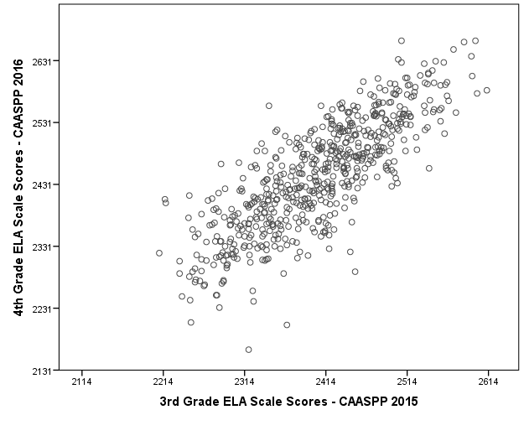
Figure 1
Next, a straight regression line is drawn through those points that best fits all of the plotted values (Figure 2). This regression line represents the predicted score on the grade four CAASPP ELA for each possible grade three CAASPP ELA score.
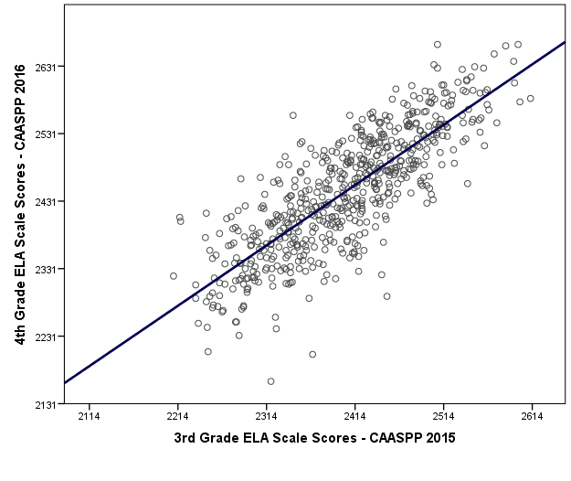
Figure 2
Each plotted value represents a student’s score (Figure 3) that will be compared to the regression line.
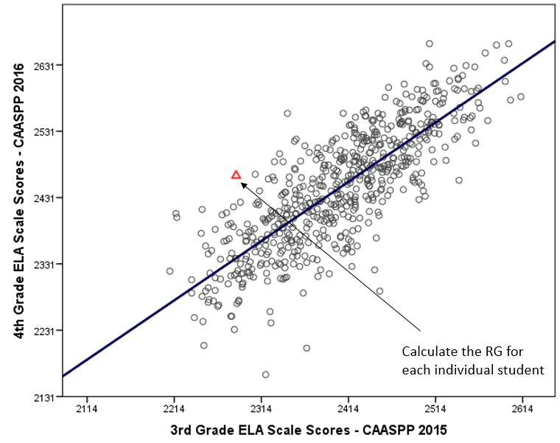
Figure 3
Residual Gain Score = Observed Grade 4 Score - Expected Grade 4 Score
The residual gain for each student is calculated from the difference of a student’s actual score and their predicted score (Figure 4). In this example, an observed score of 2480 would have a residual gain score of +100 because it is 100 points above the predicted score of 2380. A positive residual gain score indicates that a student met and/or exceeded their growth prediction.
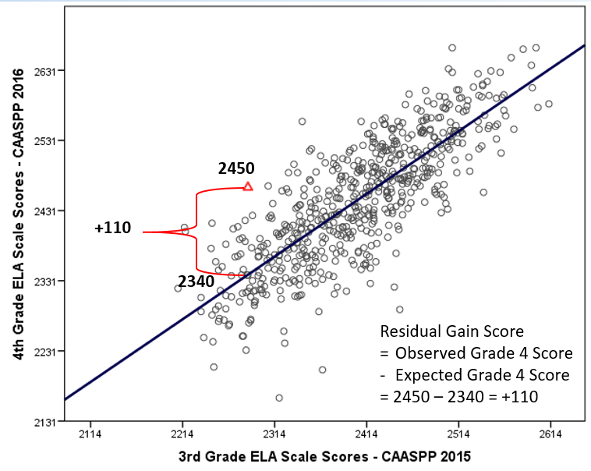
Figure 4

Comparison Among Models
In February 2018, the “Educational Testing Service Memorandum: California Growth Model Study Results” report compared the three models using the test data from the 2015 and 2016 CAASPP administrations of the. All three models were compared against three criteria discussed at the January 2017 SBE meeting: (1) strength or relationship with background characteristics, (2) sensitivity to school configuration and assessment content area, and (3) statistical precision. The Residual Gain growth model best fit the SBE’s stated expectations for a growth model to be included in California’s accountability system.
When looking at the strength of relationships of each model with background characteristics, the Conditional Percentile Rank of the Gain performed the poorest of all three models. The CDTM was the most sensitive to school configuration and assessment content areas (ELA and mathematics) and had the least statistical precision. In the end, the Residual Gain model had the most promising results from the evaluation of these statistical attributes (see Table 1).
Table 1 (Note: the “X” indicates the growth measure performed the poorest of the three modes)
Criteria | CDTM | CPR | RG
Strength or relationship with background characteristics | Blank | X | Blank
Sensitivity to school configuration and assessment content area | X | Blank | Blank
Statistical precision | X | Blank | Blank
The CDE’s TDG also evaluated all three models and recommended the Residual Gain model for inclusion in the accountability model.

Preparations for the July 2018 SBE Meeting
Following the SBE selection of a student-level growth model in May, the TDG will meet in June to discuss any possible technical refinements that should be made to the model to best fit California’s accountability system. Any refinement recommendations will be presented to multiple stakeholder groups for feedback, such as the Local Control Funding Formula stakeholder group, prior to it being brought for consideration by the SBE at the July 2018 meeting.

Recommendation
The CDE recommends that the SBE approve the Residual Gain model for further exploration and direct CDE staff to bring additional information on the growth model for consideration by the SBE at the July 2018 meeting.

Attachment 2

Proposed One-Year Graduation Rate for Schools with Dashboard Alternative School Status
At the March 2017 State Board of Education (SBE) Meeting, the discussion regarding how to best evaluate alternative schools began with a presentation by three of the California Advisory Task Force on Alternative Schools members: Jorge Ruiz de Velasco, Associate Director John W. Garner Center at Stanford University; Roger Rice, Deputy Superintendent, Student Services, Ventura County Office of Education; and Elsbeth Prigmore, Principal at Pioneer Continuation High School, Shasta Union High School District. They presented on the unique challenges that students at alternative schools face on a daily basis. They also provide information on the learning and support strategies that schools implement to increase the success of their students, based on the most recent research available.
In July 2017, the SBE approved criteria for schools to apply for Dashboard Alternative School Status (DASS). While DASS schools did not receive performance levels on the California School Dashboard (Dashboard) in the spring and fall of 2017, they will receive a Dashboard report beginning in 2018. For the 2018 Dashboard, DASS schools will be held accountable for meeting all of the same state indicators that are currently reported in the Dashboard, although modified methods will be used (when appropriate) to more fairly evaluate the success and progress of alternative schools that serve high-risk students. Additionally, LEAs will be held accountable for DASS schools in their Dashboard report.
Additionally, the California Department of Education (CDE) provided an overview of the work with the California Advisory Task Force on Alternative Schools, a joint project with the John W. Gardner Center at Stanford University under the leadership of Jorge Ruiz de Velasco, supported with a grant from the Stuart Foundation, on identifying modified measures for DASS schools. To facilitate the work of the Alternative Schools Task Force, three subcommittees were formed: (1) Modified Academic Indicators, (2) Local Indicators of Student Progress, and (3) Emerging Best Practices. The Modified Academic Indicators subcommittee was tasked with developing modified measures for DASS schools, which includes a one-year graduation rate for the Graduate Rate Indicator.
The subcommittee made the decision to begin with developing a modified method for the graduation rate indicator because most students who enroll at DASS schools are not on track to graduate within four years after entering grade nine. Therefore, producing a four-year cohort graduation rate for DASS schools does not fairly evaluate the school’s impact on their students. The subcommittee reviewed numerous simulation results using the one-year graduation rate over the course of five meetings. At its March 2018 meeting, it reviewed additional simulations and recommended the following methodology:
- First, the subcommittee felt it was important to hold as many DASS schools accountable as possible. Because so many DASS schools have small enrollments, the subcommittee recommended an n-size of 15.
- Second, DASS schools should only be held accountable for students who are enrolled long enough for the schools to have an impact on student outcomes. Therefore, minimum enrollment requirements are being recommended.
  - Most students are required to be enrolled at the same DASS school for 90 days without a gap of enrollment of more than 30 consecutive calendar days. (Note: calendar days includes holidays and weekends.)
  - Adults, foster youths, and students who receive specialized services who graduate must be enrolled at least 30 consecutive calendar days.
  - Summer graduates (those who graduate between July 1 and August 15) do not have a minimum enrollment requirement.
- Third, summer graduates should be counted in the prior year’s graduation rates, as is done for non-DASS schools. For example, if a student graduated on July 15, 2017, that student would be included in the graduating class of 2017. Subcommittee members indicated that assigning summer graduates for DASS vs. non-DASS schools should not be treated differently. It may also lead to students enrolled in summer school to be counted as a non-graduate in one academic year and as a graduate in the following academic year. As a result, two academic years were established and any student meeting the criteria and enrollment requirements is considered for inclusion in the one-year graduation rate. The two academic years are:
  - Non-graduates: July 1 through June 30
  - Graduates: August 16 through August 15
June 30, 2017
July 1, 2016
August 15, 2017
August 16, 2016
Academic Year

Academic Year for Graduates

Stakeholder Feedback
In April 2018, the TDG reviewed the proposed methodology and determined that the approach to calculating the one-year graduation rate was statically sound. However, the TDG expressed concerns about the proposal to reduce the n-size from 30 to 15. They appreciated the Alternative Schools Task Force desire to give up some accuracy in order to increase the number of DASS schools that receive a Dashboard report. However, the TDG indicated they could only support the n-size of 15 if it was applied to all state indicators. Otherwise, the n-size should remain at 30. The CDE will bring this issue to the May 2018 Alternative Schools Task Force meeting for discussion and bring it back to the SBE for consideration at the July 2018 SBE meeting.
In addition, the CDE has obtained feedback on the proposed methodology for calculating one-year graduation rates for DASS schools from the following stakeholder groups:
- The Advisory Commission on Special Education
- The Local Control Funding Formula Stakeholder Group
- The California Practitioners Advisory Group
- The Capital Regional Assessment Network
- Reaching At-Promise Students Association Webinar, which included the participation of accountability coordinators.
Some stakeholder group members voiced concern that the implementation of the one-year graduation rate may produce the unintended consequence of more students being transferred to DASS schools, and that students with disabilities may be at particular risk. The CDE is committed to monitoring the overall school enrollment of DASS schools, as well as monitoring the enrollment of particular student groups, to identify any unintended consequences as a result of the implementation of the one-year graduation rate. If any concerns are identified, the CDE will bring it to the SBE for consideration.
The CDE is requesting that the SBE approve the proposed methodology and the n-size of 15 for the one-year graduation rate for DASS schools. Following SBE approval, the CDE will consult with the TDG to establish cut scores for Status and Change and to develop options for the best approach for incorporating the DASS graduation rates at the local educational agency level. (Note: As with all other indicators, the one-year graduation data for DASS charter schools will not be included in the authorizing districts Dashboard results.) The CDE will seek feedback from stakeholder groups regarding the proposed Status and Change cut scores prior to it being brought for consideration by the SBE at the September 2018 meeting. In addition, the CDE will begin communicating with DASS schools regarding the implementation of the one-year graduation rate.

Attachment 3

California School Dashboard Educational Outreach Activities

Table 1. California Department of Education Policy Work Group Meetings
Date | Title | Estimated Number of Attendees | Description
March 13, 2018 | English Learner Progress Indicator (ELPI) Work Group | 8 | Discussed possible options for incorporating the English Language Proficiency Assessments for California (ELPAC) into the ELPI.
March 23, 2018 | California Advisory Task Force on Alternative Schools: State Indicator Subcommittee | 18 | Shared new simulations on the one-year graduation rate and sought member feedback on: (1) most appropriate option; and (2) proposed Status and Change cut scores for the one-year graduation rate.
April 19, 2018 | Technical Design Group (TDG) Meeting | 7 | Reviewed simulation data on the student-level growth model, the one-year graduation rate (using methodology recommended by the California Advisory Task Force on Alternative Schools), and the incorporation of the participation rate into the Academic Indicator.

Table 2. In-person Meetings/Conferences
Date | Location | Title | Estimated Number of Attendees | Description
March 16, 2018 | Sacramento | State and Federal Programs Director Meeting | 100 | Presented the State Board of Education February 2018 Information Memorandum on the student-level growth model.
March 17, 2018 | San Francisco | Migrant Parent Conference | 12 | Presented an overview of the California School Dashboard (Dashboard) to Spanish speaking conference participants.
March 21, 2018 | Sacramento | Regional Assessment Network Meeting | 20 | Provided an update on proposed revisions to the Every Student Succeeds Act (ESSA) State Plan, the incorporation of the participation rate into the Academic Indicator, and proposed revisions to the 2018 Dashboard.
March 22, 2018 | Sacramento | Senate Budget and Fiscal Review Subcommittee No. 1 | 40 | Provided an update on the implementation of the Local Control Funding Formula (LCFF), including an update on the implementation of the Dashboard.
March 23, 2018 | Lakeport | Professional Development Day | 60 | Provided an update to Lake County Office of Education staff and local educational agencies regarding changes to Dashboard and California Longitudinal Pupil Achievement Data System (CALPADS) data.
March 26, 2018 | Merced | Merced County Office of Education | 45 | Provided an update to Merced County Office of Education and local district staff on the Dashboard and ESSA State Plan.
March 26, 2018 | Merced | Merced County Office of Education Annual Spring School Board Meeting | 80 | Presented to Merced County Office of Education School Board members and local school board of education members and staff on updates to the Dashboard.
March 28, 2018 | Sacramento | California Association for Bilingual Educators 2018 Conference | 20 | Provided an overview of the Dashboard and inclusion of English learners as a key student group in each state indicator as well as an overview of the ELPI.
March 29, 2018 | Sacramento | ESSA Stakeholder Group Meeting | 80 | Provided an overview of the proposed changes to the accountability sections of the ESSA State Plan and impact on the Dashboard.
April 4, 2018 | Sacramento | Assembly Education and Senate Education Joint Information Hearing: California System of Accountability and Continuous Improvement | 45 | Provided legislators an overview of the system of continuous improvement and an update on the Dashboard.
April 10, 2018 | Sacramento | Assembly Budget Subcommittee No. 2 on Education Finance | 50 | Provided an overview of the implementation of the LCFF and the implementation and budget proposal for user interface updates to the Dashboard.
April 11, 2018 | Sacramento | Promoting Authentic College, Career, and Civic Readiness Assessment Systems (PACCCRAS) Meeting | 40 | Reviewed upcoming career measures being incorporated in the College/Career Indicator (CCI) for 2018.
April 18, 2018 | Sacramento | Advisory Commission on Special Education Meeting | 18 | Provided an overview of the CCI and the modified career measures for schools with Dashboard Alternative School Status (DASS); shared the CCI data that districts will report during the 2018–19 school year.
April 20, 2018 | Sacramento | State and Federal Programs Director Meeting | 100 | Presented options for incorporating the participation rate in the Dashboard.
April 20, 2018 | Sacramento | Capitol Regional Assessment Network Meeting | 40 | Provided update on the student-level growth model; reviewed changes (including modified methods for alternative schools) and implementation timeline for the 2018 Dashboard.
April 23, 2018 | Sacramento | Local Control Funding Formula Stakeholder Meeting | 10 | Provided update on the student-level growth model; reviewed changes (including modified methods for alternative schools) and implementation timeline for the 2018 Dashboard.
April 26, 2018 | Sacramento | California Practitioners Advisory Group Meeting | 40 | Presented on the one-year graduation rate, student-level growth model, and ESSA Waiver Proposed for the ELPI.

Table 3. Webinars
Date | Title | Estimated Number of Attendees | Description
April 17, 2018 | California Longitudinal Pupil Achievement Data System Information Meeting | 730 | Provided CALPADS administrators an update on accountability and the data elements that are planned for inclusion in the 2018 Dashboard.
April 27, 2018 | Reaching At-Promise Students Association Webinar | In progress | Provided an update on modified methods proposed for DASS schools, including modified career measures for the CCI and a one-year graduation rate.

