California Department of Education
Executive Office
SBE-004 (REV. 11/2017)
addendum01-nov18item01

ITEM ADDENDUM
DATE: November 7, 2018
TO: MEMBERS, State Board of Education
FROM: KAREN STAPF WALTERS, Executive Director, California State Board of Education
SUBJECT: Item 1 – 2019-2020 State Board of Education Student Member: Recommendation of Three Finalists for Submission to the Governor for Consideration and Appointment.

Summary of Key Issues
The State Board of Education Screening Committee (consisting of Members Burr (Chair), Holaday, Ortiz-Licon, and Cardenas) recommends that the State Board of Education approve three 2019-20 student member finalists for submission to the Governor, as indicated in Attachment 1.

Attachment(s)
Attachment 1: Recommended Finalists for the 2019-20 Student Member of the Board for the Governor’s Consideration and Appointment (2 Pages)

Attachment 1

STATE OF CALIFORNIA
EDMUND G. BROWN JR., Governor

CALIFORNIA STATE BOARD OF EDUCATION

1430 N Street, Suite 5111
Sacramento, CA 95814
Phone: 916-319-0827
Fax: 916-319-0175
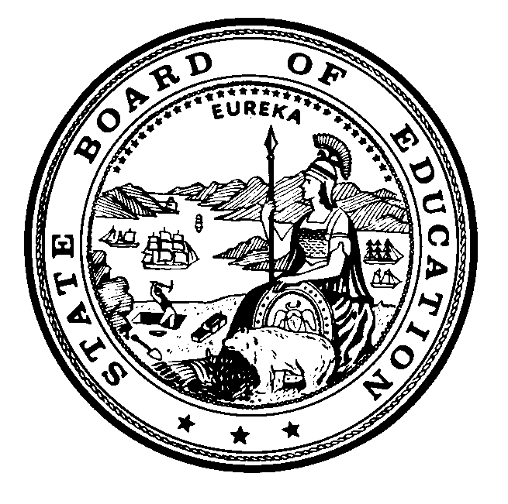

November 7, 2018
TO: Members, State Board of Education
FROM: Sue Burr, Chair, and Members of Screening Committee of the State Board of Education
RE: Recommended Finalists for the 2019-2020 Student Member of the Board for the Governor’s Consideration and Appointment
The State Board of Education (SBE) Screening Committee met on Wednesday, October 17, 2018 to review the applications that were submitted for consideration of the 2019-2020 Student Member of the Board, and selected 12 semi-finalists. The semi-finalists have attended the 2018 Student Advisory Board on Education (SABE) conference beginning on November 5, where student delegates listened to presentations made by the semi-finalists, and then voted to select six candidates.
On Wednesday, November 7, 2018, the SBE Screening Committee interviewed the six candidates, and identified three finalists for consideration by the Board. If approved, the names of these individuals will be submitted to the Governor’s Office for the Governor’s review and consideration. He will appoint one of them as the 2019-2020 Student Member of the Board.
We wish to thank all the students who made the effort to apply, and would like to encourage them to continue offering their impressive abilities to local, regional, or other state activities.
Students who are being recommended as finalists to the State Board of Education by the Screening Committee of the State Board of Education are provided in alphabetical order below:
- Olivia Ang-Olson, C.K. McClatchy Senior High School, within the Sacramento City Unified School District, Sacramento County
- Udayanti Mukherjee, Dublin High School, within the Dublin Unified School District, Alameda County
- Brenna Pangelinan, Eastlake High School, within the Sweetwater Union High School District, San Diego County
In addition to the finalists named above, the following students were identified as candidates for the 2019-2020 Student Member of the Board:
- Hanwul Choi, South Pasadena High School, within the South Pasadena Unified School District, Los Angeles County
- Angel Jimenez, Mountain View High School, within the El Monte Union High School District, Los Angeles County
- Wudase Yigletu, Oxford Academy, within the Anaheim Union High School District, Orange County
The following students were also identified as semi-finalists for the 2019-2020 Student Member of the Board:
- Isaiah Colmenero, Gary and Jerri-Ann Jacobs High Tech High, within the San Diego Unified School District, San Diego County
- Norma Garcia, Bright Star Secondary Charter Academy, within the Los Angeles Unified School District, Los Angeles County
- Allison Gray, Salinas High School, within the Salinas Union High School District, Monterey County
- Cloe Moreno, High Tech High, within the San Diego Unified School District, San Diego County
- Mariam Mustafa, Irvington High School, within the Fremont Unified School District, Alameda County
- Naina Singh, Arthur A. Benjamin Health Professions High School, within the Sacramento City Unified School District, Sacramento County

