California Department of Education
Executive Office
SBE-003 (REV. 11/2017)
pptb-adad-nov18item04

California State Board of Education
November 2018 Agenda
Item #09

Subject
English Language Proficiency Assessments for California: Approval of the Recommended Summative English Language Proficiency Assessments for California Threshold Scores.

Type of Action
Action, Information

Summary of the Issue(s)
The California Department of Education (CDE) is seeking approval of the operational Summative English Language Proficiency Assessments for California (ELPAC) recommended threshold scores for the 2018–19 administration and beyond. These are revisions to the 2017–18 threshold scores approved by the State Board of Education (SBE) in November 2017 and that were in effect for the 2017–18 administration of the Summative ELPAC. These changes are based on information from two studies of the Summative ELPAC data that were summarized in the October 2018 Information Memorandum to the SBE.

Recommendation
The CDE recommends that the SBE approve the State Superintendent of Public Instruction’s (State Superintendent) Proposed Overall and Composite Threshold Scores beginning with the 2018–19 Summative ELPAC (Attachment 1).

Brief History of Key Issues
In November 2017, the SBE adopted Summative ELPAC threshold scores established through an ELPAC standard setting workshop. Those threshold scores provided the basis for the ELPAC Threshold Score Validation Study Final Report (Attachment 2) and the Report on Supplemental Empirical Analyses of the ELPAC (Attachment 3) described in the October 2018 Memorandum.

Results of the Validation Study and the Empirical Analyses
In the Threshold Score Validation Study, teacher judgments of students’ English language development were collected and compared to student performance on the Summative ELPAC. Select teachers evaluated the English language development of their students by classifying them on the basis of the ELPAC general performance level descriptors. Data was collected approximately six months into the 2017–18 school year and prior to the administration of the 2017–18 Summative ELPAC. In the final analysis, 1,521 teachers and 11,128 students from 154 local educational agencies (LEAs) across California were included. The student sample characteristics were representative of the 2017–18 operational Summative ELPAC test-taker population.
Supplemental empirical analyses, performed by the California Comprehensive Center at WestEd (CA CC), examined the relationship of over 511,000 students’ scores from the 2017–18 Summative ELPAC matched to grades three through eight students’ performance on the spring 2017–18 California Assessment of Student Performance and Progress (CAASPP) English language arts/literacy (ELA) summative assessment. The analyses provided an evaluation of the relationship between English language proficiency score ranges and levels and content achievement score ranges and levels.
In general, both the validation study and supplemental empirical analyses suggest that increasing the threshold scores, particularly where ELPAC level 3 ends and level 4 begins, would set the ELPAC level 4 threshold to more closely approximate the performance level estimations given by teachers and the achievement distribution of the English only students on the CAASPP ELA assessment.

Proposed Final Summative ELPAC Threshold Scores
The CDE, considering the findings of Educational Testing Service (ETS) and the CA CC, is recommending:
- Change the grade span threshold scores to grade-specific threshold scores for grades three through eight
- Adjust the threshold scores, as appropriate, at each grade level
In general, the goal was to make minor changes to the threshold scores in order to honor the intent of the standard setting panels’ work while also taking into consideration this new data. With the exception of grades one and two, most of the threshold scores were changed by two or fewer raw score points.
In grades one and two, the standard setting panelists recommended threshold scores that yielded much greater proportions of students scoring in level 4 than the resulting proportions from the teachers participating in the threshold score validation study. Therefore, a slightly larger adjustment of three raw score points was made at grades one and two.
Attachment 1 provides the State Superintendent’s recommended Summative ELPAC threshold scores across the eleven grades/grade spans by overall scale score, oral language scale score, and written language scale score. The recommendations in Attachment 1 were based on the 2017–18 threshold scores, the results of the threshold study, and the CA CC empirical analyses. The adjustments have been reviewed by members of the ELPAC Technical Advisory Group. Additionally, Californians Together, the California Association for Bilingual Education, and members of the Statewide Assessment Stakeholders were provided a briefing on these recommended changes.
Once approved, these proposed final threshold scores will be implemented starting with the 2018–19 administration. The outcome of this board action will not affect the performance levels for students who were administered the 2017–18 Summative ELPAC, and the CDE will not be reissuing student score reports. Pending approval of the recommendations, the CDE would produce a crosswalk to show the changes between the 2017–18 threshold scores and the approved 2018–19 threshold scores to assist LEAs in making reclassification decisions. Because the reporting scale has not changed, LEAs will be able to compare 2017–18 scale scores with 2018–19 scale scores. However, performance levels will not be comparable.

Next Steps
If the SBE approves the attached threshold score changes, the CDE will notify LEA Superintendents and charter school administrators of those changes to the 2018–19 threshold scores.
In addition, the CDE has begun recruitment of teachers to participate in the Initial ELPAC threshold validation review process this fall. The CDE is anticipating collecting surveys from teachers for approximately 1,500 students of which 50 percent will be English learners and 50 percent will be initial fluent English proficient (IFEP). Teachers will use the approved general performance level descriptors to agree or disagree with the classification of their students as either EL or IFEP. After surveys are collected, an analysis of the responses will be conducted by ETS. The CDE will utilize the results from the analysis to inform a recommendation to either maintain or revise the Initial ELPAC threshold scores for the 2019–20 school year. The recommendation related to the Initial ELPAC threshold scores is anticipated to be brought before the SBE in March 2019.

Summary of Previous State Board of Education Discussion and Action
In October 2018, an Information Memorandum provided the SBE with a summary of the Summative ELPAC Threshold Score Validation Study and Supplemental Empirical Analyses (https://www.cde.ca.gov/be/pn/im/infomemooct2018.asp).
In July 2018, the SBE approved amended ELPAC regulations (https://www.cde.ca.gov/be/ag/ag/yr18/documents/jul18item04.docx).
In June 2018, an Information Memorandum provided the SBE with a summary of the main ELPAC activities and developments, including the Initial ELPAC Student Score Report (https://www.cde.ca.gov/be/pn/im/documents/memo-pptb-adad-jun18item02.docx).
In May 2018, the SBE approved the operational threshold scores and composite weights for the Initial ELPAC (https://www.cde.ca.gov/be/ag/ag/yr18/documents/may18item04.docx).
In April 2018, an Information Memorandum provided the SBE with a review of the proposed Initial ELPAC threshold scores and composite weights (https://www.cde.ca.gov/be/pn/im/documents/memo-pptb-adad-apr18item01.docx).
In March 2018, the SBE approved revisions to the Initial ELPAC blueprints (https://www.cde.ca.gov/be/ag/ag/yr18/documents/mar18item09.docx).
In February 2018, an Information Memorandum provided the SBE with an update on the Initial ELPAC standard setting process and provide a review of the revisions to the Initial ELPAC blueprints (https://www.cde.ca.gov/be/pn/im/documents/memo-pptb-adad-feb18item01.docx).
In January 2018, the SBE approved general performance level descriptors (PLDs) for the Initial ELPAC (https://www.cde.ca.gov/be/ag/ag/yr18/documents/jan18item09.docx).
In December 2017, an Information Memorandum provided the SBE with an update on the development of the ELPAC, including a detailed timeline (https://www.cde.ca.gov/be/pn/im/documents/memo-pptb-adad-dec17item03.docx).
In November 2017, the SBE approved the operational Summative ELPAC threshold scores, composite weights, and LEA apportionment rates (https://www.cde.ca.gov/be/ag/ag/yr17/documents/nov17item08.doc).
In October 2017, an Information Memorandum provided the SBE with the standard setting and domain weighting process (https://www.cde.ca.gov/be/pn/im/documents/memo-pptb-adad-oct17item01.doc).

Fiscal Analysis (as appropriate)
The 2017–18 Budget Act includes $13.8 million for the ELPAC ETS contract activities, which includes standard setting, as well as the threshold score validation study.

Attachment(s)
- Attachment 1: State Superintendent of Public Instruction’s Proposed Overall and Composite Threshold Scores (3 Pages)
- Attachment 2: Summative English Language Proficiency Assessments for California Threshold Score Validation Study Final Report (14 Pages)
- Attachment 3: Report on Supplemental Empirical Analyses of the English Language Proficiency Assessments for California (11 Pages)

Attachment 1

State Superintendent of Public Instruction’s Proposed Overall and Composite Threshold Scores

Overall Score Kindergarten through Grade Twelve
Table 1. State Superintendent of Public Instruction’s (State Superintendent) Recommendations for the Proposed Thresholds for Performance Levels on the Summative English Language Proficiency Assessments for California (ELPAC), Overall Score.

Oral/ Written  Weight | Grade | Level 1  % of Students | Level 2  Scale Threshold Score | Level 2  % of Students | Level 3  Scale Threshold Score | Level 3  % of Students | Level 4  Scale Threshold Score | Level 4  % of Students
70/30 | K | 10 | 1374 | 33 | 1422 | 40 | 1474 | 17
50/50 | 1 | 11 | 1411 | 33 | 1455 | 41 | 1507 | 15
50/50 | 2 | 8 | 1424 | 29 | 1471 | 47 | 1532 | 16
50/50 | 3 | 14 | 1448 | 34 | 1488 | 40 | 1535 | 12
50/50 | 4 | 13 | 1459 | 30 | 1499 | 43 | 1549 | 14
50/50 | 5 | 13 | 1467 | 33 | 1514 | 37 | 1560 | 17
50/50 | 6 | 15 | 1475 | 31 | 1517 | 39 | 1567 | 15
50/50 | 7 | 17 | 1481 | 33 | 1527 | 35 | 1576 | 15
50/50 | 8 | 18 | 1486 | 32 | 1534 | 36 | 1590 | 14
50/50 | 9–10 | 26 | 1493 | 29 | 1545 | 29 | 1606 | 16
50/50 | 11–12 | 27 | 1500 | 32 | 1555 | 27 | 1615 | 14

Oral Composite Score Kindergarten through Grade Twelve
Table 2. State Superintendent’s Recommendations for the Proposed Thresholds for Performance Levels on the Summative ELPAC, Oral Composite Score.
Grade/Grade Span (Weight) | Level 2 | Level 3 | Level 4
K (70/30) | 1386 | 1427 | 1478
1 (50/50) | 1408 | 1451 | 1493
2 (50/50) | 1414 | 1460 | 1510
3 (50/50) | 1435 | 1466 | 1512
4 (50/50) | 1439 | 1472 | 1522
5 (50/50) | 1447 | 1477 | 1533
6 (50/50) | 1450 | 1484 | 1542
7 (50/50) | 1456 | 1498 | 1554
8 (50/50) | 1461 | 1505 | 1569
9–10 (50/50) | 1465 | 1512 | 1579
11–12 (50/50) | 1470 | 1514 | 1583

Written Composite Score Kindergarten through Grade Twelve
Table 3. State Superintendent’s Recommendations for the Proposed Thresholds for Performance Levels on the Summative ELPAC, Written Composite Score.
Grade/Grade Span (Weight) | Level 2 | Level 3 | Level 4
K (70/30) | 1346 | 1410 | 1463
1 (50/50) | 1414 | 1459 | 1520
2 (50/50) | 1433 | 1481 | 1554
3 (50/50) | 1461 | 1509 | 1557
4 (50/50) | 1478 | 1525 | 1575
5 (50/50) | 1487 | 1550 | 1587
6 (50/50) | 1499 | 1550 | 1592
7 (50/50) | 1505 | 1556 | 1598
8 (50/50) | 1510 | 1562 | 1610
9–10 (50/50) | 1520 | 1578 | 1632
11–12 (50/50) | 1529 | 1595 | 1646

Attachment 2

Summative English Language Proficiency Assessments for California Threshold Score Validation Study Final Report

Background
The Summative English Language Proficiency Assessments for California (ELPAC) field test administration was conducted in spring 2016–17, and the first operational administration was conducted in spring 2017–18. The assessments, given in paper and pencil, were administered at seven grades or grade spans (kindergarten [K], one, two, three through five, six through eight, nine and ten, and eleven and twelve) and assessed four domains (Listening, Speaking, Reading, and Writing). The task types and domain descriptions are described on the California Department of Education (CDE) ELPAC web page. The score-reporting hierarchy for the Summative ELPAC was approved in September 2017 by the State Board of Education (SBE); four performance levels are reported for three composite scores: Oral Language, Written Language, and Overall Score.
To develop threshold-score recommendations aligned to the score-reporting hierarchy, Educational Testing Service (ETS) conducted standard-setting workshops in Sacramento, California, in October 2017. All four domains and the overall score were considered in the process of standard setting. Teachers who are familiar with the 2012 California English Language Development (ELD) Standards and familiar with the students taking the Summative ELPAC participated in a four-day workshop, during which they reviewed and discussed the items on the test, the general and specific performance level descriptors (PLDs), and the knowledge and skills measured by the ELPAC that differentiate student performance levels. Teachers recommended threshold scores for all grades and grade spans. The SBE approved threshold scores on November 8, 2017.

Overview
At the request of the CDE, ETS conducted a threshold score validation study to provide additional validity evidence of the Summative ELPAC threshold scores. The process that was implemented is known as the Contrasting Groups Method. In this method, teachers familiar with the 2012 California ELD Standards and with the students in their classroom who are classified as English learners (ELs) were asked to make judgments about the students’ performance levels based on the approved ELPAC PLDs. Using data from the operational Summative ELPAC, student performance levels based on the threshold scores were compared to performance levels based on the teacher judgments. Results from the validation study will allow the CDE to consider information across standard-setting methods, as described herein.
The purpose of conducting the threshold score validation study was to evaluate the degree to which the threshold scores and performance levels of the Summative ELPAC consistently distinguish between levels of students’ English language proficiency, based on teacher ratings from a multistep process (standard setting in October 2017 and the validation study). Implementing a multistep process offers increased confidence in decisions utilizing threshold scores based on ELPAC results. Because the classification of the proficiency levels for students who are EL entails relatively high-stakes decisions for individual students’ academic paths, school program funding, and resource plans, it is crucial to cross-validate the threshold scores for each proficiency level to the extent possible.

Contrasting Groups Method
Using a methodology known as Contrasting Groups, teacher judgments of students’ performance levels were collected. At a point approximately seven months into the school year, teachers familiar with students in their classroom were asked to classify students according to the approved ELPAC general PLDs and ELPAC domain and grade/grade-span–specific PLDs. The Contrasting Groups Method requires a large number of teacher ratings of students from a representative sample of local educational agencies (LEAs). It is also desirable to have ratings of students with a wide range of performance and to require a reasonable number of student ratings from each teacher.
The judgment of the teachers was based on their knowledge and understanding of their own students’ levels of proficiency, relative to the California-approved final PLDs. Note that California-approved PLDs were the starting point for this contrasting groups study, thereby maintaining the meaning of the performance levels from the standard-setting studies for consistency and standardization. A statistical analysis was conducted comparing students’ ELPAC scores to teachers’ ratings.
The results of the statistical analyses and teacher ratings can be used in concert with other information, including the results from the panel-based standard setting and post-standard-setting considerations and the impact of threshold scores on the ELPAC score distributions.

Description of Sample of Participating Teachers and Students
Recruitment of LEAs was done in concert with input from the CDE and the ELPAC Technical Advisory Group (TAG). The goals of the teacher recruitment were: (1) to obtain teacher ratings on ELs across the state who represent the full range of English language proficiency levels and (2) to select teachers who had not administered the operational ELPAC to their students in order to eliminate potential bias in their ratings.
In the final analysis, 1,521 teacher produced ratings for 11,128 students who had matched summative ELPAC scores. There were 429 schools nested within 154 LEAs, which included school districts and independent charter districts across the state. Figure 1 presents school size, represented by total enrollment, for all California schools (state sample) and for the schools in the study (study sample). The results show that the study sample includes a reasonable distribution of school sizes. Additional analyses compared student characteristics of the participating schools to the populations of schools in California; results indicate that the participating schools have a similar composition/distribution of students, as shown in Tables 2 through 8.
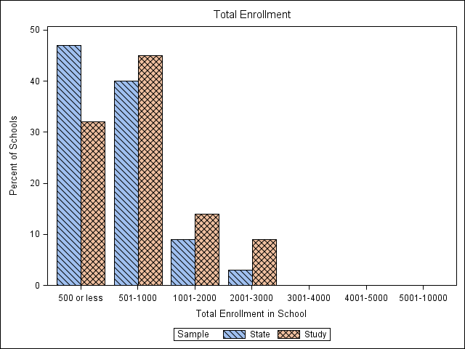
Figure 1. Total enrollment for California (state) schools and participating schools (study)
The percentages of students who are ELs from each geographic region in California (North, Central, and South) and for the study sample are presented in Table 1. The study sample has the highest percentage of students in the southern region, as is the case in the study sample.
Table 1. Percent of Students by Geographic Region: ELs in California and in Study Sample
Region | ELs in California (%) | Study Sample (%)
North | 8 | 9
Central | 29 | 17
South | 63 | 74
Table 2 through Table 8 show the comparison of student characteristics in the study sample to student characteristics of ELPAC test takers based on the 2017–18 operational ELPAC test-taker population (ELPAC test takers). The percent of students in each performance level based on ELPAC Overall scores shows that the sample is representative of the ELPAC test takers, the mean ELPAC overall scale scores for the two samples are comparable, and the standard deviation for the study sample is smaller, as expected. The performance of students based on ELPAC Overall scores provides evidence that an important criterion was met. The study sample includes a reasonable distribution of students in each of four performance levels (Level 1 through Level 4).
Student characteristics are shown for the study sample and the ELPAC test takers, specifically, gender, economic status, students with disability, English Language Acquisition Status, and home language. Recruiting efforts for the study focused on students who are EL. Students who were classified as Initial Fluent English Proficient (IFEP) or Reclassified Fluent English Proficient (RFEP), as well as students with disabilities (SWD), were not part of the target sample for the study. Overall, the student sample characteristics were representative of the 2017–18 operational ELPAC test-taker population for those targeted characteristics.
Table 2. Student Characteristics of Study Sample and ELPAC Test Takers for Kindergarten
Kindergarten | Study Sample | ELPAC Test Takers
N Count | 843 | 176,668
Performance Based on ELPAC Overall Scores: Percent in Level 1 | 12.34 | 12.84
Performance Based on ELPAC Overall Scores: Percent in Level 2 | 23.25 | 24.06
Performance Based on ELPAC Overall Scores: Percent in Level 3 | 24.32 | 27.28
Performance Based on ELPAC Overall Scores: Percent in Level 4 | 40.09 | 35.81
Mean ELPAC Overall Scale Scores | 1433.15 | 1429.64
Standard Deviation (SD) of ELPAC Overall Scale Scores | 55.03 | 64.60
Percent Male | 49.47 | 51.47
Percent Female | 50.53 | 48.53
Percent Socio-Economically Disadvantaged (SED) | 78.53 | 77.44
Percent SWD | 4.74 | 8.40
Percent EL | 98.33 | 98.41
Percent IFEP | 0 | 0.08
Percent RFEP | 0 | 0.01
Percent English or American Sign Language Only (EO) | 0.36 | 0.31
Percent To Be Determined (TBD) | 1.31 | 1.19
Percent of Home Language: Spanish | 79.74 | 77.72
Percent of Home Language: Chinese | 2.62 | 3.97
Percent of Home Language: Vietnamese | 0.72 | 2.74
Percent of Home Language: Arabic | 0.83 | 1.38
Percent of Home Language: Filipino | 0.36 | 1.07
Table 3. Student Characteristics of Study Sample and ELPAC Test Takers for Grade One
Grade One | Study Sample | ELPAC Test Takers
N Count | 885 | 136,113
Performance Based on ELPAC Overall Scores: Percent in Level 1 | 8.81 | 13.35
Performance Based on ELPAC Overall Scores: Percent in Level 2 | 13.33 | 14.34
Performance Based on ELPAC Overall Scores: Percent in Level 3 | 29.15 | 28.21
Performance Based on ELPAC Overall Scores: Percent in Level 4 | 48.7 | 44.10
Mean ELPAC Scale Scores | 1473.29 | 1464.14
SD of ELPAC Scale Scores | 58.75 | 65.42
Percent Male | 53.67 | 51.80
Percent Female | 46.33 | 48.20
Percent SED | 85.08 | 81.42
Percent SWD | 7.57 | 9.31
Percent EL | 99.43 | 99.52
Percent IFEP | 0 | 0.06
Percent RFEP | 0 | 0.04
Percent EO | 0.23 | 0.23
Percent TBD | 0.34 | 0.16
Percent of Home Language: Spanish | 86.52 | 79.41
Percent of Home Language: Chinese | 1.13 | 3.83
Percent of Home Language: Vietnamese | 0.91 | 2.32
Percent of Home Language: Arabic | 1.13 | 1.50
Percent of Home Language: Filipino | 0.68 | 1.17
Table 4. Student Characteristics of Study Sample and ELPAC Test Takers for Grade Two
Grade Two | Study Sample | ELPAC Test Takers
N Count | 974 | 119,935
Performance Based on ELPAC Overall Scores: Percent in Level 1 | 6.88 | 6.99
Performance Based on ELPAC Overall Scores: Percent in Level 2 | 11.7 | 11.63
Performance Based on ELPAC Overall Scores: Percent in Level 3 | 34.91 | 34.59
Performance Based on ELPAC Overall Scores: Percent in Level 4 | 46.51 | 46.79
Mean ELPAC Scale Scores | 1486.18 | 1485.57
SD of ELPAC Scale Scores | 51.41 | 59.94
Percent Male | 50.31 | 52.34
Percent Female | 49.69 | 47.66
Percent SED | 88.6 | 83.46
Percent SWD | 9.45 | 11.27
Percent EL | 99.69 | 99.53
Percent IFEP | 0 | 0.04
Percent RFEP | 0.1 | 0.07
Percent EO | 0.1 | 0.21
Percent TBD | 0.1 | 0.14
Percent of Home Language: Spanish | 95.16 | 81.01
Percent of Home Language: Chinese | 0.21 | 3.29
Percent of Home Language: Vietnamese | 0.21 | 2.18
Percent of Home Language: Arabic | 0.31 | 1.54
Percent of Home Language: Filipino | 0.51 | 1.32
Table 5. Student Characteristics of Study Sample and ELPAC Test Takers for Grades Three to Five
Grades Three through Five | Study Sample | ELPAC Test Takers
N Count | 2613 | 296,567
Performance Based on ELPAC Overall Scores: Percent in Level 1 | 13.16 | 14.71
Performance Based on ELPAC Overall Scores: Percent in Level 2 | 22.69 | 22.00
Performance Based on ELPAC Overall Scores: Percent in Level 3 | 44.2 | 43.07
Performance Based on ELPAC Overall Scores: Percent in Level 4 | 19.94 | 20.22
Mean ELPAC Scale Scores | 1503.8 | 1500.32
SD of ELPAC Scale Scores | 48.33 | 60.79
Percent Male | 53.58 | 54.08
Percent Female | 46.42 | 45.92
Percent SED | 87.1 | 86.11
Percent SWD | 16.26 | 17.70
Percent EL | 99.77 | 99.44
Percent IFEP | 0 | 0.04
Percent RFEP | 0.11 | 0.16
Percent EO | 0.11 | 0.16
Percent TBD | 0 | 0.19
Percent of Home Language: Spanish | 92.79 | 83.95
Percent of Home Language: Chinese | 0.46 | 2.39
Percent of Home Language: Vietnamese | 0.69 | 1.93
Percent of Home Language: Arabic | 0.96 | 1.45
Percent of Home Language: Filipino | 0.96 | 1.19
Table 6. Student Characteristics of Study Sample and ELPAC Test Takers for Grades Six to Eight
Grades Six through Eight | Study Sample | ELPAC Test Takers
N Count | 2368 | 198,337
Performance Based on ELPAC Overall Scores: Percent in Level 1 | 12.12 | 14.09
Performance Based on ELPAC Overall Scores: Percent in Level 2 | 17.74 | 21.65
Performance Based on ELPAC Overall Scores: Percent in Level 3 | 36.49 | 36.13
Performance Based on ELPAC Overall Scores: Percent in Level 4 | 33.66 | 28.13
Mean ELPAC Scale Scores | 1534.01 | 1521.51
SD of ELPAC Scale Scores | 59.94 | 73.76
Percent Male | 55.49 | 57.16
Percent Female | 44.51 | 42.84
Percent SED | 86.23 | 87.40
Percent SWD | 16.39 | 24.82
Percent EL | 98.81 | 99.07
Percent IFEP | 0.08 | 0.06
Percent RFEP | 0.72 | 0.35
Percent EO | 0.34 | 0.22
Percent TBD | 0.04 | 0.29
Percent of Home Language: Spanish | 86.19 | 84.45
Percent of Home Language: Chinese | 3.68 | 2.45
Percent of Home Language: Vietnamese | 1.65 | 1.77
Percent of Home Language: Arabic | 1.48 | 1.64
Percent of Home Language: Filipino | 1.61 | 1.37
Table 7. Student Characteristics of Study Sample and ELPAC Test Takers for Grades Nine to Ten
Grades Nine and Ten | Study Sample | ELPAC Test Takers
N Count | 1453 | 98,838
Performance Based on ELPAC Overall Scores: Percent in Level 1 | 24.43 | 23.86
Performance Based on ELPAC Overall Scores: Percent in Level 2 | 21.68 | 22.52
Performance Based on ELPAC Overall Scores: Percent in Level 3 | 27.32 | 28.42
Performance Based on ELPAC Overall Scores: Percent in Level 4 | 26.57 | 25.21
Mean ELPAC Scale Scores | 1536.26 | 1529.56
SD of ELPAC Scale Scores | 80.52 | 96.88
Percent Male | 56.85 | 59.11
Percent Female | 43.15 | 40.89
Percent SED | 86.85 | 85.10
Percent SWD | 13.76 | 23.78
Percent EL | 98.69 | 98.64
Percent IFEP | 0.14 | 0.07
Percent RFEP | 0.21 | 0.44
Percent EO | 0.28 | 0.26
Percent TBD | 0.69 | 0.60
Percent of Home Language: Spanish | 79.31 | 82.84
Percent of Home Language: Chinese | 5.54 | 3.08
Percent of Home Language: Vietnamese | 1.73 | 2.12
Percent of Home Language: Arabic | 2.21 | 1.78
Percent of Home Language: Filipino | 0.97 | 1.69
Table 8. Student Characteristics of Study Sample and ELPAC Test Takers for Grades Eleven to Twelve
Grades Eleven and Twelve | Study Sample | ELPAC Test Takers
N Count | 896 | 77,486
Performance Based on ELPAC Overall Scores: Percent in Level 1 | 24 | 22.02
Performance Based on ELPAC Overall Scores: Percent in Level 2 | 21.99 | 21.78
Performance Based on ELPAC Overall Scores: Percent in Level 3 | 32.14 | 33.07
Performance Based on ELPAC Overall Scores: Percent in Level 4 | 21.88 | 23.13
Mean ELPAC Scale Scores | 1535.81 | 1526.02
SD of ELPAC Scale Scores | 81.4 | 110.48
Percent Male | 56.58 | 58.29
Percent Female | 43.42 | 41.71
Percent SED | 87.28 | 83.83
Percent SWD | 12.28 | 25.63
Percent EL | 98.88 | 99.09
Percent IFEP | 0 | 0.07
Percent RFEP | 0.34 | 0.42
Percent EO | 0.22 | 0.25
Percent TBD | 0.56 | 0.17
Percent of Home Language: Spanish | 75.25 | 80.27
Percent of Home Language: Chinese | 8.1 | 3.99
Percent of Home Language: Vietnamese | 2.02 | 2.58
Percent of Home Language: Arabic | 2.02 | 2.01
Percent of Home Language: Filipino | 1.12 | 1.98

Instructions to Participating Teachers
Teachers were provided the domain- and grade-specific PLDs for each of the four domains, and the general PLDs, and asked to become familiar with these documents for their students’ grade level.
Participating teachers received an overview of the ELPAC, the score-reporting hierarchy and how the Overall score is calculated, and a review of the rating form and how to complete the form. Teachers were asked to complete one form per student and to provide the expected overall score performance level.

Analytic Methods

Rater Agreement Analysis
Table 9 through Table 15 show the cross-tabulation of the number of students classified in each of the four ELPAC performance levels based on two methods. Each table presents for a grade or grade-span test, the number of students classified based on the contrasting groups study teacher ratings and based on the Summative ELPAC Threshold Overall Score (ELPAC performance level). The number of students classified as the same level by both methods can be found on the diagonal. For example, for kindergarten, 60 students were classified as Level 1 both by teacher rating and by ELPAC performance level, and 85 students were classified as Level 2 by both methods. Table 16 provides a summary of the agreement by grade and shows the exact agreement and the sum of exact and adjacent agreement between teacher ratings and student performance levels based on ELPAC performance level.
Table 9. Teacher Ratings by ELPAC Performance Levels for Kindergarten
Teacher Rating Level | ELPAC Performance Level 1 | ELPAC Performance Level 2 | ELPAC Performance Level 3 | ELPAC Performance Level 4
1 | 60 | 56 | 28 | 8
2 | 33 | 85 | 76 | 78
3 | 9 | 47 | 73 | 156
4 | 2 | 8 | 28 | 96
Table 10. Teacher Ratings by ELPAC Performance Levels for Grade One
Teacher Rating Level | ELPAC Performance Level 1 | ELPAC Performance Level 2 | ELPAC Performance Level 3 | ELPAC Performance Level 4
1 | 55 | 37 | 34 | 4
2 | 21 | 59 | 123 | 79
3 | 2 | 17 | 80 | 187
4 | 0 | 5 | 21 | 161
Table 11. Teacher Ratings by ELPAC Performance Levels for Grade Two
Teacher Rating Level | ELPAC Performance Level 1 | ELPAC Performance Level 2 | ELPAC Performance Level 3 | ELPAC Performance Level 4
1 | 52 | 39 | 30 | 4
2 | 14 | 67 | 159 | 80
3 | 1 | 8 | 128 | 204
4 | 0 | 0 | 23 | 165
Table 12. Teacher Ratings by ELPAC Performance Levels for Grades Three through Five
Teacher Rating Level | ELPAC Performance Level 1 | ELPAC Performance Level 2 | ELPAC Performance Level 3 | ELPAC Performance Level 4
1 | 203 | 117 | 39 | 5
2 | 109 | 319 | 428 | 89
3 | 29 | 138 | 544 | 271
4 | 3 | 19 | 144 | 156
Table 13. Teacher Ratings by ELPAC Performance Levels for Grades Six through Eight
Teacher Rating Level | ELPAC Performance Level 1 | ELPAC Performance Level 2 | ELPAC Performance Level 3 | ELPAC Performance Level 4
1 | 174 | 74 | 44 | 5
2 | 85 | 187 | 263 | 121
3 | 25 | 137 | 409 | 384
4 | 3 | 22 | 148 | 287
Table 14. Teacher Ratings by ELPAC Performance Levels for Grades Nine and Ten
Teacher Rating Level | ELPAC Performance Level 1 | ELPAC Performance Level 2 | ELPAC Performance Level 3 | ELPAC Performance Level 4
1 | 158 | 29 | 10 | 2
2 | 156 | 126 | 90 | 49
3 | 38 | 130 | 198 | 168
4 | 3 | 30 | 99 | 167
Table 15. Teacher Ratings by ELPAC Performance Levels for Grades Eleven and Twelve
Teacher Rating Level | ELPAC Performance Level 1 | ELPAC Performance Level 2 | ELPAC Performance Level 3 | ELPAC Performance Level 4
1 | 80 | 9 | 6 | 2
2 | 99 | 86 | 82 | 23
3 | 28 | 78 | 142 | 80
4 | 8 | 24 | 58 | 91
Table 16. Percent Agreement Between Teacher Ratings and ELPAC Performance Levels
Grade(s) | Exact Agreement | Exact Plus Adjacent Agreement
K | 37.2% | 84.2%
1 | 40.1% | 86.0%
2 | 42.3% | 88.2%
3–5 | 46.8% | 93.0%
6–8 | 44.6% | 90.7%
9–10 | 44.7% | 90.9%
11–12 | 44.5% | 89.8%

Logistic Regression Analysis
Two variables are used as input in the logistic regression approach: the ELPAC overall scale score and a teacher rating of the student performance level. The ELPAC score is a continuous variable and is used to predict whether students are eligible for reclassification, which is a dichotomous variable, where Level 4 is equal to one and below Level 4 is equal to zero. Using the Statistical Analysis System Proc Logistic, ETS obtained the B0 and B1 estimates for the fitted logistic line. For each grade or grade-span, the scale score where students have a 50 percent chance of being classified as Level 4, based on the fitted logistic line is provided in Table 17. Also provided are the corresponding threshold scores based on the ELPAC Level 4 Threshold Score.
Table 17. Logistic Regression Results
Y^ = B0 + B1 x ELPAC score
Grade(s) | N | B0 (Intercept) | B1 (ELPAC Score) | Threshold Score Based on 50 Percent Chance of Level 4 Classification | ELPAC Level 4 Threshold Score
K | 843 | -27.382 | 0.018 | 1538 | 1444
1 | 885 | -29.093 | 0.019 | 1556 | 1467
2 | 974 | -47.085 | 0.030 | 1549 | 1489
3–5 | 2613 | -37.652 | 0.024 | 1602 | 1539
6–8 | 2368 | -27.737 | 0.017 | 1632 | 1554
9–10 | 1453 | -25.509 | 0.016 | 1646 | 1581
11–12 | 896 | -22.751 | 0.014 | 1661 | 1588

Results
Results from the rater-agreement analysis of the contrasting groups study indicated a trend for most grades for most performance levels. Teacher ratings of expected performance levels were compared to the students’ performance levels based on the 2017–18 threshold scores. The comparison indicated an exact or adjacent agreement rate between 85 percent and 90 percent in kindergarten and grades one and two, and a rate at 90 percent or above for grades three through twelve. This means, for example, where teacher ratings of students indicated a Level 3, exact or adjacent agreement was met if the students’ ELPAC performance level was a Level 2, 3, or 4, based on the ELPAC threshold scores.
For most grades, the difference in performance level classification between the teachers’ ratings of students and the threshold scores shows that teachers who rated the students who are ELs in their classrooms placed their students at a lower performance level than what the ELPAC threshold score would have indicated. If the results from the contrasting groups study were used to set threshold scores, at least some threshold scores would be higher than the current threshold scores.

Summary
The standard-setting workshop conducted in October 2017 resulted in recommendations for threshold scores, which resulted in performance levels for students who took the spring 2016–17 Summative ELPAC field test. Subsequently, a threshold score validation study was conducted, using a Contrasting Groups standard-setting method. Teachers considered the performance of EL students in the classroom and provided expected performance levels for their students. A comparison of these expected performance levels with the levels for those students based on the threshold scores was conducted.

Next Steps
Final analyses based on the 2017–18 ELPAC operational data are underway by the CDE. Considerations of the impact on the students who will be classified into each performance level must be made prior to making recommendations for adjusting the Summative ELPAC threshold scores. Analyses will take into account the score scales and score distributions as well as the four performance levels reported for three composite scores, Oral Language, Written Language, and Overall Score.

Attachment 3

Report on Supplemental Empirical Analyses of the English Language Proficiency Assessments for California
Robert Linquanti, Min Huang, and Eric Crane
California Comprehensive Center at WestEd

Background
The California Department of Education (CDE) conducted the first administration of the English Language Proficiency Assessments for California (ELPAC) in the 2017-18 school year. For that administration, the test developer, the Educational Testing Service (ETS), applied preliminary threshold scores developed in a standard setting process involving teachers reviewing ELPAC field test results. These preliminary threshold scores were approved by the State Board of Education (SBE) in November 2017. At the request of the CDE, ETS conducted a threshold score validation study to provide additional validity evidence of these threshold scores for the Summative ELPAC. In addition, the CDE requested the California Comprehensive Center at WestEd (CA CC) to conduct supplemental analyses to examine how English learners (ELs) perform on the California Assessment of Student Performance and Progress (CAASPP) English language arts/literacy (ELA) disaggregated by their ELPAC performance level. Validation of threshold scores and empirical analyses of ELs’ ELA test performance by English language proficiency test level are widely used by states to support appropriate standard setting and to inform state-level policy discussions on establishing an English-proficient performance standard. This report summarizes the supplemental empirical analyses conducted by the CA CC.
Specifically, these empirical analyses examined the relationship of student test scores and performance levels on the first operational Summative ELPAC to student test scores and performance levels on the 2017-18 CAASPP ELA. Both assessments were administered in spring 2018. The ELPAC is administered in test forms by grade (kindergarten, one, and two) or grade span (three through five, six through eight, nine through ten, and eleven through twelve). The CAASPP is administered by grade in grades three through eight and grade eleven.

Timeline and Data Sources
The CA CC developed and shared an ELPAC-CAASPP supplemental analysis plan with CDE and ETS in May through June 2018. In July, the CDE securely transferred a data file to CA CC for analysis. Specifically, the CDE supplied the CA CC with a matched student-level data file containing: a) 2018 CAASPP ELA assessment data for all students in grades three through eight and grade eleven, including overall scale score and performance level results; and b) 2018 Summative ELPAC assessment data for all ELs in grades three through eight and grade eleven, including scale score and performance level results at the overall, oral and written, and individual (listening, speaking, reading, and writing) domain levels.
The CA CC team conducted the empirical analyses during August, and presented preliminary results to staff from CDE Assessment Development and Administration Division and English Learner Support Division as well as ETS ELPAC contractors on August 24, 2018. The CA CC team conducted further empirical analyses during August through September, and shared results with staff from CDE and ETS on September 7, 2018. In September, the CA CC team also prepared a brief summary of these supplemental analyses for CDE’s October Information Memorandum to the SBE regarding next steps for threshold cut scores and the English-proficient performance standard on the Summative ELPAC.

Analytic Methods
Three analytical methods were undertaken in this supplemental study. These methods, described in Cook, Linquanti, Chinen & Jung (2012), are used by many states to support decision making on setting an optimal English-proficient performance standard on their state English language proficiency (ELP) assessments. They included the following:
- Descriptive box plot analysis examines the distribution of overall scale scores on CAASPP ELA for ELs by each performance level on ELPAC, for each applicable grade level. This analysis also includes the distribution of overall scale scores on CAASPP ELA for reclassified fluent English proficient (RFEP), initially fluent English proficient (IFEP), and monolingual English (English only, or EO) students for comparison. The purpose of the analysis is to identify an ELPAC performance level where a) ELs have an equal likelihood of scoring at or above the CAASPP ELA Level 3 threshold (Standard Met); or b) ELs’ score distribution on CAASPP is very similar to that of EO students statewide.
- Logistic regression analysis estimates the probability of reaching Level 3 (Standard Met) on CAASPP ELA for each ELPAC overall scale score. This approach helps to identify the ELPAC overall scale score range in which ELs have a probability equal to or greater than 50 percent of attaining that standard on the CAASPP ELA.
- Decision consistency analysis analyzes ELPAC and CAASPP proficient-level categorizations and optimizes consistent categorization of ELs at or above the current CAASPP ELA threshold score for Level 3 (Standard Met). The analysis determines the ELPAC overall scale score range that maximizes the amount of agreement between achieving ELPAC proficiency and CAASPP ELA proficiency.

Findings
Distribution of ELs by ELPAC overall performance level
Across grades three through eight and grade eleven, a total of 24 percent of ELPAC examinees attained the 2018 ELPAC Overall performance level (PL) 4, which is the ELPAC’s intended threshold level for the English-proficient criterion based on the preliminary threshold scores approved by the SBE in November 2017. Figure 1 illustrates the distribution of ELs’ ELPAC performance levels by grade. As can be seen, ELs in grade three had the lowest percentage of students at Overall PL 4 (11.1 percent), and the percentage increases from grades three through five. ELs’ performance likewise increases from grades six through eight, with higher percentages attaining Overall PL 4 compared to those tested in grades three through five. This performance pattern is not unusual in grade span test forms where performance standards have been set by grade span.
Figure 1. The distribution of ELs by ELPAC overall performance level and grade
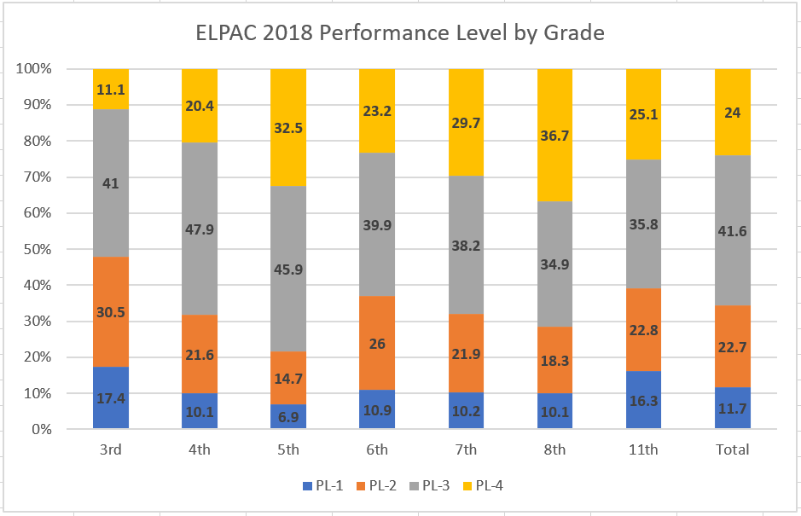

ELs’ performance on CAASPP ELA by ELPAC overall performance level
Empirical analyses by grade level largely converged across the three methods. Analyses suggest that, for grades four through eight and 11, ELs at ELPAC Overall PL 4 do not approximate the 50 percent probability of attaining Level 3 (Standard Met) on CAASPP ELA, nor do they approximate EO student performance. This is particularly so for ELs in grades seven, eight, and eleven. In grade three, ELs at ELPAC Overall PL 4 outperformed EO students and had a greater than 50 percent probability of reaching Level 3 on CAASPP ELA. The following sections illustrate these findings for each of the analytic methods used.
Results from descriptive box plot analyses
Figures 2 through 8 display box plots for grades three through eight and eleven, respectively, which examine the distribution of overall scale scores on CAASPP ELA for ELs by each overall performance level on ELPAC. Each figure also displays the distribution of overall scale scores on CAASPP ELA for RFEP, IFEP, and EO students for comparison. As illustrated in Figure 2, in grade three, nearly 75 percent of ELs at ELPAC Overall PL 4 reach Level 3 on CAASPP ELA, and substantially outperform EO students. This suggests that the ELPAC Overall PL 4 threshold score for grade three may be set unnecessarily high. As seen in Figure 3, in grade four, the proportion of ELs at ELPAC Overall PL 4 attaining Level 3 on CAASPP ELA drops below 50 percent, with median and mean values that are slightly below those of their EO counterparts. Figures 4 through 8 illustrate that ELs at ELPAC Overall PL 4 in grades five through eight and eleven, respectively, demonstrate substantially lower performance on CAASPP ELA relative to their EO counterparts. This is particularly so at grades seven, eight, and eleven, where the proportion of ELs at Overall PL 4 attaining CAASPP ELA Level 3 drops below 25 percent, with median and mean performance that are substantially below those of their EO counterparts. This suggests that the ELPAC Overall PL 4 threshold scores at these grades may be set too low.
Figures 2 through 8. CAASPP ELA performance by ELPAC overall level or language status
Figure 2. Grade 3 Figure 3. Grade 4
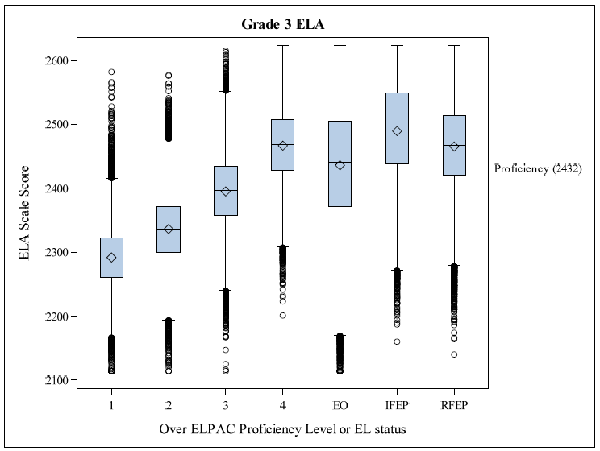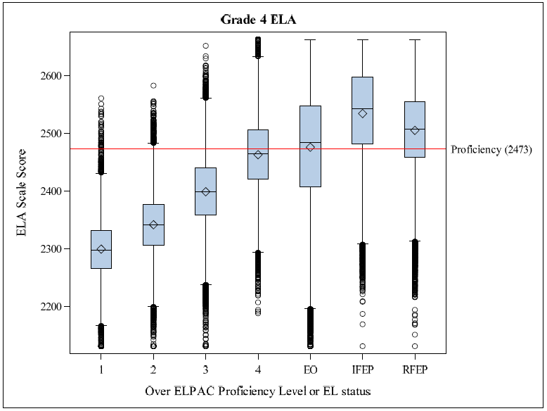
Figure 4. Grade 5 Figure 5. Grade 6
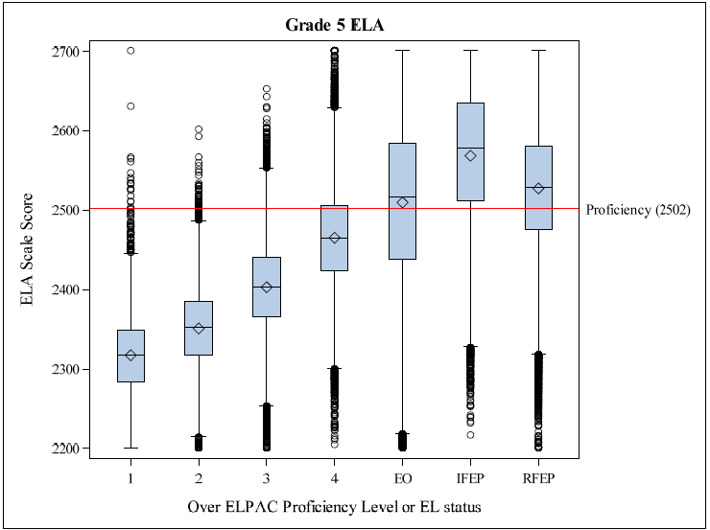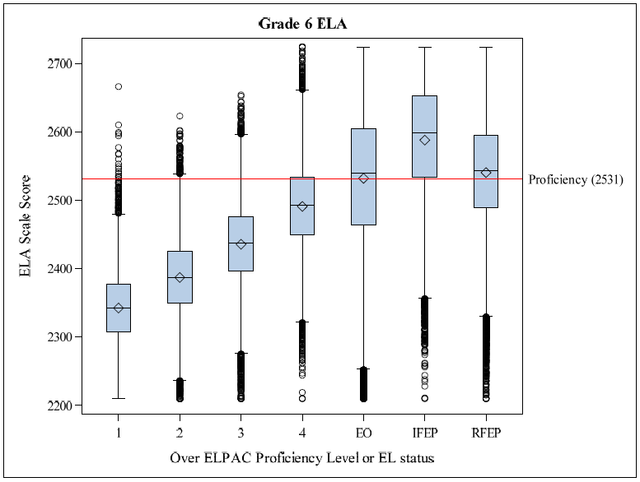
Figure 6. Grade 7 Figure 7. Grade 8
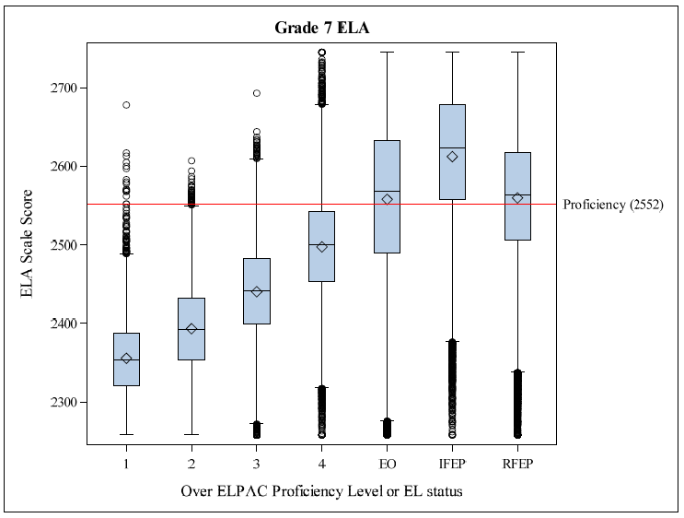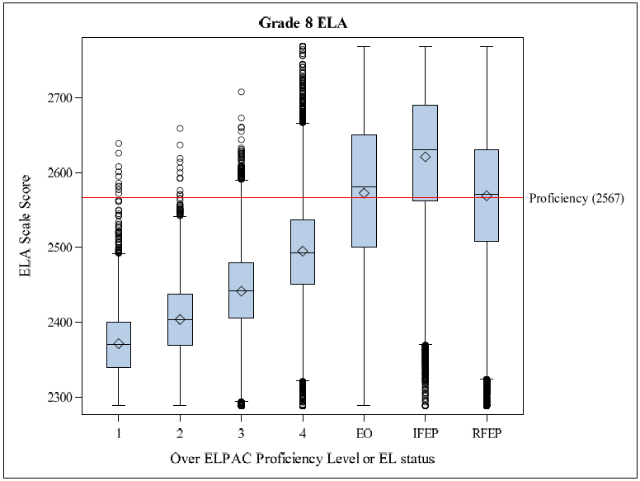
Figure 8. Grade 11
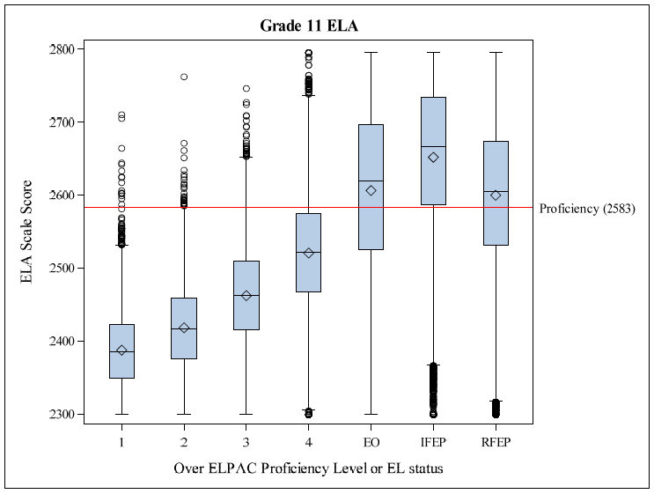

Results from logistic regression analysis
The CA CC team also conducted logistic regression analyses of EL student performance on CAASPP ELA by ELPAC overall scale score to estimate the probability of reaching Level 3 (Standard Met) on CAASPP ELA for each ELPAC overall scale score value. These analyses largely corroborated the findings from the box plot analyses. That is, other than grade three, where ELs at ELPAC Overall PL 4 exceeded a 50 percent probability of scoring at Level 3 on CAASPP ELA (see Figure 9), ELs at Overall PL 4 in all other grades examined displayed probabilities well below the 50 percent level. For example, the fitted logistic regression model for grade seven (see Figure 10) predicts that fewer than 10 percent of ELs at Overall PL 4 would score at or above Level 3 on CAASPP ELA.
Figure 9. Grade 3 logistic regression. Figure 10. Grade 7 logistic regression
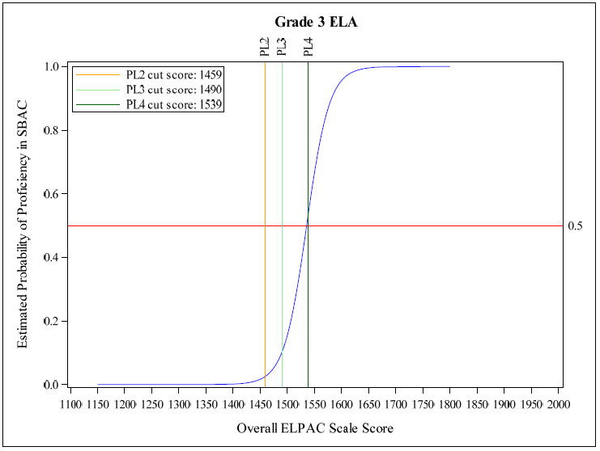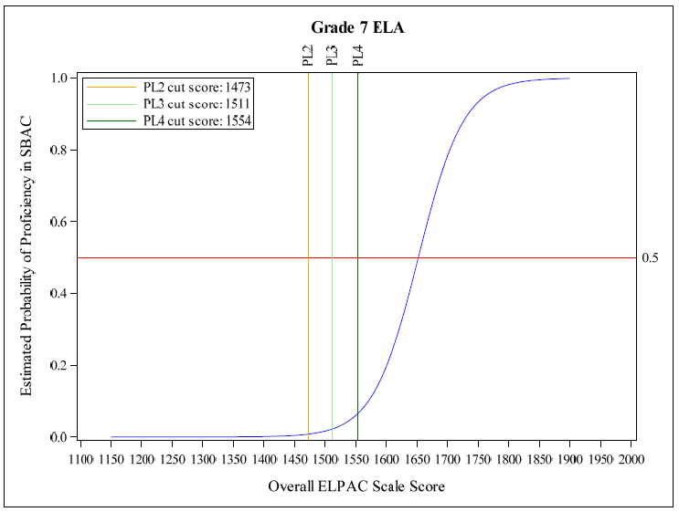

Results from decision consistency analysis
The CA CC team also conducted for each applicable grade level a decision consistency analysis, which analyzes ELPAC and CAASPP proficient-level categorizations and optimizes consistent categorization of ELs at or above the current CAASPP ELA threshold score for Level 3 (Standard Met). Again, results of these analyses corroborate earlier findings from box plot and logistic regression analyses. As Figure 11 illustrates, for grade 3, consistent decisions are maximized at the lower end (threshold to below the midpoint) of the Overall PL 4 scale score range. That is, after that point, the curves slope downward, indicating a student’s ELP performance no longer contributes to maximizing consistent decisions. However, all other grades examined indicate that consistent decisions are not maximized (i.e., the curves at the median value of both the lower and higher half of Overall PL 4 continue to have increasing slopes through the scale score range). This indicates that a higher level of ELP performance is needed to maximize consistent decisions, and that consequently the threshold scores for ELPAC Overall PL 4 may be set too low.
Figure 11. Grade 3 decision consistency Figure 12. Grade 7 decision consistency
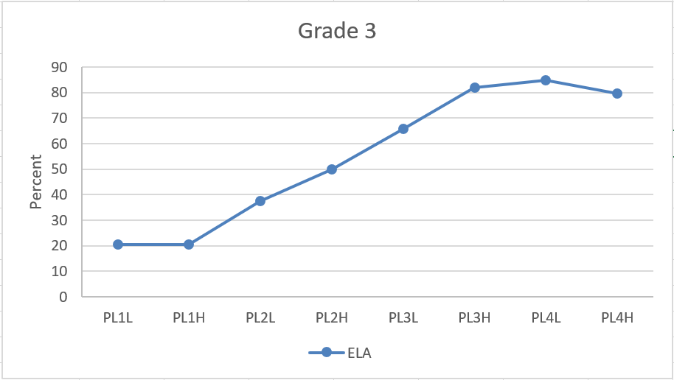 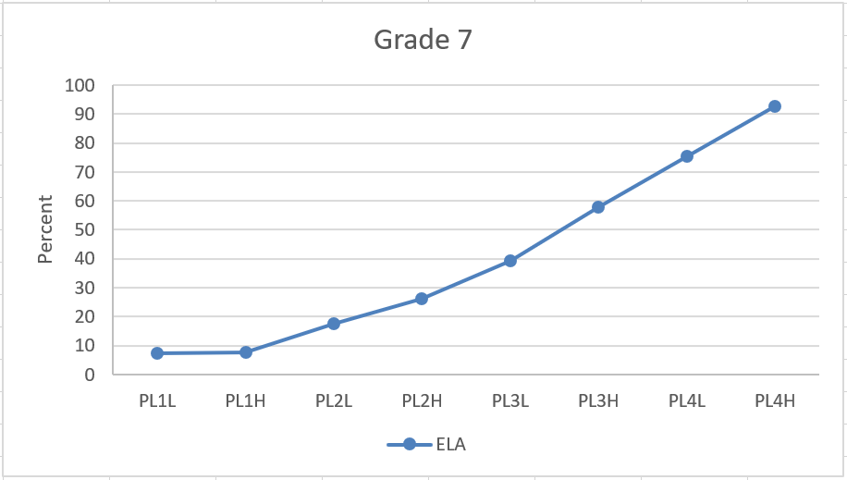Note: PL#L and PL#H denote scale scores below the midpoint, and at or above the midpoint, respectively, of the scale score range for each ELPAC Performance Level.
Exploratory analysis of performance on CAASPP ELA for ELs with ELPAC Overall PL 4
To examine how a higher Overall PL 4 performance standard, or conjunctive rules that further disaggregate the performance of ELs at Overall PL 4, might result in ELs having a 50 percent probability of attaining Level 3 on CAASPP ELA or approximating EO students’ performance, the CA CC team conducted exploratory analyses that disaggregated subgroups of ELs at ELPAC Overall PL 4. The results are described in the following sections.
Results from analysis of evenly splitting scale score range of ELPAC Overall PL 4
In this analysis, the CA CC team disaggregated ELs at ELPAC Overall PL 4 by evenly splitting the score range for this level: One group had overall scale scores from the threshold to just below the midpoint of the Overall PL 4 scale score range; the other group had scale scores from midpoint to the maximum of the range. The descriptive box plot analyses of these two subgroups show that, for ELs with scale scores at or above the midpoint of the ELPAC Overall PL 4 score range, well above 50 percent achieved Level 3 on CAASPP ELA and surpassed EO students’ performance for all applicable grade levels except grade eleven, where they approximated EO student performance. However, the percentage of ELs at or above this level of ELPAC performance was very low (ranging from 0.2 percent in grade three to 0.8 percent in grade eleven). Figures 13 through 16 illustrate these results for grades three, five, seven, and eleven, respectively. These analyses suggest that raising the threshold score for ELPAC Overall PL 4 increases the likelihood that ELs have the English proficiency needed to perform at higher levels on CAASPP ELA. That said, setting the threshold score too high (e.g., at a level yielding greater than 50 percent chance of attaining Level 3 on CAASPP ELA or exceeding EO performance), may substantially and unnecessarily constrain the percentage of ELs categorized as English-proficient on the Summative ELPAC.
Figure 13. Grade 3 split PL 4 box plots Figure 14. Grade 5 split PL 4 box plots
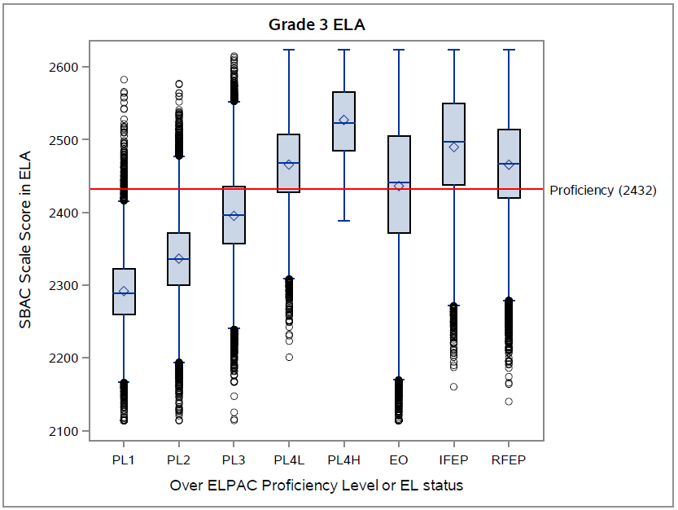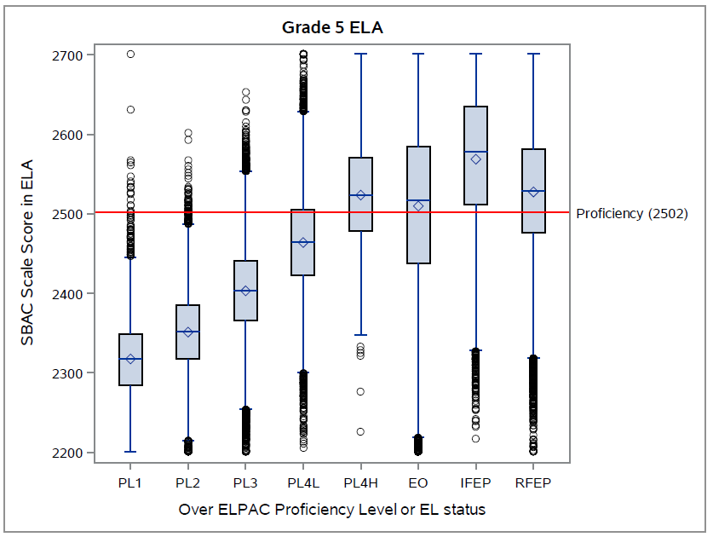
Figure 15. Grade 7 split PL 4 box plots Figure 16. Grade 11 split PL 4 box plots
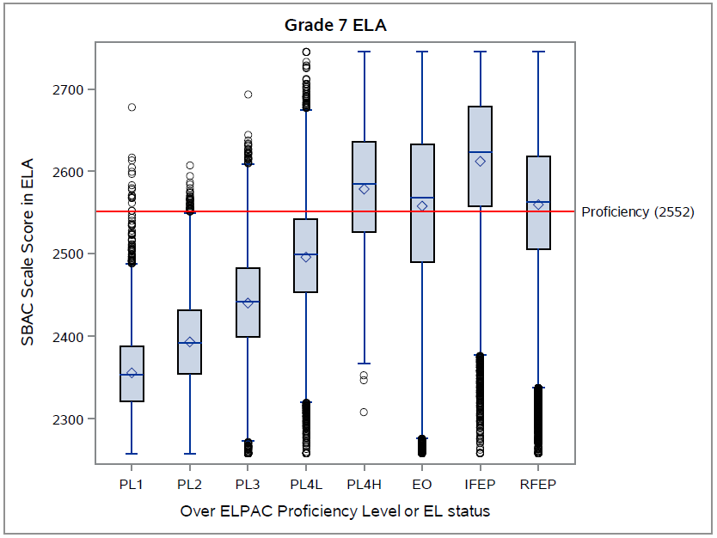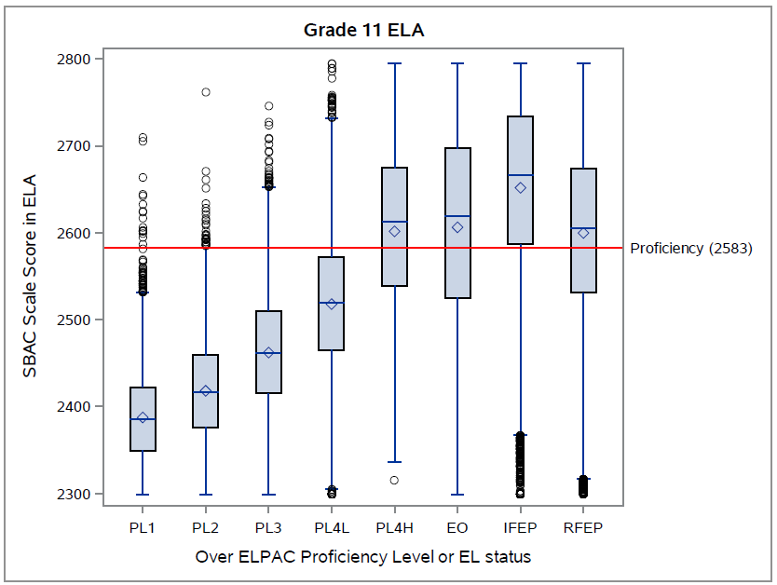
Results from exploring conjunctive rule options
Since California had utilized a conjunctive rule to define the English-proficient performance standard on CELDT, the team explored this option for ELPAC. In examining the performance level of each composite domain for ELs with ELPAC Overall PL 4, the CA CC team found a notable proportion of these students had either the oral composite domain (comprising listening and speaking) or the written composite domain (comprising reading and writing) at or below PL 3 (Figure 17). The team therefore disaggregated ELs with ELPAC Overall PL 4 into various profiles for analysis to explore whether composite domain performance affects performance on CAASPP ELA and warrants inclusion in defining an English-proficient criterion. Several analyses were performed, but none of these yielded consistent outcomes on CAASPP ELA across grades. For example, Figures 18 through 21 illustrate results for grades three, five, seven, and eight, respectively, for three profiles of ELs with Overall PL 4: Written at PL 4; oral at PL 4 and written at PL 3; and oral at PL 4 and written below PL 3. Only in grades three and four did ELs with ELPAC Overall PL 4 and written at PL 4 have at least 50 percent who achieved Level 3 on CAASPP ELA and approximated or exceeded EO student performance.
Figure 17. Distribution of ELs at ELPAC Overall PL 4 by composite domain level and grade
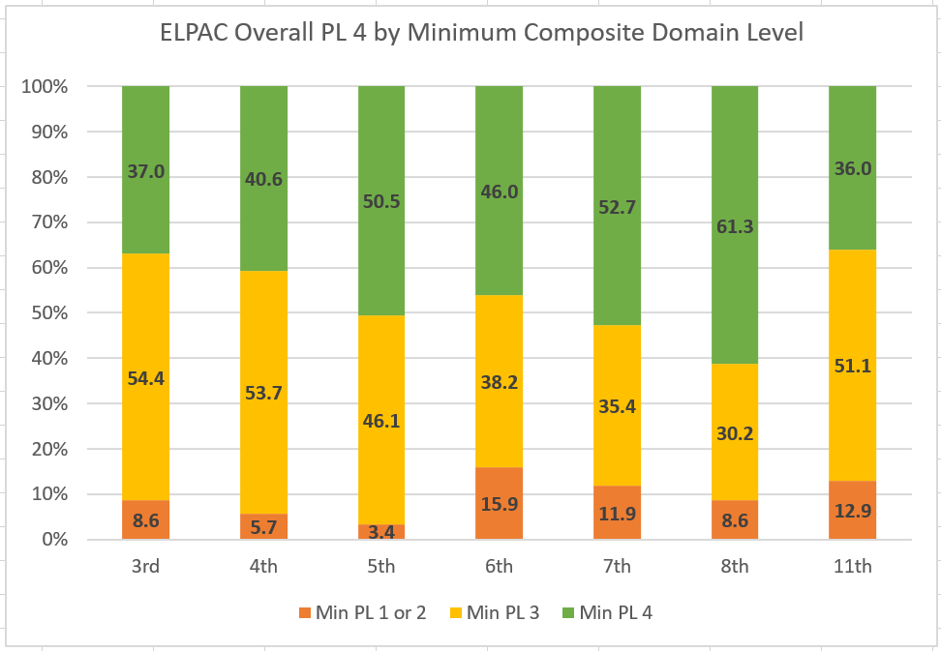

Figure 18. Grade 3 PL 4 by composite domain profile
Figure 19. Grade 5 PL 4 by composite domain profile

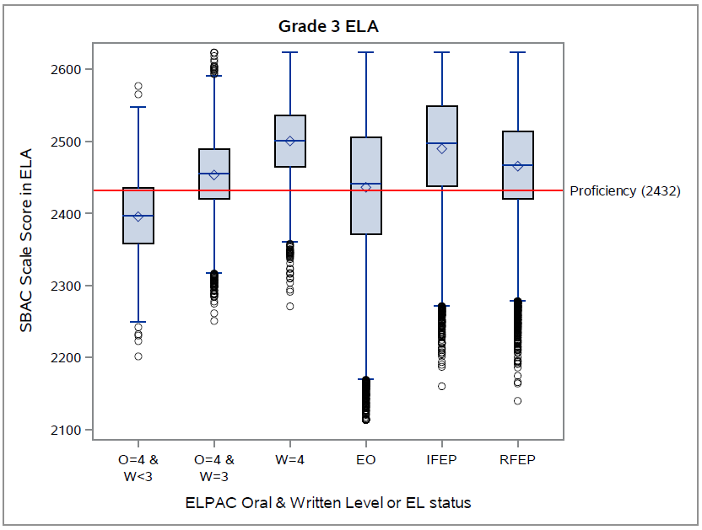 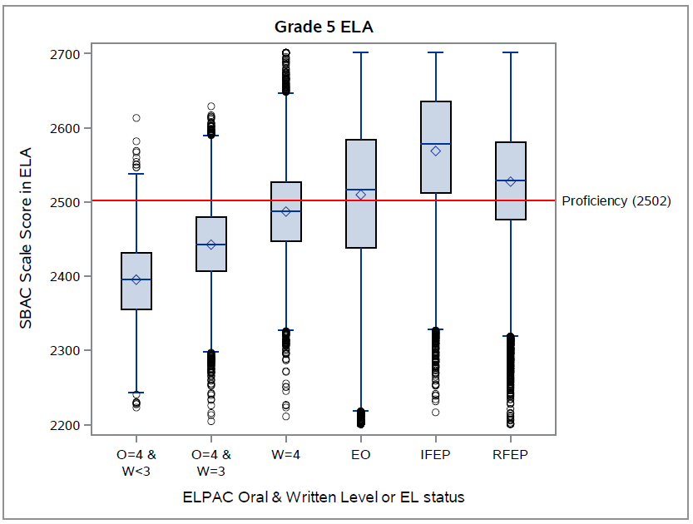 Note: O: Oral composite domain; W: Written composite domain; PL levels of each are indicated.

Figure 20. Grade 7 PL 4 by composite domain profile
Figure 21. Grade 8 PL 4 by composite domain profile

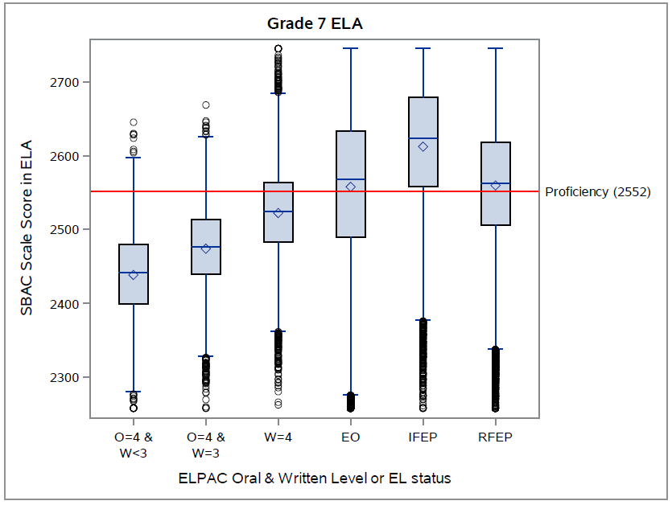 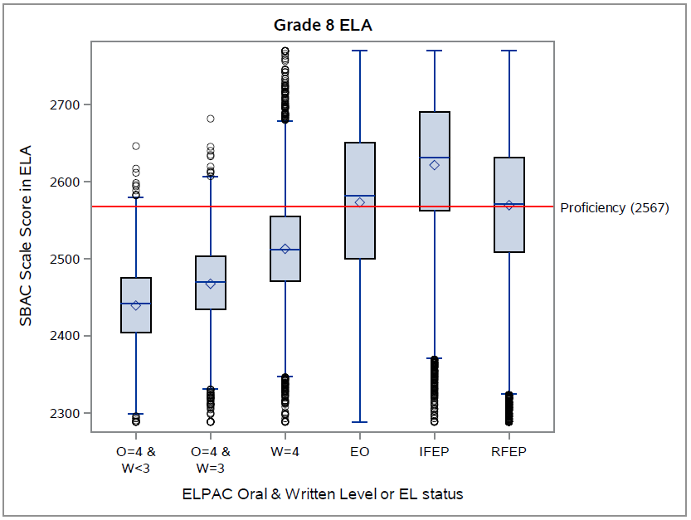 Note: O: Oral composite domain; W: Written composite domain; PL levels of each are indicated.

Summary and Considerations
Grade-level ELPAC-CAASPP empirical analyses largely converged across the methods. Analyses suggest that, for grades four through eight and eleven, ELs at ELPAC Overall PL 4 do not approximate an equal likelihood of attaining Level 3 on CAASPP ELA, nor do they approximate EO student performance. This is particularly so for ELs in grades seven, eight, and eleven. In grade three, ELs at ELPAC Overall PL 4 outperformed EO students and had a greater than 50 percent probability of reaching Level 3 on CAASPP ELA.
The CA CC team also examined the difference in CAASPP performance for ELs at the minimum scale score for ELPAC Overall PL 4 to just below the midpoint of the PL 4 scale score range, compared to those at the midpoint or higher. For grades four and higher, the ELs scoring at or above the midpoint of Overall PL 4 performed at or above a 50 percent probability of attaining Level 3 on CAASPP ELA, and as well as or better than EO students, but there were proportionally very few students scoring at or above the midpoint relative to those in the lower half of ELPAC Overall PL 4. The team also explored several options for adding conjunctive rules related to the oral and written composite domains for ELs at ELPAC Overall PL 4. While these conjunctive rules identified a group of ELs at Overall PL 4 that were at or approaching an equal likelihood of reaching Level 3 on CAASPP ELA and approximated or exceeded the performance of their EO counterparts (i.e., grades three and four), this finding was not consistent in the other grades examined.
Given the findings from these supplemental analyses, the CDE may want to consider raising threshold scores for ELPAC Overall PL 4 at grades four through eight and grade eleven.

Zieky, M.J, Perie, M., & Livingston, S.A. (2008). Cutscores: A manual for setting standards of performance on educational and occupational tests. Princeton, NJ: Educational Testing Service.
Based on the data file for student enrollment by student group information—https://www.cde.ca.gov/ta/ac/sa/accessdata1617.asp
A box plot shows graphically five-number summaries—the smallest observation, lower quartile, median, upper quartile, and largest observation—as well as individual outliers, if applicable.
The analysis takes the CAASPP Level 3 as given and determines the ELPAC overall score range that maximizes the percentage of agreement (i.e., proficient on ELPAC and “standard met” on CAASPP; not proficient on ELPAC and below “standard met” on CAASPP) and minimizes the percentage of non-agreement (i.e., proficient on ELPAC, below “standard met” on CAASPP; not proficient on ELPAC, “standard met” on CAASPP).
Overall Performance Level at Early Advanced or Advanced, with each domain at Intermediate or higher.
Analyses (not shown) found that, across grades three through eight and grade eleven, 58,594 ELs (11.5%) met ELPAC Overall PL 4 with both oral and written composite domains at PL 4; 62,965 ELs (12.3%) met Overall PL 4 with oral greater than or equal to PL 3, and written equal to PL 4; and 62,981 ELs (12.3%) met Overall PL 4 with written equal to PL 4. Differences in performance on CAASPP ELA were very small among these three groups of ELs at ELPAC Overall PL 4
Estimated percent of students statewide who would be placed at this performance level on the basis of these proposed threshold scores.

