

California Department of Education

Executive Office

SBE-003 (REV. 11/2017)

ssb-sfsd-jan19item03

# California State Board of Education January 2019 Agenda Item #05

## Subject

Appeal from an Action of the Santa Clara County Committee on School District Organization to Disapprove a Petition to Transfer Territory from the Campbell Union School District and the Campbell Union High School District to the Saratoga Union School District and the Los Gatos-Saratoga Joint Union High School District.

## Type of Action

Action, Information, Public Hearing

## Summary of the Issue(s)

The Santa Clara County Committee on School District Organization (County Committee) disapproved a petition to transfer territory from the Campbell Union School District (USD) and the Campbell Union High School District (UHSD) to the Saratoga USD and the Los Gatos-Saratoga Joint Union High School District (JUHSD). Pursuant to California *Education Code* (*EC*) Section 35710.5, the chief petitioners for the territory transfer proposal submit an appeal to the California State Board of Education (SBE) from the County Committee’s action.

The SBE may affirm or reverse the County Committee’s action. If the SBE reverses the County Committee’s action, thus approving the territory transfer, it must establish an election area for the proposal.

In 1999, the SBE considered a similar appeal (involving County Committee disapproval of a proposed transfer of the same territory that is the subject of the current appeal). At that time, the SBE unanimously affirmed the County Committee’s action to disapprove the transfer.

## Recommendation

The California Department of Education (CDE) recommends that the SBE affirm the unanimous action of the County Committee to disapprove the proposal to transfer territory from the Campbell USD and the Campbell UHSD to the Saratoga USD and the Los Gatos-Saratoga JUHSD.

## Brief History of Key Issues

The Santa Clara County Superintendent of Schools (County Superintendent) received a petition signed by at least 25 percent of the voters living in the Camino Barco neighborhood, located in the city of Saratoga. The petition is to transfer the 10 parcels in this neighborhood from the Campbell USD and the Campbell UHSD to the Saratoga USD and the Los Gatos-Saratoga JUHSD. Chief petitioners state the two primary reasons for requesting transfer are: (1) the neighborhood has a very strong sense of identity with the Saratoga community, and the current school district boundary isolates them from this community; and (2) students from the neighborhood have a significantly more dangerous commute to schools in the Campbell USD and the Campbell UHSD than they would have to schools in the Saratoga USD and the Los Gatos-Saratoga JUHSD.

The County Committee determined that one of the nine minimum threshold conditions of *EC* Section 35753(a) is not substantially met[1]. That condition is:

* *EC* Section 35753(a)(2): *The school districts are each organized on the basis of a substantial community identity*.

The County Committee subsequently disapproved the proposed transfer of territory from the Campbell USD and the Campbell UHSD to the Saratoga USD and the Los Gatos-Saratoga JUHSD on a unanimous vote.

The CDE reviewed the entire administrative record provided by the County Superintendent (including summaries and transcripts of public hearings and meetings, documentation prepared by chief petitioners and affected school districts, and information presented to the County Committee by Santa Clara County Office of Education [County Office] staff)—as well as new information requested and received from the County Superintendent and the affected school districts (pursuant to *EC* Section 35751). After this review, the CDE completed an analysis of the appeal and the proposed territory transfer. This analysis, and resultant recommendations, are contained in Attachment 1. A summary of the CDE’s findings follows:

The CDE disagrees with the County Committee’s determination that the “community identity” condition is not substantially met. However, the CDE does note that there are concerns with the proposed territory transfer, which support the County Committee’s action to disapprove the proposal—primarily that the historical interest and activity in transfers from the Campbell UHSD to the Los Gatos-Saratoga JUHSD, along with the circumstances of the current transfer proposal, likely would encourage additional territory transfer requests (see Attachment 2 for more detail).

The CDE further finds that there are no compelling educational reasons to overturn the unanimous action of the County Committee to disapprove the proposal to transfer territory from the Campbell USD and the Campbell UHSD to the Saratoga USD and the Los Gatos-Saratoga JUHSD.

## Summary of Previous State Board of Education Discussion and Action

As noted earlier, the SBE considered a similar appeal from the action of the County Committee to disapprove transfer of this same Camino Barco neighborhood at its February 1999 meeting. The SBE unanimously affirmed the County Committee’s action to disapprove the transfer at that time.

## Fiscal Analysis (as appropriate)

Affirming the action of the County Committee will result in no financial costs to any local or state agency. Overturning the action of the County Committee constitutes an order to the County Superintendent to call an election for the proposed territory transfer. Costs for this election will depend upon the timing of the election and the size of the election area established by the SBE—election costs will be borne by the County Office.

## Attachment(s)

**Attachment 1**: Analysis of Administrative Record (19 pages)

**Attachment 2**: Santa Clara County West Valley Reorganizations (7 pages)

# ATTACHMENT 1 Analysis of Administrative Record

**Appeal from an Action of the  
Santa Clara County Committee on School District Organization  
to Disapprove a Petition to Transfer Territory from the  
Campbell Union School District and the   
Campbell Union High School District to the   
Saratoga Union School District and the  
Los Gatos-Saratoga Joint Union High School District**

## 1.0 Recommendation

The California Department of Education (CDE) recommends that the State Board of Education (SBE) affirm the action of the Santa Clara County Committee on School District Organization (County Committee) to disapprove the proposal to transfer territory from the Campbell Union School District (USD) and the Campbell Union High School District (UHSD) to the Saratoga USD and the Los Gatos-Saratoga Joint Union High School District (JUHSD).

## 2.0 Background

### 2.1 Affected Districts

The territory of the Campbell USD comprises portions of the city of San Jose, the city of Campbell, the town of Los Gatos, the city of Saratoga, and unincorporated Santa Clara County. Territory of the Saratoga USD includes a large portion of the city of Saratoga, as well as portions of the city of Monte Sereno and unincorporated Santa Clara County. In addition to the territory described in the Saratoga USD, the Los Gatos-Saratoga JUHSD includes portions of the town of Los Gatos and the city of Cupertino. A general area map portraying the affected districts and municipalities can be found on page 2 of Attachment 2.

The Campbell USD (2017–18enrollment: 7,298) is a kindergarten through eighth grade (K-8) district that is a component of the Campbell UHSD (2017–18enrollment: 8,043), while the Saratoga USD, also a K-8 district (2017–18enrollment: 1,817), is a component of the Los Gatos-Saratoga JUHSD (2017–18enrollment: 3,425).

The two largest racial/ethnic categories in the Campbell USD and the Campbell UHSD are “Hispanic” and “White,” while the two largest racial/ethnic categories in the Saratoga USD and the Los Gatos-Saratoga JUHSD are “Asian” and “White.” Table 1 depicts the percentage of students in the most populous California Longitudinal Pupil Achievement Data System (CALPADS) racial/ethnic categories for each of the school districts.

***Table 1: Percent Race/Ethnicity in Districts Affected by Proposed Transfer***

| District | Asian | Hispanic | White | Two or More | Other* |
| --- | --- | --- | --- | --- | --- |
| Campbell USD  (K-8 enrollment: 7,298) | 14.6% | 48.7% | 24.0% | 6.3% | 6.5% |
| Campbell UHSD  (9-12 enrollment: 8,043) | 16.5% | 35.1% | 38.6% | 3.7% | 6.1% |
| Saratoga USD  (K-8 enrollment: 1,817) | 59.8% | 4.4% | 28.0% | 7.0% | 0.9% |
| Los Gatos-Saratoga JUHSD  (9-12 enrollment: 3,425) | 30.6% | 7.6% | 51.2% | 9.6% | 1.1% |

*Source:* *2017*–*18 CALPADS*

* *The “Other” category includes “African American,” “American Indian or Alaska Native,” “Filipino,” and “Pacific Islander.” Students in the “Not Reported” CALPADS category are omitted from calculations for this table.*

### 2.2 Historical Actions Related to the Appeal

#### Early Transfers of Territory

Since the mid-1990s, the County Committee (and the SBE through the appeal process) has been addressing requests to transfer territory from the Campbell UHSD (and its component elementary districts) to the Los Gatos-Saratoga JUHSD (and, to a lesser degree, the Fremont UHSD and its component Cupertino USD). From these early years to the present, the Campbell UHSD (and its component districts) have been concerned about the “cascading” effect of territory transfer approval (i.e., concerned that approval of one territory transfer, which would have minimal effects on any affected district, would lead to a “cascade” of additional transfers that ultimately would deplete the Campbell UHSD [and its component districts] of sufficient assessed valuation and student population to have significant negative effects on the districts).

In response to the number of requests to transfer territory from the Campbell UHSD, the Santa Clara County Superintendent of Schools (County Superintendent), in 1997, contracted with an independent consultant to study reorganization options regarding the Campbell UHSD boundaries. This study included not just an analysis of the effects of territory transfers but also “piecemeal” adjustments to existing boundaries. The study found that continuing erosion of the Campbell UHSD boundary through territory transfers would have significant negative effects not only on the Campbell UHSD (and its component districts) but also on the Los Gatos-Saratoga JUHSD (and its components). The findings in the study added vociferous opposition from the Los Gatos and Saratoga districts (and the residents of those districts) to the existing opposition of the Campbell districts and residents toward proposed district reorganizations.

In response to the negative findings of the study, and the lack of school district and community support for territory transfers, the County Committee voted unanimously not to support territory transfers from the Campbell UHSD unless exceptional circumstances existed. The County Committee also adopted guidelines for these exceptional circumstances, which primarily addressed home to school transportation issues (e.g., distance and safety). This action by the County Committee was welcomed and supported in newspaper editorials appearing in the San Jose Mercury News, the Los Gatos Weekly Times, and the Saratoga News.

More detailed information regarding the area-wide study findings and responses is included as Attachment 2.

#### Prior Appeal Involving the Same Territory

In February 1999, the SBE heard an appeal from a County Committee decision to deny a request to transfer the same territory that is the subject of the current appeal. In 1999, the current territory was a portion of a larger area proposed for transfer (see Figure 1).

***Figure 1: Map Comparing Territory of Current and 1999 Appeals*** 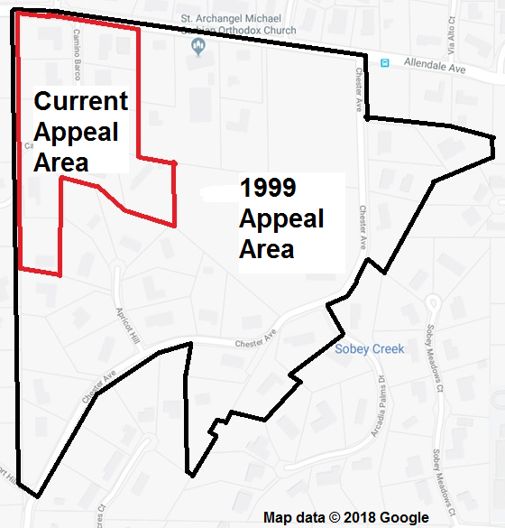

*Source map: Google Maps ©2018*

The County Committee’s unanimous action to disapprove the territory transfer took place a year after the previously described area-wide study (see Attachment 2). The rationale for this County Committee action was (1) the transfer would have a negative effect on the community identity of the affected school districts given the widespread opposition to such territory transfers that was expressed by residents of the districts during public hearings for the area-wide study; (2) increase in property values due to the transfer appeared to be the motivating factor for petitioners since their reasons for the transfer were not supported by objective analysis; and (3) there existed no compelling reason to approve the territory transfer.

The chief petitioners submitted an appeal to the SBE. After reviewing the appeal, the CDE recommended that the SBE affirm the County Committee action to disapprove the transfer. The SBE, in 1999, unanimously affirmed the County Committee’s decision by denying this previous appeal.

### 2.3 Current Territory Transfer Proposal

The current proposal is to transfer 10 parcels (along Camino Barco) located in the city of Saratoga (see Figure 2 on the following page). As already noted, those 10 parcels were included as part of the 38 parcel territory transfer proposal considered by the SBE in 1999. The current proposal was submitted to the County Superintendent as a petition signed by at least 25 percent of the voters residing within this Camino Barco area.

Petitioners’ reasons for the territory transfer are:

* Commute routes between petitioners’ homes and schools in the Campbell USD and the Campbell UHSD are less safe than routes to Saratoga USD and Los Gatos-Saratoga JUHSD schools.
* Members of the Camino Barco community share a very strong sense of community identity with their neighbors in the Saratoga USD and with the city of Saratoga. Transfer of their homes into the Saratoga USD would remove an “awkward and isolating division” within the larger city of Saratoga community.
* Some of the Camino Barco residents have owned their homes for many years and children in those homes attended Saratoga schools from the 1970s to the 1990s. Thus, there is a historical precedent for residents on Camino Barco to attend Saratoga schools.
* The territory transfer proposal meets all California *Education Code* (*EC)* Section 35753 conditions.

The above reasons for the territory transfer are similar to the reasons put forward by chief petitioners for the territory transfer considered by the SBE on appeal in 1999.

***Figure 2: Map of Area Proposed for Transfer***

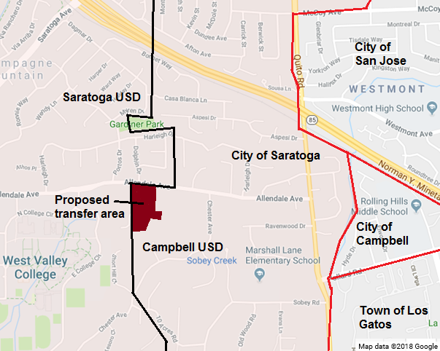

*Sources: Base map with city/town boundaries (Google Maps ©2018)*

## 3.0 Action of the County Committee

The County Committee held two public hearings for the proposed transfer—one within the boundaries of the Campbell USD and one within the boundaries of the Saratoga USD. Under the California *Education Code*, the County Committee then had the following options:

* If the County Committee determined that all nine conditions of *EC*Section 35753(a) are substantially met, it could approve the petition (though not required to do so), and would notify the County Superintendent to call an election on the proposed transfer (an election is required when an affected district opposes an approved transfer of territory petition).
* The County Committee could disapprove the petition to transfer territory for other concerns even if it finds that all nine conditions of *EC* Section 35753(a) have been met.
* If the County Committee determined that all nine conditions of *EC*Section 35753(a) are not substantially met, it would be required to disapprove the petition to transfer territory.

The County Committee found that the proposal failed to substantially meet one of the nine required conditions of *EC* Section 35753: *The school districts are each organized on the basis of a substantial community identity*.

The County Committee subsequently disapproved the territory transfer petition by a unanimous vote.

Chief petitioners or affected school districts may appeal a County Committee decision on territory transfers for issues of noncompliance with the provisions of *EC* sections 35705, 35706, 35709, 35710, and 35753(a). The Camino Barco chief petitioners submitted such an appeal to the County Superintendent, who subsequently transmitted the appeal (including the complete administrative record of the County Committee action) to the SBE.

## 4.0 Positions of Affected School Districts

The governing boards of all four affected school districts adopted resolutions opposing the proposed transfer of territory for a number of common reasons, including.

* A previous proposal, which included the current territory proposed for transfer, already was disapproved by the County Committee and the SBE.
* The territory transfer proposal does not meet all the minimal threshold requirements of *EC* Section 35753.
* Transfer of the territory into the Saratoga USD and the Los Gatos-Saratoga JUHSD will result in significantly increased property values for the petitioners.
* Approving the transfer proposal will set a precedent for future transfers from the Campbell UHSD to the Los Gatos-Saratoga JUHSD.

In addition to the above common concerns of all affected districts, the Campbell USD and the Campbell UHSD state that future transfers of territory out of the districts will result in an increased financial obligation to remaining property owners for the general obligation bonds of the Campbell USD and the Campbell UHSD.

The Los Gatos-Saratoga JUHSD also is concerned that additional territory transfers into the district will negatively affect its facility needs and disrupt its educational programs. The Los Gatos-Saratoga JUHSD already is facing substantial enrollment growth and the current general obligation bond programs approved by district voters to address this growth are not designed to accommodate students from outside the current boundaries of the district.

Finally, both the Saratoga USD and the Los Gatos-Saratoga JUHSD note that the home-to-school commute safety concerns stated by the petitioners are not unique to the Camino Barco neighborhood and will not be resolved by transferring the territory to different districts.

## 5.0 Reasons for the Appeal

The chief petitioners assert that the County Committee violated their “right to due process” for the following reasons:

* The County Committee did not adhere to the *Education Code* or its own definitions and guidelines when it determined that the area proposed for transfer failed to substantially meet the following *EC* Section 35753 minimum threshold requirement: *The school districts are each organized on the basis of a substantial community identity.*
* Petitioners did not receive a written justification for the County Committee’s action in the notice they received of the disapproval of the territory transfer.
* Petitioners were not granted the ability to challenge unsubstantiated opinions expressed by County Committee members.
* Petitioners were not granted a full three minutes each to address the County Committee before it took action (as had been the case at a previous hearings and as was indicated on forms that speakers were required to complete).

## 6.0 CDE Analyses of Reasons for the Appeal

CDE staff has reviewed the administrative record provided by the County Superintendent, which details (1) the County Committee actions in its consideration of the *EC* Section 35753 threshold conditions; and (2) the concerns raised by the appellants regarding the County Committee’s actions. As noted previously, the County Committee determined that all *EC* Section 35753 minimum threshold requirements are substantially met by the proposed transfer of territory except for the following: *The school districts are each organized on the basis of a substantial community identity*.

For its analysis of the proposal, the CDE conducted its own studies of the above condition, using information provided by the County Superintendent, the four affected school districts, and the chief petitioners. This analysis will address the issues raised by the appellants regarding their concerns that the County Committee violated petitioners’ “right to due process” when determining that the “community identity” minimum threshold condition was not substantially met.

Although the remaining three “right to due process” issues raised by the appellants (receipt of written justification of County Committee action, ability to challenge County Committee members’ opinions, and length of speaking time) are not matters for appeal pursuant to *EC* Section 35710.5, the CDE will address these issues briefly following the analysis of the “community identity” threshold requirement.

### 6.1 Community Identity

*EC* Section 35753(a)(2): *The school districts are each organized on the basis of a substantial community identity*.

#### Standard of Review

The SBE regulation regarding this condition (California *Code of Regulation*s, Title 5   
[5 *CCR*] 18573[a][2]) lists the following criteria that should be considered: Isolation; Geography; Distance between social centers; Distance between school centers; Topography; Weather; and Community, school, and social ties and other circumstances peculiar to the area. Additionally, the *School District Organization Handbook[2]* notes that no single factor is likely to determine that districts are organized on the basis of a substantial community identity and examination of several attributes likely will be required. The Handbook also states that there is no legal necessity that school district boundaries match city boundaries.

#### County Committee Action

Staff from the Santa Clara County Office of Education (County Office) presented the following information to the County Committee regarding the 5 *CCR* regulations:

* The proposed transfer area is not isolated from either the Campbell school districts or the Saratoga school districts.
* There are no significant geographical distinctions between the proposed transfer area and any affected school district.
* Distance between social centers is not a significant issue since there are several social centers, retail establishments, and grocery stores within a reasonable distance from the territory proposed for transfer. Camino Barco residents are able to choose those centers that best suit their needs.
* Distance between school centers is not a significant issue since the distances and travel times to each of the schools in the affected districts are similar.
* Petitioners state that heavily traveled traffic routes (Quito Road and Highway 85) separate their neighborhood from the Campbell schools. The County Office notes that the Camino Barco area also is separated from Saratoga schools by equally heavily traveled traffic routes (Fruitvale Avenue and Saratoga Avenue).
* The weather is the same throughout the area and therefore is not a factor.
* Petitioners do have a sense of community identity with the city of Saratoga given their residency within that municipality, participation in many city activities, and receipt of citywide services from Saratoga. Additionally, in the past, students residing in the proposed transfer area have attended Saratoga schools, especially when interdistrict transfers were more easily available. However, these circumstances are not unique in the city of Saratoga, or in Santa Clara County. Many city of Saratoga residents, who are within the boundaries of the Campbell school districts, share circumstances identical to the proposed transfer area residents—thus, there is an equal sense of community identity between those residents and the Camino Barco residents.

The County Office specifically addressed the chief petitioners’ concern that the “home-to-school” commute to Campbell schools was less safe than the commute to Saratoga schools. As noted previously, the County Office found that the geographic distances and travel times from the proposed transfer area to each of the schools in the affected districts are similar. Additionally, the County Office found that there are concerns with the safety of potential walking and biking routes to schools in each of the affected districts. Such travel to the Campbell schools typically would be along routes that do not always have sidewalks or bike lanes, including the heavily traveled two-lane Quito Road, while travel to Saratoga schools involves traveling past the multiple exits and entrances into West Valley College and its parking lots, crossing Saratoga Avenue (which is the only access in the area to the freeway ramps of Highway 85), and traversing many residential streets that have no sidewalks or bike lanes.

The County Office also examined reported traffic incidents in the vicinity of the proposed transfer area, finding that there were more reported accidents in the Saratoga schools’ area than in the Campbell schools’ area (the majority of the Saratoga-area reported accidents were on Saratoga Avenue—as noted previously, this is the only area access to Highway 85).

In their discussions prior to voting on the “community identity” condition, County Committee members made a number of points[3] including:

* Community identity of the school districts is not affected regardless of which of the affected districts contains the proposed transfer area.
* Petitioners have provided no compelling argument that their neighborhood is isolated from the Campbell USD and the Campbell UHSD.
* There was no evidence presented that the home-to-school commute to Campbell schools is less safe than the commute to Saratoga schools.
* The petitioners’ issues regarding community identity are not unique—there are many residents in the neighborhoods near the proposed transfer area who are in the city of Saratoga but in the Campbell USD and the Campbell UHSD.
* Alignment of city boundaries and school district boundaries in Santa Clara County does not exist.
* The County Committee has dealt with numerous similar petitions in the past, and has come to these same conclusions in each.

The County Committee then voted that this minimum threshold requirement is not substantially met.

#### Appeal

The appellants argue that both the County Office and the County Committee deviated from the County Committee’s own definitions of geographic isolation and community identity when determining that the “community identity” condition is not substantially met. The appellants further claim that the County Committee (1) did not appropriately consider the valid home-to-school commute safety concerns of the petitioners and (2) ignored the fact that the Camino Barco neighborhood is the only neighborhood in the vicinity that has to deal with the dangerous commute to Campbell schools.

#### CDE Findings/Conclusion

Although the County Committee found that the proposed transfer failed to substantially meet this condition, both the information presented by the County Office to the County Committee regarding this “community identity” condition and the comments from County Comments from County Committee members prior to voting on this condition (see “County Committee Action,” page 8) appear to indicate, to the CDE, that the “community identity” condition is substantially met. The *Education Code* language for this condition is “The school districts are each organized on the basis of a substantial community identity.” Nothing in the County Office analysis or the County Committee discussion suggests that the transfer would have a negative effect on the community identity of the affected districts. Instead, the basis for the County Office recommendation and the County Committee action appears to be that the petitioners have not demonstrated that the proposed transfer would “improve” the community identity within the districts.

It is the CDE’s opinion that an analysis of this condition does not require that a burden be placed upon the petitioners to prove that the territory transfer is beneficial to the community identity of the affected districts. The focus of the “community identity” condition, as a minimum threshold requirement, is that the proposed reorganization does not negatively affect the community identity of the districts. The information provided to the County Committee by the County Office, and the subsequent comments of the County Committee, both indicate that the proposed reorganization has no effect on the community identity of the districts. Again, the CDE believes that petitioners are not required to prove that the proposed transfer would improve community—the standard is that the affected districts would maintain substantial community identity after the proposed reorganization. The CDE disagrees with the County Committee finding that this “community identity” condition is not substantially met.

Both the County Office and the County Committee disagree with the appellants’ claims that (1) home-to-school commutes to Campbell schools are not as safe as commutes to Saratoga schools; and (2) no other residences in the vicinity share their unique problems with commute safety. Since the SBE may still view these issues as compelling reasons to approve the transfer, the CDE will examine the two concerns in more detail.

### 6.2 Commute Safety

During the 1990s, the County Office and the County Committee addressed the issue of home-to-school commute safety in previous territory transfer proposals in the general vicinity of the Camino Barco area. Separate proposals were considered from the Twain Court and Fortuna Court communities directly across Allendale Avenue from the Camino Barco area, from communities just south of the Camino Barco area (Ten Acres Road and Emerald Hills Court), and the Camino Barco area itself as part of a larger territory transfer proposal (see Figure 4 on page 14). County Office studies identified no differences in home-to-school commute safety in these five previous proposals.[4]

The primary safety concern raised by the appellants is the lack of sidewalks or bike lanes along a portion of Allendale Avenue (see Figure 3). Appellants note that students must walk or bike along this road to access any of the Campbell schools, which becomes a dangerous trip due to the lack of sidewalks or bike lanes. The safety of the students is further threatened when obstacles along the side of the road (e.g., trash cans, service vehicles) force students to walk/bike into the street. Appellants also note that Quito Road, which separates the Camino Barco community from Westmont High School and Rolling Hills Middle School is a heavily traveled street.

***Figure 3: Schools in Affected Districts***

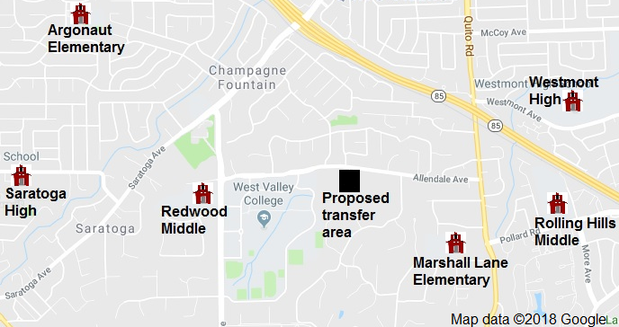

*Source map: Google Maps*

The County Office, in its study, notes that commute safety is a concern in the area—but, that concern is not limited to the routes used to access Campbell schools. The County Office finds that commutes to Saratoga schools are no safer (and are potentially more dangerous), noting the following issues:

* Traveling west along Allendale Avenue takes students past multiple entrances to the campus and parking lots of West Valley College. That portion of Allendale Avenue is a major commute route for students attending this college.
* Other than Redwood Middle School, all Saratoga schools are on the other side of Saratoga Avenue from the proposed transfer area. Saratoga Avenue is the only route in the area with access ramps to Highway 85 (Quito Road, though heavily traveled, goes over Highway 85 instead of connecting to it). The County Office examined reported traffic accidents in the vicinity of the proposed transfer area and found more reported accidents on the Saratoga side than on the Campbell side, with the majority of those accidents occurring on Saratoga Avenue.
* Portions of Saratoga Avenue also have limited sidewalks and bike lanes, which can be blocked by roadway obstacles.

The CDE agrees with the findings of the County Office regarding “home-to-school” commute safety. Additionally, the CDE completed a further analysis of commute safety issues through its own site visits and examination of information available through internet traffic pattern sites. Table 2 presents both driving times and walking times from the Camino Barco area to three Campbell schools and the three Saratoga schools. With the exception of travel to the Redwood Middle School (Saratoga USD), both driving and walking times to Campbell schools are shorter than to Saratoga-area schools.

***Table 2: Distances and Commute Times to Schools***

| School/District | Distance | Driving Time | Walking Time |
| --- | --- | --- | --- |
| Marshall Lane Elementary (Campbell USD) | 1.1 miles | 4 minutes | 21 minutes |
| Rolling Hills Middle (Campbell USD) | 1.4 miles | 4 minutes | 25 minutes |
| Westmont High  (Campbell UHSD) | 1.5 miles | 5 minutes | 27 minutes |
| Argonaut Elementary (Saratoga USD) | 1.8 miles | 6 minutes | 37 minutes |
| Redwood Middle (Saratoga USD) | 0.7 miles | 2 minutes | 15 minutes |
| Saratoga High  (Los Gatos-Saratoga JUHSD) | 2.1 miles | 7 minutes | 37 minutes |

*Source:* *Google Maps (©2018)*

Furthermore, the CDE notes that the available traffic pattern apps identify alternative walking routes to Campbell-area schools. These walking routes, although slightly longer than the routes used in Table 2, avoid the stretch of Allendale Avenue posing the safety concerns identified by appellants and (for elementary and high schools) still are shorter than walking routes to Saratoga-area schools.

Given this information, and the fact that none of the many previous analyses of “home-to-school” commute safety issues identified any significantly greater safety concerns with travel to the Campbell-area schools, the CDE disagrees with appellants’ claim that it is more dangerous for Camino Barco students to travel to Campbell-area schools.

### 6.3 Unique Commute Safety Issues

Appellants claim that no other neighborhoods in the vicinity of theirs share their unique problems with commute safety. However, as noted previously, five other nearby neighborhoods have petitioned the County Committee in the past to transfer from Campbell schools to Saratoga schools (see Figure 4).

***Figure 4: Location of Previous Territory Transfer Proposals in the Area***

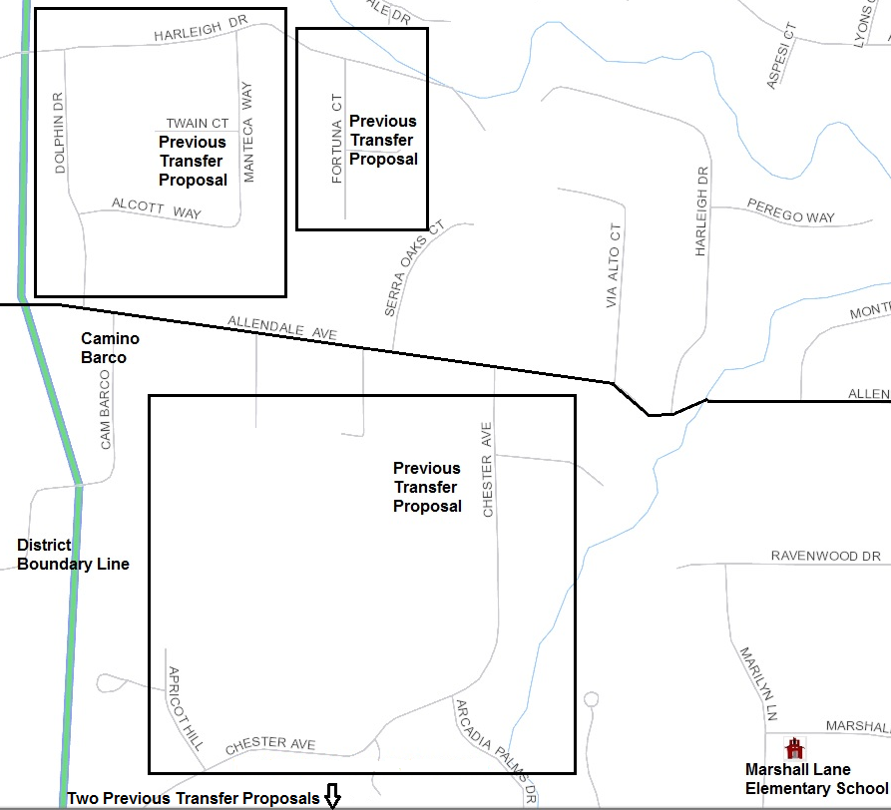

Source map: U.S. Census Bureau (Note: Census district boundary is inaccurate)

Petitioners identified school commutes as a reason for the territory transfer request in each of the previous territory transfer proposals. Moreover, there are numerous other neighborhoods (Sierra Oaks Court, Via Alto Court, Harleigh Drive) that feed directly into Allendale Avenue—each share geographic and commute circumstances that are identical to those of the Camino Barco neighborhood. The CDE disagrees with the appellants claim that their circumstances are unique.

### 6.4 Other “Right to Due Process” Issues

As noted earlier, part of the appeal is based on the perception that the petitioners’ “due process rights” were violated. Specifically, the appellants claim that petitioners:

* Did not receive a written explanation for the County Committee’s decision to disapprove the territory transfer.
* Were not granted the ability to “question, challenge, or verify” the knowledge and opinions of County Committee members.
* Were not allowed sufficient time to address the County Committee before it took action.

The CDE already has stated that it does not believe that the specific procedures employed by the County Office and the County Committee in conducting meetings and providing notification of actions are matters for appeal pursuant to *EC* Section 35710.5. Public meeting statute (the “Brown Act” in the case of the County Committee [*Government Code* Section 54950 et seq.]), parliamentary procedure (i.e., *Robert’s Rules of Order*), and the County Committee’s adopted bylaws guide the County Office and the County Committee in such matters. The CDE is unaware of any guidance in these sources that would address the specific “due process” concerns raised by the appellants.

### 6.5 Summary

CDE staff does not find sufficient support in the issues raised in the appeal or in the administrative record to justify overturning the unanimous decision of the County Committee to disapprove the territory transfer proposal. The CDE finds that:

* The County Committee substantially complied with all requirements for public hearings and consideration of information regarding the proposal.
* The CDE finds no compelling educational reason to support overturning the action of the County Committee (see Section 7.1 for potential compelling reasons considered by the CDE).
* The CDE notes that there are concerns with the proposed transfer (identified in Section 7.2) that support the County Committee’s action to disapprove the transfer.

## 7.0 Compelling Reasons and Concerns

Approval of a territory transfer by the SBE is a discretionary action, whether the SBE finds that all *EC* Section 35753 conditions are substantially met or even if all the conditions are not met. The SBE may consider compelling reasons offered by affected districts, petitioners and appellants, community members, and the CDE in making its determination to approve a territory transfer. It also may consider any concerns raised by these same parties in a determination to disapprove the transfer.

The affected school districts and the petitioners/appellants supporting the territory transfer have offered a number of reasons and concerns regarding the proposed transfer, some of which have been included in other sections of this report. In this section, the CDE will summarize the potential compelling reasons and concerns it considers most relevant.

### 7.1 Compelling Reasons for Approval

The SBE, even if it determines the transfer fails to substantially meet *EC* Section 35753 conditions, may consider any issue it determines to be compelling as a reason to reverse the County Committee’s disapproval action, including the following:

* Community identity: (See discussion in Section 6.1).
* Safety of home-to-school commute: (See discussion in Section 6.2).
* Uniqueness of proposal: (See discussion in Section 6.3).
* Concerns that due process rights were violated: (See discussion in Section 6.4).

### 7.2 Concerns Regarding Moving the Proposal Forward

The SBE, even if it determines the transfer substantially meets *EC* Section 35753 conditions, may consider any concerns that warrant disapproving the proposal, including (but not limited to) the following:

* Encouragement of future transfers: Significant areas of the city of Saratoga remain within the Campbell USD and the Campbell UHSD. Historically, there has been significant interest and activity regarding transfers from the Campbell UHSD to the Los Gatos-Saratoga JUHSD (see Attachment 2).
* Fiscal effects: Future additional transfers from the Campbell USD and the Campbell UHSD may result in significant negative financial effects on those districts. Both districts could lose significant assessed valuation resulting in declining bonding capacity and increase property taxes for residents shouldering a larger share of the districts’ bonded indebtedness. Moreover, the Campbell UHSD currently is an excess tax (or basic aid) district, so loss of assessed value directly results in reduced funding.
* Overcrowding: The Los Gatos-Saratoga JUHSD expressed concerns that additional territory transfers into the district will negatively affect its facility needs and disrupt its educational programs. The district already is facing substantial enrollment growth and the current general obligation bond programs approved by district voters to address this growth are not designed to accommodate students from outside the current boundaries of the district.
* Public policy: Piecemeal transfers of territory may result in school district boundaries that make little sense, which can reflect poor public policy.
* Increased property values: The County Committee determined (and the CDE agrees) that the proposed transfer is not primarily due to a desire to increase property values. However, the affected districts note that increased property values likely play a major role in the petitioners’ desire for the transfer, especially given the lack of any other compelling reasons for the transfer.
* The general issues raised by the petitioners are not unique to the Camino Barco neighborhood and will not be addressed by transferring the territory to different districts.

## 8.0 Staff Recommended Amendments

The SBE has authority to amend or add certain provisions to any petition for reorganization. The CDE recommends only one provision be added to the petition if the SBE overturns the action of the County Committee by approving the appeal: the determination of the area of election. The following information details the CDE recommendation regarding this provision.

### 8.1 Area of Election

The County Committee voted to disapprove the proposed territory and, therefore, did not take any action regarding establishing an election area. If the SBE approves the appeal (thus triggering a local election for approval of the territory transfer proposal), the SBE must determine the territory in which this election will be held (*EC* Section 35756).

### 8.2 Area of Election Principles

In establishing the area of election, the CDE and the SBE follow the legal precedent set by the California Supreme Court in *Board of Supervisors of Sacramento County, et al. v. Local Agency Formation Commission* (1992) 3 Cal. 4th 903 (the *“LAFCO”* decision). *LAFCO* holds that elections may be confined to within the boundaries of the territory proposed for reorganization (the “default” area), provided there is a *rational basis* for doing so. *LAFCO* requires we examine: (1) the public policy reasons for holding a reorganization election within the boundaries specified; and (2) whether there is a genuine difference in the relevant interests of the groups that the election plan creates.

A reduced voting area has a fair relationship to a legitimate public purpose. State policy favors procedures that promote orderly school district reorganization statewidein a manner that allows for planned, orderly, community-based school systems that adequately address transportation, curriculum, faculty, and administration.

Discussion of other judicial activity in this area is warranted. In a case that preceded *LAFCO,* the California Supreme Court invalidated an SBE reorganization decision that approved an area of election that was limited to the newly unified district. As a result, electors in the entire high school district were entitled to vote (*Fullerton Joint Union High School District v. State Board of Education* [1982] 32 Cal. 3d 779 [*Fullerton*]). The *Fullerton* court applied strict scrutiny and required demonstration of a compelling state interest to justify the exclusion of those portions of the district from which the newly unified district would be formed.

The *Fullerton* case does not require that the SBE conduct a different analysis than that described above. The *LAFCO* decision disapproved the *Fullerton* case, and held that absent invidious discrimination, the rational basis approach to defining the election area applied. In the matter of this transfer of territory from the Campbell USD and the Campbell UHSD to the Saratoga USD and the Los Gatos-Saratoga JUHSD, no discrimination, segregation, or racial impacts are identified. Accordingly, the *LAFCO* standard and analysis applies.

### 8.3 Recommended Area of Election

CDE staff finds that the transfer of territory would have no significant effect on the voters in either the remaining Campbell USD and Campbell UHSD or the receiving Saratoga USD and Los Gatos-Saratoga JUHSD. The CDE finds no reason to believe that the proposed transfer would affect the present or future racial composition of any affected district, or have any significant negative fiscal effect. Therefore, there is no reason relative to the territory transfer itself to expand the election area beyond the area proposed for transfer. The CDE recommends that the election area for the territory transfer, should the SBE approve the appeal, be the territory proposed for transfer.

However, the SBE may consider the concerns of districts, and residents of these districts, that the proposed transfer could encourage future transfer proposals. As detailed in Attachment 2, there historically have been significant concerns raised by residents throughout all the affected districts regarding potential territory transfers from the Campbell UHSD to the Los Gatos-Saratoga JUHSD. If the SBE reverses the County Committee and approves the territory transfer, it may consider that a reasonable nexus exists between widespread public concerns and an expanded election area.

## 9.0 State Board of Education Action

Subdivision (c) of *EC* Section 35710.5 provides that the SBE, upon receiving an appeal from an action of a County Committee, may review the appeal (either in conjunction with a public hearing or based solely on the administrative record) or ratify the County Committee’s decision by summarily denying review of the appeal. Since the CDE does not find any rationale to summarily deny review of the appeal, and the practice of the SBE has been to hear all appeals in conjunction with a public hearing, the assumption in this section is that the SBE will conduct a public hearing as part of its review.

### 9.1 State Board of Education Options

The SBE has the following options for this territory transfer appeal:

* The SBE will review the appeal in conjunction with a public hearing
* Following review of the appeal, the SBE must affirm or reverse the action of the County Committee.
* If the proposal will be sent to election, the SBE must determine the territory in which the election is to be held.
* The SBE may reverse or modify the action of the County Committee in any manner consistent with law.
* The SBE may request additional information regarding the appeal or the territory transfer, and choose not to take action until a later meeting.
* The SBE, pursuant to *EC* Section 35720, may direct the County Committee to formulate plans and recommendations for an alternative reorganization. The County Committee then would report back to the SBE regarding its actions.

### 9.2 Recommended Action

The CDE recommends that the SBE deny the appeal, thus affirming the action of the County Committee to disapprove the proposal to transfer territory from the Campbell USD and the Campbell UHSD to the Saratoga USD and the Los Gatos-Saratoga JUHSD. Should the SBE decide to approve the appeal, and overturn the County Committee’s unanimous decision to disapprove the territory transfer proposal, the CDE recommends that the SBE establish the territory proposed for transfer as the election area.

# ATTACHMENT 2 Santa Clara County West Valley Reorganizations

## Background

For the past 20-25 years in Santa Clara County, the Campbell Union High School District (UHSD), along with its component elementary school districts, has been the center of territory transfer requests along its western boundary, which it shares with the Los Gatos-Saratoga Joint Union High School District (JUHSD) (and its Los Gatos Union School District [USD] and Saratoga USD components) and the Fremont UHSD (and its Cupertino USD component).

There are a number of reasons for this, including:

* A history of approvals of interdistrict transfer requests among the districts. However, a number of factors led to the interdistrict transfers becoming less available, including (1) student population growth due to the economic expansion in Silicon Valley and influx of new residents; (2) fiscal concerns in school districts (including excess tax districts that do not receive increased funding for additional students[5]); Proposition 13, which restricted the ability of school districts to construct facilities with local tax revenue; and (3) class size reduction practices, which further exacerbated the school capacity problem.
* The explosive growth of technology and Silicon Valley in the 1980s brought a large influx of employees for the high tech sector from areas outside of California. Many were unfamiliar with the concept of school districts not matching city boundaries (which is very common in California) and assumed that, if they bought a home in a given city they would be within the school district that shared that city name. Realtors often blurred the distinctions by noting the ease with which interdistrict transfers could be attained.
* As noted above, the school district boundaries in this area do not match city and town boundaries. There are large portions of the town of Los Gatos and the city of Saratoga within the Campbell UHSD (see Figure 1). Residents of Los Gatos and Saratoga, who are not also residents of the Los Gatos USD and the Saratoga USD, believe they do not receive full advantage of Los Gatos and Saratoga residency when they are in the Campbell UHSD.

***Figure 1: Los Gatos Town Boundaries and Saratoga City Boundaries***

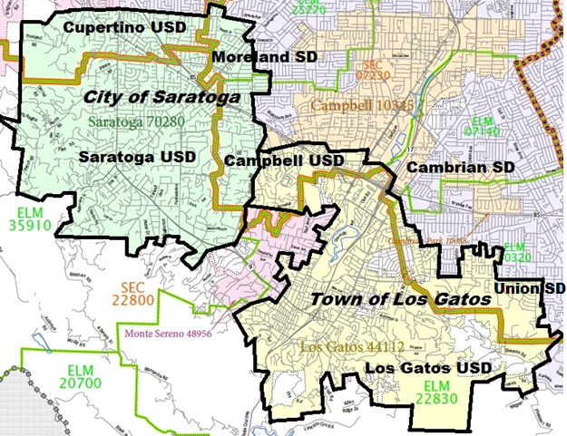

Source Map: United States Census Bureau, 2010

(<https://www.census.gov/geo/maps-data/maps/2010ref/st06_sch_dist.html>)

Key to Boundary Lines on Map

Map key for city or town boundary. City/Town Boundary

Map key for high school district boundary line. High School District Boundary

Map key for elementary school district boundary line. Elementary School District Boundary

* The town of Los Gatos and the cities of Saratoga and Cupertino are considered much more affluent than the cities of Campbell and San Jose (see Table 1), which comprise the remainder of the Campbell UHSD.

***Table 1: Select Census Data[6] for Affected Municipalities***

| Census Data Element | Los Gatos Town | Saratoga City | Cupertino City | Campbell City | San Jose City |
| --- | --- | --- | --- | --- | --- |
| Per Capita Income | $74,855 | $79,870 | $60,040 | $51,269 | $37,845 |
| Percent Bachelors Degree or Higher | 65.5% | 77.0% | 76.6% | 51.5% | 40.2% |
| Median Home Value | $1,338,400 | $1,742,900 | $1,214,300 | $804,500 | $658,000 |

* Although the academic performance of the Campbell UHSD and its component elementary districts exceeds state averages, the academic performance of the schools in the Cupertino, Los Gatos, and Saratoga USDs is perceived to be superior. Table 2 displays California Assessment of Student Performance and Progress (CAASPP)[7] data for affected elementary school districts.

***Table 2: Percent CAASPP Standards Exceeded or Met***

| Elementary School District | District Enrollment | English/ Language Arts | Math |
| --- | --- | --- | --- |
| Cambrian SD | 3,514 | 66.1% | 56.3% |
| Campbell Union SD | 7,465 | 53.4% | 48.3% |
| Moreland SD | 4,780 | 68.3% | 62.3% |
| Union SD | 5,751 | 77.9% | 75.7% |
| Cupertino Union SD | 18,598 | 84.3% | 86.2% |
| Los Gatos Union SD | 3,263 | 79.2% | 76.7% |
| Saratoga Union SD | 1,906 | 86.9% | 90.1% |

* The combination of higher levels of affluence and academic performance often results in property values in the Cupertino, Los Gatos, and Saratoga USDs that are 10 to 20 percent higher than in the neighboring Campbell UHSD.

## Early Transfer Requests from the Campbell UHSD

In 1994, the Santa Clara County Committee on School District Organization (County Committee) approved a request to transfer territory from the Campbell USD and the Campbell UHSD to the Saratoga USD and the Los Gatos-Saratoga JUHSD. The County Committee approved the proposal over the opposition of the Campbell districts, who claimed that such approval would open the “floodgates” to additional transfer requests out of the districts. In response to this concern, the County Committee expanded the election area to the entire Campbell USD.[8] At this time, both the Saratoga USD and the Los Gatos-Saratoga JUHSD supported the transfer.

The Campbell districts appealed the County Committee’s action to approve the transfer to the California State Board of Education (SBE), while chief petitioners for the transfer proposal similarly appealed the expansion of the election area. Both appeals were pulled from SBE consideration after the districts and the chief petitioners negotiated an agreement allowing the transfer to occur after certain conditions were met.

Following this initial proposal, the Santa Clara County Office of Education (County Office) reported receiving 17 inquiries regarding territory transfers from residents of the portion of the city of Saratoga that is in the Campbell districts. These inquiries resulted in the County Committee receiving five territory transfer proposals.[9] It disapproved all five—however, two of these disapprovals were appealed to the SBE. The SBE overturned the County Committee’s action to disapprove the first appeal, allowing the transfer to be approved following an election only in the area proposed for transfer. The second appeal was heard by the SBE a few months later at the same meeting it considered a Santa Clara County request to waive timelines for processing territory transfer proposals pending a comprehensive study of reorganization issues. The SBE affirmed the action of the County Committee regarding this second appeal.

Following this SBE action, additional proposals to transfer territory out of the Campbell UHSD were filed with the County Office, with interest expanding beyond the portion of the city of Saratoga that is in the Campbell UHSD to the portion of the town of Los Gatos in the Campbell UHSD. These transfer proposals, along with formal action by the Saratoga City Council to support the transfer of all property within the city of Saratoga to the Saratoga USD, and the support for previous transfer proposals from the Los Gatos and Saratoga USDs, raised concerns by the County Office and the County Committee that the “piecemeal”[10] approach to changing the boundaries of the school districts was not sound policy.

The County Office and the County Committee approved a comprehensive study of school district reorganization options for the entire west valley of Santa Clara County, which included 13 school districts (over one-third of the districts in the county). To allow for the proper focus on this area-wide study, the Santa Clara County Board of Education (County Board) requested that the SBE waive the timelines required for the County Committee to act on territory transfer proposals until after the study had been completed. The SBE approved the County Board’s request at its June 1997 meeting.

## West Valley Study of District Reorganization Options

The County Office contracted with an independent consultant for a study of reorganization options for the west valley of Santa Clara County (West Valley Study). This study included not just an analysis of the comprehensive effects of territory transfers but also unification options and “piecemeal” adjustments to existing boundaries. In February 1998, the Santa Clara County Superintendent of Schools (County Superintendent) notified the SBE of the study results and the County Committee’s response to the study, along with public reception.

The study noted numerous negative effects on school districts due to the removal of the municipal portions of Los Gatos and Saratoga from the Campbell UHSD, with the Los Gatos and Saratoga districts particularly hard hit. Those negative effects included:

1. The Los Gatos and Saratoga districts would experience significant increases in student population without commensurate school facilities, resulting in increased overcrowding of schools and future costs for new facilities.
2. Residents of the Los Gatos and Saratoga districts would experience increased property taxes due to shifts of bonded indebtedness into the districts.
3. Per pupil funding would decline for the Los Gatos and Saratoga districts.

While the Campbell UHSD (along with its component districts and residents of those districts) already opposed the idea of transferring territory out of the districts, the findings in the study gave rise to additional, and even more vociferous, opposition from the Los Gatos and Saratoga districts (and the residents of those districts) toward proposed district reorganization. Throughout the course of the study, the County Office received, in writing, over 2,800 responses from area residents regarding the possibility of territory transfers. Over 2,500 of those responses were in opposition to the idea of territory transfers and fewer than 300 were in support. Overwhelming opposition also was expressed at the numerous public hearings conducted by the County Committee.

Regarding “piecemeal” adjustments to the existing boundaries, the general finding in the West Valley Study was that “reorganization of portions of the territories of the … school districts will shift community identity problems rather than resolve them.” Absent any viable global reorganization options that are supported by the communities and the districts, the study noted that current boundaries “may be optimal.”

In response to the negative findings of the study and the lack of school district and community support for territory transfers, the County Committee voted unanimously not to support territory transfers in the West Valley area unless exceptional circumstances existed. The County Committee also adopted guidelines for these exceptional circumstances, which primarily addressed home to school transportation issues. This action by the County Committee was supported in newspaper editorials appearing in the San Jose Mercury News, the Los Gatos Weekly Times, and the Saratoga News.

Although no boundary adjustments resulted from the West Valley Study, the study did lead to a number of efforts to address some of the concerns raised, including:

* The County Office worked with the Santa Clara County Association of Realtors to address the practice of touting proximity to Los Gatos and Saratoga schools when marketing Los Gatos and Saratoga homes located in the Campbell UHSD.
* In collaboration with the Santa Clara County Assessor, the County Office developed one of the first internet sites in the state to allow potential home buyers to enter an address and determine the school district(s) of residence.
* Affected districts and municipalities worked more closely with local community organizations (e.g., Little League) to address issues regarding residency, participation, and communication.

## Territory Transfers Subsequent to West Valley Study

The County Superintendent, in her February 1998 communication to the SBE, noted that the County Committee likely would continue to receive territory transfer requests from this area despite the findings in the West Valley Study and the actions of the County Committee—and that the SBE likely would continue to receive appeals from future County Committee actions on territory transfer proposals.

Since the West Valley Study, the SBE has received 11 appeals from actions of the County Committee to disapprove territory transfers from the Campbell UHSD (including the three on the current SBE agenda). The action of the County Committee has been affirmed by the SBE in each of these previous appeals.

1. Pursuant to *EC* sections 35709 and 35710, a county committee may approve a territory transfer only if it finds that the conditions in *EC* Section 35753 are substantially met.
2. The *School District Organization Handbook* was prepared through the joint efforts of the SBE, the California County Superintendents Educational Services Association, the Fiscal Crisis and Management Assistance Team, and the CDE. It is online at: <https://www.cde.ca.gov/re/lr/do/>.
3. The County Office included a transcript of the meeting proceedings as part of the administrative record. The referenced points made by County Committee members are from that transcript.
4. The SBE considered three of these proposals on appeal: Twain Court, Emerald Hills, and the 1999 appeal that included the Camino Barco area. None of the analyses completed for these previous appeals identified concerns with commute safety.
5. For 2018–19 Advance Apportionment purposes, the Campbell UHSD, the Los Gatos-Saratoga JUHSD, and the Fremont UHSD are all excess tax districts, along with the Campbell USD and all component elementary districts of the Los Gatos-Saratoga JUHSD (<https://www.cde.ca.gov/fg/aa/pa/ada75701819.asp>).
6. U.S. Census population estimates (July 1, 2017) at <https://www.census.gov/quickfacts>.
7. For more detail, see the CDE’s CAASPP website at <https://www.cde.ca.gov/ta/tg/ca/>.
8. *Education Code* (*EC*) Section 35710 requires an election for a territory transfer if an affected district opposes the transfer. *EC* Section 35732 provides the County Committee the authority to expand an election area beyond the default election area, which is “the territory proposed for reorganization.”
9. The County Office also reported that the County Committee had addressed only six territory transfer proposals from the entire county over the previous 10 years.
10. County agencies believed that this “piecemeal” approach did not allow for a comprehensive look at what, in the opinion of these agencies, was a clear intent to transfer all Los Gatos and Saratoga municipal territory from the Campbell UHSD to the Los Gatos-Saratoga JUHSD. Small transfers by themselves did not cause significant concerns regarding the minimum standards (*EC* Section 35753) and the county agencies wanted a more comprehensive analysis of their effects on school district reorganization in the area.